MOHAMMAD KAMRUZZAMAN
ID number: UD83206BU92424

COURSE NAME:
Administration and Management Skills

ATLANTIC INTERNATIONAL UNIVERSITY
December 2023

Table of Contents
Lesson 1 3
Lesson 2 8
Lesson- 3 12
Lesson: 4 17
Lesson: 5 21
Lesson: 6 25
Lesson: 7 29
Lesson: 8 33
Lesson: 9 38
Lesson: 10 45
References: …………………………………………………………………………………………………………………………………………. 52

Questions to Answer:

Lesson 1

- Describe the management of Intellectual Capital (Human Capital) in terms of Recruitment, Selection and Training?
Introduction
Intellectual capital, often referred to as human capital, stands at the core of an organization's success and competitiveness in the contemporary business landscape. Recognizing the significance of human potential, organizations focus on effective management of intellectual capital through strategic processes such as recruitment, selection, and training. This holistic approach ensures that the organization attracts, identifies, and cultivates talent to unleash its full potential. In this context, recruitment involves the identification and acquisition of individuals with the right skills and attributes, selection involves choosing the best-fit candidates, and training is the continuous process of developing and enhancing the skills and knowledge of employees. Together, these elements form a dynamic framework that empowers organizations to harness and optimize their intellectual capital, fostering innovation, adaptability, and sustainable growth. In this discussion, we delve into the intricate aspects of managing intellectual capital through the lens of recruitment, selection, and training, highlighting their interconnectedness in shaping a thriving organizational culture. The management of Intellectual Capital, often referred to as Human Capital management is a strategic and systematic approach to leveraging the collective knowledge, skills, and abilities of an organization's workforce. It involves recognizing human resources as a valuable asset that contributes significantly to an organization's competitive advantage, innovation, and overall success.
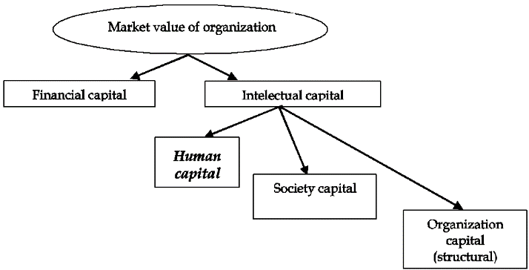
The management of Intellectual Capital encompasses several key elements:
a). Recruitment and Acquisition
- Identifying and attracting talent that aligns with the organization's goals and values.
Identifying and attracting talent aligned with an organization's goals and values involves a strategic process where HR professionals collaborate with hiring managers to define required skills, competencies, and cultural fit. Strategic workforce planning ensures the organization anticipates future needs, while a positive employer brand communicates values and culture. Diverse recruitment channels are employed to cast a wide net, and comprehensive selection processes, including assessments and interviews, evaluate both technical aptitude and alignment with organizational values. This meticulous approach aims to build a workforce that not only possesses the necessary skills but also shares the company's mission, contributing to long-term success.
- Strategic workforce planning to ensure that the right skills are present within the organization.

Strategic workforce planning is a systematic process wherein organizations anticipate and align their workforce with future needs and business objectives. It involves a comprehensive analysis of the current workforce, understanding the skills and competencies required for organizational success, and forecasting future skill requirements. By identifying gaps in the existing talent pool, strategic workforce planning enables proactive recruitment, training, or development initiatives. This approach ensures that the organization possesses the right skills and expertise to adapt to changing industry demands, fostering agility and long-term viability.

b) Selection and Placement
- Rigorous selection processes to match individuals with the right roles based on skills and competencies.
Rigorous selection processes entail a thorough evaluation of candidates to align their skills and competencies with the specific requirements of roles within the organization. This involves meticulous assessments, interviews, and reference checks to ensure a precise match between the individual's capabilities and the demands of the position. The goal is to identify candidates not only with the necessary technical skills but also those who exhibit the behavioral attributes essential for success in their designated roles. This methodical approach enhances the likelihood of optimal talent placement, contributing to improved job performance and organizational effectiveness.
- Ensuring a cultural fit and alignment with the organization's mission and vision.
Ensuring a cultural fit and alignment with the organization's mission and vision is a critical aspect of the recruitment process. Beyond evaluating technical skills, employers aim to assess whether candidates share values, work ethics, and aspirations consistent with the company's culture and overarching goals. This involves considering how well an individual's professional demeanor and personal values align with the established norms and long-term objectives of the organization. Prioritizing cultural fit enhances employee satisfaction, teamwork, and overall cohesion within the workplace, contributing to a positive and harmonious organizational environment.
c) Training and Development
- Continuous learning initiatives to enhance skills and adaptability.
Continuous learning initiatives represent a proactive approach to employee development, emphasizing the ongoing enhancement of skills and adaptability within the workforce. Organizations implement programs and resources that encourage employees to acquire new knowledge, stay abreast of industry trends, and hone their existing skills. This commitment to continuous learning not only fosters individual professional growth but also ensures that employees remain adaptable in the face of evolving job requirements and technological advancements. By investing in continuous learning, organizations cultivate a dynamic and resilient workforce, better positioned to contribute to the company's long-term success in a rapidly changing business landscape.
- Tailored training programs to address specific organizational needs and industry trends.
Tailored training programs are designed to address the specific needs and industry trends relevant to an organization. These initiatives are carefully crafted to align with the unique challenges and goals of the company, ensuring that employees receive targeted development opportunities. By customizing training content to match organizational requirements and staying current with industry trends, these programs empower employees with the skills and knowledge necessary to excel in their roles. This strategic approach not only enhances individual performance but also equips the workforce to contribute effectively to the organization's overall success in a rapidly evolving business landscape.
Effective management of Intellectual Capital recognizes that employees are not just a cost but a valuable investment. By focusing on recruitment, development, engagement, and retention, organizations can maximize the potential of their human capital, fostering a dynamic and innovative workforce that contributes to long-term success.
- What is a Staff Development Program?

Introduction
A staff development program is a strategic and organized initiative implemented within an organization to enhance the skills, knowledge, and capabilities of its workforce. This comprehensive program is designed to foster continuous learning and support the professional growth of employees. A Staff Development Program is a structured and intentional initiative undertaken by organizations to enhance the skills, knowledge, and overall effectiveness of their employees. In the ever-evolving landscape of the professional world, organizations recognize the pivotal role of continuous learning and growth in maintaining a competitive edge and fostering employee satisfaction. A well-designed Staff Development Program goes beyond traditional training, encompassing a range of activities and opportunities aimed at unlocking the full potential of individuals within the workforce. From workshops and seminars to mentorship programs and on-the-job learning, these initiatives contribute to both individual and organizational success by cultivating a culture of learning, adaptability, and innovation. In this exploration, we delve into the key components and benefits of Staff Development Programs, shedding light on their transformative impact on employee engagement and organizational performance.
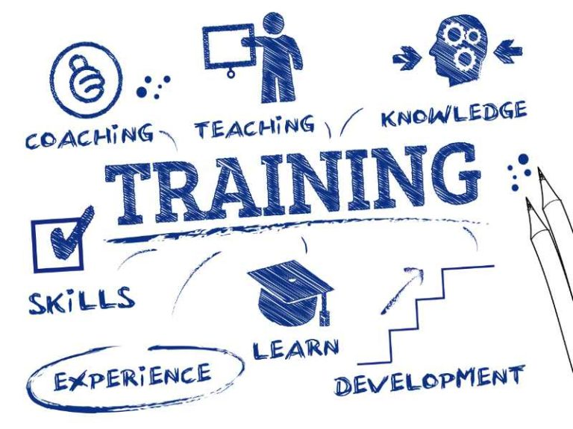
Objectives and Purpose
The primary purpose of a staff development program is to empower employees with the necessary tools for success. This includes improving job performance, supporting career progression, and preparing individuals for future roles and responsibilities.
Diverse Range of Activities
Staff development programs encompass a wide array of activities tailored to meet the specific needs of employees. These activities may include formal training sessions, workshops, seminars, mentoring programs, coaching sessions, and other learning opportunities.
Methods of Implementation
Organizations employ various methods to implement staff development programs, ensuring a holistic approach to employee growth. Formal training sessions provide structured learning, while informal methods such as on-the-job experiences and peer collaborations contribute to a well-rounded development strategy.

Impact on Individual and Organization
The positive impact of staff development programs extends beyond individual career growth. By enhancing the skills and competencies of employees, organizations experience improved job satisfaction, increased productivity, and heightened overall performance.
Focusing on Personal and Professional Development
A distinctive feature of effective staff development programs is their commitment to addressing both personal and professional development needs. This dual focus contributes to a well-rounded and fulfilled workforce.
Benefits Including Retention
One of the significant benefits of a robust staff development program is its association with lower turnover rates. Employees who feel supported in their professional growth are more likely to remain engaged and committed to the organization.
Conclusion
Effective management of intellectual capital, involving recruitment, selection, and training, is crucial for organizational success. This holistic approach ensures the strategic acquisition of talent, optimal placement, and continuous development. Additionally, well-designed Staff Development Programs play a pivotal role in enhancing individual and organizational capabilities, fostering a culture of continuous learning, and contributing to improved job satisfaction and retention. Together, these practices are strategic investments that empower organizations to thrive in a dynamic and competitive business environment.

Lesson 2

- Describe Business Communication?
Introduction
Business communication is a fundamental and integral aspect of organizational functioning, encompassing the exchange of information, ideas, and messages within and between entities. It serves as the lifeblood of any successful enterprise, facilitating the smooth flow of data, instructions, and feedback among various stakeholders such as employees, management, customers, suppliers, and investors. Effective business communication is crucial for achieving organizational objectives, fostering collaboration, and maintaining a harmonious work environment. Business communication is the lifeblood of organizational interactions, serving as the essential conduit for exchanging information, ideas, and messages within and outside a company. In the dynamic landscape of the business world, effective communication is a cornerstone of success, influencing relationships with employees, stakeholders, customers, and the broader market. This multifaceted concept encompasses verbal and written exchanges, as well as non-verbal cues, all working together to convey a clear and impactful message. Business communication is not only about transmitting information but also about fostering understanding, building relationships, and achieving common goals. In this exploration, we delve into the intricacies of business communication, examining its diverse forms, importance, and the role it plays in shaping organizational culture and success.

Business communication involves both internal and external interactions. Internally, it plays a pivotal role in conveying corporate policies, disseminating important updates, and ensuring that employees are well-informed about organizational goals and strategies. It includes formal channels such as official memos, reports, and presentations, as well as informal channels like team meetings, discussions, and electronic communication platforms. Clear and transparent internal communication is vital for employee engagement, motivation, and alignment with the company's mission. Externally, business communication extends to interactions with external stakeholders, including customers, suppliers, regulatory bodies, and the wider community. This facet encompasses marketing and promotional activities, customer service communications, negotiations with suppliers, and compliance reporting. A positive external communication strategy enhances the organization's reputation, builds customer trust, and strengthens partnerships with key collaborators. Business communication is not solely about the transmission of information; it also involves the art of persuasion, negotiation, and conflict resolution. Effective communicators within a business context possess the ability to articulate ideas clearly, listen actively, and adapt their communication style to suit diverse audiences. Whether it's delivering a persuasive sales pitch, resolving a workplace conflict, or negotiating a business deal, effective communication skills are critical for achieving successful outcomes. In the contemporary business landscape, technological advancements have significantly transformed the landscape of communication. Email, video conferencing, instant messaging, and social media platforms have become integral tools for business communication, enabling real-time interactions across geographical boundaries. However, the widespread use of technology also brings challenges such as information overload, misinterpretation, and the need for cyber security measures to protect sensitive data. Business communication is a multifaceted and dynamic process that underpins the functioning of organizations. It involves the exchange of information, ideas, and messages both within and outside the company, influencing its internal dynamics and external relationships. A strategic and thoughtful approach to business communication is essential for achieving organizational success, fostering collaboration, and adapting to the evolving demands of the business environment.

- Give 3 Example of Non – Verbal Communication?
Introduction
Non-verbal communication involves conveying messages without using words. It encompasses facial expressions, body language, gestures, postures, and other forms of non-verbal cues. Human interaction, communication extends beyond spoken or written words. Non-verbal communication, a rich and nuanced aspect of our daily interactions, plays a crucial role in conveying messages, emotions, and intentions without relying on language. It involves the use of facial expressions, gestures, body language, and other non-verbal cues to express thoughts, feelings, and attitudes. Non-verbal communication serves as a powerful complement to verbal expression, often influencing how messages are interpreted and understood. In this exploration, we will delve into three examples of non-verbal communication, each illustrating the significance and impact of unspoken forms of expression in our interpersonal interactions.

Here are three examples of non-verbal communication:
a. Facial Expressions: Facial expressions are a powerful form of non-verbal communication. People naturally convey a wide range of emotions through their facial expressions, such as happiness, sadness, surprise, anger, or disgust. For instance, a smile can indicate friendliness or agreement, while a furrowed brow might signal confusion or displeasure. The subtleties of facial expressions contribute significantly to understanding the emotional context of a conversation.

b. Body Language: Body language involves the use of physical gestures, postures, and movements to convey messages. For example, crossing arms may indicate defensiveness or resistance, while maintaining eye contact can signal attentiveness and confidence. The way individuals stand, sit, or move during a conversation can provide insights into their level of comfort, engagement, or agreement with the communication at hand.

c. Hand Gestures: Hand gestures are a common form of non-verbal communication and can vary widely across cultures. Different gestures can convey different meanings, and they often complement or emphasize spoken words. For instance, a thumbs-up gesture is generally interpreted as a sign of approval or agreement, while pointing can be used to draw attention to a specific object or idea. It's important to be aware of cultural differences in interpreting hand gestures to avoid misunderstandings.
Understanding and being aware of these non-verbal cues is crucial for effective communication, as they can significantly impact the overall message being conveyed. Additionally, non-verbal communication often complements verbal communication, providing additional layers of meaning and context to the spoken words.

CONCLUSION
Business communication is a vital element for organizational success, involving the exchange of information both verbally and non-verbally. It plays a crucial role in shaping internal dynamics, fostering collaboration, and building positive external relationships. Effective communication, whether through clear internal messaging or understanding non-verbal cues, is essential for achieving organizational goals and adapting to the evolving business landscape.

Lesson- 3
- What is “Benchmarking”?
Introduction
Benchmarking is a strategic management and performance improvement process that involves a comprehensive evaluation of an organization's various aspects, including operations, processes, products, or services. This evaluation is conducted by comparing the organization's performance to that of industry leaders, competitors, and best practices both within and outside its industry. The overarching goal of benchmarking is to identify areas for improvement, gain insights into how high-performing organizations achieve success, and implement strategic changes to enhance the organization's own performance. The benchmarking process is systematic and data-driven, relying on the analysis of key performance indicators, metrics, and practices. By examining and comparing these elements, organizations can identify gaps, inefficiencies, or opportunities for innovation within their own operations. Benchmarking is not limited to a single industry or sector; it encourages organizations to look beyond their immediate competitors and draw inspiration from diverse sources to foster innovation and continuous improvement.
There are several types of benchmarking, including:

a. Internal Benchmarking: Involves comparing performance and processes within different units or departments within the same organization. This helps identify and share best practices across different parts of the organization.
b. Competitive Benchmarking: Focuses on comparing the organization's performance with direct competitors in the same industry. This type of benchmarking provides insights into market positioning and competitiveness.
c. Functional Benchmarking: Extends the comparison beyond direct competitors to organizations that perform similar functions or activities, regardless of industry. This broader perspective allows for cross-industry learning and innovation.
d. Strategic Benchmarking: Involves comparing an organization's strategies, structures, and processes with those of organizations recognized as leaders in a particular industry or business area. The goal is to adopt and adapt strategies that contribute to superior performance.

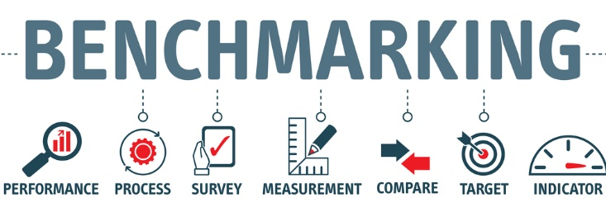
The benchmarking process typically involves several key steps:

a. Identifying Metrics and Processes: Organizations begin by selecting specific performance metrics or processes that they want to evaluate. These could include operational efficiency, product quality, customer satisfaction, cost-effectiveness, or any other relevant aspect of their business.
b. Identifying Benchmarking Partners: Organizations then identify benchmarking partners, which can be companies within the same industry (competitive benchmarking), companies outside the industry that excel in a particular area (functional benchmarking), or even internal benchmarking where different departments within the same organization are compared.
c. Data Collection and Analysis: Data is collected from the benchmarking partners, and a detailed analysis is conducted to understand the practices, processes, and performance levels of the benchmarked entities. This often involves site visits, interviews, surveys, and the examination of publicly available information.
d. Setting Performance Targets: Based on the analysis, organizations set performance targets and goals for improvement. These targets are often aligned with the best practices observed during the benchmarking process.
e. Implementing Changes: Once performance targets are set, organizations implement changes and improvements in their own processes or operations. This may involve adopting new technologies, restructuring workflows, enhancing employee training, or making other adjustments based on the insights gained from the benchmarking exercise.
f. Monitoring and Continuous Improvement: Continuous monitoring and evaluation are crucial to assessing the impact of the changes and identify any additional areas for improvement. Benchmarking is an ongoing process that supports a culture of continuous improvement within an organization.

CONCLUSION
Benchmarking can be applied to various aspects of business, including operations, customer service, product development, and strategic planning. It provides a systematic and structured approach for organizations to learn from others, stay competitive, and strive for excellence in their industry.
- Describe “Process Improvement”?
Introduction
Process improvement is a strategic and iterative approach aimed at enhancing organizational efficiency and effectiveness. It involves analyzing existing workflows, identifying bottlenecks, and implementing targeted changes to align processes with business objectives. This journey is marked by the continuous measurement of key performance indicators (KPIs) and the incorporation of feedback from stakeholders. Process improvement goes beyond mere procedural adjustments, fostering a culture of adaptability and innovation within the organization. By engaging employees and utilizing methodologies such as Six Sigma or Lean, businesses can systematically refine and optimize their operations, ensuring they remain agile and competitive in an ever-evolving business landscape.

Key aspects of process improvement include:
a. Identification of Processes: Organizations begin by identifying the key processes that contribute to the delivery of products or services. This could include any aspect of operations, such as production, sales, customer service, and administrative functions.
b. Mapping and Analysis: Once processes are identified, they are often mapped out in detail to visualize the steps involved, the interactions between different components, and potential bottlenecks or inefficiencies. Process analysis involves studying performance metrics, gathering data, and identifying areas for improvement.
c. Setting Objectives: Clear objectives are established for the process improvement initiative. These objectives may include improving efficiency, reducing costs, enhancing product quality, shortening lead times, or improving customer satisfaction.
d. Benchmarking: Benchmarking is often part of the process improvement process. Organizations compare their processes and performance metrics against industry standards or best practices to gain insights and identify areas where improvements can be made.
e. Implementation of Changes: Based on the analysis and benchmarking results, changes and improvements are implemented. This may involve restructuring workflows, introducing new technologies, providing additional training to employees, or making other adjustments to enhance the efficiency and effectiveness of the processes.
f. Monitoring and Measurement: Continuous monitoring is essential to ensure that the implemented changes are producing the desired results. Key performance indicators (KPIs) are tracked to measure the impact of the improvements and identify any further adjustments that may be necessary.
g. Feedback and Adaptation: Organizations encourage feedback from employees and stakeholders involved in the processes. This input helps in identifying any unforeseen issues or opportunities for further improvement. The process improvement approach is iterative, allowing organizations to adapt and refine their processes overtime.
h. Documentation and Standardization: Successful process improvement initiatives often involve documenting the optimized processes and establishing standardized procedures. This documentation serves as a reference for employees and helps maintain consistency in operations.
Continuous process improvement is a fundamental aspect of modern business management, contributing to organizational agility and the ability to adapt to changing market conditions. By fostering a culture of continuous improvement, organizations can stay competitive, enhance customer satisfaction, and achieve operational excellence.
CONCLUSION
Benchmarking and process improvement are integral components of strategic management, contributing significantly to an organization's quest for excellence and competitiveness. Benchmarking serves as a compass, guiding organizations to evaluate their performance against industry leaders, competitors, and best practices. By identifying areas for improvement and adopting successful strategies, organizations can enhance their operational efficiency and overall effectiveness. On the other hand, process improvement embodies a proactive and iterative approach to refining internal workflows, reducing inefficiencies, and fostering a culture of adaptability and innovation. Through systematic analysis, targeted changes, and continuous monitoring, organizations can optimize their processes, align them with business objectives, and ensure sustained excellence in an ever-evolving business landscape. Together, benchmarking and process improvement form a dynamic duo, providing organizations with a structured framework for learning from external best practices and driving internal enhancements. By embracing these strategic initiatives, businesses position themselves to not only stay competitive but also to thrive in an environment where continuous improvement is the key to long-term success.

Lesson: 4
- Briefly describe the five aspects that define a personality.
Introduction
The exploration of human personality represents a compelling journey into the intricacies of individuality and psychological composition. Personality, the unique and enduring pattern of thoughts, emotions, and behaviors that distinguish one person from another, is a complex interplay of various facets. To unravel this complexity, psychologists have identified five fundamental aspects that collectively define and elucidate the richness of human personality. These aspects delve into the emotional, cognitive, and behavioral dimensions, forming a comprehensive framework to fathom the intricacies of how individuals perceive, interact, and respond to the world around them. In this extensive exploration, we embark on a nuanced examination of these five core dimensions, each contributing distinct insights into the mosaic that constitutes the essence of an individual's identity and character.Personality, a complex and multifaceted construct, is typically understood and assessed through various aspects. While different theories of personality exist, one widely accepted framework is often referred to as the "Big Five" personality traits.


These traits, also known as the Five Factor Model (FFM), provide a comprehensive overview of an individual's personality and include the following five aspects:

a. Openness to Experience: This aspect reflects the extent to which an individual is open-minded, imaginative, curious, and willing to engage in novel ideas and experiences. People high in openness tend to be creative, adventurous, and open to unconventional thinking, while those low in openness may prefer routine and familiarity.
b. Conscientiousness: Conscientiousness pertains to the degree of organization, responsibility, and reliability in an individual's behavior. Highly conscientious individuals are typically organized, diligent, and detail-oriented, while those lower in conscientiousness may be more spontaneous and less focused on order and planning.
c. Extraversion: Extraversion refers to the extent to which an individual is outgoing, sociable, and energized by social interactions. Extraverts tend to be assertive, talkative, and enjoy the company of others, while introverts are often more reserved, reflective, and may prefer solitude.
d. Agreeableness: Agreeableness reflects the level of warmth, empathy, and cooperativeness in a person's interpersonal relationships. Highly agreeable individuals are generally compassionate, considerate, and cooperative, while those lower in agreeableness may be more competitive or assertive.
e. Neuroticism (Emotional Stability): Neuroticism relates to emotional stability and the tendency to experience negative emotions such as anxiety, fear, and sadness. Individuals high in neuroticism may be more prone to stress and emotional fluctuations, while those low in neuroticism tend to be more emotionally stable and resilient in the face of challenges.
These five aspects are often represented as a spectrum, with individuals falling at various points along each dimension. The Big Five traits provide a broad and comprehensive framework for understanding and describing personality, and they have been widely used in psychological research and personality assessments. It's important to note that personality is complex, and these traits capture general tendencies rather than specific behaviors in all situations. Additionally, other personality theories and models exist, each offering unique insights into the complexities of human personality.

- Describe 2 habits of an effective person?
Introduction
Personal and professional success, the cultivation of effective habits stands as a cornerstone. Effective habits are the building blocks that empower individuals to navigate challenges, achieve goals, and lead fulfilling lives. These habits, rooted in intentionality and discipline, extend beyond mere routines—they shape the very essence of an individual's character and contribute to their overall effectiveness. As we delve into the intricacies of effective habits, we'll explore two key pillars that define the habits of a highly effective person. These habits not only propel individuals toward their objectives but also foster a mindset and approach to life that transcends daily routines, creating a sustainable foundation for long-term success and personal growth. Join us in this exploration as we uncover the profound impact of intentional habits on individual effectiveness and the pathways they pave toward a life of purpose and accomplishment. Effective individuals often exhibit habits that contribute to their success in various aspects of life. Here are two habits commonly associated with effective people:
a. Time Management: Effective individuals are skilled at managing their time efficiently. They prioritize tasks based on importance and deadlines, creating a structured approach to their daily activities. This habit involves setting clear goals, breaking them down into manageable tasks, and allocating time appropriately. Time management also includes the ability to identify and focus on high-priority activities, delegate tasks when necessary, and minimize distractions. By maintaining a well-organized schedule and being disciplined in adhering to it, effective individuals can maximize their productivity and achieve their objectives.
b. Continuous Learning and Adaptability: Effective individuals cultivate a habit of continuous learning and adaptability. They recognize the importance of staying informed about industry trends, acquiring new skills, and expanding their knowledge base. This habit involves seeking out opportunities for professional development, whether through formal education, workshops, mentorship, or self-directed learning. Additionally, effective individuals are adaptable in the face of change. They embrace challenges, learn from setbacks, and adjust their strategies accordingly. This adaptability allows them to thrive in dynamic environments, navigate uncertainties, and capitalize on emerging opportunities.
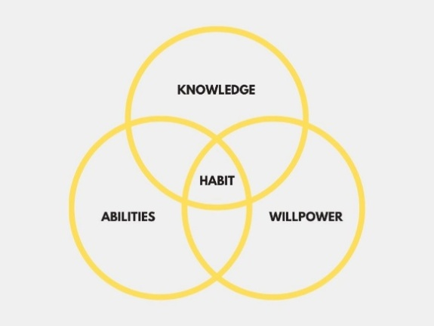
These habits contribute to the overall effectiveness of individuals by promoting efficiency in their actions, fostering personal and professional growth, and enhancing their ability to navigate challenges successfully.
CONCLUSION
The exploration of personality and effective habits provides profound insights into the intricacies of human behavior and success. The five aspects of personality, encapsulated by the Big Five traits, offer a comprehensive framework for understanding individual differences. These aspects, ranging from openness to experience to emotional stability, contribute to the unique mosaic of each person's identity.
Transitioning to the realm of effective habits, two key pillars—time management and continuous learning/adaptability—emerge as critical contributors to personal and professional success. The ability to manage time efficiently, prioritize tasks, and remain adaptable in the face of change distinguishes highly effective individuals. These habits create a foundation for increased productivity, resilience, and continuous growth. In essence, personality and habits are intertwined elements that shape the trajectory of an individual's life. By understanding and harnessing the complexities of personality and cultivating effective habits, individuals can navigate the nuances of their personal and professional landscapes, propelling themselves towards purposeful and accomplished lives.

Lesson: 5
- Why would empathy be important for management?

Introduction
Empathy is crucial for effective management as it establishes a foundation of understanding, trust, and connection between managers and their teams. A manager's ability to empathize with the experiences, emotions, and perspectives of employees contributes to stronger relationships and improved communication. Empathetic leaders are adept at recognizing and addressing the needs and concerns of their team members, leading to a positive work environment. This quality becomes particularly valuable in conflict resolution, as empathetic managers can navigate disputes with sensitivity, finding solutions that consider the feelings and perspectives of all parties involved. Moreover, empathy enhances employee engagement and motivation, as individuals are more likely to be committed and contribute their best efforts when they feel valued and understood. In the long term, an empathetic approach to management fosters talent retention and supports a culture of inclusive decision-making, ultimately contributing to the overall success and well-being of the organization. Here are several key reasons why empathy is paramount for effective management:
a. Enhanced Communication: Empathetic managers are adept at listening actively and understanding the perspectives and concerns of their team members. This skill facilitates clear and open communication, as employees feel valued and heard. By fostering a communicative environment, empathy enables managers to address challenges proactively, prevent misunderstandings, and build trust within the team.
b. Improved Employee Morale and Satisfaction: Demonstrating empathy signals to employees that their well-being and individual experiences are acknowledged and respected. This recognition contributes to higher morale, job satisfaction, and overall engagement. When employees feel understood and supported, they are more likely to be motivated, committed, and loyal to the organization.
c. Conflict Resolution: Workplace conflicts are inevitable, but empathetic managers are well-equipped to navigate and resolve them effectively. By understanding the perspectives of conflicting parties and showing empathy towards their concerns, managers can mediate conflicts, find common ground, and foster resolutions that benefit the entire team.
d. Building Stronger Teams: Empathy creates a sense of unity and cohesion within teams. Managers who empathize with their team members can forge stronger connections and create an environment where individuals feel comfortable collaborating and supporting each other. This sense of camaraderie contributes to increased team performance and productivity.
e. Adaptability and Flexibility: In dynamic work environments, adaptability is crucial for success. Empathetic managers are more attuned to the needs and challenges faced by their team members. This understanding enables them to adapt leadership styles, provide necessary support during changes, and guide their teams through transitions effectively.
f. Employee Development: Empathy aids in recognizing the strengths, weaknesses, and potential of individual team members. Managers who understand the unique aspirations and capabilities of their employees can tailor professional development plans, assign tasks that align with their strengths, and provide constructive feedback that promotes growth.
g. Enhanced Decision-Making: Empathy contributes to a well-rounded perspective in decision-making. Managers who consider the emotional and personal aspects of a situation, in addition to factual information, make more informed and compassionate decisions. This approach fosters a culture of fairness and equity within the organization.
h. Increased Employee Retention: Employees are more likely to stay with an organization where they feel understood, valued, and supported. Empathetic managers contribute to a positive work culture that enhances employee retention by creating an environment where individuals feel a sense of belonging and loyalty.
Empathy in management is a powerful catalyst for building strong, collaborative teams, fostering effective communication, and enhancing overall organizational success. By recognizing and responding to the emotions and needs of others, empathetic managers create a workplace culture that not only values individuals but also promotes a harmonious and productive work environment.
- How is the “Happiness Inventory”?
Introduction
The term "Happiness Inventory" in a professional context might be associated with organizational well-being assessments or workplace satisfaction surveys. Such inventories could be utilized by businesses to gauge the overall happiness and job satisfaction of their employees. These assessments often involve questions and metrics aimed at evaluating various factors contributing to workplace happiness, such as work-life balance, job fulfillment, relationships with colleagues, and organizational culture. Analyzing a Happiness Inventory can provide valuable insights for employers, helping them identify areas for improvement, implement targeted interventions, and create a more positive and productive work environment.
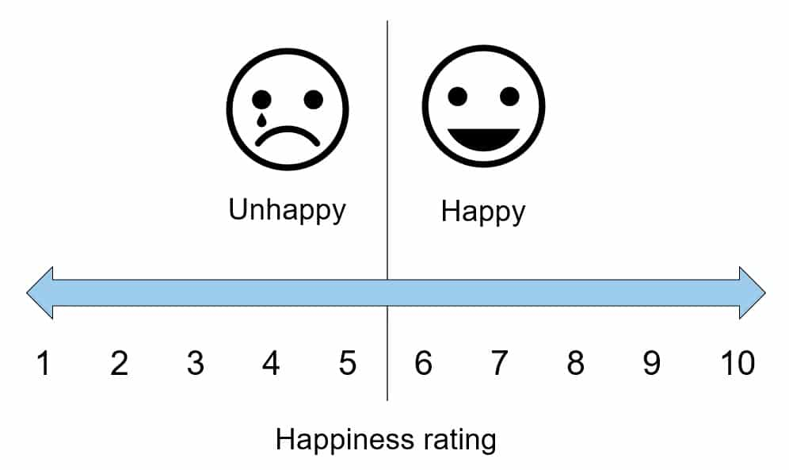
Regularly conducting such inventories aligns with contemporary approaches to organizational management that recognize the importance of employee well-being not only for individual satisfaction but also for overall workplace productivity and success.
a. Organizational Assessment: The term "Happiness Inventory" may refer to a tool or assessment used by organizations to measure the overall well-being and job satisfaction of their employees.
b. Employee Well-being Metrics: Inventories likely include metrics related to various aspects of employee well-being, such as work-life balance, job fulfillment, and the overall workplace environment.
c. Subjective Assessments: Happiness inventories often involve subjective assessments, allowing employees to self-report their levels of satisfaction and happiness based on their individual experiences and perspectives.
d. Identifying Areas for Improvement: Analyzing the results of a Happiness Inventory helps organizations identify specific areas where improvements can be made to enhance the overall happiness and satisfaction of their workforce.
e. Workplace Interventions: The insights gained from these inventories may guide employers in implementing targeted interventions, policies, or initiatives to address identified concerns and foster a more positive work environment.

CONCLUSION
The importance of empathy in management cannot be overstated, as it serves as a linchpin for fostering positive workplace dynamics, effective communication, and overall organizational success. Empathetic leaders who understand and connect with the emotions and perspectives of their team members create an environment where individuals feel valued, supported, and motivated to contribute their best efforts. This quality not only enhances team cohesion and collaboration but also plays a pivotal role in conflict resolution, employee development, and adaptive leadership. Furthermore, the concept of a "Happiness Inventory" aligns with modern approaches to organizational management that prioritize employee well-being and satisfaction. Regular assessments of workplace happiness provide valuable insights for organizations, enabling them to identify areas for improvement, implement targeted interventions, and create a positive and productive work culture. Recognizing the subjective nature of happiness, these inventories empower employees to contribute their perspectives, fostering a sense of inclusivity and shared responsibility for the overall well-being of the workforce.Ultimately, the integration of empathy in management practices and the utilization of tools like the Happiness Inventory contribute to creating workplaces that not only drive individual success and satisfaction but also cultivate a culture of continuous improvement and collective flourishing.

Lesson: 6
- Why is “Great Energy” considered an aspect of a leader?
Introduction
Great energy is a fundamental aspect of effective leadership for several compelling reasons. Leaders who radiate enthusiasm and vitality have the innate ability to inspire and motivate their teams, fostering a positive and dynamic work environment. Their contagious energy not only uplifts team morale but also instills a sense of determination and perseverance, essential qualities in overcoming challenges. Beyond communication skills, a leader's energy plays a pivotal role in crisis management, providing stability and reassurance during turbulent times. Furthermore, high-energy leaders contribute to a vibrant workplace culture, shaping a positive atmosphere that encourages innovation, adaptability, and a strong work ethic.

By leading with great energy, a leader sets a powerful example, influencing the team's mindset and commitment to the organization's goals.
- Inspiration and Motivation
- Energetic leaders inspire and motivate their teams by radiating enthusiasm and passion.
- Contagious energy creates a positive and dynamic work environment.
b. Resilience and Persistence
- High energy levels often correlate with resilience and persistence in the face of challenges.
- Optimism and determination inspire the team to overcome obstacles.
c. Effective Communication
- Great energy contributes to effective and engaging communication.
- Clear and energetic communication conveys enthusiasm for the organization's vision.
d. Crisis Management
- During crises, energetic leaders provide stability and reassurance.
- Positive attitude and energy alleviate fear and uncertainty among team members.
e. Team Morale and Culture
- Energetic leaders contribute to a positive and vibrant workplace culture.
- Boosting team morale and fostering camaraderie are key outcomes.
f. Adaptability and Innovation:
- High-energy leaders are often open-minded and adaptable.
- They encourage innovation and creativity within their teams.
g. Lead by Example
- Leaders with great energy set an example for their teams.
- Demonstrating a strong work ethic and dedication, they inspire their teams to emulate similar qualities.

- Describe “Fate Control” in Leadership?
Introduction
"Fate control" in the realm of leadership can be understood as the leader's ability to exert influence over the outcomes and trajectory of their team or organization. Effective leaders are characterized by their strategic decision-making, vision-setting, and capacity to inspire and guide their teams toward success. In a professional context, fate control reflects the leader's role in shaping the destiny of the collective efforts under their guidance. This involves making informed choices, navigating challenges, and fostering a positive and productive work environment. Leaders who effectively wield fate control are adept at steering their teams through uncertainties, adapting to change, and ultimately contributing to the overall success and achievements of the organization. While external factors play a role, the leader's actions and decisions significantly influence the path and outcomes of the collective endeavors they lead.
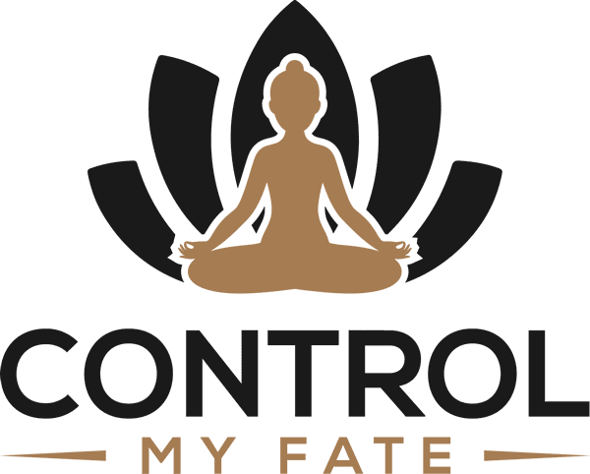
The concept of "fate control" in leadership underscores several important aspects that contribute to the effectiveness of leaders and the success of their teams or organizations:
a. Strategic Decision-Making: Leaders with a sense of fate control are likely to engage in strategic decision-making. They understand the implications of their choices on the future trajectory of the organization and make decisions that align with long-term goals.
b. Vision Setting: Effective leaders set a clear vision for their teams or organizations. By having a proactive and forward-thinking approach, they provide a roadmap that guides the collective efforts toward a shared goal, exercising a level of control over the desired future outcomes.
c. Influence on Organizational Culture: Leaders significantly impact organizational culture. A leader who embraces fate control tends to shape a positive and proactive culture where the team is motivated, adaptable, and focused on achieving success.
d. Adaptability and Change Management: Leaders with a sense of fate control are better equipped to navigate change and uncertainty. They can lead their teams through challenges, adapting strategies and approaches to maintain a course toward success despite external factors.
e. Motivation and Inspiration: Believing in the capacity to influence outcomes, leaders inspire and motivate their teams. This belief in fate control fosters a sense of purpose and commitment among team members, driving them to contribute their best efforts toward shared objectives.
f. Accountability and Responsibility: Leaders who acknowledge their role in fate control also accept accountability for the outcomes. This sense of responsibility encourages leaders to be proactive in addressing challenges, learning from setbacks, and continuously improving their leadership approach.
g. Long-Term Success: The belief in fate control is often associated with a focus on long-term success rather than short-term gains. Leaders who prioritize sustainable growth and development contribute to the lasting success of their teams and organizations.
h. Enhanced Team Performance: When leaders assert a level of control over the fate of the organization, it can translate into enhanced team performance. Team members are likely to be more engaged, collaborative, and aligned with the overall vision set by their leader.
The importance of "fate control" in leadership lies in its ability to drive strategic decision-making, inspire teams, foster a positive organizational culture, and navigate challenges with adaptability. Leaders who embrace this concept contribute significantly to the long-term success and resilience of their teams and organizations.

CONCLUSION
The consideration of "great energy" as an aspect of leadership is deeply rooted in its transformative impact on individuals and organizations. Leaders who exude great energy possess the ability to inspire, motivate, and guide their teams towards success. The contagious nature of this energy creates a positive and dynamic work environment, fostering resilience, effective communication, and a culture of innovation. Furthermore, the concept of "fate control" in leadership emphasizes the significant influence leaders have on the outcomes and trajectory of their teams or organizations. Leaders who embrace fate control engage in strategic decision-making, set visionary goals, and shape a positive organizational culture. Their adaptability, motivation, and long-term focus contribute to enhanced team performance and overall success. Ultimately, the combination of great energy and a belief in fate control creates a leadership approach that goes beyond day-to-day management. It sets the stage for a transformative and enduring impact, where leaders not only guide their teams through challenges but also inspire a collective commitment to shared goals and long-term success.

Lesson: 7
- Describe 3 features of a leader?
Introduction
A leader is an individual who guides, influences, and directs a group of people toward achieving common goals. Leadership can be observed in various contexts, including business, politics, community organizations, and more. Leadership is a multifaceted and dynamic quality that plays a pivotal role in guiding individuals or groups toward shared goals and aspirations. Effective leaders exhibit a range of features that contribute to their ability to inspire, influence, and drive positive change. In this exploration, we delve into three key features that characterize successful leaders. These features encompass a combination of traits, skills, and behaviors that collectively define the essence of leadership. Understanding these features is crucial for individuals aspiring to lead effectively, as they form the foundation for building strong relationships, fostering teamwork, and achieving collective success. Join us in examining these essential features that distinguish exemplary leaders and contribute to their impact on individuals, teams, and organizations.
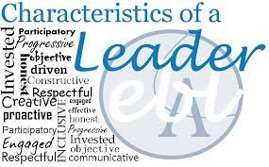
Here are three features of a leader:
a. Inspirational Vision: A leader often possesses a compelling vision of the future that motivates and inspires others. This vision serves as a guiding light, outlining the direction in which the leader wants to take the team or organization. By effectively communicating this vision, a leader can rally support and commitment from the group, fostering a shared sense of purpose.
b. Decisiveness and Accountability: Leaders are required to make tough decisions, often in the face of uncertainty. Decisiveness is a crucial trait, as leaders need to assess situations, weigh options, and make choices that align with the overall goals. Additionally, good leaders take accountability for their decisions, whether they lead to success or failure. Accepting responsibility builds trust and credibility among team members.
c. Effective Communication: Communication is a cornerstone of effective leadership. Leaders must be able to articulate their vision, expectations, and strategies clearly. Moreover, they should actively listen to their team members, encouraging open dialogue and feedback. Strong communication skills facilitate understanding, prevent misunderstandings, and create a collaborative and transparent work environment.
Leadership is a complex and multifaceted trait, and effective leaders often exhibit a combination of various qualities tailored to their specific context and the needs of their team or organization.

- How is “Creative Learning” important in leadership?
Introduction
Creative learning plays a pivotal role in effective leadership, contributing to a host of positive outcomes such as fostering innovation, enhancing adaptability, and promoting a forward-thinking approach. The integration of creative learning into leadership practices is instrumental in navigating the complexities of today's dynamic and ever-changing environments. Leadership, the ability to foster and embrace creative learning is a distinguishing factor that sets effective leaders apart. Creative learning involves cultivating an environment that encourages innovative thinking, continuous development, and adaptability. Leaders who prioritize creative learning recognize its significance in navigating complex challenges, fostering a culture of innovation, and promoting sustained success. In this exploration, we delve into the importance of creative learning in leadership, examining how it contributes to personal growth, team collaboration, and organizational resilience. Understanding the role of creative learning equips leaders with the tools to inspire innovation, cultivate a learning culture, and drive positive transformation within their teams and organizations. Join us as we explore the multifaceted ways in which creative learning becomes a cornerstone for effective leadership in today's ever-evolving and dynamic business landscape.
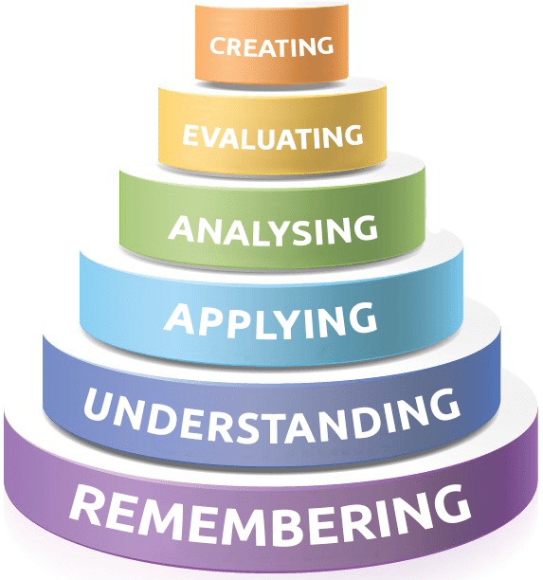
Here's a more in-depth exploration of how creative learning contributes to leadership:
a. Problem-Solving and Innovation: Creative learning empowers leaders to cultivate a culture of innovation within their teams. By encouraging a mindset that values thinking outside the conventional boundaries, leaders can inspire their team members to approach challenges with fresh perspectives. This approach not only facilitates effective problem-solving but also stimulates the generation of novel ideas, leading to innovative solutions.
b. Adaptability to Change: The ability to adapt to change is a hallmark of effective leadership. Creative learning equips leaders with the skills and mindset necessary to navigate uncertainties and embrace new opportunities. Leaders who engage in creative learning are more likely to guide their teams through transitions smoothly, demonstrating flexibility and resilience in the face of evolving circumstances.
c. Encouraging a Learning Culture: Leaders who prioritize creative learning contribute to the development of a learning culture within their organizations. This involves promoting continuous education, skill development, and a commitment to staying informed about emerging trends. By fostering an environment that values curiosity and exploration, leaders create a foundation for ongoing improvement and advancement.
d. Enhancing Employee Engagement: Creative learning initiatives have a direct impact on employee engagement. When leaders support and encourage their team members in pursuing creative endeavors and expanding their skill sets, it fosters a sense of fulfillment and satisfaction. Engaged employees are more likely to bring enthusiasm and dedication to their work, positively impacting overall team dynamics and productivity.
e. Visionary Leadership: Creative learning encourages leaders to adopt a visionary approach. Leaders who engage in continuous learning and creative thinking are better positioned to envision and pursue ambitious goals. This visionary mindset allows leaders to challenge the status quo, set strategic objectives that push the boundaries of what is possible, and inspire their teams to contribute to a future characterized by progress and success.
The integration of creative learning into leadership practices serves as a catalyst for positive organizational outcomes. Leaders who prioritize creative learning contribute to a culture of innovation, enhance adaptability, foster continuous learning, and inspire visionary thinking, ultimately positioning their teams and organizations for sustained success in a rapidly evolving world.
CONCLUSION
Effective leadership is a multifaceted quality characterized by a combination of features, traits, and behaviors that guide individuals or groups toward common goals. Three key features that define successful leaders include an inspirational vision, decisiveness and accountability, and effective communication. Leaders with a compelling vision motivate and inspire others, while decisiveness and accountability are crucial for making tough decisions and building trust. Effective communication is fundamental for articulating the vision and fostering a collaborative work environment. Additionally, creative learning emerges as a critical component of leadership, contributing to innovation, adaptability, and a forward-thinking approach. Leaders who prioritize creative learning foster a culture of innovation, enhance problem-solving skills, and encourage a learning culture within their organizations. Creative learning also plays a pivotal role in enhancing employee engagement, supporting visionary leadership, and positioning teams for success in dynamic environments. In essence, successful leaders navigate the complexities of their roles by embodying these features and embracing creative learning as a catalyst for positive organizational outcomes. The integration of these qualities equips leaders to inspire, influence, and drive positive change, contributing to the overall success of individuals, teams, and organizations.

Lesson: 8
- How can a manager improve the work environment?
Introduction
Improving the work environment is a multifaceted endeavor that requires strategic efforts from managers to enhance employee satisfaction, boost productivity, and contribute to overall organizational success. Creating a positive and productive work environment is a crucial responsibility for managers, as it directly influences the well-being and performance of their teams. A conducive work environment fosters employee satisfaction, engagement, and overall organizational success. In this exploration, we delve into strategies and approaches that managers can employ to improve the work environment. From fostering open communication to promoting work-life balance, effective managers play a pivotal role in shaping a culture that encourages collaboration, innovation, and employee growth. Join us as we explore the multifaceted ways in which managers can enhance the work environment, creating a space where employees thrive and contribute their best to the success of the organization.

Recognizing the pivotal role managers play in shaping workplace culture and atmosphere, here are several comprehensive strategies they can employ to create a positive and conducive work environment:
a. Open Communication: Cultivate an environment of open and transparent communication. Encourage regular dialogue between managers and team members, making sure that employees feel comfortable expressing their ideas, concerns, and feedback. Actively listen to their input and demonstrate a commitment to addressing their needs.
b. Recognition and Appreciation: Establish a culture of recognition and appreciation. Regularly acknowledge and celebrate individual and team achievements. Recognition can take various forms, including public commendation, personalized notes, or the implementation of employee recognition programs. Feeling valued and appreciated fosters a positive atmosphere.
c. Professional Development Opportunities: Support the professional growth of employees by providing ample opportunities for training, skill development, and career advancement. Investing in your team's continuous learning not only enhances their capabilities but also underscores a commitment to their long-term success.
d. Work-Life Balance: Prioritize work-life balance by promoting reasonable working hours, discouraging a culture of overwork, and encouraging employees to take breaks. Implement policies that support flexible working arrangements when feasible. A healthy work-life balance is essential for employee well-being and sustained productivity.
e. Team Building Activities: Organize regular team-building activities and events. These activities can range from informal gatherings to more structured team-building exercises. They serve to strengthen interpersonal relationships, improve collaboration, and contribute to a positive and cohesive team culture.
f. Clear Expectations and Goals: Set clear expectations and goals for the team. Ensure that each team member understands their role and how it aligns with the overall objectives of the organization. Regularly communicate goals, celebrate achievements, and provide constructive feedback to maintain a positive and focused work environment.
g. Flexible and Inclusive Policies: Implement policies that promote flexibility and inclusivity. This may include offering flexible work hours, remote work options, and adopting inclusive practices that accommodate diverse needs. Creating an environment that embraces diversity and supports individual needs contributes to a positive and inclusive work atmosphere.
h. Provide the Right Tools and Resources: Ensure that employees have access to the necessary tools, technology, and resources to perform their jobs effectively. Regularly assess and upgrade equipment to prevent frustration and productivity bottlenecks. Investing in the right tools demonstrates a commitment to the success and well-being of your team.
i. Conflict Resolution: Establish effective conflict resolution mechanisms. Provide a platform for employees to voice concerns and ensure that conflicts are addressed promptly and impartially. Proactive conflict resolution fosters a harmonious work environment and prevents issues from escalating.
j. Wellness Programs: Implement comprehensive wellness programs that address both physical and mental well-being. This may involve offering fitness programs, mental health resources, and stress management workshops. Prioritizing employee wellness contributes to a positive and healthy work environment.
By focusing on these comprehensive strategies, managers can play a crucial role in creating a work environment that not only meets the professional needs of their team but also nurtures a positive and thriving organizational culture.
- What are the 5 Components of Emotional Intelligence (EQ)?
Introduction
Emotional Intelligence (EQ) is a multifaceted set of skills that plays a crucial role in personal and professional success. Popularized by psychologist Daniel Goldman, EQ comprises five key components, each contributing to an individual's ability to understand, manage, and leverage emotions for effective interpersonal interactions. Emotional Intelligence (EQ) is a critical aspect of personal and professional success, emphasizing the ability to recognize, understand, and manage one's own emotions while effectively navigating interpersonal relationships. Coined by psychologists Peter Salovey and John D. Mayer and popularized by author Daniel Goleman, emotional intelligence comprises a set of skills and attributes that go beyond traditional measures of intelligence. In this exploration, we delve into the five key components of Emotional Intelligence, shedding light on how individuals with high EQ can navigate the complexities of social interactions, communicate effectively, and lead with empathy. Understanding and developing these components is essential for personal growth, effective leadership, and cultivating positive relationships in various aspects of life. Join us as we explore the multifaceted dimensions that constitute Emotional Intelligence, empowering individuals to thrive in both personal and professional spheres.
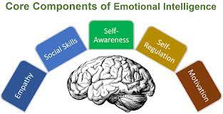
Here's an in-depth exploration of these five components:
1. Self-Awareness: Self-awareness forms the cornerstone of emotional intelligence. It involves the ability to recognize and understand one's own emotions, including their origins, impact on thoughts, and influence on behavior. Individuals with high self-awareness possess insight into their strengths, weaknesses, values, and beliefs. This foundational skill enables them to navigate various situations with authenticity and a clear understanding of their emotional state.
2. Self-Regulation: Self-regulation refers to the capacity to manage and control one's own emotions, impulses, and reactions. This component involves staying composed under pressure, adapting to changing circumstances, and maintaining emotional balance. People with strong self-regulation can effectively channel their emotions; avoid impulsive behavior, and make thoughtful decisions even in challenging situations.
3. Motivation: Motivation, in the context of emotional intelligence, relates to the drive to achieve personal and professional goals. Individuals with high emotional intelligence are often intrinsically motivated, displaying a strong work ethic and perseverance in the face of obstacles. Motivated individuals set challenging yet attainable goals, demonstrating a commitment to continuous improvement and accomplishment.
4. Empathy: Empathy is the ability to understand and share the feelings of others. This component involves not only recognizing the emotions of those around you but also responding with genuine compassion. Empathetic individuals excel in perspective-taking, allowing them to connect with others on a deeper level. This skill is essential for building and maintaining positive relationships, fostering effective communication, and creating a supportive social environment.
5. Social Skills: Social skills encompass a range of abilities that facilitate positive interactions with others. This component includes effective communication, active listening, conflict resolution, and collaboration. Individuals with strong social skills can navigate social complexities, build rapport, and contribute to a harmonious and productive team environment. These skills are particularly valuable in leadership roles and collaborative settings.
Emotional Intelligence comprises these five interconnected components—self-awareness, self-regulation, motivation, empathy, and social skills. Together, they form a holistic framework that empowers individuals to navigate the complexities of their own emotions and build meaningful, positive relationships with others. Developing and honing these skills contributes not only to personal well-being but also to success in various professional and social contexts.
CONCLUSION
Emotional Intelligence (EQ) stands as a crucial aspect of personal and professional development, encompassing five key components: self-awareness, self-regulation, motivation, empathy, and social skills. Understanding and cultivating these components are essential for individuals seeking to thrive in diverse social and work environments. The ability to recognize and understand one's own emotions (self-awareness) provides a foundation for authentic interactions. Coupled with self-regulation, individuals can effectively manage their emotions, adapting to challenges with composure and making thoughtful decisions. Motivation fuels the drive to achieve personal and professional goals, contributing to resilience and a commitment to continuous improvement. Empathy, a cornerstone of positive relationships, involves understanding and sharing the feelings of others, fostering connection and effective communication. Social skills, the final component, encompass a range of abilities vital for navigating social complexities, building rapport, and contributing to collaborative environments. Together, these components create a holistic framework for navigating emotional landscapes and fostering meaningful connections. Leadership, Emotional Intelligence becomes a powerful tool. Leaders with high EQ can inspire, motivate, and build strong, cohesive teams. Moreover, these skills are transferable across various aspects of life, contributing to personal well-being and success in diverse social and professional contexts. Ultimately, the cultivation of Emotional Intelligence is an ongoing journey. Individuals committed to developing their EQ enhance their ability to navigate complex social interactions, communicate effectively, and lead with empathy, creating a positive impact on both their personal and professional lives.

Lesson: 9
- Why is “Delegation” so important for management? What is the best way to delegate?
Introduction
Delegation is a critical aspect of effective management, playing a pivotal role in achieving organizational goals, fostering employee growth, and optimizing overall efficiency. The importance of delegation stems from various factors that contribute to the success of both the manager and the team.
Delegation is a critical aspect of effective management, playing a pivotal role in achieving organizational goals and fostering the professional development of team members. The ability to delegate tasks efficiently is a hallmark of strong leadership, allowing managers to leverage the strengths of their team, streamline workflows, and focus on strategic priorities. This delegation process involves entrusting responsibilities to individuals based on their skills and capabilities, creating a collaborative and empowered work environment. In this exploration, we delve into the significance of delegation in management, highlighting its benefits for both leaders and team members. Additionally, we examine the best practices for delegation, offering insights into how managers can optimize this process to maximize productivity, enhance employee engagement, and drive overall success within the organization. Join us as we navigate the intricacies of delegation, unraveling its importance in effective management and providing guidance on how to delegate tasks effectively.

Here's a detailed exploration of why delegation is crucial for management and the best practices for effective delegation:
Importance of Delegation:
a. Optimal Resource Utilization: Delegation allows managers to distribute tasks among team members based on their skills and expertise. This ensures that resources, including human capital, are utilized optimally, leading to increased productivity and efficiency.
b. Employee Development: Delegating tasks provides team members with opportunities to take on new challenges, acquire new skills, and broaden their experience. This promotes professional development, job satisfaction, and a sense of ownership, contributing to higher employee engagement and retention.
c. Focus on Core Responsibilities: Managers often have a multitude of responsibilities, and delegation enables them to focus on high-priority tasks that align with their core competencies. By entrusting routine or specialized tasks to others, managers can dedicate more time to strategic planning and decision-making.
d. Enhanced Team Collaboration: Delegation encourages collaboration within the team. When responsibilities are distributed among team members, it fosters a sense of teamwork and mutual support. This collaborative environment contributes to a positive work culture and helps build strong, cohesive teams.
e. Improved Decision-Making: Delegating responsibilities allows for a more diverse set of perspectives in decision-making. Team members, with their unique skills and insights, contribute to the decision-making process, resulting in well-rounded and informed choices.
f. Adaptability and Resilience: Delegation builds resilience within the team by ensuring that multiple individuals are familiar with various aspects of the work. This adaptability becomes crucial during periods of change, ensuring that the team can continue to function effectively despite fluctuations in workload or staffing.

Best Practices for Delegation:
a. Clearly Define Tasks and Expectations: Provide clear and detailed instructions when delegating tasks. Clearly communicate the desired outcomes, deadlines, and any specific expectations. This clarity reduces the likelihood of misunderstandings and ensures alignment with organizational objectives.
b. Match Tasks with Skills: Assign tasks based on the skills and capabilities of each team member. Consider their strengths, expertise, and developmental goals to ensure that the right person is assigned to the right task. This enhances efficiency and supports individual growth.
c. Encourage Questions and Feedback: Create an open communication channel for team members to ask questions and seek clarification. Encouraging feedback fosters a collaborative environment, reduces the risk of misunderstandings, and allows for adjustments as needed.
d. Provide Adequate Resources: Ensure that individuals delegated with tasks have the necessary resources, information, and support to successfully complete their assignments. This includes access to relevant tools, training, and ongoing assistance.
e. Monitor Progress and Provide Feedback: Regularly check in on the progress of delegated tasks. Provide constructive feedback, recognize achievements, and address any challenges that may arise. This ongoing communication ensures that tasks stay on track and expectations are met.
f. Promote Accountability: Encourage a sense of accountability among team members. Clearly communicate the responsibility and authority associated with the delegated task, empowering individuals to take ownership of their assignments.
g. Trust and Empower: Trust team members to handle delegated tasks independently. Empower them to make decisions and take initiative within the scope of their responsibilities. Trust is fundamental to a successful delegation.
h. Evaluate and Learn: After completion, evaluate the outcomes of delegated tasks. Identify successes and areas for improvement. Use these insights to refine future delegation strategies and continuously improve the process.
Effective delegation is integral to successful management. It optimizes resource utilization, fosters employee development, and contributes to a collaborative and resilient work environment. By following best practices, managers can ensure that delegation becomes a strategic tool for achieving organizational objectives and promoting the growth and well-being of their teams.

- Describe the “Negotiation Process”?
Introduction
The negotiation process is a complex and strategic interaction between two or more parties with the goal of reaching a mutually agreeable outcome. Whether in business, legal contexts, international relations, or interpersonal relationships, negotiations involve a series of steps and considerations.
Negotiation is an essential skill in both personal and professional realms, representing the art and science of reaching agreements between parties with differing interests and objectives. The negotiation process is a dynamic and strategic interaction where individuals or groups seek to find common ground, resolve conflicts, and secure outcomes that are mutually beneficial. Whether in business transactions, diplomatic relations, or everyday interactions, effective negotiation involves a thoughtful and collaborative approach to navigate differences and achieve optimal results. In this exploration, we delve into the intricacies of the negotiation process, examining its key stages, principles, and strategies. Understanding the dynamics of negotiation equips individuals with the tools to communicate persuasively, build relationships, and arrive at agreements that satisfy the interests of all parties involved. Join us on this journey through the negotiation process, unraveling the complexities of this crucial skill and gaining insights into successful negotiation techniques.
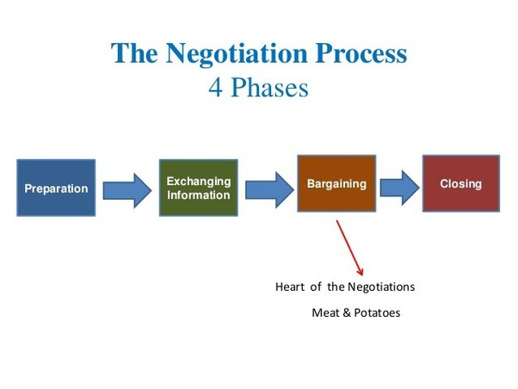
Here's a detailed exploration of the negotiation process:
a. Preparation: Before entering into negotiations, thorough preparation is crucial. This involves researching and understanding the issues at hand, clarifying goals and priorities, and anticipating the needs and positions of the other parties. Gathering relevant data, assessing potential concessions, and identifying alternative solutions are essential elements of the preparation phase.
b. Relationship Building: Building a positive relationship with the other parties can set a constructive tone for negotiations. Establishing rapport and trust creates a more open and collaborative atmosphere. Building relationships can involve informal discussions, shared information, and finding common ground to foster a sense of goodwill.
c. Definition of Ground Rules: Establishing ground rules helps ensure a fair and structured negotiation process. This includes agreements on the format of discussions, the order of agenda items, time limits, and the handling of sensitive information. Clear ground rules contribute to a more organized and transparent negotiation environment.
d. Clarification of Interests and Positions: Parties involved in negotiations often have underlying interests that drive their positions. Identifying and understanding these interests is crucial for finding mutually beneficial solutions. Participants share their positions, needs, and concerns, working toward a deeper understanding of the underlying motivations guiding the negotiation.
e. Proposal and Bargaining: The heart of the negotiation process involves the exchange of proposals and counterproposals. Each party presents its initial offer, and subsequent rounds of bargaining may follow. Negotiators use various tactics, such as compromising, conceding, or finding creative solutions, to reach a middle ground. Effective communication and active listening are key during this phase.
f. Concession Management: Negotiation often involves making concessions to move the process forward. Effective negotiators strategically manage concessions, offering compromises that address the needs of both parties. Understanding the value and significance of concessions is crucial for maintaining a balanced and sustainable agreement.
g. Agreement and Contract Formation: Once the parties reach a consensus on the terms of the agreement, the next step is formalizing the deal. This may involve drafting a contract, memorandum of understanding, or another formal document that outlines the terms and conditions. Clear communication about expectations and responsibilities is vital during this phase.
h. Implementation and Follow-Up: The negotiation process doesn't end with the agreement. Implementing the terms of the agreement and monitoring its effectiveness are essential for long-term success. Parties may need to collaborate on the execution of their commitments and address any unforeseen challenges that arise.
i. Relationship Maintenance: Successful negotiations contribute to ongoing relationships between the parties. Maintaining a positive relationship is important for future collaborations and can be crucial in cases where the negotiated agreement is part of a broader, ongoing partnership.
j. Evaluation and Learning: After the negotiation concludes, it's essential to evaluate the process and outcomes. Reflecting on what worked well and what could be improved informs future negotiation strategies. Continuous learning from negotiation experiences contributes to the development of more effective negotiation skills.
The negotiation process is a dynamic and strategic interaction that involves careful preparation, effective communication, and a willingness to collaborate. It is a structured journey from initial preparation through proposal and bargaining to the formalization of agreements, with ongoing efforts in implementation, relationship maintenance, and learning from the experience. Successful negotiators understand the importance of a well-managed and principled negotiation process to achieve positive outcomes for all parties involved.
CONCLUSION
Delegation serves as a cornerstone for efficient resource utilization, employee development, and overall team success. By distributing tasks based on individual strengths, managers can focus on strategic priorities while fostering a collaborative and empowered work environment. Clear communication, matching tasks with skills, and promoting accountability are key elements in successful delegation. On the other hand, the negotiation process is a dynamic and strategic interaction aimed at reaching mutually agreeable outcomes. Through stages such as preparation, relationship building, proposal and bargaining, and agreement formation, effective negotiators navigate differences and build positive relationships. Continuous learning and evaluation ensure the refinement of negotiation skills for future interactions. In essence, both delegation and negotiation underscore the importance of effective communication, strategic thinking, and collaborative approaches in achieving organizational goals. Managers who excel in delegation empower their teams, while skilled negotiators facilitate positive outcomes through understanding, compromise, and relationship building. These practices cont
ribute to the overall success and resilience of organizations in today's dynamic and competitive landscape.

Lesson: 10
- In your opinion, what is the best way to manage conflicts in a business?
Introduction
Conflict is an inevitable aspect of any business environment, arising from diverse perspectives, competing interests, and varying priorities among individuals and teams. How conflicts are managed significantly influences the overall health and productivity of an organization. Effectively addressing conflicts fosters a positive workplace culture, enhances collaboration, and propels organizational growth. In this exploration, we delve into the nuances of conflict management in business, examining strategies and approaches that contribute to constructive resolution. By understanding the importance of proactive conflict management and embracing appropriate methodologies, businesses can transform conflicts into opportunities for innovation, strengthened relationships, and sustainable success. Join us on this journey as we navigate the intricacies of conflict resolution in the dynamic landscape of business operations. Effectively managing conflicts in a business requires a comprehensive and proactive approach that addresses the root causes, encourages open communication, and fosters a positive organizational culture.

Here's an in-depth exploration of the best ways to manage conflicts in a business setting:

a. Promote a Positive Organizational Culture: Cultivate a culture that values collaboration, open communication, and respect. When employees feel supported and appreciated, they are more likely to approach conflicts with a constructive mindset. Positive organizational culture serves as the foundation for effective conflict resolution.
b. Clear Communication Channels: Establish clear and transparent communication channels throughout the organization. Regular team meetings, one-on-one check-ins, and accessible platforms for open discussions contribute to a culture where conflicts can be addressed promptly and effectively.
c. Define Roles and Responsibilities: Clearly define the roles, responsibilities, and expectations for each team member. Ambiguity in these areas can lead to conflicts. When everyone understands their role and how it contributes to the overall goals of the organization, it minimizes the chances of disagreements.
d. Conflict Resolution Training: Invest in conflict resolution training for employees and managers. This training should cover essential skills such as effective communication, active listening, negotiation techniques, and strategies for managing emotions during conflicts. Well-trained individuals are better equipped to navigate and resolve conflicts.
e. Establish Formal Conflict Resolution Processes: Develop a formal conflict resolution process within the organization. This process should outline the steps to be taken when conflicts arise, the individuals or teams involved, and themechanisms for resolution. Having a well-defined process ensures consistency and fairness in conflict resolution.
f. Encourage Open Dialogue: Create an environment that encourages individuals to express their concerns openly and provide constructive feedback. A culture of open dialogue reduces the likelihood of conflicts being suppressed or escalating due to lack of communication.
g. Mediation and Facilitation: When conflicts arise, consider using mediation or facilitation techniques. A neutral third party can guide discussions, ensure that all perspectives are considered, and facilitate the negotiation process. Mediation can be particularly useful for more complex or deeply rooted conflicts.
h. Address Conflict Promptly: Deal with conflicts promptly and directly. Avoiding or delaying conflict resolution can lead to increased tension and potential negative consequences for the business. Addressing issues early on prevents them from escalating and becoming more challenging to resolve.
i. Encourage Empathy and Understanding: Promote empathy among team members. Encourage individuals to consider the perspectives and feelings of others. An empathetic approach fosters understanding and helps build stronger relationships within the team.
j. Learn from Conflicts: View conflicts as opportunities for learning and improvement. After resolving a conflict, conduct a debrief to identify root causes and explore preventive measures. Use conflicts as a catalyst for continuous improvement and organizational growth.
Effective conflict management in business requires a multifaceted and intentional approach that considers the organizational culture, communication strategies, training, and formal processes. By embracing conflicts as opportunities for growth and improvement, businesses can cultivate a resilient and collaborative environment that contributes to long-term success.
- What is “Change Management”?
Introduction
Change management is a systematic approach to transitioning individuals, teams, and organizations from their current state to a desired future state. It involves the planning, implementation, and monitoring of changes to ensure that they are adopted smoothly and effectively. Business and organizations, change is a constant force driven by technological advancements, market dynamics, and internal growth strategies. Change management, as a discipline, is a structured approach to navigating and implementing organizational change successfully. It involves planning, communicating, and supporting individuals and teams through transitions to achieve desired outcomes. Change can be met with resistance, uncertainty, and challenges, making change management a crucial element in ensuring that transformations are not only implemented but embraced by the workforce. In this exploration, we delve into the essence of change management, examining its principles, processes, and significance in facilitating a smooth and effective transition within an organization. Join us as we unravel the complexities of change management and understand how it plays a pivotal role in shaping the future and sustainability of businesses.
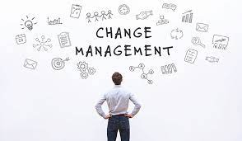
Here's a comprehensive exploration of change management:
1. Definition of Change Management:
Change management is a structured process that aims to facilitate organizational change by managing the human side of the transition. It involves understanding the reasons for change, communicating the change effectively, and supporting individuals and teams as they adapt to new ways of working.
2. Reasons for Change: Change in organizations can be driven by various factors, including technological advancements, market shifts, competitive pressures, or the need to improve efficiency. Identifying the reasons for change is crucial for developing a compelling case and gaining support from stakeholders.
3. Change Management Process:
a. Initiation and Assessment:
- Identify the need for change and define the scope.
- Assess the impact of the change on individuals, teams, and processes.
- Identify key stakeholders and their roles in the change process.
b. Planning:
- Develop a comprehensive change management plan.
- Define specific objectives, milestones, and success criteria.
- Create a communication plan to keep stakeholders informed.
c. Communication:
- Clearly communicate the reasons for change.
- Provide information about the expected benefits and impact on individuals.
- Address concerns and provide a platform for feedback.
d. Implementation:
- Execute the change according to the plan.
- Provide necessary training and resources.
- Monitor progress and adjust as needed.
e. Evaluation:
- Assess the effectiveness of the change.
- Gather feedback from stakeholders.
- Identify lessons learned and areas for improvement.
4. Key Principles of Change Management:
a. Leadership Support:
- Visible and consistent support from leadership is critical for successful change.
- Leaders should communicate the vision for change and model the desired behaviors.
b. Employee Involvement:
- Involve employees in the change process.
- Seek input, address concerns, and actively engage individuals in the transition.
c. Clear Communication:
- Communication should be transparent, consistent, and tailored to different audiences.
- Regularly update stakeholders on the progress of the change.
d. Training and Development:
- Provide training to equip individuals with the skills needed for the new state.
- Offer ongoing support and resources to facilitate learning.
e. Flexibility and Adaptability:
- Be flexible and willing to adjust the change plan based on feedback and evolving circumstances.
- Adaptability is key to overcoming resistance and unforeseen challenges.
f. Recognizing and Managing Resistance:
- Anticipate and address resistance to change.
- Identify the root causes of resistance and develop strategies to mitigate it.
5. Types of Change
Change can be categorized into different types, including:
- Incremental Change: Small, gradual adjustments.
-Transformational Change: Significant and fundamental shifts in processes or structures.
-Strategic Change:Aligning organizational strategy with changes in the external environment.
6. Change Management Models
Various change management models, such as Lewin's Change Management Model, Kotter's Eight-Step Model, and Prosci's ADKAR Model, provide frameworks for guiding organizations through the change process.
7. Continuous Improvement:
Change management is an iterative process that involves continuous improvement. Organizations should regularly assess and refine their change management practices based on feedback and evolving needs.
8. Benefits of Effective Change Management:
- Improved employee morale and engagement.
- Increased likelihood of achieving project objectives.
- Reduced resistance and negative impacts on productivity.
- Enhanced organizational agility and adaptability.
Change management is a dynamic and strategic process that involves thoughtful planning, clear communication, and active engagement of individuals and teams. It is an essential capability for organizations seeking to thrive in a rapidly evolving business environment.
CONCLUSION
The effective management of conflicts and change within a business is paramount to fostering a healthy and resilient organizational environment. Addressing conflicts requires a proactive and comprehensive approach, emphasizing positive organizational culture, clear communication, and the cultivation of open dialogue. Conflict resolution strategies that promote understanding, empathy, and learning contribute to a workplace where conflicts become opportunities for innovation and strengthened relationships. Similarly, change management serves as a strategic discipline to guide organizations through transitions and transformations. By understanding the reasons for change, developing robust plans, and adhering to key principles such as leadership support, employee involvement, and clear communication, businesses can navigate change successfully. The continuous improvement of the mindset inherent in change management models ensures adaptability and ongoing growth. Ultimately, businesses that skillfully manage conflicts and embrace change as a natural part of their evolution are better positioned for sustained success. These organizations not only weather challenges effectively but also use conflicts and change as catalysts for innovation, improvement, and long-term sustainability in the dynamic landscape of business operations.

References:
- Bakunin, S., & Sabena, S. (2023). Exploring the Link between Training and Development, Employee Engagement and Employee Retention. Journal of Business and Management Studies, 5(1), 173-180.
- Burro, R., Branching, E., Capitan, E., Barnaby, V., Farman, A., Parades, C., & Bianchi, I. (2023). Is there an association between consumers’ personality traits and the sensory characteristics they look for in wine? Food Quality and Preference, 105, 104767.
- Brice, W. D., & St James, M. (2023). Cultural Determinants of Bureaucracy: Empirical Findings From The University. The USV Annals of Economics and Public Administration, 23(1 (37)), 109-120.
- Curti, F., &Kazinnik, S. (2023). Let's Face It: Quantifying the Impact of Nonverbal Communication in FOMC Press Conferences⋆. Journal of Monetary Economics.
- Chan, E. W., & Lill, J. B. (2023). The Effects of Explicit versus Implicit Targets on Worker Performance, Reciprocity, and Trust and the Role of Peer Benchmarking. Journal of Management Accounting Research, 35(1), 69-91
- Emshoff, J. R., & Freeman, R. E. (2023). Stakeholder management: a case study of the US Brewers Association and the container issue. In R. Edward Freeman’s Selected Works on Stakeholder Theory and Business Ethics (pp. 29-59). Cham: Springer International Publishing.
- Fleming, K. (2023). Reducing staff turnover through the implementation of a peer mentoring program. Nursing Management, 54(1), 32-39.
- Farmitani, Z., Farokhzadian, J., Forouzi, M. A., Ramezani, T., &Zarandi, B. E. (2023). Improving the Hope and Happiness of Patients With an Ostomy: Effects of Group Cognitive Therapy. Journal of Wound Ostomy & Continence Nursing, 50(2), 131-136.
- Gusain, A., Singh, T., Pandey, S., Pachourui, V., Singh, R., & Kumar, A. (2023, March). E-Recruitment using Artificial Intelligence as Preventive Measures. In 2023 International Conference on Sustainable Computing and Data Communication Systems (ICSCDS) (pp. 516-522). IEEE.
- Gürbüz, A., Abi, M., &Canlı, B. (2023). Students’ perceived cultural styles, second language communication, and confidence in communication. Journal of Business, Communication & Technology, 2(1), 13-25.
- Jabeen, R., & Rahim, N. (2021). Exploring the effects of despotic leadership on employee engagement, employee trust and task performance. Management Science Letters, 11(1), 223-232
- Linvill, J. S., &Onosu, G. O. (2023). Stories of Leadership: Leading with Empathy through the COVID-19 Pandemic. Sustainability, 15(9), 7708.
- Lussier, R. N., & Kimball, D. C. (2023). Applied sport management skills. Human Kinetics.
- Malik, A. M. A., Siow, C. L., & Khairuddin, J. (2023). ARTIFICIAL INTELLIGENCE FOR SHIP DESIGN PROCESS IMPROVEMENT: A CONCEPTUAL PAPER. Available at SSRN 4447464
- Ma, Z., Khan, H. S. U. D., Chughtai, M. S., Li, M., Ge, B., & Qadri, S. U. (2023). A review of supervisor–subordinate guanxi: Current trends and future research. Sustainability, 15(1), 795.
- Maas, V. S., & Shi, B. (2023). The effects of target difficulty and relative ability on managers’ delegation decisions. Management Accounting Research, 100851
- Prabahar, I. B., & Jerome, V. B. (2023). The Leadership Styles of Administrators and the Professional Effectiveness of Teachers-Enlighten Innovation and Creative Learning Among Educational Institutions. International Journal of Professional Business Review, 8(5), e01996-e01996.
- Phillips, J., & Klein, J. D. (2023). Change management: From theory to practice. TechTrends, 67(1), 189-197.
- Rahim, M. A. (2023). Managing conflict in organizations. Taylor & Francis
- Syam, A. R., Wiyono, B. B., & Imron, A. (2023). Leadership behaviour of a boarding school in Indonesia. Pegem Journal of Education and Instruction, 13(1), 100-108
- Widjaja, W., Kartini, T., Yuningsih, E., Yusuf, M., & Hayati, F. A. (2023). KAHATEX BANDUNG REGENCY'S EMPLOYEE SELECTION AND PLACEMENT IMPACT. Transformasi: Journal of Economics and Business Management, 2(2), 72-84.
- Yotha, N., Khaopraay, A., Narkprom, N., &Rungruang, W. (2023). The Development of Emotional Quotient Evaluation for Thai University Students. Journal of Education and Learning, 12(3).
- https://www.intechopen.com/chapters/16921
- https://www.toppr.com/guides/business-management-and-entrepreneurship/human-resource-management/training-and-development/
- https://www.inc.com/anna-johansson/7-forms-of-business-communication-youre-using-wrong.html
- https://www.linkedin.com/pulse/non-verbal-communication-ijngp
- https://humanresourcesmba.net/faq/what-is-hr-benchmarking/
- https://www.cflowapps.com/process-improvement-tools/
- https://www.caltech.edu/about/news/what-is-personality
- https://hubton.com/2019/08/05/7-habits-of-highly-effective-people-at-work/
- https://acendahealth.org/blog/why-its-important-to-show-empathy/
- https://www.trackinghappiness.com/happiness-scale-from-1-to-10/
- https://www.greatenergy4you.com/upon-awakening.html
- https://controlmyfate.com/
- https://leadguideinspire.weebly.com/characteristics-of-a-leader.html
- https://www.international-school.edu.rs/creative-learning/
- https://www.hongkiat.com/blog/positive-working-environment/
- https://ewfinternational.com/5-components-emotional-intelligence-effective-leadership/
- https://www.insperity.com/blog/how-to-delegate-effectively/?__cf_chl_tk=Rl_kO7zCB3usJuh3WgOi0_mJM.Xqd6ROv_Pt.dcGsd8-1703080312-0-gaNycGzNDmU
- https://www.quora.com/What-is-a-negotiation-process
- https://www.hrcloud.com/blog/7-tips-on-how-to-manage-and-resolve-conflict-in-the-workplace
- https://pulselearning.com/6-steps-effective-organizational-change-management/

