LUNGILE BAPHETSILE NGCAMPHALALA

**ID: UD78403ED87615**

COURSE NAME:

**AFRICAN EDUCATIONAL THEORIES & PRACTICES**

ASSIGNMENT TITLE:

**EDUCATIONAL ASSESSMENT AND ANALYSIS IN THE AFRICAN CULTURAL CONTEXT**

ATLANTIC INTERNATIONAL UNIVERSITY

**September/2022**

Table of Contents

1. INTRODUCTION 3

2. PURPOSE OF ASSESSMENT 3

2.1. MASTERY OF CONTENT 3

2.2. CLASSIFICATION AND PROGRESSION 4

2.3. UNIT OF MEASURE 4

2.4. FEEDBACK 5

2.5. QUALITY OF INSTRUCTION 6

3. TYPES OF ASSESSMENTS 8

3.1. FORMATIVE ASSESSMENT 8

3.2. SUMMATIVE ASSESSMENT 8

3.3. CONTINUOUS ASSESSMENT 9

3.4. SUMMARY OF FORMATIVE AND SUMMATIVE ASSESSMENTS 10

4. CONCLUSION 11

5. REFERENCES 13

# INTRODUCTION

Assessment is the means used to determine the attainment of teaching and learning aims and objectives. In Eswatini, schools must conduct assessments that are in line with Eswatini Education and Training Sector Policy (2011), National Development Plan (2023) and the National Education and Training Improvement Programme (2014). Assessment is the end result of the purpose of educational endeavours that are set by educators at the beginning of all educational programmes. Assessment of the knowledge, skills and attitudes of all involved it learning activities is key to determining if the approaches to teaching and learning are appropriate or they need to be revised. Traditional educational processes have always depended on pre-determined forms of assessment presented in the lessons plans of teachers.

There are many types of assessments that a teacher can use to evaluate a learning experience. The essay will discuss the formative and summative assessments as they are commonly used in Eswatini education system. The essay will discuss the general purpose of assessment in education. Major challenges with assessment will follow. Examples will be drawn from personal experiences as a product of the education system and as an educator in the current system. Lessons learnt will be used to individualize and customize assessment in my current job. In our college for example, we only use formative assessments to analyse mastery of course content.

# PURPOSE OF ASSESSMENT

## 2.1. MASTERY OF CONTENT

Assessment in a school in Eswatini has always emphasized paper based examinations that indicate whether a student has mastered a lesson, and the extent to which that particular lesson has been understood. Assessment in schools assumes that all learners are the same, and if presented and exposed to the same lesson, they should perform the same. Assessment provides visible proof of the knowledge, skills and attitudes that learners have acquired. The **Handbook of African Educational Theories & Practices** written by A. Bame Nsamenang andTherese M.S.Tcho, emphasizes that people are different and should not be subjected to the same form of assessment because those results

## CLASSIFICATION AND PROGRESSION

Assessment is also used as a form of separating achievers from non-achievers. Until recently, education has always been used to distinguish between above average, average and below average students. Most assessment have rating scales that give the student a position in terms of achievement of learning outcomes. Classification requires increased attention to school-based assessment. As a student progresses through the education system, assessment from the previous level will determine whether you qualify for the next level or not. There is a standard set for qualifying for the next grade, anything below that standard, results in repetition of the grade. The education system is classified as a long route to the finish line; everything is connected to the other. To progress for primary to secondary school, assessments reports are

examined to determine that. Assessment at all levels of the school system provides information that will enable judgements to be made about students’ progress towards desired competencies.

## UNIT OF MEASURE

Even if a student moves from one educational institution to the next, the assessment conducted in the previous school will determine if you are considered fit to enter a new school in that level. There are usually differences in the forms of assessments and rating criteria used in one training institution compared to another.

## FEEDBACK

Students need to know how they are performing at any given point of their learning. The feedback received helps the students to understand where they are in terms of educational aims. There are different ways of giving feedback to learners about their performance, but the most common method is the assessment result. It is usually so vague that a student may get feedback but still not know for sure what they have to fix. For example, how can a student fix a difficult assessment? They cannot. Yet an assessment score can classify a student as failed, when in fact, they know the course very well, but the way it was assessed left them confused as to what was expected of them. So yes, assessment play that role of giving feedback on performance towards the achievement of learning outcomes, but those assessments should give a good picture of the extent of learning and minimise external factors from interfering with that overall picture painted by the assessment score.

Feedback can be obtained from an internal assessment is set and marked by the subject teachers. Students get the mark and feedback regarding the assessment a few days after taking that assessment. External assessment is set by the governing body, and is marked by personnel external to the institution. With external assessment, students only receive a mark. Therefore, they have no idea how they actually performed and how they can actually improve their performance. It is feedback, but it does not add any value to the development of the learner, they can retake the same assessment but still fail because it not clear where they actually miss the point (Nsamenang & Tchombe, 2011).

I remember when I joined St. Francis High school in 1998, I was good in my studies, but I always scored very low in English Language. Fortunately, the school principal picked this when teachers submitted assessment results to his office. He called my English teacher to ask why my test scores were so low, because in the other subjects I do very well. She said she did not know, and he asked her to go and investigate the problem I have, and find a solution before it was too late. The teacher approached me, we talked and we discovered that the reason behind the low results, were that I answered test questions chronologically yet the questions that appeared first were complicated, needed a lot of time to complete, yet, they carried little weight towards final mark. She advised me to start with the tasks that carried more weight, because even if I do not finish on time, I would still pass the test. It worked. I will always be grateful to my principal for being concerned about what my teacher was overlooking.

## QUALITY OF INSTRUCTION

Assessment is developed and administered by teachers to rate students on a pass or fail basis. It puts the learner in a position where whatever the results of the assessment are; it is their doing that they got those results. Yet, in essence, assessment is used to determine many other factors that influence the teaching and learning process, such as the quality of instruction. In Eswatini, the curriculum has the component of extra curricula activities that mainly involve talent in various sporting and cultural activities. By their nature of being student centred and passion driven, it is always very disturbing that the students who fail dismally in curriculum subjects, usually come out top in those extra curricula activities, and this happens across the country. Schools that are very competitive even head hunt such students to enrol in their schools because they know that extra curricula events draw media attention, so they want to come out in first position in sporting or cultural activities like sibhaca or ummiso. The question is what lessons can be drawn from this scenario? Should teachers be structuring subjects into live games that will generate interest in the learners?

Figure I MACMILLAN IS THE MAJOR SPONSOR OF CULTURAL COMPETITIONS IN ESWATINI (Macmillan Education Eswatini, 2018)

“This year, we sponsored E250 000 and the competition was fierce. Schools from around the four regions in the Kingdom participated and were judged in the categories of Drama, Ummiso, Sibhaca, Ingadla, Drum Majorettes, African Dance and Kwaito Dance. The winners were presented with their trophies and prizes at an evening event held at The Happy Valley Hotel. The Guest of Honour, Doctor Sibongile Mtshali, The Principal Secretary in The Ministry of Education presented the winning schools with their trophies” (Macmillan Education Eswatini, 2018). How can the education system then come out to say some students who are winning trophies in extra curricula events are failures because they do not meet the criteria for a pass. Is it the students or the quality of instruction if not the whole curriculum that is actually failing?

# TYPES OF ASSESSMENTS

## 3.1. FORMATIVE ASSESSMENT

This types of assessment is used on a daily basis to determine the level at which a lesson is progressing. It is done during the lesson itself. It gives both the teachers and the students a chance to address any challenges that a learner might be facing as and when it happens. Teachers get instant feedback on whether the particular lesson is being understood. If there are challenges, they are fixed on the spot. If a training course has five chapters that learner must complete in order to be rated as successful, the assessment will be conducted for each paragraph, page, chapter in whatever fashion the educator deems fit to get desired feedback.

## SUMMATIVE ASSESSMENT

This type of assessment is conducted at the end of a learning program. It is more formal and structured than a formative assessment. With summative assessment, we can draw an example from the above example. For the five chapters that one will cover for the course, summative assessment will sum up a few compontents of the course snd conduct an assessment. The nature of this type of assessment does not allow for the instant fixing of educational problems or challenges. If a learner does not perform well in a summative assessment, it is usually difficult to determine the reason behind the poor grade. The lesson could have been missed when it took place, the learner could have had difficulty understanding topics during lessons, or they could have lost a loved one during the assessment, hence they were distracted.

## CONTINUOUS ASSESSMENT

Continuous assessment was introduced in the overall assessment of students in Eswatini. It was meant to minimize the impact of a single event that may disrupt the summative assessment and end up with a large number of students who have not performed well, when in actual fact they had mastered course content to an acceptable standard. Our continuous assessment comprises of three summative assessments that are taken after a few chapters throughout the school year. Those scores are then summed and divided by three to give the continuous assessment score, which is then added to the final examination score of the summative examination that covers the entire syllabus. Through this method, you find that even if the final assessment mark was low for whatever reason, the continuous assessment mark is high, the student progresses. The two scores are added, divided by two and that becomes a determining score for either a fail, repeat, or promoted result.

## SUMMARY OF FORMATIVE AND SUMMATIVE ASSESSMENTS

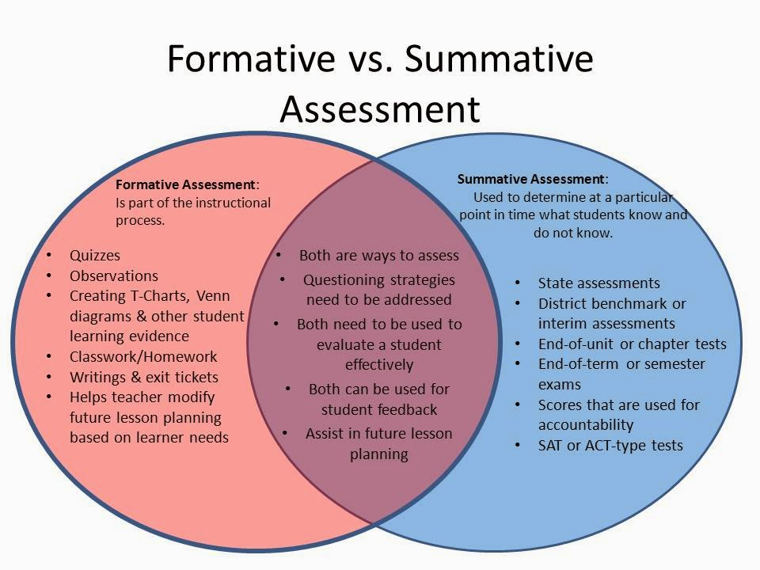

Figure Have summative assessments become obsolete? ( Tarte, 2014)

Figure I shows a comparison of formative and summative assessment. However, Dr Tarte has a valid question, “have summative assessments become obsolete?” In his argument, he points out that formative assessment covers assessment of mastery and application of course content from beginning of the program until the end. It even accommodates the different paces at which students learn, because the teacher will be assessing learners on an individual basis on an on-going basis. So if the teacher already knows where a student stands in terms of course content understanding, then why do they need summative assessments to tell them what they already know? ( Tarte, 2014). I feel that Dr Tarte has a point, if formative assessment are done right and students are progressing through a course and meeting the expectations of the teacher, how can the same teacher then come back to say, here is your summative assessment score, you have failed the course. It really does not make sense, and it can make students to lose confidence and motivation for learning.

# CONCLUSION

The “formal education” kind of assessment that is decided by and administered by the teacher is not a good fit in African countries. In Africa, we are taught basic life skills from an early age but these skills cannot be transferred into credits when you begin the formal school system. Schools in Africa only benefit those who are academically gifted. During assessment, they meet all the requirements and progress to the next grade. That is not a problem, the problem lies at that point where teachers fail to develop alternative methods of assessment in order to accommodate life skills that the learner has acquired outside the classroom setting.

In our African schools, especially in rural areas, assessment should be customised, there should be better ways to appreciate the natural talent and the skills already mastered through parental guidance at home. For example, students whose basic chores at home are to plough fields and herd cattle and goats should not fail the agriculture subject. How can the school assessment classify that learner as a failure when they do what is in the textbooks practically and daily, they know the content even better than the teacher because for some teachers, practical subjects are learnt at college or university, but for the students in Africa like Eswatini, this is not another course, it is our life. Whether you fail us or not, when we leave the classroom, we are going to practice agriculture, something we have done way before attending school.

Cultural factors like language do have a bearing on the performance of learners in an assessment. Most assessment are generic and are biased towards the cultural backgrounds of those setting them. Anyone from a different cultural background who has to sit for that assessment is already discriminated upon. In Eswatini for example, mastery of English as a second language is a challenge. Most students do not understand it very well and it is always easy for them to miss a question all together because they could not interpret it correctly. Worse, English was a passing subject until a few years back (Sibandze, 2019). It was also the official language in a school setting. This ended up worsening the lack of motivation that African learners usually have. Year in year out, Swazi students were thrown out of the education system because they did not “know” English, or because their level of English made them to fail all the subjects that are taught in English.

# REFERENCES

Tarte, J. (2014, September 7). *Have 'summative' assessments become obsolete?* Retrieved from http://www.justintarte.com/2014/09/have-summative-assessments-become.html: http://http://www.justintarte.com/2014/09/have-summative-assessments-become.html/2014/09/have-summative-assessments-become.html

Macmillan Education Eswatini. (2018, April 30 ). *Macmillan Education Eswatini is the proud major sponsor for the School's Culture Competition.* Retrieved from www.macmillan.co.sz: https://www.macmillan.co.sz/public/news/macmillan-news/1/macmillan-education-eswatini-is-the-proud-major-sponsor-for-the-schools-culture-competition/17

Nsamenang , B. A., & Tchombe, T. M. (2011). *Handbook of African Educational theories and Practices: A Generative Teacher Education Curriculum.* North West Region: Bamenda.

Sibandze, M. (2019, December 4). *Thumps up yo english must fall campaign victory.* Retrieved from new.observer.org.sz: http://new.observer.org.sz/details.php?id=11008