LUNGILE BAPHETSILE NGCAMPHALALA

**ID: UD78403ED87615**

COURSE NAME:

**HUMAN RESOURCES MANAGEMENT**

ASSIGNMENT TITLE:

**RECRUITMENT AND SELECTION IN ESWATINI PUBLIC SCHOOLS, AND THE EFFECTS OF TEACHER HIRING FREEZE ON SCHOOL PERFORMANCE**

ATLANTIC INTERNATIONAL UNIVERSITY

**September/2022**

Table of Contents

1. INTRODUCTION 2

1.1. MANPOWER PLANNING 2

1.2. JOB ANALYSIS 4

1.3. JOB ADVERTISMENT 5

1.4. MAKING AN OFFER 6

2. RECRUITMENT AND SELECTION IN EDUCATION 7

3. EFFECTS OF TEACHER HIRING FREEZE IN SCHOOL PERFORMANCE 10

3.1. DEGRADATION OF THE TEACHING PROFESSION 10

3.2. LOW STAFF MORALE 11

3.3. DROP IN STUDENT MOTIVATION 11

3.4. HIGH STAFF TURNOVER 12

4. CONCLUSION 13

5. References 15

# INTRODUCTION

Employment is the recruitment and selection of qualifying candidates to fill available company vacancies. Organizations are formed to achieve goals and objectives. These goals determine the kind of organization that is formed, the kind of infrastructure that must be put in place in order to support the achievement of the set objectives. The directors of the organization make all these decisions, if it is a one-man show, the decisions are made by the owner of the organization. When all else is in place, the directors plan for the manpower that will be needed to turn the goals and objectives into a reality. Amongst all the resources and equipment that can be purchased by the company, the most difficult to manage is the human resources; unfortunately, there is no doing away with them, at least not yet.

## MANPOWER PLANNING

Manpower planning involves certain processes including, the total number of employees that the company needs to be fully functional. The goals and objectives of the company are broken down during a strategic planning process until they are grouped into functional areas that will attract a certain type of employees, this results in an organizational chart. Therefore, over and above the required number, the directors have to decide what kinds of people are required in each section that has to be formed to achieve objectives. With that information together, the next decision is to conduct a survey of the labour market to see if the required human resources are readily available in the local labour market, if not, plans have to be made on how to source skills from outside the country, which is usually expensive for companies.

The Teaching Service Commission does planning for closing vacancies in Eswatini schools. The commission in liaison with the Ministry of Public Service determine the numbers teachers that will be required in a school calendar year, and this figure is matched with the numbers of graduating students from local training institutions. Gaps in certain teaching programs are also analysed to inform training institutions where gaps need to be closed. It happens that sometimes, there are many teachers produced in one area of teaching, and there are few in others, so those gaps are always hardest to close. I remember when I joined Phonjwane High School, after completing my teaching qualification; I had come to do “teaching practice” a requirement for graduation. However, the Principal told me she was going to hire me as soon as I completed teaching practice, because if she let me go, she might find it hard to get someone for the already existing vacancy. Getting Commercial subjects teachers was difficult at the time.



Figure I We will hire and renew contracts for teachers - TSC Chairman (The Swati Newsweek, 2022)

|  |  |
| --- | --- |
| Categories and numbers for hiring and contract renewal | |
| Primary school head teachers | 8 |
| High school head teachers | 2 |
| Temporary teachers | 1310 |
| Tertiary and National Curriculum Centre | 69 |

Figure II Manpower needs in Eswatini Schools and Colleges as at April 2022 (The Swati Newsweek, 2022)

Dr. Mahlalela, the Chairperson reported that hiring of teachers on a permanent basis was not in the pipeline, the same applies to posts of school deputies and departmental heads. This means that qualified teachers will continue to lie idle at home (The Swati Newsweek, 2022). It is so disturbing to see the very high number of contract teachers being hired. That alone is an indication that there are shortages of teaching staff in schools, and that qualified candidates are there, why then is government not employing these teachers permanently. In June 2021, the TSC chairperson told unemployed teachers to go and do farming because there were no jobs for them. This caused a stir in the education fraternity; it was an insult to the entire profession that has made him who he has become (Swaziland News, 2021).

## JOB ANALYSIS

If the environmental assessment indicates that, there is plenty of all essential skills in the labour market, the organization its job analysis to produce two important documents, the job description and specification of each position that was created during the planning process (Dixit, 2014). The job description outlines the position being referred to, the reporting line in

the organizational hierarchy, people you will be responsible for, if any. It further outlines the main responsibilities for the job and all duties to be performed by the candidate who gets the position. The job specification outlines the attributes that a candidate should possess in order to be considered for a particular position. These include, qualification, skills, job related experience, and qualities needed to perform successfully in a particular position.

The hiring commission does not do any job analysis for hiring. The teacher training institutions produce graduates according to the expectations of the school system. Therefore, upon graduation, potential teachers already meet the job specification of a teacher in a particular stream. Their job descriptions are also taught as part of the curriculum at tertiary level. Any changes or proposals are made at the appropriate forums.

## JOB ADVERTISMENT

The information gathered in the job analysis is then used to determine how much a particular position is worth. How much will the jobholder be paid, does the position attract any other benefits, what will be the terms and conditions of employment. All this information is then used to draw up a job advertisement to attract interested people to apply for the job (Gentle, 2017). The complexity of the job will determine the kind of advert that will be put forward. Some jobs are basic, and individuals can be hired through a simple word of mouth. Some need to be more formal. A complete job advert should have the description of the job, conditions under which it will be performed and the kind of person who can successfully complete the job. Some organizations put the compensation package in the advert; some expect the candidates to make an offer.



Figure III A job advert showing three teacher training colleges in Eswatini (Eswatini Live Feed, 2021)

## MAKING AN OFFER

After the organization has put up the advert, in the relevant communication media, applications will start to flow in. This part is the recruitment; you have simply announced a job vacancy and potential employees apply. The advert should always have an application deadline so that the

organization knows when to start processing the applications for decision-making. Once the deadline arrives, the company moves to another step, the selection process. This is when the organization chooses the best candidate amongst the pool of applicants and make the job offer. The candidate will make their decision to join the company based on the terms and conditions of employment.

# RECRUITMENT AND SELECTION IN EDUCATION

Educational institutions in Eswatini have been the easiest to enter for employment after getting the relevant teaching qualification. There were always positions available in schools and even colleges. It even became the first option for most school leavers; they knew that if they did teaching at tertiary, the Ministry of Education and Training would automatically absorb them. Unlike the scenario presented above, teachers did not have to apply for employment the way it is done in other sectors in the country. Just before graduation, all completing teachers took their documents to the Ministry to indicate that they were about to finish their teaching qualification, when hiring time came, they were called and posted to schools.

I underwent the same process. I submitted my documents at the Ministry looking for a temporal teaching position since I had a first degree in commerce, but I did not have a teaching qualification yet. I got the position of temporal teacher at Ensingweni High School in 2006. This was after I had done some lecturing in a private college in town, Oxford Business Institute. I left the college because there was no job security at all, nothing was formal, we were paid cash, there was no pension or benefits of any sought. I could not build my future around all that

uncertainty. The college eventually closed shortly after I left due to financial crises. I taught at Ensingweni for one year, I did not renew my contract. I went back to university to pursue my postgraduate certificate in education. I had discovered that the principal had a very bad attitude towards temporal teachers. He wanted to treat us like less of teachers, because he had the right to dismiss you anytime if he felt like it.

However as time went by, things changed drastically. Getting a teaching position became harder than getting employment anywhere. As we speak, there are hundreds of idle teaching graduates because there are no available teaching posts. This was caused by the influx of teacher training institutions in the country (Ngwenya, 2022). There was a high demand for teacher training programs because jobs were guaranteed. Except, there was no one building more schools on the other side of the chain. This has been going on for some years. The ministry has been hiring too few numbers per year since then. The recruitment and selection process is still based on qualifications only. They apply the first in first out method, whosoever graduated first; are employed first when vacancies arise. What is sad is that, institutions are still producing teachers, while the current 2022 graduates will have to wait about 5 years before any chance of employment. Hiring is still absorbing candidates who graduated in 2017.

Figure I shows an announcement inviting 2017 graduates to bring their qualifications to the Ministry’s Teaching Service Commission on 1 September 2022, five years after the students graduated.



Figure Announcement inviting 2017 graduates to submit certificates for hiring by TSC

In 2018, the government of Eswatini introduced the freezing of employment in all sectors of government, the main reason was to control the wage bill that was said to be very high and had become unmanageable, as government had no money. This decision all affected the hiring of teachers in the country. It was a tricky situation because it was known that there were always

vacancies in that ministry, teachers had been operating short staffed for a while. They did not understand how they would survive with zero hiring when they were already suffering because of the slow process or unavailability of qualified teachers from the labour market. The Swaziland National Association of Teachers (SNAT) tried to persuade government to reconsider the decision, but government was not budging. This led to various riots across the country by the aggrieved teachers through the leadership of their association, see figure II.

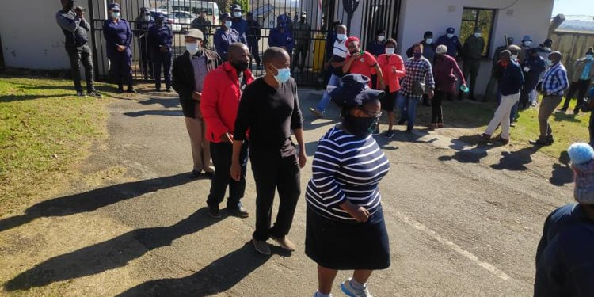Figure SNAT petition cabinet on teachers hiring freeze (Ngwenya, 2022)

# EFFECTS OF TEACHER HIRING FREEZE IN SCHOOL PERFORMANCE

## 3.1. DEGRADATION OF THE TEACHING PROFESSION

The freezing of hiring of teachers, regardless of the reason, seems to be a mockery to the profession. Out of all jobs, teachers believe their work is most critical to the overall development of a student from childhood to adult hood. They feel this task cannot be handles

casually, or be fixed to suit some agenda other than the welfare of the child. How can teachers be expected to be the best they can be when they are overwhelmed by the task of being all-rounders? Juggling the little time they have in a school calendar year amongst many classes can certainly not produce the best results.

## 3.2. LOW STAFF MORALE

The expectation that very few teachers can handle the workload of several teachers reduces staff morale. What happens to one can happen to you. This principle stands true in the issue of teachers in the country. Even if government can do this in one school, the teachers in the other schools have every reason to be concerned because it may happen to them any time. Even the graduates that lie idle at home are friends and relatives of the same teachers that government expects optimal performance from. In 2021, March 25, government recalled teachers to school, especially those teachers whose contracts had expired. These teachers were supposed to close some of the gaps that existed in vacancies. According to the Swaziland News, government told these contract teachers to resume work, and that their contracts will be renewed later (Swaziland News, 2021).

## 3.3. DROP IN STUDENT MOTIVATION

Students understand the standoff between government and the teachers union when it comes to employment of teachers in the country. These students actually feel the pinch of teacher shortage more than anyone who claims they read about the matter in the press, because all this happens to them. The class periods they have to lie idle, or have any teacher bombard them with work just to keep them busy can be demotivating for the learners. However, government

does not seem to see things through to the effects of her decisions on the learners who are on the receiving end.

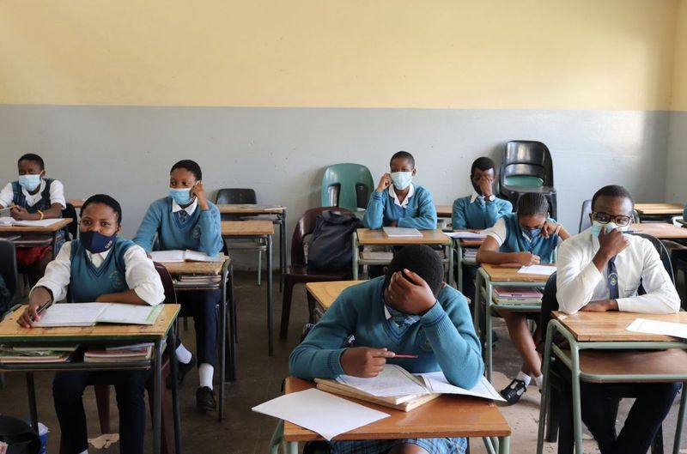Figure Students leave their ailing Eswatini schools for South African schools (New Frame, 2022)

## 3.4. HIGH STAFF TURNOVER

Government pumps in money in public teacher training colleges to produce high numbers of teachers. Unfortunately, the hiring of these teachers has always had many unresolved and somewhat political issues that end up preventing the hiring of these teachers on a permanent and pensionable basis. It is a different case if there are no vacancies. In the case of Eswatini, there is evidence that these vacancies exist as shown by the high numbers of contract teachers employed per school, and the continued renewal of these contracts. The frustration does not only affect the new graduates looking for jobs, but the permanent teachers in the schools who

have to shoulder the burden of teaching more classes because of staff shortages. Some of these teachers end up quitting and going to look for greener pastures in other countries (García & Weiss , 2019). There has been a growing trend of Eswatini teachers leaving for teaching jobs in the United Kingdom. This becomes a brain drain, because government needs these teachers.

# CONCLUSION

The recruitment and selection process in Eswatini public schools is clear-cut. Government sponsors public teacher training colleges and universities across the country to produce teachers that will feed directly into the current school system. There has been tremendous growth however in private colleges who now produce teacher graduates which has caused an influx in the teacher labour market. Government has limited schools, and therefore has been failing to absorb all these graduates into employment in the permanent and pensionable category. What becomes confusing is the growing numbers of temporal teachers that government still hires year in year out.

The question remains, why government is not prioritizing such a sensitive matter. Because teachers play a crucial role in raising the citizens of tomorrow. It is a bad thing for these students to be exposed to the now highly politicized profession. Because in order to try and be heard, teachers are usually on the streets demanding government to fill vacancies and improve their terms and conditions of service. However, government does not respond positively. At some point, students have even taken part in riots to complain about shortage of teachers in their schools.

The effects of teacher hiring freeze on school performance are many and they affect not only students and teachers, but also the entire public education system. Government must treat the teaching profession as an essential service just like health and make the necessary amendments to the freezing policy, so that teachers are employed to close the current vacancies in the schools. Students, by their nature can be wild and uncontrollable, the shortage of teachers is becoming the nurturing element of these behaviours, and these students will not end up in the education system. They will form part of the workforce, in one way or the other, and if the current culture of teacher strikes, abrupt closing of schools, and exodus of teachers persists, the whole country will be worse than it already is, as the nation wants the King to step down from the throne. They blame the whole non-functionality of government on his controlling and selfish agendas.

# References

Dixit, A. (2014, February). *Job Analysis – Relevance And Applicability For Modern Business Environment*. Retrieved from www.researchgate.net: https://www.researchgate.net/publication/346920470_Job_Analysis_-_Relevance_And_Applicability_For_Modern_Business_Environment

Eswatini Live Feed. (2021, April 15). *Urgent Announcement From Eswatini'sTeaching Service Commission*. Retrieved from www.facebook.com: https://www.facebook.com/EswatiniLiveFeed/photos/a.109468690430098/509944823715814/

García, E., & Weiss , E. (2019, March 26). *The teacher shortage is real, large and growing, and worse than we thought*. Retrieved from www.epi.org: https://www.epi.org/publication/the-teacher-shortage-is-real-large-and-growing-and-worse-than-we-thought-the-first-report-in-the-perfect-storm-in-the-teacher-labor-market-series/

Gentle, S. (2017, February 3). *Essay: Recruitment and selection process in eduction*. Retrieved from www.onrec.com: https://www.onrec.com/news/news-archive/essay-recruitment-and-selection-process-in-education

New Frame. (2022, May 12). *Eswatini pupils leave for South Africa*. Retrieved from www.thesouthafrican.com: https://www.thesouthafrican.com/lifestyle/eswatini-pupils-leave-for-sa/

Ngwenya, N. (2022, January 20). *SNAT petitions Cabinet on teachers hiring freeze*. Retrieved from independentnews.co.sz/news: https://independentnews.co.sz/news/7196/snat-petitions-cabinet-on-teachers-hiring-freeze/

Swaziland News. (2021, March 25). *SNAT takes on Government for forcing contract teachers to work without written documentation. BY GCINA DLAMINI(Student Journalist) Swaziland News, 25th March 2021 MBABANE:Mbongwa Dlamini, the President of the Swaziland*. Retrieved from www.facebook.com: https://www.facebook.com/436326986822300/photos/a.806576383130690/1175819782873013/?type=3

Swaziland News. (2021, June 16). *Teacher must do farming*. Retrieved from www.facebook.com: https://www.facebook.com/search/top?q=teachers%20must%20do%20farming%20dr%20mahlalela

The Swati Newsweek. (2022, April 16). *We will hire and renew contracts for teachers - TSC Chairman*. Retrieved from www.facebook.com: https://www.facebook.com/TheSwatiNewsweek/photos/a.2132355556998533/3279743455593065/?type=3