LUNGILE BAPHETSILE NGCAMPHALALA

**ID: UD78403ED87615**

COURSE NAME:

**THEORIES OF LEARNING**

ASSIGNMENT TITLE:

**BEHAVIORISM THEORY OF LEARNING**

ATLANTIC INTERNATIONAL UNIVERSITY

**September/2022**

Table of Contents

1. INTRODUCTION 3

1.1. Learning defined 4

1.2. Teaching defined 4

1.3. What is knowledge? 5

2. LEARNING THEORIES 6

2.1. Behaviourism theory 6

2.1.1. Operant conditioning vs Classical conditioning 7

2.1.2. Behaviourism and classroom management 8

2.1.3. An example 9

2.1.4. Criticism of behaviourism theory 11

3. CONCLUSION 14

Figure I Theories of learning (Bagasbas, 2021) 6

Figure II Behaviourism terms and connections (Villa, 2014) 7

Figure III Behaviourism Pavlov, Waston and Skinner (Snow, 2015) 8

Figure IV Positive and negative reinforcement (Zhou & Brown, 2015) 9

# INTRODUCTION

The word theory is always associated with research and its complicated theoretical processes. Therefore, when one sees it associated with a particular concept, the first thing on the mind is I am not going to survive this topic. Maybe that is the reason I did not start with it when I began my phase II courses. As we interact with these topics posed as theories, we begin to understand that theories are a part of us, what we go through every day. Understanding a particular theory makes your interactions with other components of society very simple. In our profession, it helps us to serve our valuable customers (the students) in an effective and efficient manner. Students are all different, and they respond to the same teaching approaches differently, because their learning styles are also different from the next.

Whilst most traditional education tried to ignore the differences that exist amongst humanity, modern methods of teaching and learning are trying to individualize all teaching and learning to suit the unique needs of students. We cannot expect teaching and learning programs to go on without an end, but we can make learning within a stipulated period fulfilling for the learner. This can be done by exploring the various theories of learning and associating them with students, by targeting students with teaching approaches that will fit their theories. This essay will look at three learning theories, behavioural, cognitive and gestalt theories and what implications they have for instructional design.

## Learning defined

Learning is a process whereby, a human being, who has been exposed to a particular new experience or environment, begins to react to that environment by behaving in a certain way. This is called to adapting to the experience or environment. This type of learning happens naturally, one may not even attend school to go through this kind of learning. I can relate it to the kind of learning that happens to children at an early age. Before a grown up can start educating a child, or before the child can start learning from the guidance of parents or guardians, that child has already learnt a lot from the way they interact with their environment. Children can also imitate adults perform an activity and learn in the process. According to the Management Study Guide, learning starts as soon as a person is born, until they pass on. We are a learning species, we are always learning, even when we think we are not and the environment is the teacher ( (Juneja, 2022).

## Teaching defined

Teaching involves all types of processes that one person initiates with the intention of imparting knowledge to another person. Unlike learning which happens almost naturally and does not depend on the next person to occur, teaching is usually a deliberate effort made by one person to achieve certain aims and objectives. It is worth noting that even though the person teaching can structure their process of imparting knowledge, they do not have any control over what the person they are teaching actually learns, so the outcome, even though anticipated and planned for, can be different. Instead, you may find that the learner you are trying to teach actually learns the direct opposite of what you were planning for them to learn. That does not mean, however, that planning for teaching should be discarded. “Teaching is the process of attending

to people’s needs, experiences and feelings, and intervening so that they learn particular things, and go beyond the given” (Smith , 2018).

## What is knowledge?

Knowledge has to be the outcome of all learning whether intended or not. It is the set of ideas, data, or information that a person accumulates as a result of learning. Everyone has a knowledge base, the only difference is the exposure, how much one has interacted with a learning opportunity that would result in him or her having knowledge about a particular subject or topic. Some have basic knowledge, other, who get the knowledge by undergoing a teaching and learning process, end up with advanced knowledge on a particular topic. Even the knowledge you have keeps changing, because earlier on we said learning happens through interaction with one’s environment, and variables in the environment are always changing. In order to have relevant knowledge at all times, one has to continuously engage in some sort of learning on that particular subject area.

Researchers through their work are always trying to find new knowledge. Even if you do not conduct your own research, reading research finding from other people’s work, enriches your knowledge on that area of interest. Sharing the knowledge with other e.g. through teaching others reinforces it. Knowledge can be classified into three types; declarative (facts), procedural (how to do things) and metacognitive (awareness of mental processes) knowledge (World Citizens2, 2022).

# LEARNING THEORIES

[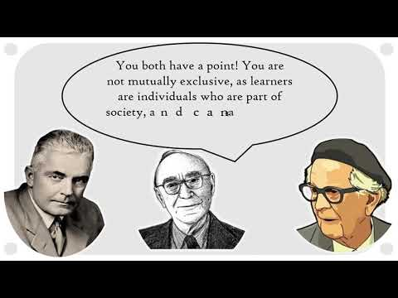](https://www.youtube.com/watch?v=PzTHof3RpUY)

Figure I Theories of learning (Bagasbas, 2021)

## Behaviourism theory

This theory suggests that people learn through interacting with their environment. It believes that learning has everything to do with what a person comes across in life, as opposed to learning a certain way because of genetic reasons. If the environment presents an interesting event, the person is likely to want to be associated with that event. If it is negative, they may shun the event. Let us familiarize ourselves with some of the main terms associated with behaviourism theory in figure II.

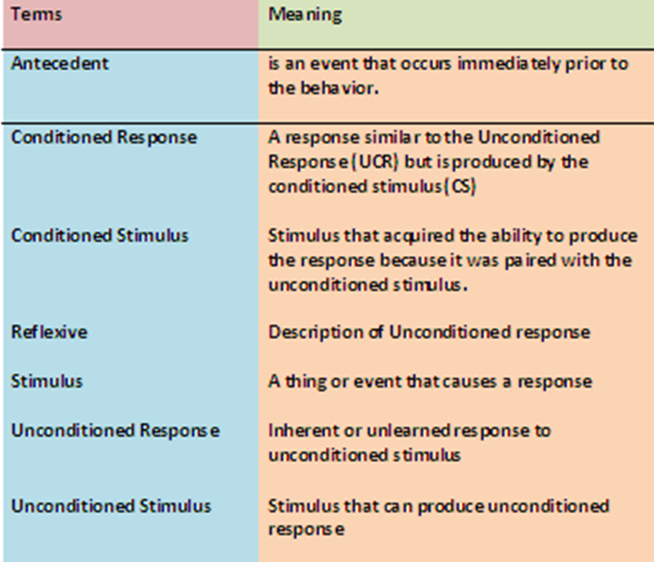

Figure II Behaviourism terms and connections (Villa, 2014)

### Operant conditioning vs Classical conditioning

Classical conditioning is associating an unintentional response and a stimulus, while operant conditioning is about associating an intended behaviour and a consequence (Cherry, 2020).

[](https://www.youtube.com/watch?v=xvVaTy8mQrg)

Figure Behaviourism Pavlov, Watson and Skinner (Snow, 2015)

### Behaviourism and classroom management

Positive and negative reinforcement works best in a classroom environment as a means of controlling students’ behaviour towards acceptable behaviours. Students are restless human beings; their energy pushes them all over place, as they want to interact with others in the classroom. Whilst this behaviour is classified as normal student behaviour when they are out playing during their own spare time. This kind of behaviour is not acceptable in the classroom setting, especially during the teaching and learning process, where the student concerned automatically disrupts the entire class during these movements usually accompanied by talking. The teacher as the classroom manager should be in a position to control this behaviour.

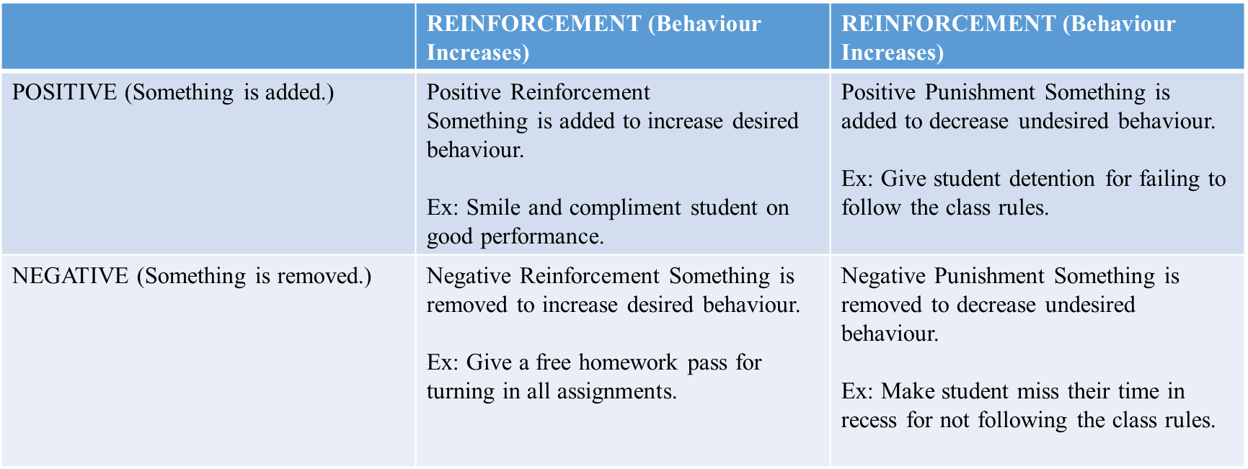Figure IV Positive and negative reinforcement (Zhou & Brown, 2015)

The behaviourism theory assumes that students behave a certain way in response to a particular stimulus, which in this case should be presented by teacher in charge of the classroom. This stimulus is not a one size fits all; the teacher will present different actions towards the students to attract a certain behaviour. The teacher will always use whatever stimuli the students respond to the most in producing the desired behaviour, or something close to it, and the students are likely to always respond in the same way. Thus the behaviour, which the student did not demonstrate before the stimuli, will eventually seem as if it comes naturally from the student

### An example

When I was in my lower primary school, in grade four, we had just been introduced to a syllabus where teacher teaches according to their area of specialization. It was a rural community school. The living conditions of students were poor, we did not afford basic snacks that would entice school going students like candy, chips or biscuits. We just did not afford anything. It was even a challenging transition for me because I had done the first three years of my schooling in an urban area where I stayed with my mother. Life was easier then, I was

still a last born too, so freebies were easy to come by. Now I was staying in this hard-core rural community with my granny who did not have a job and depended on grandfather who came home monthly. It was an entirely different life all together.

So one teacher who taught us science, introduced a reward system to our subject, which by its nature is always challenging for students, especially students in rural communities where students do not associate learning with future goals. Science always seems like an unnecessary, yet very difficult subject that does not answer anyone’s real life problems, especially at that age. The teacher used to buy expensive chocolates, expensive because I still do not buy them now, unless I want to motivate my son. The chocolates were rewarded anyone who passed his subject above a certain percentage. The rewarding session was always fulfilling for those who made the mark, I always made the mark, and so for me whenever there was a test, chocolate was guaranteed.

It was a good motivation for us to want to do better in the subject, we all wanted to pass. However, even if you attach a reward to performance, some students would still fail the subject because it is too abstract for them. This usually results in them engaging in bad behaviour, they cheat in order to get the good grade that will put them in a position to get whatever reward is offered. I remember in one of the science test I was bashed with a bunch of other students after being accused of cheating the test. It was one of the saddest days of my life. We were accused of presenting the same work, word for word in the test. The teacher said that the responses were so identical; it was difficult to tell who was copying from who.

So I in order to be fair, he beat everyone with those responses. I cried, not because of the beating, because the teacher knew what had happened but did not protect me. When we submitted the test, the teacher left the classroom and our submitted work on his table. The other students took my test book, reproduced my answers, and put it back on the teacher’s table. I still got the chocolate, but I hated everything that had just happened. They wanted to behave like the good students, they wanted to be classified as best science students, but their approach to it was not the correct one. Out of their desire to earn the reward, they learned and demonstrated a behaviour that the teacher had not planned. In order to correct it, he used punishment.

### Criticism of behaviourism theory

* The theory is one-dimensional and treats human beings as though they do not have free will to make their own decisions. It also eliminates the existence of internal factors that may influence a person’s behaviour. Take for example the reward of chocolates for doing well in a science test, that reward, like I had mentioned earlier, was not going to work as a reinforcement if the school was situated in the urban area where parents afford such snacks. The approach also did not affect other students who do not like chocolate anyway. Rural community raised children do not have a hype for sweets; they prefer bread, as it sustains their hunger more.
* Behaviourism does not consider other theories of learning as existing and impactful on the way a person learns. Other theories like cognitivism and constructivism are not considered for their contribution to learning. In the case of Pavlov’s dogs, the major focus was on the food, the dog’s salivation, and the bell. Pavlov did not associate the

relationship the dog has developed with him to play a part in the eventual behaviour change. First, the dog had to feel safe and comfortable under Pavlov’s care, it has to trust Pavlov to have its best interest at heart. It also knew that in order to continue to enjoy the good life, it had to respond positively to the owners demands.

Going back to the science test example. I understood science concepts and did well in all my class tests. This was something that happened naturally. I already had the right mental strength to learn and master complex concepts on the science subject at that level. Chocolate did not make me study harder or do anything different. It made me excited about getting results that are accompanied by chocolate. There was no chocolate reward offered by the other teachers in the school, but I did exceptionally well in those subjects too. What became a problem for me in this scenario is that I believed I had a trust relationship with the teacher. However, he broke that trust when he punished me, together with the students who cheated using my work. From that day on, it did not matter if I got chocolate or not, but my own personal dream of becoming a teacher when I grow up remained the driving force, and that was only possible if I commit to my schoolwork.

* People adapt at the availability of new information, but the behaviourism seems to assume that once reinforced, a behaviour persists indefinitely. That is not the case. I believe at some point something is bound to change, priorities and focus can change and a person may start behaving in the new direction that a particular new piece of information has presented. I have worked in the same department for about seven years now. As a lecturer, I have always loved my job and being given all teaching resources was good enough to set me going. I have a passion for teaching. However when I joined

my college in 2015, things changed. The institute did not prioritize academic work, hence teaching and learning materials were secondary to meals that are supposed to be served participants. As long as they had a good meal, the management was proud. There were no teaching materials, even a basic laptop. Therefore, I gave up trying to be the good person. I did what I could, no extra effort no extra mile, nothing. That was not me, but I was helpless. Even when you brought your own laptop to work, and it crashed, it was your problem. When you raised the issue in that once a year meeting, you were seen to be bitter and instigating lecturers towards industrial action.

* Our principal retired and was given a two year contract, it was the same environment, no working tools for lecturers. He has eventually retired forever on 25 August 2022, and a new principal has already been introduced. I have a new laptop as we speak, I am enthusiastic, while I was almost killed by depression, and the future looks bright. I am happier and I am planning to work to impress. Maybe I needed that old principal a little longer to complete my doctorate, because now I have to apply myself to work because I have all the necessary resources I need to do my best job. So yes, we do adapt in the existence of new information.
* The study of human behaviour should not be left only to experiments conducted through animals as the behaviourists do. Human beings are superior to animals in so many ways. Whilst a study can give similarities between those animals and humans, it cannot be held as conclusive, because with humans, so many other mental processes could be at play and change the outcome of the theory, if a human being was used to conduct many of these experiments. That is why, after all these experiments have been

conducted, we still cannot account for some of the behaviours that are demonstrated by humans.

Behaviourism advocates over emphasise the use of external influencers to shaping a human’s behaviour yet there is more to it than that. Take students for example who are born from rich families, attend the best schools, and are dropped by flashy cars at school. They were label clothes that some teachers cannot even afford to buy. They always have the best lunch boxes and enough pocket money they could feed the whole class. Moreover, all the parents wish for, is that their children become like them or better. Usually such parents are successful professionals in industry. However, by modelling a corporate life and pledges gifts for good results from these students, leads to broken families as the children would usually fail academically therefore fail to imitate their parents. Instead, the more pressure the parents put on their kids, the more they resort to substance abuse, which they afford, and sometimes leave home to share shacks with poor kids. How can we explain that, if all behaviour is learned?

# CONCLUSION

Even though there are some criticism to the behavioural theory of learning, the theorist did make some useful observations on what can influence a person’s behaviour, and these insights have become beneficial to both students and teachers in terms of making the most of the teaching and learning experience fulfilling. Students behave in relation to what they think they will benefit from demonstrating a certain behaviour either by getting material rewards of the attention and approval of people that matter to them. Their behaviour revolves around what they hold highly at a given point in time. If a student want to go to university, they will know

what kind of behaviour will get them admission into university? If some friends are a bad influence, or have different dreams like pursuing a talent, the friendship may even breakdown.

It is important for us as teachers to acknowledge that behaviour is learned, but if the learned behaviour is bad, it can be unlearned through negative punishment to get rid of that behaviour. However, if as a teacher you notice the gradual positive change in the student’s behaviour, he or she must reward that behaviour so that it is repeated until it becomes a new habit for the student. Unrewarded good behaviour will be replaced by bad behaviour. In addition, ignoring bad behaviour can spread and be learned by the other students in the classrooms, and then it becomes difficult to control it.

# References

Bagasbas, A. (2021, June 17). *Theories of learning.* Retrieved from www.youtube.com: https://www.youtube.com/watch?v=PzTHof3RpUY

Cherry, K. (2020, June 4). *Classical vs operant conditioning.* Retrieved from www.verywellmind.com: https://www.verywellmind.com/classical-vs-operant-conditioning-2794861#:~:text=Classical%20conditioning%20involves%20associating%20an,conditioning%20involves%20no%20such%20enticements.

Gamboa, A. (2020, November 6). *Comparing learning theories.* Retrieved from medium.com: https://medium.com/applied-learning-theory/comparing-learning-theories-99c4f827c6a0

Juneja, P. (2022). *Definition, characteristics and types of learning in psychology.* Retrieved from www.managementstudyguide.com: https://www.managementstudyguide.com/definition-characteristics-and-types-of-learning-in-psychology.htm

Smith , M. K. (2018). *What is teaching.* Retrieved from infed.org: https://infed.org/mobi/what-is-teaching/

Snow, A. (2015, October 14). *Behaviorism Pavlov, Waston ans Skinner.* Retrieved from www.youtube.com: https://www.youtube.com/watch?v=xvVaTy8mQrg

Valamis. (2022, February 28). *Cognitive learning.* Retrieved from www.valamis.com: https://www.valamis.com/hub/cognitive-learning

Villa, M. G. (2014, February 20). *Behaviorism terms and connections.* Retrieved from moninagracevilla.wordpress.com: https://moninagracevilla.wordpress.com/2014/02/20/my-connection-on-behaviorism/

World Citizens2. (2022). *Learning theories.* Retrieved from www.worldecitizens.net: https://www.worldecitizens.net/freestate/resources/fs/LEARNING%20THEORIES.pdf

Zhou, M., & Brown, D. (2015). *Educational Learning Theories.* Retrieved from oer.galileo.usg.edu: https://oer.galileo.usg.edu/cgi/viewcontent.cgi?article=1000&context=education-textbooks