LUNGILE BAPHETSILE NGCAMPHALALA

**ID: UD78403ED87615**

COURSE NAME:

**RESEARCH THEORY, DESIGN AND METHODS**

ASSIGNMENT TITLE:

**QUALITATIVE RESEARCH**

ATLANTIC INTERNATIONAL UNIVERSITY

**September/2022**

Table of Contents

1. INTRODUCTION 2

2. QUALITATIVE RESEARCH METHODS 3

2.1. INTERVIEW METHOD 3

2.1.1. Advantages and disadvantages of the interview method 4

2.2. FOCUS GROUPS 4

2.2.1. Advantages and disadvantages of the focus group method 5

2.3. ETHNOGRAPHIC RESEARCH 5

2.3.1. Advantages and disadvantages of the ethnographic research method 6

2.4. PROCESS OF OBERVATION 6

2.4.1. Advantages and disadvantages of the process of observation 7

2.5. RECORD KEEPING 7

2.5.1. Advantages and disadvantages of record keeping 7

3.6. CASE STUDY RESEARCH 8

3.5.1. Advantages and disadvantages of the case study research methods 8

3. CONCLUSION 9

4. References 10

# INTRODUCTION

Qualitative research is research that uses words to describe situations in an investigation or enquiry. It studies mainly the feelings, attitudes, opinions of participants involved in a study. It is descriptive in nature. It describes what people think and why that think that way (QuestionPro, 2022). A systematic observation and course registration forms concludes that the number of junior public officers attending Eswatini Institute of Management and Public Administration (EIMPA) courses are more. One good method to determine why senior managers were not attending EIMPA courses is to conduct an in-depth interview of potential participants in those positions. The essay will discuss the methods of qualitative research.

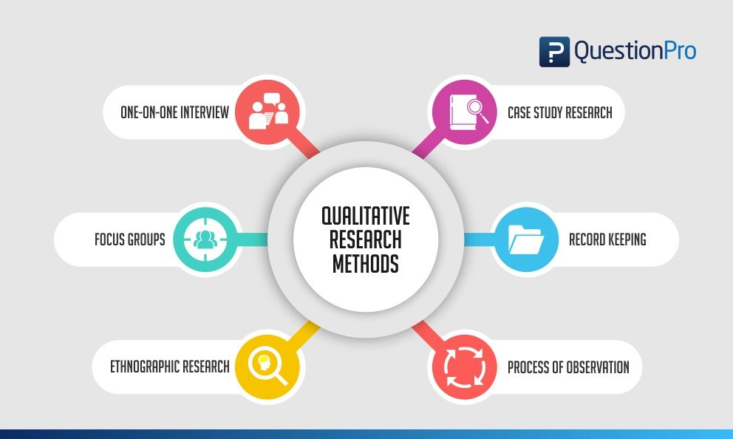Figure Qualitative research methods (QuestionPro, 2022)

# QUALITATIVE RESEARCH METHODS

## 2.1. INTERVIEW METHOD

The researcher prepares a list of questions to ask research participants in a research study. The method is the most commonly used under qualitative research. This is a one on one conversation between the researcher and research participants to get details about the topic from the respondent. It can take place face to face (though video platforms if very far, or telephonic. For example, as a lecturer I can conduct interviews with senior government officials to ascertain their perception of EIMPA courses and find out the reasons why they do not attend our courses.

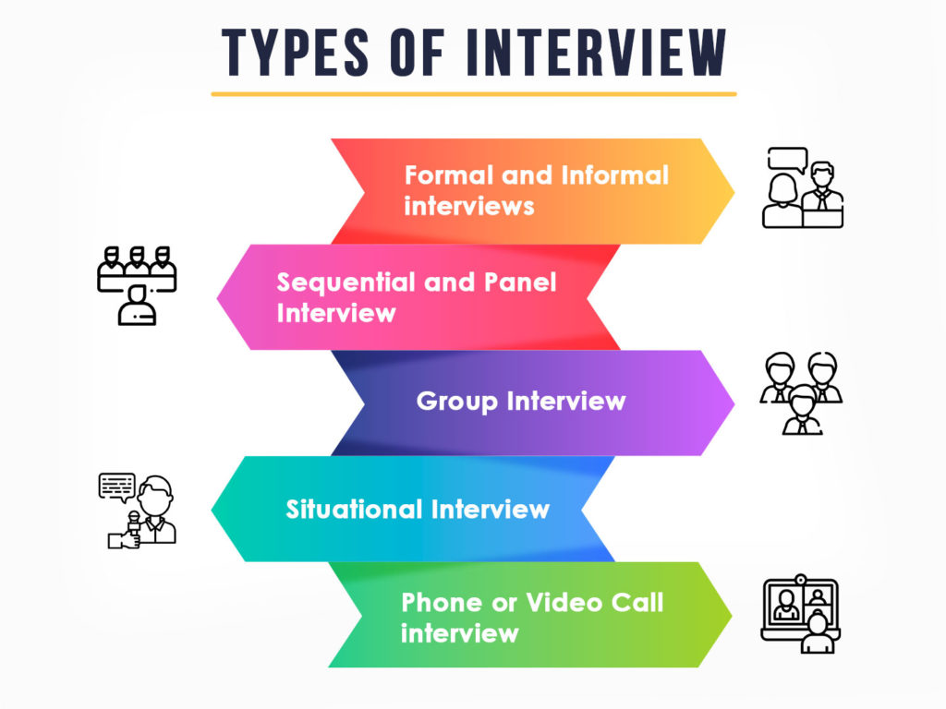Figure Types of interview (Talent Services, 2021)

### 2.1.1. Advantages and disadvantages of the interview method

The method allows for instant feedback from the participant, if they do not get a question, they can ask the interviewer to clarify or rephrase to give an appropriate response. The researcher also has the opportunity to probe for more details during the question and answer session, thus resulting in more precise data (QuestionPro, 2022). A major drawback of the interview is that it can be time consuming if the researcher cannot guide and limit the participants’ responses. Responses can end up being lengthy but with no substance that will add value to the study.

## 2.2. FOCUS GROUPS

In the focus group method, questions are posed to an experienced group of about six to ten people about a particular topic, members discuss and respond. Focus groups are most effective if they are led by a more experienced moderator who follows a script (Busetto, Wick, & Gumbinger , 2020). A group of lecturers can meet to discuss the feasibility of online learning as EIMPA.

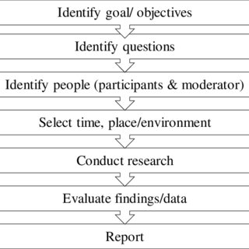

Figure Focus group discussion (Omar, 2018)

### 2.2.1. Advantages and disadvantages of the focus group method

Focus groups have the potential of bringing out more depth in the topic, from discussions amongst the group participants. However, there is not control over the actual participation of all members of the group. One or two individuals may dominate the group with the others just playing a passive role, hence adding not value to their entire discussion.

## 2.3. ETHNOGRAPHIC RESEARCH

Researchers join interest organizations or groups to part of them and in the process, study their behaviours in the natural environment and capture incidents and events as they occur. For example, if you want to understand the way of life of university students, you may enrol at the university and become a student yourself. You may also just observe the students over a certain period.

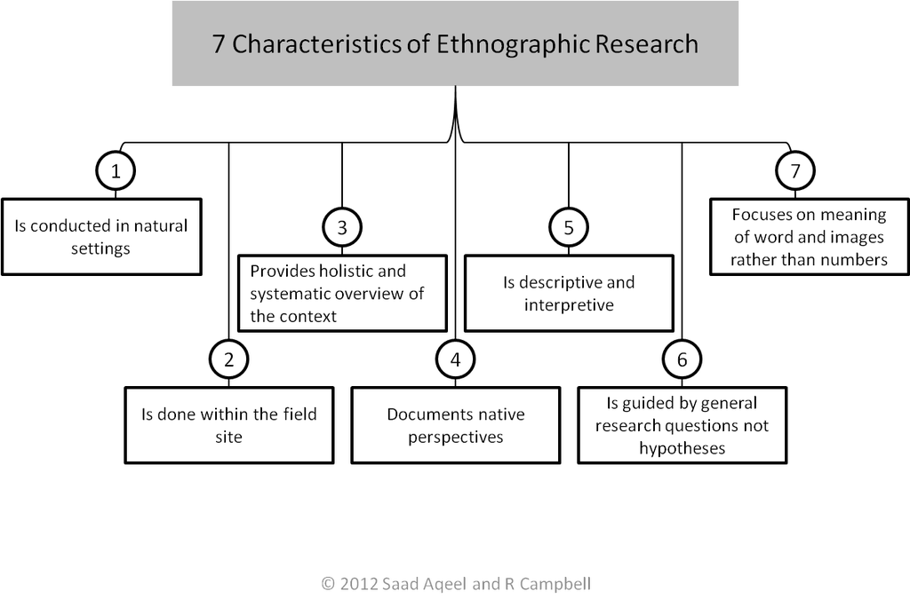Figure Ethnographic research is the key to understanding your customers (Tyne, 2017)

### 2.3.1. Advantages and disadvantages of the ethnographic research method

One main advantages of the ethnographic method is the originality of the data that is being collected since it occurs and is captured in real time. The physical location of the organization/ group of interest may inhibit the possibility of engaging this kind of research method, since it calls for the researcher to be present in the environment as the behaviours or whatever is being watched unfolds in its natural environment.

## 2.4. PROCESS OF OBERVATION

The process of observation involves using one’s senses to draw conclusions from the events happening in a particular natural environment (Fuel Cycke, 2022).

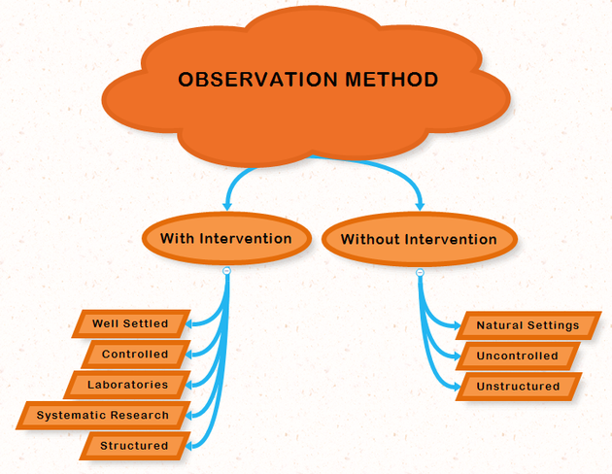Figure Observation method (Introduction to psychology, 2017)

### 2.4.1. Advantages and disadvantages of the process of observation

This method needs a lot of time; you cannot just observe the behavioural patterns of other and draw conclusion unless enough time was allowed for observation.

## 2.5. RECORD KEEPING

This is data collection that collect data from existing documents like reading through available research in a library. Various documents of a personal or non-personal manner can be consulted including, journals, books, letters, reports, policies, minutes of meetings (Gumbinger , Wick, & Busetto, 2020). A researcher who wishes to study the history of EIMPA can consult old college documents and government policies to find the information.

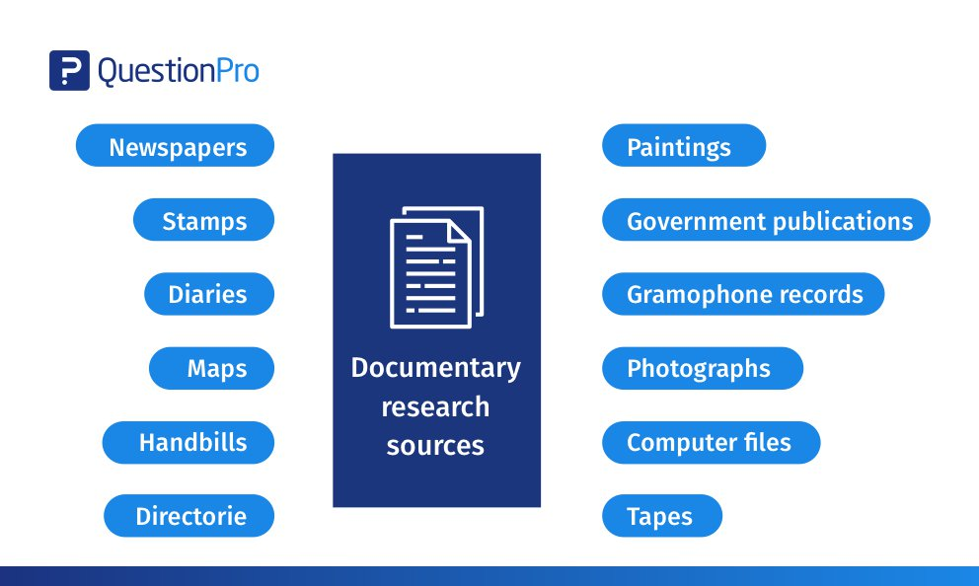Figure Documentary research (QuestionPro, 2022)

### 2.5.1. Advantages and disadvantages of record keeping

Recording can give accurate finding on a topic because several researchers have done work on the topic and presented their conclusions. If the researcher has enough time to find information, record keeping should yield better results. Reading lengthy documents maybe take very long periods and the researcher might likely lose focus. However, going through books can be cumbersome for the researcher, thus few books read may not give the true indication of the situation occurring in real time.

## 3.6. CASE STUDY RESEARCH

The case study research generally questions why some decisions were taken, what implementation strategy was adopted and what the result was (Idania, 2012). The case is a single person, business, event, group, organization or entity being studied (Gaille, 2018). An investigation of a change process and its effects on employees can be conducted at Eswatini College of Technology (SCOT), however the recommendations can be applied by EIMPA when she want to undergo a similar process.

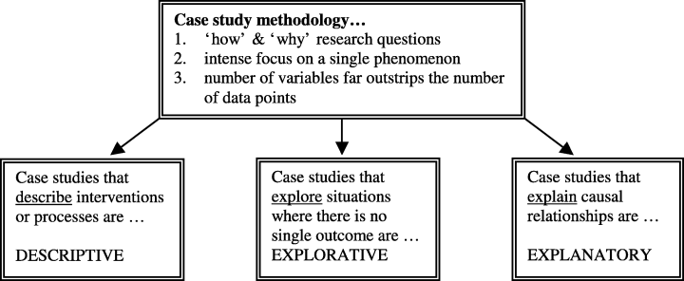Figure Explanatory case studies (Fisher & Ziviani, 2004)

### 3.5.1. Advantages and disadvantages of the case study research methods

It easier to conduct research when you focus on a single entity, the risk of wondering of your research topic are minimal. However, the case study may not give findings that can be generalized to the wider population. The data takes longer to analyse because there is too much data to deal with, and the researcher needs to ensure that the data received is accurate. Some participants may be reluctant to share information; others may overshare, throwing an inexperienced researcher off the research objectives (Gaille, 2018).

# CONCLUSION

The essay looked at some of the qualitative methods of research. These include interview, case study, ethnographic method, document analysis and others. The advantages and disadvantage of each where highlighted. The course helped me to refresh my memory on qualitative research, which will help me to undertake phase III of my program with ease. I personally have a phobia for research, so getting the course underway has helped me to get a little confidence.

I will use the information learnt in this course to conduct research in my current work. There are many issues that affect operations at work, but most of them do not get any attention because they are not backed by research. I will continue to practice my research and improve my research skills even after training, so that I can also guide others who wish to conduct research in other government departments.

# References

Busetto, L., Wick, W., & Gumbinger , C. (2020, May 27). *How to use and assess qualitative research methods*. Retrieved from neurolrespract.biomedcentral.com: https://neurolrespract.biomedcentral.com/articles/10.1186/s42466-020-00059-z

Fisher, I., & Ziviani, J. (2004, August 12). *Explanatory case studies*. Retrieved from onlinelibrary.wiley.com: https://onlinelibrary.wiley.com/doi/abs/10.1111/j.1440-1630.2004.00446.x

Fuel Cycke. (2022). *The 3 most common observation reseach methods*. Retrieved from fuelcycle.com: https://fuelcycle.com/blog/the-3-most-common-observation-research-methods/

Gaille, B. (2018, July 11). *12 Case Study Method Advantages and Disadvantages*. Retrieved from brandongaille.com: https://brandongaille.com/12-case-study-method-advantages-and-disadvantages/

Grad Coach. (2021, October 29). *How To Write A Methodology Chapter For A Dissertation Or Thesis*. Retrieved from www.youtube.com: https://www.youtube.com/watch?v=W0vNS1VafXA

Gumbinger , C., Wick, W., & Busetto, L. (2020, May 27). *How to use and assess qualitative research methods*. Retrieved from neurolrespract.biomedcentral.com: https://neurolrespract.biomedcentral.com/articles/10.1186/s42466-020-00059-z

Idania, B. (2012, July 2). *Case study research method*. Retrieved from www.slideserve.com: https://www.slideserve.com/beyla/case-study-research-method

Introduction to psychology. (2017). *Introduction to psychology*. Retrieved from scienceaid.net: https://scienceaid.net/Introduction_to_Psychology

Omar, D. (2018, February). *Focus group discussion in built environment qualitative research practice*. Retrieved from www.researchgate.net: https://www.researchgate.net/figure/The-process-of-FGD_fig1_323669687

QuestionPro. (2022). *Qualitative Research: Definition, Types, Methods and Examples*. Retrieved from www.questionpro.com: https://www.questionpro.com/blog/qualitative-research-methods/

Scribbr. (2020, June 12). *How to Write a Research Methodology in 4 Steps*. Retrieved from www.youtube.com: https://www.youtube.com/watch?v=yplWZs3dqNQ

Talent Services. (2021, February 24). *Types of interview*. Retrieved from asktalentservices.com: https://asktalentservices.com/blogs/what-is-interview-and-types-of-interviews/

Tyne, S. V. (2017, December 20). *Ethnographic Research is the Key to Really Understanding Your Customers’ Needs*. Retrieved from medium.com: https://medium.com/@sean_82431/ethnographic-research-is-the-key-to-really-understanding-your-customers-needs-f31e89f26b43