ASSIGNMENT

THE DEVELOPMENT OF THE CLASSICAL ORCHESTRA {1750- 1950}

INTRODUCTION

During the Renaissance Era {1400 – 1600}, the family of viols began their transformation

into the development of the early string family of the Baroque Era {1600-1750},

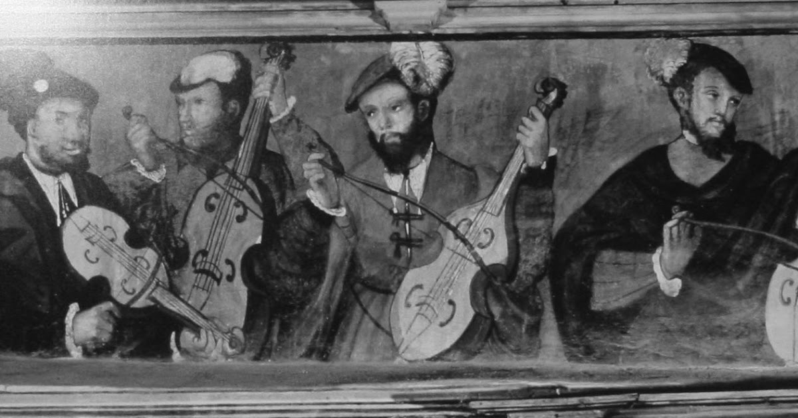

FIGURE 1 *An early consort of Renaissance Viols*

The early chamber ensemble was known as ‘A Consort’, which would usually comprise of Viols, recorder, cembalo, and various other Renaissance instruments to suit the composition. The players would comprise of a small collection of players and would often perform for small gatherings or dances. The ‘Minstrels Gallery’ is aptly named as the sound would project over the audience as there was no amplification. Famous Renaissance composers included the imminent Thomas Morley, William Byrd, and Thomas Tallis are just some of the eminent names from the renaissance period.

THE DEVELOPMENT

During this early period, the stringed instruments which were known as ‘VIOLS’ were very different from those of the baroque period. The transition of the instruments began to can the sound and tonal quality of the ensemble in general. As we now move swiftly into the Baroque period which is {1750- 1820} the entire sphere of the exponential growth of both the instruments, and consequently the development of the compositions which were being produced.

This image is of a German Baroque period

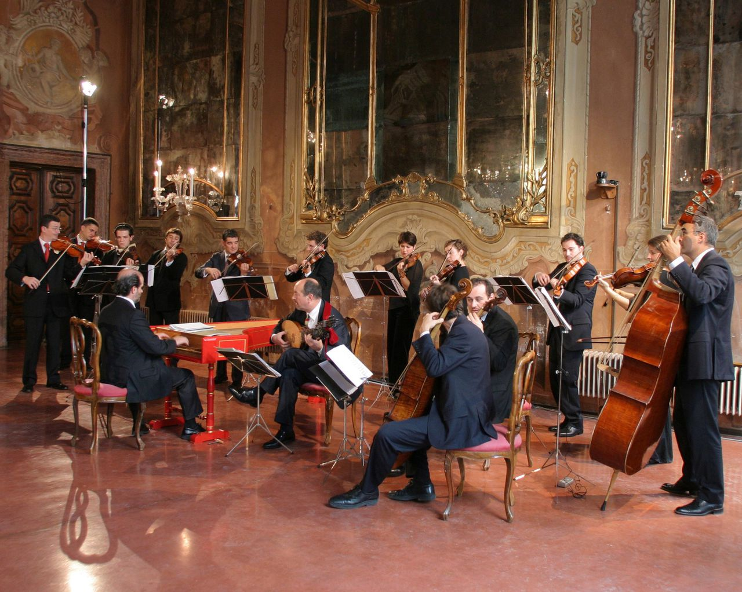

As we can see from the picture, it comprises of a small group of violins, violas, cellos. 1 double bass and cembalo. The cembalo or harpsichord as it is named, would be the instrument in which the player would conduction the small ensemble from.

In contrast to this, if we look at the famous oratorio by Handel – ‘The Messiah,’ there is a much greater orchestral score.

In this work, we have an orchestra of:

* violins 1
* violins 2
* viola
* cello
* double bass
* harpsichord
* organ
* timpani
* trumpet
* oboe

The vocal score :

* Soprano 1 and 2
* Alto
* Tenors
* Basses

The soloists:

Soprano

Alto or counter tenor

Tenor

Bass.

In the short period of time, the size of the orchestra has increased rapidly. An oratorio is a sacred work based upon the bible. The text is often taken directly from the bible and would have probably been taken from The King James version.

Work from the period also includes:

* ‘THE GLORIA’ Vivaldi
* ‘THE FOUR SEASONS’ VIVALDI
* UNACCOMPANIE CELLO SUITES JS BACH
* SOLO VIOLIN PARTITAS FOR VIOLIN JS BACH
* THE ITALIAN COMPOSERS WORKS. The composers would be Corelli, Tartini, Pachelbel, Viotti. and these composers would write a lot for the violin They consisted of an amalgamation of teachers, performers, composers, and would often performers their own works or encourage their advanced students to.

THE LINKING EPISODE.

During the classical period, Mozart was the favourite that was on the circuit and that time. Sadly, for such composers as Antonio Salieri, Mozart would dominant the concert scene until his sudden and tragic death. The classical period is from 1750 – 1820 and during this time the instruments developed, not only stringed instruments but all the instruments from the pianoforte to the horn in D and the type of works which were being composed by the close of this era.

In the classical era, the orchestra became more standardized with a small to medium sized

string section and a core wind section consisting of pairs of oboes, flutes, bassoons, and

horns, sometimes supplemented by percussion and pairs of clarinets and trumpets.

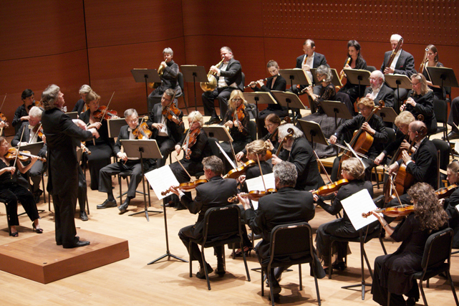

THE CLASSICAL PERIOD ORCHESTRA.

The vital transformation was the development of the stringed violin bow which subsequently enable the players to produce a louder richer tonal quality and therefor the composers could use dynamics- louds and softs. Beethoven lived during this period , and if we observed his works, you can see, heard and observe just how much musical compositions changed. The pianoforte by the end of Beethoven’s late period had introduce the semi sustain pedal and the length of the keyboard and rapidly increased in size length. The range and was now more like 7.5 octaves so the piano concertos were so advanced in style, characterization, and technical facility.

The romantic period is a time when life changed, the style of the dress altered and the way in which new and exciting inventions began to transpire such as the invention of electricity.

The period covers {1820 – 1890}

This is when the size of the orchestra went from around 45 players to 120 players which must have been incredible to be able to go and watch a live concert or a ballet of Tchaikovsky.

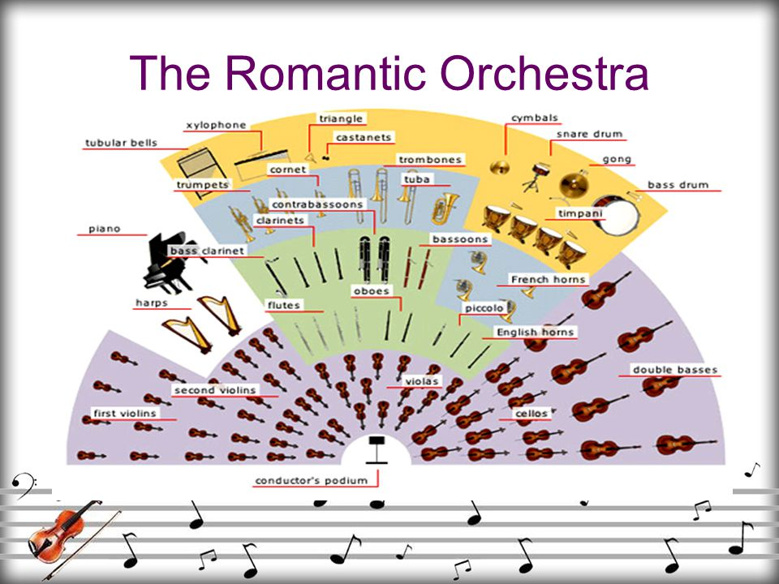

What a transformation in a period of 100 years!

Such works include:

* Chopin ballades, concerti, and nocturnes
* Tchaikovsky ballets and concerti and symphony
* German lieder
* Lizst Hungarian rhapsody
* Brahms symphonic works

IMPRESSIONISTIC PERIOD

This period relates to the French influence which in namely the impressionistic artist such as Monet, Manet, Renoir, and Degas. Their paintings inspired the 3 key French composers of the era.

* RAVEL
* DEBUSYY
* SATIE

Imagery was the focus, and the composers would use sonnets of such works by Shakespeare and Rosetti poems to set their works to. Renoir moved to England in 1901 and the English composers such as Vaughan Williams and Sir Edward Elgar use the same compositional ideas and techniques within their works.

THE MODERN ERA.

The modern era transcends form around 1910 onwards with a fusion of influences from blues, jazz, Indian raga, and folk songs. The Russian composers such as Igor Stravinsky wrote his ‘Rite of Spring’ which was very atonal and dissonant, which was rather controversial due to this new, perhaps strange work. With the blues and jazz taking over America during that time, composers such as George Gershwin wrote such pieces as ‘RAPSODHY IN BLUE’. Other composers from that era were Arron Copland: who liked the idea of folk music like that of Bela Bartok, and the adaption of the revised story based on ‘Romeo and Juliet’ by Bernstein.

IN CONCLUSION

This is a very brief outline of the development of the orchestra and the key elements of those periods. I should write a large dissertation on this topic, but have compressed it into a small educational assignment.

A very interesting topic which would be advantageous to explore in the future.

References

En.tchaikovsky-research.net. 2022. *Ballets - Tchaikovsky Research*. [online] Available at: <https://en.tchaikovsky-research.net/pages/Ballets> [Accessed 8 September 2022].

Kallen, S., n.d. *The history of classical music*.

Nevala, A., n.d. *The influence of jazz and impressionistic ideals found in the music of Claude Debussy, Darius Milhaud, Maurice Ravel, Bix Beiderbecke, Art Tatum, and Bill Evans*.