|  |
| --- |
| ATLANTIC INTERNATIONAL UNIVERSITY |
|  |
| Doctorate in Music Education |

|  |
| --- |
| FACULTY OF SOCIAL SCIENCES |

Zelda Hill

Thesis

‘*The Art of Violin Pedagogy with the significance of the collaboration of Francois Tourte and Giovanni Baptista Viotti’*

Dedicated in loving memory to my dear parents

‘Thomas Roy Hill ‘and ‘Gillian Hill’

Thank you for inspiring me with the love of music

|  |
| --- |
| **Special Acknowledgements** |
|  |
|  |

|  |
| --- |
|  |

ACKNOWLEDGEMENTS

1. Special and sincere gratitude to Francis Morgan for your

constant encouragement, support, and dedication

towards my goals and aspirations. I would never have

achieved so much without you.

1. Atlantic International University

Sincere gratitude for the excellent support, guidance,

and inspiration you have provided during my studies.

The professionalism of the advisors and tutors have

been outstanding.

Grateful appreciation and thank you.

CONTENTS

|  |  |
| --- | --- |
| Front page | 1 |
| Title page | 11 |
| Special thanks | 111 |
| Special Acknowledgements | 1V |
| Acknowledgement | V |
| Contents page | V1 |
| Pedagogic Diagram | V11 |
| Abstract | Page 1 |
| New Beginnings | Page 2 |
| Chapter 1 | Page 4 |
| Chapter 2 | Page 10 |
| Chapter 3 | Page 13 |
| Chapter 4 | Page 23 |
| Chapter 5 | Page 27 |
| Chapter 6 | Page 33 |
| Summary | Page 43 |
| References /  Bibliography | Page 45 |

**FIGURES**

|  |  |
| --- | --- |
| Figure1 | Page 2 |
| Figure 2 | Page 3 |
| Figure 3 | Page 4 |
| Figure 4 | Page 6 |
| Figure 5 | Page 6 |
| Figure 6 | Page 7 |
| Figure 7 | Page 7 |
| Figure 8 | Page 9 |
| Figure 9 | Page 10 |
| Figure 10 | Page 14 |
| Figure 11 | Page 14 |
| Figure 12 | Page 21 |
| Figure 13 | Page 22 |
| Figure 14 | Page 24 |
| Figure 15 | Page 25 |
| Figure 16 | Page 26 |
| Figure 17 | Page 26 |
| Figure 18 | Page 28 |
| Figure 19 | Page 34 |
| Figure 20 | Page 35 |
| Figure 21 | Page 36 |
| Figure 22 | Page 37 |
| Figure 23 | Page 38 |
| Figure 24 | Page 39 |
| Figure 25 | Page 42 |
|  |  |

**DIAGRAM**

|  |  |
| --- | --- |
| Diagram 1 | Page 12 |
| Diagram 2 | Page 13 |
| Diagram 3 | Page 31 |
| Diagram 4 |  |

**TABLE**

|  |  |
| --- | --- |
| Table 1 | Page 5 |
| Table 2 | Page 10 |
| Table 3 | Page 16 |
| Table 4 | Page 16/17 |

PAGE Break

ABSTRACT

The eminent Italian trilogy of the early pedagogical approaches, were Antonio

Vivaldi, Arcangelo Corelli, and Giovanni Battista Viotti. The violinists were significant

historical composers, and virtuosic violin performers whose works are among the major

classical repertoire. A strong understanding of the historical of their approaches towards the

art of performing, and teaching is clearly seen throughout the lineage line of pedagogic

teaching which permeates through to the various schools of violin playing. Each era of violin

development was of significant for that time, and it is vital as a teacher and performer

examine closely their work. Without the Italian trilogy, we would not have the violinist of

today.

Therefore, the purpose of this dissertation is to evaluate and examine the development

of the pedagogic lineage. and to see how influential the collaboration of Giovanni Battista

Viotti and his colleague, the French master bow maker Francais Tourte. Together their work

exponentially altered the course of history, not just in violin playing, but the compositional

works that were later produced.

Subsequently, I had the privilege of being taught the violin by several of the key professors

of the modern school of violin playing.

* *Professor Simon Fischer from the lineage of Carl Flesch and the Ivan Galamian American school.*

*Professor Yfrah Neaman was from the pedagogic lineage of Carl Flesch and Max Rostal.*

* *Professor Nigel Kennedy from the Ivan Galamian School American School*
* *Professor Erich Greunberg from the Carl Flesch school.*

The knowledge I obtained from these great teachers has inspired me to write this dissertation.

**BEGINNINGS**

During the Renaissance Era {1400 – 1600}, the viols began their transformation into the

early string family of the Baroque Era {1600-1750},

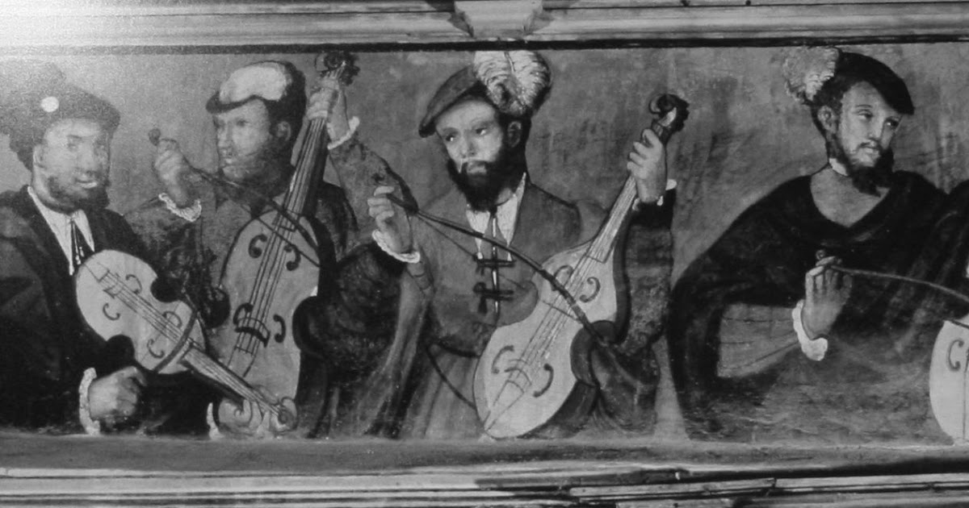

FIGURE 1 *An early consort of Renaissance Viols*

The bowed string family began to emerge through various forms to a treatise

composed in 1556. The history of violinmaking lends itself to the Cremona school producing

masterpieces of exceptional substance. There are 3 main schools of violin makers, The

Amati family who established the violin-making art at Cremona. Subsequently the artistry

of the famous Antonius Stradiuarius and Joseph Guarnerius del Jesû. Each master would

extend their knowledge to the next era of successors. The stringed instruments of that

periods are still played to this day and are among the finest in the world.

While a violin scholar at ‘The Royal Academy of Music ‘in London, I was loaned a G. Cappa

1690 from the vaults of the RAM. Cappa was a pupil of one of the early Amati family of

Luthiers and its tone was well-balanced, rounded with the upper registers producing a

beautiful bel-canto singing style. The varnish was a yellow brown in colour, and it was small in size in comparison to a ‘Del Gesu’.

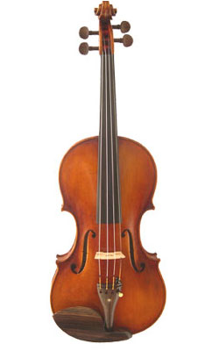

FIGURE 2 *Il Cannone, violin by Giuseppe Guarneri*

*Played by one of the greatest violinists of all time ‘Paganini’*

Such was the flourishing state of Italian art during the great Cremona period, which

opened a mine of artistic wealth for succeeding generations. It is a curious fact that not only

the violin, but violin music was the creature of the most luxurious period of art; for, in that

golden age of the creative imagination, musicians contemporary with the great violinmakers

were writing music destined to be better understood and appreciated when the violins then

made should have reached their maturity.

**CHAPTER 1**

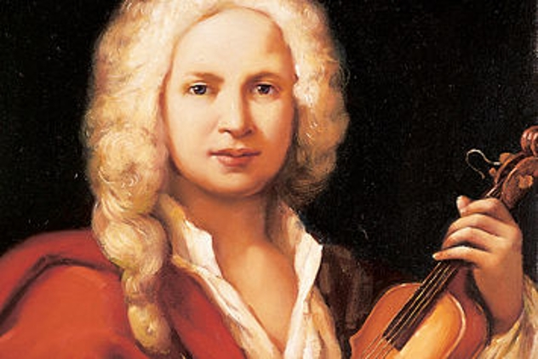

FIGURE 3

*The eminent master of the violin Antonio Vivaldi {1678-1741}*

Antonio Vivaldi – ‘The Father of the Violin’

Antonio Vivaldi was born in Venice and grew up with a close connection to the church and eventually was ordained as a priest. He was named the red headed priest and his distinct hair was a prominent feature of his outward appearance. Although writing concerti, sacred works etc, he began compiling five-finger exercises for students for finger dexterity.

It is believed that his violin concerti were indeed exercises which he would play with his many talented pupils. We can see by the string crossing passages, the scale passages and written cadenzas that these were composed more as studies. The four seasons are extremely technical and would have been viewed highly in the violin repertoire. We must remember however, that the violin of that period was very different from the modern violin of today. The actual body of the violin is the same, but changes occurred latterly.

THE VIOLIN OF VIVALDI

|  |
| --- |
| The length of the fingerboard would be much shorter |
| There was no chin rest |
| There was no shoulder rest |
| The strings would be dried untreated sheep gut |
| The violin bow was much shorter and very curved making string crossing much easier |
| The bridge would be flattened |
| The pitch of the instrument would be much lower than the modern day A440 |

TABLE 1

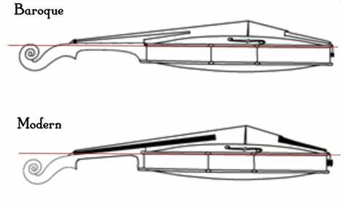

FIGURE 4

*The comparison of the Baroque and Modern Violin*

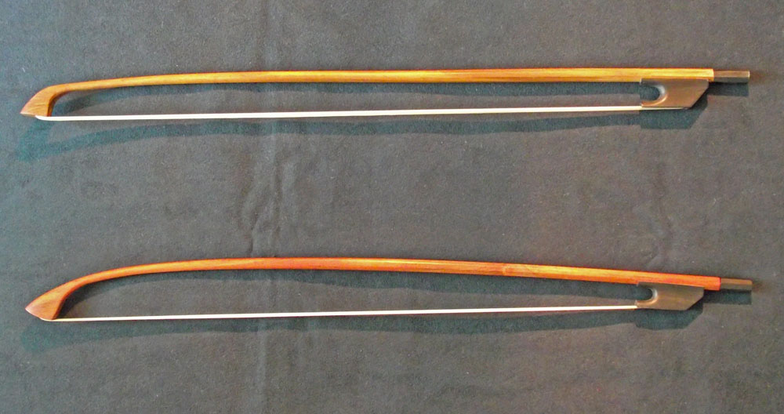

FIGURE 5 *The Baroque bow*

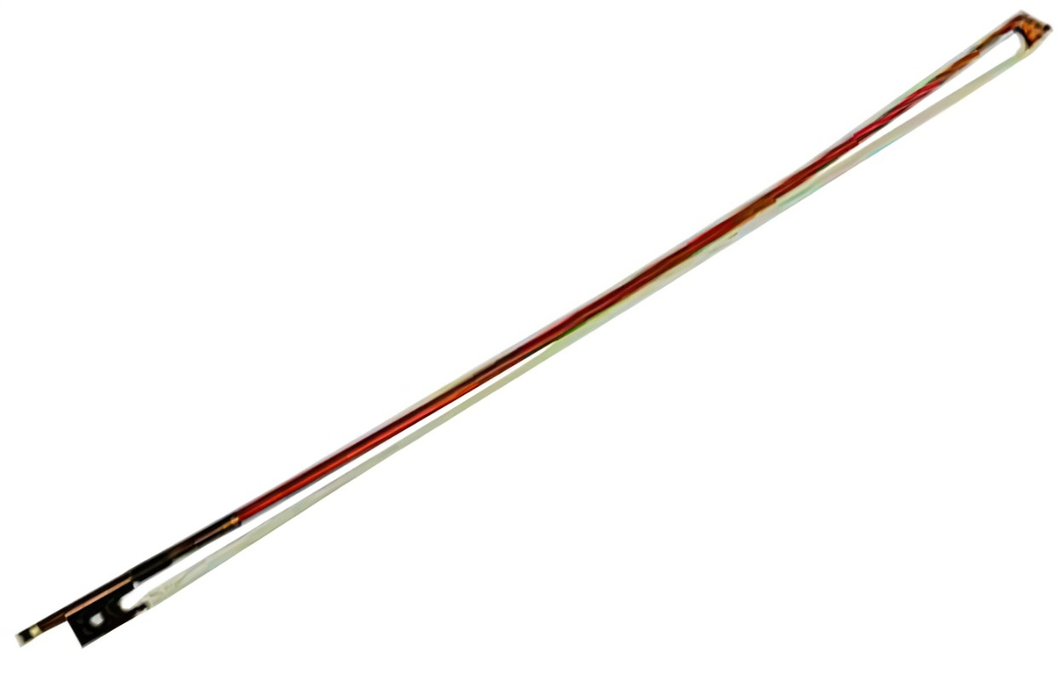 FIGURE 6 The Modern Bow

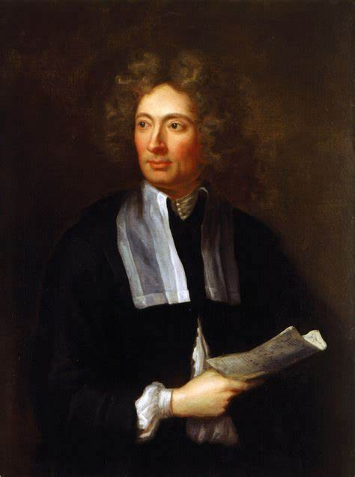

FIGURE 7 *Italian composer and violinist Arcangelo Corelli {1653– 1713}*

Corelli significantly influenced the development of string playing and was in fact the first

teacher to begin to break down the technique into concise areas on his contemporaries and

on the succeeding generation of composers. Born in Fusignano, Italy, in 1653, studied in

Bologna, and began an exciting career as a composer, performer, and teacher. Like that of

Vivaldi, his contribution to the development was exponential. History has remembered him

with such titles as:

* *"*Founder of Modern Violin Technique"
* "World's First Great Violinist"
* "Father of the Concerto Grosso.

The violin was becoming more popular during Corelli’s career and in his

time was equalled to that of Paganini in the 19th century. His works were intrinsic of the

baroque stylistic writing and was very virtuosic. He is well known for his early sonatas for

violin with cembalo and especially his ‘Christmas Concerto Grosso’. The famous "La Folia"

Variations for violin and accompaniment is a work that I enjoyed a student. One can clearly

observe the way in which he was becoming very structured in early techniques. The

prominence of the concerto grosso was expedited with Corelli and the stylistic evidence of

this type of work is seen in a work by Haydn. One of the earliest compositions of Haydn has

taken the format and inspiration from this master.

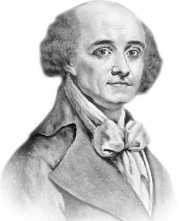

FIGURE 8 Giovanni Battista Viotti {1753-1824}

Viotti was born in [Piedmont](https://en.wikipedia.org/wiki/Piedmont) in Italy and as a child was taken into the care of Alfonso

dal Pozzo della Cisterna in [Turin](https://en.wikipedia.org/wiki/Turin), where he received a musical education that prepared him

to be a pupil of [Gaetano Pugnani](https://en.wikipedia.org/wiki/Gaetano_Pugnani). After his studies he began a career as a performer

teacher, and composer. Being born at the start of the classical period, the development of

the instruments were beginning a unique transformation, In conjunction with this, the

compositions were also being to become more elaborate. He only had a few pupils that he

allowed to study with him that of both [Pierre Rode](https://en.wikipedia.org/wiki/Pierre_Rode) and [Pierre Baillot](https://en.wikipedia.org/wiki/Pierre_Baillot) and an important

influence on [Kreutzer](https://en.wikipedia.org/wiki/Rodolphe_Kreutzer), all of whom became notable teachers themselves. Viotti is

considered the founding father of the 19th-century French violin school. It is intriguing how

interwoven the teacher pupil lineage has started to become.

His compositional works are rather demanding to play, compared with that of the

early composers. The concerti were used as the first concerti after the famous Violin

Concerto in A minor by Vivaldi, and I describe them as a link between the eras. As a student,

we were always taught several of the concerti for technique and stylistic interpretation. I

was taught the importance of his works as a music student. However, research with ISMLP

clearly evidenced just how successful and important a composer he was. He composed a

vast array of works

A list of some of his compositional works composed by Viotti

|  |
| --- |
| Violin sonatas |
| Over 30 violin concerti |
| Cello Concerti |
| Piano Concerti |
| Flute and harp concerti |
| Chamber music / string quartets |
| Cello concerto in C |
| Symphonic concertante for 2 violins and orchestra |
| Duo’s |
| Violin and cembalo |

TABLE 2

**CHAPTER 2** *AGE OF TRANSITION*

FIGURE 9 *Francois Tourte Invertor of the modern violin bow*

The exciting collaboration of the Frenchman Francois Tourte and the violinist,

teacher, and performer Giovanni Baptista Viotti. Let us recall the pictures in the previous

chapter of the ‘Baroque style’ bow, shorter in length than the modern bow and very curved.

This style bow was ideal for the compositional techniques of the day, however Tourte began

to research into the development of the bow. The Viol family had moved through a

transitional stage with the master luthiers such as Antonio Stradivari, the bow had not been

addressed. The tone produced would have been much thinner in texture and the use of

dynamics would have far less effective.

A revolutionary explosion of developmental ideas began to swipe its way across

the instrument world. Viotti and Tourte lived at the same time as Mozart then latterly

Beethoven and Schubert. If we examine the fortepiano, we had the advancements of

additional notes so that the note range was far greater. With the invention of the single

semi sustain pedal, things had become very exciting. This was producing a louder sound and

more sustain but the physics and mathematics of the bow had to have some serious

research to be undertaken.

As the instruments developed, so could the compositions, so Viotti worked with

Tourte to have a longer bow fit for longer melodic lines. Tourte standardised the bow length

to 74 to 75 centimetres. Additional changes were the use of more wood in the tip, a heavier

frog for balance and he introduced a spreader block. A screw was implemented at the end

to moderate the bow hair tension. A new type of wood was also innovated, it was Brazilian

Pernambuco wood. This wood, when exposed to heat, can be bent to optimal shape for

bowing a stringed instrument. The Tourte bow was bend in the opposite direction to its

predecessors, a concave dip that tightens and then extends when pressed downward.

Now this suddenly enabled string players to produce longer melodic lines, longer

shaped phrases, far greater dynamics, and tonal range and quality never yet heard in the

concert halls. Viotti had composed such impressive works, that if it was not for the

requirements necessary of a new style bow, our string playing history would have looked

very different.

Playing characteristics of the modern violin bow after Tourte

The massive successes which François Xavier Tourte enjoyed even during his lifetime

were not solely due to the mathematical sophistication of his bows; they were also

attributed to the ideal playing characteristics he made possible. The F.X. Tourte bow was

perfectly balanced and had a quick and agile response because of its strong inward arch.

This bow offered the largest spectrum of playing techniques ever encountered — from full

cantabile playing to newer spiccato techniques such as saltando, ricochet and sautillé.

François Xavier Tourte perfected every aspect of the model, including the contours of the

head and the mounting for the horsehair, which he widened and increased. Much like

Cremonese violin.

F. X. Tourte's style was only marginally modified by other craftsmen. The most significant

heirs of his legacy include the “German Tourte,” [Ludwig Christian August Bausch](https://www.corilon.com/us/library/masters-portraits/ludwig-bausch-the-german-tourte) (1805-

1871), [François Nicolas Voirin](https://www.corilon.com/us/library/masters-portraits/francois-nicolas-voirin-and-the-new-french-violin-bow) (1833-1885) and, last but not least,

the great [Eugène Sartory](https://www.corilon.com/us/library/master-portraits/eugene-nicolas-sartory-the-modern-classic-of-bow-making) (1871-1946).

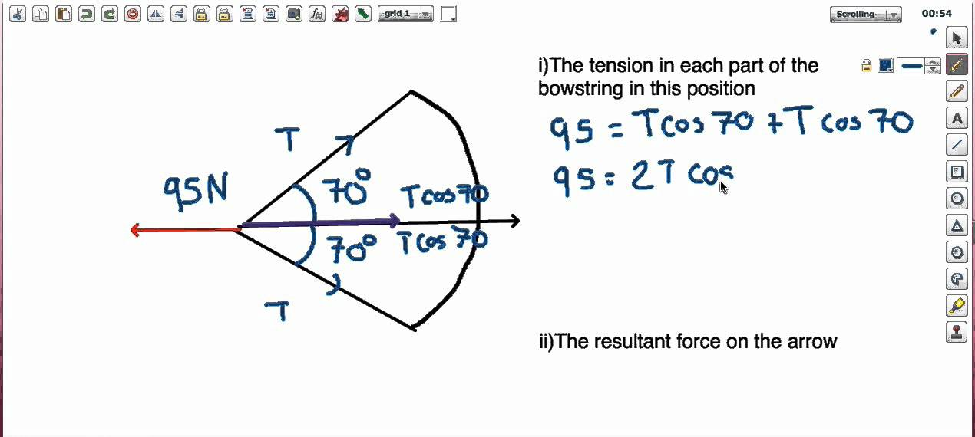

DIAGRAM 1 *The Physics of bowstring contact due to the new bow development of Francois Tourte*

CHAPTER 3 ‘The Great Masters’

|  |  |  |
| --- | --- | --- |
| CORELLI |  | VIVALDI |
|  | VIOTTI |  |

DIAGRAM 2 ^

^

^

^

The teacher pupil relationship was begun to rapidly emerge with the pupils transcending

from Viotti. From the diagram situated at the front of this dissertation, you the reader shall

see how the expansion is evolving. From Viotti, you have movement towards the various

schools of violin playing. If we look primarily at the line from Viotti to ‘Ballot’, this is of such

great importance.

Looking through that line, we come to the great master Carl Flesch. Developments in

pedagogy were evolving constantly, but it was Carl Flesch who has left a huge legacy.

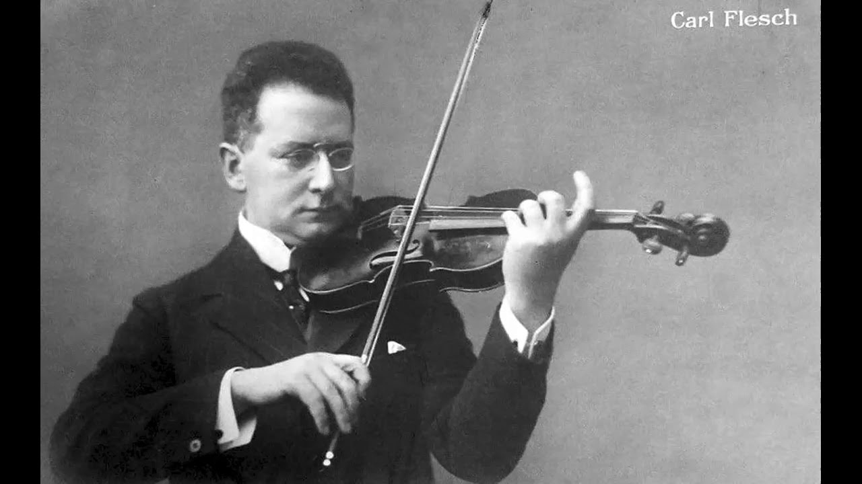

FIGURE 10 Carl Flesch: - *The pedagogic master.*

[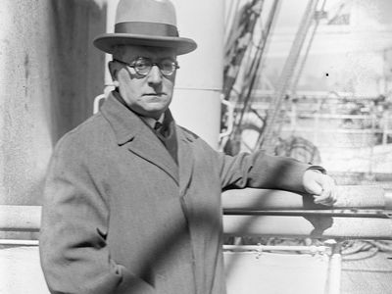](https://cdn.britannica.com/50/135850-050-28ACFA56/Karoly-Flesch.jpg)

FIGURE 11*Flesch, Károly {1873-1944}*

A BRIEF HISTORY

Carl Flesch was a violinist and teacher whose studies included Jakob Grun at the Vienna

Conservatoire, followed by Marsick and Sauzay in France at the Paris Conservatoire. Marsick

was a student from the Belgian school of violin pedagogy which involved from the German

school of thought. The German school began in the 1820 ‘s which was not that long after

the new bow. With the new bow came new techniques, especially with the likes of the

works of Paganini. Flesch had a well-balanced, refined style which was conjunction with

exceptional technique. He taught in Europe and in America, so his expertise was widely

delivered.

Professorships and solo and ensemble data

|  |  |  |  |
| --- | --- | --- | --- |
| DATE | TAUGHT | SOLO/ENSEMBLE | ADDITIONAL INFO |
| 1897- 1902 | Conservatoire in Bucharest | Leader of the Romanian queen’s string quartet |  |
| 1903- 1908 | Amsterdam Conservatoire | lived in Berlin. He performed as a soloist and chamber musician and achieved international recognition as a member of the Schnabel-Flesch-Becker trio | Held a famous series of concerts in Berlin |
| 1921-1922  1928-1934 | Professor at The Music Academy in Berlin |  |  |
| 1922=1928 | Curtis institute in America |  |  |
| 1934-1939 | Moved to London to teach |  | Due to the Nazi uproar in Germany |
| 1939-1943 | Lucerene Conservatoire in the Netherlands till he sadly died |  |  |

Table 3*Carl Flesch expertise travels worldwide*

**THE IMPORTANCE OF BOWING TECHNIQUE**

Carl Flesch published a book in 1931 which focused on the importance of the tone

production because at that point in time, he considered the level of left-hand technic had

reached a larger development due to the popular music for commercial purposes. The

contents of this publication are:

1. Generalities
2. Mechanical requirements of tone-production
3. Tone-production and equipment for playing
4. Tone-production and left-hand technique
5. Tone-production and bowing technic
6. Tone-production and bowing varieties
7. Tone-production and dynamics
8. Carl Flesch wrote Tone-production and bowing technic
9. Tone-production and bowing varieties
10. Tone-production and dynamics
11. Tone-production and fingering
12. Tone-production and choice of bowing varieties

As a first point, Flesh defines the relation between the **technic of the bow** and **tone-**

**production** as only partially dependent upon each other. As a motive for direct tonal faults

he mentions backward bowing; a too deliberate incline of the bow; hindrances during

change of the bow; incorrectly gauges pressure of the bow or bow-arm. So, bow-arm

pressure is a consequence of the point of contact and not as a pre-condition.

|  |  |
| --- | --- |
| Long stroke | **near the bridge** |
| *forte* |  |
| High position |  |
| Short stroke | **near the fingerboard** |
| *piano* |  |
| Low position |  |

TABLE 4

Furthermore, Flesch explains that the purity and regularity of string vibrations necessary for

the production of the perfect sound…depends primarily upon the bow setting the strings

into vibration at the right place, that is, at the correct point of contact…dependent upon

three factors: time duration of the stroke, prescribed tonal volume and height of

position. (p.7). In summary:

Another issue connected with tone production is “**holding and position**” of the instrument:

1. Height at which the violin is held (low position/high position)
2. Plane of the violin (holding at too flat a plane/acute angular position)
3. Direction in which the violin is held (position towards the left/position towards the right)

In the matter of the **tone-production and the left-hand technic**, Flesch mentions two issues:

pressure (too weak/too slow) and flat/pointed setting of the fingers. But the important issue

that the Author brings up is the interconnection between the intonation and sound effect

and the changes of the point of contact when changing the position (here the Author

proposes as an exercise – *every position study may serve simultaneously, as a tone –*

*respectively a point of contact study*, p.11.). Another example is when we begin the tonal

sequence *piano* and with *forte* the difference as to point of contact is even greater, but the

other way round is quite the same.

**Vibrato** is emphasized as a more determinative for the intimate spiritual make-up of the

tone than for sound production in the physical sense. Flesh mentions the use of vibrato

during *passages* (introduced by Kreisler) as one of the most important achievements of

modern violinistic art.

Another important issue is surely the **chord playing**, where in the simultaneous sounding of

the three strings, the point of contact will be near the fingerboard. When the strings have

been sounded, the bow must leave the lower string and set *the two upper ones into*

*vibration which results in a long drawn double-stop and in consequence demands nearness*

*to the bridge*.

**Tone-production and bowing technic** – the need of inclined position of the bow with strong,

and a non-inclined position with weaker tension. Regarding the little finger, the Author

stressed that the aid of the little finger at the lower half of the bow in order to counteract

the superfluous weight of the frog is necessary to enable a smooth and even change of the

bow.

Flesch defines the introduction of the finger stroke into violin pedagogics (in his Ur-

studien/Basic Studies in 1910) as a helpful exercise but not a crucial moment of the bow

tecnic: *the finger-stroke must only be used for practical playing in connection with the wrist*

*movement and even then, only in minimal doses, because- if the change of bow is seen, it will*

*also be heard!*

The **tonal shadings** (*f*, *p*, *decresc.*, *sfz.*) and the choice their point of contact is, for Flesch,

complicated because of the length of bow and height of position. In Appendix 1-20 he gives

the exercises in the 45 fundamental types from a combination of these three factors. He

considers *mf* as the best one for tonal strength studying.

The explanations about **tone production and bowing varieties** such as: Legato stroke,

Detaché, accented stroke, Martelé, Staccato and Flying Staccato, Portato. Fingering should

be adjusted first of all to musical and then to tonal needs.

In the end Flesch express his opinion *that a violinist should consider free functioning of both*

*arms, only as a means for the higher purpose of a perfect tone-production*. (p. 17)

In the **Appendix** (studies for tone-production) we may find 54 exercises regarding: whole

bow strokes, change of position, change of string, bowing varieties, exercise for spring-and

throwing bow, double stops, high position studies, chords.

THE 7 FUNDAMENTAL MOVEMENTS OF VIOLIN BOWING

I was taught the 7 fundamentals of violin playing by both Professor Simon Fischer and

Professor Yfrah Neaman OBE.

**Movement 1**

This comprises of middle to tip bowing

**Movement 2**

Heel to middle bowing

**Movement 3**

Change of bow at the heel

**Movement 4**

Change of bow at the tip

**Movement 5**

String crossing at the tip

**Movement 6**

Monkeys paw

**Movement 7**

Straight and curved finger exercise

The violin bible is Carl Flesch 2 volumes on the art of violin playing. Everything can be found

in these books from bowing technique, tone production, vibrato, shifting etc. These books

are widely published and can be bought all over the world. Websites such as amazon sell

these pure work of art. Also, the Carl Flesch scale system is a book that is so practical

amongst violinists, teachers, and the student.

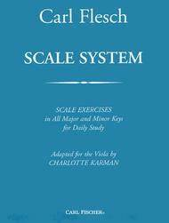

FIGURE 12 *Carl Flesch scale system*

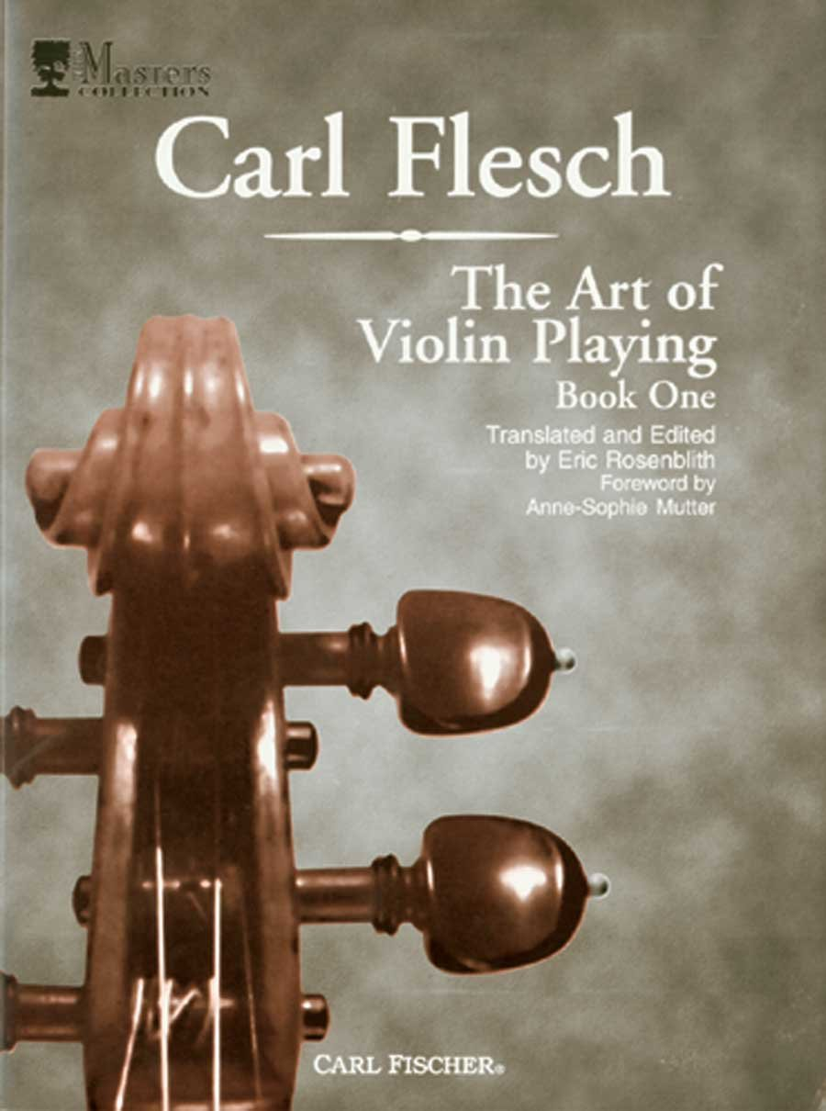

FIGURE 13 *The Art of Violin Playing*

**Chapter 4** *The Various Bow holds*

*A DETAILED TABLE TO EXPLAIN THE VARIOUS BOW HOLDS. AND HOW AND WHY THEY WERE USED.*

|  |  |  |
| --- | --- | --- |
| *Date* | *Description* | |
| *1750 – 1800*   * Francois Tourte began his developments of the bow * Leopold Mozart {1793} = The difference is that he instructs to put the bow straight on the string, instead of pivoting it, so you bow with all the hair and achieve a bigger tone.   violin bow hold campagnoli  The hand is placed a bit further on the stick, not at the frog (see picture). The first phalanx of the first, second and third fingers rest on the bow. The pinky was stretched and placed on the bow. The thumb was curved, and the fingers are placed close together. | | Leopold Mozart was very modern in his approaches to that of the early bow holds |
| *1802*  Ballot, Rode, and Kreutzer | In the book ‘Méthode de Violon’ (1802) the bow hold was described as follows: the stick is carried by all fingers. The thumb is placed against the frog opposite the middle (third) finger. The index finger rests with the second joint on the stick and joins the other fingers in a natural posture. | |
| old german violin bow hold  1800 The German Bow Hold | *The Great Virtuosos*  Violin technique developed at a fast pace, but not much violin methods were developed to teach it. Virtuoso players had their own ways that they developed intuitively. One explained the unique technique as a sign of genius. | |
| In [‘The Art of Violin Playing’](https://amzn.to/34fjNlU) Carl Flesch describes old and new bow holds. One of them is the old German bow hold, where the index finger touches the bow between the first and second phalanx, so the first joint. The thumb is placed opposite the middle finger, balancing the weight. The other fingers are held relatively close together. As you see in the picture, the fingers are placed not much over the bow. This is caused by the placement of the index finger. The fingers are more stretched than curved. The hold looks more edgy than round.  If you try this, you’ll notice it feels very unstable. |  | |

TABLE 5

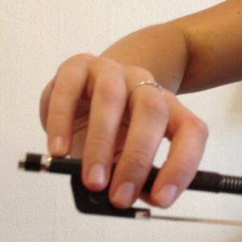

FIGURE 13 ‘*Franco Belgian violin bow hold* ‘

In this bow hold, the index finger is placed sideways on the stick right before the first joint.

The hand is placed a bit more in the direction of the tip. When you do this, you’ll feel more

control over the bow. You will be better able to transfer weight into the bow. By spreading

the fingers a bit more you can transfer even more weight. The fingers are placed more over

the bow, as the position of the index finger allows this. This hold looks rounder and gives

you more ‘grip’ in general.

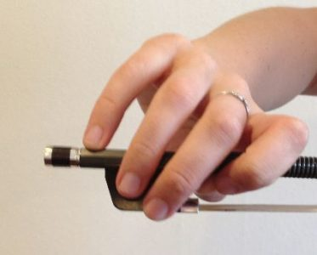

FIGURE 14 ‘*The new Russian bow hold’ made famous by Leopold Auer*

At first Flesch preferred this hold (before the modern hold developed). The index finger is

even further over the bow compared to the old German and Franco Belgian bow holds. The

stick touches the third phalanx of the index finger. The index finger embraces the bow with

the second and third phalanx. The index finger and middle finger are close together.

In this Russian bow hold the hand it tilted in the direction of the tip more. We call this

pronation. The bow strokes are led by the index finger. The little finger has less to do; it’s

placed on the bow when bowing with the lower half of the bow and can leave the bow

when bowing with the upper half. In playing the little finger often leaves the bow. This hold

is the basis of the modern bow hold and still used today by those taught in the Russian

school of violin playing.

**Modern violin bow hold**

This is the bow hold as taught and used today. However, of course the bow grip is

something highly personal and you’ll notice differences between players. No use in copying

me or anyone else exactly ;). Here’s mine JUST for reference:

[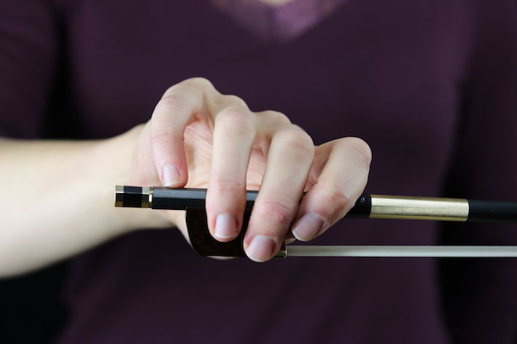](https://violinlounge.com/wp-content/uploads/2020/04/violin-bow-hold-1.jpg)

FIGURE 15*Development in violin bow grip*

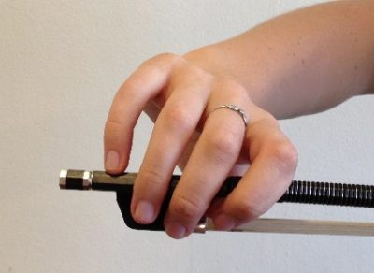

FIGURE 16*The revised bow hold*

As you observed the three last bow holds described above, you might notice that

the index finger is placed more and more over the bow and the hand is tilted more and

more in the direction of the tip (pronation). The advantage of this is that you can transfer

more weight into the bow creating a deeper sound and you experience more control over

the bow. This was required to create a powerful tone in the [concert](https://violinlounge.com/tag/concert/) halls that got larger and

larger. Just give those three bows holds a try and see what happens to your sound and bow

control!

I was taught the last bow hold and I find that it produces a rich lush tonal colour for works

such as ‘Tzigane’ by Maurice Ravel. I prefer the Leopold Auer bow hold for performing

works by JS Bach and Mozart as I feel that less weight is being applied to the bow stick and

therefore, the fast light passages are easier to play.

**CHAPTER 5**

THE OTHER GREAT PEDAGOGIC MASTERS

The masters which transcend through the pedagogic lineage, evolved into

various schools of pedagogy. The franco-Belgium professor Carl Flesch came from Jacob

Grun, but now I would like to discuss the Leopold Auer School.

Extraordinary examples of old records found from various ‘you tube.’

* <https://www.bing.com/videos/search?q=leopold+auer+violin+pedagogy&&view=detail&mid=11F67D98E2DE32D476A111F67D98E2DE32D476A1&&FORM=VRDGAR&ru=%2Fvideos%2Fsearch%3Fq%3Dleopold%2520auer%2520violin%2520pedagogy%26%26FORM%3DVDVVXX>
* <https://youtu.be/0HJ4VFpvr58> {Heifetz and Auer}
* <https://youtu.be/BR7f9ecD6yA?t=7> { The Auer pedagogy }

FIFURE 17 LEOPOLD *AUER {1845-1930}*

Amazing old recording of the master

Brahms Hungarian Dance in G minor.

<https://youtu.be/QygG9ZFnmfk>

Due to the political revolution in Russia, the Petrograd Conservatoire had to close.

With it went all the eminent professors, one of which was the celebrated virtuoso Leopold

Auer. Professor [Leopold Auer](http://www.theviolinsite.com/violinists/leopold_auer.html) decided to flee Russian and head for the United States of

America where music was an always been significant to its culture. Producing

several world class solo performers and teachers, his name had long preceded him. His

pupils were included the violinists such as Efrem Zimbalist, Mischa Elman, Kathleen Parlow,

Eddy Brown, Francis MacMillan, and more recently [Yascha Heifetz](http://www.theviolinsite.com/violinists/heifetz.html), Toscha Seidel, and Max

Rosen.

Many music critics and other musicians marvelled at this genius from Russia and

wanted to know about his magical secret Such questions I would be asking in the presence

of the ‘Deity’ are as follows:

"How do you form such wonderful artists?

What is the secret of your method?"

When listening to this extraordinary early recording of Leopold Auer, I can distinguish the

similarity in Jascha Heifetz. Both have that magical singing tone, the rich power sound

produced in lower registers and the lightness in the presto passages. Professor Auer is

apparently to have stated that it no magic, but I personally believe its 10% talent and 90%

hard work. In fact, It is an accumulation of excellent teaching which is inspiring and

encouraging, combined with that of a talent hard working student.

My professor at Guildhall School of Music in London, Professor Yfrah Neaman OBE, was

himself a pupil of Carl Felsch and Max Rostal. Violin playing is divided into several clear

sections which produce the polished performer and teacher.

Primarily, as a teacher one of the most vital components is intonation: how well

you play in tune. A stringed instrument: especially the violin requires a gruelling and

arduous process to acquire perfect intonation. In the book written by Margaret Campbell

‘The Great Violinists’, she writes an article on the Jascha Heifetz debut at Carnegie Hall age

the tender age of just 16. Margaret Campbell states that a priest was in the audience, and

after the recital he went to congratulate the young master.

‘*’ You play the violin so exquisitely, but at night after you pray, please play 1 wrong note as a penitence to God.’’*

In other words. ‘Your playing is perfect!’

When you play a note on the violin, the sound is produced by drawing the bow at a

90-degree angle to the bridge. The sound vibrates from the bass bar situated inside the

instrument, travels to the sound post and comes direct through the sound hole. If the bow

angle is correct and the intonation is perfect, then the vibrations will create the correct

tonal production. The bow hold, ‘Leopold Auer’ bow {see previous chapter}, allows bow

pressure to be controlled by the index finger. Violinist can alter the pressure according the

the pieces they are playing. A lighter pressure for Bach and Mozart, and more pressure for

Tchaikovsky.

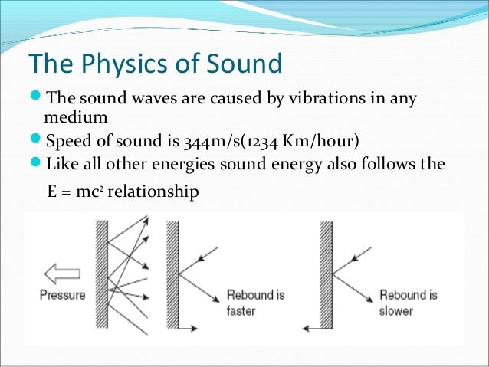

DIAGRAM 2 How the physics of the sound is produced and this is why it is so crucial to implement the correct bow and use of the bow speed and bow preesure for purity of sound and tonal production.

SCALES AND STUDIES

The importance of scales is that you train your neuropathways in the brain with correct

muscle memory. Pieces comprise of melodies, scales passages and linking episodes. At

conservatoire, I would begin my practice at 7 am with 1 hour of Oktar Sevick finger exercises

for dexterity. The aim of this was to train the finger motion to move from the knuckle joint,

like a piston. When you practice, it is ideal to always use a metronome as the brain trains

more thoroughly in patterns and rhythms. This would be followed by scales, which would be

the Carl Flesch Scale System. A scale book compromised of each key, taken daily, and

practised. The scales would be on 1 string, 3 and 4 octave scales, arpeggios, scaled in 3rds,

6th octaves and tenths. We would then study 3 works over a period of 6 weeks.

* A violin concerto
* Bach partita or sonata
* A virtuosic work

Having a sound technique is crucial, once that has been established, then the real work can

start. It is like layers of a cake; I was once taught by Professor Simon Fischer from the

American School of pedagogy.

THE KEY ELEMENT OF THE VIOLIN

* Posture
* Good bow hold
* Sound straight bowing technique for correct string vibration
* Shifting techniques of the left hand. Beginning slide and end slide and knowing where and when to implement them.
* Perfect intonation
* Sound structure of the work
* Dynamics
* Interpretation
* Memory
* Rehearsal
* Concert.

Auer explained this case study.

*"As regards the theory that you can tell who a violinist's teacher is by the way in which he*

*plays, I do not believe in it. I do not believe that you can tell an Auer pupil by the manner in*

*which he plays. And I am proud of it since it shows that my pupils have profited by*

*my encouragement of individual development, and that they become genuine artists, each*

*with a personality of his own, instead of violinist automats, all bearing a marked family*

*resemblance."*

*{From Leoplold AUER book on the art of violin pedagogy}*

Auer also mentions in his memories about the importance of hour of correct practice.

Incorrect practice is not good as it is training the muscle memory opposite than what is

required and therefor if bad habits are created, then it can take twice as long to correct

them.

VIOLIN MASTERY

 "Violin mastery? To me it represents the sum of accomplishment on the part of those

who live in the history of the Art. All those who may have died long since, yet the memory

of whose work and whose creations still lives, are the true masters of the violin, and its

mastery is the record of their accomplishment.

Chapter 6

THE AMERICAN SCHOOL OF VIOLIN PLAYING

This chapter is of Significance to me as a violinist and tutor, due to the fact that my previous

Professor Simon Fischer was linked to this pedagogic lineage.

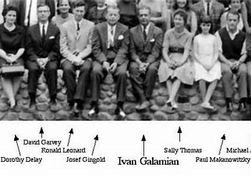

FIGURE 17 *The pedagogic master and his pupils.*

Ivan Alexander Galamian {1903-1981}

Born in [Tabriz](https://en.wikipedia.org/wiki/Tabriz), [Iran](https://en.wikipedia.org/wiki/Iran) to an [Armenian](https://en.wikipedia.org/wiki/Armenians) family but the family soon left for Moscow, Russia. He

studied violin at the [School of the Philharmonic Society](https://en.wikipedia.org/wiki/Russian_Academy_of_Theatre_Arts) with [Konstantin Mostras](https://en.wikipedia.org/wiki/Konstantin_Mostras) (a student

of [Leopold Auer](https://en.wikipedia.org/wiki/Leopold_Auer)) and graduated in 1919.Galamian furthered his studies in Paris

under [Lucien Capet](https://en.wikipedia.org/wiki/Lucien_Capet) . Sadly, this young violinist had severe combination of nerves while

performing on stage but decided to transfer into the role of a teacher full time.

Subsequently, he took up the most of Professor at ‘The Rachmaninoff Conservatoire’

between 1925-1929. Just before the start of World War 2, he moved permanently to the

the United States and had the fortune to meet his wife. He taught violin at the [Curtis Institute of Music](https://en.wikipedia.org/wiki/Curtis_Institute_of_Music) beginning in 1944, and became the head of the violin department at

the [Juilliard School](https://en.wikipedia.org/wiki/Juilliard_School) in 1946.

He wrote two violin [method](https://en.wikipedia.org/wiki/Method_(music)) books:

* *Principles of Violin Playing and Teaching* (1962)
* *Contemporary Violin Technique* (1962).

Galamian analysed the various schools of thought, and combined aspects of both the

Russian and French schools of violin technique in his approach.[[6]](https://en.wikipedia.org/wiki/Ivan_Galamian#cite_note-ig-nyt-obituary-6) In 1944 he

founded the [Meadowmount School of Music](https://en.wikipedia.org/wiki/Meadowmount_School_of_Music" \o "Meadowmount School of Music), a summer program in Westport, New

York. The school has remained operational and has trained thousands of world-class

musicians.[[4]](https://en.wikipedia.org/wiki/Ivan_Galamian#cite_note-ig-nyt-teacher-4)[[7]](https://en.wikipedia.org/wiki/Ivan_Galamian#cite_note-ig-meadomount-7) Galamian taught concurrently at Curtis, Juilliard, and Meadowmount

schools. Like many of the great teaching masters, he continued his fulltime teaching

schedule until his death at the age of 78 in 1981. Galamian had several teaching

assistants, but the greatest is Miss Dorothy Delay.

My pedagogic line transcends from Galamian, to Dorothy Delay, Professor Simon

Fischer and then finally myself, Zelda Hill.

**Notable pupils include:**

* Kyung Wha Chung
* Dorothy Delay
* Eugene Fodor
* Carmel Kaine
* Dong-Suk Kang
* Pinshas Zukerman
* Itzhak Perlman

Since his death Ivan Galamian has passed into legend as perhaps the greatest

teacher the string world will ever know. Barbara L. Sand asked some of his ex-pupils

whether them former master really lived up to his reputation.

FIGURE 18 *IVAN GALAMIAN ‘The young master’*

Galamian became the most powerful and sought-after violin teacher in the country. Many

of his students have certainly. His pupil Buswell describe Galamian as a man with an

analytical mind who tried to in still in students his profound philosophy of order. 'Galamian

had a revolutionary technique for the bow arm, which was based on his knowledge of the

laws of physics and anatomy,' Galamian had an amazing ability to make the violin soar over

the critical ability to project the violin sound. He was able to inculcate into his students just

how to make the violin soar over an orchestra. As a pedagogy, he was renown to have

exceptional patience and a man of quiet determination and processed a constant work

ethic.

Galamian ‘could make a violinist out of a table,' says Peter Oundjian, ex-first violinist of the

Tokyo Quartet and now a conductor. He had the opportunity to study with both Galamian

and Dorothy DeLay. You can see this ethos has been projected into his students.

Observing pictures of his students your can see the importance of the position of the violin,

and the bowing arm.

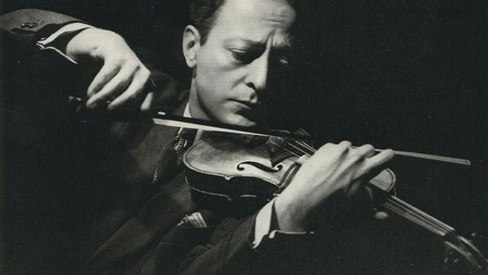

FIGURE 19 *Jascha Heifetz*

The violin needs to be placed at the correct mathematical angel so that the bow weight can

distribute onto the string. The weight is directed from the shoulder, but the shoulder must

never raise. It is the index of the finger that controls the bow pressure accumulating in a

most sonorous rich tonal quality. Scales and studies I personally believe are the key to

success, hours of proper practice and dedication.

H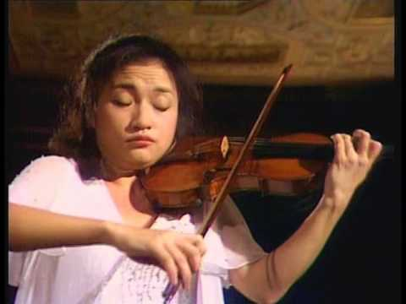

FIGURE 21 *Kung Wa Chung The Korean violinist: pupil of Galamian*

Chapter 7

Current day violin pedagogic masters

Through the historical lineage, we arrive at the masters of the current era. Professor Simon

Fischer is a violinist of exceptional technical prowess, renowned for his books on the

pedagogical approach to the violin. Like that of Carl Flesch. Léopold Auer, and Ivan

Galamian, his books are of an exceptional advancement to education. Simon Fischer’s

{Basics: 300 exercises and practice routines for the violin} was being written

during my student years at Wells Cathedral School. I had the privilege of working on these

new studies and scales in the 1980’s.

|  |  |
| --- | --- |
|  |  |
|  |  |

Basics is a collection of practice methods and exercises, and belongs on the music stand, not on

the bookshelf. It can be used by players of all standards, from concert violinists to students.

Much of the material is also suitable for teaching elementary players. Each exercise is designed

to achieve the maximum possible result in the least possible time. Some are very short and need

to be done only once or twice to explore a particular aspect of technique. Others are practice

routines or warm-up exercises that can returned to regularly. Basics is not a book to play

through from cover to cover. Everybody's needs are different, and there is little point in practising

anything that does not need to be practised. The book is invaluable, however, in its presentation

of the most effective technical work in a single volume, making it possible to work directly on any

aspect of technique that needs attention.

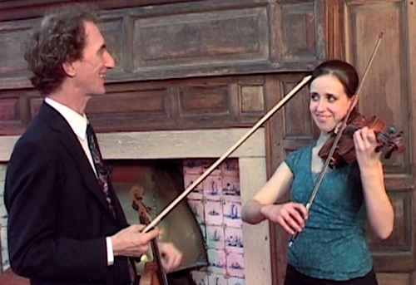

FIGURE 22 *Professor Simon Fischer*

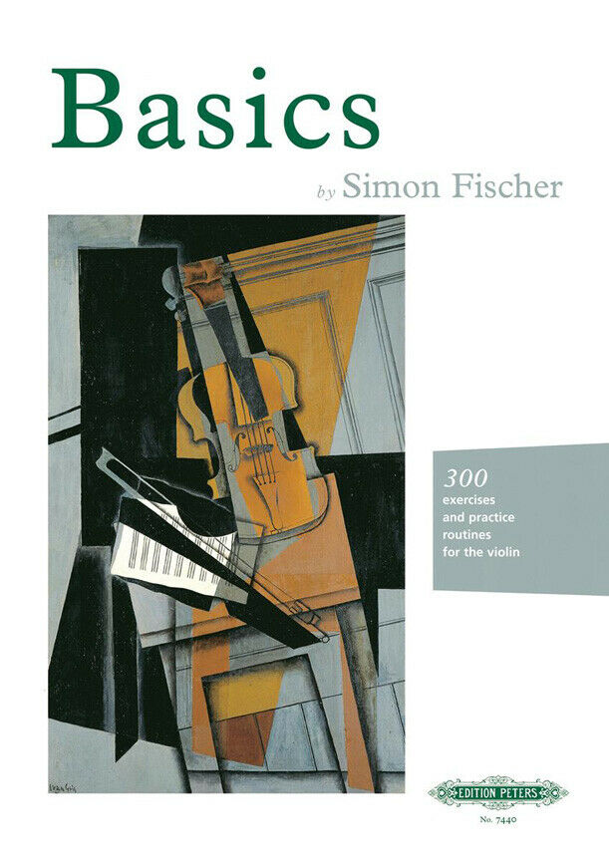

FIGURE 23

*Only the most ambitious violinist could attempt all three of Brahms's Sonatas in the one recital, and only an unusually gifted one could play them as well as did Simon Fischer"*- **The Times**

Simon Fischer was my teacher for several years while a student at ‘Wells Cathedral School’

and ‘The Guildhall School’ LONDON.

Like that of the other pedagogic masters, Simon has created various books, thesis,

dissertations and important and is recognised as one of the pre-eminent musicians of our

time, enjoying a distinguished and wide-ranging career as a performer, educator and

Simon Fischer would be often joined by his father, the eminent pianist Raymond Fischer

who together performed many sonatas including the 3 Brahms Sonatas. He has frequently

played as soloist or leader/soloist with major orchestras including the Philharmonic, Royal

Philharmonic, BBC Philharmonic, Scottish Chamber, and the Ulster Orchestra, working with

celebrated conductors such as Vladimir Ashkenazy, Sir Charles Groves, Richard Hickox,

Andrew Litton, Sir Yehudi Menuhin, Yan-Pascal Tortelier and André Previn.

As a chamber musician he was leader of the Chamber Group of Scotland, with

whom he gave many broadcasts and concerts of contemporary music and worked closely

with composers such as Sally Beamish and James MacMillan. He has directed the European

Union Chamber Orchestra on tours including to Korea, China, and Ireland.

Simon Fischer is recognised as having a place amongst the world's elite teachers. Having

studied in London with Yfrah Neaman, and in New York with Dorothy DeLay, Fischer's

approach unites the best elements of the French, Russian and American violin traditions.

He is a professor at the Guildhall School of Music & Drama. He has also held positions at

three specialist music schools, the Yehudi Menuhin, Wells Cathedral and Purcell, For 15

years he was also a visiting professor at the Royal Scottish Academy of Music.

Fischer's published work greatly influences the teaching of the violin. Having written for *The*

*Strad* magazine from 1991-2014, his monthly articles attracted a worldwide following.

Published by Edition Peters, his technique books *Basics* and *Practice,* *Scales* and *The Violin*

*Lesson*(translated variously into Korean, Italian, Japanese and German), have become

standards on many continents - as has his DVD *The Secrets of Tone Production*, His book and

DVD *Warming Up*, was described by The Strad magazine as "23 pages of pure technical

gold".

In 2014 Simon Fischer was awarded the European String Teachers Association prize "In

celebration of a lifetime contribution to String Teaching".

In conjunction with his playing engagements, he frequently gives masterclasses and

workshops. Recent residencies have taken place in the USA, Holland, Italy, Norway, Ireland,

Hong Kong, Germany, and Australia. Simon Fischer plays a violin by Peter Guarnerius

Venice from c. 1732.

Recordings of Simon Fischer

* **https://youtu.be/39JardUtX2g**
* **https://youtu.be/VbzeCMUVi4o**

THE RUSSIAN MASTER: Maxim Alexandrovich Vengerov {1974-

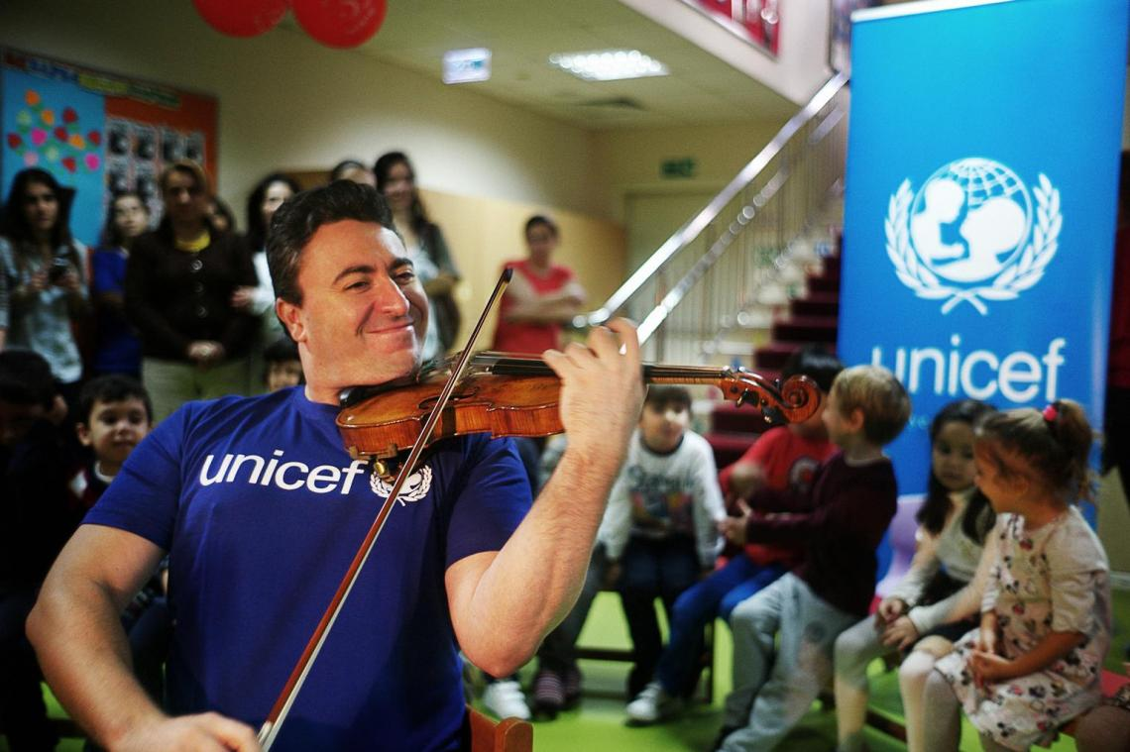

Russian-born [Israeli](https://en.wikipedia.org/wiki/Israelis) [violinist](https://en.wikipedia.org/wiki/List_of_contemporary_classical_violinists), [violist](https://en.wikipedia.org/wiki/Violist), and conductor. [Classic FM](https://en.wikipedia.org/wiki/Classic_FM_(UK)) has called him “one of the greatest violinists in the world.”[]](https://en.wikipedia.org/wiki/Maxim_Vengerov#cite_note-CFM-3)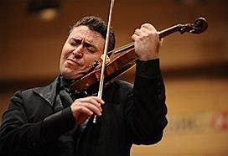

Recording of the great Maximhttps://youtu.be/839rK8fFwMo

FIGURE 23 AND 24

Maxim Vengerov is a master of violin performing, teaching, and conducting who

transcends through the Russian Leopold Auer School of thought. He has performed

and taught throughout the world and is often referred to as a modern day Jascha

Heifetz. With his rich tonal quality, exceptional technique, purity of sound, and hailed

as a pure genius his teaching is now apart of the spiral of pedagogic masters.

Maxum Vengerov, is a voluntary worker for UNICEF and like many other musicians

has donated vast sums of money for people in aid and this is something my music

academy permeates with its ethos.

Summary

The educational viewpoint of music has been of paramount significance to the great

philosophers and scholars of the pre-modern era, they continued studying music from a

harmonic point of view and often delved deeper into the concept “musica universalis”–this

time was mediating it with Christianity, starting from the eighteenth-century discussions

surrounding the art of music became more articulate and varied.

**Pythagoras (c.570 BC-c.495 BC)**

***“There is geometry in the humming of the strings, there is music in the spacing of the spheres.” (Pythagoras)***

**Plato (c.428 BC-c.348 BC)**

Plato maintained that the arts could shape one’s character to a great extent, and, for that

reason, they needed to be strictly controlled. Poetry, drama, music, painting, dance can all

stir up emotions. Along with poetry and drama, music was regarded as important for young

people’s education in his ideal republic— only the “good” music, that is. He was largely influenced by the theories of Pythagoras and his numeric mysticism,

inspired by a series of overtones connected to the vibration of a string. “Ordered” music (i.e., the one following harmonies) meant ordered souls.

***“Music is a moral law. It gives soul to the universe, wings to the mind, flight to the imagination, and charm and gaiety to life and to everything.” (Plato)***

As educators, whether it is sciences, art, and literature, we never stop learning. Violin

pedagogy will continue to develop with the introduction of new and inspiring teachers,

performers. Composers and conductors. The ethos of Atlantic International University is so

poignant and bodes well with my soul. If we have a talent, a gift that we have been blessed

with, we should use it to the good of humanity. To make this world a better place, humanity

must work together, and then we might just have a chance to have a planet that will not die

from too much pollution. What a wonderful world it would be if we could all live in peace

and harmony, like that of a piece of music, producing perfect harmonies together as a

global organisation.

***‘Let music be the food of love, play on.’***

References

Acri, E. and Patterson, R., n.d. *The everlasting Folia*.

Amazon.com. 2022. [online] Available at: <https://www.amazon.com/Great-Violinists-Musicians/dp/0571277446> [Accessed 10 September 2022].

Bach-cantatas.com. 2022. *Kyung-Wha Chung (Violin) - Short Biography*. [online] Available at: <https://www.bach-cantatas.com/Bio/Chung-Kyung-Wha.htm> [Accessed 10 September 2022].

Corilon violins. 2022. *François Xavier Tourte and the modern violin bow*. [online] Available at: <https://www.corilon.com/us/library/instruments/francois-xavier-tourte-and-the-modern-violin-bow> [Accessed 10 September 2022].

Discogs. 2022. *Yfrah Neaman*. [online] Available at: <https://www.discogs.com/artist/917044-Yfrah-Neaman> [Accessed 10 September 2022].

En.tchaikovsky-research.net. 2022. *Ballets - Tchaikovsky Research*. [online] Available at: <https://en.tchaikovsky-research.net/pages/Ballets> [Accessed 8 September 2022].

En.wikipedia.org. 2022. *Antonio Vivaldi - Wikipedia*. [online] Available at: <https://en.wikipedia.org/wiki/Antonio_Vivaldi> [Accessed 10 September 2022].

En.wikipedia.org. 2022. *Royal Academy of Music - Wikipedia*. [online] Available at: <https://en.wikipedia.org/wiki/Royal_Academy_of_Music> [Accessed 10 September 2022].

En.wikipedia.org. 2022. *Simon Fischer (musician) - Wikipedia*. [online] Available at: <https://en.wikipedia.org/wiki/Simon_Fischer_(musician)> [Accessed 10 September 2022].

Encyclopedia Britannica. 2022. *Ivan Galamian | Iranian musician*. [online] Available at: <https://www.britannica.com/biography/Ivan-Galamian> [Accessed 10 September 2022].

Encyclopedia Britannica. 2022. *Plato | Life, Philosophy, & Works*. [online] Available at: <https://www.britannica.com/biography/Plato> [Accessed 10 September 2022].

FETIS, F., Bishop, J., Stradivari, A. and TOURTE, F., 1964. *Notice of Anthony Stradivari, the celebrated violin-maker, known by the name of Stradivarius: preceded by historical and critical researches on the origin and transformations of bow instruments ; and followed by a theoretical analysis of the bow, and remarks on Francis Tourte ... by F.J. Fétis ... Translated ... by John Bishop, etc. [A facsimile of the edition of 1864.]*. London: William Reeves.

Fischer, S., 2007. *Basics*. London: Edition Peters.

Flesch and Flesch, C., 2022. *The Memoirs Of Carl Flesch*. [online] Goodreads.com. Available at: <https://www.goodreads.com/book/show/3980344-the-memoirs-of-carl-flesch> [Accessed 10 September 2022].

Flesch, C., Rosenblith, E. and Mutter, A., 2000. *The art of violin playing*. New York: C. Fischer.

Guildhall School of Music & Drama. 2022. *Welcome to Guildhall*. [online] Available at: <https://www.gsmd.ac.uk/> [Accessed 10 September 2022].

Haylock, J., 2022. *Who was Jascha Heifetz? Everything you need to know about the iconic violinist | Classical Music*. [online] Classical-music.com. Available at: <https://www.classical-music.com/features/artists/jascha-heifetz-2/> [Accessed 10 September 2022].

Interlude. 2022. *Who was the founder of the Russian violin school?*. [online] Available at: <https://interlude.hk/leopold-auer/> [Accessed 10 September 2022].

It, V., Auer, L., It, V., Auer, L., 1, G., Auer, L., Method, M., Bang, M., Auer, L., Interpretation, V., Auer, L., Martens, F., Maia Bang Violin Method, P., Bang, M., Auer, L., 2, O., Auer, L., It, V., Auer, L., Maia Bang Violin Method, P., Bang, M., Auer, L., Music, M. and Auer, L., 2022. *Books by Leopold Auer (Author of Violin Playing As I Teach It)*. [online] Goodreads.com. Available at: <https://www.goodreads.com/author/list/57166.Leopold_Auer> [Accessed 10 September 2022].

Kallen, S., n.d. *The history of classical music*.

Lemonds, P. and Flesch, C., n.d. *The Carl Flesch Violin scale system*.

MusicVibe. 2022. *Famous Violinists Throughout History and Why You Should Know Them - MusicVibe*. [online] Available at: <https://musicvibe.com/famous-violinists-throughout-history/> [Accessed 10 September 2022].

n.d. *Strad*.

Nevala, A., n.d. *The influence of jazz and impressionistic ideals found in the music of Claude Debussy, Darius Milhaud, Maurice Ravel, Bix Beiderbecke, Art Tatum, and Bill Evans*.

Quotesgram.com. 2022. *Aristotle Quotes Music. QuotesGram*. [online] Available at: <https://quotesgram.com/aristotle-quotes-music/> [Accessed 10 September 2022].

Sand, B., 2005. *Teaching Genius*. Milwaukee: Hal Leonard Corporation.

Schwarz, B., 1983. *Great masters of the violin*. New York: Simon and Schuster.

SIMON FISCHER ONLINE. 2022. *SIMON FISCHER ONLINE*. [online] Available at: <https://www.simonfischeronline.com/> [Accessed 10 September 2022].

The Strad. 2022. *The Strad, essential reading for the string music world since 1890*. [online] Available at: <https://www.thestrad.com/> [Accessed 10 September 2022].

Vengerov, M., 2022. *Maxim Vengerov | Home*. [online] Maximvengerov.com. Available at: <https://maximvengerov.com/> [Accessed 10 September 2022].

Violinist.com. 2022. *Who are the top 10 Violin teachers in the world?*. [online] Available at: <https://www.violinist.com/discussion/thread.cfm?page=1527> [Accessed 10 September 2022].

Violinonline.com. 2022. *History of Violin Pedagogy - Violin Online*. [online] Available at: <https://www.violinonline.com/violin-pedagogy.html> [Accessed 10 September 2022].

Wells Cathedral School. 2022. *Specialist Music School | Wells Cathedral School*. [online] Available at: <https://wells.cathedral.school/music/> [Accessed 10 September 2022].

Yamaha.com. 2022. *The Structure of the Violin:How sound is produced - Musical Instrument Guide - Yamaha Corporation*. [online] Available at: <https://www.yamaha.com/en/musical_instrument_guide/violin/mechanism/mechanism004.html> [Accessed 10 September 2022].