**What is the Sabbath and is It Still Important Today?**

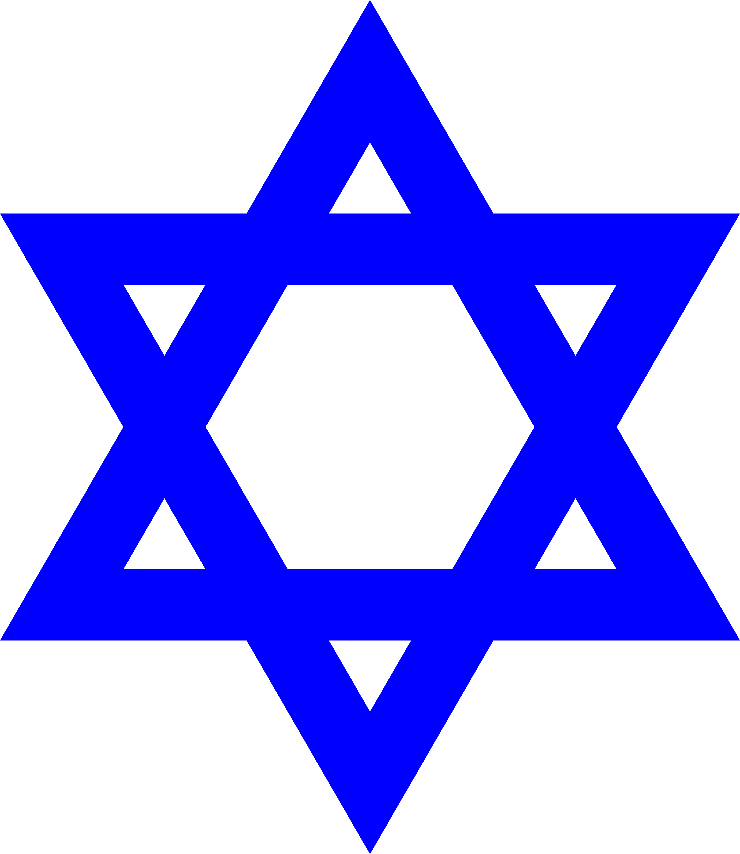

INTRODUCTION

The bible contains 66 books and transcends from Genesis through to Revelation. It

is divided into 2 distinct sections, ‘The Hebrew scriptures’ and ‘The Christian Greek

scriptures.’ The Hebrew scriptures are also known as the Jewish ‘Tanakh’ and

comprises of 39 books. ‘Tanakh’ means the promise of Jehovah God through the

lineage line of Abraham through to the coming of Jesus Christ in the New

Testament. The Old Testament contains the creation of the universe, the history of

the patriarchs, the exodus from Egypt, the formation of Israel as a nation, the

subsequent decline and fall of the nation, the Prophets (who spoke for God), and the

Wisdom Books.

The books of the bible commence with the Pentateuch, the first 5 books of the bible written by Moses.

* Genesis
* Exodus
* Leviticus
* Deuteronomy
* Numbers
* Joshua
* Judges
* Ruth
* 1 Samuel
* 2 Samuel
* Kings 1
* Kings 2
* Chronicles 1
* Chronicles 2
* Ezra
* Nehemiah
* Ester
* Job
* Psalms
* Proverbs
* Solomon
* Jeremiah
* Lamentations
* Ezekiel
* Daniel
* Hosea
* Joel
* Amos
* Obadiah
* Jonah
* Nahum
* Habakkuk
* Zephaniah
* Zechariah
* Malachi
* Micah

‘The New Testament’ or ‘Christian Greek scriptures are a collection of 27 books. The

name refers to the new covenant (or promise) between God and humanity through

the death and resurrection of Jesus Christ. The New Testament portrays the life and

ministry of Jesus, the growth and impact of the early church, and instructive letters to

early churches.

* Matthew
* Mark
* Luke
* John
* Acts
* Romans
* 1 Corinthians
* 2 Corinthians
* Galatians
* Ephesians
* Philippians
* Colossians
* 1 Thessalonians
* 2 Thessalonians
* 1 Timothy
* 2 Timothy
* Titus
* Philemon
* Hebrew
* James
* 1 Peter
* 2 Peter
* 1 John
* 2 John
* 3 John
* Jude
* Revelation

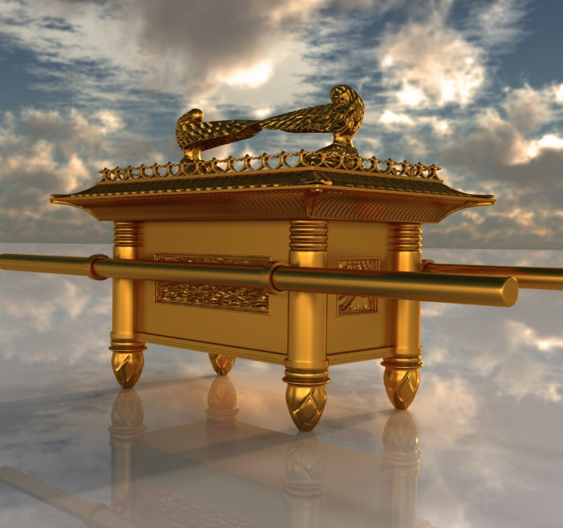

THE ARK OF THE COVENIENT

Proud

*“By the seventh day God had finished the work he had been doing; so on the seventh day he rested from all his work. Then God blessed the seventh day and made it holy, because on it he rested from all the work of creating that he had done.”*([Genesis 2:2-3](https://www.biblestudytools.com/genesis/passage/?q=genesis+2:2-3))

This scripture was written by the prophet Moses, who wrote that Jehovah God rested

on the 7th day. Moses wrote the creation story so that man could comprehend that

the work of Jesus and God has completed the creation od the universe and

everything upon this planet. He then handed the planet over to Adam and finally Eve

to care and look after the planet,

Gods people were the Jewish nation, but they were slaved in Egypt for over 400

years. The bible has a mathematical theme with each number having a special

significance and I realised this after research.

**One**

The number one denotes absolute singleness.

**Two**

The number two symbolizes witness and support.

**Three**

The number three signifies completion or perfection, and unity. Three Persons are in the [Trinity](https://www.learnreligions.com/what-is-the-trinity-700729).

**Four**

The number four relates to the earth.

**Five**

Five is a number associated with [grace](https://www.learnreligions.com/meaning-of-gods-grace-for-christians-700723).

**Six**

Six is the number of man.

**Seven**

Seven refers to the number of God, divine perfection, or completeness.

**Eight**

The number eight may signify [new beginnings](https://www.learnreligions.com/what-does-the-bible-say-about-new-birth-700358), although many scholars don't attribute any symbolic meaning to this number.

**Nine**

The number nine may mean fullness of blessing, although many scholars don't assign any special meaning to this number.

**Ten**

The number ten relates to human governments and law.

**Twelve**

The number twelve relates to divine government, God's authority, perfection, and completeness.

**Thirty**

Thirty is a time frame and number associated with mourning and sorrow.

**Forty**

Forty is a number associated with testing and trials.

**Fifty**

The number fifty holds significance in feasts, celebrations, and ceremonies.

**Seventy**

The number seventy is tied to [judgment](https://www.learnreligions.com/judgment-seat-of-christ-700687) and human delegations.

**666**

666 is the number of the beast.

As we can see, the number 7 refers to divine perfection, thus referring to Jehovah

God

*“Remember the*[*Sabbath*](https://www.crosswalk.com/faith/spiritual-life/what-is-the-sabbath-and-is-it-still-important-today.html)*day by keeping it holy. Six days you shall labor and do all your work, but the seventh day is a sabbath to the Lord your God. On it you shall not do any work, neither you, nor your son or daughter… For in six days the Lord made the heavens and the earth, the sea, and all that is in them, but he rested on the seventh day. Therefore, the Lord blessed the Sabbath day and made it holy.”*

THE SABBATH

“Sabbath” originates from the Hebrew root that means to “cease” or “stop.” During

the slavery of the Hebrews, that if they rested for 1 day, that they would produce

better work for the Egyptians It was declared, that for 1 day each week the slaves

would rest and regain their strength. Jehovah God gave the Jewish nation 1 day to

worship and praise and to keep it holy.

The ideology of rest for all of us is good but from a biblical viewpoint, the sabbath

should still be kept. The Jewish Sabbath starts at sundown on a Friday to Sundown

on a Saturday, so the start of the new week is in fact on a Sunday.

Growing up as a child in the late 1970’s and 1980’s, the ethos in the UK was more

focussed upon the church. Christmas masses would be attended by the entire

neighbourhood, and it was expected for children to attend Sunday school. This

period in history appeared to be more family orientated and with the slow collapse of

the family unit with increased divorces, the church in some areas began to decline.

The Jewish faith still celebrate their Sabbath as per the bible, but modern day has

transferred Gods Day to the Sunday.

JEHOVAH GOD AND HIS 10 COMMANDMENTS

Most people would have heard or watched the famous television movie ‘The Ten

Commandments’. Although an adaptation of the story of Moses, slavery, the 10

plagues of Egypt and the parting of the Red Sea, there is historical evidence that it

did occur. In the Hebrew scriptures, the commandments were placed there as a

guidance for the nation of Israel on how to live their lives. We still need to adhere to

these orders as Gods ways are just and our lives will be easier if we keep to the laws

However, when Jesus arrived, he gave 2 laws for us to follow. These laws were to love the Lord your God with your heart, body, and soul. The other was to love thy

neighbour as yourself. To simply, these new laws were put into place because Jesus

was the new law. The old law was concluding, Jesus was the ultimate ‘Sacrificial

lamb,’

**THE MODERN TIMES SABBATH DAY**

Nowadays many people will have a Sunday to relax from the busy week. It is good

for our health to go for a brisk walk, get air into our lungs and break the cycle of a

mundane week. In the 1970’s, the shops would close on a Sunday, but with the

introduction of the supermarkets, this Sunday closing was a thing of the past. I can

recall how the UK was in uproar about Sunday opening and it was strongly detested.

It is important to have time away from work and stress and enjoy life, this will help

our mental health and increase serotonin and dopamine.

IN CONCLUSION

I was brought up in the church, with our lives being involved with church services

and church events. My mother was from a Jewish family, but she embraced the

Christian faith and when she sadly passed over 3 years ago, I had the star Of David

and the cross of Jesus on her funeral programme order of service.

I was taught by my parents to respect all people, faiths and cultures, but my heart is

always founded upon prayer and every day for me is a Sabbath day. I acknowledge

gratitude for my life and I thank God for everyday that I have.

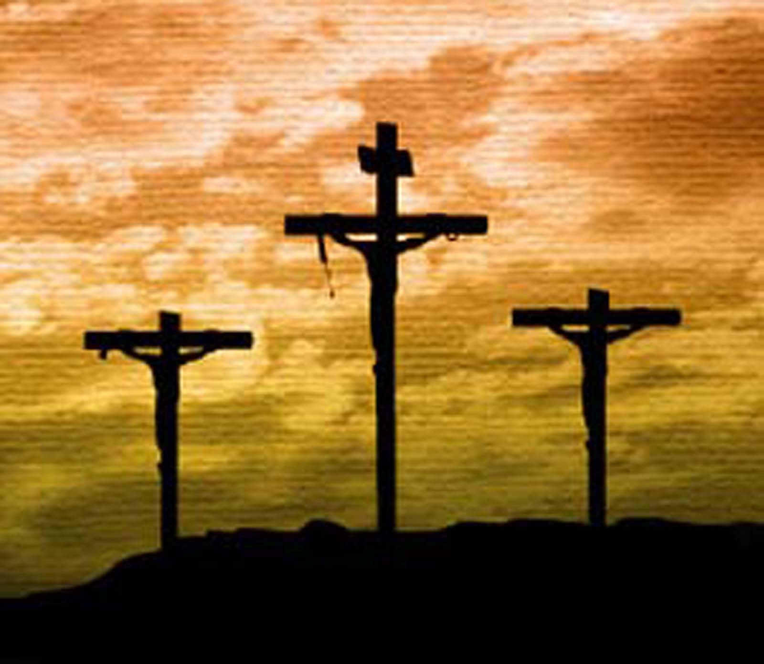

Bibliography

* Website

**ANGLICAN CHURCH BELIEFS CAN VARY WIDELY**

**In-text:**(Anglican Church Beliefs Can Vary Widely, 2022)

**Your Bibliography:**Learn Religions. 2022. *Anglican Church Beliefs Can Vary Widely*. [online] Available at: <https://www.learnreligions.com/anglican-episcopal-church-beliefs-and-practices-700523> [Accessed 31 August 2022].



Top of Form

Bottom of Form

* Website

**FAITH - ENCOURAGING CHRISTIAN SPIRITUAL GROWTH**

**In-text:**(Faith - Encouraging Christian Spiritual Growth, 2022)

**Your Bibliography:**Crosswalk.com. 2022. *Faith - Encouraging Christian Spiritual Growth*. [online] Available at: <https://www.crosswalk.com/faith/> [Accessed 31 August 2022].



Top of Form

Bottom of Form

* Website

**GUIDE TO THE BELIEFS AND RELIGIONS OF THE WORLD**

**In-text:**(Guide to the Beliefs and Religions of the World, 2022)

**Your Bibliography:**Learn Religions. 2022. *Guide to the Beliefs and Religions of the World*. [online] Available at: <https://www.learnreligions.com/> [Accessed 31 August 2022].



Top of Form

Bottom of Form

* Journal

**HOSSLER, B.**

Christianity

**In-text:**(Hossler, 2022)

**Your Bibliography:**Hossler, b., 2022. Christianity.



Top of Form

Bottom of Form

* Book

**OXFORD SELF-PRONOUNCING BIBLE**

**In-text:**(Oxford self-pronouncing Bible, 1966)

**Your Bibliography:**1966. *Oxford self-pronouncing Bible*. London: University Press.