**ISRAR WAHEED**

**Student ID: UD76841SMA86036**

**AMA 616- ADVANCED MARITIME BUSINESS MANAGEMENT**

Presented to The Academic Department of the School of Business and Economics

In Partial Fulfillment of the Requirements for the Degree of Doctorate in Maritime Management

**ATLANTIC INTERNATIONAL UNIVERSITY**

PIONEER PLAZA, 900 FORT STREET

HONOLULU, HAWAII, UNITED STATES

May 2022

**TABLE OF CONTENTS**

Introduction…………………………………………………………….….…………………….3

Brief history of Vancouver …………………………………………………………………….4

Marine Transportation System in Vancouver.…………...…………………………….…….6

Advanced Maritime Safety System ………………………………….……………………….8

Gateway to North American market…………………………………………………………10

Strategic Development and Expansion of the Vancouver ports………….………….…...11

Conclusions………………………………………………….………….……………………...13

Bibliography.….………………………………….…………………………………………….15

**VANCOUVER AS A MARITIME BUSINESS CENTRE OF CANADA**

**INTRODUCTION**

In this module “Advanced Maritime Business Management”, I am going to research about Vancouver and its geographical location where it can be a maritime hub and centre of activities for Canadian trade, transportation and serve as a backbone of Canadian maritime economy.

Vancouver is strategically located at the most western site of Canada, in the province of British Columbia. Vancouver is surrounded by many natural deep-water areas which are ideal for the port and terminals operation. (City of Vancouver, 2022)

Vancouver weather is also ideal to operate the maritime operations year around, weather never get too cold or hot where either water get freeze or too hot to operate, as many of other Canadian ports are closed due to freezing of harbours such as port of Toronto.

Vancouver deep port characteristics are ideal for the larger container ships and oil tankers to come in the port for the loading.

Port of Vancouver can also serve to connect other North American markets through rail and road network and can provide alternate route to many US cities which are required much longer trips from the Asian markets.

It is geographically closest to Asian markets and largest Canadian trading partners such as China and Japan than any other major port of Canada. It makes the most attractive place for the maritime transportation.

Government can introduce further tax credit and attractive environments where business operator can take advantage of Vancouver port.

**BRIEF HISTORY**

Vancouver has a long history as a busy hub for people’s activities, market, and commerce. Vancouver and its surrounding areas were traditional territory of indigenous peoples which settled in the area for more than 8,000 years ago. Musqueam indigenous peoples are settled here for many centuries ago. (Roy S. , 2016)

Captain George Vancouver and his crew were the earliest peoples from Europe who visited the area and subsequently settled here in around 1792. (ROY, 2022)

First permanent settlement was established in 1827 in Fort Langley, which is on the Fraser River and close by to Vancouver. Initial trade were fur, fish, and food within local communities.

Vancouver area was linked with rest of Canada through the rail network in 1887. Transportation of goods expanded, and trade flourished by exporting the fish, lumber, and minerals to other areas in Canada, States and Europe.

During the gold rush era, Vancouver was one of leading trade and commercial centre as well as movement and transportation of goods to the northern part of Canada.

Vancouver economic and industrial activities continued to boom in the fish, minerals, and lumber industries. There were many processing plants all over the coast which were connected by the marine as well as rail links. (Forward, 1982)

Vancouver played an important role during both World wars, in particular Second World war, where local ship building, and related industries flourished.

After the wars, Canada economic was boomed and greatly improved in the expansion of transportation system. Vancouver port was further expanded to rest of other Canadian cities through rail as well as road network.

Today, Vancouver port is one of the busiest ports of Canada and handling all different type of commodities from container ships to bulk cargoes. (Roy, 2022)

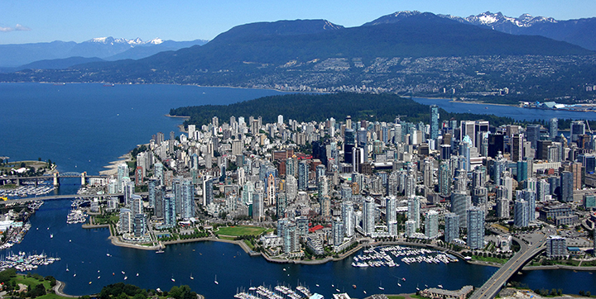

Source: City of Vancouver, <https://vancouver.ca/news-calendar/geo.aspx>

**MARINE TRANSPORTATION NETWORK AND SYSTEM IN VANCOUVER**

During the early stage of ports’ developments, infrastructure, supply chain and port management in Canada, all Canadian ports were under the jurisdiction of National Harbours Board (STATCAN, 2022). Later, in 1983 most of the ports were diversified and transferred to the different port authorities.

Vancouver port is one of the major port of Canada and manage largest quantities of bulk cargoes of grain, concentrates, lumber, coal, potash as well as containerized cargoes. Since 1950s, Vancouver is the leading Canadian port and handled most of the cargo transportation in Canada.

In, 2008, three different port governing authorities of Metro Vancouver port, Fraser River port and North Fraser ports were merged to form Vancouver Fraser Port Authority (VFPA) as a single port authority for Vancouver and its surrounding areas.

VFPA is a federal agency to manage ports related activities in Vancouver and Fraser areas. Port has seen a steady increase of marine transportation and trade. Port of Vancouver is the largest port of Canada and it consist of twenty-nine terminals within the port jurisdiction. (Authority, 2022).

Vancouver port is third largest port in North America in term of cargo movements. Port has leased many different terminals to operators which are handling different type of cargoes from cruise terminals to the bulk cargo terminals.

Vancouver is also a busy area with associated businesses which are providing services to the domestic as well as international shipping. It includes from large shipyards, repair yards, builders, marine suppliers, freight forwarders, ship agencies and many more to have a competitive maritime business in Vancouver. (The Maritime Industry Knowledge Centre, 2020)

VFPA is continuous expanding its capacity through the expansion of different terminals operated by various operators. Such as Delta container terminal expansion project which is under review to increase its capacity and allow more ships to come in for loading. (Impact Assessment Agency of Canada, 2022)

Cruise ship Terminals are another great example where many different stakeholders are collaboratively working for the best services to the tourists visiting Vancouver and surrounding areas. It required a year long preparation and planning from all different parties: such as from the airports, agents, port authority, different government agencies such as Immigration, Health, Transport, Services Canada offices, hotels, restaurants, transportation companies to provide the services.

Federal and provincial governments have been continuously investing in the road and rail improvement projects; to connect national highways and rail network to the different terminals for easy flow of cargoes to and from the terminals (PORT VANCOUVER, 2022).

Source: Delta port Terminal, Road, and Rail Improvement Project (Port Vancouver, 2014)

**ADVANCED MARITIME SAFETY SYSTEM**

Canada has a longest coastline than any other maritime nation, stretching from Pacific coast, Arctic area and to the Atlantic coast.

Maritime transportation and shipping are crucial for the economy. Government of Canada has always prepared its marine emergency departments to act in case of any marine incidents, specially after the famous pollution incident of Exxon Valdex 1989 in Alaska.

Lately, federal government has invested to further improve the maritime management, marine emergency preparedness and response regime through Ocean Protection Plan (OPP) initiatives (Canada, 2022).

There has been steady increase in all type of marine traffic, either those are very large container vessels, oil tankers or smaller pleasure yachts, government has been improving the preparedness level by different programs.

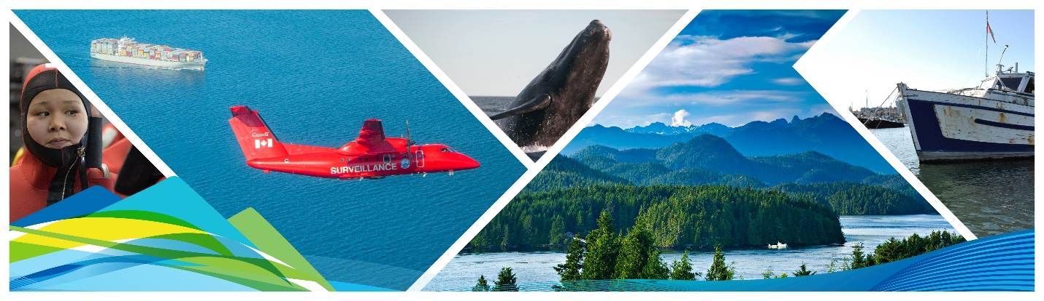

Transport Canada – Ocean Protection Plan. (Canada, Ocean Protection Plan, 2022)

Improving in the ship navigation products and services through electronic navigations and route planning. Optimising the vessel stay in the ports and terminal by integrated coordination of all different parties.

Government has been partners with the provincials, municipalities, First Nations as well as private industries to enhance the maritime safety and better prepared in case of any marine emergency. (PROGRAM, 2022)

For the west coast of Canada, Western Canada Marine Response Corporation (WCMRC) is a responsible party to initiate a response action plan in case of pollution emergency. WCMRC has been actively involved to increase the capability to respond any marine pollution emergency by providing the onsite cleaning support under the supervision of Canadian Coast Guard. (WCMRC, 2022)

Private companies have been also partners to support the OPP initiatives, in case of any marine emergency response, support and ship assistance. (WCMRC, WCMRC & KOTUG, 2021).

All these initiatives are enhancing the confidence level of the shipping industry and have a safe transportation program in Canada and in particular, Vancouver area and west coast.

**GATEWAY TO NORTH AMERICAN MARKET**

Vancouver has seen a continuous growth in the goods and trade. Economy of scale let to expand the terminals to handle more cargo capacity in all commodities from containers to bulk cargoes.

Vancouver port’s terminals are serving as a focal point for not only cargo destined for overseas but also within Canadian sea and dry ports. There are many smaller ships which are working to deliver the cargoes to shallow water ports and isolated coastal communities; all over from Vancouver to Alaskan boarder.

There are also well-established network of roads and railway systems, where bulk and containers are being delivered to the final destinations in rest of Canada and US markets.

Governments and VFPA are encouraging the stakeholders to invest in the short sea shipping initiatives to move the cargo through smart shipping initiatives. (Authority, Short Sea Shipping, 2020)

Provincial government is continuing to attract and invest in the infrastructure and development of new transportation network through its North America’s gateway strategy (The Pacific Gateway - Transportation Strategy, 2012)

Since natural resources and energy are the mostly exported to the Asian markets, therefore government has invested in the clean energy initiatives and many international energy producing companies have been actively developing the new facilities for exporting natural gas. When those will be in full operation, natural gas will be transported in the liquified form as commonly known as Liquified Natural Gas (LNG). Vancouver will emerge has a LNG export trading place (District of Squamish, 2022).

**STRATEGIC DEVELOPMENT AND EXPANSION OF THE VANCOUVER PORTS**

Vancouver steady growth and its close ties with the emerging markets of Asia, made it more attractive on the global level.

In late 2015, Federal and provincial governments invited international ship owners, operators, investors, and other stakeholders to invest in Vancouver through different tax and business incentives.

Government has partnered with the international ship owners to set up their operation in Vancouver and established the Vancouver International Maritime Centre (VIMC). (Vancouver International Maritime Centre, 2022)

VIMC helps and promote Vancouver in the international maritime business as a preferred place where companies can take advantage of certain government incentives as well as it is one of the best and stable places to work.

All different level of governments, federal, provincial and municipalities have invested to attract the international shipping companies as well as improve the transportation network among different terminals in Vancouver area to link rest of the Canada and US markets.

Port expansion projects are also aligned with the government initiatives to reduce the greenhouse gases, air pollution, and noise reduction by the ships.

Port has introduced shore power connection capabilities to some terminals where ship can use it and turned off their diesel generators while in the port. (PORT OF VANCOUVER, 2022)

Port is also active partner with many other national and international forums for reduction of air pollution such as Global Maritime Forum.

Vancouver also suits well between different time zones from European markets to the Asians since it is halfway from both major economies and trade.

Source: Shore Power – Port of Vancouver

According to United Nations Conference on Trade and Development (UNTAD), East Asia, pre-dominantly China and North America will continue as most of the busiest route for the international shipping. Further expansion and investments can be made to be a competitive port of North America. (UNCTAD, 2021)

**CONCLUSION**

Vancouver is a vital centre for trade and maritime commerce of Canada. Over the years, it has expanded and now it is the busiest port of Canada.

Port can further expand to increase its short sea capabilities for storage and transportation of goods to North American market. In particular, during the winter months when Eastern and Northern ports of Canada are shut down due to ice and cold weather conditions.

As part of the National Trade Corridor Funds, short sea shipping can further be strengthened for the smaller coastal communities and Vancouver can serve as a main trading center.

Although all different level of Canadian governments introduced business incentives and tax regime to attract maritime businesses since 1992 but lately, it has been observed a slow progress and not many new international companies are attracted. Government should revisit the tax incentives and other programs to attract more international companies. (The Maritime Executive, 2017)

Vancouver remains a world class competitive place in maritime shipping, VFPA and terminals continue to adopt new technologies and techniques to be efficient, reliable, and cost effective in operation.

All different level of governments and industry further increase the road and rail capacity for efficient transport of goods from the port.

Government should also attract more international ship owners to operate their fleet from Canadian Ship Registry. Provide an attractive tax benefit as well as competitive regulatory environment.

Vancouver is a deep port where very large ships can come in the port. It has a geographic advantage than rest of other Canadian ports. It is a leading Canadian port with most of the cargo is handled from here, as illustrated below. (Nikotina, 2016)

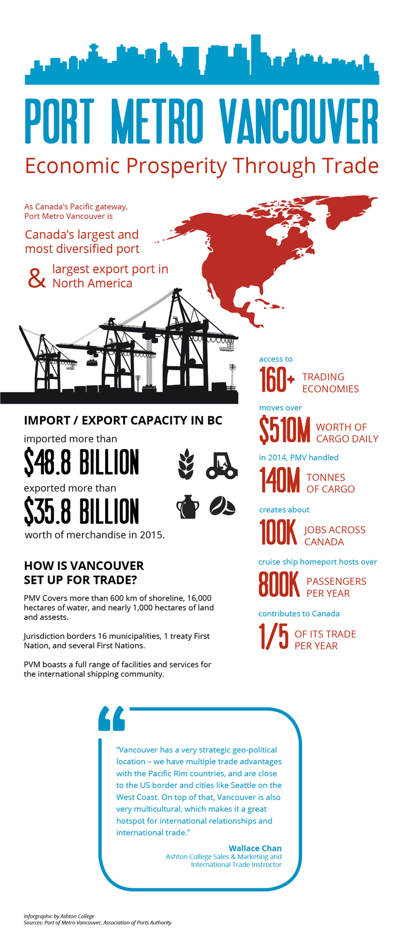

Source: Ashton College by Wallace Chan

**BIBLIOGRAPHY**

Authority, V. F. (2020, 06 01). *Short Sea Shipping*. Retrieved from Portvancouver.com: https://www.portvancouver.com/wp-content/uploads/2020/07/VFPA-Short-Sea-Shipping-June-2020-Update.pdf

Authority, V. F. (2022, 05 17). *Supporting National Trade objectives on behalf of all Canadians*. Retrieved from Port Vancouver: https://www.portvancouver.com/about-us/

Canada, T. (2022, 05 15). *Ocean Protection Plan*. Retrieved from Transport Canada: https://tc.canada.ca/en/initiatives/oceans-protection-plan/report-canadians-investing-our-coasts-through-oceans-protection-plan#world-leading

Canada, T. (2022, 05 12). *Report to Canadians: Investing in our coasts through the Oceans Protection Plan*. Retrieved from Ocean Protection Plan - Transport Canada: https://tc.canada.ca/en/initiatives/oceans-protection-plan/report-canadians-investing-our-coasts-through-oceans-protection-plan#world-leading

City of Vancouver. (2022, 05 21). *About Geography of City of Vancouver*. Retrieved from City of Vancouver: https://vancouver.ca/news-calendar/geo.aspx

District of Squamish. (2022, 05 22). *Woodfibre Liquefied Natural Gas and Fortis BC/Eagle Mountain Pipeline*. Retrieved from District of Aquamish BC: https://squamish.ca/business-and-development/projects-in-our-community/woodfibre-liquefied-natural-gas-and-fortisbceagle-mountain-pipeline/

Forward, C. N. (1982). The Development of Canada's Five Leading National Ports. *Urban History Review*, 23.

Impact Assessment Agency of Canada. (2022, 05 16). *GCT Deltaport Expansion - Berth Four Project*. Retrieved from IAAC - Impact Assessment Agency of Canada: https://iaac-aeic.gc.ca/050/evaluations/proj/81010

Nikotina, A. (2016, 02 26). *Trade Ready - FITT*. Retrieved from Vancouver is Canada gateway to the Pacific: https://www.tradeready.ca/2016/trade-takeaways/vancouver-is-canadas-gateway-to-the-pacific-vancouver-infographic/

PORT OF VANCOUVER. (2022, 05 23). *Climate action at the Port of Vancouver - Shore Power*. Retrieved from Port Vancouver: https://www.portvancouver.com/environmental-protection-at-the-port-of-vancouver/climate-action-at-the-port-of-vancouver/shore-power/

Port Vancouver. (2014, 12). *Delta Terminal Improvement Project.* Retrieved from Port Vancouver: https://www.portvancouver.com/wp-content/uploads/2015/05/PMV-DTRRIP-Project-Update-December-2014.pdf

PORT VANCOUVER. (2022, 05 23). *Delta Terminal, Road and Rail Improvement Project*. Retrieved from Port Vancouver - Projects: https://www.portvancouver.com/permitting-and-reviews/per/project-and-environment-review-applicant/status-of-permit-applications/deltaport-terminal-road-and-rail-improvement-project/

PROGRAM, C. R. (2022, 05 15). *Coastal Response Program - Working to Protect Our Coast*. Retrieved from COASTAL RESPONSE PROGRAM: http://coastalresponse.ca/

Program, C. R. (2022, 05 15). *Working to Protect Our Coast*. Retrieved from Coastal Response Program: http://coastalresponse.ca/

Roy, P. E. (2022, 05 14). *Vancouver*. Retrieved from THE CANADIAN ENCYCLOPEDIA: https://thecanadianencyclopedia.ca/en/article/vancouver?utm_source=google-grant&utm_medium=cpc&utm_campaign=tce-en&utm_agid=57984063066&utm_term=vancouver%20history&creative=493346031579&device=c&placement=&gclid=Cj0KCQjwg_iTBhDrARIsAD3Ib5hBYU7CQMAlEtSE5Q

Roy, S. (2016). *These Mysterious Peoples, Second Edition: Shaping History and Archaeology in a Northwest Coast Community.*

ROY, T. C. (2022, 03 29). *Vancouver*. Retrieved from The Canadian Encyclopedia: https://thecanadianencyclopedia.ca/en/article/vancouver?utm_source=google-grant&utm_medium=cpc&utm_campaign=tce-en&utm_agid=57984063066&utm_term=vancouver%20history&creative=493346031579&device=c&placement=&gclid=Cj0KCQjwg_iTBhDrARIsAD3Ib5hBYU7CQMAlEtSE5Q

STATCAN. (2022, 05 18). *Harbours*. Retrieved from Stat Canada: https://www66.statcan.gc.ca/eng/1938/193807490687_p.%20687.pdf

The Maritime Executive. (2017, 01 29). *Advantage Vancouver: Building a Maritime Hub*. Retrieved from Maritime Exective - article: https://www.maritime-executive.com/blog/advantage-vancouver-building-a-maritime-hub

The Maritime Industry Knowledge Centre. (2020, 03 11). *PORT OF VANCOUVER*. Retrieved from Maritime info.org: https://www.maritimeinfo.org/en/Maritime-Directory/port-vancouver

*The Pacific Gateway - Transportation Strategy*. (2012). Retrieved from Government of British Columbia - www2.gov.bc.ca: https://www2.gov.bc.ca/assets/gov/driving-and-transportation/reports-and-reference/reports-and-studies/planning-strategy-economy/gateway_strategy.pdf

UNCTAD. (2021, 11 18). *Review of Maritime Transport 2021*. Retrieved from United Nations Conference on Trade and Development: https://unctad.org/system/files/official-document/rmt2021ch1_en.pdf

Vancouver International Maritime Centre. (2022, 05 19). *Vancouver International Maritime Centre VIMC*. Retrieved from VIMC mandate and Canada Unique Value: http://vancouverimc.org/about-us-vancouver-international-maritime-centre/

WCMRC. (2021, 12 08). *WCMRC & KOTUG*. Retrieved from Western Canada Marine Response Corporation: https://wcmrc.com/wcmrc-and-kotug-canada-announce-agreement-to-supply-and-operate-osv/

WCMRC. (2022, 05 15). *Response Organiztion*. Retrieved from Western Canada Marine Response Corporation: https://wcmrc.com/