**Emmanuel Njadvara Musa**

**UD75647HSO84827**

COURSE NAME:

**UN Sustainable Development Goal 1: No Poverty**

Assignment Title: **No Poverty**

ATLANTIC INTERNATIONAL UNIVERSITY

**February/2022**

1. **Introduction**:

Presently, one in every five individuals, which translates to 767 million people worldwide who live in developing nations subsist on less than $1.90 per day on average. Those living in sub-Saharan Africa and Southern Asia are the most severely affected. A strong correlation exists between abject poverty, nations, and areas impacted by military and financial turmoil.

This is connected to the high decreased salaries and the jobless, youths-generalized group seem to be more exposed to poverty and its associated factors, a scenario that has gotten acute as a result of the global crisis spurred on by the epidemic, mass migration associated to regional conflicts, natural disaster in recent years.

Continently, lack of sufficient income, extreme poverty has a wide range of consequences, including hunger and malnutrition, fuel poverty, reduced educational opportunities, social exclusion and discrimination, exclusion from basic health and social protection services, as well as from decision-making mechanisms. People living in poverty often are more exposed to the consequences of catastrophic events.

The first goal states that "productivity recovery has to be inclusive to provide long-term jobs and promote equality." By 2030, the world aspires to reduce global poverty by half, eradicate extreme poverty (defined as people living on less than $1.25 per day), ensure that all people have access to basic services, establish governance structures and policies are at all levels of government to encourage investment in poverty-eradication actions and initiatives.

Substantial progress has already been made: during 1990, the overall proportion of people living in severe poverty has indeed been reduced by half around the world.

This paper is strictly for academic purposes, aimed at evaluating the UNs' Sustainable Development Goal-1 from the angle of ending poverty globally. The position of policies and what are needed to end poverty in all its ramifications?

Despite being Africa's largest economy, over half of the population lives in terrible poverty, while a small elite fraction earns expanding riches. With increased wealth, just a few gain, while the mass continues to suffer from poverty and hardship (Mayah et al, 2017). Being the world's sixth-largest oil exports, Nigeria also has the third-largest impoverished population. Nigeria is among the 20 countries with the biggest disparity between the affluent and the poor (Igbuzor, 2006). Inequality hinders both the individual's and the country's growth. Nigeria, like other nations, adopted the Millennium Development Goals in early 2000. The Millennium Declaration set out eight aims to end severe hunger and poverty by 2015. To combat poverty, the Nigerian government launched several programmes and formed various agencies/offices tasked with achieving MDG 1. To achieve the MDGs, for example, the National Economic Empowerment and Development Strategy (NEEDS) was mandated. The President's Senior Special Assistant on MDGs was also established. Regardless of the programmes implemented to attain the MDGs, Nigeria fell short of the objective. With a new set of development goals (SDGs) in place for around five years, it's time to examine the country's progress towards achieving them, especially Goal 1. which aimed to end poverty in all its forms by 2030).

They are supposed to conclude the MDGs' unresolved issues, while their 15 year lifetime (2015-2030) is for countries to strive extra hard forward into a sustainable society. So, how dedicated is Nigeria to achieving these goals, notably eradicating poverty in all its manifestations by 2030?

**SDG Goal-1 Official Logo:**

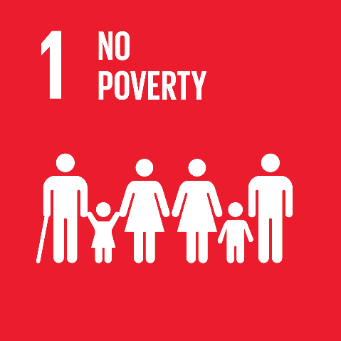

*Figure 1: SDG Goal-1, No Poverty Logo*

1. **Background:**

A total of about 385 million kids lived on less than $1.90 per day in 2013. These estimates are questionable owing to data shortages on child welfare globally. Ninety-seven per cent of nations lack data to assess child poverty and develop estimates towards SDG Goal 1, while 63 per cent lack statistics on child poverty. [1]

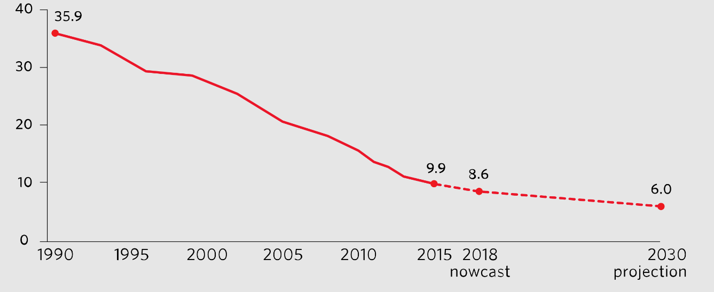

***Figure 2:*** *Proportion of people living below $1 90 a day,**(UNICEF, 2018)*

Since 1990, governments have attempted numerous ways to eliminate poverty with impressive outcomes. Extreme poverty fell from 1.8 billion to 776 million in 2013[2]. Despite this, the World Bank estimates that 40-60 million people will be living in severe poverty by 2020. The necessity of individuals in the most disadvantageous position justifies a low poverty threshold. Because such an aim may not be sufficient for human sustenance and basic requirements, fluctuations compared to higher poverty standards are frequently observed.

Poverty is defined as a lack of fundamental services such as healthcare, security, and education. They also face starvation, social marginalisation, and decision-making exclusion. The Multidimensional Poverty Index is one possibility. [3]

Examples of the underlying factors, such as early and repeated pregnancy put women's lives are endangered. The lower level of education and inadequate teaching facilities with poorly trained teachers and poor income levels. Poverty impacts all age groups differently, with children suffering the most. Emotional and spiritual growth are hampered by poverty (UN, 2020). Goal 1 is hampered by slow economic and social development in the world's poorest countries, rising inequality, government fragility, and the impacts of climate change. Local governments have an important role in poverty issues. These responsibilities vary globally and include: Good government to serve the urban poor are directly linked to accountability and integrity for optimum progress. Ensure inclusive education to improve employability. Working on the business ethics of disadvantaged and rural communities.

Before the COVID-19 outbreak in 2020, it must have been predicted that the worldwide aim of eradicating poverty by 2030 will not be achieved. Nevertheless, the epidemic is reversing years of progress for tens of millions of people. While In 2020, the worldwide severe poverty rate is expected to be between 8.4% and 8.8%, similar to 2017. As a result, 40-60 million people will be driven back into extreme poverty, the first increase in over 20 years (UN, 2020).

**The Concept of Poverty:**

There are many different perspectives on what poverty is and is not. To put it another way, poverty has been conceptualised in a variety of ways. The majority of research reflects the traditional notion of poverty as a negative experience that develops as a result of a lack of funds for ensuring the availability of fundamental products and services. However, poverty is a reality that has been characterised in a variety of ways that are complicated and interconnected, going further than financial or income measures.

According to the United Nations Human Development Report (1998), poverty is characterised as a multifaceted issue including a lack of resources and a lack of options that would allow people to live in decent conditions. Poverty is defined as a lack of access to commodities, services, and pleasures that others around us take for granted (Addae-Korankye, 2014). Deprivation, lack, and denial are all synonyms for poverty. It's a multifaceted phenomenon. Many attempts have been made to define poverty due to its multi-dimensional character, each description expressing the author's view of the idea.

Poverty is classified as either relative or abject poverty. According to Aliyu (2003), relative poverty is a condition in which an individual or group of individuals has the availability to their fundamental requirements but is comparably poor in comparison to other people or the community as a whole. This means that what one location or civilization considers to be the lowest degree of poverty may be regarded as the highest level of well-being in another. Poverty focuses exclusively on people whose quality of living falls below an adequate threshold level (such as a poverty line), whether measured in absolute or relative terms (Oluwashakin et al, 2018). People who live on less than $1.90 per day are considered poor.

The term "absolute poverty" refers to a situation in which a person is in people's income are so low that they are unable to get the services they require to survive (Oluwashakin et al, 2018). To put it another way, humans have ultimate control over their lives. When a person's income is insufficient to meet their basic needs, they are said to be in poverty. fundamental requirements for survival The term "relative poverty" refers to a situation in which a person People's income is significantly lower than the national average that they are poor in comparison to their peers in society.

They can't afford to have the level of living that the rest of the country enjoys a standard of life that the majority of their community enjoys (Oluwashakin et al, 2018). As an example, Inequality in income will almost always lead to a rise in poverty. a greater degree of absolute and relative deprivation Inequality in the workplace is more directly linked to relative poverty. that what it means to be poor is a reflection of current conditions Using what he dubbed "poor qua poverty," (Ikejiaku, 2009) differentiated between relative and absolute poverty. The phrase "poverty qua poverty" (PQP) was coined to define Africa's practical absolute poverty.

Particularly in Sub-Saharan Africa, where the majority of people have difficulty meeting or satisfying their fundamental necessities. People who are in poverty qua poverty are those who have been in poverty for so long that it is nearly difficult for them to break free using their own means (Ikejiaku, 2009). While relative poverty may be applied to any country, rich or developing, absolute poverty (poor in its purest form) is a key feature of emerging countries (Ikejiaku, 2009).

Poverty has been seen as a human rights concern by the Women Budget Group[4]. Consequently, poverty is indeed a multifaceted issue consisting encompasses a lack of money, deprivation, lack of access to basic amenities, increased susceptibility, and so on, and it can be relative or absolute depending on the individual, community, or location.

**Roadblocks to Achievement of the SDG-1:**

Strategic efforts towards poverty eradication in all of its manifestations remain one of humanity's biggest hurdles. The fact remains unchanged that the number of individuals living in severe poverty fell by more than half between 1990 and 2015, many individuals continue to struggle to meet even the fundamental human requirements (UNDP, 2019).

Nigeria among other nations holds several hurdles to reaching Sustainable Development Goal-1 (end poverty) which need addressing. Corruption and lack of accountability, for example, are amid them are poorly stated policies, a paucity of adequate fundamental infrastructure, policy instability, and rising violence in the nation.

Worst among these factors in Nigeria is corruption been the key roadblock in the fight against poverty. Even though Nigeria has Africa's strongest economy it benefited from oil riches and economic progress in 1960 through 1990, the benefits of oil exports have not properly trickled down to the poor (Freedom House, 2012). The corrupt elite’s gross embezzlement of government finances and resources is largely acknowledged as the principal reason for Nigeria's poverty (Global Witness, 2012).

The fight to bring additional Nigerians out of severe poverty is an indictment of Nigerian governments who have mishandled the country's massive oil wealth via corruption. Poverty and inequality in Nigeria are caused by the ill-use, begrudged, and misuse of resources rather than a lack of resources. Nigeria does not lack resources, deviation by political office holders and those elites into foreign accounts by elite, corruption is a culture of corruption and tenancy, and made a circle that is prevalent every political regime, as well as a political elite out of touch with ordinary Nigerians' everyday difficulties. Funds intended for development projects and economic growth have been misappropriated by unscrupulous authorities.

The majority of funding allocated to poverty eradication programmes seldom reach its intended recipients, as well as the battle to eliminate poverty often lacked sufficient political will and strong policies (Akinbi, 2003). According to Oshewolo (2011), public officials who are meant to be responsible public employees have become emergency multimillionaires by diverting public cash to bolster their own fortunes. Despite the efforts of the present government of Muhammadu Buhari administration launching a war on corruption and has made progress in imprisoning corrupt people, his efforts appear to be a drop in the ocean, due to corrupt schemes and weak policies entrenched in the constitution of the country.

**Weak Policies**:

Incapacitated as it were by some intangible factors, Nigerian policymakers were faced with a metal wall in breaching the divide between policymaking and policy implementation, whereby the other arm of government ineffectively enact those laws, especially on poverty-related programmes. Nigerian officials are continuously looking for ways to build flexibility into laws and programmes so that they may exploit gaps for personal gains which is similarly seen during employment whereby positions are given out on favour and not on merit or bought with money. This is why the majority of poverty-eradication efforts in Nigeria hardly achieve their goals.

**Inconsistent Policies**:

Established schemes have been hampered by periodic policy changes (Taiwo et al, 2016). When there is a change in government, any of the exiting governments put on hold all current programmes and initiatives of the past government, Instead of focusing on current projects to add value for money and people’s lives. Furthermore, personal interest frequently overshadows the continuity of those projects and thereby abandons.

# **Conclusion:**

SDGs’ first priority remains to eradicate poverty in all of its forms. Nigeria, like many other nations throughout the world, has embraced the SDGs. However, the government has had difficulty combating poverty.

Despite substantial efforts and huge funding to programs aimed at eradicating poverty, yet, the poverty scale remains unmoved, while the poor, especially children still live below $2. However, substantial governmental programmes such as the National Social Investment Scheme and the formation of numerous agencies and committees tasked with eradicating poverty,

The government and its officials, political office holders and those in authority must be held accountable to provide evidence-based programs that span the period while they are in the office while stringent policies should be tied around the management of funding allocated to SDG programs and monitoring and reporting should be made on a routine basis.

# **Bibliography**

Addae-Korankye, Alex (2014). Causes of Poverty in Africa: A Review of Literature. American International Journal of Social Science, Vol. 3, No. 7, pp. 147-153

Aliyu, A. (2003). “Implementation Progress Report: Background, Structure, Achievements and Problems.” A Paper Presented at a One Day Special Presidential Retreat for Permanent Secretaries

Akinbi J. O (2003). “Corruption in the politics and economy of Nigeria: Implications for national development.” Nigerian Journal of Economic History, 5 and 6: 122-136

Global Witness. (2012). “Global Witness Submission to International Development Select Committee Inquiry on Tax and Development.” http://www.globalwitness.org.sites/default/files/library/global%20witness% (Accessed 5 June 2018)

Freedom House. (2012). “Countries at the Crossroads: Nigeria.” http://www.freedomhouse.org/report/countriescrossroads/ 2012/Nigeria (Accessed 4 June 2018)

Ikejiaku, Brian-Vincent (2009). “The Concept „Poverty‟ towards Understanding in the Context of

Developing Countries „Poverty qua Poverty‟: With Some Comparative Evidence on Britain”, Journal

of Sustainable Development, Vol.2, No.2

Otive Igbuzor (2006). Review of Nigeria Millennium Development Goals - 2005 Report. https://www.dawodu.com/igbuzor11.htm (Accessed 5 June 2018)

Oluwashakin, Ajinde, and Osondu-Oti (2018). “No Poverty Vs Reduced Inequality: Partnerships to Achieve the Goal”, Advanced Management Science 2(1): 12 -16

Oshelowo Segun. (2011). “Poverty Reduction and the Attainment of the MDGs in Nigeria: Problems and Prospects.” Africana, vol.3, No.2

Retrieved from UNICEF (2018) [Progress for Every Child in the SDG Era"](https://data.unicef.org/wp-content/uploads/2018/03/Progress_for_Every_Child_V4.pdf) (PDF). *UNICEF*. Retrieved 2 April 2018.

Taiwo J.N and Agwu M.E (2016). Problems and Prospects of Poverty Alleviation Programmes in Nigeria. International Journal of Business and Management Review Vol 4, No. 6, pp. 18-30

United Nations (2020) “[End Poverty in all its forms everywhere - Progress and Info"](https://sdgs.un.org/goals/goal1). United Nations Department of Economic and Social Affairs - Sustainable Development. Retrieved 17 September 2020.

1. UNICEF (2018) [Progress for Every Child in the SDG Era"](https://data.unicef.org/wp-content/uploads/2018/03/Progress_for_Every_Child_V4.pdf) (PDF). *UNICEF*. Retrieved 2 April 2018.
2. World Bank (2017) [World Development Indictors (2017)"](https://openknowledge.worldbank.org/handle/10986/26447). April 2017. Retrieved 22 October 2021.
3. UNDP (2020) [Goal 3: Good health and well-being"](https://www.undp.org/content/undp/en/home/sustainable-development-goals/goal-3-good-health-and-well-being.html). *UNDP*. Retrieved 2020-09-03.
4. *Women Budget Group. Women and Poverty: Experiences, Empowerment and Engagement. (United Kingdom: Joseph Rowntree foundation, 2008)*