**SOUMBOUNOU AMINATA**

**ID: UD75519BFI84699**

COURSE NAME:

**(Financial Planning and control)**

Assignment Title:

**(Write title of Assignment here)**

ATLANTIC INTERNATIONAL UNIVERSITY

**March/2022**

Table of Contents

**INTRODUCTION…………..……………………………………………………………….3**

**PART 1 FINANCE OVERVIEW**: ..………………………………………………………..5

1.1 Personal finance…………………………………………………………... ………5

1.2 Corporate Finance…………………………………………..………………………7

1.3 Public finance………………..………………………………………………………8

1.4 The others aspect of finance …………………………………………………….. .10

**PART 2: BUDGET**: ……………………………………………………………………….11

2.1 Personal Budget……………………………………………………………………… 11

2.2 Corporate budget ……………………………………………………………………..12

2.3 Government budget …………………………………………………………………..14

2.4 Business start budget ………………………………………………………………...14

2.5 Event Management budget ………………………………………………………….15

**PART 3: BUDGET CRISIS ………………………………………………………………16**

**PART 4: GOVERNMENT BUDGET BALANCE ………………………………………17**

4.1 The different types of balance situation to know ………………………………… .17

4.2 How is financed the Budget deficit ………………………………………………….17

**PART 5: WEALTH MANAGEMENT ……………………………………………………18**

5.1 Understanding Wealth Management ……………………………………………….18

5.2 Strategies of Wealth Management ………………………………………………….19

**PART 6: PROFIT MODEL ……………………………………………………………….19**

6.1 The Types of Profit Models …………………………………………………………..20

6.2 Components of A Profit Model ……………………………………………………...20

**PART 7: PROFORMA AND ICENTIVE PROGRAM ………………………………….21**

7.1 Proforma ……………………………………………………………………………….21

7.2 Icentive Program ……………………………………………………………………...22

**PART 8: INTERNAL CONTROL ………………………………………………………..22**

**PART 9: CENTER FOR AUDIT QUALITY …………………………………………….23**

**PART 10: MY KNOWLEDGE AND PERSONAL EXPERIENCES…………………..24**

**CONCLUSION …………………………………………………………………………….25**

**Bibliography ………………………………………………………………………………26**



**Introduction**

Finance management become unavoidable in everyday life for an individual or company. To have a successful finance management you are oblige to set a performant financial planning and controlling. Whether it is a student, small-business owner, industrialist or large company has roles and responsibility in order to financial planning and control is everyday life strategies therefore it is an essential factor in [businessfinance](https://wikifinancepedia.com/finance/business-planning/what-is-business-finance-definition-examples) as well as personal finance

Financial planning and control is the combination of strategies in the purpose to bring supports to the entire [financial management](https://wikifinancepedia.com/finance/financial-management-definition-examples) process for an organization. Financial planning is the process of getting 100% match between your needs and your goals in every aspect of your finance and business as well. It gives you a complete picture of where you are now and where you can get to in the future.

Financial controls is the process of developing policies and procedures by an organization in order to manage its financial resources and operate efficiently. It is essential for a healthy financial life and give you a certain insurance on your finance and business security.

In the followings pages, we will go deeply through all the aspect and process of financial planning and control. At the end of this analyze we will be able to have a better understanding of it roles on a business financial life.

**PART 1: FINANCE OVERVIEW:**

Finance is a wide field that cover all mechanism of seeking necessary source of income with regards on spending, investing and saving needs. It makes possible to balance between decision-making, implementation and value creation. In short, it therefore consists to:

* Ensure that the decisions taken will generate added value
* Set up a provisional financial plan
* Facilitate the implementation of decisions

Thus, finance is essential to have a better view of the future and to determine whether the project or the decisions taken are conceivable or not, and whether they will have positive impacts on everyone's standard of living.

In addition, the term financing means giving the necessary financial resources to a legal or natural person to carry out a project.

We have many areas of finance but we can resume it in three essentials aspect detailed below:

* 1. **Personal finance**

Personal finance simple means individual finance, it based on how an individual use his income to cover all his expenses and get a minimum margin to invest simply save it. We will give more details on personal finance component:

1. **Source of Income**

The source of income is generally where an individual get money from to support his expenses, we generally have:

* Salaries
* Bonuses
* Hourly wages
* Pensions
* Dividends (for shareholders)

Income is the heart of personal finance and finances in general, without income the others aspects cannot really exist.

1. **Spending**

Spending includes all the fix expenses and variable charges a person can usually have on monthly basis or with a certain period. We generally have:

* Rent
* Mortgage payments
* Taxes
* Food
* Entertainment
* Travel
* Credit card payments

In addition to this we can bring fuels or transport, school fees, social as supporting a family member which is common in Africa.

A perfect spending habit is crucial in personal finance management, when the expenses exceed the income it create a deficit. Deficit should be avoided as much as possible. This is where the word “priority” has all sense, spends have to be set by the level of priority.

1. **Saving**

When the income exceeds the expenses, the excess cash is use for saving or investing. As saving we have:

* Physical cash
* Savings bank account
* Checking bank account
* Money market securities

People usually save money to prevent future spends or money worries, is good to save at least 20% of the income. Too much saving is not also good, if that happens investing will be the best option.

1. **Investing**

Investing simply means buying an asset with the purpose that it will generate an income in the future, the future profit earning included some risks that needs to be reduce to minimal. As source of investing we have:

* Stocks
* Bonds
* Mutual funds
* Real estate
* Private companies
* Commodities
* Art

There is another type of investment called protection or security; protection included health assurance, life assurance or any type or assurance. This investment protects you from disabilities and future money worries.

Example of personal finance: (corporate finance institute)

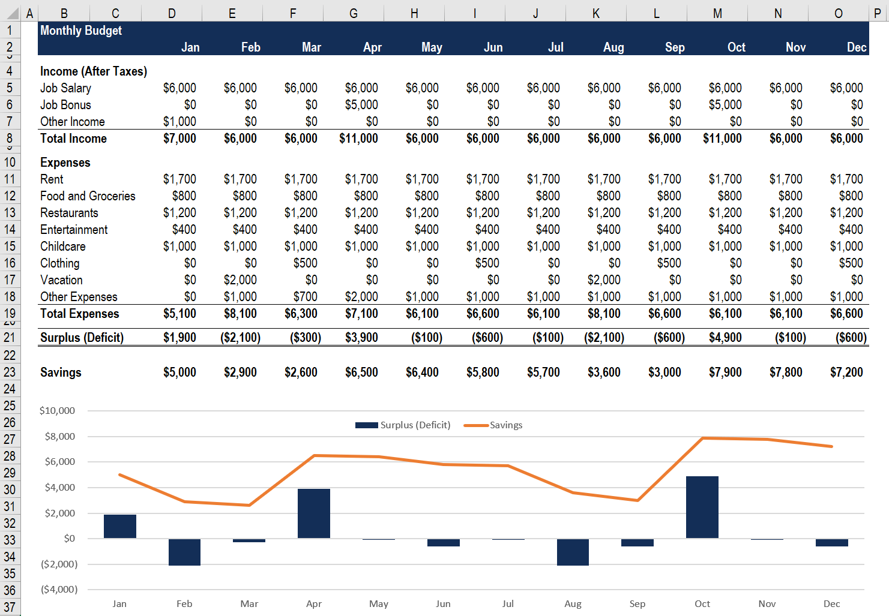

* 1. **Corporate finance**

Corporate finance can be define by the capacity of an entity to use his financial resources and make capital investment, generate profit, and create a value in the future.

The ultimate purpose of corporate finance is to maximize the value of a business through planning and implementation of resources, while balancing risk and profitability.

The name corporate finance is also use to index the service managing the company’s finance. We have three principals aspect of corporate finance detailed below:

1. **Investments & Capital Budgeting**

Investing and capital budgeting includes planning where to place the company’s long-term capital assets in order to generate the highest risk-adjusted returns. This mainly consists of deciding whether or not to pursue an investment opportunity, and is accomplished through extensive financial analysis.

In another words for any investment decision making a company must verify the budget planning to make sure that all decision support the best estimation of the profit earning in the future according to the budget plan, risk of losing money before deciding which projects to include in its capital budget.

1. **Capital Financing**

Capital finance empowered the company with financials resources required to fund all activities and support all investment decision making. There is two principals source of investment:

* Equity: this source is based essentially on the shareholder decision to invest their earning to the business which is less expensive. They can also decide to sell some stock or debt securities.
* Debts this one refers to bank loan principally, it is more expensive because of the interest rate and the payment method.

It is therefore possible to use both of those methods to reduce as much as possible the financing cost.

1. **Short-Term Liquidity**

Corporate finance is also tasked with short-term financial management, where the goal is to ensure that there is enough liquidity to carry out continuing operations. Short-term financial management concerns current assets and current liabilities or working capital and operating cash flows.

The company must generate enough of cash flow to cover all needs for short term spends.

* In addition to capital investments, corporate finance is concerned with dividends and Return of Capital, monitoring cash flows, accounting, preparing financial statements, and taxation.
  1. **Public finance**

As personal finance or corporate finance, public finance is the management of a country or government source of income, expenditures, budget and debts through government institution. In simply term, the government collects tax as an income and invest that income to public and social development wellbeing.

(corporate finance institute, n.d.)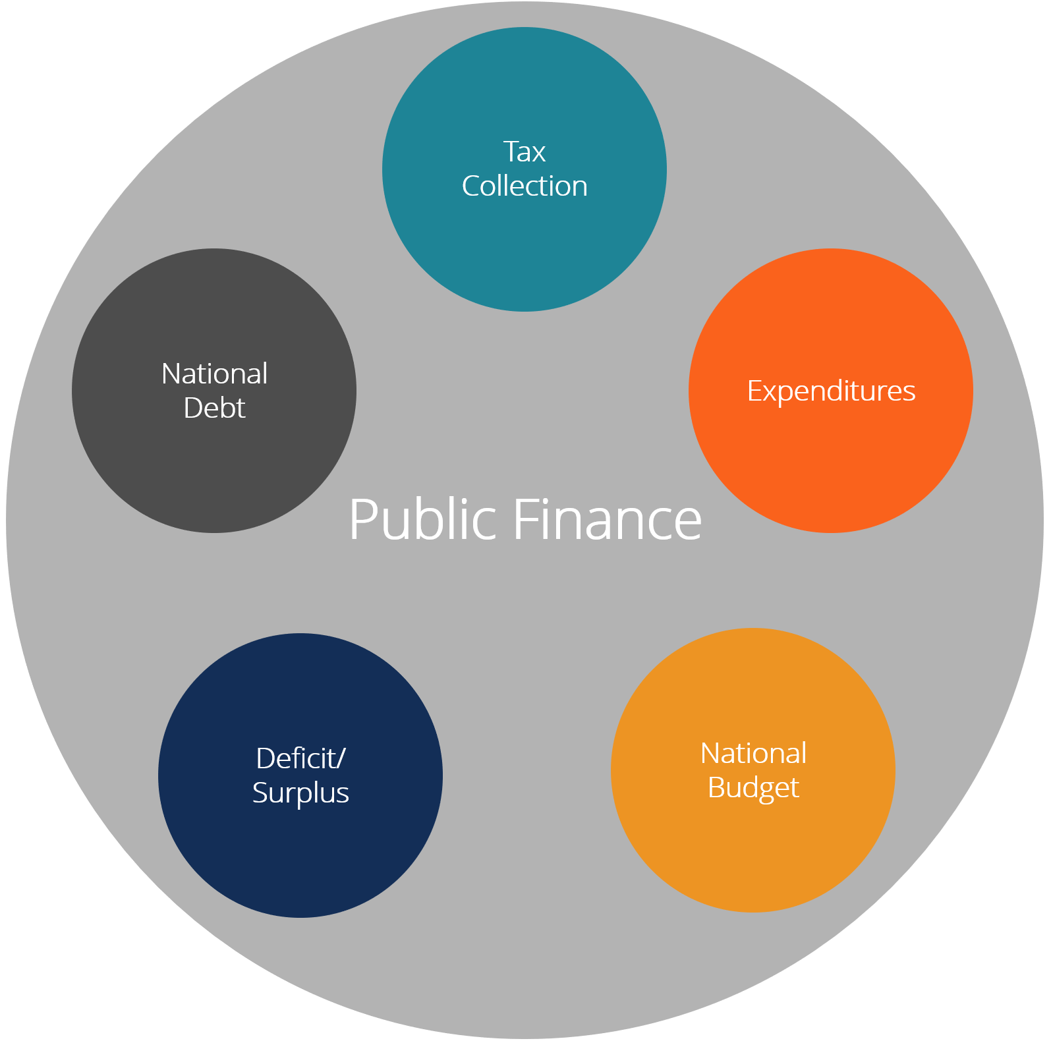

* 1. **Tax collection :**

Tax collection is the principal revenue source for governments. We have different types of taxes as sales tax, income tax, estate tax, and property tax. As part of tax collection government can get revenue from duties and tariffs on imports and revenue from any type of public services that are not free. Examples of tax:

* Income tax (personal, corporate)
* Property tax
* Sales tax
* Value added tax (VAT)
* Import duties
* Estate tax
  1. **Budget**

The budget is a plan of what the government intends to have as expenditures in a fiscal year. In another word, when investment or expenditures plan are set, funds are allocated to each expense according to the original plan. This allocation is called budget.

* 1. **Expenditures**

Expenditures are each and everything that a government actually spends money on, as example we have health and social programs, education, and infrastructure. The government simply redistributes his income or wealth for the society benefit. The actual expenditures may be greater than or less than the budget. More examples:

* Income tax (personal, corporate)
* Property tax
* Sales tax
* Value added tax (VAT)
* Import duties
* Estate tax
  1. **Deficit/Surplus**

If the government spends more then it collects in revenue there is a deficit in that year. If the government has less expenditure than it collects in taxes, there is a surplus.

* 1. **National Debt**

In opposite to personal and corporate finance, government may have a deficit when spending is greater than revenue; this statement is common and is usually solved by borrowing money and issuing national debt as selling government securities to investors.

* 1. **the others aspect of finance:**
* Financial Economics:

It is a branch of economics that study the interrelation between financial variable, risk financial market, price and inflation.

* Financial Mathematics:

Financial Mathematics is the application of mathematical methods to financial problems. (Equivalent names sometimes used are quantitative finance, financial engineering, mathematical finance, and computational finance.)

* Experiment finance:

Experimental finance is a branch of experimental economics aimed at validating or deepening financial theories, through the study of simulations within small groups observed. In simple term its means exanimate an existing process, learn and upgrade it.

* Behavioral finance:

It study how psychology can influences or affect the financial behaviors of investors and financial practitioners.

**PART 2: BUDGET**

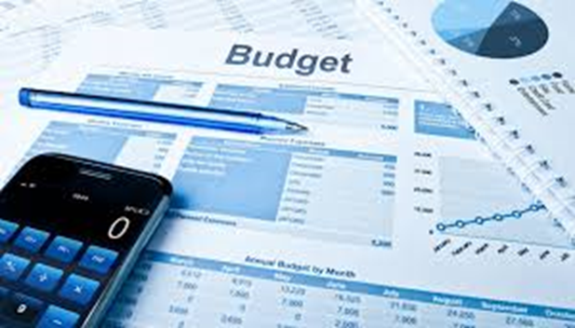

The Budget is a spending plan based on income and expenses. In a simple term, it is a plan of where you will get money from and how you will spend this money with in a length of time. Managing your budget should not be a punishment; it should give you the power to control money and to be out of stress.

Every person or entity has it on way to manage his budget, what will work for you will not work for others. Several searches proved that the best way to manage your budget is to follow the **50/30/20 Method**. This method suggests you to spend about 50% of your monthly after-tax income on necessities, 30% on wants and 20% on savings and paying off debt. This method is most for individuals because it prevent you for any unforeseen spend and money worries.

The budget management type differs from one to another according to your legal status. Let us see below the main type of budget:

**2.1 Personal Budget:**

Finances are different for everyone, and budget is a way of keeping an eye on your money to make sure you can achieve your goals without spending more than you earn. Personal budget is unique to each person but there are some tips that work for us all – let us explore some of them:

* **Your income** :

To plan an accurate budget plan, the very first thing is to work out your take-home income.

Most people know how much they earn, but you need to thing about the real income you take home. Generally, an employee receive the Net Salary after tax and other deductions.

It is possible to get other sources of income as equity, bonus, pension selling used home equipment or others. All sources of income should be set as your income.

* **Your expenses:**

The second step is to set up a spending plan, how and where are going to spend your money. The purpose is to spend less then you earn so that you can have some saving at the end of month for others plan.

When your spend is higher than your earning you should review your plan to focus on what you really needs as an expense than spending on what you Want.

To make the difference between what you really needs and what you want. To help, ask yourself whether you need it to survive, or whether it is something to make your way of living more enjoyable. Thank focus on priority as mortgage, utilities and reduce as much as possible entertainments until you get a higher source of income to cover all your desires.

Only after managing well this step, it will take you on the next step.

* **Saving or investing:**

Savings are great for avoiding the stress of future money worries and becoming a bit more financially comfortable. Pick an amount you are comfortable with, and adjust it according to your budget.

Investment also is important if you do not exceed your budget limit. Typically, it is good to use some of your earnings to invest. It will give you the possibility to increase your source of income.

* **Tracking your budget**

It is easier to set a budget than respecting the limit to do not exceed, this is why it important to track your budget every day to avoid as much as possible to spend more than you earn.

**2.2 Corporate Budget**

A corporate budget is a forecast of all revenue and expenses over a length of time and is an essential part of running a business efficiently.

Budget compares a company's revenue with its expenses in a given period.

The budget components can be different from one company to another but generally, the main aspects are:

* **Revenue:** wehave allocation, donation, income from sales, gains from investments or other sources. All income should be recorded in the budget.
* **Operating expenses:**we have all the expenses from business as usual as rent, utilities, and maintenances.
* **Capital expenses:**those are investment in buying a new building, heavy equipment as a generator.
* **Employee expenses:** all cost related to the employees such as wages and healthcare.

We have many types of budget and it depends on a type of business or entity, an entity modeled his budget type according to his business to set the most accurate forecast. Let us see bellow few types of budget:

1. **Master Budget**

Most companies will start with a master budget, which is a projection for the overall company. In simply term master budget cover the main or principles activities or budget line of the business, those activities are part of the balance sheet, income statement or cash flow such as revenue, expenses, operating costs, sales, and capital expenditures.

1. **The Static Budget**

A [static budget](https://www.investopedia.com/terms/s/staticbudget.asp) is a budget with numbers based on planned outputs and inputs for each of the firm's divisions. The static budget is one of the most important step for a good budgeting. This budget look into fix income and fix expenses, which will not vary or depends on the business evolution.

For example, rent, would be a fixed cost regardless of the sales volume for a company and some industries such as [non-profits](https://www.investopedia.com/terms/n/non-profitorganization.asp) receive donations and grants resulting in a static budget from which they cannot exceed.

1. **Operating budget**

The operating budget includes the expenses and revenue generated from the day-to-day business operations of the company. In simple term the operating budget, cover all the expenses and cost of the business object as producing goods and services in a short period. However, the operating budget does not include items such as capital expenditures and long-term debt.

1. **The Cash Flow Budget**

The cash flow represent the total cash generated by the business in a length of time.

This aspect is important because expenses need to be paid on time from the cash generated.

Its help to budget the expenses accurately or to prepare enough cash in time to cover things as supplier’s payment or urgent purchase.

Periodically it is necessary to compare the actual results to the original forecasts and allocations to determine the variance and balance the budget. Remember that sometime the budget can be flexible and improved.

**2.3 Government budget**

Government budget is the government forecast of its [expenditures](https://www.britannica.com/dictionary/expenditures) and revenues for a specific period of time. In national finance (Kay)as others finance, the period covered by a budget is usually a year, known as a financial or fiscal year, sometime which may or may not correspond with the calendar.

Generally the responsibility for preparing the budget usually lies with the ministry of finance, which will work with all the ministries and spending agencies. This exercise is normally controlled by a central budget department located in the ministry of finance, or sometimes in a separate budget ministry**.**

**Government sources of income:**

Government income comes mainly from taxes. The four biggest sources are:

* **Personal income tax**: Income tax is paid by everyone who earns a regular wage or salary. In some country as Mali richer people pay a higher percentage of their income as tax and once a person earns below a certain amount they pay no income tax.
* **Company tax**: All registered companies have to pay taxes of their profits as company tax.
* **Value added tax** (VAT): this Tax in Mali is 18%
* **Customs and Excise**: When you import things from other countries you have to

pay taxes to protect national producers or national concurrence

**Composition of public expenditure:**

Expenditures authorized under a national budget are divided into two main categories:

* The first is the government purchase of goods and services in order to provide services such as education, health care, or defense.
* The second is the payment of social security and other transfers to individuals and the payment of subsidies to industrial and commercial companies.

Both types are usually labeled “public expenditure,” and in many countries attention usually focuses on the aggregate of the two. This obscures important differences in the economic significance of the two items, however. The first represents the public sector’s claim on total national resources; the second the scale of its redistribution within the private sector**.** (Kay)

**2.4 Business start budget:**

A business start budget is a detailed plan of where are you getting your revenue and how you will spend that revenue through a specific period of time (monthly or annually).

A budget will help you:

* Forecast what money you expect to earn
* Plan where to spend that revenue
* See the difference between your plan and reality

It is important time to time to review your business reality and compare it to what you have forecasted previously. That will help you to track any unforeseen.

To start a successful business you should planned:

* **Your estimated revenue**

This is the amount you expect to make from the sale of goods or services. It is all cash you earn from your business. It is also called income; this is the first line on your budget. It can be based on last year’s numbers based on industry averages or results from your business plan**.**

* **Your fixed costs**

These are all your regular, consistent costs that don’t change according to how much you make things like rent, insurance, utilities, bank fees, accounting and legal services, and equipment leasing.

* **Your variable costs**

These are things which can vary with regards to the business level; they need to be forecast to maximum. Example: raw materials, inventory, production costs, packaging, or shipping. Other variable costs can include sales commission, credit card fees, and travel, moving offices, equipment, furniture, and software, as well as other costs related to launch and research.

* **Your cash flow**

Cash flow is all money traveling into and out of a business. Since cash flow is the oxygen of every business, make sure you monitor this weekly, or at least monthly. It is important to have enough money on hand to pay your suppliers.

* **Your profit**

Profit is the benefice came out from your business, in another words profit is what you take home after deducting your expenses from your revenue.

Profit is your business existing reason, you have to keep on tracking where you can get the maximum benefice and it needs to be planned.

**2.5 Event Management budget:**

Establishing an event budget is a crucial step during the planning phase, right after setting your goals and objectives. A budget is a detailed forecast of what will be happening financially at your event. It helps control your expenses and revenues, and measures the success of your meeting or event performance.

One of the first steps for every event planner is preparing an event budget and predicting as accurately as possible if the event will result in a profit, loss or break-even. However, determining what financial success means for your event depends on the type of event and objectives. For example, a leadership summit is often a loss leader, association events are usually events that break-even, and trade-shows are often the best opportunity to yield a profit.

(Eventmobi Team, 2022)

Sometime the amount of budget is given to organize the event, but most of the time is the event objective which defines the budget. In both cases the event financial aspect management is primordial for the event success.

**PART 3: BUDGET CRISIS**

A **budget crisis** is an informal name for a situation in which the [legislative](https://en.wikipedia.org/wiki/Legislative) and the [executive](https://en.wikipedia.org/wiki/Executive_(government)) in a [presidential system](https://en.wikipedia.org/wiki/Presidential_system) deadlock and are unable to pass a budget. In presidential systems, the [legislature](https://en.wikipedia.org/wiki/Legislature) has the power to pass a [budget](https://en.wikipedia.org/wiki/Budget), but the executive often has a [veto](https://en.wikipedia.org/wiki/Veto) in which there are insufficient votes in the legislature to override. If no emergency provisions are made for the government's budget, a budget crisis may develop into a [government shutdown](https://en.wikipedia.org/wiki/Government_shutdown) in which the government temporarily suspends non-essential services until a budget is passed.

Unlike parliamentary systems, where a [loss of supply](https://en.wikipedia.org/wiki/Loss_of_supply) would trigger the immediate fall of the government, a budget crisis can often lead to an extended stand-off. At the federal level in the [United States](https://en.wikipedia.org/wiki/United_States), a crisis can often be averted by a [continuing resolution](https://en.wikipedia.org/wiki/Continuing_resolution) which appropriates funding at the same level as the previous budget.

A budget crisis can also occur if the legislative branch has a constitutionally mandated dissolution or suspension date and the budget hasn't been passed up to that point. The term "budget crisis" could be used for situation where the executive branch freezes certain funds ([impoundment](https://en.wikipedia.org/wiki/Impoundment_of_appropriated_funds)) despite the directions of the law on annual budget already passed by [parliament](https://en.wikipedia.org/wiki/Parliament).

Politically, a budget crisis may develop in a situation of disagreement between [state](https://en.wikipedia.org/wiki/Sovereign_state) and [civil society](https://en.wikipedia.org/wiki/Civil_society). [Constitutional economics](https://en.wikipedia.org/wiki/Constitutional_economics) is a field of [economics](https://en.wikipedia.org/wiki/Economics) and [constitutionalism](https://en.wikipedia.org/wiki/Constitutionalism) which describes and analyzes the specific interrelationships between constitutional issues and functioning of the economy including [budget process](https://en.wikipedia.org/wiki/Budget_process). The standards of constitutional economics when used during annual budget planning, as well as the latter's transparency to the society, are of the primary guiding importance to the implementation of the [rule of law](https://en.wikipedia.org/wiki/Rule_of_law). Also, the availability of an effective court system, to be used by the [civil society](https://en.wikipedia.org/wiki/Civil_society) in situations of unfair government spending and executive impoundment of any previously authorized appropriations, becomes a key element for the success of any influential civil society. (WIKIPEDIA, 2009)

**PART 4: GOVERNMENT BUDGET BALANCE**

The government budget also known as a public budget is a document representative of government revenue and spends within a year. The difference between revenue and spend at a specific time is called balance. This is where the spelling of government budget balance, public budget balance or fiscal budget come from.

When the government revenue is higher than it spends that create a positive balance called Surplus, in the opposite situation create a negative balance called Deficit.

**4.1**) **The different types of balance situation to know:**

**Primary Balance**

The primary balance is the fiscal balance excluding net interest payments on public debt. The primary balance is the difference between the amount of revenue a government collects and the amount it spends on providing public goods and services.

**Primary Deficit**

When the primary balance is negative, this means the government must borrow money to pay for the everyday public goods and services it provides for citizens, which may not be sustainable. Primary deficit is usually based on one-year.

**Total Deficit**

When the interest payment on public debt is included in the deficit balance calculation, the result is call total deficit.

**Fiscal Debt**

It is the accumulation of many year deficits.

**Cyclical Deficit**

A cyclical (temporary) deficit is a deficit that referred to the business or economic cycle. The business cycle is the period of time it takes for an economy to move from expansion to contraction, until it begins to expand again. This cycle can last anywhere from several months to many years, and does not follow a predictable pattern.

**Structural Deficit**

The structural deficit is that part of the deficit that is not related to the state of the economy. This part of the deficit will not disappear when the economy recovers.

**4.2)** **How is financed the Budget deficit**

Generally, the budget deficit is financed by the sale of government bonds. Bonds are letter written by government with the engagement to pay back the money borrowed with an interest to bonds Buyers. The buyers could be a pension funds, insurance companies, households and foreign investors. Bonds cover public debt, once you purchased a bond, you can sell it later in the secondary markets and make profit.

**PART 5: WEALTH MANAGEMENT**

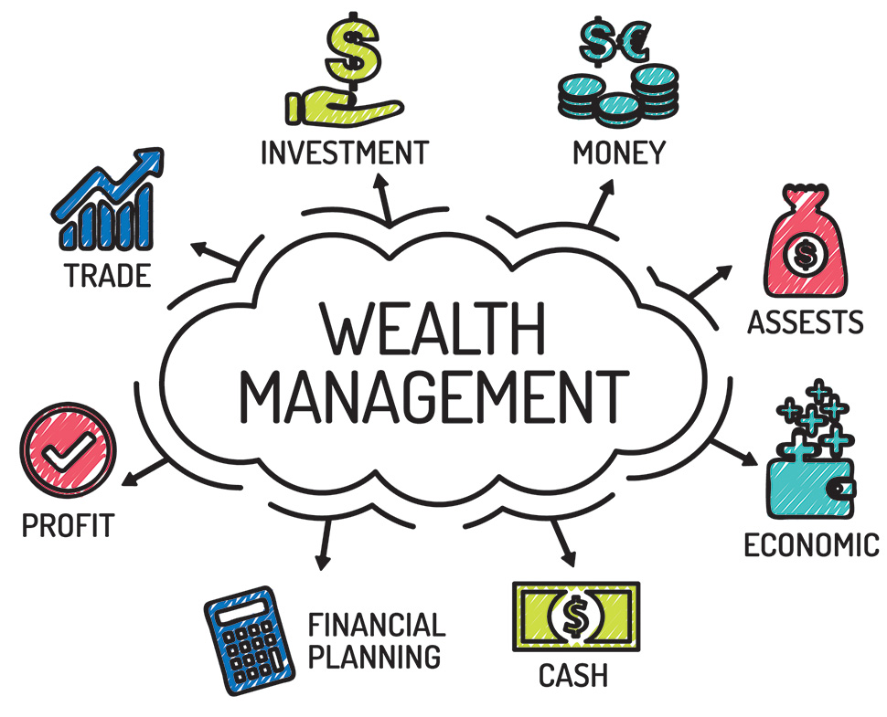

The wealth management is a process that includes the management of many financials services as investment or mortgage to meet a client expectation of earning profit. The person providing the management service is the wealth manager, he provide more than investment advisements, and he follows the process until the end.

**5.1) Understanding Wealth Management**

Generally, the seekers of wealth management advisor are for wealthy peoples with a broad array of diverse needs. Many often they do not have time to manage their own fortune or they do not have the necessary knowledge and skills to do so.

To have a better understanding of wealth management you should ask one question: **what should I do to increase my fortune?** The first thing coming in mind is **“Investment”** but where and how should I invest my money**,** this is where the wealth management take place.

Nowadays many person has perform skills in wealth management at a professionalism level. We usually call them **Advisors** or wealth managers. They receive a percentage on the part of assets under their management as a fee.

Wealth management is more than just investment advice. It can encompass all parts of a person’s financial life. In this method, a wealth manager coordinates the services needed to manage their clients’ assets, along with creating a strategic plan for their current and future needs.

**5.2) Strategies of Wealth Management**

The wealth manager starts by developing a plan that will maintain and increase a client’s wealth based on their financial situation, goals, and risk tolerance.

Importantly, each part of a client’s financial picture, whether it is tax planning or wills and estates, are coordinated together to protect the wealth of the client. This may coincide with financial projections and retirement planning.

After the original plan is developed, the manager meets regularly with clients to update goals, review, and rebalance the financial portfolio. At the same time, they may investigate whether additional services are needed, with the ultimate goal being to remain in the client’s service throughout their lifetime. (Ganti, 2021)

**PART 6: PROFIT MODEL**

A profit model is a plan or process that resume specific business activities for a specific company. In other words, it is a start to finish process of a product. In this process, the expected profit is determinate and realized within a period.

It lays out what the company plans to manufacture or provide, how sales will be generated, how much will be the production cost and how much is the expected profit. Without a concrete profit model, the business will be operating blindly and will be much less likely to become profitable.

The very first thing to understand at the starting point of the profit model is the **Value Proposition** of the business. The value proposition is a statement detailing the business products from start to finish; it also details what makes the product to be value to customers.

**6.1 The Types of Profit Models**

There is different types of Model according to the business or product, the principals are:

* **Production Model**

The production model summarize or include the cost of the production and the benefit to cost, this cost is the sell price. The production take into account the purchase of the raw materials, transport etc. this make the price attractive to the consumers.

* **Rental/Leasing model**

This model refer on fix cost and variable cost as leasing of motor vehicles, buildings, machinery and equipment, land, office furniture, and computers. Generally, there is a written agreement between the property owner and the tenant.

* **Advertising model**

This model provide an advertising space that the businesses can use to promote their service and product offerings. This is mainly for Media companies that provide free information to the public and rely on advertisements to generate revenue. They sell advertising space in newspapers, magazines, television, websites, and mobile applications.

* **Commission model**

The commission model generates revenues by charging a fee when it offers a service to another party. For an example: when there is an intermediary between two parties as in the purchase of a property between the buyer and property owner. The person in between the two parties’ charge a fee for the service provided, this fee is the commission.

**6.2** **Components Of A Profit Model**

* **Production and operating component**

The production level is the starting point of the product life, this where the product is manufactured. At this level, the production department should produce a very high quality of product at the very lowest cost possible. The aim is to have a value for money and avoid the product to be too expensive for buyers.

The operating component comprises both personnel and production equipment.

The company should be very careful when recruiting employees. The personnel under the production department should be well trained, well skilled and experienced to avoid damage on product or an accident with the machines.

* **Sales and marketing component**

This an important of the process because nowadays you have put effort on sale and marketing to access customers. The product needs to be known, the sales and marketing plan should be focus on the potential consumers of the product. For an example the potential customers of a toys will be the Childs, then the marketing department will advertise the product on kids TV channel etc.

* **Delivery of goods and services**

The last component of a profit model is the delivery of goods and services to the customer. Once the sales and marketing department has made potential customers aware of the company’s products, and the customers purchase the items, the seller should ensure that the buyer receives their goods or services in a timely manner. Failure to deliver the goods will be wasting all the efforts spent in developing and marketing the product.

After delivery, the company should provide a communication channel that customers can use to submit complaints, make recommendations, and ask questions about its products and services. (CFI, 2022)

**PART 7: PROFORMA AND ICENTIVE PROGRAM**

**7.1 Proforma**

Pro forma, Latin for “as a matter of form” or “for the sake of form”, is a method of calculating financial results using certain projections or presumptions. (Ganti, 2021)

**What will happens if the business execute it proposed business plan?** The answer of this question will help you understand the meaning of the pro forma**.**

The Proforma outline the business purpose or identify the potential benefit or earning gain with a minimum risk level. The proforma give a result of a plan which will run as normal as possible without any gap or any deviation from the proposed plan.

The proforma is apply in many field as law or engineering but let us see three common use of it:

* In financial statement

Pro forma financial give a «picture» of a company’s profit where nonrecurring items is excluded. It takes into account previous lessons and hypothetical situation, which might happens in the future.

* In financial accounting

The *pro forma* accounting is a statement of the company's financial activities, which exclude "unusual and nonrecurring [transactions](https://en.wikipedia.org/wiki/Expense)".

* In invoice

A *pro forma*[*invoice*](https://en.wikipedia.org/wiki/Invoice) is a document details the seller commitment about the [goods](https://en.wikipedia.org/wiki/Good_(economics)) sells condition to the [buyer](https://en.wikipedia.org/wiki/Buyer) at specified prices and terms.

**7.2 Icentive Program**

An incentive program it as a planned activity designed to motivate people to achieve a specific objective or goal within a certain period. In other words, it simply means to set a plan or activities to motivate group of person to meet your expectations. In a company, It can apply to:

* Sell department to increase the company turn over
* Consumers to attract their interest on a product and retain them
* Pay performance to to increase overall [employee performance](https://en.wikipedia.org/wiki/Performance_management)

**PART 8: INTERNAL CONTROL**

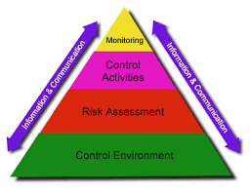

Internal controls are a set of procedure and policies used by an entity to monitor and verify the utilization of it allocation or resources.

Now a day financial controls are essentials to all finance management process.

To set the best control system a deep analyzing of the company existing policies and procedures should be done, hence it is necessary to follow some of the rules bellow:

* Detecting overlaps and anomalies

Focus on the financial statements and report, analyze the budget, the transaction and cash flow to record all the discrepancies and overlaps to set a picture of a business. The next step will be to correct them all while setting the control process.

* Timely updating

Once you set up a financial control model, it is very important to monthly, quarterly even annually review it and update the process to meet the entity updated expectation and policy.

* Analyzing all possible operational scenarios

To cover all the operational aspect it necessary to image all possible scenarios, there is no good or bad scenarios only just a way to avoid as much as possible any failure or fraud inside the organization.

* Forecasting and making projections

This stage will proceed as a budget tracker, to monitor all expenditures to meet the budget future goals.

An effective financial control mechanism ensures overall operational efficiency and fraud prevention.

**PART 9: CENTER FOR AUDIT QUALITY**

Formed in 2007 and affiliated with the AICPA, the Center for Audit Quality (CAQ) is devoted to enhancing investor confidence and public trust in the global capital markets. Focused exclusively on public company auditing, the CAQ carries out this mission in three primary ways:

Fostering high quality performance by public company auditors;

Convening and collaborating with other stakeholders to advance the discussion of critical issues requiring action and intervention; and

Advocating policies and standards that promote public company auditors' objectivity, effectiveness, and responsiveness to dynamic market conditions.

The CAQ is an autonomous, nonpartisan, and nonprofit public policy organization based in Washington, DC. Supported by a membership of US accounting firms registered with the Public Company Accounting Oversight Board, the CAQ is led by a Governing Board made up of CEOs from leading public company auditing firms and the AICPA, as well as independent representatives from key communities: audit committees, investors, and academics.

CAQ Executive Director Julie Bell Lindsay oversees a team that includes CPAs and experts in public policy, professional practice, research, stakeholder engagement, communications, and operations.

The CAQ provides a wealth of resources such as reports, research, comment letters, webcasts, symposia, and technical alerts for auditors and other key players in the financial reporting supply chain. Visit the CAQ's website to find these resources and to learn more about its policy work, collaborative efforts, and initiatives. (AICPA, 2022)

**PART 10: MY KNOWLEDGE AND PERSONAL EXPERIENCES**

In a global competitive world where the key of success are definitely price turnover, profits, costs, financial planning and control give a knowledge and a better understanding of the importance of financial planning and control. It can be tailored to suit any kind and any size of business. It also increases the effectiveness of the company and all the departments are concerned.

As a finance manager in my actual position, I deal every day with the financial plan and control. It is part of my main duties; the finance team is under my responsibility.

I improve the effectiveness and efficiency of the Embassy's finances, with an emphasis on ensuring compliance with finance regulations as well as oversight of any procurement of services or goods following guidelines and legal frameworks. I am responsible for the allocations and monitoring of funds and forecasting spend to ensure the embassy does not over or underspend its budget.

In my experience I have learn that a successful financial planning and control can have challenges:

* **Disconnected Systems and Processes**

It is important to have access to accurate and timely data from other part of the organisation. When the system update is non-effective it can affect your daily reporting and control.

* **Manual Tasks Take Too Much Time**

Finance managers or finance professionals are spending too much time performing manual tasks such as account reconciliation and financial close. They might be not productive or be more focus on sorting reporting than analysing them. It can cause lack of business insights.

* **Inaccurate Budgeting and Forecasting**

Budgeting and forecasting is crucial for an effective financial planning and control. The budget allocation should be reflecting the real need of each budget line, and the forecast should be the more accurate possible to avoid money and time waist. The previsions in the forecast should be realistic and needs to be update timely.

* **Lack of Collaboration**

With a non-effective collaboration between departments, the entire business in in danger. For example, information shared by the operations team aids in financial planning and cost optimization through a supportive system of shared information. Collaborative forecasting is one of the key to a successful business.

I have 10 years’ experience working in finance but I have learned new things with this course. I am familiar to all of aspect details above; it is part of my daily duties. The course grows my understanding of what are my responsibilities as a finance manager; it will perform my budget management skills and I will give more attention on how I will improve the control system.

**Conclusion**

The objective of this research will certainly lead you into the development of techniques, methods, strategies for financial planning and control to assist management in making related rules, principles, polices. Creating policies and rules can create an opportunity for an organization to obtain the maximum [revenue](https://wikifinancepedia.com/finance/financial-advisor/accounting/what-is-revenue-and-expenses-definition-with-accounting-examples) that is beneficial to that shareholders, future project writers, employees and company at large.

A very good financial planning and control will help you to answer question as: are we able to run this business successfully? Can we afford the company spends? do we have an effective finance control system ? Will I be able to maintain my lifestyle in retirement?

Whatever your questions or your life goals, financial planning and control is one of the best tool or support for your financial life freedom. It allows you to focus on what is important and prevent you from any money lost or worries, wherever it may take you.

**Bibliography**

AICPA. (2022, March 22). Récupéré sur https://us.aicpa.org/interestareas/centerforauditquality

CFI. (2022, March 17). Récupéré sur https://corporatefinanceinstitute.com/resources/knowledge/strategy/profit-model/

Clark, J. (2021, March 25). Cooperatives in Australia. (W. Mora, Intervieweur)

*corporate finance institute*. (s.d.). Consulté le February 13, 2022, sur https://corporatefinanceinstitute.com/resources/knowledge/finance/personal-finance/

Eventmobi Team. (2022, February 03). *Eventmobi*. Consulté le March 08, 2022, sur https://www.eventmobi.com/blog/event-budget-basics/#:~:text=Establishing%20an%20event%20budget%20is,your%20meeting%20or%20event%20performance.

Ganti, A. (2021, JUNE 02). *INVESTOPEDIA*. Récupéré sur https://www.investopedia.com/terms/w/wealthmanagement.asp#:~:text=Key%20Takeaways-,Wealth%20management%20is%20an%20investment%20advisory%20service%20that%20combines%20other,typically%20for%20one%20set%20fee.

Idehen, S. (2019). *Cost Accounting in a Family Business.* Anywhere: Galaxy Press.

IMF. (2018, Mayo 18). *IMF Financial Operations: Overview*. (Youtube, Éditeur) Récupéré sur https://www.youtube.com/watch?v=WQdLDMLrYIA

International Monetary Funds. (s.d.). Consulté le MARCH 01, 2022, sur https://www.imf.org/external/pubs/ft/expend/guide3.htm

Kay, J. A. (s.d.). *BRITANICA*. Consulté le March 07, 2022, sur https://www.britannica.com/topic/government-budget/Components-of-the-budget

OECD, P. (2014, JULY). *PUBLIC GOVERNANCE AND TERRITORIAL DEVELOPMENT.* Consulté le MARCH 01, 2022, sur https://www.oecd.org/gov/budgeting/Draft-Principles-Budgetary-Governance.pdf

Rodriguez, D. S. (2021, Febrero 22). Trabajo Social y la Salud Mental. (E. L. Dr, Intervieweur)

WIKIPEDIA. (2009, DECEMBER). *BUDGET CRISIS*. Consulté le MARCH 9, 2022, sur https://en.wikipedia.org/wiki/Budget_crisis