**Pedro Guadiana**

**UD75184HSa84363**

COURSE NAME:

**CTI 058. Critical Thinking**

Assignment Title:

**(Inside the Black Box of the Venn of Thinking: Connection and contribution of the Knowledge and Intelligence Management Model, and its Structured Thinking Corpus to Critical and Complex Thinking)**

ATLANTIC INTERNATIONAL UNIVERSITY

**04/2022**

**Inside the Black Box of the Venn of Thinking**

Connection and contribution of the Knowledge and Intelligence Management Model, and its Structured Thinking Corpus to Critical and Complex Thinking

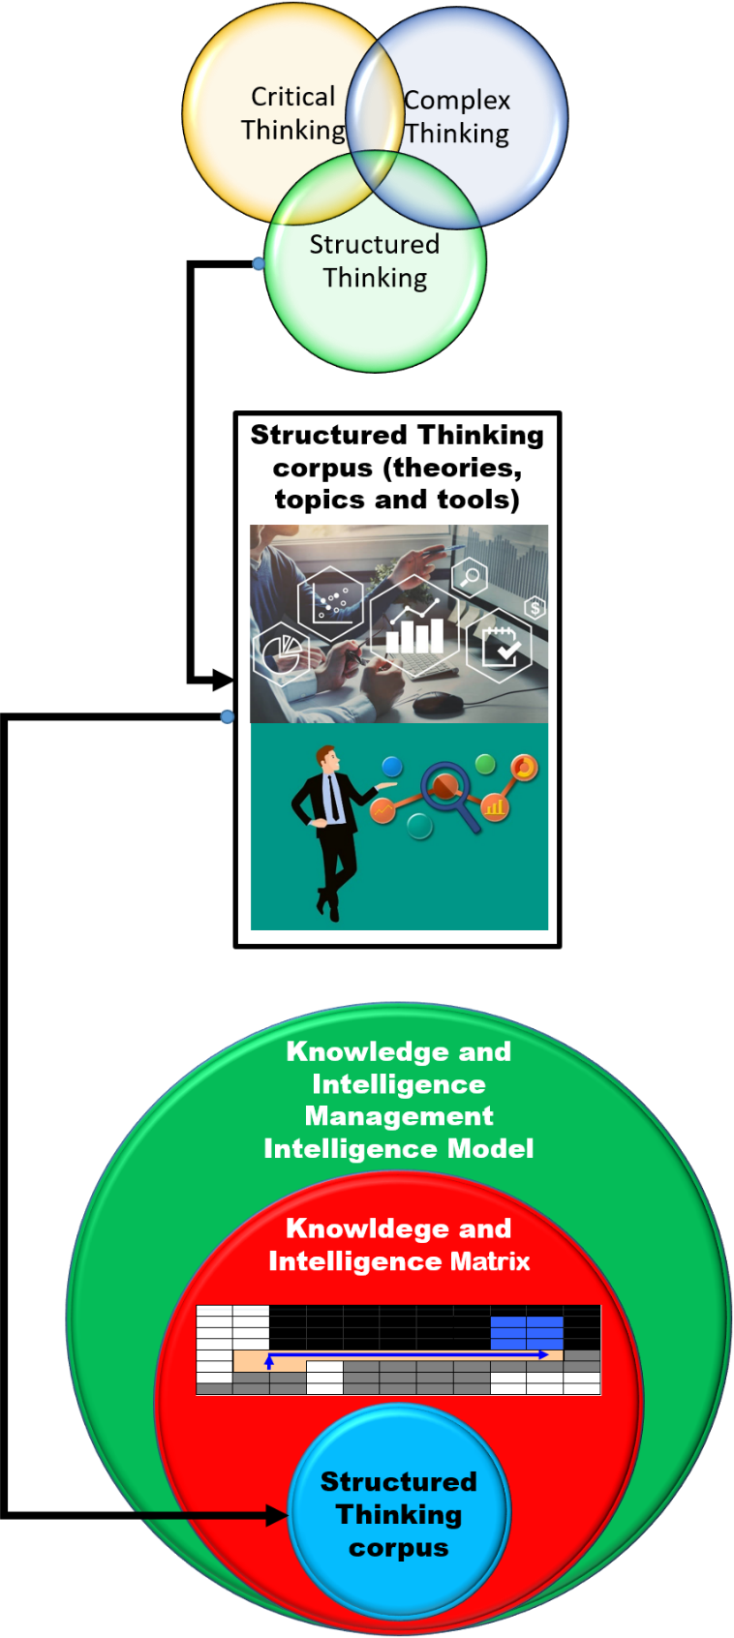

Contents

Introduction 1

Inside the Black Box of the Venn of Thinking 6

Critical Thinking 7

Complex Thinking 15

Connection and contribution of the Knowledge and Intelligence Management Model, and its Structured Thinking Corpus to Critical and Complex Thinking paradigms 22

What is The Knowledge and Intelligence Management Model 23

The Knowledge and Intelligence Matrix 24

The Corpus of own and external theories, topics, tools and developments belonging to the Knowledge and Intelligence Management Model, and its relationships and contribution to Critical Thinking and Complex Thinking 29

1. Systems General Theory. 31

2. Set Theory. 33

3. Knowledge Society 34

4. Fuzzy Logical 35

5. Complexity Theory. 35

6. Chaos Theory. 36

7. Principles of Cyber Control. 36

8. Five Characteristics of Reality. 38

9. Analogic and Logic maps. 40

The Aristotelian Map: a special case 42

10. State Theory. 52

11. Management Theory. 55

Feedback between members of the Thinking Trilogy 71

Conclusion 72

Works Cited 74

# Introduction

No theory or paradigm is totally original. All theories are influenced by others belonging to many fields of knowledge in order to create new knowledge and paradigms. All theories feedback between and within them. Moreover, they experience dialectic processes of theory-practice and they are a result of thinking.

It is the case of this current essay: to examine the similarities, differences and synergy of three powerful theories and practices of thinking: Critical Thinking, Complex Thinking and Structured Thinking, with special emphasis in the contribution of the last one due to it is the less known of them and for being, as we will see, the suitable complement of the other two paradigms. And, as an added value, this trilogy of knowledge and thinking will be the lighthouse of my doctorate in Public Health.

Frequently, I have known and heard about different paradigms of thinking, whose purposes and final results are used to give us theoretical fundaments and practical actions or solutions to face situations in real life. We don’t say “problems”, but “situations”, because we consider actions or solutions can be aimed to reach an aspiration or vision of future, to satisfy a curiosity, to improve something good (everything is perfectible and improvable), to accomplish a goal, to grow up, to expand our horizons of knowledge and wisdom, to contribute to well-being and happiness, among other scopes.

For years, in my profession and in different jobs, I have had a special curiosity and interest when hearing two concepts: Structured Thinking and Complex Thinking while I have been working with a few known paradigm called Structured Thinking. What are their singularities, what are their interjections and their conjunctions? Are they alike, similar or totally different? Do they have the same Corpus with different names? What are their contributions?

After a theoretical and practical study, and a comparison, I have concluded that they can be represented as a Venn diagram that illustrates their particular and joint contributions to different fields of knowledge.

I have figured out that both Critical and Complex Thinking provide excellent bodies of knowledge and practices based on concepts, elements, important guides and studies of cases. However, they must be reinforced with a methodological route or path to structure ideas more accurately. Two books on Critical Thinking were consulted. One of them is aimed to teachers and students. The second one is oriented to strictly commercial American logical… but the world goes beyond companies. The book about Complex Thinking is the European vision of Edgar Morin, known as the Father of Complex Thinking. He talks very little about money and companies, and it is mostly philosophical, but it lacks of specific tools. Between these two worlds, we have Structured Thinking, a proved instrument that has been applied in human beings, groups companies (public, private and non-profit). That is the main contribution of Structured Thinking, which is a logically ordered collection of own and known theories, and improved tools with value-added, similar to a flexible and available menu to be used according to the needs, visions, missions, targets and goals. "Flexible" means that order and elements can be changed or even some of them can be used or not. Of course, theories and tools of Critical and Complex Thinking have been included in the Structured Thinking Corpus.

Critical Thinking has remarkable references such as Paul D. Eggen and Donald P. Kauchak, Joe Lau and Jonathan Chan, and The National Council for Excellence in Critical Thinking.

Complex Thinking has its main exponent in Edgar Morin, known as the Father of Complex Thinking.

Less known is the paradigm of Structured Thinking, whose creator is the Mexican researcher, journalist and professor Yuri Serbolov, who was awarded with Journalism National Prize in 1998 in the genre of Prospective, in Mexico. The Structured Thinking’s tools belong to the Knowledge and Intelligence Management Model that is permanently developed and updated since 1986.

The Knowledge and Intelligence Management Model is the short name of the Universal Model of Management of Knowledge and Perception Prospective Strategic[1], created, coordinated and developed by Yuri Serbolov. We work with the short name because is more manageable, but we always explain the meaning of every single word of the long name because they are its fundament. Yuri is the main compiler, author and co-author of this Model. Since 2003, I am also a compiler, author and co-author[2].

Structured Thinking is a paradigm that has no book… so far. Currently, I am writing the first collection of five fascicles of the Knowledge and Intelligence Management Model collection: 1) Change Management (currently. in review before printing), 2) Knowledge Management, 3) Vision of Future, 4) Diagnosis, and 5) Dashboards and Indicators. Fascicles from 2 to 5 are in writing phase. They are drafts. Structured Thinking theory and tools belong to fascicle 2. All tools have been used in teaching, training, thesis, journalism, researching and consultancy projects in public, private and non-profit companies. In 2008, Yuri and I got the legal copyright of Knowledge and Intelligence Management Model in Mexico by registering the Power Point slides in the Mexican Office called “Derechos de Autor” (“Author Rights Office”). In this paper, I am going to use even new personal developments and updates that I have worked in and are not in that copyright from 2008. These updates will be in the fascicles that I am currently writing.

In order to reach the purpose of this paper, it is necessary, first, to know and talk about the main aspects of Critical and Complex Thinking. We will do a brief synthesis of them, because they are better known worldwide and they can be consulted in several books and papers. Second, due to Structured Thinking is less known even in Mexico, we must show its place into the Knowledge and Intelligence Matrix which, in turn, belongs to the Knowledge and Intelligence Management Model. So, deductively, we need to work this essay in the next order: Knowledge and Intelligence Management Model, Knowledge and Intelligence Management Matrix, and, finally, the Structured Thinking Corpus. Third, once we have characterized the main elements of this trilogy of thinking, we develop the Structured Thinking Corpus. This Corpus is developed in a general order, route or path. Remember the order of tools are flexible. It is important to clarify that similarities, differences and connections between these three types of thinking are growing up throughout the paper from the very basic to the most advanced level.

As we can see, this essay will have special emphasis in the contribution of the chain Knowledge and Intelligence Model, Knowledge and Intelligence Matrix and Structured Thinking Corpus to Critical and Complex Thinking, but it is necessary to clarify that we are going to relate these three paradigms throughout this paper.

In summary, Critical Thinking, in general, needs to be enriched and complemented with other paradigms. Understanding and working with this trilogy of thinking as a background will be helpful in many aspects such as researching, teaching, consultancy, studying and, beyond this doctorate in Public Health, will be one more powerful light to guide my life.

This is a first immersion inside the Venn of Thinking.

# Inside the Black Box of the Venn of Thinking

Let’s start the exploration of these three currents of thought. The first step is to explain main aspects of Critical thinking by reviewing two American perspectives: one comes from the teaching-learning environment in the classroom; the other one comes from the enterprise world. The second step is to talk about the most important aspects of the European and philosophical vision of Complex Thinking, which is applicable on all the fields of life. These both currents of thought are widely known, but the third one don’t, as we have already said. In consequence, Structured Thinking requires a more extended explanation. Thus, the third step consists in describing and circumscribing it. Structured Thinking belongs to something bigger: The Knowledge and Intelligence Matrix which, in turn, belongs to The Knowledge and Intelligence Management Model. Once we have described and circumscribed it, we will be in condition to work on the elements of it Corpus to, finally, display the connection and feedback between these three currents, as well as their respective contributions to the Venn of Knowledge. All of them will be the lighthouse in our Doctorate of Public Health.

## Critical Thinking

“The National Council for Excellence in Critical Thinking states Critical Thinking is the intellectually disciplined process of actively and skillfully conceptualizing, applying, analyzing, synthesizing, and/or evaluating information gathered from, or generated by, observation, experience, reflection, reasoning, or communication, as a guide to belief and action” (Inter-American Teacher Education Network 6).

Eggen and Kauchak say Critical Thinking is “the ability and disposition to make and assess conclusions based on evidence” (Inter-American Teacher 6).

Critical Thinking involves interconnected skills of curiosity, creativity and systemic vision. The conception of systemic vision is also present in Complex and Structured Thinking.

The Critical Thinking Toolkit book refers the next four ways or methodologies to promote Critical Thinking:

1. Socratic Seminar. “Is an activity where students are given opportunities to examine a common piece of text, whether it is no the form of a novel, poem, art, print, or piece of music. After actively reading the common text, **open-ended** questions are posed” (Inter-American Teacher 18). According to the book, the open-ended questions are the key to think critically.

According to the International Literacy Association and the National Council of Teachers of English of the United States (Inter-American Teacher 19), Socratic Seminar works on six steps:

1. Choosing a text. It must be a real text.
2. Preparing the students. They should read carefully and prepare well for sessions.
3. Preparing the questions. Making questions that encourage exploration, not answers.
4. Establishing student expectations. Work on debate, discussion, persuasion, prepared rebuttals, inquiries and responses.
5. Establishing moderator’s role. Teacher is a discussion leader.
6. Assessing effectiveness. Reflection, evaluation, measuring.

2. Academic Conversation Skills. They are aimed not to be a session dominated by teachers, but to work on all subjects. In order to have productive academic conversations is important to start with key questions and work in building ideas, supporting ideas with evidence, synthesizing, paraphrasing, elaborating and clarifying (Inter-American Teacher Toolkit 22). It is also important to consider internal and external dimensions of studied phenomena, such as: politics, culture, social, legal, institutional, ecologic and technologic, among others. Several resources and materials like graphic organizers, cards, objects, audios, videos, photos, computers and internet are used to have academic conversations. These dimensions and materials are mapped and aligned in the Structured Thinking Corpus.

3. Project Based Learning. This practice is highly related with constructivism. It means learning and thinking critically is a result of doing real things. We can do from simple to sophisticated projects. For example, making a vegetable garden helps to conceptualize, analyze, understand, explain, synthesize and interpret how nature works. This knowledge put in action allows to think critically.

Common steps of Project Based Leaning are: Defining topic or theme, organization, coaching and motivating, gathering materials, creating projects, feeding and evaluating, presenting and publishing.

4. Service Learning. This is “a process of involving” people “in community services” (Inter-American Teacher 29). Service learning strengthens links between people who does service and community members who are the receivers of goods and products.

On the other hand, Michael Kallet, talks about three steps of the Critical Thinking process: clarity, conclusions and decisions. “Clarity allows us to define what the issue, problem, or goal really is” (Kallet 16). Being specific instead of generic is a better guide to achieve results. We can use the following dimensions to clarify: What, When, With What, With Whom, How, What For, Who For, Where and Impacts. Conclusions “are solutions and a list of actions” (Kallet 16) that includes innovation. For instance, we can say: “Our CEO have decided to implement the new system of salaries and benefits”. These “W” questions (and the How question) are developed in the Aristotelian Map belonging to Structured Thinking Corpus.

Before reviewing the main concepts related to critical thinking, it is important to say that most of them are worked and articulated by the Knowledge and Intelligence Management Model in a different sequence.

Figure . Critical Thinking.

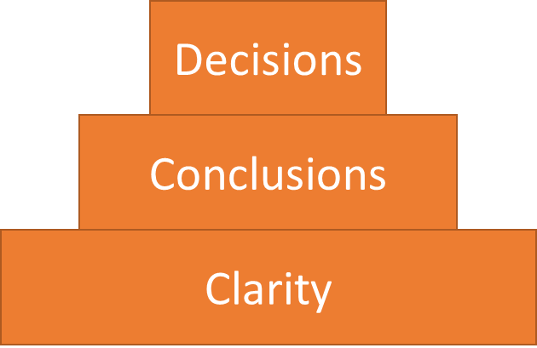

Source: Kallet, Michael. Think Smarter: *Critical Thinking to Improve Problem-Solving and Decision-Making Skills*. New Jersey: John Wiley & Sons, Inc., Hoboken, 2014. Figure 3.2.

Clarity (Kallet 24-78) involves:

1. Empty buckets. Buckets contain bad and good experiences that must make us to think “there is always a way” (Kallet 24), which is the empty bucket. That means, we have to recover all these experiences to clarify the situation or problem.
2. Inspection. It is a diagnosis of everything: Human Factor, infrastructure, technology, finance, administration, internal and external communications, teamwork, information, learning, organizational climate, designs, processes, marketing, products, goods, services, coverage and impacts.
3. Why? This question can be expanded to “Why we want… this?”, “Why we must work, do, make, improve… this?” “This” is more specific than “that”. The better response to a “Why” question is “Because of this.”
4. So What? It is equivalent to say “And then?” This means we have to think in what we must do, what we need.
5. Need. It refers to necessity. Do we need better processes? Better decisions? More learning? More and better technology? Communication?
6. Anticipatory Thinking. It is looking at the future in order to build it. Making prospective (future scenarios) is needed. We have to build different kind of scenarios, e.g. Optimus, Possible, Probable, Worst, Uncertain. This means to make several feasibility analysis for short, middle and long terms.
7. What else? This means “What more is need to make this and/or these…”?
8. The Ingredient Diagram. In this case, we can say ingredient = resources. Resources are materials, people, manuals, money. People are ingredients, too.
9. Vision. How do we see the future? This means we have to pursue a purpose, to reach and aspiration.
10. The Thinking Coach. A leader must be a guide, a motivator and leader in order to achieve the vision. He or she has to have moral authority more than formal authority.

Conclusions involves:

Figure 2. The conclusion process.

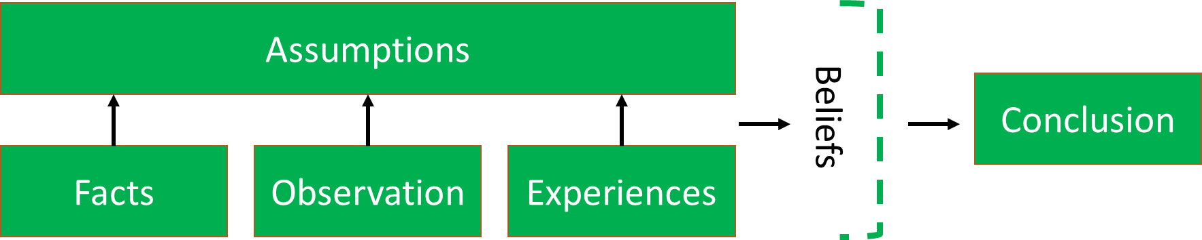

Source: Kallet, Michael. Think Smarter: *Critical Thinking to Improve Problem-Solving and Decision-Making Skills*. New Jersey: John Wiley & Sons, Inc., Hoboken, 2014. Figure 15.1.

1. It’s all about the Premise. Thinking deductively –from general to particular and inductively –from particular to general-. It´s about syllogism: premises lead to conclusions, causes lead to effects, as we can see in next figure (Kallet 88).
   1. Facts. Facts are events that are known or proved to be truth. It is important to emphasize that everybody have their own vision and paradigm of truth.
   2. Observations. Consist in all we see, read and hear. When we respond something, we are talking about our observations.
   3. Experiences. It is what we have lived and learned in our existence. This includes to witness facts.
   4. Assumptions. They are a result of the optimal connection of facts, observations and experiences. Even, we can use probabilities. All this set of assumptions supports our beliefs.
   5. Beliefs. It’s about including emotions and intuition, all of them related with values.
   6. The conclusion: Putting It All Together. It’s both a logical and qualitative synthesis of all we think, write, research, study, make and do with added value, as a result of thinking critically.
2. Credibility. It refers to the chains from premises to conclusion. Feasible analysis, validation (result, e.g., of a pilot testing) and consistency given by reliable and verifiable sources.
3. Consistency. It is strongly related to stability, coherence, articulation between premises' elements that lead to conclusion. This means to show patterns, parameters and trends in order to make solid arguments when presenting something.
4. Triangular Thinking. It is “looking at the same problem but using different perspectives” (Kallet 137). This is same vision of multidiscipline by Edgar Morin. When talking on predictions, Kallet is talking about prospective in other words. Prospective is a notion that Structured Thinking develops further.
5. Change. The premise of change is managing people and their attitudes, actions and adaptation to new processes or procedures. These premises aims to individual, groups, processes and organization-wide changes that impact to final users, match perfectly with the Change Management module of Structured Thinking.
6. Influencing and Persuading. It talks about leadership with other words. It points out that influence is “changing other´s conclusions” (Kallet 147) indirectly, while persuasion is “directly causing someone to adapt or concur with” our “conclusion” (Kallet 147). This is part of Change Management, too.
7. Outside the Box Thinking. It is part of Change Management as well. It is about of changing our paradigms and leaving comfort zones.
8. Adductive Thinking. It is the connection of knowledge with experience; an educative guess. This level of thinking “requires a deep, extensive knowledge base” (Kallet 164).
9. Impossible Thinking. It should be used when everyone says something can’t be done. It is alike to an uncertain scenario, such as having a long meeting or interview between Noam Chomsky and Donald Trump.

Decisions

1. Who, Need, and When. Who is responsible of making decisions? Who is responsible to take actions, to make activities to operate the processes? Next, it is absolutely necessary to define the entire process, from the first ideas and their respective design to their impacts, in order to work on a timeline with deadlines. This elements are aligned and explained in the Aristotelian Map of Structured Thinking Corpus.
2. Criteria. It is a set of parameters, conditions, characteristics to choose alternatives of thinking, actions, production, tangible and intangible products.
3. Risk. This topic responds to the question “What’s something bad or unexpected that could occur?” (Kallet 189) and it can impede the achievement of results. They are related to ups and downs into or outside the project. This is one more contribution of Structured Thinking Corpus to grow the analysis or risks. Inside, we talk about the variables we have under control like aptitudes and attitudes of our people, infrastructure and processes; outside, we talk about the variables we don’t have under control, such as: inflation, epidemics, earthquakes or study subjects behavior.

## Complex Thinking

Edgar Morin, the maximum exponent or Complex Thinking, intentionally, does not give a formal definition but exposes its main structure based on the notion of complexity, even though Marcelo Pakman says in the introduction of the book “Introducción al Pensamiento Complejo” (“Introduction to Complex Thinking”) that it is a method[3].

We have identified thirteen main themes around the underlying philosophy of Complex Thinking.

1. Complexity is a woven of inseparably associated heterogeneous elements.
2. Complex Thinking is “a theoretical / methodological / epistemological set opened and coherent” (Morin, *Complex Thinking* 46) in the framework of the *scienza nova* (“new science”), that means a “modification**,** transformation and enrichment of the concept of science that, as Bronowski” says, is “neither absolute nor eternal” (Morin, *Complex Thinking* 47).
3. Complex Thinking is a multidimensional unity in opposition to globalizer or totalizer thinking. Complexity is incompleteness, it is not omniscience. It is the work and the acceptance of opposites and their contradictions from their concepts to their impacts in different realities, such as: cosmos/chaos, order/disorder, disjunction/conjunction, unity/diversity, continuity/rupture, globalization/contextualization, global/local, whole/part, quantitative/qualitative, objectivity/subjectivity, object/subject, individualism/collectivism, I-we/my-our circumstance(s), metropolis/suburbs, love/hate, health/illness, linear/no linear, reason/emotion, abstract/concrete, complexity/simplicity, black/white, yes/no, true/false. All of these realities are complementary despite being antagonistic.
4. As a result of the opposite interactions, the reality trends to entropy (measure of disorder) and “negentropy” (negative entropy), which is the development of an organization, the development of complexity and reorganization. Homeostasis is the complement of entropy and “negentropy” Complexity is the relation order/disorder/organization (Morin, *Complex Thinking* 58) and balance.
5. Complex Thinking involves uncertainty, random phenomena and accidents.
6. Complex Thinking can be the one and the multiple at the same time. For instance, humans are bio, psycho and social beings.
7. Complexity does not mean simplicity. Morin takes this French philosopher Bachelard statement “The simple does not exist, but only the simplified” (Morin, *Complex Thinking* 19). Better to work with different levels of complexity, from low to high (Morin, *Complex Thinking* 37).
8. Everything is a cause and effect of something else, mediate and immediate.
9. Complex Thinking / Complexity means science with conscience.
10. All of these propositions of Complex Thinking and/or Complexity are summarized by Morin (*Complex Thinking* 67-70) in the Three Principles to Think Complexity. 1) Dialogic principle: duality, transition, order and chaos (complementary and antagonist terms). 2) Organizational recursion. Everything is cause and effect of something else. 3) “Hologrammatic”. The part is in the whole, the whole is in the part. Society is in us (inductions and prohibitions) and we are in the society.
11. “Pluri” or Multidiscipline.

Figure 3. Our interpretation of Pluri or Multi-discipline´s Edgar Morin concept.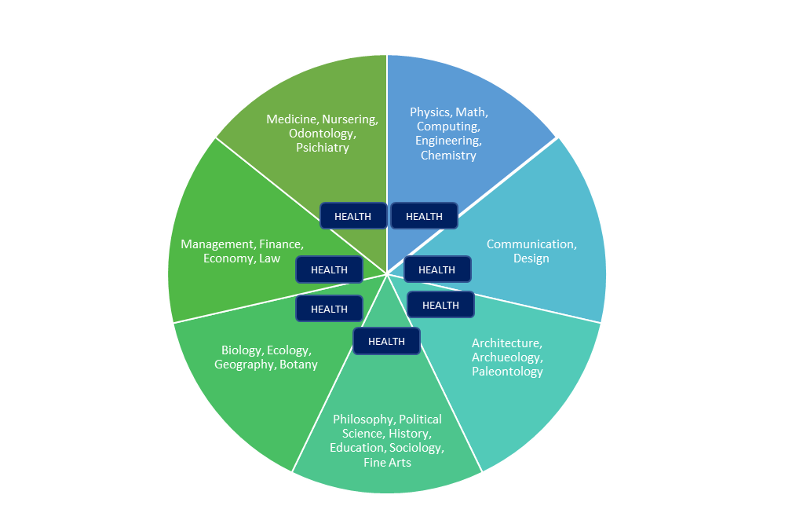

Source. Own elaboration base on Morin, Edgar. *¿Qué es la transdisciplinariedad?* <https://edgarmorinmultiversidad.org/index.php/que-es-transdisciplinariedad.html#:~:text=%C2%BFQu%C3%A9%20es%20pluridisciplina%3F,espec%C3%ADfica%20sobre%20un%20campo%20determinado>.

“Pluri” or Multidiscipline is the “way of knowledge organization that joins several disciplines in order to each one projects a specific vision about a specific domain. “Pluri-discipline” or Multidiscipline don’t alter disciplinary fields or objects under study nor their methodological arsenal” (Morin, *Trans-discipline* n. pag.).

1. Inter-discipline

Figure 4. Our interpretation of Inter-discipline´s Edgar Morin concept.

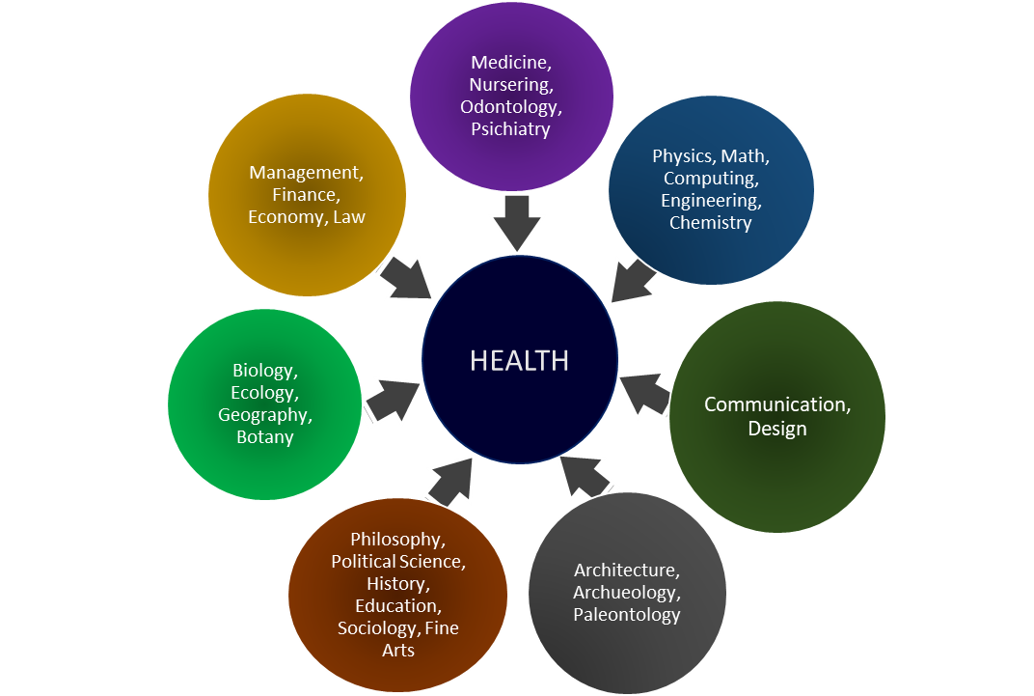

Source. Own elaboration base on Morin, Edgar. *¿Qué es la transdisciplinariedad?* <https://edgarmorinmultiversidad.org/index.php/que-es-transdisciplinariedad.html#:~:text=%C2%BFQu%C3%A9%20es%20pluridisciplina%3F,espec%C3%ADfica%20sobre%20un%20campo%20determinado>.

Inter-discipline is the “way or knowledge organization whose methods are successfully transferred into other discipline” (Morin, *Trans-discipline* n. pag.). As a result, we can get an extension and a change on transferred method, even a total disciplinary change when a hybrid new discipline is created, such as Electric-Electronic or Ethno botany.

1. Trans-discipline

Figure 5. Our interpretation of Trans-discipline y´s Edgar Morin concept.

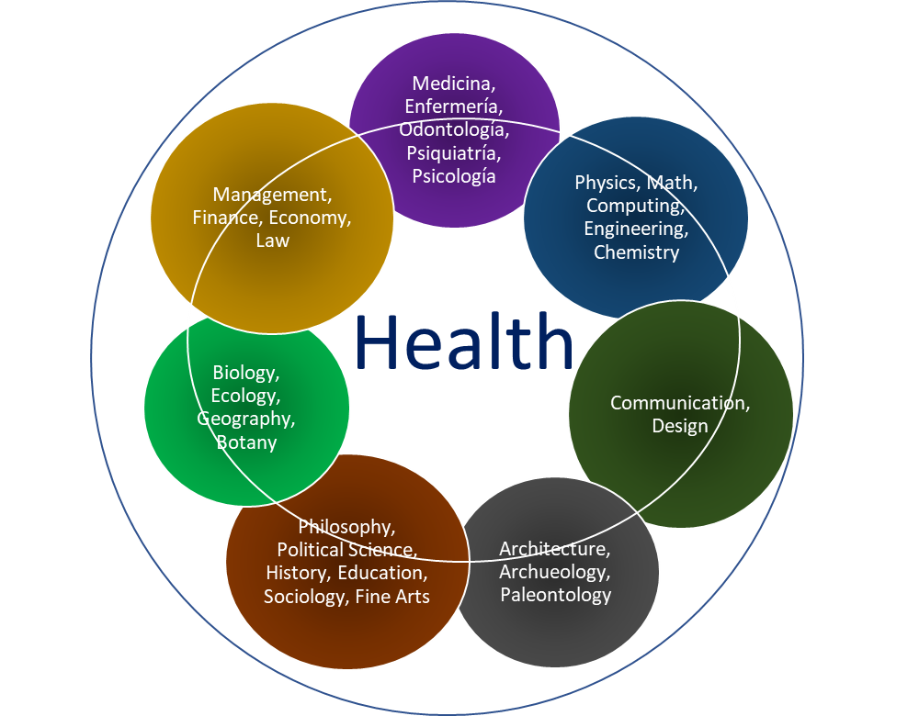

Source. Own elaboration base on Morin, Edgar. *¿Qué es la transdisciplinariedad?* <https://edgarmorinmultiversidad.org/index.php/que-es-transdisciplinariedad.html#:~:text=%C2%BFQu%C3%A9%20es%20pluridisciplina%3F,espec%C3%ADfica%20sobre%20un%20campo%20determinado>.

Trans-disciplineis the **“**way of knowledge organization that transcends disciplines radically” (Morin, *Trans-discipline* n. pag.). Trans-discipline emphasizes in a) what is between the disciplines, b) what is crossing all of them, and c) what is beyond them. Trans-discipline represents the aspiration to knowledge that is as complete as possible, that is capable of dialoguing with the diversity of human knowledge.”

The twelve themes or topics of Complex Thinking are developed and extended in other twelve topics in the Structured Thinking Corpus, in different order and sequence.

At this point, we have enough information to show the coincidences and parallelisms, with same or different names, and the own contributions of Structured Thinking to this Venn of knowledge. The main twelve points of its Corpus matches with the main points of Critical and Complex Thinking as we will see next.

## Connection and contribution of the Knowledge and Intelligence Management Model, and its Structured Thinking Corpus to Critical and Complex Thinking paradigms

Figure 6. Connection and contribution of the Knowledge and Intelligence Management Model, and its Structured Thinking Corpus to Critical and Complex Thinking paradigms.

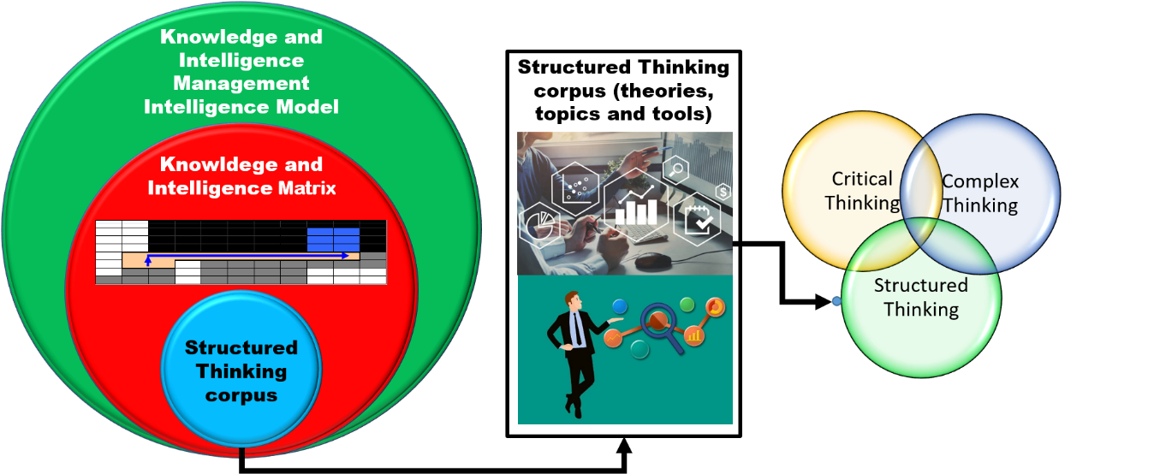

Source. Own elaboration based on Systems General Theory and Set Theory.

Next, we will work on topics related to the illustration above.

### What is The Knowledge and Intelligence Management Model

The Knowledge and Intelligence Management Model is the short name of the Universal Model of Management of Knowledge and Perception Prospective Strategic, created, coordinated and developed by Yuri Serbolov. Several people have made contributions, including the present paper's author.

This Model is neutral because it has not ideology, it does not have a preconceived idea, and it is a continent, a container or repository of all theories, paradigms and practices.

Why it is a Model? Because is an abstraction and an ideal representation of reality that has a structure, an order, a sequence and a logic route or path that leads to structured thinking.

Why it is universal? It is based on Scientific Method, Systems General Theory, Principles of Cyber Control, General Theory of Management, Knowledge and Intelligence Management Model, Management Theory and universal geometric, mathematical, logical and physics principles. In addition, it is applicable to any field of knowledge.

What is Management about? First, management refers to administration and leadership. We administrate material, technological, economic, and financial and natural resources. This implies planning, organizing, making decisions and controlling. Second, leadership is aimed to human beings.

Why it is a Model of Knowledge and Perception? Because it emphasizes in both technical and encyclopedic knowing (knowledge), and reflection, introspection and wisdom (perception). Knowledge can be the same but its utility to people depends on individual perception. For instance, gravity formula is universal, but it can be insignificant for one person; on the contrary, others can build a rocket for going to the moon.

Why it is prospective? If we understand reality, we can predict it. If we know the laws that rules phenomena, we can predict their behavior and we can see the future.

Why it is strategic? If we know the laws that rules phenomena, we can predict their behavior, build a strategy and take actions in advance to reach the future we want or change it.

This Model is in permanently updating, and all updates are included in the Intelligence Matrix, which is the tangible expression and the repository of own and external theories, topics, tools and developments related with knowledge.

### The Knowledge and Intelligence Matrix

One of the most important constructs of the Knowledge and Intelligence Management Model is the Matrix of Intelligence. This matrix transcends the Morin’s notion about science with conscience. Science is equated to technical and encyclopedic knowledge, such as scientific method, aptitudes or competences, and is called “Gnosis”; Conscience is equated to wisdom, perception, reflection, introspection and is called “Sophy”. There are seven levels of “Gnosis”, represented by letter N, and seven levels of “Sophy”, represented by letter S. “Gnosis” is exogenous; “Sophy” is endogenous. “Gnosis” goes from N1 to N7; “Sophy” goes from S1 to S7.

We can see in Figure 1 the levels of “Gnosis” (N).

Figure 7. Seven levels of “Gnosis” or Knowledge.

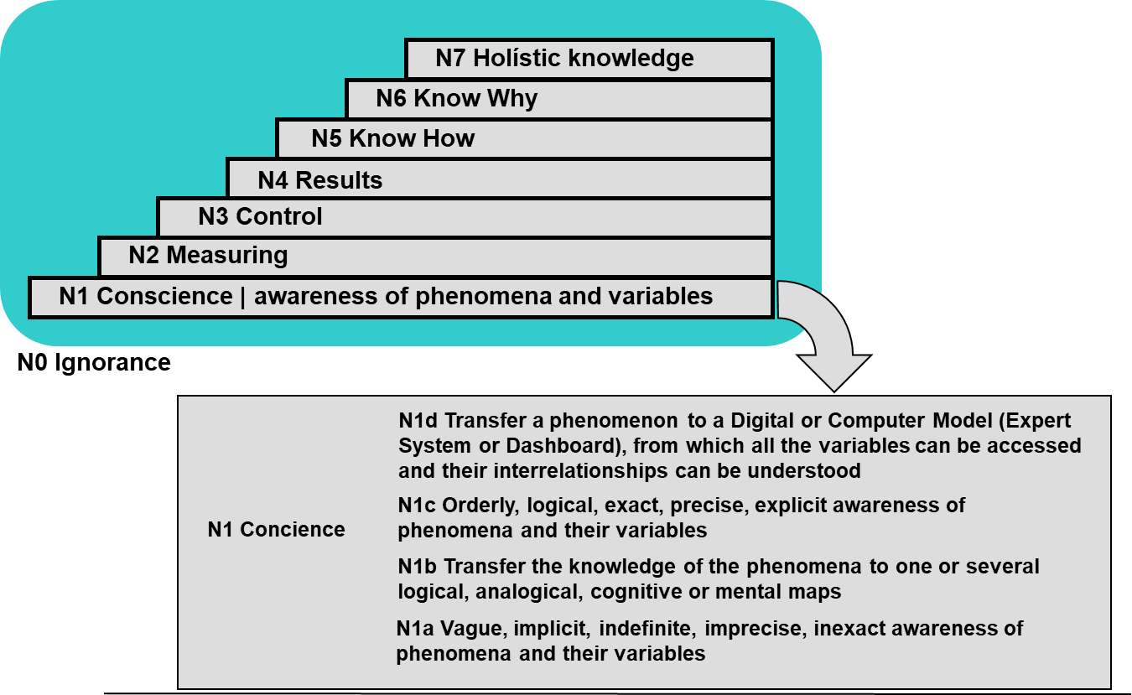

Source. Serbolov, Yuri comp. ed. and author. *Modelo Universal de Gestión del Conocimiento y Percepción Prospectivo Estratégico*. México, 2008. Digital file. Indautor 03-2008-081511360200-01.

As we can see before, Edgar Morin refuses to equate Complexity with holistic. Serbolov, too. A precision is needed. Any scale and effort to measure something either quantitative and/or qualitative needs limits, even though holistic knowledge (N7) and absolute ignorance (N0) don’t exist,

Figure 2 show levels of “Sophy” (S).

Figure 8. Levels of “Sophy”, perception or wisdom.

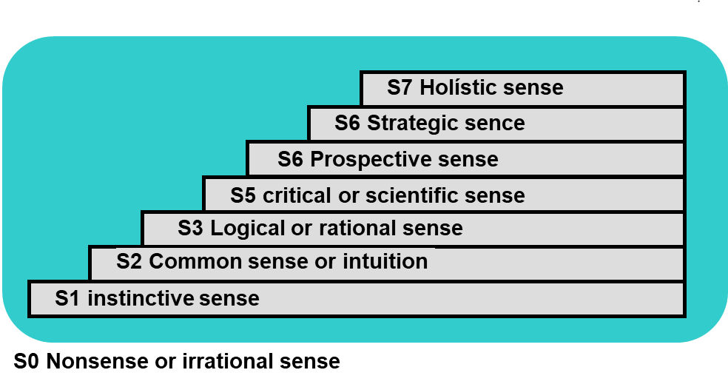

Source. Serbolov, Yuri comp. ed. and author. *Modelo Universal de Gestión del Conocimiento y Percepción Prospectivo Estratégico*. México, 2008. Digital file. Indautor 03-2008-081511360200-01.

As happens in the case of “Gnosis”, holistic perception (S7) and absolute nonsense (S0) don’t exist.

When we put the seven levels together in an arrangement of rows and columns, we have the Knowledge and Intelligence Matrix

Figure 9. Knowledge and Intelligence Matrix by Yuri Serbolov. The materialization of Science with Conscience by Edgar Morin.

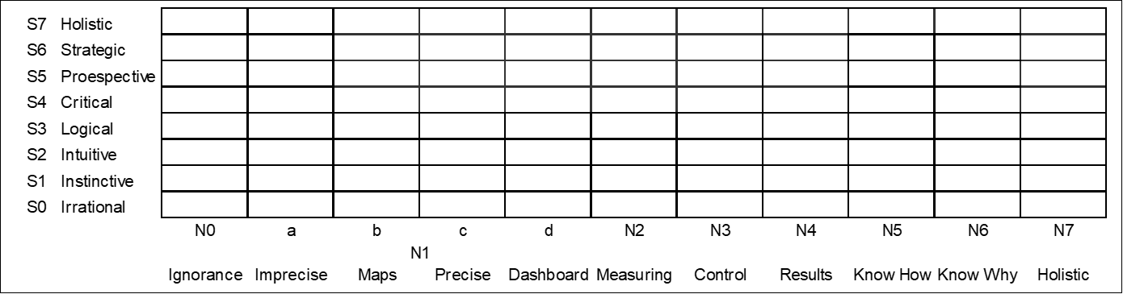

Source. Serbolov, Yuri comp. ed. and author. *Modelo Universal de Gestión del Conocimiento y Percepción Prospectivo Estratégico*. México, 2008. Digital file. Indautor 03-2008-081511360200-01.

We can see the kind of relationships between knowledge and perception in next figure.

Figure 10. Relationships between knowledge and perception.



Source. Serbolov, Yuri comp. ed. and author. *Modelo Universal de Gestión del Conocimiento y Percepción Prospectivo Estratégico*. México, 2008. Digital file. Indautor 03-2008-081511360200-01.

The Matrix shows different kind of relationships in four colors.

|  |  |
| --- | --- |
|  | Nonexistent relationship or empty set |

Cases: 1) Coordinate N1d-S2 can be misunderstood as precise and intuitive knowledge. This is false, 2) Coordinate N0-S3 is an inconceivable ignorance-logical.

|  |  |
| --- | --- |
|  | Vague relationship |

Case: 1) Coordinate N1a-S2 is an imprecise and intuitive knowledge. It can grow to N1c-S3, what it means a precise and logical knowledge.

|  |  |
| --- | --- |
|  | Exact and precise relationship |

Cases: 1) Coordinate N1c-S4 means a precise and critical knowledge because is a result of applied science, 2) Coordinate N1d-S5 can be the management of a prospective dashboard.

|  |  |
| --- | --- |
|  | Optimus objective of a knowledge organization |

It began from a critical know-how (N5-S4) and is consolidated with a strategic know-why (N6-S6). At this level we are talking about a Think Tank or Knowledge Center.

The Knowledge and Intelligence Matrix allows to locate and measure quantitatively and qualitatively methods, processes and tools of Critical, Complex and Structured Thinking. It means, we can know in which level of Intelligence a person, a group of people or an organization is thinking, working and facing diverse situations.

This means that:

1. Critical Thinking process of:
   1. Conceptualizing, gathering, analyzing, synthesizing and evaluate information,
   2. Encouraging curiosity, creativity and systemic vision.
2. Complex Thinking aspects, such as:
   1. Examining the contradictions of things and actors.
   2. Mapping uncertainty, causes and effects.
   3. Identifying the relationships between the whole and its fractals…
   4. Seeing a big picture, in other words, seeing the complexity of woven and associated, inseparable and heterogeneous parts of an object of study, through dimensioning the exogenous and the endogenous.

…can be worked with generally known and own theories and practices belonging to Structured Thinking Corpus. The main virtue of this Model is to join, articulate and draw a sequence (whenever is possible because exceptions can be present frequently) of visual tools in order to make coherent the argumentation, narrative, premises and conclusions. Drawing maps or graphic organizers are not the most important of Structured Thinking, but their interpretations.

What tools are used by Structured Thinking that can match with Critical and Complex Thinking?

### The Corpus of own and external theories, topics, tools and developments belonging to the Knowledge and Intelligence Management Model, and its relationships and contribution to Critical Thinking and Complex Thinking

The main contributions of the Knowledge and Intelligence Management Model are:

1. A strong using of visual components. We firmly believe that “an image worth a thousand words.” Therefore, there is a predominance of images and graphic organizers, that we commonly name “maps”, to work with own and external theories, topics, tools and developments, in different levels of complexity. We (the occidental societies) use more the left brain hemisphere. This means, we must use right hemisphere more in order to reach a balance. The more right brain hemisphere using, the better analysis, synthesis and creativity development.

Mapping –navigation cards or maps- can be used in two different ways. Either, it can be the background of a well-articulated prose or narrative, or it can visually support a well-articulated prose or narrative. As a background it will not be visible; as a visible support it will be visible.

1. The articulation of its own and external components in several flexible routes or paths according to the kind of study, research or project –such as cultural, political, social, academic, intervention, health, ecological, among others-, its time, its coverage and all aspects that determine its level of complexity. We won’t always have the same route, necessarily. It depends on the project.
2. The spiral growth of knowledge. Same own and external tools and developments can be used in different levels of knowledge according to the complexity levels of a study or project.
3. Added value to an important part of external topics, tools and developments. It is almost impossible to change the fundamentals of solid scientific theories. We can make additional and complementary interpretations about them. We can question them, even confront them and create an opposite theory, but not to change their original postulates. Instead, we have been able to add value to several tools and developments. For example, we have taken the SWOT (Strengths, Weaknesses, Opportunities and Threats) tool from a declarative level to a weighted level, with the use of probability. This addition allows to know and prioritize the prevailing or critical variables in which we need to take action first.

Next, I will talk about the Corpus of the Knowledge and Intelligence Management Model. Almost forty own and external theories, topics, tools and/or developments, grouped in twelve categories of this Corpus, have been selected to show its contributions to Critical and Complex Thinking. According to the purposes of this paper, some of them were worked deeply, others were mentioned and explained in a general way. We counted them in the footnotes under the label "item" to show the exact number of contributions.

#### Systems General Theory.

**Systems General Theory**[4] has the same origin that philosophy and science. “The word System comes from the word systêma, which in turn comes from synistanai (to gather) and synistêmi (to keep together)” (Universidad Nacional Autónoma de México n. pag.). George Wilhem Friedrich Hegel is credited the following ideas (Universidad Nacional Autónoma de México n. pag.): 1) The whole is more than the sum of its parts, 2) the whole determines the nature of its parts, 3) its parts cannot be understood if there are isolated of the whole, 4) its parts are dynamically interrelated and they are interdependent. To Ludwig Von Bertalanffy, Systems General Theory should be a mechanism of integration between nature and social sciences (Universidad Nacional Autonóma de México n. pag.).

National Autonomous University of Mexico defines a system as “It is an organized set of interacting and interdependent things or parts, which are related to form a unitary and complex whole. It should be clarified that the things or parts that make up the system do not refer to the physical field (objects), but rather to the functional field. In this way the things or parts become basic functions performed by the system. We can list them in: inputs, processes and outputs” (Universidad Nacional Autónoma de México n. pag.).

According to Universidad Nacional Autónoma the México (n. pag.), these are the main characteristics of systems.

* Systems can be represented as a Black Box when we don’t know which elements or things belong to the systems or their processes, but we can know how they are working through the relationship between their inputs and outputs.
* Systems are composed by parts and, at the same time, they are part of others and bigger systems called commonly supra-systems. To National Autonomous University of Mexico, this supra-system is the “environment”, the area of events and conditions that influences on system behavior. To the Knowledge and Intelligence Management Model, this characteristic is called Hierarchy.
* Systems have a tendency to entropy, which “is the maximum probability to a progressive disorganization and, eventually, their homogenization with the environment.”
* Systems work on “negentropy”, which “is the energy that the systems import from environment in order to maintain their organization and to survive.”
* Systems search for their balance. This process is called homeostasis. Systems get homeostasis through a feedback that allows to make corrections and balance internal processes connected with environment changes.

All these characteristics appear in the arguments of Edgar Morin. The Knowledge and Intelligence Management Model, mention these additional characteristics:

* Objectives. Systems aim to goals, achievements and targets.
* Regulation. Interactions can be regulated or self-regulated in order to reach the objectives.
* “Equifinalidad” (“Equafinality”). Same results can be reached from many initial points. A result can have different causes.
* Differentiation. Specialized elements have different and specialized systemic functions.

Systems General Theory is a base of The Knowledge and Intelligence Management Model.

#### Set Theory.

Highly related to Systems General Theory and Complex Thinking, we use them to represent in **our own** **maps** the **introspective** (internal components, parts or subsystems) of a subject / object or phenomenon of study, and the **“extrospective”** of it (external realities located in the supra-system). Also, it shows internal and external actors and their pro and con positions. **Venn diagram** is used to represent similarities and differences, such as the image of this essay.

#### Knowledge Society

**Knowledge Society[5]** is an **own and alternate theory and interpretation** based on a derivation of “Gnosis” and “Sophy” notions. If “Gnosis” is science, technical and encyclopedic knowledge, and “Sophy” is conscience, wisdom, perception, reflection and introspection, a Knowledge Society is one formed by human beings aligned to technical knowledge and ethical principles. These individuals are Individuals of knowledge. Individuals of Knowledge can form groups of knowledge and, eventually, Knowledge Organizations, and all together (people, institutions, companies, etcetera) form a Knowledge Society. Thus, if mostly people and groups or organizations integrate a collective “Gnosis” and “Sophy”, we can say “The” Knowledge Society, it means, the Global Knowledge Society, is one that accomplish high standards of technical and scientific knowing and is fair, inclusive and respectful of human rights, diversity and “interculturality”. This is our own definition.

#### Fuzzy Logical

**Fuzzy logical[6]** It is an **external notion** that we apply while working Critical Thinking –conceptualizing, gathering, analyzing, synthesizing and evaluating- and Complex Thinking –the Three Principles of Thinking Complexity plus contradictions, uncertainty, and a vision of the Big Picture and the relationship whole/part and part/whole-. Fuzzy logical is multi-bivariate, it means, it is not a dichotomy, such uniquely black and white, yes or no, true or false. Instead, fuzzy logical is about 64 grey tones between black and white, is “yes” and “no” –or in which part is “yes” and which part is “no”-. Many times, dichotomy can be associated to fundamentalism and Manichaeism.

#### Complexity Theory.

We use the following definition of **Complexity[7]**: “A situation with a high quantity of variables, high level of relationships between them and high dynamism that makes impossible to think in a simple process of making decisions to face problematic events. It is the difference between resources demand and available resources to face those problems.”

#### Chaos Theory.

**Chaos[8]** is an “undefined and amorphous state which precedes the order of cosmos.” People, groups and organizations have a struggle between order and chaos. This notion matches with the fifth characteristic of the Five Characteristics of Reality map: reality is “chaortic”. Very important is the idea of **fractals[9]**, which are objects that have the quality of being alike the whole. This notion has a special connection with the relationships whole/part of Complex Thinking by Morin.

#### Principles of Cyber Control.

Before talking about the Principles of Cyber Control we must talk about the definition of Cybernetics. “The concept of ‘Cybernetics’ has been used in various disciplines that start from a study of a character derived from political science, to studies with mathematical approaches” (Ríos 35). In 1848, Ampere (France) used this concept in a political sense to indicate and understand “the art of government”. “Cybernetics is the Greek word that indicates the art of government, the art of guiding” (Ríos 35). Norbert Wiener defined cybernetics as “the science of control and communications in the animal and machine” (Britannica n. pag.). Stafford Beer said Cybernetics is the science of effective organization” and “cybernetics studies the flow of information round a system, and the way in which this information is used by the system as a means of controlling itself: it does this for animate and inanimate systems indifferently” (Umpleby n. pag.). The key word is “systems”: cybernetics is highly related with systems because a system involves “ordering and structuring” and, as Wiener says, a system is “a complex formed by diverse elements that maintain relationships between them in order to preserve the systematic whole” (Rios 37-38).

Based on this, the Knowledge and Intelligence Management Model postulates **Three Principles of Cyber Control[10]** : 1) Feed-back activated by error. Error gives us information and allows us making corrections and learning. Errors can be present in objectives, targets, supplies, installed capacity, processes, people, products or services, prices, distribution channels, advertisement, promotion, marketing, etcetera, 2) Black Box. This concept talks about the difficulty of knowing how supplies become products or results. The most reasonable alternative is making comparisons between those inputs and outputs, and 3) Homeostasis. This is the adaptive change equitable to a metabolism change. This is possible through to self-organization and the “negentropy” (reorganization) mentioned by Morin. A classic example is when traffic lights don’t work. It is a chaos at the beginning. Later, little by little, people is self-organized and traffic become a self-regulated system.

#### Five Characteristics of Reality.

Besides “Gnosis” and “Sophy” and their levels located in the Knowledge and Intelligence Matrix that we have explained, we have the **Five Characteristics of Reality**[11], an **own** **map** of Structured Thinking that extends the Three Principles of Thinking Complexity by Edgar Morin: 1st) Dialogic: duality, transition, Order and chaos are complementary and antagonist terms, 2nd) Organizational recursion. Everything is cause and effect. 3rd) “Hologrammatic”. The part is in the whole, the whole is in the part. Society is in us and we are in the society. Our Structured Thinking map shows that: 1) Reality is Multi-systemic (applied **Systems General Theory[12]** and **Set Theory[13]**). A “whole” or a system is integrated by parts called subsystems or subsets and, at the same time, it is a part of something bigger called supra-system. Number 1 of Structured Thinking matches with 3rd principle of Thinking Complexity, 2) Reality is interconnected and complex. Everything is connected with everything, directly or indirectly. Even, there are hidden connections. We can represent these connections with a **network structure** or a **matrix**. Through matrix algebra, we can find the motor and dependent variables of any phenomenon (**Structural Analysis: Mobility and Dependency[14]**). There is no an equivalent specific concept by Morin on this point, 3) Reality is Multi-causal. Everything is cause and effect of something more. Number 3 matches with 2nd principle of Thinking Complexity. We can represent this characteristic with the **Ishikawa Fishbone Diagram** or **Cause-Effect Diagram[15]**, 4) Reality is Dynamic. Change is the only constant. Everything is moving. We can represent this moving with a time series graph. There is no an equivalent specific concept by Morin on this point, and 5) Reality is “Chaortic”. This means that reality moves from chaos to order and vice versa. Number 5 matches with 1st principle of Thinking Complexity.

Figure 11. The Five Characteristics of Reality and their similarities with The Three Principles of Thinking Complexity belonging to Complex Thinking by Edgar Morin.

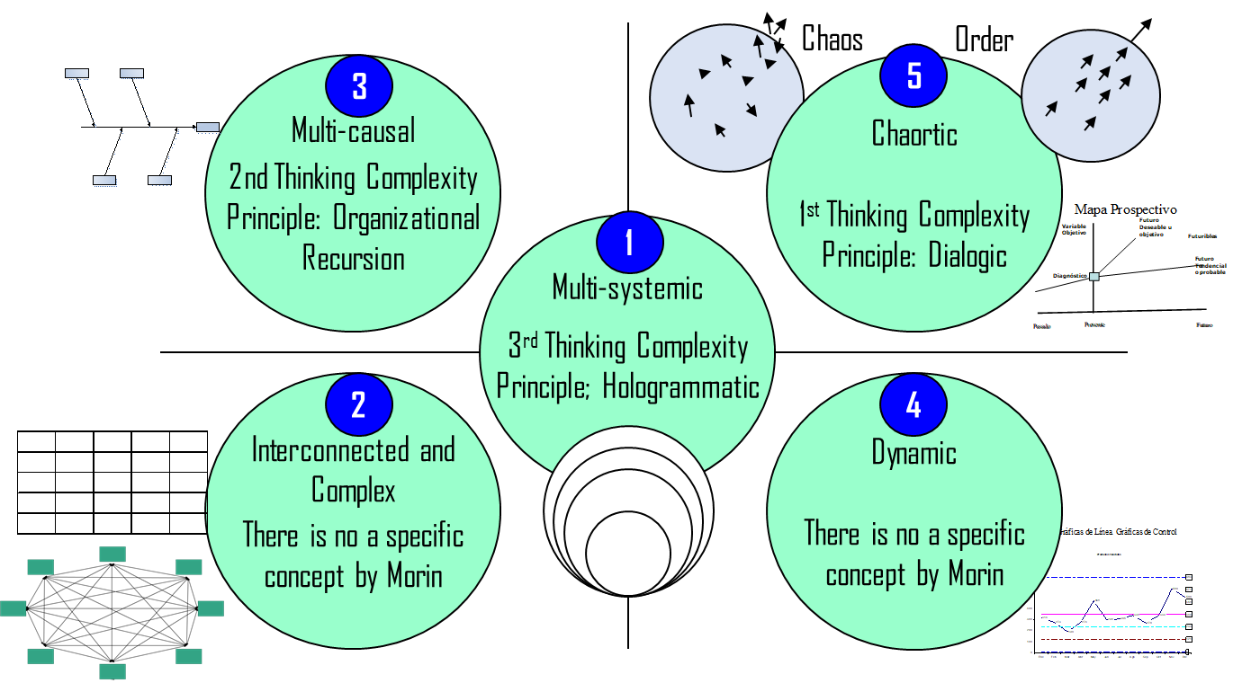

Source. Serbolov, Yuri comp. ed. and author. *Modelo Universal de Gestión del Conocimiento y Percepción Prospectivo Estratégico*. México, 2008. Digital file. Indautor 03-2008-081511360200-01.

#### Analogic and Logic maps.

In general, we classify all our set of maps in two basic groups: 1) **Analogic maps[16]**. They are flexible based on free drawing. Map and reality are made simultaneously. As examples, we can mention **Mind** and **Conceptual Maps**, 2) **Logic maps** are made *a priori*. First the map, then the reality in it. We must adapt our reality to them. They are necessary to structure orderly and systematically our information. One classical map is the **Cartesian Map** of quadrants that we use in algebra. Positive numbers are located at right side on X axis, and at top side on Y axis; negative numbers are located at left side on X axis, and at below side on Y axis. We have X, Y coordinates: i) +X, +Y (top and right quadrant), ii) –X, +Y (left and top quadrant), iii) -X, -Y (left and below quadrant), and iv) +X, -Y (right and below).

In both cases, levels of complexity can increase and, in some cases, they can be hybrid maps.

An example of **hybrid map** is the **Interactions Map[17]**, a development of **Six Sigma[18]** paradigm of quality.

Figure 12. Interaction Map by Six Sigma paradigm of quality.

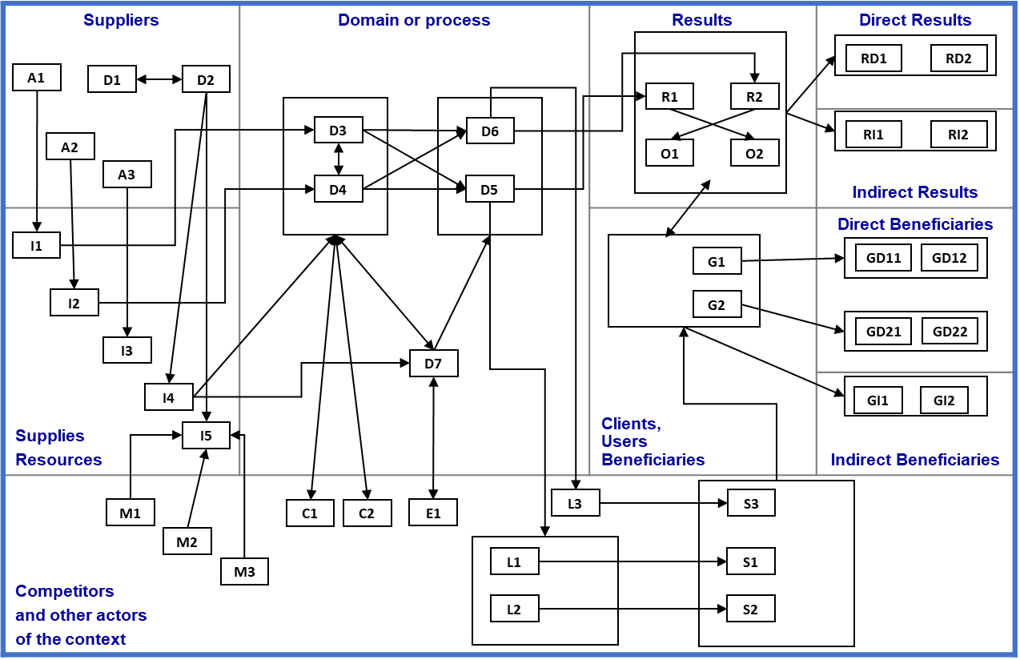

Source. Own elaboration based on Six Sigma paradigm.

This map is an interesting extension of the traditional three dimensions process map: inputs (supplies and resources), domain or process and outputs (products or results). It incorporates two hybrid (internal and external) dimensions: i) suppliers / resources and users, and ii) an external dimension (in this case, it is a part of its supra-system) which includes competitors and other actors of the context. Additionally, it disaggregates results and beneficiaries in both direct and indirect. This map is hybrid because it has ten fixed logical dimensions –suppliers, supplies, domain, results in general, direct results, indirect results, beneficiaries in general, direct beneficiaries, indirect beneficiaries and competitors (including external actors)- and, at the same time, interactions of elements freely drawn. As we can see, arrows can cross their logical “frontiers” in order to show the complexity or their multiple connections.

#### The Aristotelian Map: a special case

**The Aristotelian Map[19] is a fundamental development of the Knowledge and Intelligence Management Model**. Next, we explain its building process and some uses.

Figure 13. Path in quadrants of original Cartesian Map.

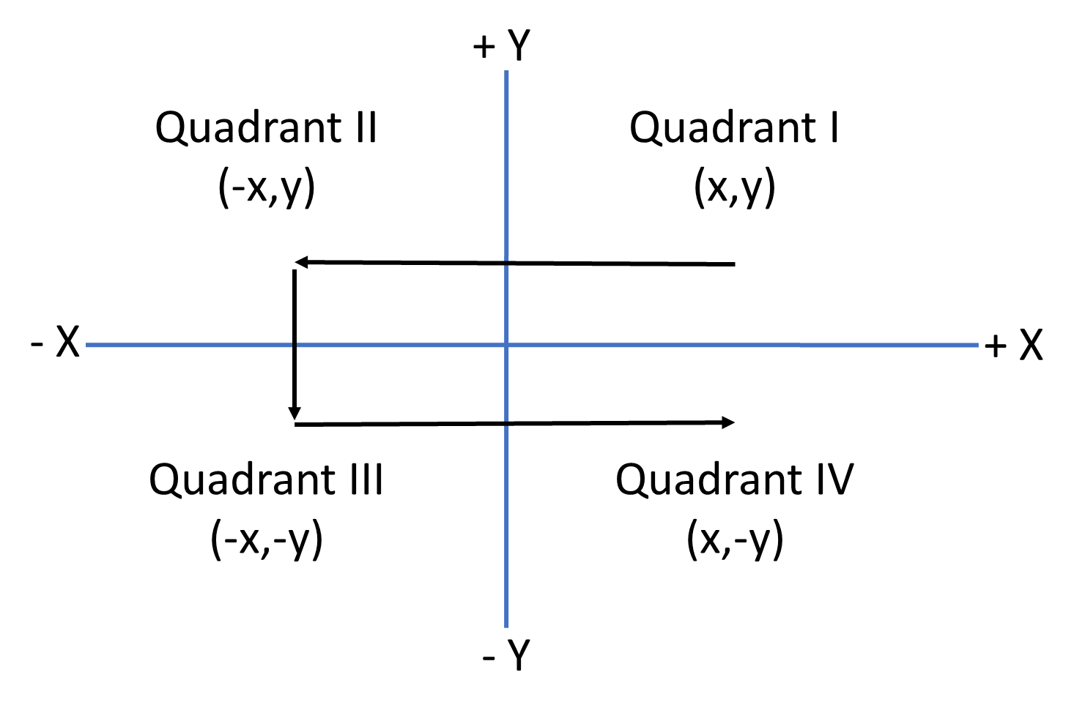

Source. Own elaboration based on traditional Cartesian Map.

Figure 14. Building the Aristotelian Map. The first step: changing the path of Classic Descartes Map by using binary mathematics.

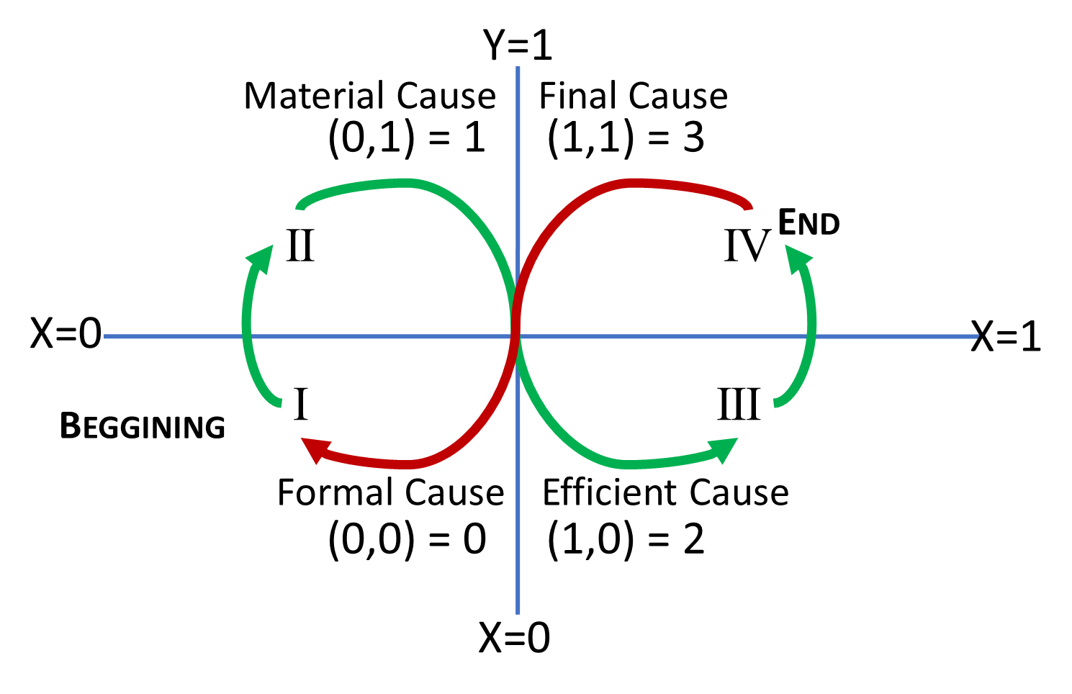

Source. Own elaboration based on Serbolov, Yuri comp. ed. and author. *Modelo Universal de Gestión del Conocimiento y Percepción Prospectivo Estratégico*. México, 2008. Digital file. Indautor 03-2008-081511360200-01.

As we can see in two previous figures: we used a Cartesian Map as a base, but me made important changes in its path, i) we worked with binary logical by using numbers 0 and 1, ii) due to mathematical conventionalisms, in Cartesian Map, we placed minor numbers on left side of X axis and major numbers on right side of X axis; minor numbers were placed on the below side of X axis and major numbers were placed on the top side of Y axis, iii) we placed the coordinates X,Y and, through binary mathematics, we calculated their values in Arabic numbers. Thus, we got (0,0) = 0, (0,1) = 1, (1,0) = 2 and (1,1) = 3, and iv) In consequence, the path and colocation of quadrants is different to original Cartesian Map. It has a path alike infinity symbol.

Now, in next figure, we added the Potential Cause.

Figure 15 Building the Aristotelian Map. The second step: Adding The Potential Cause.

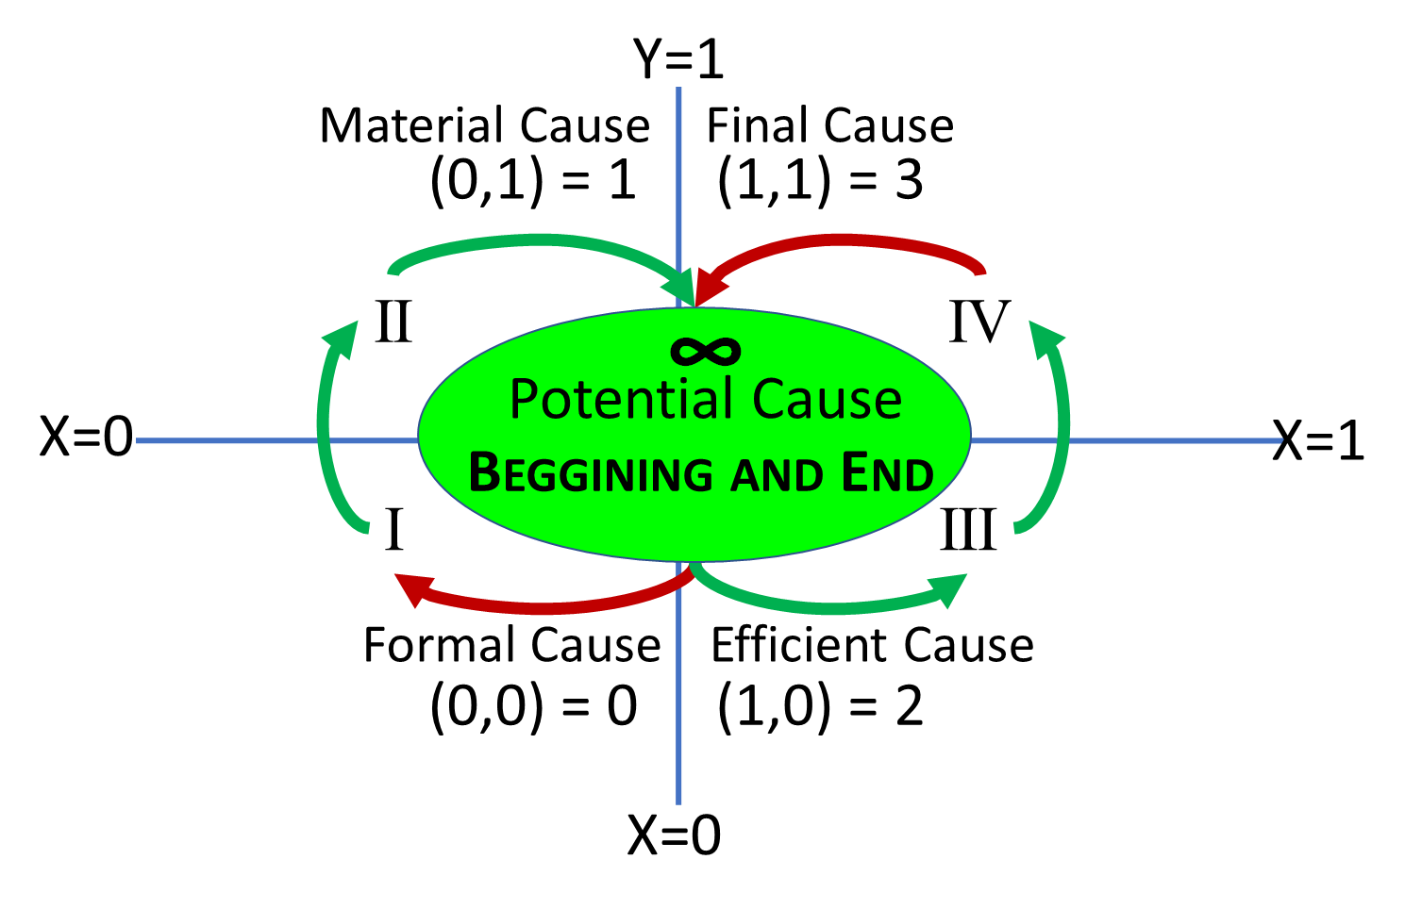

Source. Own elaboration based on Serbolov, Yuri comp. ed. and author. *Modelo Universal de Gestión del Conocimiento y Percepción Prospectivo Estratégico*. México, 2008. Digital file. Indautor 03-2008-081511360200-01.

The Potential Cause is located at the center. It means “Why” or “The Reason Why”, the justification of everything what we do. Its path or route follows the infinity symbol.

The relationship between spiral growing of knowledge and complexity of Aristotelian Map is showed next.

Figure 16. Relationship between spiral growing of knowledge and complexity of Aristotelian Map.

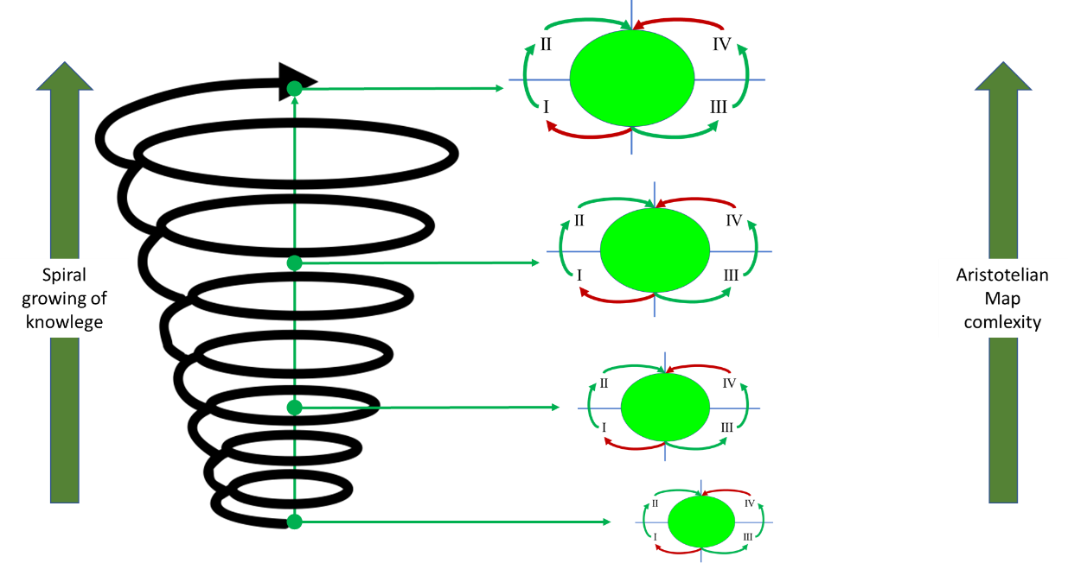

Source. Own elaboration.

This means, we can use the Aristotelian Map in several levels of complexity by adding in the causes’ spaces new information and/or more variables or details. It goes from general to particular. Examples:

Figure 17. A guide of the lowest level of Aristotelian Map complexity.

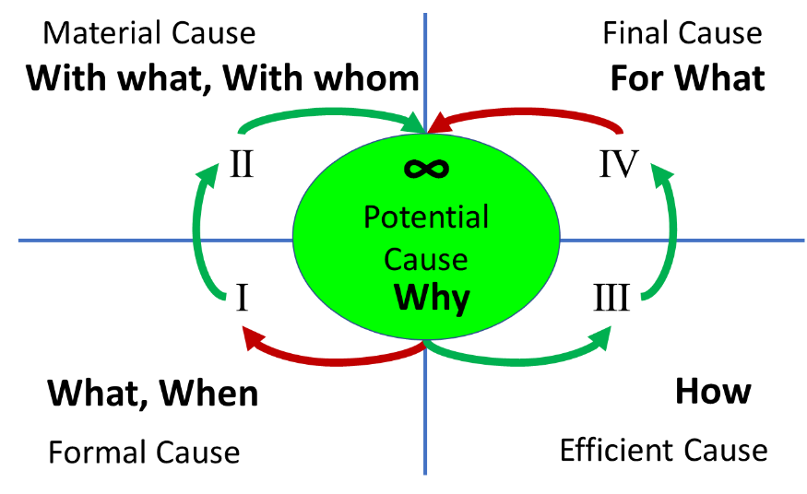

Source. Own elaboration based on Serbolov, Yuri comp. ed. and author. *Modelo Universal de Gestión del Conocimiento y Percepción Prospectivo Estratégico*. México, 2008. Digital file. Indautor 03-2008-081511360200-01.

This first map can have the basic information for a project, a thesis, a researching, an essay, an academic article, even a book.

The next map adds complementary information.

Figure 18. An example of specific content in an Aristotelian Map.

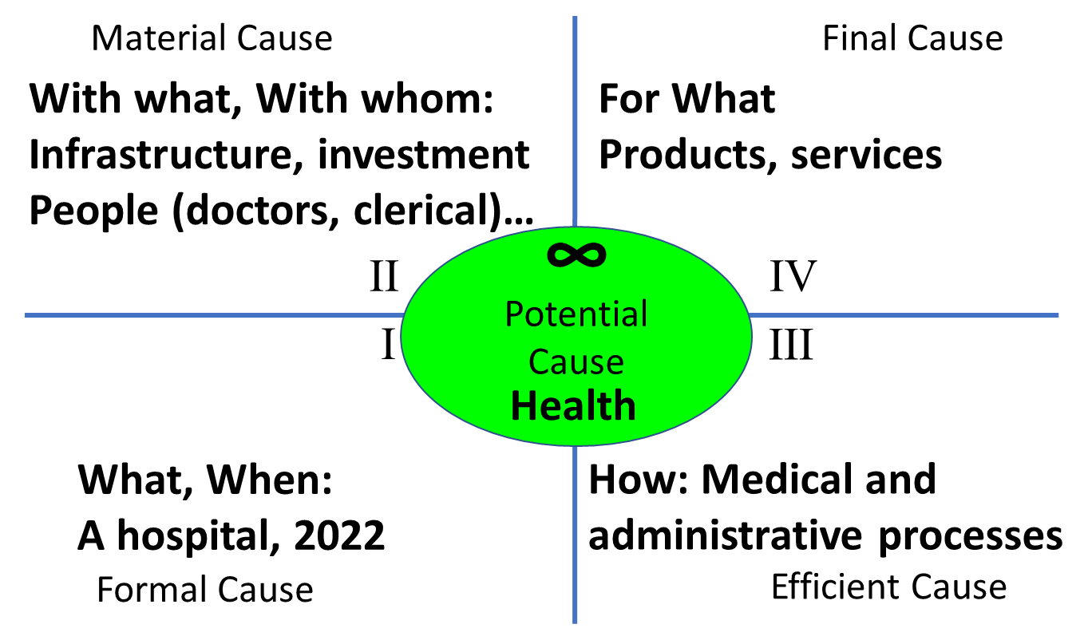

Source. Own elaboration based on Serbolov, Yuri comp. ed. and author. *Modelo Universal de Gestión del Conocimiento y Percepción Prospectivo Estratégico*. México, 2008. Digital file. Indautor 03-2008-081511360200-01.

This second map that has more topics can be used in a project, such a development about health.

Next, we can see one of the more complex Aristotelian Maps

Figure 19. Example of an advanced Aristotelian Map with 14 dimensions.

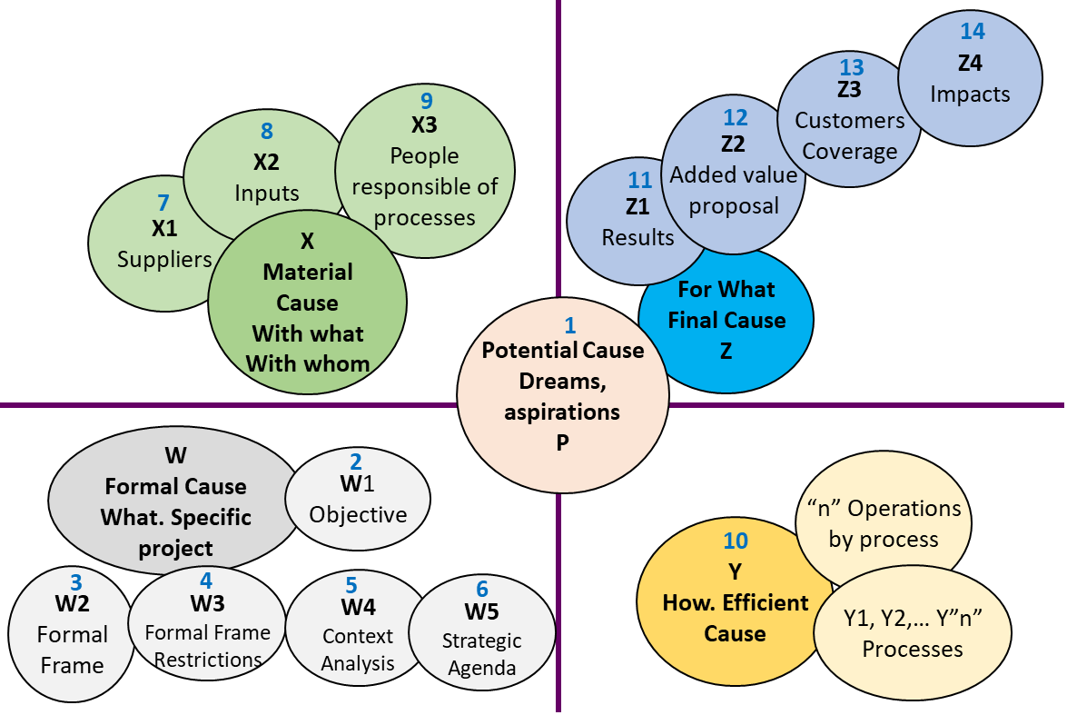

Source. Own elaboration based on Serbolov, Yuri comp. ed. and author. *Modelo Universal de Gestión del Conocimiento y Percepción Prospectivo Estratégico*. México, 2008. Digital file. Indautor 03-2008-081511360200-01.

This map gives much more accurate information by incorporating more dimensions, sub-dimensions and variables, even more Aristotelian Maps in it. It is used in Participative, Strategic and Operational Planning, as well as in the real operation, in its follow-up, monitoring and control.

We have been used this map successfully in any kind of projects, such as: political, social, organizational and educational, among others, in either private, public or non-profit companies.

As we can see, causes have been coded with letters. P = Potential Cause, X = Formal Cause, X= Material Cause, Y = Efficient Cause and Y = Final Cause. Let’s see each one:

**P = Potential Cause[20]** contains the vision of future expressed in aspirations, needs and dreams. It is highly related to Participative Planning, which includes consultation to beneficiaries, via surveys, interviews, documental and field researching

**W = Formal Cause** has four dimensions:

**W1 = Objective[21]**. It has the classic statement: an infinitive verb + “what” + “for what.” The use of “With what” is optional. Example: To evaluate the components, processes and results of Educational Mexican System in order to improve its quality.

**W2 =** **Formal Framework[22]**. It is an Aristotelian Map that includes four frameworks: 1) Consensual and Political Framework (agreements and negotiations previous to laws), 2) Legal Framework (set of laws, such as: the Constitution, laws and specific regulations), 3) Institutional Framework (infrastructure, organization charts, manuals, procedures), 4) Budget[23] Framework (economic resources, physical and digital spaces, materials, people). Formal Framework is the sum of we can do and all we really have.

**W3 =** **Formal Framework’s Restrictions[24]**. It is the Aristotelian Map opposite to Formal Framework, it means, it is all we cannot do and all we really don’t have in order to reach our purposes: 1) Consensual and Political Restrictions (disagreements, resistances), 2) Legal Restrictions (outdated laws, lack of laws and/or regulations), 3) Institutional Restrictions (insufficiency or lack of infrastructure, resources, manuals, procedures, organization charts), 4) Budget Restrictions (insufficiency or lack of money, physical and digital spaces, materials, people).

**W4 = Context analysis[25]**. It is the punctual description of what is happening in all realities related uniquely and strictly with the project, in its inside and its outside, such as: Economics (inflation, crisis…), Technology (hardware, software), Energy, Ecology (Climate Change), Culture and Society (conflicts, progress, regressions, social activism…), Health (COVID), Politics (war, agreements and disagreements), Infrastructure (roads, freeways, transportation), National and International Institutions (United Nations Organization, Senate…) Competitors, etcetera.

**W5 = Strategic or Changes Agenda[26]**. It is built just when we have known what we can do and what we really have (Formal Framework), what we cannot do and what really don’t have (Formal Framework’s Restrictions) and what is happening in our project and around it. It is necessary to build or rebuild the Formal Framework by adding the changes that restrictions (W3) and context (w4) demand.

**Eight Dimensional Process Map[27], composed by X = Material Cause[28]** (second quadrant), **Y = Efficient Cause[29]** (third quadrant) and **Z = Final Cause[30]** (fourth quadrant) are the traditional components of Process Map X, Y and Z or inputs, transformation and outputs that we show next:

Figure 20. Eight Dimensions Process Map.

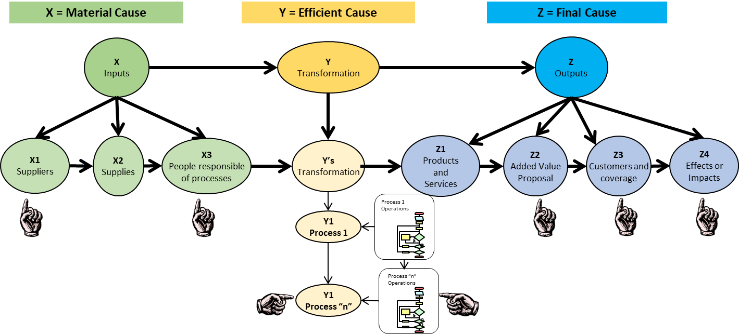

Source. Own elaboration based on Serbolov, Yuri comp. ed. and author. *Modelo Universal de Gestión del Conocimiento y Percepción Prospectivo Estratégico*. México, 2008. Digital file. Indautor 03-2008-081511360200-01.

We drew a hand on the additions we did. We added suppliers (X1) and people responsible of processes (X3). This complete the notion that supplies are given by other people (internal and/or external suppliers) and they are worked for other people (employees and/or external people). On Y dimension, we added process that convert inputs in outputs, and their respective operations, usually represented by **flow charts[31]**. We can have many processes, from 1 to “n”, and every processes can have several operations. After transformation of inputs, we have to the classic output: Products and Services (Z1). We added three more sub-dimensions. The first one, is a proposal of added value (Z2). Products and services must have it. If it is a private company, this added value comes from incorporating in its products and services its comparative or competitive advantages in order to outperform the competition. If it is a public or non-profit company, the added value comes from its proposal of satisfying the citizens’ needs, of accomplishing their highest personal and social aspirations, and it turns in legitimacy. The second one, it is about the products and services’ delivering to clients and places (Z3) where clients and citizens will evaluate the added value proposal. The third one, must show that everything we do or produce will have a wide variety of desired, undesired, direct and indirect effects or impacts (Z4). Besides benefits (e.g. direct and indirect new employments or comfort), everything we do can produce unintended effects, such as pollution or illnesses.

X, Y and Z dimensions of this Aristotelian Map represent the value chain of a company, project, even a social or political phenomenon.

This Aristotelian Map can be used in any kind of phenomena and it is important to say that it is not a rigorous sequence of steps or stages from P to Z. We can have a different order and simultaneous events. Let’s see one example. If we talk about elections, we have politicians, people, political parties (X3), who have tangible and intangible supplies (X2) -e.g. speeches, plans, slogans, caps, t-shirts and banners- provided by suppliers (X1) -e.g. intellectuals, books, factories and stores-. All of them make processes (Y) such as rallies, debates and voting. The candidates give to people a proposal of added value that is allegedly superior to their rivals (Z2). They spread their messages to the whole country and all the people, specially their supporters (Z3). They, their speeches, their supporters and their opponents can produce positive or negative effects in advance or after elections (Z4). The result (Z1) is a victory or a defeat. As a precedent or even simultaneously, an election has a goal (W1) and takes place under a Formal Framework (W2) or against it (W3 = Formal Framework Restrictions) -e.g. Rule of Law or a lack of it, agreements and disagreements, budget, a physical or virtual space-, in the middle of a determined context (W4 = Context Analysis) that leads to changes (W5 = Strategic Agenda).

The Aristotelian Map contributes to mapping the whole picture of any reality, it means, it contributes to critical and complex thinking with proved tools.

#### State Theory.

**State Theory**[32] is an external paradigm that we must use frequently. Regardless of individual and collective conceptions, the variety of cultures, politics, societies, worldviews, religions, beliefs, etcetera, all the countries worldwide are organized under a human construct called “State”. Regimes can be democratic or dictatorial or oscillate between both of them, they can be religious, atheist or agnostic regimes, they can have a free market, statist or mixed economy and they can have elections (alternation in power) or rulers with a prolonged stay on power, with distinct kind of freedoms and oppressions. All the countries have institutions, even strong, middle or weak, and their societies have a determined way of organization. All of them are States with different characteristics. Everything we do is regulated fairly or unfairly (depending on our particular visions) by the State. Therefore, understanding the reality, having critical, complex and structured thinking requires and means working through the knowledge of the State role. Any kind of projects, companies or phenomena are subjects of regulations.

The Knowledge Management Model agrees with Manuel Castells’ definition: “The State is a political organization, an independent power externally and a supreme power internally.” These internal and external powers are quite different in worldwide. However, we can illustrate the paradigm of the Occidental State as follows:

Figure 21. State Theory. A representation of an Occidental State.

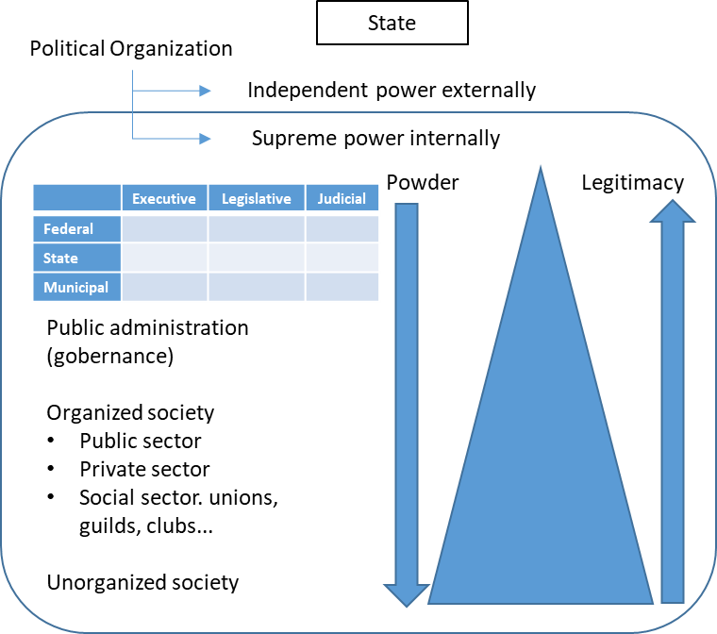

Source. Own elaboration based on Serbolov, Yuri comp. ed. and author. *Modelo Universal de Gestión del Conocimiento y Percepción Prospectivo Estratégico*. México, 2008. Digital file. Indautor 03-2008-081511360200-01.

* 1. The definition “The State is a political organization is an independent power externally and a supreme power internally” comes from Enríe Prat de la Riba (Catalan identity), cited by Manuel Castells in his book “Information Era: Economy, Society and Culture. Volume II. The Power of Identity”, Mexico, Siglo XXI, 2001.

#### Management Theory.

**Management Theory[33]** is an external paradigm involves all types of organizations: public, private and non-profit. All of them have to work in **Planning**, **Organizing**, **Directing**, **Operating**, **Controlling** and **Informing**. Planning has three phases:

11.1) **Participatory Planning[34]**, which consists of making an ally of our target audience or our objective public (customers, clients, citizens). We must aim our enforcements to accompany them in achieving their visions of future. Depending on the project, we will visit them in their homes, communities or cities to gather information via conversations, surveys, interviews, questionnaires. After exploration, identification of needs, description and correlation of related variables we can explain the situation and propose, for instance, a project of intervention.

11.2) **Strategic Planning[35]** is the construction of the big picture about our project. We have to describe the current situation inside and outside of it (endogenous and exogenous), its past (retrospective) and the future we want to build (prospective). We have made an own Model called **General Timeline for Strategic Planning[36]**, that applies to any project.

It is very important to emphasize that all next steps belonging to 12.2 point are not strictly sequential. Most of them must have worked simultaneously.

Figure 22. General Timeline for Strategic Planning.

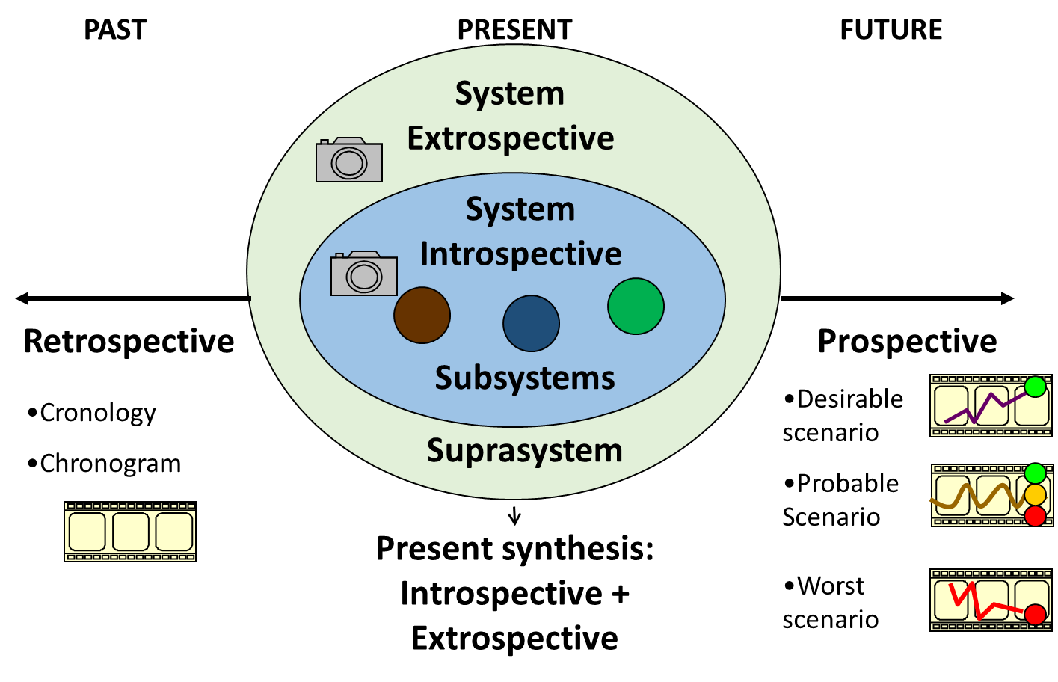

Source. Own elaboration based on Serbolov, Yuri comp. ed. and author. *Modelo Universal de Gestión del Conocimiento y Percepción Prospectivo Estratégico*. México, 2008. Digital file. Indautor 03-2008-081511360200-01.

Present, or current situation, is like a photograph. Paste narrative is like telling the movie on how we have arrived to current, concrete and specific situation. Future are the possible future movies or scenarios we can arrive as a result of our planning and actions.

When analyzing the past it is highly recommendable to work on a **Multidimensional Timeline**[37] with several horizontal dimensions or levels related with the main topic, and work on three vertical dimensions: present, past and future. That allows to make horizontal and vertical analysis. Let’s see an example of a timeline about COVID-19 pandemic.

Figure 23. Multidimensional timeline.

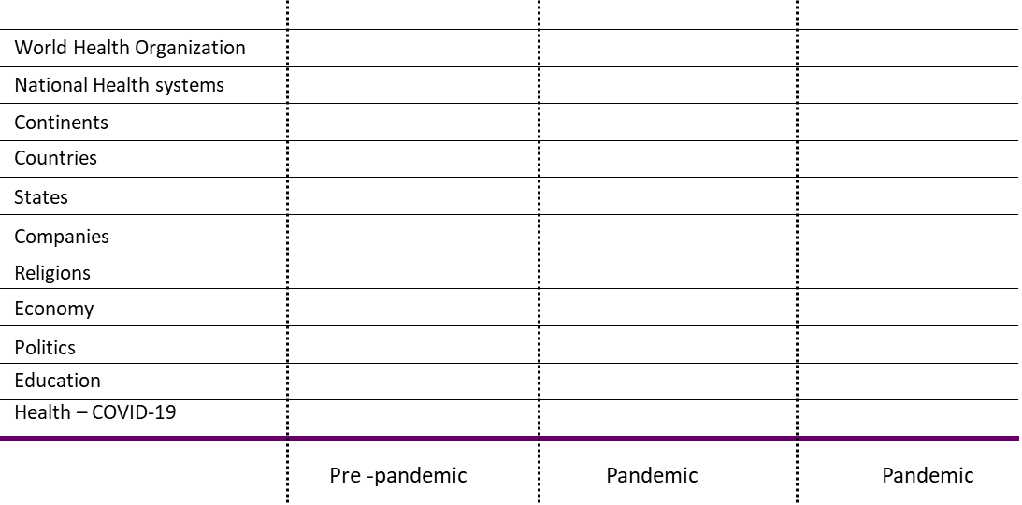

Source. Own elaboration based on Serbolov, Yuri comp. ed. and author. *Modelo Universal de Gestión del Conocimiento y Percepción Prospectivo Estratégico*. México, 2008. Digital file. Indautor 03-2008-081511360200-01.

The main topic, COVID-19, is on the lowest level. The next levels above it are dimensions related with it. The most important is just including culminating events, booms and crisis. It is better starts with current situation: the present. At this point, the Aristotelian Map must have all important and critical information. Then we can cross information on the COVID-19 with other levels:

The analysis about present is focused in topics like: What is COVID-19? What are its symptoms? What is the difference between infection and illness? What are the effects or beliefs, perceptions and religions? Which have been the actions to face pandemic (mask, distance, lockdown, flattening the curve? How pandemic is affecting economy? What the World Health Organization is doing? What the world are doing? How about vaccination? How about producers of vaccines? Why some people are anti-vaccination? What are the effects on politics?

Retrospective must respond on aspects like: Health of people (diabetes, obesity, hypertension…), capacity of hospitals, geographic and economic conditions to make decisions (lockdown, flights), among others.

Prospective can make scenarios of evolution post-pandemic. It responds to the question “What if”?

On this works we can use **Delphi Method[38]**, **Logical Framework Methodology[39]**, **Internal and Externals Actors Map[40]** to reinforce elements of P, W, X, Y and Z dimensions of the Aristotelian Map worked in point 10. **Delphi Method** is known as well as **Expert Consultation Method**. Through this method we can gather information and evaluations of critical and specialized aspects.

Logical Framework Methodology has two opposite trees: the problems tree and the solution tree:

Figure 24. Trees of problems and solutions, belonging to Logical Framework Methodology.

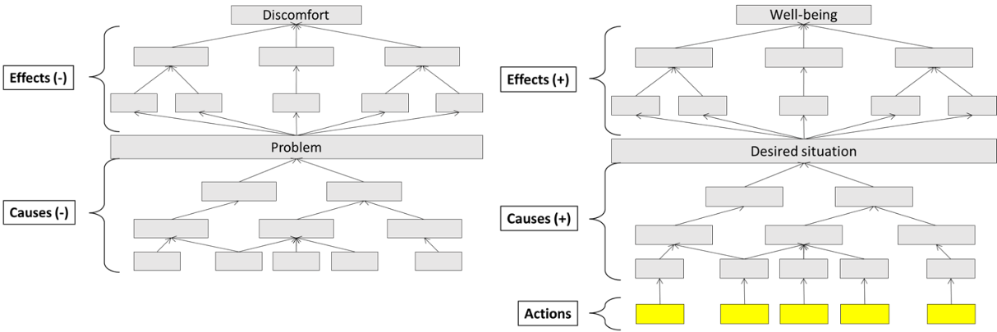

Source. Own elaboration based on Logical Framework Methodology.

As we can see, first, we have the problem in the center of the tree. Below it, we have causes and causes of causes. Above it, we have chained effects and the big negative effect on top. The solutions tree has the same number of squares with antonyms. On the base we put the actions that chain positive causes that lead to a desired situation and positive effects that end in well-being.

In real life, there are allies, opponent, active, passive and neutral actors. It is very important to locate their positions to be elements of making decisions when facing determined situations. This is our Internal and External Actors Map:

Figure 25. Internal and External Actors Map.

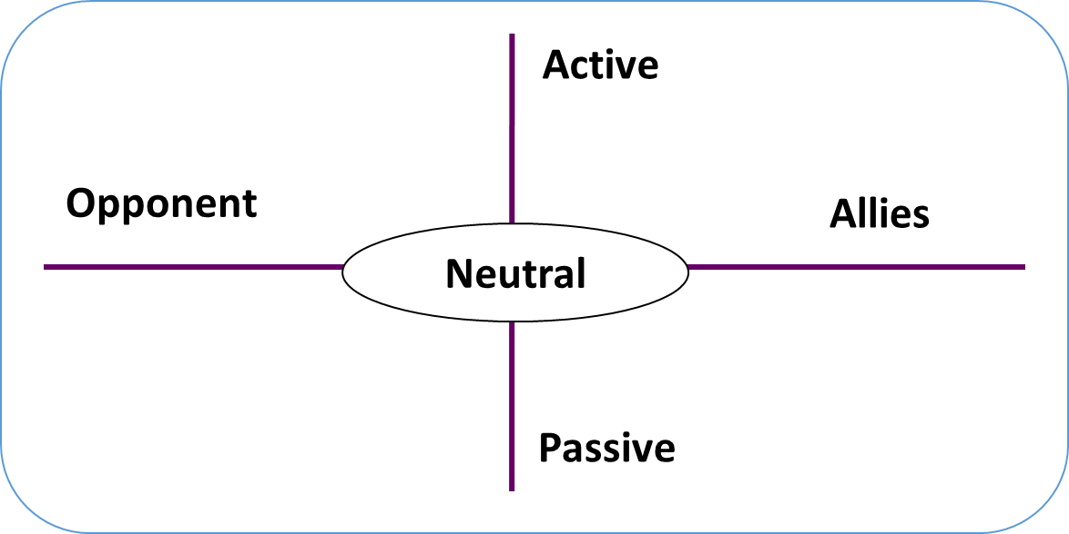

Source. Serbolov, Yuri comp. ed. and author. *Modelo Universal de Gestión del Conocimiento y Percepción Prospectivo Estratégico*. México, 2008. Digital file. Indautor 03-2008-081511360200-01.

All the above gives us inputs to make a **Risks Matrix[41]**. A risk is an event that can hinder or prevent the fulfillment of our purposes. Usually, a map risk gives us information to identify the likelihood of project risks and the potential impacts caused by those risks.

Figure 26. The typical Risk Matrix.



Source. Own elaboration based on known Map of Risks (public domain).

This matrix allows us to focus on yellow, orange and red colors, mainly. Before, we need to fill up list of risks like next:

Figure 27. Table of risks and impacts.



Source. Own elaboration based on known Map of Risks.

Now, it is time to make a diagnosis. There are several tools. The **Pondered SWOT[42]** (Strengths, Weaknesses, Opportunities and Threatens) is an own tool. As we know, the SWOT Model has two balances: the exogenous balance and the endogenous balance. We added two components: a vertical weighting called Importance and a horizontal weighting called Probability.

Next, we have an example on how Opportunities dimension must be worked:

Figure 28. How to weight SWOT dimensions. Example with Opportunities dimension.

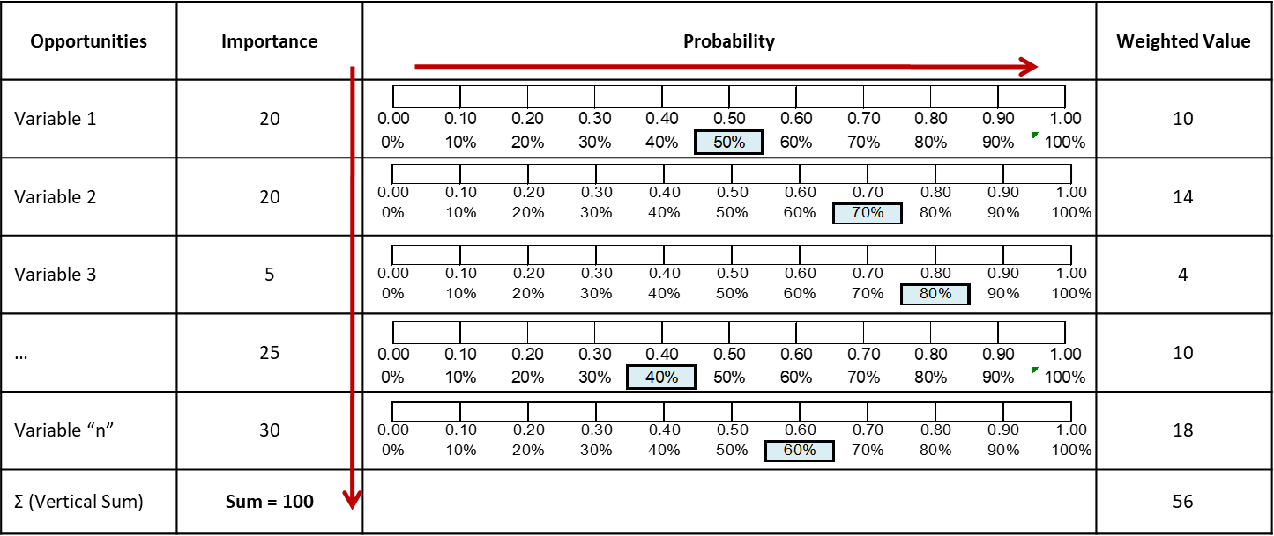

Source. Own elaboration based on Serbolov, Yuri comp. ed. and author. *Modelo Universal de Gestión del Conocimiento y Percepción Prospectivo Estratégico*. México, 2008. Digital file. Indautor 03-2008-081511360200-01.

When we weight vertically and horizontally we can have a clearer vision of analyzed variables. For instance, variables 1 and 2 have 20 points in column “Importance”, but “presence” or probability are different on both. Variable 1 has weighted 50% in probability. Therefore, the weighted value of variable 1 is 10 points. Variable 2 has been assigned weight of 70%. Thus, its weighted value is 14. Even though variables 1 and 2 have 20 points in column “Importance”, after horizontal weighting, they both have 10 and 14 points in “Weighted Value” column.

These steps must be repeated on Strengths, Weaknesses and Threatens.

Opportunities and Threatens are exogenous variables due we don’t have control over them. They must be placed on X axis. Strengths and Weaknesses are variables under our control. So, they must be placed on Y axis. That means, the result will be a position in a Cartesian Map like the following:

Figure 29. Example of a Position Graphic.

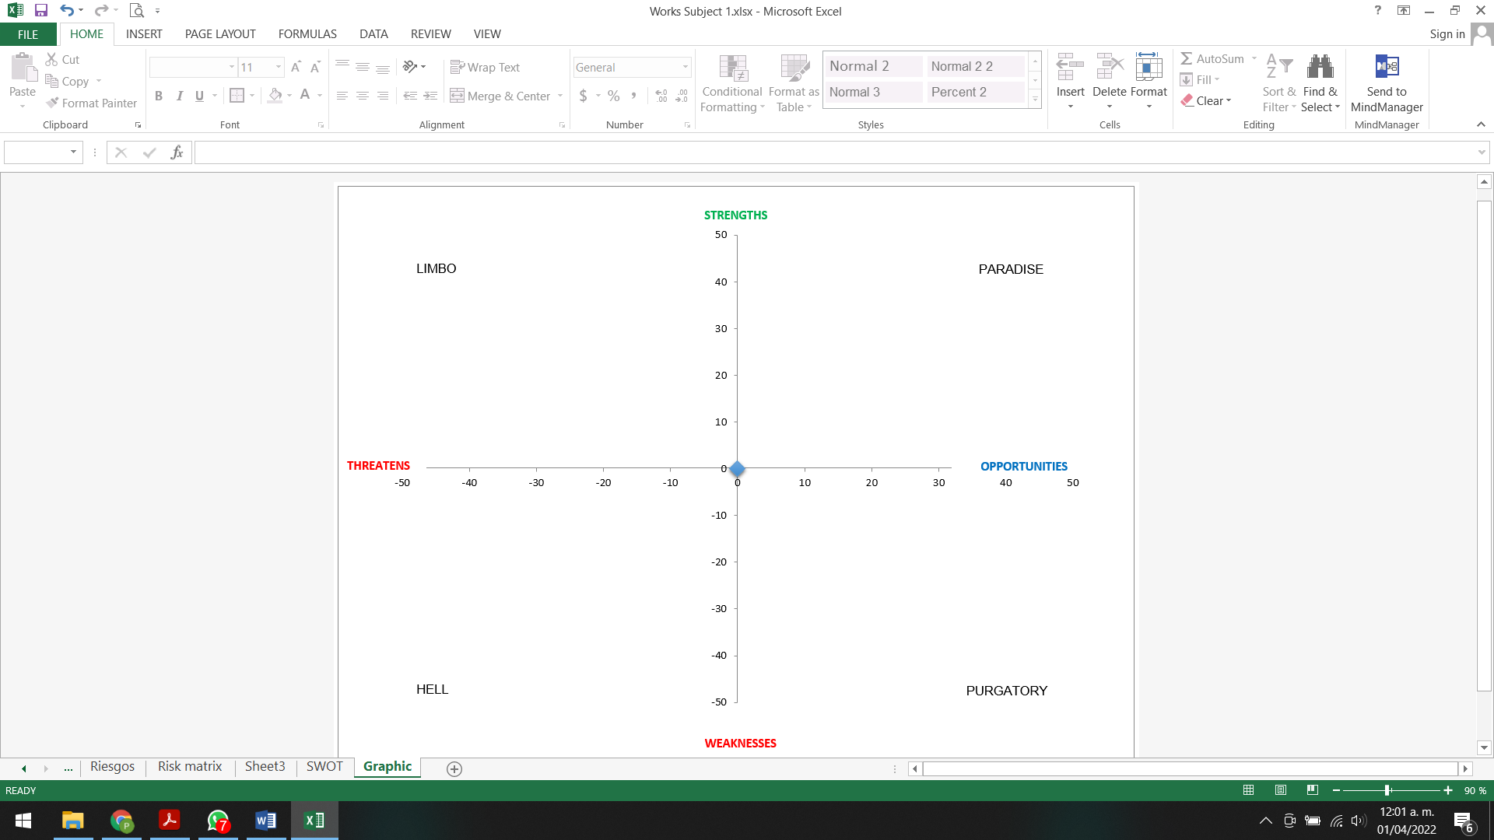

Source. Own elaboration based on Serbolov, Yuri comp. ed. and author. *Modelo Universal de Gestión del Conocimiento y Percepción Prospectivo Estratégico*. México, 2008. Digital file. Indautor 03-2008-081511360200-01.

Positions are calculated as it follows:

* On axis X, Strengths minus Weaknesses. The location will be on right side if the result is positive, or it will be on the left side if it is negative.
* On axis Y, Opportunities minus Threatens. The location will be on top side if the result is positive, or it will be on below side if it is negative.
* We will have a coordinate X, Y to be located on the Cartesian Map.

Let’s see a hypothetical case:

Figure 30. Example of an exogenous balance.



Source. Own elaboration based on Serbolov, Yuri comp. ed. and author. *Modelo Universal de Gestión del Conocimiento y Percepción Prospectivo Estratégico*. México, 2008. Digital file. Indautor 03-2008-081511360200-01.

The exogenous balance is positive because 78 (Opportunities) – 58 (Threatens) = 20. It means, X point will be located on the right side of axis X.

Figure 31. Example of an endogenous balance.



Source. Own elaboration based on Serbolov, Yuri comp. ed. and author. *Modelo Universal de Gestión del Conocimiento y Percepción Prospectivo Estratégico*. México, 2008. Digital file. Indautor 03-2008-081511360200-01.

The endogenous balance is negative because 75.5 (Strengths) – 85.5 (Weaknesses) = -10. It means, Y point will be located on the below side of axis Y.

The coordinate (X, Y) on Cartesian Map is (20,-10).

Graphic 1, Example of a Position Graphic.

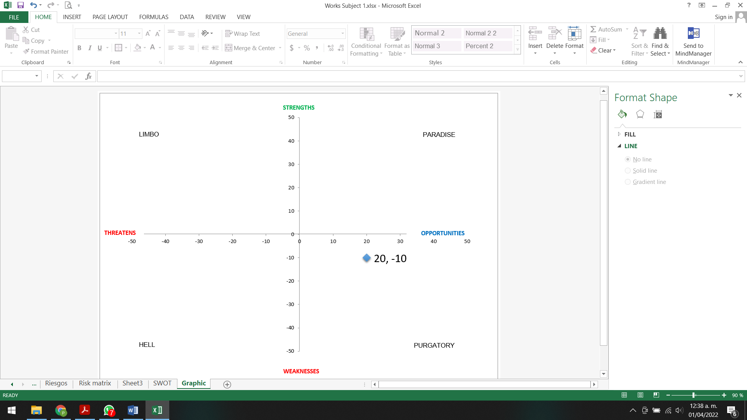

Source. Own elaboration based on Serbolov, Yuri comp. ed. and author. *Modelo Universal de Gestión del Conocimiento y Percepción Prospectivo Estratégico*. México, 2008. Digital file. Indautor 03-2008-081511360200-01.

This chart shows we have opportunities that we cannot take because of our weaknesses. We have to work on reducing our weaknesses and turning them into strengths.

Most of the times, due to we have facing a problem, coordinates of the Weighted SWOT will be located either on purgatory, limbo or hell. Exceptionally, the location will be on paradise when we have success and we want to be much better. In all cases, we have to make an interpretation and work in solutions.

Figure 32, Interpretation of a Position Graphic.

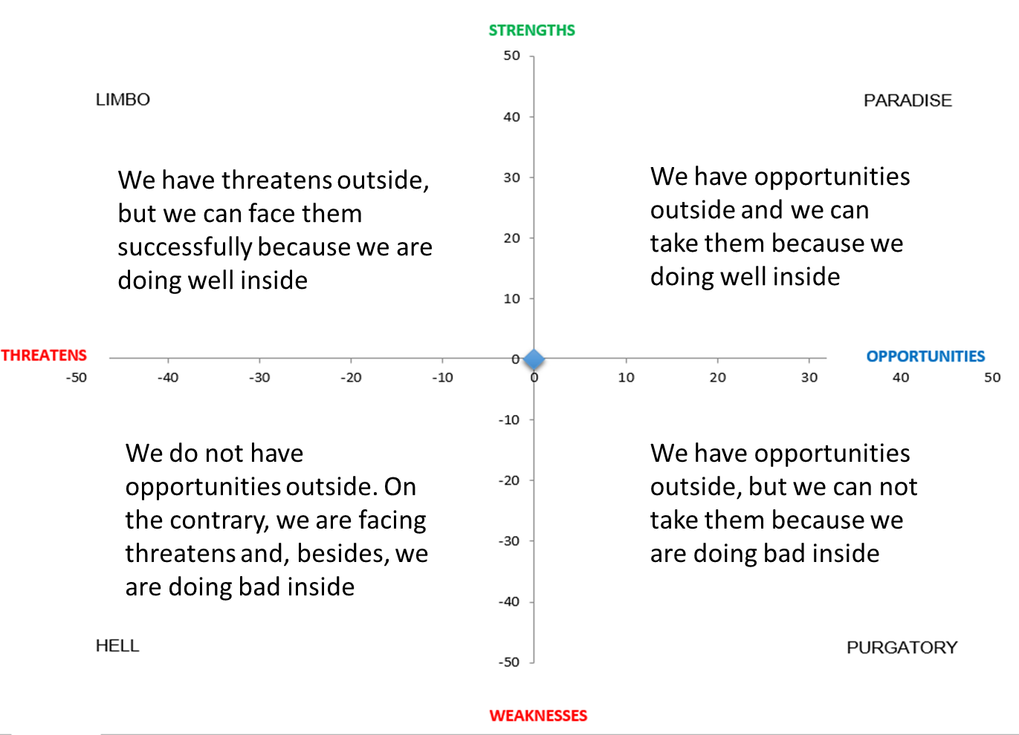

Source. Own elaboration based on Serbolov, Yuri comp. ed. and author. *Modelo Universal de Gestión del Conocimiento y Percepción Prospectivo Estratégico*. México, 2008. Digital file. Indautor 03-2008-081511360200-01.

Now, we have the big picture with pros and cons, contradictions and a diagnosis. All the things of Critical and Complex say we have to work… but without tools. It is time to make strategy.

Strategy is to determine how we are going to promote the forces in favor and counteract the forces against in order to reach the big proposals.

Besides the Solutions Three (Logical Framework Method), another ideal tool to make it is by using the **Balanced Scorecard[43] (BSC)**. This map has four levels or perspectives aimed to reach Mission (M), Vision (V) and Potential Cause (P) or aspiration.

The four BSC perspectives change depending on the kind of organization as we can see next.

Figure 33. The BSC Map to make strategy in a private organization.

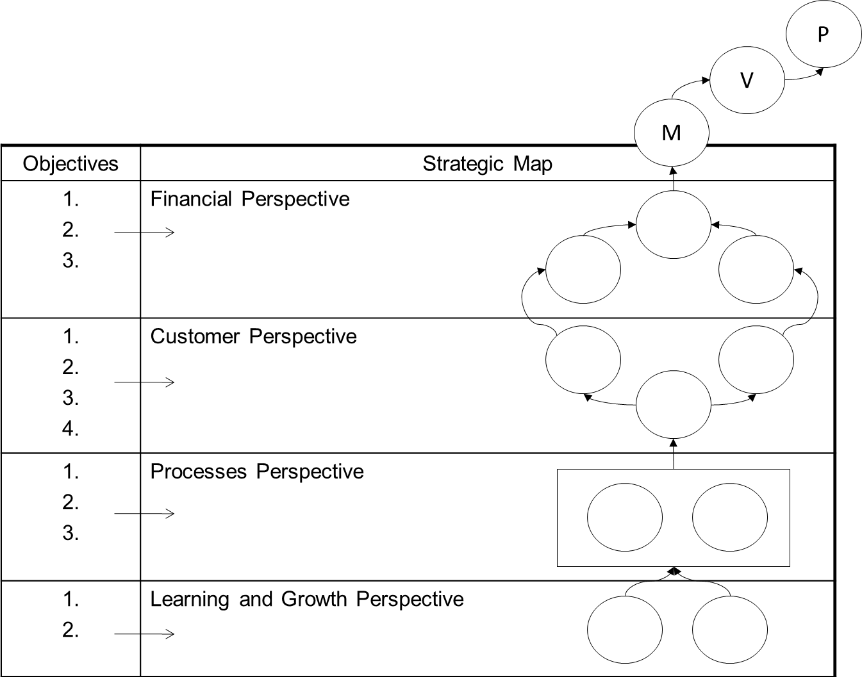

Source. Own elaboration based on BSC paradigm created by Robert Kaplan y David Norton.

Figure 34. The BSC Map to make strategy in a public and non-profit organizations.

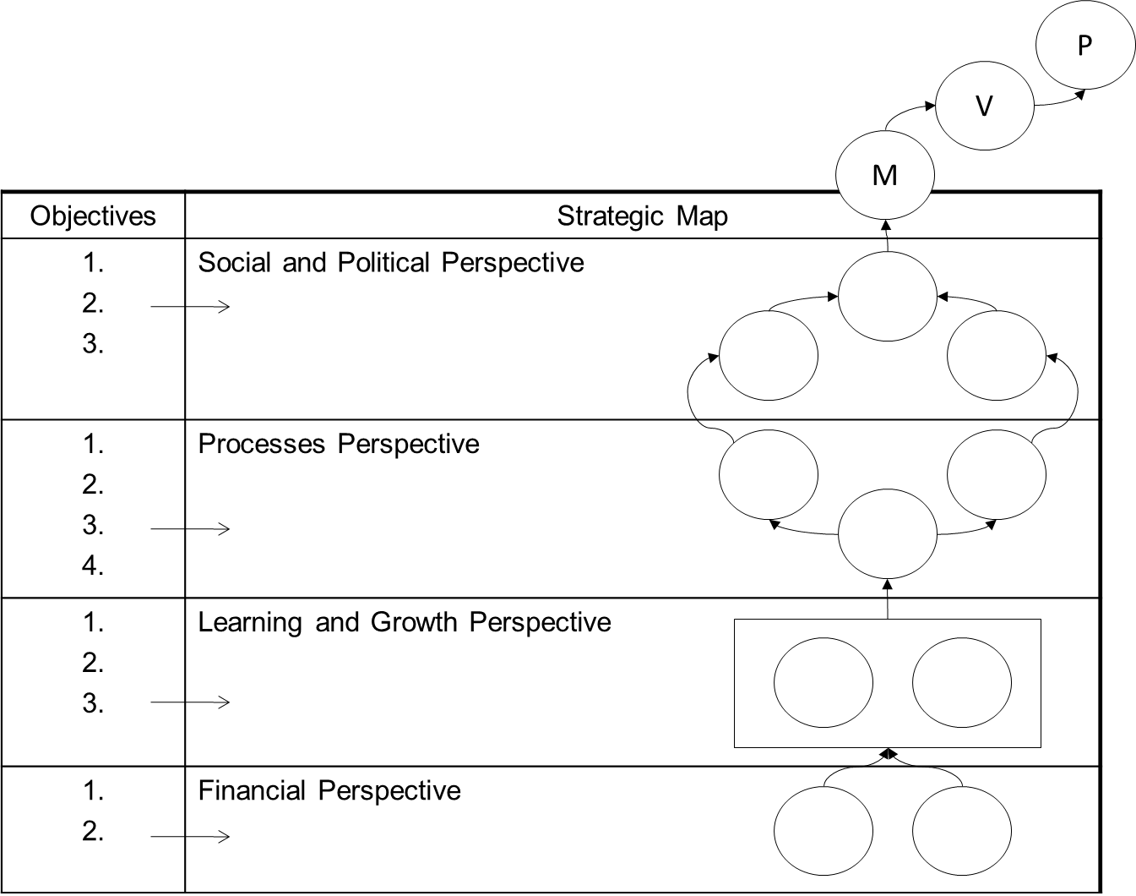

Source. Own elaboration based on BSC paradigm created by Robert Kaplan y David Norton.

11.3) **Operational Planning** prepares the routes of actions: organization chart, manuals, formats, goals, scheduling, budgeting. There are many tools, depending on the organization type -private, public or non-profit-, size –very small, small, medium, high, very high-, field of knowledge –politics, journalism, science, education, military, industry, ecology, economy, health, etcetera- and coverage: local, community, city, county, state, country, trans-national, continent, world. Structures and ways or organization will be quite different. However, all of them should use tools like a chronogram or a timeline showing how specific activities are distributed on time.

Figure . Chronogram.

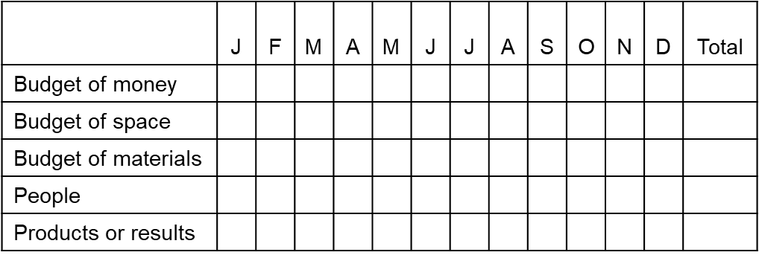

Source. Own elaboration.

11.4) **Implementing, processes, procedures, transformation of inputs into outputs**. There are many tools depending of the type and size of organizations. In all cases, Change Management is needed. Operation Management implies personal change or personal reengineering, processes reengineering, design, redesign, teamwork, motivation, self-motivation, satisfaction, and involvement, flowcharts.

Also, some private, public and non-profit companies could need quality certifications such as ISO 9000 or SIX Sigma, whose main dimensions are X, Y and Z belonging to Aristotelian Map.

All companies or projects will use quantitative or qualitative methods. Regardless their purposes, sizes, fields of knowledge and coverage, they could need analyze causes and effects of something specific. An Ishikawa Fishbone Diagram can be needed.

Figure 36. Ishikawa Fishbone Diagram.

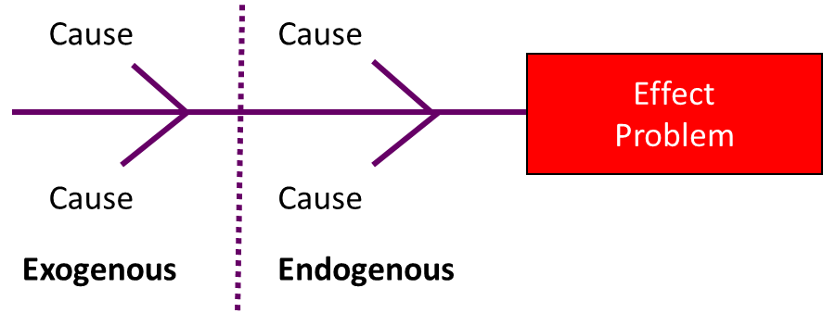

Source. Own elaboration based on Serbolov, Yuri comp. ed. and author. *Modelo Universal de Gestión del Conocimiento y Percepción Prospectivo Estratégico*. México, 2008. Digital file. Indautor 03-2008-081511360200-01.

Originally, this diagram was used in the industrial world and was related with machines and engineering. Nowadays, is quite useful in any kind of projects.

11.5) **Control, reports, indicators**. Finally, the Administration Theory ends with an extensive variety of controls, reports and indicators. We can have technical and executive reports, we can have indicators of efficiency, efficacy, effectiveness and productivity. We can have control, reports and indicators of all elements belonging to the Aristotelian Map.

The main idea is just including critical, important and aggregated indicators that can be disaggregated when necessary. That’s the principle of accountability: the traceability and traceability of information.

## Feedback between members of the Thinking Trilogy

Knowing the interactions between Structured, Critical and Complex Thinking will allow to have a solid basis to achieve our personal, professional and social pursuits.

Figure 37. Feedback of Structured Thinking, Critical Thinking and Complex Thinking.

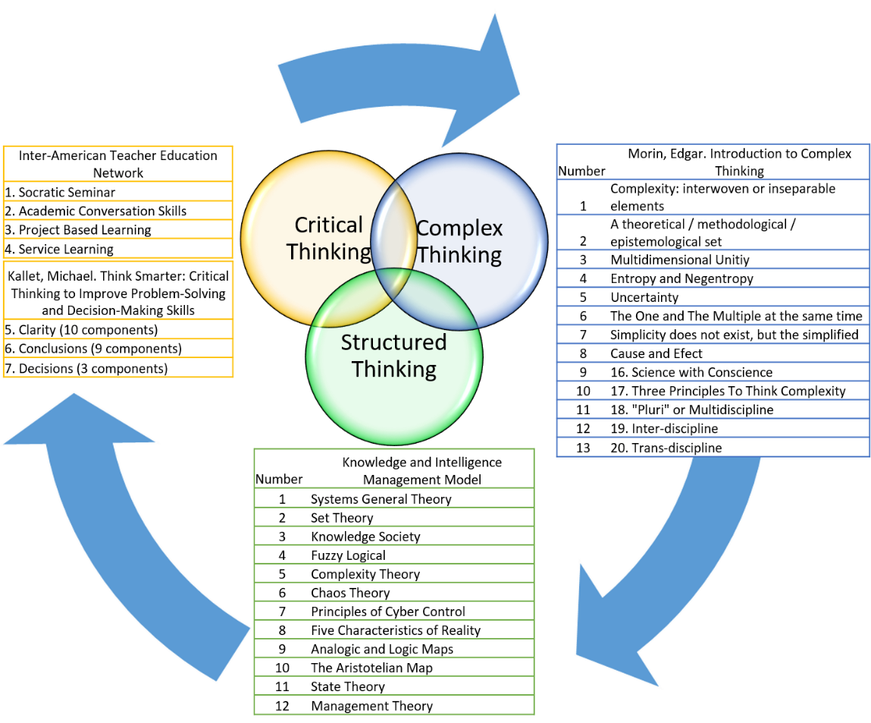

Source. Own elaboration.

# Conclusion

Critical Thinking is not enough to study the complex world, not even to study the field of Public Health. Thinking critically must be done, additionally, in both complex and structured way. We need to expand our horizons by connect it with other ways of thinking.

That is why we studied three paradigms –Critical Thinking, Complex Thinking and Structured Thinking- in order to clarify their similarities and differences. The first one, has remarkable authors and books all over the world, from different perspectives, such as: political, social, environmental, scholar and philosophical. The second one, is better known for having Edgar Morin, the called Father of Complex Thinking, as is maximum exponent.

The last one, is the less known. It has no book and this is a disadvantage. It has slides with copyright and many articles written in political magazines. Structured Thinking Corpus is much known in some Mexican universities, private, public and non-profit organizations. It has been applied successfully as a consultancy. This corpus belongs to Knowledge and Intelligence Management Matrix, which is included into the Knowledge and Intelligence Management Model. Currently, we are writing the Corpus’ books.

After a long process of reading, observing, reflecting, connecting experiences, analyzing, synthesizing and evaluating the documents located in “Works cited” section of this paper, we confirmed that Structured Thinking Corpus is comparable to Critical Thinking and Complex Thinking. Even more, we confirmed Structured Thinking can share and feedback its elements with mentioned paradigms. Structured Thinking can give them and received from them theories, topics, methodologies and methods… but we had to prove it… and we did it in this paper. We can give them what they are lack of and vice versa.

As a summary, we can say that 1) Most of American critical thinking has, besides a school vision, a commercial purpose as a basis; 2) In contrast, we have a European and mostly philosophical vision of Complex Thinking by Edgar Morin, known as the Father of Complex Thinking; 3) As a synthesis, since 1986 from now, Structured Thinking is an appropriate complement to Critical and Complex Thinking because it works on these extremes and between them.

Finally, it is quite important to say this first immersion in the world of thinking has given us the opportunity to build a basic Corpus to study this Doctorate in Public Health.

# Works Cited

Britannica, The Editors of Encyclopaedia. "Cybernetics". *Encyclopedia Britannica*, 10 Jun. 2021, <https://www.britannica.com/science/cybernetics>. Accessed 25 April 2022.

Castells, Manuel. *Information Era: Economy, Society and Culture. Volume II. The Power of Identity*. México, Siglo XXI, PDF file.

Inter-American Teacher Education Network. *Critical Thinking Toolkit*. Inter-American Teacher Education Network. 2015. PDF file.

Kallet, Michael. *Think Smarter: Critical Thinking to Improve Problem-Solving and Decision-Making Skills*. New Jersey: John Wiley & Sons, Inc., Hoboken, 2014. PDF file.

Morin, Edgar. *¿Qué es la transdisciplinariedad?* <https://edgarmorinmultiversidad.org/index.php/que-es-transdisciplinariedad.html#:~:text=%C2%BFQu%C3%A9%20es%20pluridisciplina%3F,espec%C3%ADfica%20sobre%20un%20campo%20determinado>.

Morin, Edgar. *Introducción al Pensamiento Complejo*. México. Gedisa, 2001. PDF file.

Ríos, Juan José. *Derecho e Informática en México: informática jurídica y derecho de la informática*. México. UNAM, Instituto de Investigaciones Jurídicas, 2016. PDF file.

Serbolov, Yuri comp. ed. and author. *Modelo Universal de Gestión del Conocimiento y Percepción Prospectivo Estratégico*. México, 2008. Digital file. Indautor 03-2008-081511360200-01.

Umpleby, Stuart. *Definitions of Cybernetics*. American Society for Cybernetics. 1982; revised 2000. <https://asc-cybernetics.org/definitions/#:~:text=Theory%2C%20Chapter%202)-,Stafford%20Beer,animate%20and%20inanimate%20systems%20indifferently>.

Universidad Nacional Autónoma de México. “XI. Teoría General de Sistemas”. Sisal. <http://www.sisal.unam.mx/labeco/LAB_ECOLOGIA/Ecologia_y_evolucion_files/XI.%20TEORIA%20GENERAL%20DE%20SISTEMAS.pdf>

1. With this name, cites and bibliography have been worked in this paper.
2. A version (an interpretation) of the Knowledge and Intelligence Management Model aimed to the business world called “Sistema de Gestión de Negocios: Signe” (Business Management System: Signe) has been worked in cites and bibliography in this paper.
3. “His (Edgar Morin) work must be conceived as a method that the reader is invited to use on his specific field of practices, more than a group of abstract formulations” (6).
4. Item 1.
5. Item 2.
6. Item 3.
7. Item 4.
8. Item 5.
9. Item 6.
10. Item 7.
11. Item 8.
12. Item 9.
13. Item 10.
14. Item 11.
15. Item 12.
16. Both analogic and logic maps belong to item 13.
17. Item 14.
18. Item 15.
19. Item 16.
20. Item 17.
21. Item 18.
22. Item 19.
23. Budget does not mean money uniquely. We can have budget of space, people, materials, and etcetera.
24. Item 20.
25. Item 21.
26. Item 22.
27. Item 23.
28. Item 24
29. Item 25.
30. Item 26.
31. Item 27.
32. Item 28.
33. Item 29.
34. Item 30.
35. Item 31.
36. Item 32.
37. Item 33.
38. Item 34.
39. Item 35.
40. Item 36.
41. Item 37.
42. Item 38.
43. Item 39.