GRACE KERUBO NYARANGO

STUDENT ID: UD74729BLES83444

COURSE NAME:
PhD IN SOCIAL PROTECTION

ASSIGNMENT TITLE:
DESIGNING AND IMPLEMENTING SOCIAL PROTECTION PROGRAMS

ATLANTIC INTERNATIONAL UNIVERSITY
JANUARY, 2022

Contents
1.0 Introduction 3
1.1 Importance of designing and implementing Social protection systems 4
2.0 Global Status on the design and implementation of social protection programs 7
3.0 Steps in designing a social protection Program 11
3.1 Coordination of the design and implementation of social protection system 16
4.0 Assessing the existing coordination mechanism 18
5.0 Lessons learnt. 20
6.0 Conclusion 20

Summary of the topics of discussion
- Definition of social protection systems
- Importance of coordinating the designing social protection systems
- How to design and implement social protection systems
- Coordination for the design and implementation of social protection system
- assessing the existing coordination mechanism
- improving coordination for the designing and implementing social protection systems
- How is this topic related to my studies at AIU
- How will I use the knowledge gained to improve my country and community
- Lessons learnt
- Conclusion

1.0 Introduction

Social protection has become one of the most recent discussed subject for the fact that they empower people to become more health and pursue their daily livelihood. With this in mind, many countries have seen the need to design programs and systems, put in place strategies and frameworks that are geared towards economic sustainability and wellbeing. This programs to be effective, inclusive and sustainable, proper planning and resources should be directed to the right people and the right time when they real need to be assisted. If this programs are well designed and implemented, may enhance productivity, reduce inequalities, build resilience, close inter-generational gap of poverty and finally, change the face of the world. For this to happen, it require institutions and administrative systems that are accountable, transparent and simple in design to allow for effective implementation.
Social protection programs include social insurance, social welfare, labor market interventions and social safety nets. It is a set of policies and mechanisms put in place by any government and community to safeguard its citizens from poverty and vulnerability of any nature. This has seen many countries putting in place interventions to mitigate against the risk of getting into joblessness and with a view to improve basic amenities such as health care, education of their children and help the aged to live a decent life. The designed programs are expected to contribute to economic growth of any country or society and enhance economic stability particularly income and wellbeing in families.
Some of the social protection mechanisms that have been put in place in many countries include systems such as cash transfers, food subsidies, feeding programs, schools based food programs to encourage children to attend classes, social health programs, and microfinance and price subsidies. Social protection program for example in in Philippines indicate a review of public expenditure programs with a view to redistribute income to the poor, vulnerable and marginalized groups. This has formed a priority agenda in the Pilipino government and has seen great improvement in the design and delivery of social protection programs. Consequently, poverty levels have drastically reduced (Charlotte justino Diakno Dicat and Ma. Alma, December 2018).
Social protection programs constitute policies that seek to reduce poverty, protect livelihood, employment, protecting individuals from loss of income and improving people’s capacity to manage risks. For this programs to work effectively a number of things must be done. For example the right identification of the beneficiaries must be done. There should be registration of the beneficiaries, assessment, enrollment and payment procedures in place. In most cases, the systems have been seen to exclude those that need the assistance, poor methods of data collection and complaints on mode of payment as well as delivery of the services. The registration process need to be simple and effective. This should be within reach to enable the beneficiaries to present themselves for registration and assessment of the need. There should be an eligibility criteria for registration to avoid arbitrary results among households. Ones an individual has been assessed they are registered to receive benefits. There should be accountability and transparency in all systems and processes of payment. A well-designed social protection system with proper procedures can result to effective implementation.

Importance of designing and implementing Social protection systems

Countries that have purposed to spend on social protection systems have shown great transform, improved human capital/wellbeing, reduced inequities, and improved peace, contributed to building strong institutions, improved communities and enhanced education systems. The systems and instruments put in place have transformed the social fabric and have helped the poor and most vulnerable people not only mitigate economic and fiscal shocks, but also assured equality of opportunity by allowing them to rise out of poverty and become productive members of society. Poor and vulnerable people are less inclined to move in quest of a better life when they have the opportunity to improve their lives and the lives of their families. Social protection schemes that are well-designed are cost-effective, save countries money that otherwise would be used to fight crime and unrest.
Social protection systems have been seen as a government goal in many developing countries. Like in Philippines, the establishment of a social protection (SP) strategy and operational framework by the National Economic Development Authority (NEDA) National Social Protection and Welfare Program (NSPWP) Cluster, in 2009 made progress in the design and implementation of social protection possible. This has seen the overall level of effort and institutional development in Philistines go high around the three typical pillars in social protection: social assistance, social insurance, and interventions’ (World Bank 2018, 5). As a result, there has been decreasing poverty levels since 2006. It is also evident from figure 1, that the Pilipino Government has put a lot of effort in funds allocation to improve social protection in the country and its communities
Figure 1. Philippines poverty incidents, 2013-2015
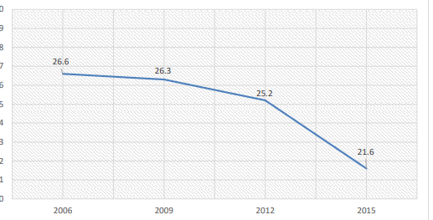
Source: Philippine Statistics Authority website (Philippine Statistics Authority 2018)
This shows the impact of the expansion of cash transfer programs in Philippine called Pantawid Pamilyang Philipino Program (4Ps) on poverty reduction. Social protection systems seeks to provide assistance to the unreached and vulnerable communities and enhance the status of the marginalized population. This in my opinion is with the view to decentralize services and basic amenities which in turn help communities particularly women and children who are normally forgotten in society to be well cushioned and participate in community activities. On the other hand administrative capability had to be enhanced in Philippine in order to implement social protection programs. Strategies and regional efforts have been seen in South Asian countries to cope with the crisis. The Association of Southeast Asian Nations (SEAN) are geared to undertake collaborative effort to establish national and regional social protection policies with a view to relieve individuals from poverty. This has not been easy to deliver due to political interference in the design and implementation of social protection programs. As a result, Philippines has developed a social protection framework to enable implementation of the priority programs through conditional cash transfers to the identified beneficiaries as seen in figure 2.
Figure 2. Social protection framework in Philippines
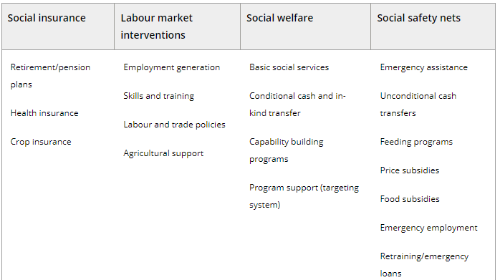
Source: NEDA-SDC (2007) and DSWD (2008)
In many developing countries, politicians have used pro-poor schemes to gain political mileage and soon after the ballot the population is seen to go back to poverty. In my opinion, the process of designing and implementing social protection programs should free from political involvement. A study at AIU in this course is expected to provide new knowledge on how to design and implement social protection program free of political platforms. Governance and transparency should be exercised to the highest level in order to direct resources to the poor and vulnerable in my community.

Global Status on the design and implementation of social protection programs

Social protection entails preventative and development of interventions aimed at meeting the poor's most basic needs and reducing the risks of unemployment, re-location, marginalization, disease and disability, old age, and the loss of family care. It is directing aid in the form of cash or in-kind transfers to the poorest and most marginalized people, as well as social services such as family and community support, alternative care, and referral services, are common features of social welfare programs.
The European Union (EU) and the government of Finland have partnered to design and implement programs to assist many developing countries put in place social and economic programs to assist communities come out of poverty and access basic amenities. The objectives of these programs are to develop tools with which to access social protection policies, programs and capabilities in partner states, to enhance administrative and technical capacity in partner states to help develop affordable, sustainable social protection systems and share knowledge that will be used by the development partners for effectiveness of social protection programs in reducing poverty and in addressing inequality and promote social cohesion. (OECD, 2019).
A well designed Social Protection system necessitates a policy and legislative strategy, which includes the financial framework, as well as a collection of specialized programs and their execution mechanisms. A thorough plan ties everything together. A growing global agreement acknowledges that social protection systems are critical to accomplishing the Sustainable Development Goals (SDGs). Human capacity development, social risk management, improved returns on other social expenditures, and larger macroeconomic implications are all examples of how social protection policies directly contribute to inclusive and resilient growth and thence help to achieve the SDGs by 2030.
Evidence from the world indicate that a well-designed social protection programs should bring about equality, quality education and wellbeing. In most developing countries Social protection has been highly regarded in government ‘s resource allocation and budgetary process with a view to improve the lives of the poor, vulnerable groups as well as put in place programs to engage communities. In this countries, it is an important element of fiscal policy that is seen to impact poverty, inequality and inclusiveness. However, this happens depending on the tax burden and public spending. Further, the programs should ensure that all those in need, whether children, working-age adults, or the elderly, have access to basic health care and financial stability throughout their lives.
The United Nations through various agencies has come out to give support establish and implement social protection programs including protection floors to developing countries as part of their contribution in order to improve the lives of the poor. Some of the programs can be seen in Cabo Verde and Mozambique. The World Bank and ILO have joined hands to share knowledge and call on leaders across the globe to embrace the element of developing social protection policies given the benefits derived from such policies. This resulted to conducting an event in China to showcase on how to achieve the SDGs in relation to social protection in 2016.
Figure 3. Indicates the impact of well designed social protection programs on the achievement of SDGs
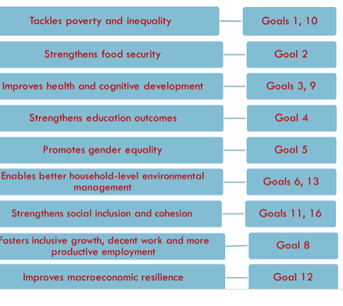
Source: OECD, Authors Own summary.
The dynamic character of vulnerability in the Ugandan environment emphasizes the necessity for fundamental social protection policies to shield the poor against the negative economic and social implications of this vulnerability while planning for poverty reduction. Orphans, people living with AIDS (PLWA), people with disabilities (PWD), internally displaced persons (IDP), widows, and the elderly have challenges in society.
The design and implementation of Social Protection programs in Kenya for example has been taken seriously. The Kenya's 2010 Constitution has incorporated a detailed Bill of Rights. The Bill provides that All Kenyans are guaranteed their economic, social, and cultural (ESC) rights. Article 43 declares that "every person has a right to social security" and obligates the government to provide enough social security to those who are unable to maintain themselves and their dependents. Other social protection rights, such as the right to healthcare, human dignity, decent working conditions, and access to justice, are inextricably tied to this right. Article 21 establishes the progressive realization of social and economic rights and requires the government to "observe, respect, preserve, promote, and fulfill the rights and fundamental freedoms enumerated in the Bill of Rights.
Following this, the Kenya government has designed and implemented various programs to address social protection aspects as shown in figure 3
Figure 4. Design and implementation of Social protection programs in Kenya
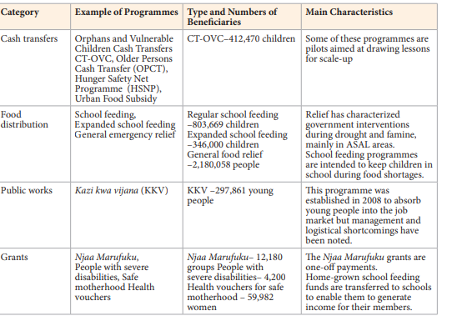
Source: Kenya social protection Policy: Ministry of Gender, children and social development.
In the design and implementation of the programs and their success was done through involvement of various stakeholders. The national government was greatly involved in the development and coordination of this activity. This was then escalated to the county and sub-county level, a framework was developed within which social protection interventions throughout Kenya will be implemented. At the national level the national Social Protection Council (NSPC) was involved and similar agencies at the county level were responsible for its implementation, standards were developed to guide the implementing teams, a set of guidelines were also developed for uniformity in implementing the programs. This process had to be properly planned with a budget, human resources and logistics.
This policy was developed to address various challenges faced by the citizens, the vulnerable, reduce poverty, inequality and safeguard the population from economic, social and natural shocks associated with environmental stresses. Further, help achieve the MDGs and the human rights declaration of 1946 and work towards meeting SDGs by 2030. (Ministry of Gender, 2011). So far, Kenya has achieved social security, social health insurance and recently has designed and implemented social assistance programs. Although Kenya has developed its social protection system for the past 10 years, the level of investment as compared to the developed countries still remain below a level it can make a significant difference in the population. (Republic of kenya, 2017)
Uganda Government recognizes the need to provide social protection to the population, especially the vulnerable group by age, social class, gender, disaster, disability or those who do not earn any income with a view to promote equity. As such, Uganda has made progress in her social protection floor. This is mainly through various mechanisms including, cash transfer, pension to the elderly, grants too children and persons living with disabilities though nutrition, decent housing, health and access to education. Consequently, social protection has become a vehicle for development because it directly reduces poverty, provides a means to access essential services, a foundation to build a livelihood and accords citizens decent and dignified livelihood. (Uganda, November, 2015)
However, due to lack of policy guidance, coordination and poor implementation social protection programs in Uganda are seen to be highly fragmented. This has led to duplication, incoherence, wastage of resources and low impact on the population. This calls for harmonization of all mechanisms pertaining to social protection in order to benefit the citizen. This state of affairs is not only in the Republic of Uganda but in most of the developing countries.
In my opinion designing and implementation of social protection programs/systems calls for the strategic leadership and strong policy implementation, effective planning and deliberate budgetary allocation. As such, this course will enhance my skill and knowledge to spearhead the already laid down mechanisms in Kenya to progress the social protection agenda in my community through the Ministry of Social Protection and State Department of Social protection. This is with a view to protect the vulnerable group, children, the aged and poor in my community

3.0 Steps in designing a social protection Program

A robust social protection floor should consist of schemes designed specifically to reach children, working-age, adults and older persons in society. The floors must ensure sufficient extent of coverage, sufficient amount of those covered to meet their basic needs. For a country to achieve this status, the design should take a full cycle approach, this means the social protection program should contain a child benefit, maternity benefit, unemployment benefit, disability benefit and old age benefit. A sustainable social security systems should combine both non-contributory schemes financed by tax-payers and contributory schemes where members contribute especially those in employment with a view to receive a higher benefit in retirement as compared to the non-contributory schemes. The benefit of this type of design is to ensure that all people are covered both in the formal and informal sector.

A well designed social protection system should provide income security and access to goods and services. Many countries have implemented SPF with the help of the already existing programs like noncontributory schemes that are designed for the poor and near poor population. The systems are also set alongside partial contributory schemes with the aim to subside service for the informal sector population. Further consideration for designing the social protection system should be hinged on the private pension scheme and civil service schemes. This is with the aim to extend coverage to a larger population in a country. This systems in their design should be able to provide acceptable and essential health care, maternity care, child care that meet the required standards. They should provide basic income security for children, nutrition, education and the necessary services for child growth. Social protection is necessary for the working population who are not able to earn decent income and even for persons in active age particularly the sick and unemployed.
UNICEF’s approach is hinged on designing and implementation of social protection programs on child protection and the vulnerable groups. It is based on best interest of the child, progressive realization of extending coverage to the vulnerable groups while taking into consideration the capacities of each country, national systems and leadership and inclusive social protection where all are included. The framework also identifies key macro-economic areas that will continue to affect children. They include climate breakdown, demographic shift, urbanization, conflict and displacement. It is expected that by 2030 majority of the population will be living in cities and 60% will be living in conflict areas thus pushing the poverty strain further. This implies that more efforts and innovative programs require to be put in place in order to address future crisis. (UNICEF, 2019)
Figure 5 illustrates the different systems already in place in many other countries where the design and implementation of social protection systems can be incorporated in other programs for easy and fast delivery of services at minimum costs.
Figure 5 Designing SPF by use of the already existing schemes.
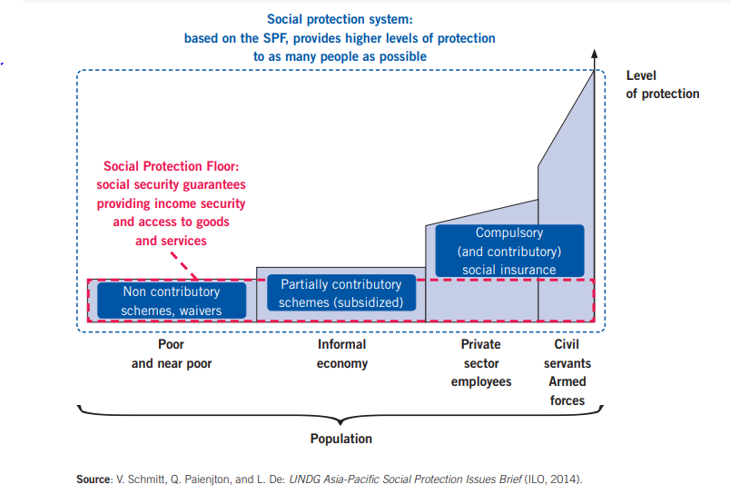
A universal social protection scheme is designed for all with a view to avoid discrimination. This type of program designs is aimed at only assisting the poor in society and therefore is less costly as it limits the number of beneficiaries. On the other hand one can design a social protection program on a targeting basis. This design involves providing social protection a certain group in society for example Kenya targeted those aged 60 and above, children and the vulnerable group. This design in most cases is not sustainable as it have various challenges. They include getting accurate data of the poor in society or to accurately measure the level of income per household and identifying the poor.

A Social protection program in its design, should enable beneficiaries to have an adequate standard of living. The benefits or income must be high enough to provide the desired lifestyle. A child benefit should be such that it provides adequate funds to access health care, adequate nutrition and education. The system should be designed to provide a holistic lifestyle. Another important policy choice is whether access to benefits should be made conditional on recipients complying with specific set of qualification outlined by governments. A well designed social protection should have access to essential health care for all, income security for children, income security for working age and income security for the older persons. Social security floors should sufficient coverage and ensure sufficient level of income is provided to meet the unique needs of the individual and a country population. For example Mongolia launched child income transfer for a targeted number of children, however within a year the country extended the social protection to 90% of the child population in the country.
Building and implementing a social protection system, takes a long time before you can effectively cover the targeted category of the population. One may start with covering a percentage of children at a given time, followed with a program of the employed, unemployed and lastly the older persons in society. Nepal is on her way to designing a social protection program for all. Other countries on this same path include, Georgia, Kyrgyzstan, Uzepakstan and Mongolia. The system should include those in formal and informal sector in order to have an impact in economic building of a country. The government should decide whether to have a targeted or universal program in place. This should be well examined to ensure inclusiveness. The targeted system may lead to several challenges including transferring money to the wrong person due to poor identification process while universal design tend to reach all. This two systems have proven to be riddled with errors of omission and discrimination. For example Philippines and Georgia use the targeted system and means tested elements. This has resulted to high exclusion giving universal system a upper and more effective way of reaching those left out.
Targeting can lead to population unrest where those identified may be at a different poverty level than others and may even fall back to poverty again. This can generate a lot of tension in society between those receiving the grant. Most of the time the identification process may be faulty resulting to leaving out the deserving cases. In most cases if family status improves the government/implementers tend to shift to others to bring them to the same. Governments implementing this programs have not put in place coping or sustainability measures to ensure those receiving continue with the same kind of assistance. This give way to people falling back to poverty. (ESCAP, 2018) . Figure 6 shows the pros and cons of different approaches of the design and implementing different systems

Figure 6. Pros and cons of the different approaches
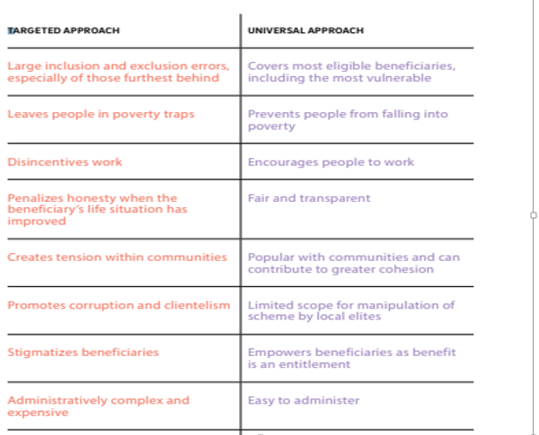

Source: United Nations Economic and Social Commission of Asia and the Pacific (ESCAP)

Many countries preferred targeted approach in designing and implementing social protection programs for simple reason that this was new and needed piloting for a while to know its viability as far as funding was concerned. Kenya is one of the countries that piloted cash transfer of Kenya shillings 2000 per month to those aged 65 and above years, orphans (shs.500) and the vulnerable (500) groups in society per household. This was started in a few provinces, Garissa, Kwale and Nairobi supported by UNICEF. The purpose was to improve the livelihood of children and encourage them to be enrolled in schools, improve health and strengthen households who are taking care of the vulnerable and poor. Despite substantive progress in this program, the coordination and cash transfer was not well done. This was highly fragmented and lacked harmonization due to proper information and identification of beneficiaries which has reduced its effectiveness and put stress on the resources.

Designing and implementing effective social protection systems requires that no one is left behind. This indicates that universal system designs do better as everyone is included in benefits and have a certain level of standards of living. Social protection can be effective depending on the leadership and political aspect of a country. This implies that leaders should make a deliberate decision to invest in social protection of the poor and vulnerable in society. The level of the benefits depend on the level of investment a country may be able to undertake.

3.1 Coordination of the design and implementation of social protection system

Designing and implementing social protection programs is a new area of work for many countries. For this reason, there is need for effective coordination, and development of new methodologies and tools for reviewing and monitoring social protection situations. At the same time, many governments need to be convinced that social protection has many benefits. Policy makers and governments should put in place innovative mechanisms and strategies to ensure the sustainability of financing the programs that have been implemented. Hence, the United Nations established a regional thematic group on social protection and developed a toolkit for coordinating social protection floors. The purpose of the toolkit was to effectively deliver the right services to the right people at the right time through effective coordination of set programs. The UN came up with a joint initiative to help countries coordinate social protection initiatives at different levels in society and share their expertise and skills in order to improve people’s livelihood.
Coordination of social protection may be defined as alignment and harmonization of stakeholder’s activities at the operational level, policy level and vertically level. Coordination can also be done stepwise with the feasible initiatives by incorporating stakeholders and further progress to the national level. There are those delicate and priority areas like early childhood development that require proper coordination of relevant activities in order to have a productive generation. At the national level many NGOs are used to design and implement social protections program and most of the time even fund and sustain them. At the community level we have persons who play an important role in shaping the social protection landscape through provision of health and child care. They too provide some level of monitoring and coordination of social protection programs. However this class of individuals on the other hand may not have properly defined roles which result to gaps and overlaps of roles. This situation may lead to poor implementation of the planned programs.
Proper coordination of the programs ensures that the poor and vulnerable receive the necessary amenities and care. Horizontal design of social protection systems emanating from use of existing programs help in developing strategies to help fill the gaps. Therefore proper coordination of social protection program between organizations with already existing platforms offer the necessary channels of cash transfer and related services. Through collaboration of many organization, there has been great improvement in extending social protection to the poor and vulnerable in many societies as per ILOs recommendation no. 202 which also requires that proper mechanisms be installed. (UN, 2016)
According to Philip White (you-Tube), Social protection has many objectives they include promoting livelihood preventing discriminations, social care services, setting minimum standards and cash transfer. The social protection programs where designed as government projects as pilots. Benefits have been identified for the poor. Despite the extensive programs in many countries, the level of coverage still remain very low. Social protection expenditure has not also improved. One perspective is the severe poverty in many countries for example in Uganda. (White, 2016)
Social pension is government established and re more likely to be spearheaded by political approach to reduce vulnerability but mostly compete for resources especially as can be seen in Tanzania. ILO and World Bank in 2015 issued a note on social protection coverage which will depend on revenue and tax systems in the developing countries. All this programs call for effective coordination

4.0 Assessing the existing coordination mechanism

Assessment of the existing coordination mechanism is very important as a country plans to develop and implement a social protection program. In implementing new programs/systems in a country a lot of planning is required. Many countries that have implemented social protection initiative lacked insight on the success of such big projects which results to their lack of effectiveness and impact in the community/ areas of implementation. An assessment of the same has revealed a lack of political will and corporation among the implementing partners and governments. Assess the existing coordination mechanism of social protection programs provides evidence of the impact the program will have in a specific country and community. It helps improve knowledge and help identify gaps for improvement and how best to strengthen the systems, Assessment of the social protection systems involves several stakeholders along with the partners and government. It helps identify priorities for implementation or extension of a nationally defined social protection floors.
The step involves designing the required program, involvement of the technical advisors and capacity building for the design and implementation of the social protection programs and improving the relevant operations. This involves the government involvement in providing the necessary services and systems required to roll out the program such as information Technology (ICT). All this aspects need to be assessed in readiness for the design and implementation of the social protection programs. This may mean building on the already set systems which may require improvement to accommodate the social protection floors (SPF).
Social protection assessment methodologies need to be used to demonstrate the program's impact in the target countries in terms of coverage expansion, benefit adequacy, and social transfer access. They'll also look at how SPFs affect poverty, inequality, formalization, and other factors throughout time. This forms part of monitoring and evaluation of the initiative and its sustainability in the short to long-term period.The existing channels of communication may be used to inform policy makers and educate workers in organizations and civil society, donors, private sector and the general public on the benefits of Social Protection initiatives. Costing and assessing tools required for the successful implementation of the programs need to be made known to support decision making and the various dialogues required to successfully implement the initiatives. This is with a view to involve all stakeholders and help educate the target population. This process will also assist in improving coordination for the designing and implementing the social protection systems. The assessment will help identify issues in the early stages of implementation of the relevant program and enable the different implementing groups respond to the necessary changes and help identify the ready mechanisms for fast recovery and avoid failure of the programs. This will also help the necessary capacity in the community and countries to help in the implementations and correction mechanism as quickly as possible.
The existing mechanisms include, social assistance, social pension, child/family benefits, disability benefits and national health services. This mechanisms use various platform to deliver services such as use of food security policy, social welfare and disaster management interventions. Assessment of the above mechanisms help to support the growth of social protection systems and offer the necessary tools and guidance for improvement and effectiveness of the programs. Assessment provides an update and help coming up with new techniques to strengthen the systems for value to society. Assessment of the existing mechanisms will help improve coordination for the design and implementation of social protections programs. This will further provide new ways of extending coverage of social protection to all citizens, especially the vulnerable group and provide more coordinated predictable forms of support. This will also lead to deeper analysis of the level of vulnerability and be able to systematically put in measures to support this group. For example, due to proper assessment of the existing mechanisms social protection programs have been able to be implemented in countries like Lesotho, Malawi, Swaziland, Zambia and Zimbabwe through donor community and civil society by addressing issues as food security, disaster management, HIV/AIDS and welfare for the vulnerable groups.
This topic relates to my studies at AIU as it speaks to me my area of study. The topic provides answers to my research question on the necessary mechanisms that should be put in place to improve social protection in developing countries, more in my country and community. Each of the aspects discussed in this paper are evident in my community and needs responses and common themes have emerged from other regions that have been experienced in my country. Therefore a study of this program at AIU will greatly help me to carry out an assessment of the existing social protection mechanisms in my country and come up with more robust ways to tackle the social protection aspects especially food security which adversely affect the large population in Africa and my community in particular. The knowledge gained will greatly improve my country and community. (Devereux, 2006)

Lessons learnt.

A study of this course/topic has enlightened me and added new knowledge on the importance of well-designed social protection programs. That well-designed social protection programs should be able to tackled poverty, inequality, address food security, improve health and cognitive development, strengthen education outcomes, especially in children, enhance household levels, improve environmental management, strengthen social cohesion and inclusion, provide decent work and employment and finally, improve macroeconomic status of a country. Further, that improvement of the existing social protection mechanisms will help in systematic coordination of priority programs and create higher impact in communities. Social protection systems not only help community and families come out and not fall back into of poverty, they also contribute to economic development.
Various principles are also important for the implementation of social protection program. These include; universality of social protection instead of targeting approach, dignity, inclusion of the vulnerable groups in the social protection programs, equality, gender consideration is important and non should be left behind; transparency in implementation, effective participation of all both young and old and access to the essential services such as health and welfare
With the onset of COVID-19 pandemic, countries are taking social protection measures to protect individual affected by the crisis. This means social protection is gaining more prominence in leadership; and governments are more aware of the importance of having a well-coordinated social protection systems that is robust and sustainable.

6.0 Conclusion

From the discussion in this paper, it is evident that social protection is an important aspect globally both socially and economically in the realization of the SDGs by 2030. Governments should more than before discuss new and innovative ways to tackle the challenges faced by the poor and vulnerable including the children in society. It is important to have a social protection policy to serve as an overarching framework for cash response to the vulnerable. There should be a strong coordination mechanism among various stakeholders, with defined roles and responsibilities and insisting on successful implementation of the earmarked programs as well as sustainable funding mechanism of the same
There should be proper assessment of the existing programs to help identify gaps which new programs can be fitted in to extend and improve social protections. Evaluation mechanism should also be put in place to help strengthen the governance of the implemented programs. At the same time, leadership has a crucial role in making change happen by influencing different stakeholders to take part and support various initiatives in communities to ensure smooth delivery of the benefits to the right people. Assessment of the existing mechanisms will help improve coordination for the design and implementation of social protections programs. This will further provide new ways of extending coverage of social protection to all citizens, especially the vulnerable group and provide more coordinated predictable forms of support. This will also lead to deeper analysis of the level of vulnerability and be able to systematically put in place measures to support this group.
The existing channels of communication may be used to inform policy makers and educate workers in organizations and civil society, donors, private sector and the general public on the benefits of Social Protection initiatives and how they can transform communities. Governments should invest in a good communication strategy with behavioral change outcomes that can reach beneficiaries and empower them. This means prevention messages that resonate, and informative messages on their entitlements.
A well-designed social protection system should provide income security and access to goods and services. Many countries have implemented SPF with the help of the already existing programs like noncontributory schemes that are designed for the poor population. The systems are also set alongside partial contributory schemes with the aim to subside service for the informal sector population. Coordination mechanisms if well outlined could service as avenues of entry and be used to strengthen social protection systems and lead to a basis for building sustainable systems and capacity building in many communities and thus improve people’s livelihood. A sound and independent Monitoring and evaluation system is important in assessing and evaluating the existing approaches and addressing any political and institutional matters that may arise in designing and implementing social protection systems such as under-funding and proper coordination.
Social protection programs if well designed and implemented can empower people to become more health and pursue their daily livelihood. Many countries have come to the realization on the need to design programs, put in place strategies and frameworks that are geared towards economic sustainability and wellbeing. This programs if well designed and implemented may enhance productivity, reduce inequalities, build resilience, close inter-generational gap of poverty and finally, change the face of the world. I look forward to a better tomorrow for social protection especially of the vulnerable groups in my country and community.

Bibliography

Charlotte justino Diakno Dicat and Ma. Alma, P. M. (December 2018). Public expenditure review of social protection in Philistines.
Development Centre, O. (2019). Implemeting Social protection staregies.
Devereux, S. (2006). Social Protection Mechanisms in Southern Africa', Institute of Development Studies. Retrieved from https://gsdrc.org/document-library/social-protection-mechanisms-in-southern-africa
ESCAP. (2018). How to design inclusive social protection systems. Thailand.
Government, K. (2011). Kenya Social Protection Policy. Givernment press.
IMF. (2018, Mayo 18). IMF Financial Operations: Overview. (Youtube, Editor) Retrieved from https://www.youtube.com/watch?v=WQdLDMLrYIA
Ministry of Gender, c. a. (2011). Kenya Social protection Policy. Nairobi: Kenya Government Press.
OECD, D. C. (2019). Implementing Social Protection Strategies.
Republic of kenya, U. W. (2017). Kenya social protection sector review, summary report, vision 2030. Nairobi: Kenya government press.
Uganda, M. o. (November, 2015). National social protection policy, Uganda. Kampala: Ministry of Gender, Labour and social Development, Uganda.
UN. (2016). UNDG social protection coordination toolkit. International labor Organization.
United nations. (July, 2018). Social protection and Social progress. United Nationas.
UNICEF. (2019). Global Social Protectionprogramme Framework. New York, U
White, P. (2016). social protection systems. Retrieved from https://gsdrc.org/professional-dev/social-protection-systems

