**Student Name: Dexter J Parker**

**ID number** UD7228BHUB1442

COURSE NAME:

**Doctorate Degree in Human Resource Management**

Assignment Title:

**(A.I.U. Principles of Business Management Course)**

**AIU Tutor:** Cyndy Dominquez

Word count: 6,308

**Turn it in report similarity Score: 21.14%**

ATLANTIC INTERNATIONAL UNIVERSITY

**January/28th/ 2022**

**Introduction**

This assignment seeks to address the critical concepts of employee behaviors in the workplace by examining the roles and responsibilities of managers as it relates to organizational behavior. It identifies and explains the managerial functions and roles performed by managers and supervisors daily and the application of each in performing or executing their assigned duties.

The course also addresses how culture affects employees’ performance and productivity impacts organizational performance. It highlights the internal and external forces that can negatively or positively affect organizational performance and processes of systems and subsystems within the organization. And how each interrelates and interacts in the change processes and the resistance to change.

The assignment draws a few main conclusions that can assist the organization in positively adjusting and reacting to the change process. And how best it can aid value to humanity and my personal development within my current organization's management and leadership processes.

This will benefit me professionally and academically within an environment to grow and contribute to society and my community by providing scientific and human relations aspects within the organizational systems of management.

Finally, this course will critically assess organizational change and its implications for management and leadership.

**Teamwork in the Organization**

What is a Team?

A team is a unit of two or more people who interact and coordinate their work to accomplish specific goals.

Types of Teams

1. Formal teams: are created by the organization as part of the formal organizational structure
2. Vertical Teams: is composed o a manager and his or her subordinates in the formal chain of command

Functions of Departments: Are Departments that have several functional departments.

Horizontal Teams: A horizontal team is composed of employees from about the same hierarchical level but different areas of expertise.

The two most common types of horizontal teams are task force and committees

Special purpose teams are usually created outside the formal organizational structure to undertake a project of special importance or creativity

Special self-directed teams: consist of 5-20 multi-skill workers who rotate jobs and produce an entire production on service.

Problem-solving teams: typically consist of 5-20 employees, from the same departments who voluntary meet discusses wages of improving quality and efficiency

Work Team Characteristics: size- the ideal size of a work team is a variation of between 5 and 7.

**Team Processes**

Stages of Team Development:

1. Forming: This is the period of orientation and getting to know each other. Members broke the ice and test one another for friendship, possibilities, and task orientation.
2. Storming: during this stage, individuals’ personalities emerged, people become more assertive in clarifying their rules and expectations. This stage is marked by conflict and disagreement. The group tender encouraged participation.
3. Norming: during this stage conflict is resolved and team harmony and unity emerged. Consensus develops on who has the power who is the leader and the member's roles. A normal organization takes place values, norms set in.
4. Performing; during the performing stage, the major emphasis is problem-solving and accomplishing the assigned task.
5. Adjourning: is occurs in committees, task forces, and teams that have a limited task to perform and disburdenment afterward.

Managing Conflict in the workplace

Styles of managing conflict include:

1. Avoiding style: this style reflects cooperativeness or ascertained. This style is appropriate when an issue is critical or when there is no chance of wining
2. Compromising: this style reflects a moderate amount of both assertiveness and cooperativeness
3. Accommodating: This reflects a high degree of cooperativeness which works best when people realized that they are wrong or when an issue is more important to others than oneself. ( Peace and harmony)
4. Collaborating: This reflects the high degree of assertiveness and cooperativeness. This style enables both parties to win although t may require substantial bargaining and negotiation

Using these conflict styles helped to manage conflict.

How to handle Team Conflict within the workplace

1. Bargaining/Negotiation: This means that the parties engaged one another in an attempt to systematically reach a solution
2. Mediation: This involves using a third party to settle a dispute. A mediator could be a supervisor or manager. Try to work with each party and sometimes an agreement might be reached
3. Facilitating communication: This involves providing opportunities for the parties, to get together and exchange information. This can be helped to reduce conflict.
4. Providing well-defined tasks: clarifying responsibilities, activities, tasks to reduce conflict limits of authority.

Teams have potential benefits:

1. The sense of belonging
2. Expanded job knowledge
3. Work harder to achieve the goals and objectives
4. Flexibility – high degree
5. Cost, free riders get the benefit
6. Coordination cost
7. Legal

What is meant by Team Cohesiveness?

May be defined as the degree to which members of the group desired to remain in the group. It is critical to study groups, it is considered vital in group decision making, goal attainment, identity, and member satisfaction

The outcomes of Team Cohesiveness are as follows:

1. What members of teams want to remain members?
2. Willing to share information
3. String interpersonal bonds
4. Want to support each other
5. Resolve conflict effectively
6. More satisfaction and experience less stress

Cohesiveness and Performance of Teams:

1. Team Norms in support of organizational goals
2. Moderately high task performance
3. High task performance
4. Team Norms against organizational goals
5. Moderately low task performance
6. Low-performance task

Low Team Cohesiveness and High Team Cohesiveness

TEAMS NORMS: These are informal rules and expectations, the team establishes to regulate members behaviors

Norms are developed through, a) explicit statements b) critical events in teams history c) Initial team experiences d) beliefs and values members bring to the team

Changing of Teams Norms:

1. Introduce norms when forming teams
2. Discuss counter-productive norms
3. Reward behaviors representing desired norms
4. Disband teams with dysfunctional norms

**Causes of team cohesiveness**

1. Member similarities
2. External challenges
3. Team success
4. Team cohesiveness
5. Somewhat difficult entry
6. Member interaction
7. Team size

**Types of Team Building**

* Roles Definition
* Interpersonal Processes
* Goals Settings
* Problem-solving

Positive and Negative of Team Cohesiveness: Highly cohesive groups can enforce group norms more effectively than less cohesive groups because people value their membership in cohesive groups they are willing to adjust their behavior to group standards.

Causes of Team Cohesiveness:

1. Severe intuition
2. External threats
3. Lots of time together
4. Small size
5. History of Swiss

Consequences of Team Cohesiveness

* They enjoyed the group memberships
* Participation in activities
* Accepts goals
* Low absenteeism
* Group thinking
* May work against organizational interests

**Actions to increase team cohesiveness**

1. Induced agreement on group goals
2. Increase membership homogeneity
3. Increase members interaction
4. Decrease group size
5. Allocate rewards to the team rather than individuals
6. Isolate from other teams
7. Introduce competition with other groups

Factors of Reducing Team Cohesiveness:

* Large size
* Intragroup competition
* Formation of checks
* Coercive environment

**BUDGETING PROCESS**

A budget is a quantitative expression of a plan for a defined period. It may include planned sales volumes and revenues, resource quantities, costs and expenses, assets, liabilities, and cash flows. It expresses strategic plans of business units, organizations, activities, or events in measurable terms.

Budgeting lies at the foundation of every financial plan. It doesn't matter if you're living paycheck to paycheck or earning six figures a year. You need to know where your money is going if you want to handle your finances. Unlike what you might believe, budgeting isn't all about restricting what you spend money on and cutting out all the fun in your life. It's about understanding how much money you have, where it goes and planning how to allocate those funds best. Here's everything you need to help you create and maintain a budget.

To achieve financial goals, it is crucial that you adequately plan your life such as how, when, and on what to spend your money because this discipline will enable you to stick to your goals.

Therefore, you must have a budgeted life. Budget refers to the financial plan which contains information on expected expenses and income within a set period. What financial tools described in this chapter can help you make better financial decisions?  
We know that success or achievement does not come before plan and good discipline. Furthermore, no good decisions can be made without reliable information. The financial tools that fascinated me in this chapter are the different kinds of [budgets](https://www.cram.com/subjects/budgets), the [financial statements](https://www.cram.com/subjects/financial-statements), the microeconomics indicators, the macroeconomic factors, and the time value of money. Budgets contain information about how to [finance](https://www.cram.com/subjects/finance) your life such as when, and on what to spend your money. Put differently, they provide meaningful information about the possible outcomes of the alternatives that you selected among the others. In this course (personal financial planning), we do this assignment and carry out some conclusions. All of that was about the benefits of financial planning, what should we do, or how we can prevent when we face financial problems and planning for a better lifestyle. For this personal financial planning is a kind of useful soft skills in our future life, it will bring us improvement of the standard of living and achieve or goals. After discussion in this assignment, we gain of understanding the financial planning process, we also learn more about the benefits of using personal financial planning by influencing the economic environment. For example, we can classify our investment and plan our wealth for better when making our decision in future planning. We also will learn about the key’s principles of personal financial planning, budgeting, studies of financial statements, the definition of financial tools, capital budget, primary characteristics, characteristics of the balance sheet, stats results, income, expenses and profits, the methods of analysis and interpretation of financial statements, senior management and the compliance with tax obligations, alternative tax and lastly, the tools of fiscal strategies.

**STRATEGIC MANAGEMENT**

The breakeven analysis technique is used by production managers and management accountants. Variable, the cost is those costs that various without-put of production.

Fixed costs- it does not change without production but within time.

Total cost = variable cost + fixed cost

Break even point total costs = total revenue

The breakeven analysis is used by the organization as a means of control. Control has to do with targets.

Critical Path Analysis it’s a tool used by management when working on a particular task or project. it’s a quantitative analysis, to minimize cost and complete the task in time.

Below are an example of a project manager utilizing this analysis

**Network Diagram with Critical Path Marked**

**A=8**

2

**C=7**

1

4

3

7

**B=4 H=4 E=3**

9

6

**I=5 J=1**

**10**

8

**D=6 F=4**

5

11

**K=5 G=5**

**A, C,H,E,I, J =28**

**B, D, H, E, I, J =23**

**B, D, H, F, I, J =24**

**B, D, K, G, I, J=26**

The table below shows project predictions

|  |  |  |  |
| --- | --- | --- | --- |
| Activity | Description | Dependency | The time needed to complete |
| Structural repairs to the roof | A | ………………………………. | 8 –days |
| Internal Structural Work | B | ………………………………. | 4-days |
| Electrical Work | C | B | 7-Days |
| Plumbing | C | B | 6-Days |
| Installing a new kitchen | E | H | 3-Days |
| Installing new bathroom | F | H | 4-Days |
| Garden | G | A&B | 5 -Days |
| Plastering | H | C&D | 4-Days |
| Internal decorations | I | E&F | 5-Days |
| Fitting Carpets | J | I | 1-Day |
| Outside Paint Work | k | A&B | 5-Days |
| **Total time in days** |  |  | **52 days** |

**Critical Path Discussion**

The Network Diagram and Critical Path for this project are significant as the duration of the project is planned as well as the start and finish date of each activity is clearly defined beside the project budget. There is a need to determine the dependency of each activity as well as define the activities that have no Immediate predecessors (activity A and B in our case). After defining the activities that have no immediate predecessors, there is a need to define all the activities that have the first act as an immediate predecessor (C, D, G in our project), afterward as a Project Manager, it's a must to continue with the same techniques with the rest of the activities (E, F, H, I, J, K, L in our project). After adding all the activities to the diagram, I needed to specify the different critical paths and calculate the days required to finish the project. By analysis of the different paths in our diagram network, our critical path will be the lower path which is path number 2 (highlighted in orange) which requires (23) days to finish the project. The four paths in our network diagram above are 1. A, C, H, E, I, J =28. B, D, H, E, I, J=23, B, D, H, F, I, J=24,4. B, D, K, G, I, J=26, and our critical path is number 2 (23 days)**.**

**Benefits of using Critical Path Method**

There are many advantages of using critical path analysis in our renovation project, such as having understanding in controlling and determining the start and end time of each activity, monitoring tasks and predicting completion date of each phase as well as anticipating problems faced during the project to find a solution accordingly, it allows to determine the critical and non-critical tasks as well as defining the activities that depend on other activities, It helps in reducing cost, allocation of resources, it minimized time and cost, accomplishing a task within the timeframe to achieved objectives. Finally, Critical Path analysis is important to support the planning schedule and monitor the activities to finish the project promptly and within the limited budget.

**Discussion of using two workers in six-week deadline constraints**

After using the critical path method and reviewing activities as mentioned above, using two workers is realistic for our project and the work can be done in less than (30) days which is the time limit of the project (5 days 6 x weeks =30) if there is no delay from any of the workers.

From the network diagram method above and specifying the critical path, two workers will start their duties at the same time, working on different activities, act one and task two. Worker (1) requires (8) days to finish the first task and worker (2) required (4) days to finish the second task, after finishing from task two, the second worker will move to task C which requires (7) days, by then, worker A will have completed task A and moves to task activity D, which requires 6 working days, during that time worker (2) will have been finished from task C and moves to task E one day before worker (2), the total days for each worker till activity D will be (14) days, after that each worker moves to another activity, supposedly worker 1 move to task F and worker (2) moves to task G, worker (1) will finish from task F and move to activity H one day before worker (2), once worker (2) finish from act G, he can move to the activity I were (5) days' work is required, while worker (1) can move to activity J which requires only one day, after that, worker 1 can move to the last activity, while worker (2) would have needed doing from activity J four days before workers (1). The explanation for the rotation of the employees between different activities was considered that worker 1 and worker 2 are different individual workers, as each activity requires a specialized and qualified employee

MOTIVATION FOR PERFORMANCE

Motivation is defined as the forces from within that help people to achieve motivational goals and objectives. Various researchers had argued that work productivity and satisfaction depend heavily on intrinsic and extrinsic motivating factors. Theoretical evidence has suggested that employees who are motivated by these factors understand their job purpose and contribute highly towards the achievement of strategic objectives.

The motivation of employees is an important key in our project and has a big influence in achieving the project goals.

The course identifies and unmotivated employee, the level of his demotivation could be overstated by his basic needs. Motivating employees is necessary for achieving organizational and individual goals.

**Self –Determination Theory**:

Focuses primarily on work productivity and increases work satisfaction towards intrinsic motivation and integration.

**Intrinsic Motivation:**

The employee is motivated by the work itself. It finds work interesting and enjoyable. Here the employee is aware of the strategic objectives to be achieved and their efforts at attaining them.

**Extrinsic Motivation:**

is referred to as a desire to meet the needs and wants that are related to the work itself. Primarily focusing on output production and performance.

**Causality Orientation Theory:**

This theory focuses on individual characteristics and behavioral factors that can affect employees’ behavior in the Organization.

**Basic Psychological Needs Theory**

Focus primarily on the promotion of an environment culture that emphasizes giving and receiving feedback and the adoption of positive reinforcement, techniques, in which appropriate behavior is rewarded.

**Theories Leadership**

Leadership is a process by which a person influences a follower to accomplish organizational goals and objectives, directing the organization in a way that makes it more cohesive and coherent. As an effective leader, there is a need to interfere in Kevin’s situation by encouraging him to perform at his full potential with a positive attitude.

**Authentic Leadership:**

This theory facilitates the progressions and development of their employee’s careers. Specifically setting targets or standards that are smart. Providing continuous feedback and evaluation of employees’ performance against the target.

**Participative Leadership**:

The leader makes decisions by soliciting input from employees. It allows the team to decide on how the task will be performed and the leader maintains how the members will evenly distribute the workload and control.

**Directive Leadership:**

It encourages collaborative efforts in achieving clear and well-understood performance standards or targets. Employees are the organization's most valuable asset and set smart performance targets that are aligned to the organizational strategic objectives.

**Distributive Leadership:**

This style of leadership constantly supports, promotes, and reinforces performance standards, and enhances employee performance that will positively contribute to the organization maintaining its competitive position. It allows operational level managers to perform roles and responsibilities in alignment with the strategic objectives of the Organization.

**Visionary Leadership:**

Focus on increasing the motivation of its workforce, maintaining, and retaining quality talented employees by strategically aligning individual goals to their vision. That will contribute to the achievement regardless of the challenges.

From the analysis above it was important to agree on the job objectives and performance targets that align employees' needs and the team concerns.

It was also important to note, to identifying those factors that lead to employee demotivation and proactively addressing them will lead to increase motivation and performance.

Seek to build a positive working relationship with the team that will motivate him in achieving the objectives. Actively monitor employee performance and provide continuous feedback as he progresses.

Encourage, guide, and support employees along the way to enable them to surpass the targets. Consult with employees on the progress of his career action plans and link identified needs with available project management resources solutions. Develop an appropriate development plan with milestone targets.

The best theory in addressing employee’s performance problems is the Self-Determination Motivation (Intrinsic and Extrinsic rewards) as it focuses on work productivity and driving up to work satisfaction.

Definition of An Organization: An organization is defined by Robbins as a consciously coordinated social unit, composed of two or more people, that functions on a relatively continuous basis to achieve a common goal or set of plans.

Managerial Roles of a manager/primary roles:

* Interpersonal

1. Figurehead- attend the employee retirement ceremony
2. Leader – encourages employees to increase performance and productivity
3. Liaison – coordinate activities of two committees

* Informational

1. Monitor - scanning business work for information about competition strategies
2. Disseminator – send out memos outlining new policies
3. Spokesperson – Hold presses conferences to announce new plants and press releases

* Decisional Making

1. Disturbance handlers – resolve disputes
2. Entrepreneur – develop ideas for new products and convince others of their merits.
3. Resource allocator – allocate budges requests
4. Negotiator - settle new labor contracts

**Critical managerial skills**

* Conceptual - skills used in abstract thinking
* Technical – having the skills to accomplish specific tasks within the organization
* Human – knowing to do the job
* Interpersonal – skills used to communicate with understanding and motivating employees within the groups or teams.
* Diagnostic – skills to understand cause-effect relationships and recognize optimal solutions to the problems.

**SYSTEMATIC APPROACH TO THE ORGANIZATION**

Means looking at relationships attempting to attribute causes and effects ad to draw conclusions based on scientific evidence

Systems and situational perspectives: A system is an interrelated set of elements that functions as a whole

1. Inputs from the environment – material human financial, informational
2. Managers combine/transform inputs into outputs
3. Outputs from the system: products and services, profit & losses, and additional information

**ATTITUDES AND JOB SATISFACTION**

This concept measures and evaluates statements either favorable or unfavorable about objects, people.

Components:

1. Cognition
2. Affective
3. Behavioral

The system approach attempts to reconsider the classical and human relations approaches. Attention is focused on the entire work organization. And the interrelated relationships and structures. Human behavior and the range of variables within the organization. The business organization is an open system. There is a continual interaction with the broader external environment of which it is apart. The system approach viewed the organization within its total environment and emphasized the importance of multiple interaction channels. In the open system model, the business organization takes in resources, such as people, finance raw materials, and information from its environment, transforms and converts them, and returns them to the environment.

ENVIRONMENTAL INFLUENCES ON THE ORGANIZATION

The business organization is an open system. This means that it is available to and in continual interaction with the external environment of which it is apart. To be effective and maintain survival and growth, the organization must respond to the opportunities and challenges—the risk and limitations presented by the external environment.

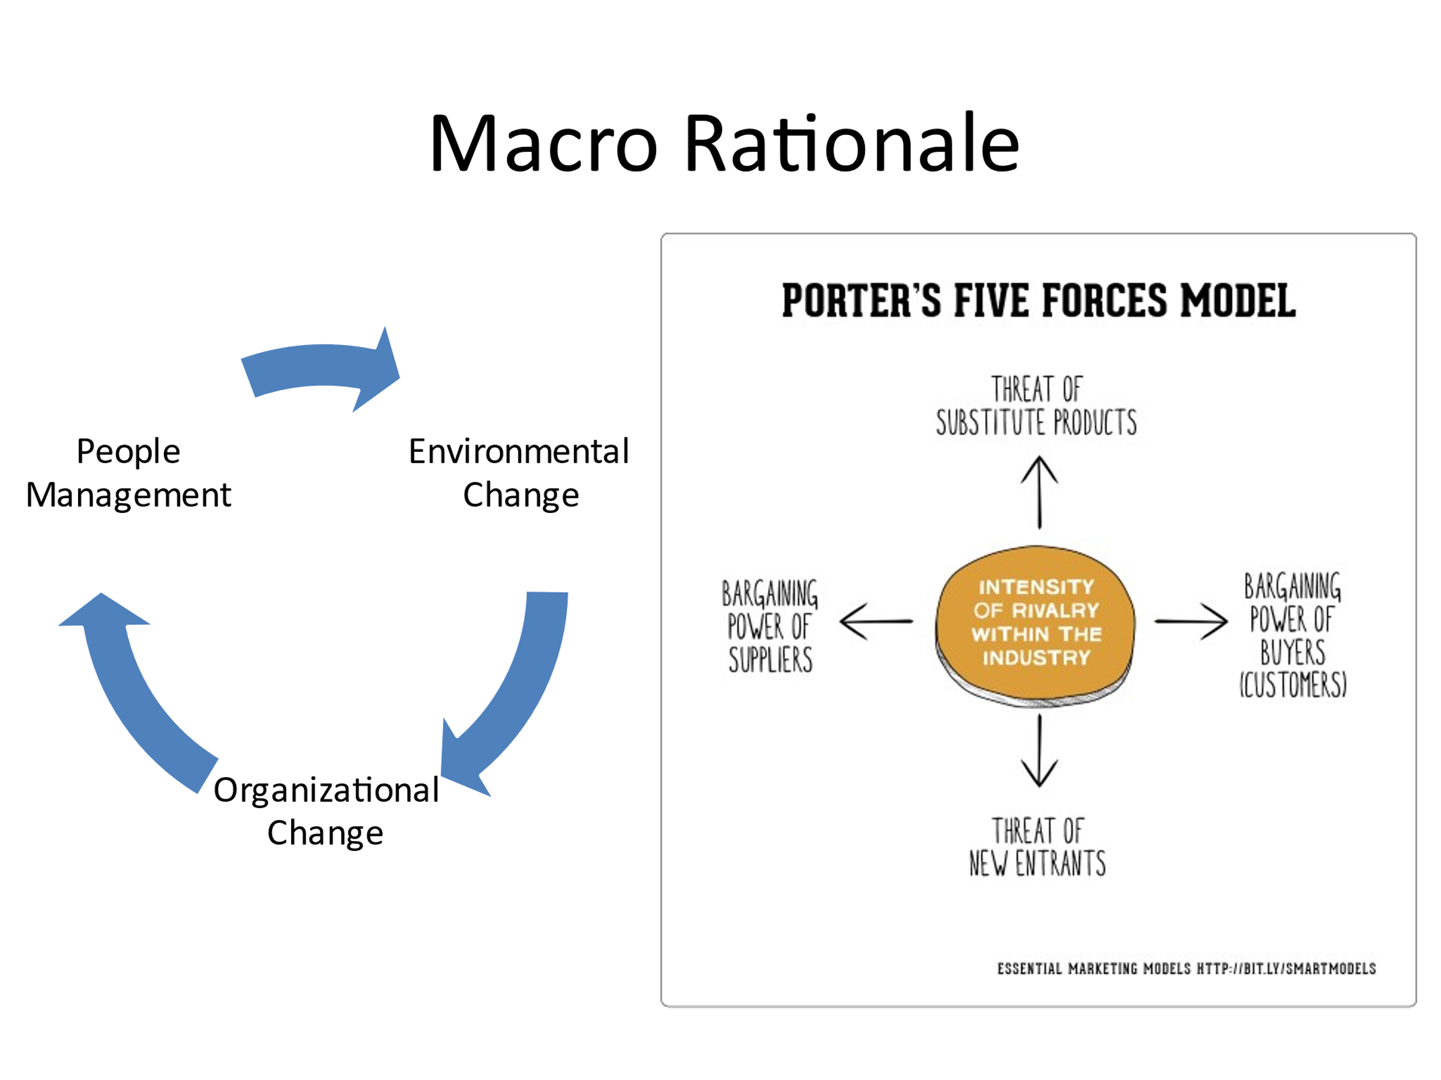

Changes in the environment will affect input, and information changes will affect the conversion process and output. The open system approach viewed the organization within its total environment and emphasized the importance of multiple channels of interactions.

1. Culture, norms, customs of society, way of life, adaptation, education, and distribution of incomes
2. Social Attitudes: how the social behavior attitudes, towards work, supervision, and management
3. Globalization: competitive market, one global market
4. Government Policies: Building permits, land fees, registrations, laws, regulations taxation by the gov’t national insurance, national health insurance schemes
5. Technological Innovations- technology new ways of improving the method of production. It also affects people within the organization. It influences the internal and external environment
6. Supplier’s impact- suitable suppliers and suppliers of poor-quality services
7. Competitors – people who compete with goods and services external environment – SWOT ANALYSIS
8. Customer- owners, finance shows prices increasing the wealth of the company
9. Economic activities- infrastructure development of the country, such as roads, hospitals, hotels, gas stations, schools, etc.
10. Trade unions- have an impact on the organization. They set there to focus on training example tribunal.

INTERNAL ENVIRONMENT – ORGANIZATIONAL SUBSYSTEMS

Each organization's different transformation or conversion activities may be viewed as subsystems with their input conversion, output processed interrelated, and interacted with the other subsystems within the organization.

1. Technological subsystem- how the organization's task is carried out and the Nature of work is performed. This includes internal systems, procedures, equipment used in the transformation process.
2. Management subsystems- this involves the coordination of tasks, technology, structure, people, and policies and procedures for the execution of work. It also involves a corporate strategy that directs the organization's activities and interaction with the external environment.
3. People subsystems- this is the Nature of the members undertaking a series of activities, such as skills and attitudes, needs and expectations, interpersonal relationships and patterns of behavior, information, and leadership styles within the system.
4. Structures are the pattern of organizations' lines of authority, formal relationships, and communication channels among members. The division of work is on coordinating tasks by which a series of activities are carried out.

Contingency Approach: This approach refutes universal management principles by stating various internal and external factors to the firm that may affect the organization's performance and productivity.

There is no one best way to manage and organize because circumstances vary. Situational characteristics are called contingencies. They include:

1. Internal strengths and weaknesses of the organization
2. Values and Goals, Skills, Attitudes of managers and their weakness in the organization
3. Circumstances in the organization’s external environment
4. Type of tasks, resources, and technologies the organization users.

Organizational Structure

There are two types of organizations

* Mechanistic
* Organic

Mechanistic Organizations are highly formalized, but organic ones are not.

Characteristics of Mechanistic Organization: this organization is characterized by

1. A specialization that has a high degree of field of task or jobs
2. Supervision: is an essential characteristic of this structure. Specialized task one supervised and coordinated by immediate supervisors
3. Comprehensive job description: outlines what needs to be done. It defines the degree of authority, privileges, responsibilities, and obligations
4. Hierarchy structure: structure of control
5. Centralization – decisions making at the top of the hierarchy top management
6. Hierarchy relationships- this shows the tendency for vertical interaction between organization members. Supervision of subordinates
7. Hierarchy control shows a tendency for operations and working behaviors to be governed by the supervisor.
8. Loyalty to supervisors is the insistencies on loyalty to the organization and obedience to superiors as a related condition.
9. Localized Experience - This is the attachment of greater importance and prestige to internal than general knowledge experience and skills.

Characteristics of Organic Organization

1. Specialized knowledge and experience highly technical people skills and abilities
2. Individualized Task- The Nature of the task to be performed
3. Broad commitment- This is the spread of commitment to the organization beyond any restrictive technical definition
4. Lateral communication- all parties are involved in the decision-making process across all levels.
5. Commitment to the organization involves a commitment to the organizational method rather than operating material progress and expansion.
6. External affiliation: This is the attachment of importance and prestige to cooperation and expertise that are valid in the industrial technical, and commercial fields external to the organizations
7. Redefinition of the task is characterized by the adjustments and continual redefinition of an individual's tasks or jobs through interaction with others.

Organizational Design Considerations

The choice of design for an organization will depend on the following:

1. Size of the organization: It is generally accepted that large organizations are characterized by greater specialization, wider spans of control, more hierarchical levels, and greater formalization.
2. Stage in the organizational life cycle: Researchers of life cycle theory point out that organizations progress through stages in the life course of their history. A typical life cycle consists of **four (4)** phases.
3. Entrepreneurial stages
4. The collectivity stage is characterized by high commitment, informal communication structures, and a high sense of collectivity continuation of innovation.
5. Formalization and Control stage: rules, stable structure, efficiency and maintenance, institutional procedures.
6. Elaboration of structure stage: Decentralization, central expansion, adaptation, and renewal

Organizational Change

The Nature of change

Organizational change can be initiated deliberately by managers. It can evolve slowly within a department. Specific policies or procedures can impose it, or they can arise through external roles or processes.

Factors that forced a change in organizations are as follows:

1. Uncertain economic conditions
2. Globalization and increased competition, communication, shifting of industries to different locations
3. The level of government intervention
4. Scared cities of natural resources
5. Rapid development in new technology initiate change
6. Increased demand for quality and high levels of customers satisfaction and services
7. Greater flexibility in the structure of work, organization, and patterns of management
8. Changing Nature of the composition of workforces
9. Conflict from within the organization

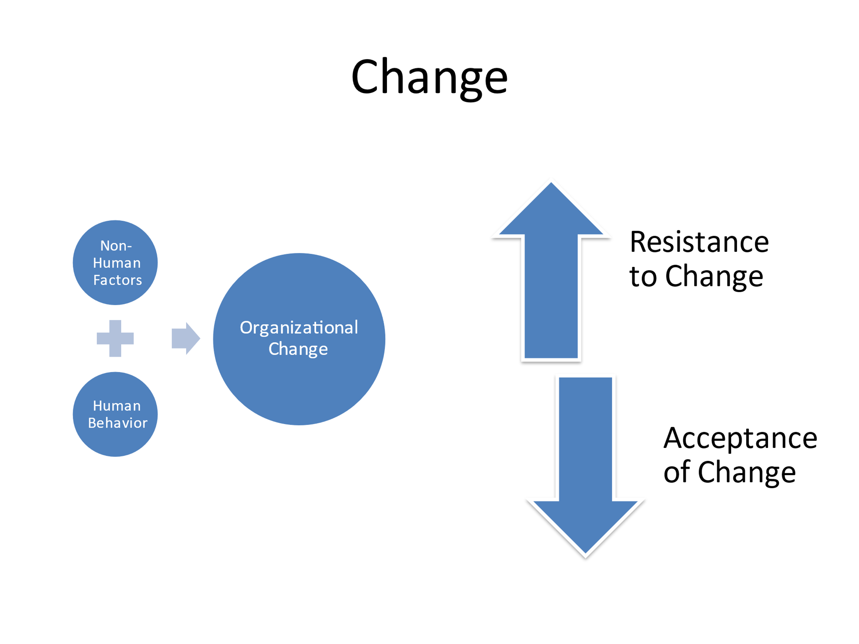

Resistance to Change

The employer sends out an email to employees that ‘the company is undergoing restructuring’. This is the first time most workers below senior management have become aware. The email includes a plan of where we want to be in 5 years. It stresses the need to support change in a dynamic and competitive environment. Why would employees resist change?

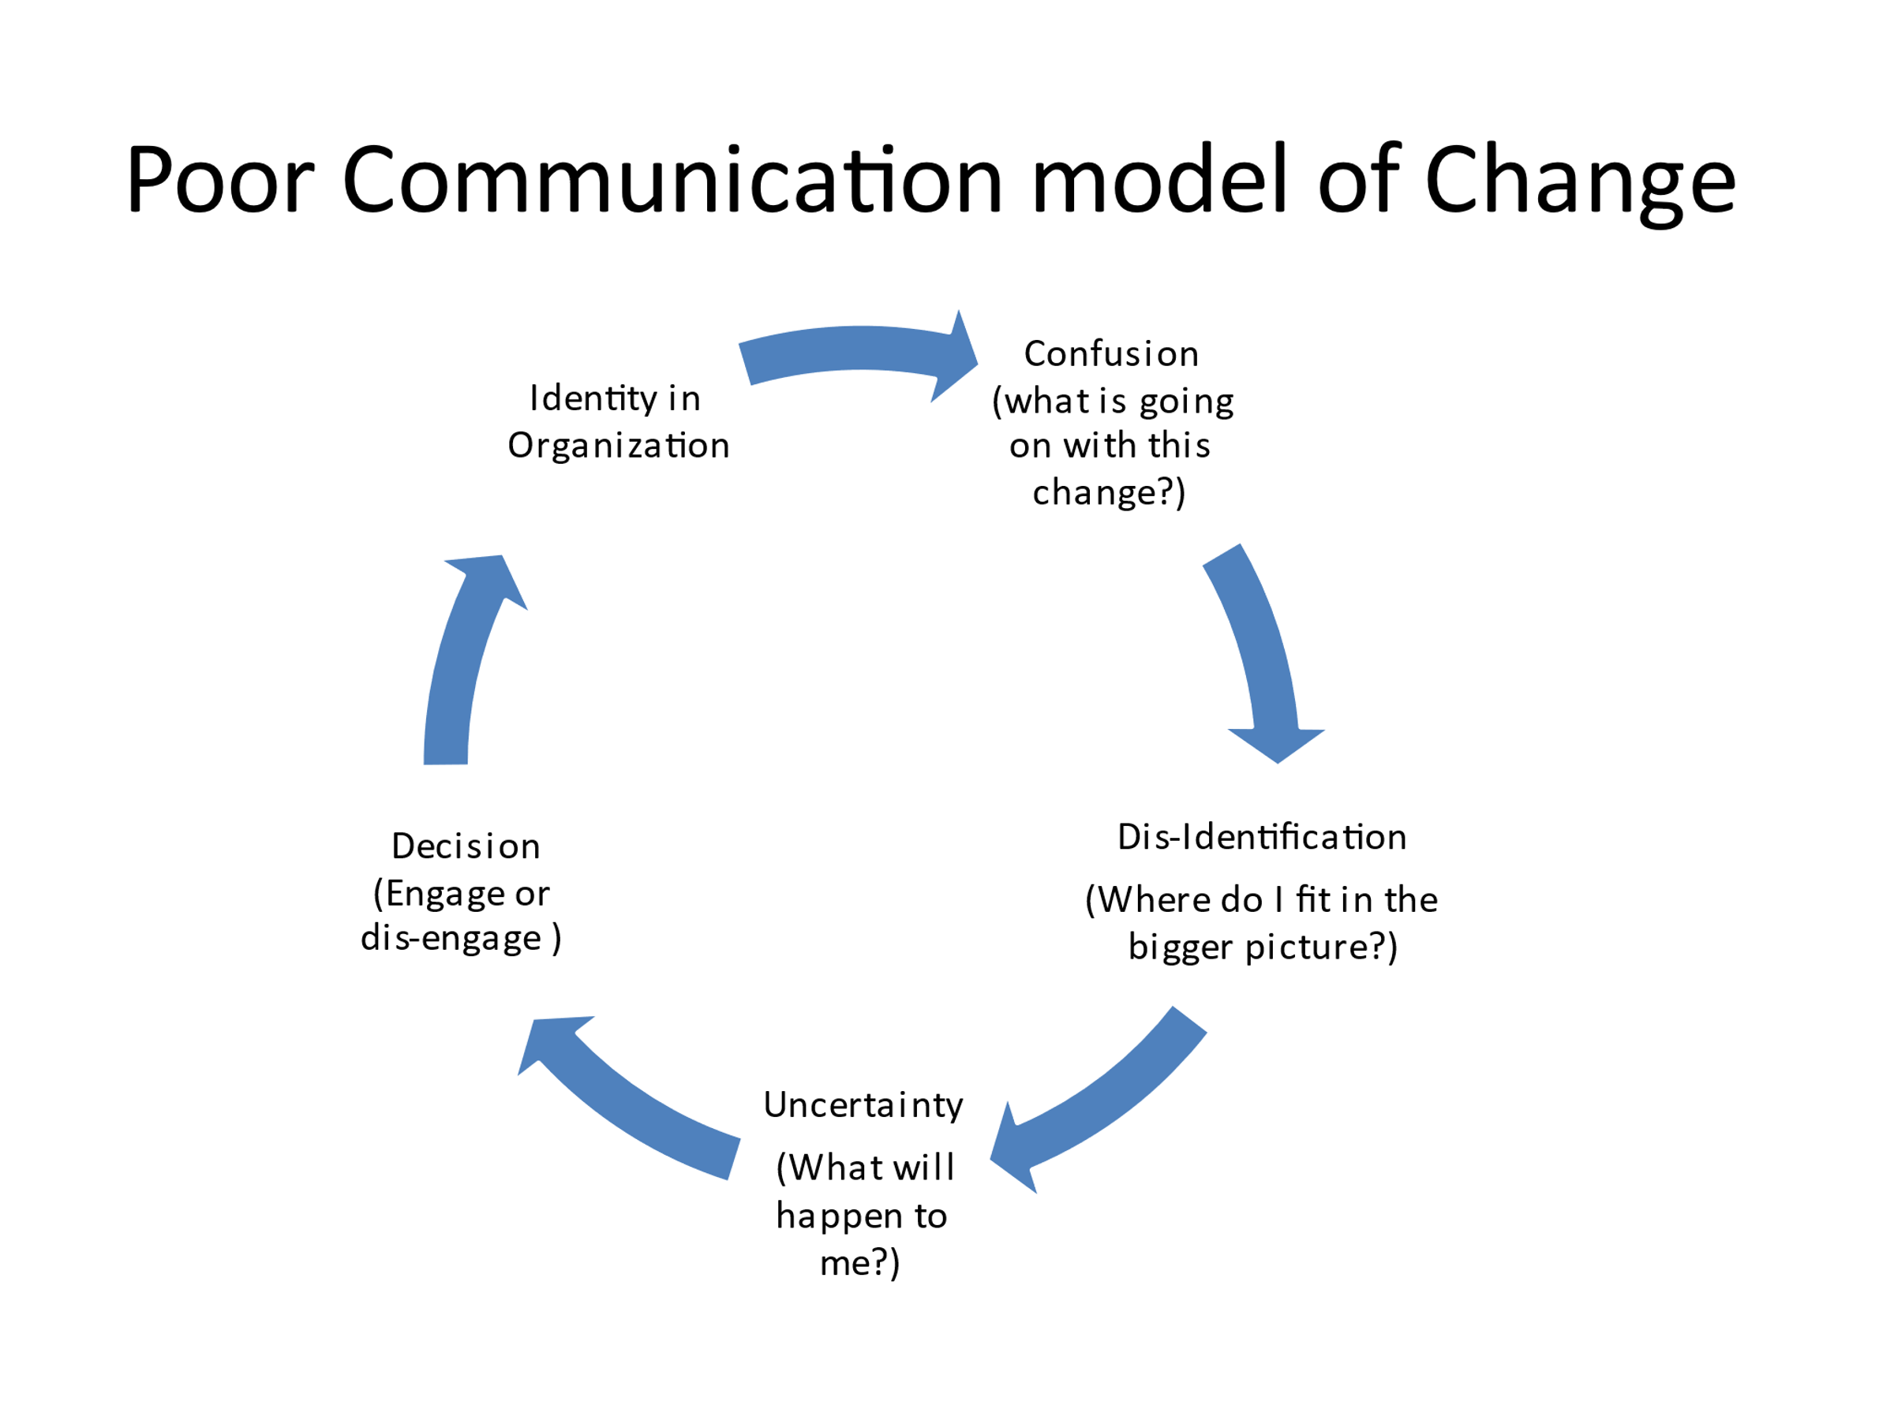

**Emotion(s):**

Workers commonly react with negative emotions (Anger, Fear, Sadness, Jealousy).

When a worker cannot face experience because his or her projects breakdown, then the worker escapes into a subjective reality (the emotional reality).

**Emotion as Resistance**

1. Sustainable strategy – Involves senior workers managing the self and others, particularly in developing an approachable and emotionally sensitive style.
2. Argument: Emotion is an open-loop system that enables social cohesion by drawing attention to the emotional states of those around you. Discuss why this is important in an organizational context?

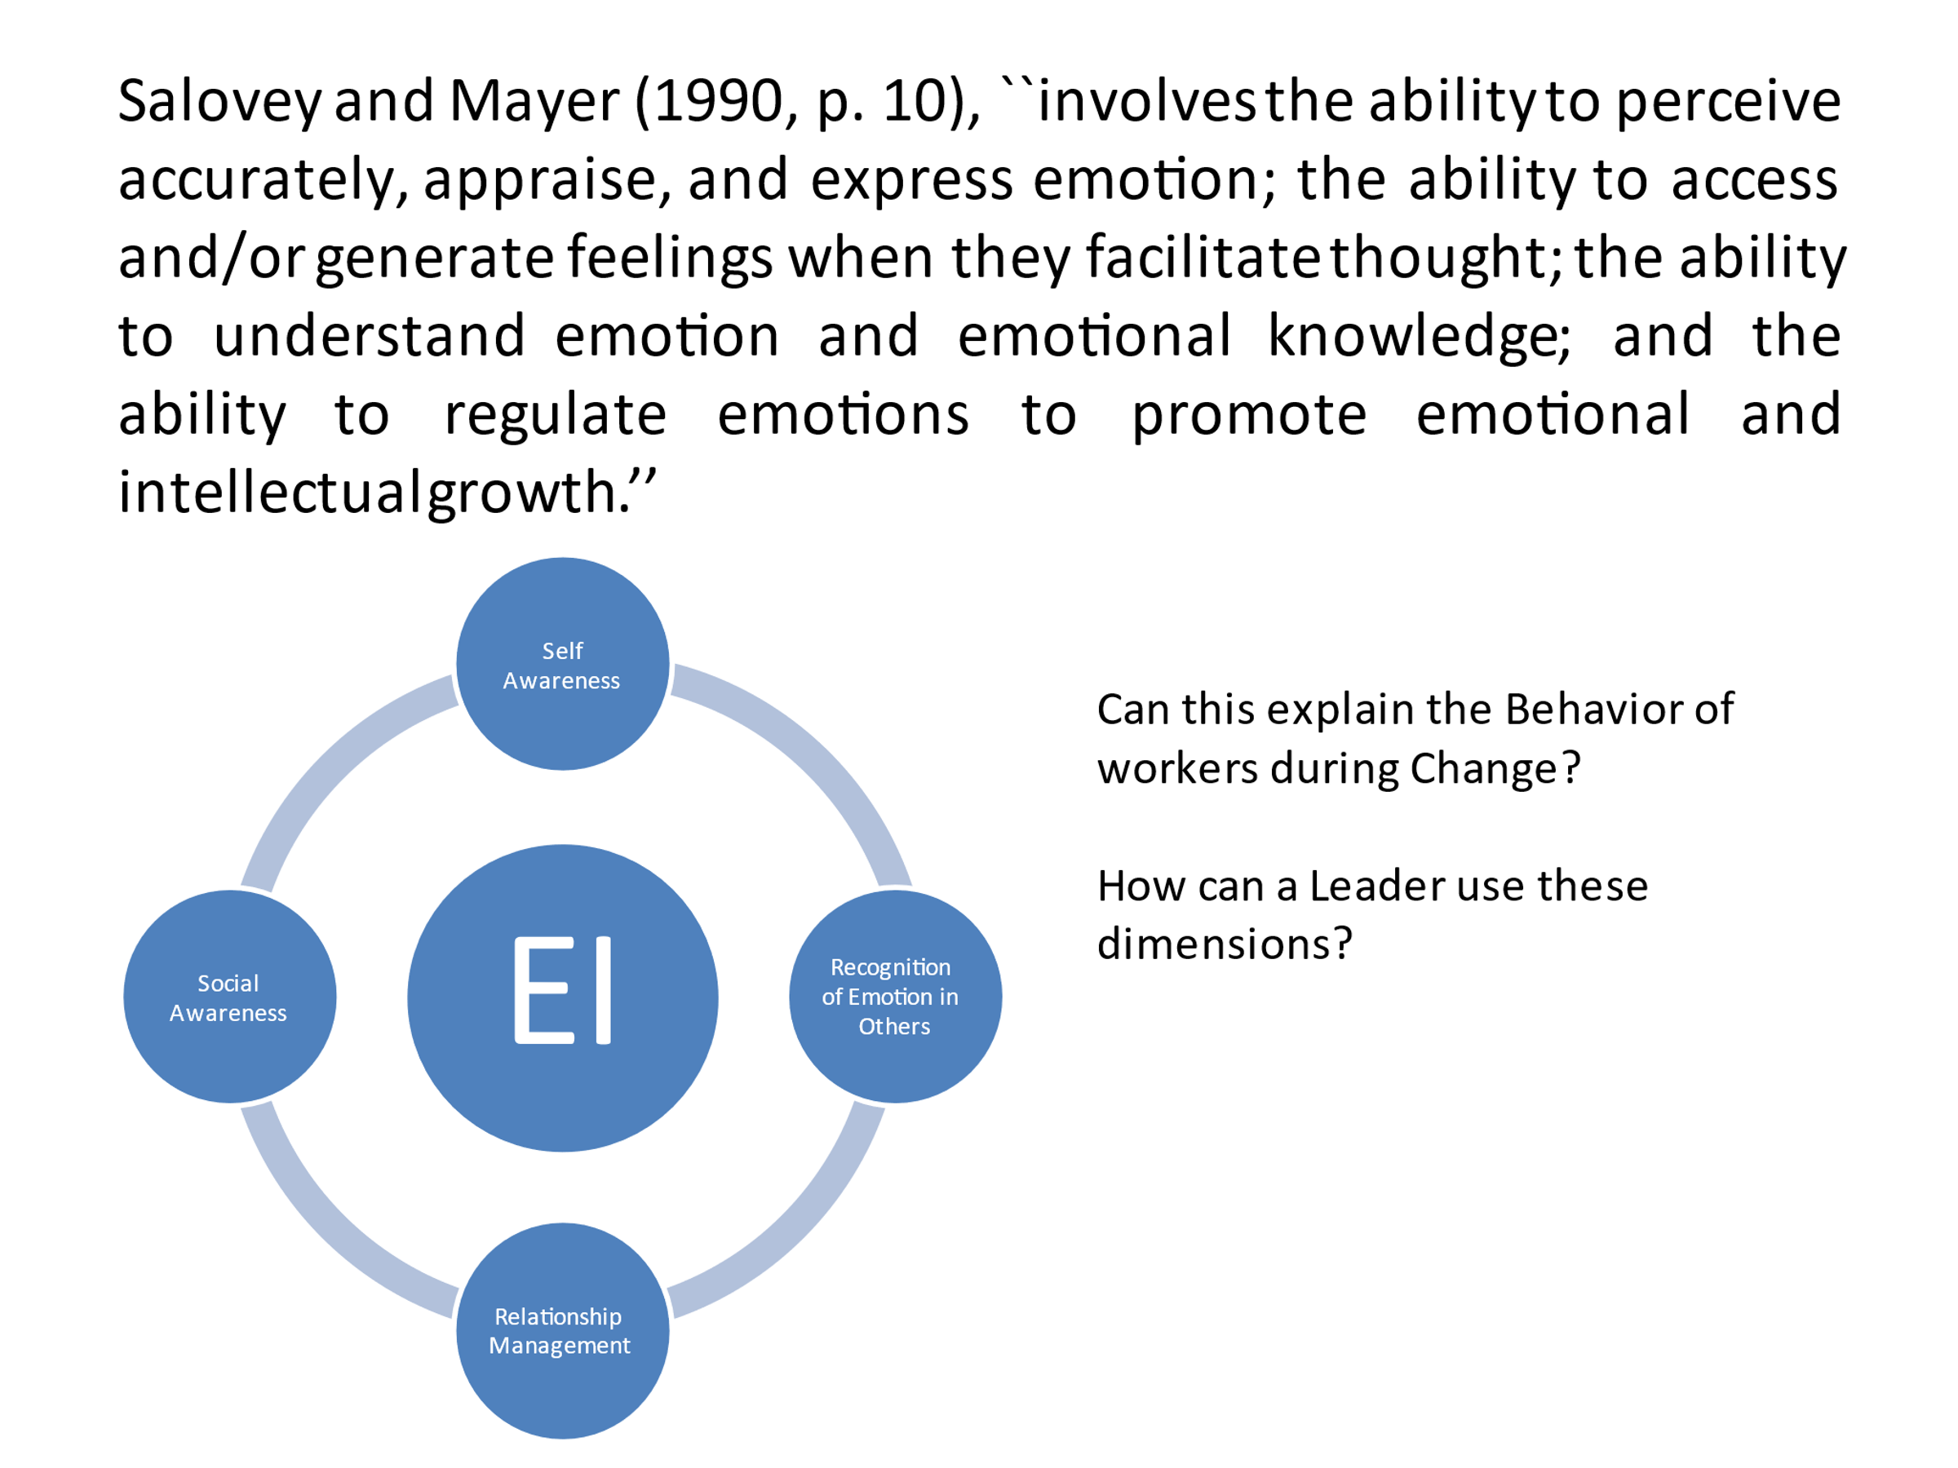

**Situation Control**

You work as a senior HR manager. You are walking down the office corridor one day and you come across a person from the operations department. The person looks upset and confronts you, she says “I cannot do this anymore. My work is tearing my life apart. There is too much stress and pressure, and I can’t talk to my team manager, because my boss is a bully”.

**Imagine**

Paul is angry because he believes that you (as their manager) unfairly promoted another staff member. This is in the context of the promise you had made to Paul. You run into him in the office corridor. What is the emotionally intelligent thing to do? Discuss for 10 min. You can offer to take him to your office and deal with the situation or to the cafeteria perhaps? What do you do?

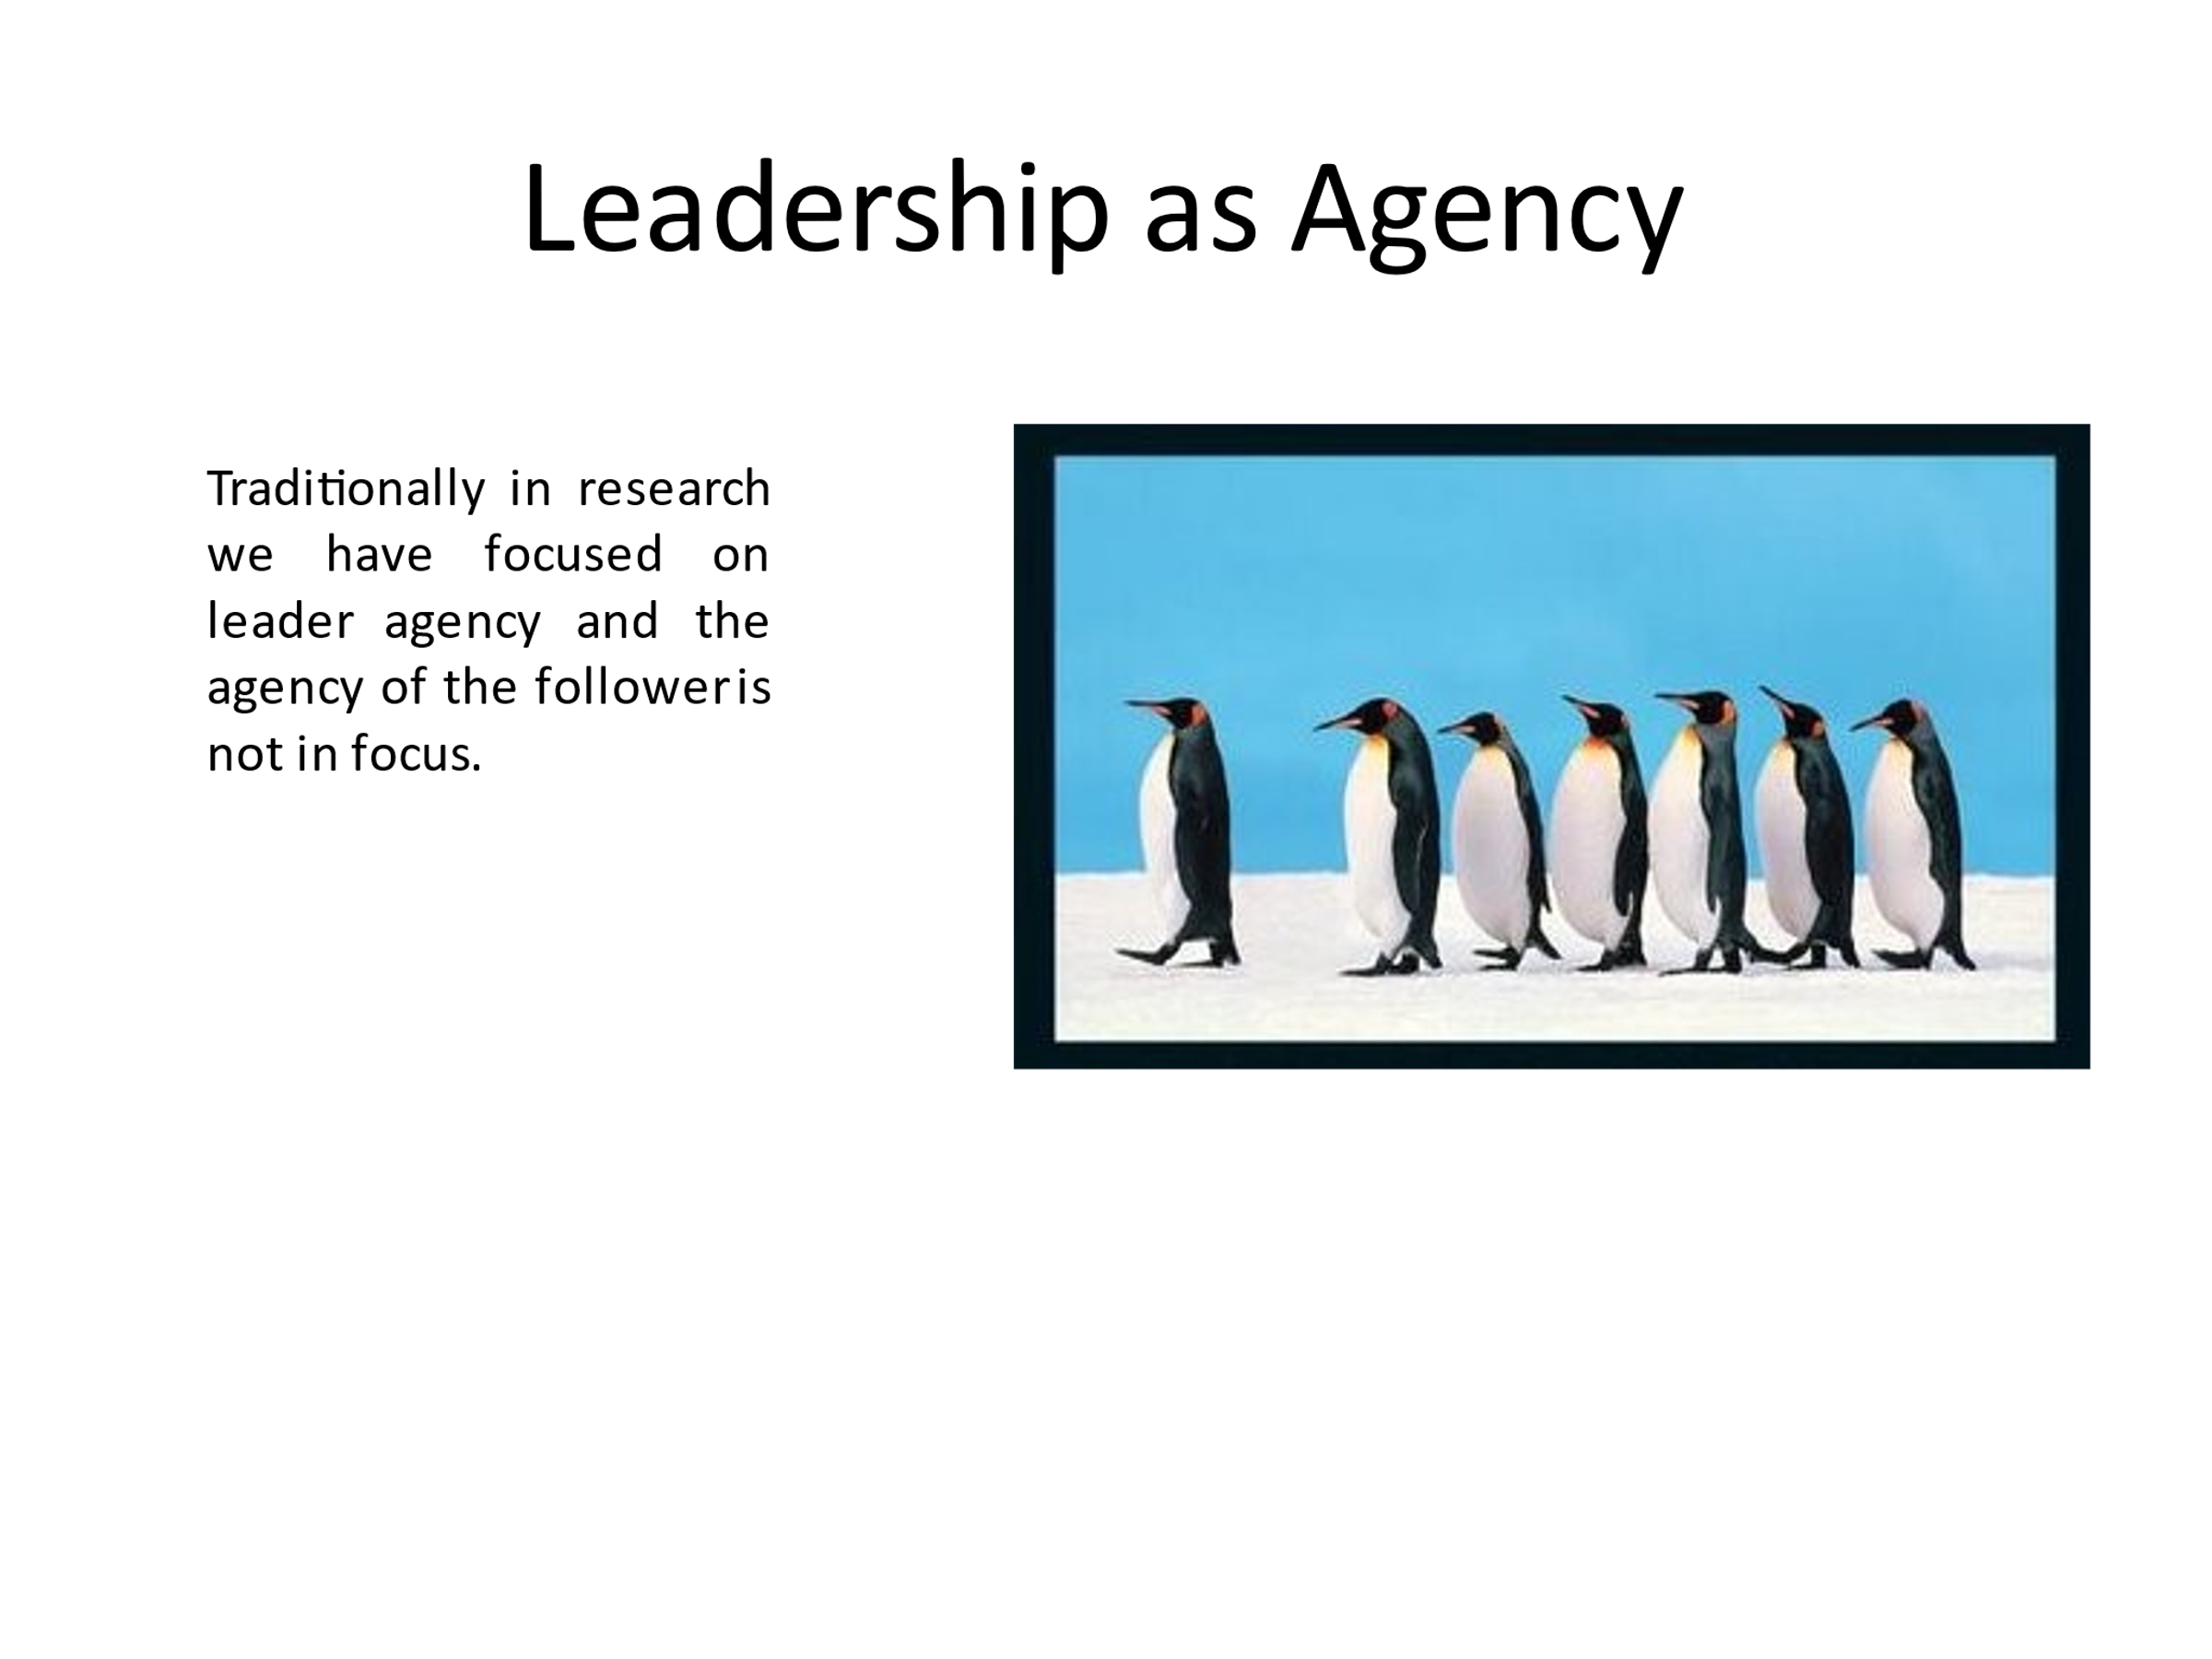

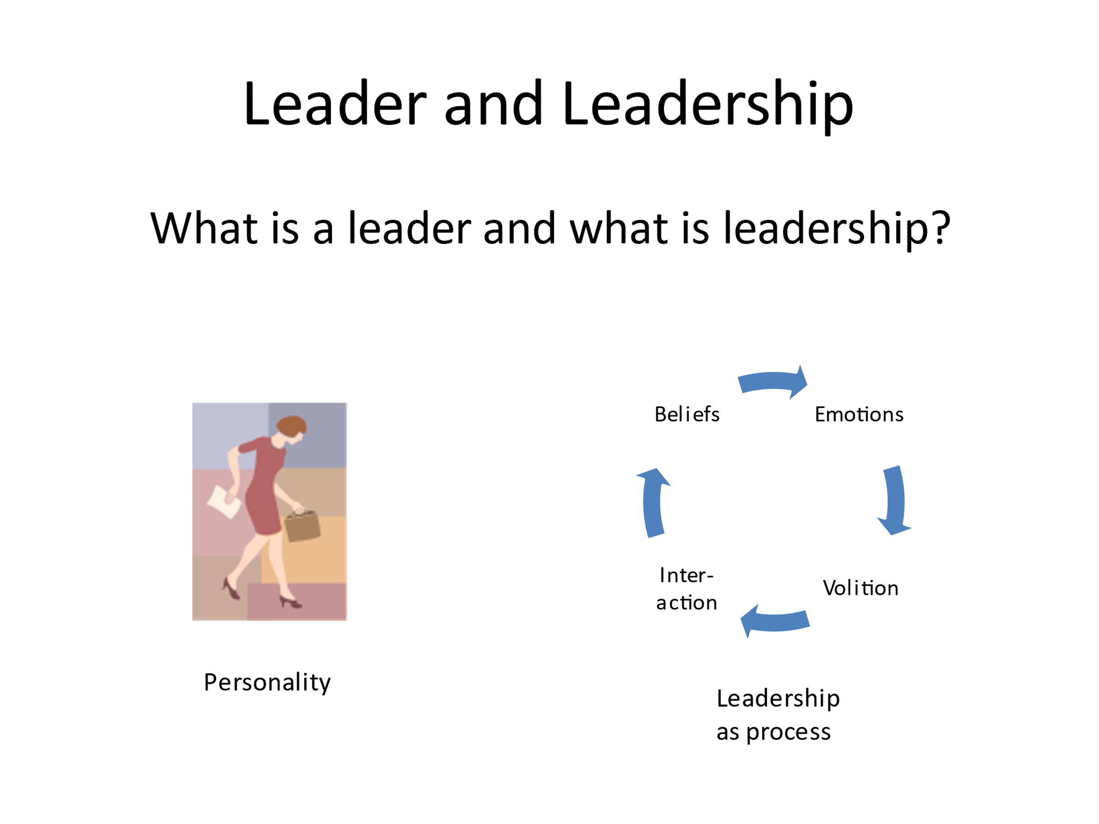

Leadership and Management:

The terms are often used interchangeably, and they are closely related but

* + Management is usually associated with terms such as planning, organizing, and control
  + Leadership is associated with terms such as providing vision and inspiration

Not all leaders are managers, but all managers could benefit from leadership skills.

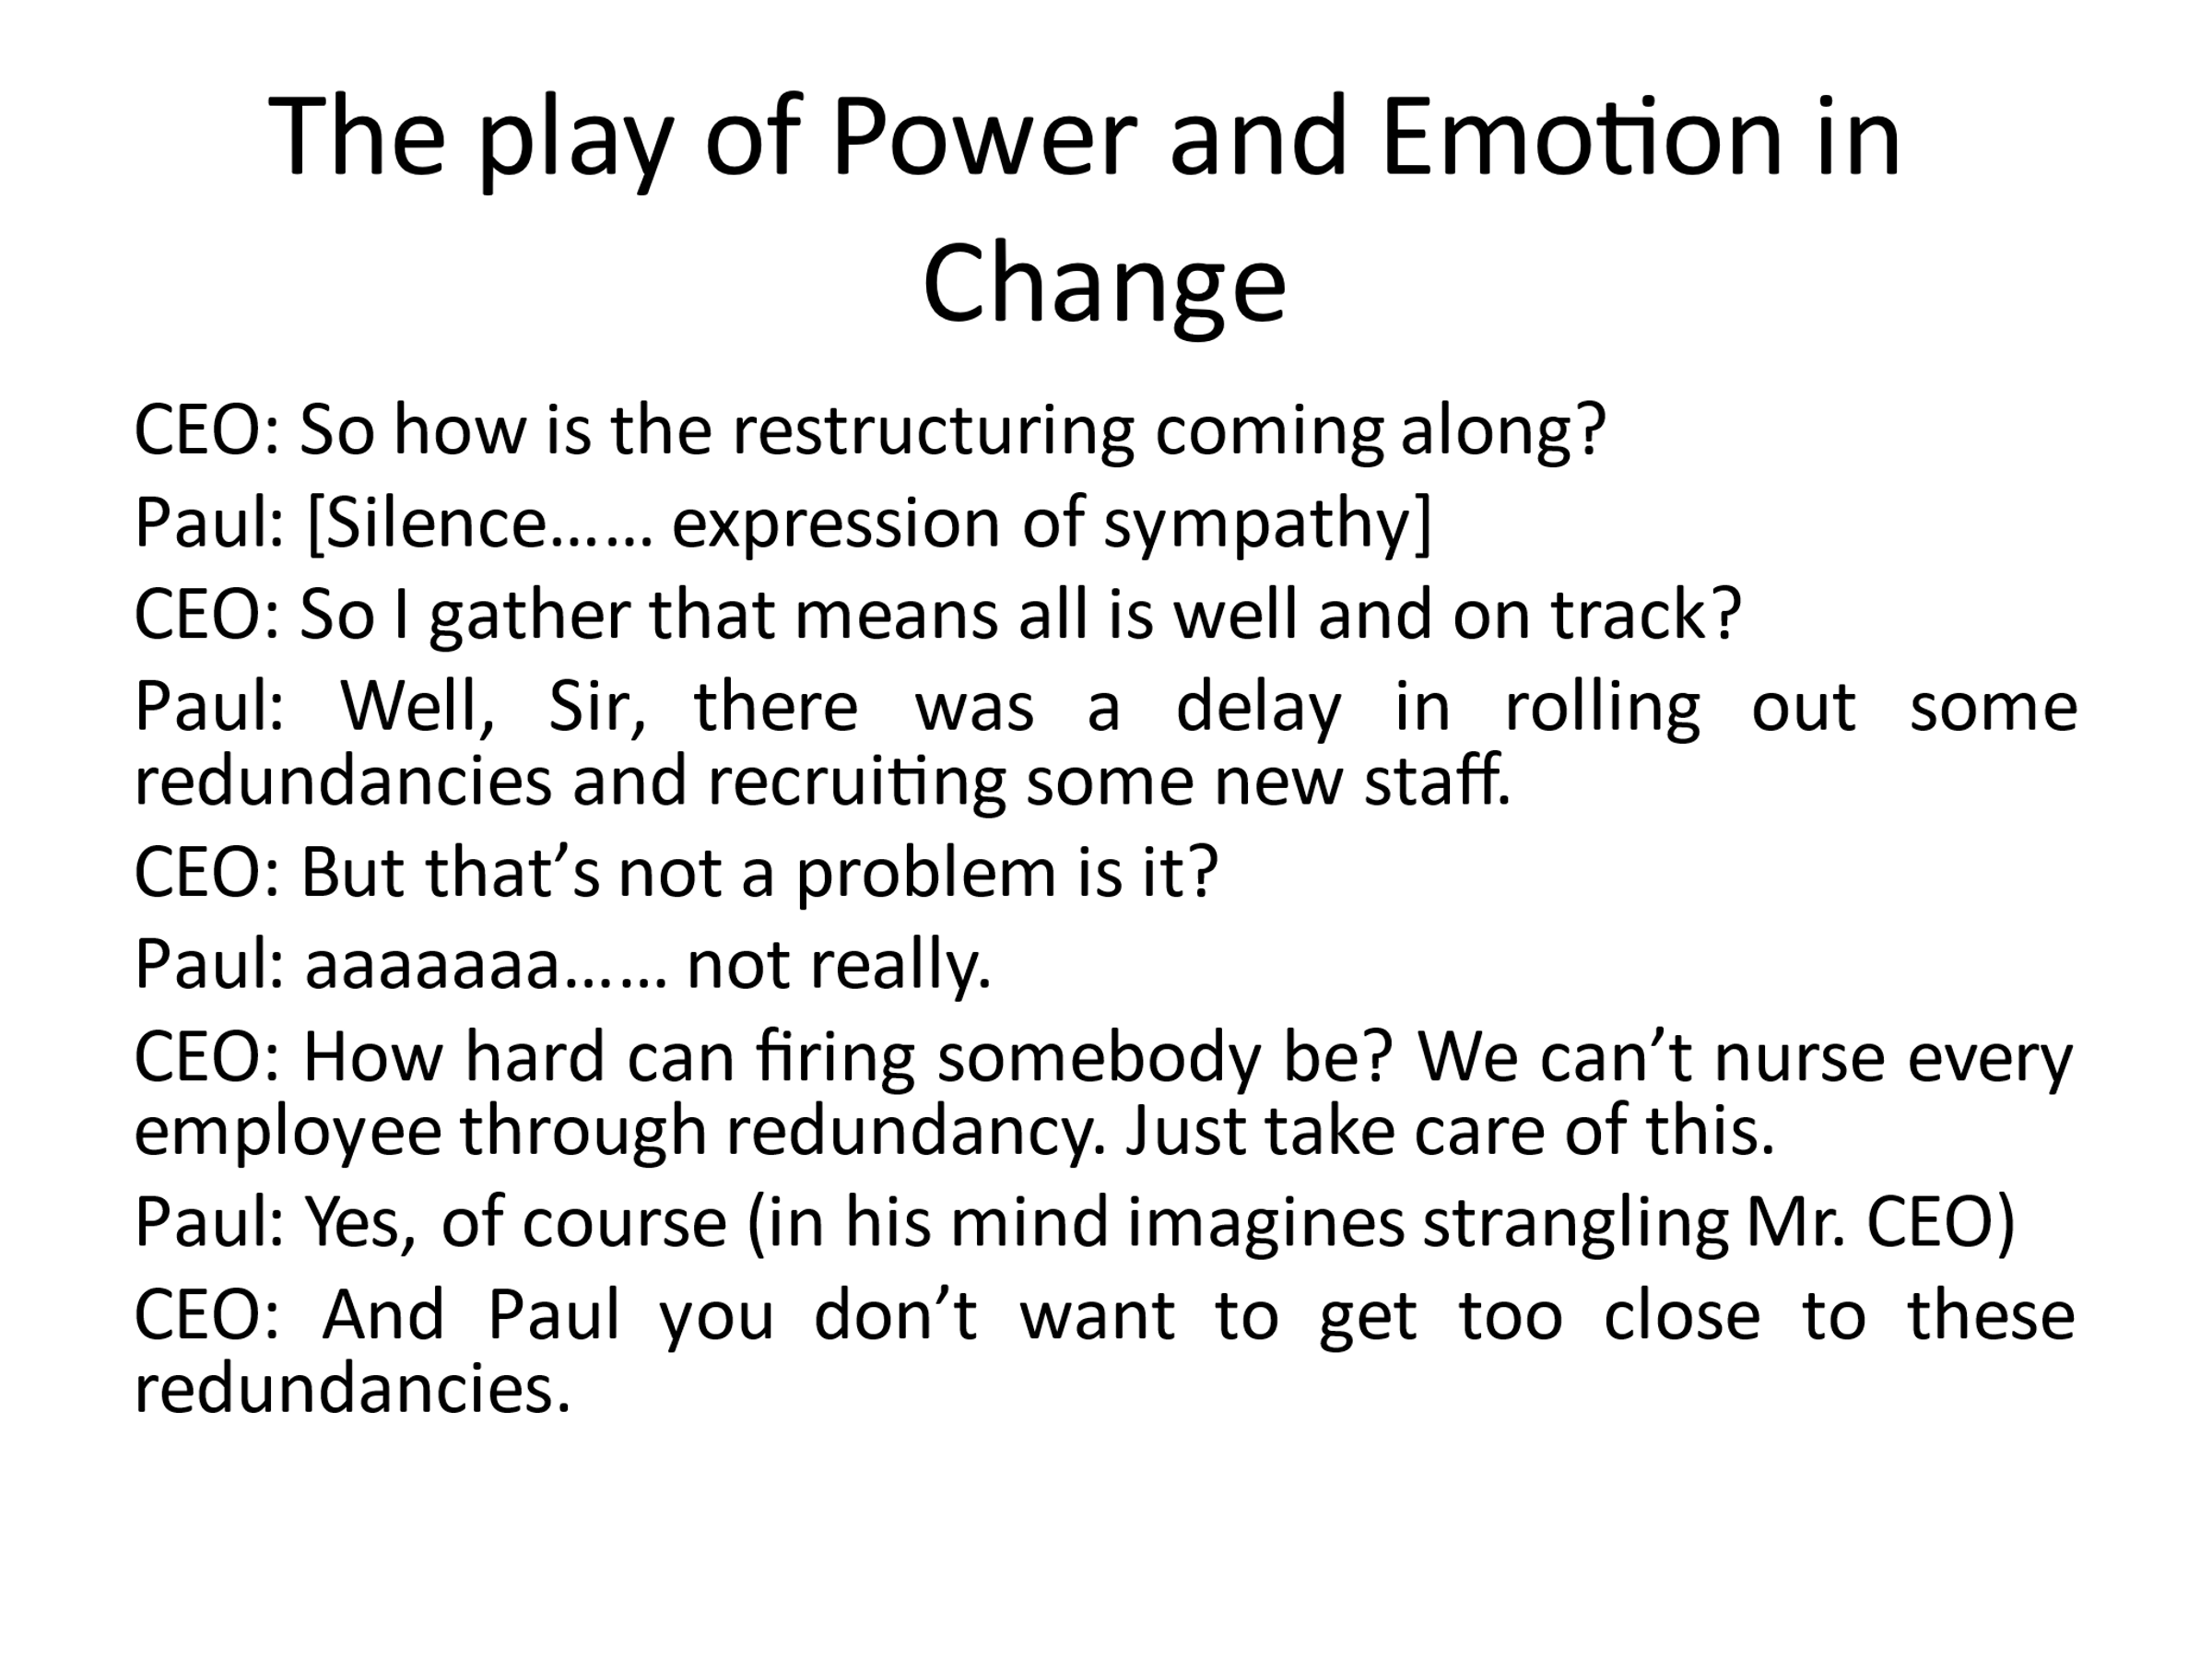

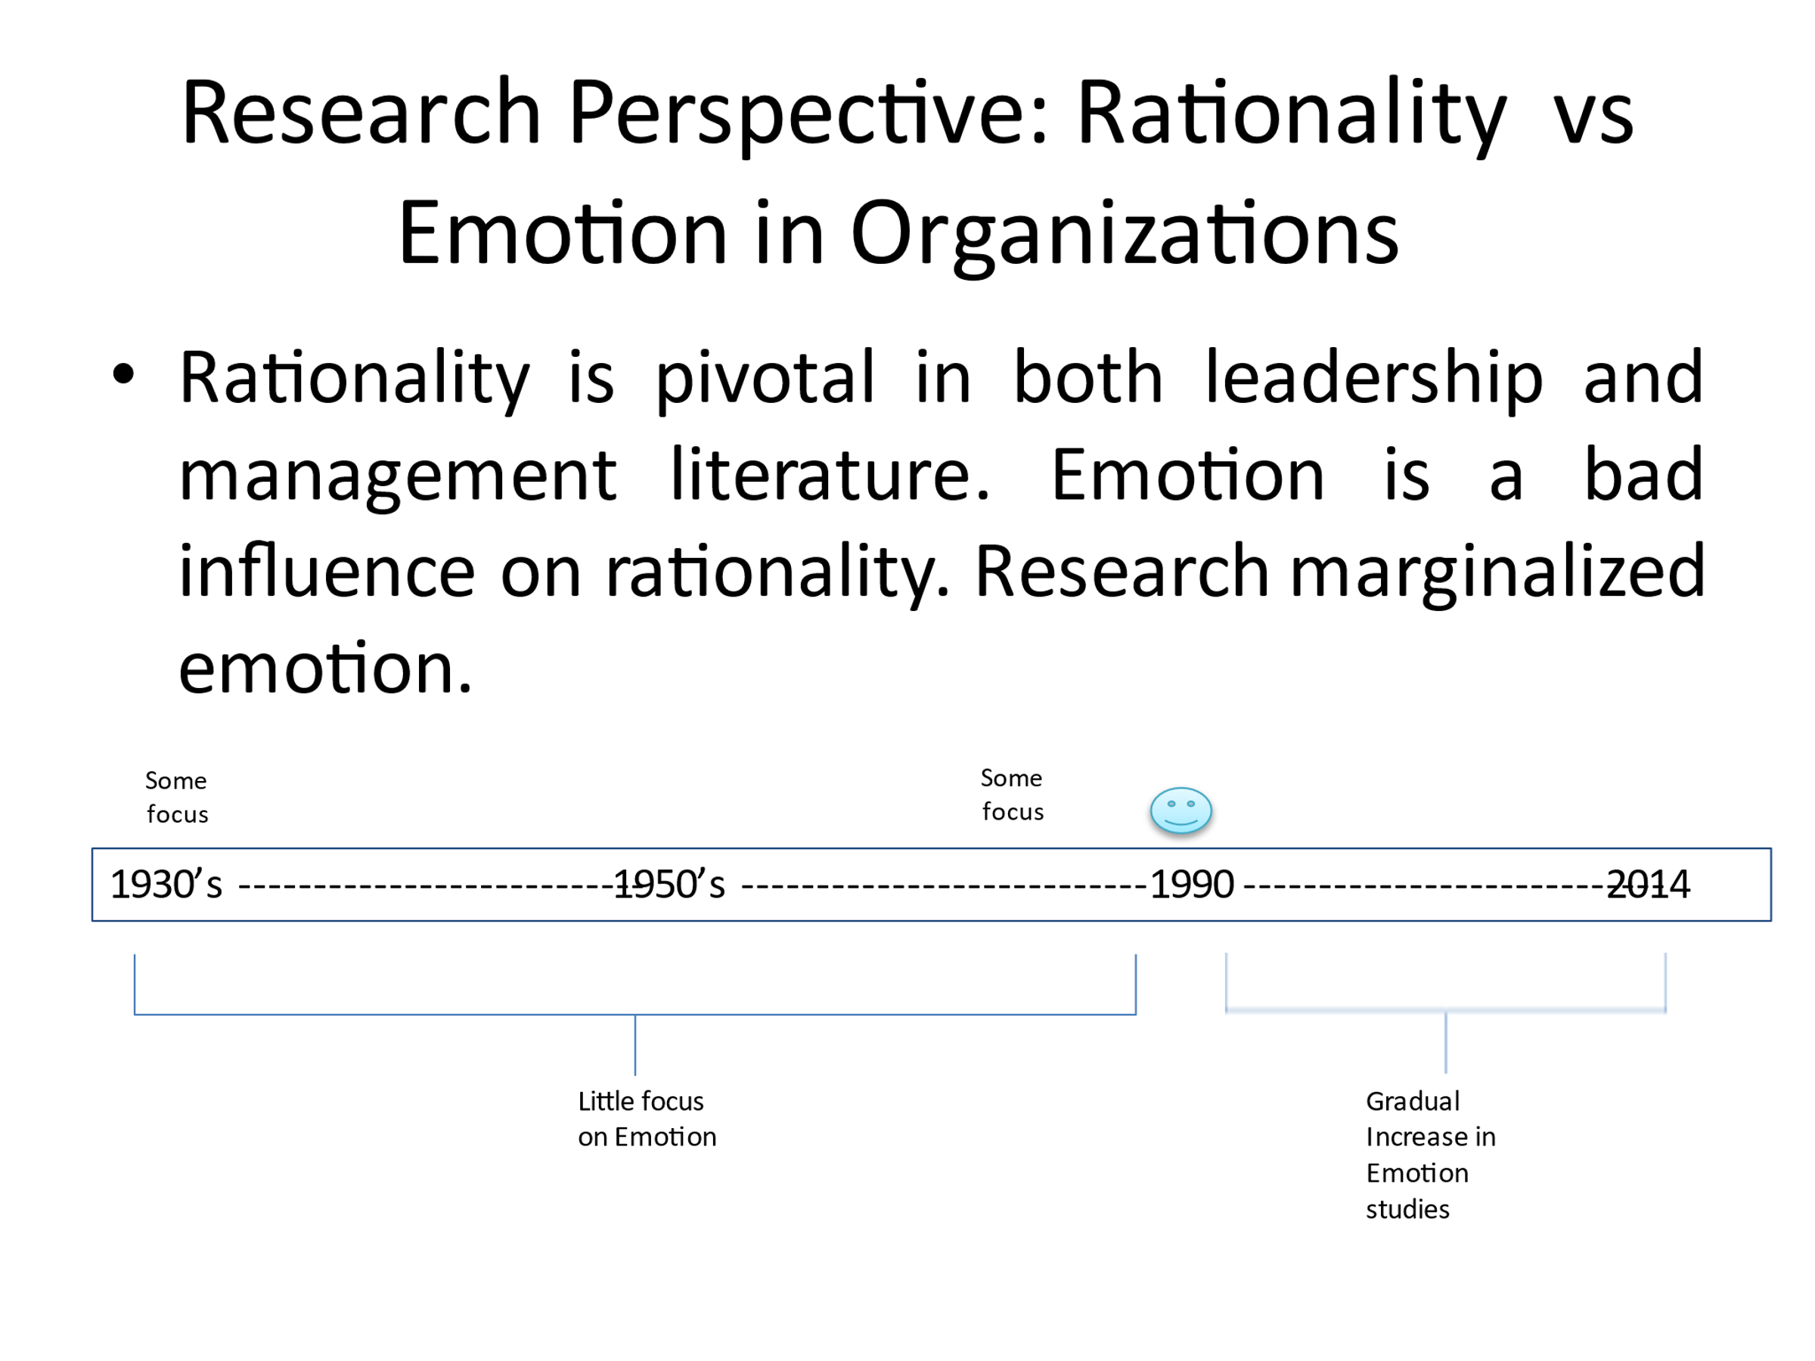

Contemporary Research

1. How do leaders use emotional Intelligence in a changing context?
2. What kind of leadership is required for successful change management?
3. How should power be distributed across the organization during organizational change and in the context of goals?

Learning to be Emotionally Effective

There is an Argument that what a Leader does, and thinks can be determined by the brain, and conversely, the leader has the potential to tell their brain what to do.

PLANNING ORGANIZATIONAL CHANGE

Most planned change is triggered by the need to respond to new challenges and opportunities presented by the external environment or anticipate the need to cope with the potential future problems. The planned change represents an intentional to improve in some significant way the operational effectiveness of the organization

Objectives of planned change:

1. Modified the behavioral patterns of employees in the organization
2. Enhancing the organization's ability to cope with changes from within its environment.

Issues that provide a window for change:

1. Improved organizational flexibility, quality or to develop new customers concerned
2. A general sense that the organization can perform better
3. A sense that skills and ability of people are underutilized or concerns about a lack of commitment about employees
4. The need to introduce technology or working practices
5. Concerns about ineffective communications or poor performance indicators
6. Job is seen as being boring

Behavioral modifications within the organization

This is a planned change and improved performance and involves management of faces processed.

1. Unfreezing involves reducing those forces that maintain the behavior in its present form.
2. Movement – this consists of the development of new attitudes or behaviors
3. Refreezing – this involves stabilizing changes at the new level and reinforcement through supporting mechanisms, e.g., policies, structures, or norms

RESISTANCE TO CHANGE

Common reasons for individual resistance to change

1. Selective perception – people's interpretation of events presents a unique image or picture of the natural world can result. this can lead to a biased view of a particular situation which fits most comfortability into a person’s perception of reality and can cause resistance to change
2. Habits- people tend to respond to a situation established and customary. Patterns may serve as a means of comfort and security and guide easy decision-making. Proposed changes to practices, especially if they are well-established, require little effort may be resisted.
3. Inconvenience or loss of freedom If the change is seen as likely to approve inconvenience and increased control, there may be resistance.
4. Economic implications people likely to resist change which is perceived as either or directly or indirectly or other rewards
5. Security in the past – there is a tendency for some people to find a sense of security.
6. Fear of people with the unknown tends to cause anxiety.

FORCE FIELD ANALYSIS

This fall into two categories:

1. Forces associated with the individual involved
2. Forces of an unpersonal nature exist in the environment.

|  |  |  |
| --- | --- | --- |
| **Unfreezing** | **Movement** | **Refreezing** |

The diagram above shows the effects of force field analysis: Restraining forces – Equilibrium - Driving forces.

According to Plotnick, Forces Field Analysis- helps diagnose the problems or the forces that operate in the specific situation.

For the change to be successful, according to Plovnick, the balance of the force field in favor of the driving forces must be changed by the following.

1. Decreasing the strength of the restraining forces
2. Plotnick identifies two points to weaken the restraining forces:
3. Generate a list of obstacles to change the restraining and resisting forces
4. Decide on the most appropriate measures or strategies to alter the problem

Plotnick four-point criteria to help identify the obstacles to change: this involves

1. Readiness for change; unfrozen and prepared for change
2. The capability of changing – identifying those people or factors that hinders the changing process
3. Accessibility of the obstacle
4. Leverage of the challenges on other obstacles

On the other hand, Kotter's Change model identifies (8) factors that lead to failure change efforts in organizations. These includes

1. Allowing to create too much complacency
2. Failing to create a sufficiently powerful guiding coalition
3. Understanding the power of vision
4. Under communicating the vision by a factor of 10 or 100 or 1000
5. Permitting obstacles to block the new vision
6. Failing to create short term wins
7. Declaring victory too soon
8. Neglecting to anchor changes firmly in the corporate

Kotter’s eight-stage change process:

1. Establishing a sense of emergency
2. Creating a guiding coalition
3. Developing a vision and strategy
4. Communicating the change vision
5. Generating short term wins
6. Consolidating gains and producing more change
7. Anchoring new approaches in the cultures
8. Empowering broad-based action

Kotter's Model for change does not see the problem as managing one but as one leading: management and leadership situations.

Management for Kotter is a set of processes that can keep a complicated system of people and technology running smoothly. The most critical aspects of management include planning to budget, organizing, staffing, controlling, and problem-solving

On the other hand, leadership is a set of processes that creates organizations in the first place or adopts them significantly changing circumstances.

Leadership defines what the future should look like, aligns people with that vision, and inspires them to make it happen despite obstacles. 70 percent to ninety percent leadership 10 % - 30% management.

**Conclusion**

This explored the fundamental of organizational Control and how it increases efficiency and work productivity. The steps of control processes and how it operates over time. It further explains how corporate culture plays a critical role in performance and productivity.

The knowledge gained will help me in the current job where I am presently employed as a supervisor and managing a department of five compliance officers.

How will it support me in my work – life? The knowledge gained from this study is timely and beneficial for me personally and my work life. It aids me with the standard principles of creating an ethical work environment that can apply the accommodative and proactive disciplines to confirm commitment and dedication in accomplishing personal and organizational goals. It has dramatically equipped me with the theoretical and practical foundation that will allow me to be more sensitive towards unethical situations in my work environment and proactively address them.

**Bibliography**

1. Trevino, LK., and M.E Brown. "The Role of Leaders in influencing unethical behavior in the workplace." *In Managing Organizational Culture Deviance, ed. R.E.J Kidwel and C.L Martin* (2005): 69 - 96. In Managing Organizational Culture Deviance, ed. R.E.J Kidwel and C.L Martin.
2. Trevino, L.K and K.A Nelson. . "Managing business ethics: straight talk about how to do it right. Hoboken: Wiley." *Managing business ethics: straight talk about how to do it right. Hoboken: Wiley* (2017): 10-20. Managing business ethics: straight talk about how to do it right. Hoboken: Wiley.
3. Weiss JW. "Business Ethics." *Journal of stakeholder and issues management approach. San Francisco: Berrett Koehler Publishers* (2014): 20-40. Journal of stakeholder and issues management approach. San Francisco: Berrett Koehler Publishers.
4. Wilcox, T. "Human Resource Management in a Compartmentalized World." *Journal of Business Ethics* (2012): 85-96. Journal of Business Ethics.

**STATEMENT OF ORIGINALITY**

**Student Name:** Dexter Jermaine Parker

**Student ID number**: UD7228BHUB1442

**PROGRAM:** Doctorate Degree in Human Resource Management and Development

**SCHOOL:** Business and Economics

Assignment Title**: (Principles of Business Management A.I.U.- EXAM )**

This Course Work assignment is a result of my work. All academic sources used in this study are fully acknowledged and disclosed, in line with the M.L.A. System Referencing.

**Student Signature Date: January 28th, 2022**

**Dexter Parker**