**Tesfaye Worku Moges**

**ID number: UD55180SAG64179**

COURSE NAME:

**(Environmental Management and Pollution)**

Assignment Title:

**(Analyzing the Causes and Impact of Pollution on Environment)**

ATLANTIC INTERNATIONAL UNIVERSITY

**March/2022**

# Table of Contents

Table of Contents 1

List of Figures 2

Abbreviations 3

Introduction 4

Environment 5

Pollution 5

Sources of pollution 5

Environmental Pollution 6

Types of Environmental Pollution 7

Causes of Pollution 10

Effects of pollution 15

Strategies to reduce pollution 17

Conclusion 19

Recommendation 19

Bibliography 20

# List of Figures

Figure 1. Contribution of Biomass Emission per Region 6

Figure 2. Water pollution from industrial wastes 9

Figure 3. Sources of Soil Erosion 9

Figure 4. A field exposed for overgrazing 12

Figure 5. Volcanic Eruption in Newzeland 13

Figure 6. Smoke (CO2) emitted from industries 14

# Abbreviations

CH₄ Methane

CO Carbon Monoxide

CO2 Carbon Dioxide

DAP Diammonium Phosphate

LDL Low-density Lipoprotein

NO2 Ozone and Nitrogen dioxide

NPS Non Point Source

PM Particulate Matter

PPE Personal Protective Equipment

UN United Nation

UNEP United Nation Environmental Program

US United States

USEIA United States Energy Information Administration

USEPA United States Environmental Protection Agency

WHO World Health Organization

**Environmental Management and Pollution**

# Introduction

This essay will assess and gives an in-depth analysis of the causes and consequences of pollution on the environment and human life. The essay will also review different types of pollution and their impact on human health and the natural environment.

The environment is a composite term referring to conditions in which organisms consisting of air, water, food, sunlight, etc., thrive and become living sources of life for all the living and non-living beings including plant life. However, our environment is heavily polluted due to many man-made phenomena and environmental degradation.

Pollution occurs when there is a release of substances into any environment which are capable of causing harm to man or any other living organisms supported by the environment.

The problem of environmental pollution, we face today, is a complex consequence of forces connected with various interrelating factors. However, the major causes of environmental pollution are population growth, economic growth, expansion of modern technologies, industrial development, deforestation, unplanned urbanization, excessive mining, and land expansion for agricultural production.

The purpose of this assignment is to briefly discuss different sources of pollution and their impact on human health, agricultural production and productivity, and the natural environment in general. The essay will also provide recommendations that could help to mitigate the pollution.

## Environment

The environment is defined as the complex of physical, chemical, and biotic factors (such as climate, soil, and living things) that act upon an organism or an ecological community and ultimately determine its form and survival (Merriam-Webster, 2022 ).

According to R. Kumar (2022), the environment is not only merely the atmosphere and other physical factors surrounding us, but, it is the complex of all factors which not only affect “one organism, one time but all organisms all the time” (R.Kumar, 2022). In a large sense, the environment constitutes the various physical, mental, social, educational, economic, and intellectual aspects of the whole humanity. When kept healthy and inspiring, it promotes progress and development.

## Pollution

The UK Environmental Protection Act defines the term "Pollution" as the release (into any environmental medium) from any process of substances that are capable of causing harm to man or any other living organisms supported by the environment (Pollution Prevention and Control Act 1999).

According to Wikipedia, pollution is the introduction of contaminants into the natural environment that causes adverse change. Pollution can take the form of any substance (solid, liquid, or gas) or energy (such as radioactivity, heat, sound, or light) (Wikipedia, 2022). Pollutants, the components of pollution, can be either foreign substances/energies or naturally occurring contaminants.

Pollution is the mixture of contaminants in the natural environment that creates an adverse effect on the environment (Mia, et al., 2019). In the simplest possible language pollution can be described as “something in the wrong place at the wrong time in the wrong quantity”.

### 

### Sources of pollution

There is a wide range of sources of pollution that include industries, vehicles, and different human activities. Pollutants affect different environmental resources such as air, water, soil, and generate danger to the ecosystem. These encountered problems require immediate scientific attention to find appropriate and cost-effective solutions. According to Yadav & Devi, [biomass](https://www.sciencedirect.com/topics/earth-and-planetary-sciences/biomass-burning) burning refers to the burning of living or dead vegetation including grassland, forest, agricultural waste, and burning of biomass for fuel. It is a complex process involving physical and chemical reactions and the transfer of mass and heat (Yadav & Devi, 2018).

Burning can be natural or man-made. Man-made fires comprise burning of vegetation for land clearing and land-use change and burning of fuelwood, while natural fires include fires caused by lightning. Savannah fires are the biggest source of biomass burning around the world, representing about 43% of aggregate worldwide emissions while burning of agricultural wastes and forest fire contribute 23% and 18% of the aggregate emission, respectively. Biomass material when burned releases extensive varieties of gases such as CO, CO2, CH4, volatile and semi-volatile organic compounds, [aldehyde](https://www.sciencedirect.com/topics/earth-and-planetary-sciences/aldehyde), organic acid and inorganic elements, and [particulate matter](https://www.sciencedirect.com/topics/earth-and-planetary-sciences/particulate-matter) (Yadav & Devi, 2018).

According to Yadav and Devi, biomass is an essential source of cooking fuel for 753 million sub-Saharan Africans which equates to 80% of the total population. Man-made fires include burning of vegetation for land clearing and land-use change and burning of fuelwood, while natural fires involve lightning-induced fires. The characteristics of biomass burning rely upon the natural condition, types of the fuel burnt, moisture content, weather condition, and particle size and emission factor of the biomass. It is estimated that man-made burning is accountable for over 90% of the fires on the planet, with little contribution from natural fires. The amount of biogas emission varies among different continents. Africa contributes the largest amount of emission from the burning of firewoods, agricultural wastes, forests, etc (Yadav & Devi, 2018). The contribution of biomass emission per region is illustrated in the following diagram:

Figure 1. Contribution of Biomass Emission per Region

# Environmental Pollution

Environmental pollution is one of the most dangerous threats to all living things on the earth. On daily basis, a variety of pollutants are released from different sources into the environment.

Though environmental pollution is not a new occurrence, it is still the major problem facing humanity in the world. Human activities through urbanization, industrialization, mining, and exploration are at the forefront of global environmental pollution (Ukaogo, Ewuzie, & Onwuka, 2020).

Both developed and developing nations share this burden, though awareness and stricter laws in developed countries have contributed to a larger extent in protecting their environment. Despite the global attention towards pollution, the impact is still being felt due to its severe long-term consequences.

### Types of Environmental Pollution

Broadly, environmental pollution is classified into, i.e., natural and man-made pollution. Natural Pollution is a condition where environment is polluted by natural phenomena, such as earthquakes, floods, drought, cyclones, etc, while man-made pollutions are caused by different human activity.

Environmental pollution can also be classified further as, air pollution, water pollution, soil pollution, noise pollution, radioactive pollution, etc.

**Air Pollution**

Air pollution is defined as the presence of toxic chemicals or compounds in the air, at levels that pose a health risk . The center further stated that air pollution is one of the most dangerous environmental problems challenging the world's people and development today. According to the Environmental Protection Agency (EPA), air pollution is a mixture of solid particles and gases in the air. Car emissions, chemicals from factories, dust, pollen, and mold spores are the main contributor to air pollution (Environmental Protection Agency, 2021). Air pollution is a complex and dynamic mixture of abundant compounds in gaseous and particle form, originating from diverse sources, subject to atmospheric transformation, and varying over space and time.

Human activities such as construction, mining, industrial work, transportation, smelting, agriculture, etc. could lead to air pollution. On the other hand, though the occurrence is low, natural phenomenon such as wildfires and volcanic eruptions also causes air pollution. Air pollutants may exist in gaseous or particulate form. Particulate matter (PM), ozone, and nitrogen dioxide (NO2), are the common air pollutants.

Long-term exposure to air pollution has been associated with heart, lungs, cancers, and other diseases. That's why we need to monitor air pollution (Climate Kids, 2022). Air pollution contributes to the global burden of disease, with an estimated 12% of all deaths in 2019 while the impacts of air pollution on respiratory diseases is widely recognized, 50% of the estimated 6.7 million deaths attributable to air pollution in 2019. Globally, nearly 20% of cardiovascular disease deaths were attributable to air pollution. Further, air pollution was the 4th highest-ranking risk factor for mortality, with more attributable deaths than high LDL cholesterol, high body-mass index, physical inactivity, or alcohol use Globally air pollution contributes to an average loss of life expectancy of 20 months (Brauer, Casadei, Harrington, Kovacs, & & Sliwa, 2021).

**Water Pollution**

Water is a unique naturally renewable resource. It can clean itself, by allowing pollutants to settle out through the process of sedimentation. However, this sedimentation is impossible when excessive quantities of harmful contaminants are added to the water. The dyeing and printing industries use a huge amount of water in their manufacturing processes. The wastewater from the dyeing and printing industries is identified as the most polluted water considering the volume generate as well as the effluent composition (Mia, et al., 2019).

Water can be contaminated by pathogens and harmful chemicals from human and natural activities. Pathogens are disease-causing organisms that include bacteria, amoebas, and viruses, as well as the eggs and larvae of parasitic worms. Harmful chemicals also pollute water through human activities such as industrial wastes, pesticides, fertilizers.

Chemicals and minerals from the natural environment, such as arsenic, common salt, and fluorides also cause water pollution. Some non-harmful contaminants may influence the taste, smell, color, or temperature of the water, and make it unacceptable to the community. For example, more than 90 million people in Bangladesh and India are at risk from arsenic poisoning as a result of using arsenic-contaminated groundwater for both domestic and agricultural purposes (Mitchell, 2013)

Figure 2. Water pollution from industrial wastes

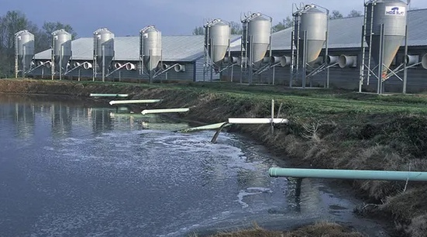

Source: <https://soapboxie.com/social-issues/What-is-Water-Pollution>

**Soil Pollution**

Fertile and nutrient-rich soils have high organic contents that support soils by binding the soils through the network of their roots. The nutrient in fertile soil also protects soils from erosion. They increase the infiltration of rainwater and allow maximum recharge of groundwater resources. Fertile soil also minimizes surface run-off (Reddy, 2017). However, if the soil is polluted by chemicals, it will have an adverse effect both on human beings and the natural environment.

Many authors shared the same definition of soil pollution. They defined soil pollution as the presence of toxic chemicals (pollutants or contaminants) in soil, in high enough concentrations to pose a risk to human health and/or the ecosystem. Soil contamination is mainly caused by human activities. Some examples are manufacturing, industrial dumping, land development, local waste disposal, and excessive pesticide or fertilizer use. Three common causes of soil pollution are agricultural activities that use excessive external inputs such as fertilizers and pesticides, excessive industrial activity, and poor waste management techniques.

Figure 3. Sources of Soil Erosion

### Causes of Pollution

Pollution can be caused by natural and human activities. Some of these causes are:

1. **Use of excessive inorganic fertilizers**

Use of high external inputs, inorganic fertilizers (such as UREA & DAP), and pesticides that have a high amount of toxic substances can distort the naturally balanced ecological relations among plants, insects, etc. During different agricultural production activities, the toxic substances that are applied into the soil and air could cause different types of human and animal health problems.

Too much use of chemical fertilizers will result in the formation of a non-porous layer between soil particles. It causes a rise in the groundwater level, a higher level of salinity, and its effect on the aeration of the soil. It also leads to the death of the roots of the cultivated plants. Excessive quantities may also make plants incapable to absorb the nutrients that are needed for growth. It converts nutrients into substances that the plant cannot absorb. This leads to a lack of plant growth (Hassan, 2021).

Excessive use of any inorganic fertilizers causes serious environmental degradation, resulting in lower crop yields. This has been confirmed in Bangladesh in the 1960s when the Bangladesh state authority launched a 'Grow More Food' campaign to feed the country's increasing population. Farmers were supplied with chemical fertilizers and pesticides at a subsidized price. Farmers increased the frequency of fertilizer applications beyond the recommended level to enhance their yields. However, the overutilization of fertilizers has caused significant environmental degradation and subsequent loss of yields (Rahman & Zhang, 2018).

Such excessive use of chemical pesticides leads plants to absorb and store them in their tissues, roots, and leaves, causing harm to humans and animals that directly eat them. Which again causes indirect harm to humans by eating animal products contaminated with pesticides (Hassan, 2021)

1. **Livestock and their manure**

Though livestock products are the main source of important diets for humans, their byproducts could cause environmental pollution. If livestock manures are used incorrectly, they will become a major source of air, soil, and water pollution and a threat to aquifers and surface waters in areas with a high density of livestock by emitting deadly pollutants such as sulfates and nitrogen oxides.

Useful greenhouse gases from animal manure are methane and nitrous oxide. Methane is a gas that is produced by fermentation during manure storage. Methane affects global warming 28 times higher than carbon dioxide. Nitrous oxide, arising from manure storage and the use of organic/inorganic fertilizers, is a molecule with a global warming potential 265 times higher than carbon dioxide (Grossi, Goglio, Vitali, & Williams, 2019).

1. **Agricultural Runoff**

Agricultural runoff is the runoff of agrochemicals (fertilizers and pesticides) discharged into surface waters and is the major Non-Point Source (NPS) pollution source. The impact of agricultural runoff has adverse effects on wildlife, aquatic ecosystems, and human health through the drinking water supply, thus contributing to surface and groundwater deterioration, with harsh environmental and economic consequences (Loannidou & Stefanakis, 2020).

The water from farm fields will run off due to irrigation, rain, or melted snow that flows over the earth that can absorb into the ground, enter bodies of water, or evaporate. This runoff can contain complex pollutant compositions such as pesticides, sediment, nutrients (phosphorus, nitrogen, and potassium from fertilizers), and metals, which can pollute water sources. When this agricultural runoff enters bodies of water it could have negative impacts on the environment. For example, pesticides and fertilizers used in agriculture can contaminate both groundwater and surface water.

The runoff water can also contaminate sources of drinking water and endanger its quality. The contaminated water can be absorbed by aquatic plants, contribute to algae blooms and affect aquatic animals' ability to find food and reproduce.

1. **Overgrazing**

Overgrazing is grazing by animals (livestock or wildlife) to the point where the grass cover is depleted, leaving bare, unprotected patches of soil. As a result, water and wind cause erosion, especially on clay soils, and the growth of poisonous plants and thorny shrubs may increase. According to the United States Environmental Protection Agency (USEPA), overgrazing exposes soils, increases erosion, encourages invasion by undesirable plants, destroys fish habitat, and may destroy stream-banks and floodplain vegetation necessary for habitat and water quality filtration.

Overgrazing occurred when plants are exposed to intensive grazing for an extended period without sufficient recovery periods. It reduces the usefulness, productivity, and biodiversity of the land and is one cause of desertification and erosion (AZ-Production, 2017).

Figure 4. A field exposed for overgrazing

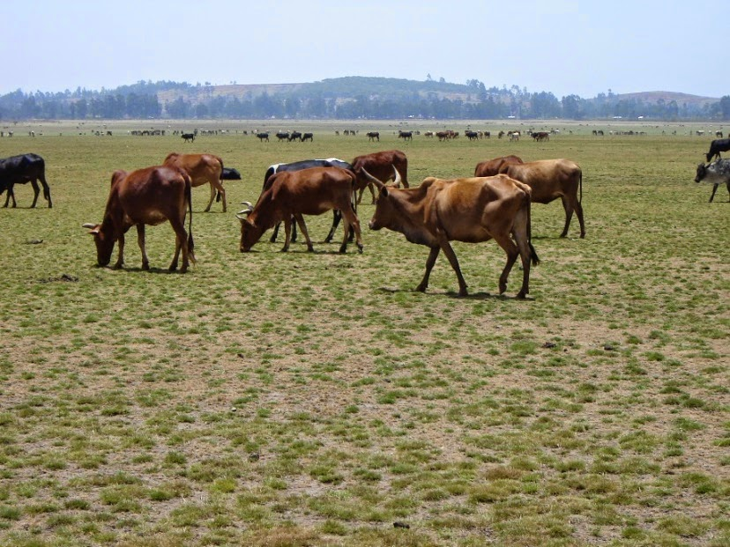

1. **Land overuse**

Cultivating farmland frequently would reduce agricultural production and productivity. Land overuse can come from different problems such as poor land ownership policy, economic pressure, and traditional farming practices.

Some people exploit land resources for their gain with little consideration for the land. Similarly, an economy or livelihood that depends on crop production can cause farmers to ignore the overutilization of the land. Natural disasters (eg., floods & droughts) also destroy the fertility of the land thereby reducing its productivity.

1. **Deforestation**

The temporary or permanent removal of forest cover from a forest land is known as deforestation (R.Kumar, 2022). The term deforestation refers to the destruction of indigenous forests and woodlands. Forests are invaluable property of a nation because they provide raw materials to modern industries, timber for building purposes, habitats for numerous types of animals, and micro-organisms.

Forests provide firewood to the majority of the people in developing countries and are the source of food and shelter for humans and animals. Forests are the main component of the biotic components of the natural environmental system. Hence, the environment and ecological balance largely depend on the condition of the forests resource.

However, there is a concern that humans have forgotten the significance of the environment and have destroyed the forests rapidly at an alarming rate. As a result, the forest areas at global, regional, national, and local levels have decreased causing serious environmental problems.

The major causes of deforestation are alteration of forest land into agricultural land, forest fires, changing of forests into pastures, overgrazing, etc. Deforestation causes environmental degradation by causing soil erosion, sedimentation, siltation, droughts, precipitation, intensification of greenhouse effects, etc. Thus deforestation would lead to complex environmental problems.

1. **Volcanic Eruption**

Volcanic eruptions are the major natural cause of environmental change. Volcanic eruptions can infuse chemically and active gases and solid particles into the environment, which affect the Earth's irradiative balance and climate, and disturb the chemical equilibrium (Robock, 2020). As volcanoes are the main pathway to the surface for volatiles, it causes disturbance to the Earth's radiation balance to affect the environment through direct radioactive effects as well as indirect effects on the atmospheric circulation.

Ninety-nine percent of the gas molecules emitted during a volcanic eruption are water vapor (H2O), carbon dioxide, and sulfur dioxide (USGS, 2022). Carbon dioxide is among the major element that contributes to global warming. When fuels are burned, pollutants release greenhouses gases. Through the photosynthesis process, plants convert carbon dioxide into oxygen and use the carbon to grow larger. However, during volcanic eruptions and the burning of fuels, the amount of carbon dioxide released is much more than plants can convert.

Carbon dioxide (CO2) constitutes approximately 0.04% of the air in the Earth's atmosphere. In an average year, volcanoes release between about 180 and 440 million tons of carbon dioxide. When this gas is emitted from volcanoes, it can pose serious risks to people and animals. Breathing air with more than 3% CO2 could cause headaches, dizziness, increased heart rate, and difficulty breathing. At mixing ratios exceeding about 15%, carbon dioxide quickly causes unconsciousness and death (USGS, 2022).

Figure 5. Volcanic Eruption in Newzeland

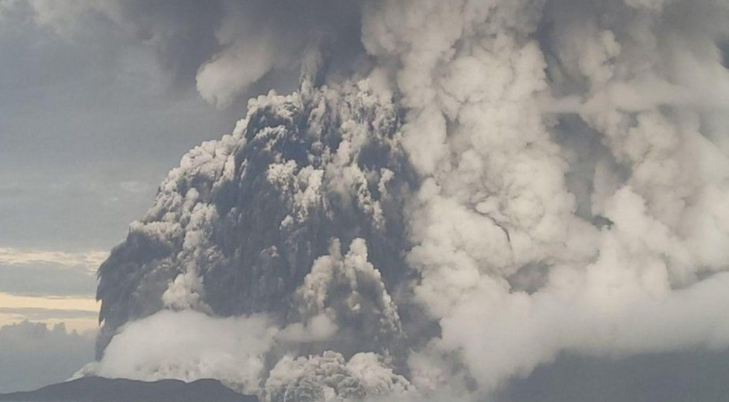

Source: <https://www.bbc.com/news/world-asia-60009944>

1. **Industrialization**

One of the strategies to transform our economy is to shift from an agriculture-led to an industry-led economy.

Industrialization is the process by which an economy is transformed from an agricultural to an industrial economy.

Industrialization contributes a large portion of pollutants to the environment. Many industrial facilities use large amounts of water in the process of production. They use water to remove wastes from the form and dump it into rivers, lakes, and oceans. For example, about 36 liters of water is needed to produce 1 kg of cement and 113 liters of water is required to produce 1 kg of paper (R.Kumar, 2022). The food and drink industries are also among the heaviest user of water.

Hence, though industries are the main water users, they are also one of the major polluters. They pollute water by discharging effluents and exert irrevocable stress, to distort the self-purification capacity of the water bodies.

Figure 6. Smoke (CO2) emitted from industries

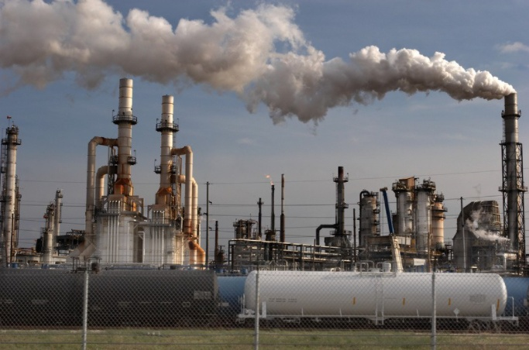

Source: <https://medium.com/carre4/the-effect-of-industrialization-and-chemical-use-on-the-health-of-inhabitants-c001f5e03a98>

### Effects of pollution

1. **Effects of pollution on the environment**

According to World Health Organization (WHO), pollution threatens the health and life of living things and causes environmental degradation. WHO estimates that about 87,000 tones of personal protective equipment (PPE) procured between March 2020 and November 2021 and shipped through a joint UN emergency initiative are expected to have ended up as waste (WHO, 2022).

The sight of discarded masks, littering pavements, roadsides, and beaches, has become a common symbol of the COVID pandemic worldwide. This is just an initial indication of the scale of the problem in our environment.

1. **Effect of pollution on natural resources**

Environmental pollution has a rebound impact on the quality and quantity of natural resources. For example, the unsustainable use of fertilizers in farming can end up with low quality and quantity of soil and water that is required for future farming and fishing (One-Planet-Network, 2022).

In the world, natural resources are under the influence of various interconnected factors like population growth, agricultural expansion and intensification, migration, resettlement, urbanization, climate change, and environmental pollution. These put pressure on the sustainability of all-natural resources.

There is a serious degradation of natural resources such as land, water, forest, rangeland, and wildlife resulting in severe soil loss, low vegetative cover, unsustainable farming practices that would lead us to the degradation of available resources, water quality deterioration, biodiversity decline, and averts ecosystem services. It further recapitulates diverse socio-economic problems, political instability, marginalization, poverty, and recurrent natural hazards (Bantigegn, 2020).

1. **Effect of pollution on agricultural production and productivity**

Many environmental issues such as climate change, genetic engineering, pollutants, deforestation, soil degradation, waste, etc are tied to agriculture, and all these can affect agricultural activities in different ways. Beyond the optimal range of temperatures, warming would reduce yields because higher temperatures also interfere with the ability of plants to obtain moisture.

There is a two-way relationship between food production and air pollution: food production contributes significantly to air pollution; in turn, air pollution can impact food production. Agriculture is the single largest contributor of ammonia pollution as well as emitting other nitrogen compounds.

According to UNEP, air pollution stunts crop growth by deteriorating the photosynthesis process. Tropospheric ozone alone causes annual losses of about 110 million tones of staple crops, i.e., wheat, rice, maize, and soybean. This represents around 4% of the total annual global crop production, and up to 15% in some regions (UNEP, 2022).

1. **Effect of pollution on countries’ socio-economy**

The utilization of natural resources and environmental pollution have socio-economic consequences for the people. Loss of natural resources and environmental damage can threaten livelihoods, especially of the more than one billion farmers in the world, which again bring food and economic insecurity. Unsustainable utilization of resources leads to major health problems in society, especially for people living in poor countries (UNEP, One Planet Network, 2022).

These socio-economic impacts caused by unsustainable consumption and production are also felt unequally throughout the world, thereby worsening inequality. It is the world's poorest people who are most directly dependent on natural resources for their livelihoods and most exposed to risk from damage to these resources.

1. **Effect of pollution on human health**

Infectious diseases are the most serious effects of water pollution, especially in countries, where sanitation is inadequate. Waterborne diseases occur when parasites or other disease-causing microorganisms are transmitted through contaminated water. Diseases like intestinal parasites, typhoid, and diarrheal diseases are caused by parasites, bacteria, and viruses. Water pollution can also affect aquatic animals.

There are many ways that humans pollute waters. Some of those ways are by dumping oil, radioactive waste, and trash into rivers, lakes, and seas. This sort of pollution over these years is only increasing at a staggering rate. Particulate matter and gaseous emission from biomass have serious consequences on both human and animal health. The burning of biomass injects a wide range of gases and aerosols into the environment that can potentially necessarily affect the air quality, visibility, atmospheric, and biogeochemical cycles.

Some of the effects of pollution on human health are listed below:

* Short-term health effects
* Minor respiratory symptoms such as cough, sore throat, and sore eyes
* Changes in bronchial reactivity
* Long-term inflammatory changes in bronchial walls
* Increased prevalence of cough, wheeze, asthma, bronchitis
* Reduction in lung function and increased incidence of lung cancer
* Increased susceptibility to infection
* Increased mortality from Respiratory and cardio-respiratory diseases

# Strategies to reduce pollution

Many forms of pollution affect human health and the environment at levels from local to global. Different contaminants are emitted from diverse sources, and some of them react together to form new compounds in the soil, air, or water. Developed nations have made important progress toward controlling some pollutants in recent decades, but pollution level is still much worse in many developing countries. Governments should take several actions to address the problems linked with pollution. Some of these actions include launching soil and water conservation campaign, and tree planting programs.

The following practices are recommended to reduce pollution:

* **Air Pollution Treatment**

Air pollution can be mitigated through many technologies and practices. The first measure which can be done by any humans is to reduce the emission of CO2. This requires encouraging the use of public transportation or reducing the number of trips in private cars; reducing fireplace and wood stove use; avoiding burning leaves, trash, and other materials; and avoiding using gas-powered lawn and garden equipment. Reduction of diesel engine emissions using ethanol, and adoption of fabricated energy-saving stoves by rural communities are also used to minimize the emission of polluted air.

* **Soil Pollution Treatment**

Soil treatment can be used to make contaminated soil usable for agriculture and other purposes. If soil contains chemicals or wastes such as oil, alkali, or some other non-degradable material, this can be treated using microbes. The biological treatment uses bacteria to break down substances in the soil. Chemical oxidation converts contaminated soils into non-hazardous soils. Soil stabilization involves the addition of immobilizing agents to reduce contaminants' leachability. There is also a need to apply regenerative agriculture and organic farming practices which are pertinent to minimize the use of external fertilizers and pesticides.

* **Water Pollution Treatment**

Water treatment is a physical process involved in removing the contaminants through filtration, disinfection, and slow sand filtration. Polluted water can be treated at household and community levels. The household water-treatment system includes boiling and domestic chlorination; while the community water-treatment system includes storage and sedimentation; up-flow roughing filter; slow sand filtration; and chlorination in piped water-supply systems.

The use of chlorine is the best effective method of disinfection. However, while in the pipes it produces small amounts of chemicals. The amount of chlorine needed to kill pathogens depends on the quality of the untreated water and by the strength of the chlorine compound used (Balasubramanian, 2011).

* **Promote Renewable Energy**

Renewable energy is energy that is collected from renewable resources that are naturally replenished on a human timescale. It includes sources such as sunlight, wind, rain, tides, waves, and geothermal heat (USEIA, 2021). Renewable energy sources are always being replenished. They can never be depleted. Some examples of renewable energy sources are solar energy, wind energy, hydropower, geothermal energy, and biomass energy. Governments should encourage the use of renewable energy sources to influence consumers' interests in renewable technologies.

# Conclusion

The causes of environmental problems are diversified and complex. The multiplicity of causes makes it difficult to delineate the causes and consequences of environmental degradation in terms of a simple one-to-one relationship.

The causes and effects are often interwoven in complex webs of social, technological, environmental, and political factors. Both human activities and natural phenomena can bring environmental pollution.

However, some of the very common causes of environmental pollution which can be pointed out are population growth, the economic growth associated with the affluence factor, and the change of technology. The population is an important resource for development, yet it is a major cause of environmental degradation when it exceeds the threshold limits of the support systems.

Combined with it the conditions of poverty and underdevelopment themselves create a situation where the people are forced to live in squalor and further degrade their environment. The process of development itself also leads to damage to the environment, if not properly managed.

Governments should take appropriate interventions to reduce pollution and to cope with the impact of pollution. Renewable resources should be promoted to minimize the causes of pollution.

# Recommendation

Individuals, private and government firms should collaborate and put their limited resources to implement environmental-friendly projects that could help to reduce the impact of pollution on human beings and the ecosystem. Governments should apply pollution charges which can be reinvested for environmental protection activities. Pollution charges are a fee determined based on the amount of pollution they generate. Special incentive packages should be offered for private firms that engage in the production of environment-friendly products. The public and private sector industries should transform their factories and firms into environmentally friendly production centers. For example, factories should be supported to produce fuel or diesel cars by electric cars, replace plastic bags with paper bags, etc.

Governments should also rethink to eliminate subsidies for any investments and projects that are believed to be economically inefficient and environmentally unsound development. At the same time, market barriers should be removed for any environmental protection materials and equipment production and distribution businesses.

# Bibliography

AZ-Production. (2017, March 19). *What is OVERGRAZING? What does OVERGRAZING mean? OVERGRAZING meaning, definition & explanation*. Retrieved February 04, 2022, from http://www.theaudiopedia.com : https://www.youtube.com/watch?v=uySynL35Dl8

Balasubramanian, R. (2011). Water Pollution and Treatment. *Proceedings of International Conference on Environmental Pollution and Recommendation* (p. 183). Ottawa, Ontario: International ASET Inc.

Bantigegn, S. (2020, November 10). Natural resource degradation tendencies in Ethiopia. *Environmental Systems Research* .

Brauer, M., Casadei, B., Harrington, R., Kovacs, R., & & Sliwa, K. (2021). *The Impact on Cardiovascular Disease Source.*

*Climate Kids*. (2022, 02 16). Retrieved 02 21, 2022, from Climate Kids: https://climatekids.nasa.gov/air-pollution/

*Environmental Protection Agency*. (2021, 12 08). Retrieved 01 13, 2022, from Effective Health Care (EHC) Program: https://medlineplus.gov/airpollution.html

Grossi, G., Goglio, P., Vitali, A., & Williams, A. G. (2019, January 24). Livestock and climate change: impact of livestock on climate and mitigation strategies. *9* (1), p. 8.

Hassan, S. H. (2021). Soil Pollution - Causes and Effects. *First International Virtual Conference on Environment & Natural Resources* (p. 790). Baghdad: IOP Publishing Ltd.

Loannidou, V., & Stefanakis, A. (2020, April 26). The Use of Constructed Wetlands to Mitigate Pollution from Agricultural Runoff. *Contaminants in Agriculture* , 233-246.

Merriam-Webster. (2022 ). *https://www.merriam-webster.com/dictionary/environment*. Retrieved 02 12, 2022, from Merriam Webster: https://www.merriam-webster.com/dictionary/environment

Mia, R., Selim, M., Shamim, A. M., Chowdhury, M., Sultana, S., Armin, M., et al. (2019). Review on various types of pollution problem in textile dyeing & printing industries of Bangladesh and recommandation for mitigation. *Journal of Textile Engineering & Fashion Technology* *, 5* (4), 7.

Mitchell, B. (2013). *Resource and Environmetal Management.* New York: Routledge .

One-Planet-Network. (2022). *Natural -Resource use and Environmental Impacts*. Retrieved March 2, 2022, from One Planet Network: https://www.oneplanetnetwork.org/SDG-12/natural-resource-use-environmental-impacts

*Pollution Prevention and Control Act 1999*. (n.d.). Retrieved January 13, 2022, from legislation.gov.uk: https://www.legislation.gov.uk/ukpga/1999/24/section/1

R.Kumar, S. (2022). *Understanding Environment.* Shahadara, Delhi: R.K. Printers.

Rahman, K. A., & Zhang, D. (2018, March 09). Effects of Fertilizer Broadcasting on the Excessive Use of Inorganic Fertilizers and Environmental Sustainability. *Sustainability* , p. 15.

Reddy, R. (2017). Environmental Pollution and Consequences. *North Asian International Research Journal of Social Science & Humanities* *, 3* (8), 11.

Robock, A. (2020, May 01). Volcanic eruptions and climate. *Advancing Earth and Space Science* , 29.

Ukaogo, P., Ewuzie, U., & Onwuka, C. (2020). Environmental pollution: causes, effects, and the remedies. *Microorganisms for Sustainable Environment and Health* , 419-429.

UNEP. (2022, March 07). *Climate and cClean Air Coalition*. Retrieved March 21, 2022, from Short-lived climate pollutants and food security: https://www.ccacoalition.org/en/content/short-lived-climate-pollutants-and-food-security#:~:text=Tropospheric%20ozone%20alone%20causes%20annual,to%2015%25%20in%20some%20regions.

UNEP. (2022, March 07). *One Planet Network*. Retrieved March 17, 2022, from Natural-Resource Use and Environmetal Impacts: https://www.oneplanetnetwork.org/SDG-12/natural-resource-use-environmental-impacts

USEIA. (2021, mat 07). *What is energy? Sources of energy*. Retrieved March 24, 2022, from U.S Energy Einformation Administration: Independent Statistics and Analysis: https://www.eia.gov/energyexplained/what-is-energy/sources-of-energy.php

USGS. (2022, January 01). *Science for a Changing World*. Retrieved March 12, 2022, from Volcano Hazards: https://www.usgs.gov/faqs/what-gases-are-emitted-kilauea-and-other-active-volcanoes

WHO. (2022, February 01). *Tonnes of COVID-19 health care waste expose urgent need to improve waste management systems*. Retrieved March 11, 2022, from World Health Organization: https://www.who.int/news/item/01-02-2022-tonnes-of-covid-19-health-care-waste-expose-urgent-need-to-improve-waste-management-systems

*Wikipedia*. (2022, 02 12). Retrieved 02 12, 2022, from Pollution: https://en.wikipedia.org/wiki/Pollution

Yadav, I., & Devi, N. (2018). Biomass Burning, Regional Air Quality, and Climate Change. *Research Gate* , 2-4.