**Samantha C. Nortier**

**ID: UB77081HIN86284**

Sociology

What is Sociology and why is it linked to International Relations?

ATLANTIC INTERNATIONAL UNIVERSITY

**June 2022**

**Table of Contents**

**Front page 1**

**Table of Contents 2**

**Introduction 3**

1. **What is sociology? 3**
   1. The Positivist Approach 4
   2. The Interpretive Approach 4
2. **The Foundations of Sociology 5**
   1. Diversity 6

2.1.1) Counting Diversity 6

2.1.2) Culture Diversity 6

2.1.3) Good-For-Business Diversity 6

2.1.4) Conflict Diversity 6

2.1.5) Prejudice 8

2.1.6) Stereotyping 8

2.1.7) Social Identity 8

2.1.8) How to manage and create Diversity 8

2.1.9) How I choose to create Diversity 8

2.2) Multiculturism 9

2.2.1) The Melting Pot Theory 10

2.2.2) The Salad Bowl Theory 10

2.3) Pluralism 11

2.3.1) Cultural Pluralism 12

2.3.2) Religious Pluralism 12

**3.) Sociology and International Relations 13**

3.1) The relevance of sociology on international relations 13

3.2) Sociology and International Relations similarities 14

**4.) Conclusion 15**

**5.) Bibliography 16**

**Introduction**

In this assignment we are going to look at sociology by breaking down the most important parts of this study.

We are going to dive into diversity and link sociology to the study of international relations and why it is important to look at sociology while studying international relations.

The exploration of multiculturalism and pluralism will also be making its appearance as it is two of the most important factors in sociology. We will look at hot multiculturalism fosters fast and diverse cultural values among individuals and groups of people.

I personally think that sociology is important because as Graham Greene said in his book, The Ministry of Fear, “One can’t love humanity. One can only love people.”

1. **What is sociology?**

Sociology has quite a simple definition. It is said to be the study of human behavior and the society around it. It also includes the study of human relationships, social situations, cultural assessments, and behavioral patterns.

Auguste Comte, a French philosopher, was seen as the father of sociology. The term "sociology" is said to have been coined by Comte (in 1839). The term "sociology" in made up of two words: socius, which means "fellow or associate," and logos, which means "science or study."

(Image by: InfoEscola, <https://www.infoescola.com/biografias/auguste-comte/>)

In the nineteenth century, sociology, which had previously been regarded as a social philosophy or history philosophy, became a distinct social science. Philosophers like John Stuart Mill and Herber Spencer helped sociology become a permanent name in science.

Sociology might have a simple definition, but it has plenty of simple definitions. Philosophers have gone on a quest to find the definition that fits just right. Here are a few philosophers that take on the definition of sociology:

"Science of social institutions," according to Emile Durkheim.

"Sociology is the scientific study of social existence," say Ogburn and Nimkoff.

"The science that tries the interpretative knowledge of social behavior in order to arrive at a causal explanation of its path and effects," as per Max Weber.

"Sociology is the scientific study of social aspects of human life," explain Kimball Young and Raymond W. Mack.

To me when trying to understand this science, Comte does explain it best. He says that Sociology is defined by the science of social phenomena "subject to natural and invariable rules, the discovery of which is the purpose of investigation."

When studying sociology, there are two approaches scholars use to determine studies:

1.1) The Positivist Approach

The positivist approach employs research-based procedures comparable to those employed in other disciplines. Its method is more like the scientific process than the interpretative method, and it is based on carefully proving and explaining specific events. Auguste Comte is widely regarded as the father of the positive approach.

1.2) The Interpretive Approach

The interpretive method asserts that reality is created by the experiences of individuals and social structures, based on social theories and concepts. Social structures are people and groups, institutions, or ideas that shape people's lives and perspectives on the world. To investigate social life, the interpretive approach frequently employs instances and stories from society.

There are many examples to study and collect data while studying sociology. You can take surveys, you can go out and deduct interviews with the people of choice, do some experiments like a psychology experiment. A good example of a psychology experiment was the Stanford Prison Experiment that happened in 1971.

Professor Philip Zimbardo of Stanford sought to know how people adapted to societal roles. For example, he asked whether the harsh connection among prison officers and convicts in jails was due to personalities or the environment. 24 male school students were randomly assigned to be a detainee or a guard during Zimbardo's EXPERIMENT. The inmates were confined in a temporary prison in Stanford's psychology department's basement. Participants went through a conventional booking procedure that was designed to remove their uniqueness and help them feel nameless. Guards were assigned eight-hour shifts and told to handle the inmates as they would in the real world. Professor Philip Zimbardo of Stanford sought to know how people adapted to societal roles.

In fact, after six days, he had to stop the experiment because it had become too risky. Zimbardo even confessed that he started to think about himself as a chief of police instead of a psychologist. People will comply with the societal roles they are supposed to play, especially those that are extremely stereotyped, such as prison guards, according to the study.

Zimbardo observed, "We discovered how easily ordinary individuals may be converted from the benevolent Dr. Jekyll to a terrible Mr. Hyde."

The Stanford Prison Experiment was not only a big experiment for the development of psychology, but a very big leap for sociology as they observed group, social and individual behaviors in an enclosed and controlled environment.

(Image by: Inside Higher Ed, <https://www.insidehighered.com/news/2018/06/20/new-stanford-prison-experiment-revelations-question-findings>) 

1. **The Foundations of Sociology:**

When studying sociology, one comes across three of the most important foundations of sociology. These three foundations help us understand what sociology is made of and how these building blocks contribute to the society we know today.

Here are the three foundations of sociology:

2.1.) Diversity

One of the keywords of the initial twenty-first century, diversity, has evolved into a term with numerous connotations for various groups of people.

One of the most difficult aspects of talks on diversity is defining it. At its most fundamental level, diversity refers to people's differences in terms of age, class, ethnicity, gender, health, physical and mental aptitude, race, sexual orientation, religion, physical size, education level, work level and function, personality traits, and other human characteristics.

However, there is a paradox of diversity:

* Each of us is distinct and unlike anyone else.
* We are alike and unlike certain people.
* We are alike and unlike some people.

Diversity is discussed by social scientists in at least four different ways:

2.1.1.) Counting diversity

This refers to the process of systematically identifying differences within a population. Using this concept, social scientists start counting the members of a population according to specific characteristics, such as race, gender, and nationality. Furthermore, it is feasible to compare the race, ethnicity, and gender distribution of a specific unit within a society, such as a school, business, or government, to that of the overall population.

2.1.2.) Culture Diversity

The significance of recognizing and respecting the cultural distinctions between race, ethnicity, and gender groupings is referred to. Because people of one culture typically judge others by their own norms, social scientists who use the add color definition say that it is critical to demonstrate that variations do not have to be categorized as good or evil or moral or immoral. People from different cultural backgrounds can cohabit in the same society with better tolerance and understanding, according to the theory.

2.1.3.) Good-for-business diversity

This refers to the assumption that varied labor forces will make businesses more lucrative and government entities and non-profit organizations more efficient.

2.1.4.) Conflict diversity

Knowing how diverse groups live in a pyramid of inequalities in terms of strength, privilege, and income is referred to as conflict diversity."

A 'Four Layers of Diversity' circle depicts the intricacy of the variety filters that all of us use to analyze inputs and data. This influences our preconceptions, which in turn influence our own behavior and, in turn, others.

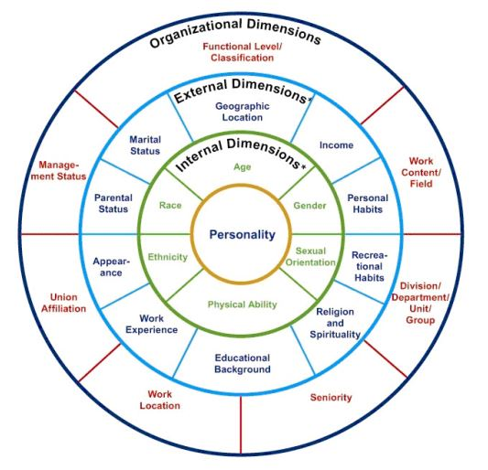

(Image by: [Gardenswartz & Rowe, Diverse Teams at Work](http://www.gardenswartzrowe.com/why-g-r) (2nd Edition, SHRM, 2003) <https://researchguides.austincc.edu/c.php?g=522627&p=7624718>)

When it comes to diversity the world still struggles with accepting differences between people and certain groups of people as well. It is understandable as the world is changing at a very fast pace and not a lot of people like change, certainly not this fast. Thus, creating roadblocks to diversity. Roadblocks to diversity can be seen as the struggles or the challenges faced when seeking a fully diverse environment.

These roadblocks include:

2.2.1.) Prejudice

Prejudice is a judgment or opinion about someone based only on their membership in a certain group. People may be biased against someone because of different ethnic background, gender, or religion, for example. There are vast types of prejudice, this includes:

* Classism
* Racism
* Xenophobia
* Sexism
* Religious prejudice
* Ageism
* Homophobia
* Nationalism

2.2.2.) Stereotyping

Stereotypes are labels that are applied to persons based on their ethnicity, nationality, or sexual orientation. These features are often generalizations of the groups involved, and stereotypes are detrimental, even if they appear "good." Examples of stereotyping include: All blonds are dumb, all black people steal or commit crimes, all gay men do drag, and all lesbian women have short hair.

2.2.3.) Social Identity

The component of one's identity that is determined by one's group memberships is known as social identity. Identity theory, developed in the 1970s by social psychologists Henri Tajfel and John Turner, analyzes the circumstances in which one's social identity takes precedence over one's personal identity. The theory helps to explain how intergroup conduct is influenced by social identity.

2.2.4.) How to manage and create diversity:

* Learn a language other than your native one.
* Attend a social gathering where at least half of the attendees are not like you.
* Visit a museum of art or history.
* Watch a film about a different country or culture.
* Make friends with someone who has a different belief system or culture.
* Talk about current events with someone who doesn't agree with you.

How I choose to create diversity:

Personally, I think diversity needs to start at home. I believe in exposing myself and my family to many other cultures, by experiencing other cuisines and traveling to places with another culture or religion to expose us to what they are used to and create a mindset to tell us that this is normal for a lot of people.

I think this is especially important to my baby boy. I don’t want him to grow up and judge other people for the way they believe or do things differently. I want him to know that just as he has his own tradition in his culture, so they have the same.

For instance, I was brought up in a very strict Afrikaans household, where we only practiced Christianity and respected only our own culture, looking down on those who don’t believe like us. When I went out in the real world, I drastically changed my mindset, as it was necessary in my past careers in the emergency medical field. There you can’t judge anyone, you need to treat every patient the same, no matter their history, race or culture. I saw how important diversity and inclusivity is in the world and I decided not to raise my child in the environment I was brought up in, but rather in a household with love for everyone and everything.

This assignment has helped me understand the importance of growing world diversity from a young age, so that the new generation, leading this world, would include all and understand that not one person on this planet is the same. We are all unique and to grow human rights all over the world, we need to stop judging and start moving forward as a human race.

(Image by: hourly.oi - <https://www.hourly.io/post/cultural-diversity>) 

2.2.) Multiculturalism

Multiculturalism is a sociological term that defines how a society interacts with cultural diversity. Multiculturalism conveys the belief that civilization is enriched by preserving, appreciating, and even fostering cultural diversity. It is based on the fundamental notion that members of frequently quite diverse cultures can coexist peacefully.

Multiculturalism is a term used in political philosophy to describe how countries formulate and develop clear policies related with the equal treatment of various cultures. Multiculturalism advocates feel that humans should keep at least some aspects of their traditional traditions. Multiculturalism, according to critics, jeopardizes the social order by eroding the dominant culture's identity and influence. While accepting that multiculturalism is a geopolitical issue, this paper will concentrate on its sociological components.

Multiculturalism offers numerous advantages. The most important benefit is that it promotes open-mindedness among various groups of people while also dispelling negative prejudices. This is critical, as the United Nations estimates that 1/3 of the world's major conflicts have such a cultural component.

Cultural diversity not only brings peace, but also makes our society more attractive to live in. Cultural differences have their own set of beliefs and interests, which they can exchange to provide new perspectives. People from various cultures can provide us with unique perspectives on food, language, music, the arts and literature, history, religion, and other topics.

There are two main theories that come up when studying multiculturalism:

The melting pot and salad bowl theories are the two basic ideas or conceptions of multiculturalism as a process of integrating multiple cultures into a single civilization.

2.2.1) The Melting Pot Theory

Multiculturalism's melting pot hypothesis assumes that distinct immigrant groups will prefer to "melt together," forsaking their cultural views or eventually becoming fully absorbed into the dominant civilization. The melting pot idea, which is commonly illustrated by the metaphor of a foundry's smelting pots wherein the metals iron and carbon are fused together just to create a single, stronger metal—steel—is sometimes used to explain the integration of immigrants into the United States. J. Hector St. John de Crevecoeur, a French American immigrant, said in 1782 that "individuals of all countries are merged into a new event of men, whose laborers and posterity will one day produce major changes in the world."

The melting pot concept has been chastised for diminishing diversity, encouraging individuals to abandon their traditions, and requiring government intervention.

For example, the United States Indian Reorganization Act of 1934 compelled approximately 350,000 Indigenous peoples to assimilate into American civilization without regard for their diverse heritages and lives.

2.2.3.) The Salad Bowl Theory

The salad bowl idea defines a structure in which individuals cohabit but maintain at least a few of the unique qualities of their culture and traditions. It's a much more liberal concept of multiculturalism than that of the melting pot hypothesis. Cultural differences are brought together in the same way as salad ingredients are mixed, but instead of merging into a single unified culture, they keep their distinct flavors. New York City, including its numerous distinct ethnic communities such as "Little India," "Little Odessa," and "Chinatown," is seen as an instance of a salad bowl life in the United States.

According to the salad bowl idea, people do not have to abandon their cultural history to be deemed part of a dominant society. To be considered "Americans," African Americans, for example, do not need to quit celebrating Kwanzaa instead of Christmas.

On the negative side, the salad bowl paradigm encourages cultural diversity, which can divide a society and lead to prejudice and discrimination. Furthermore, detractors cite a 2007 study by American political science professor Robert Putnam, which found that residents of salad bowl ethnic communities have been less inclined to vote or participate in local improvement projects.

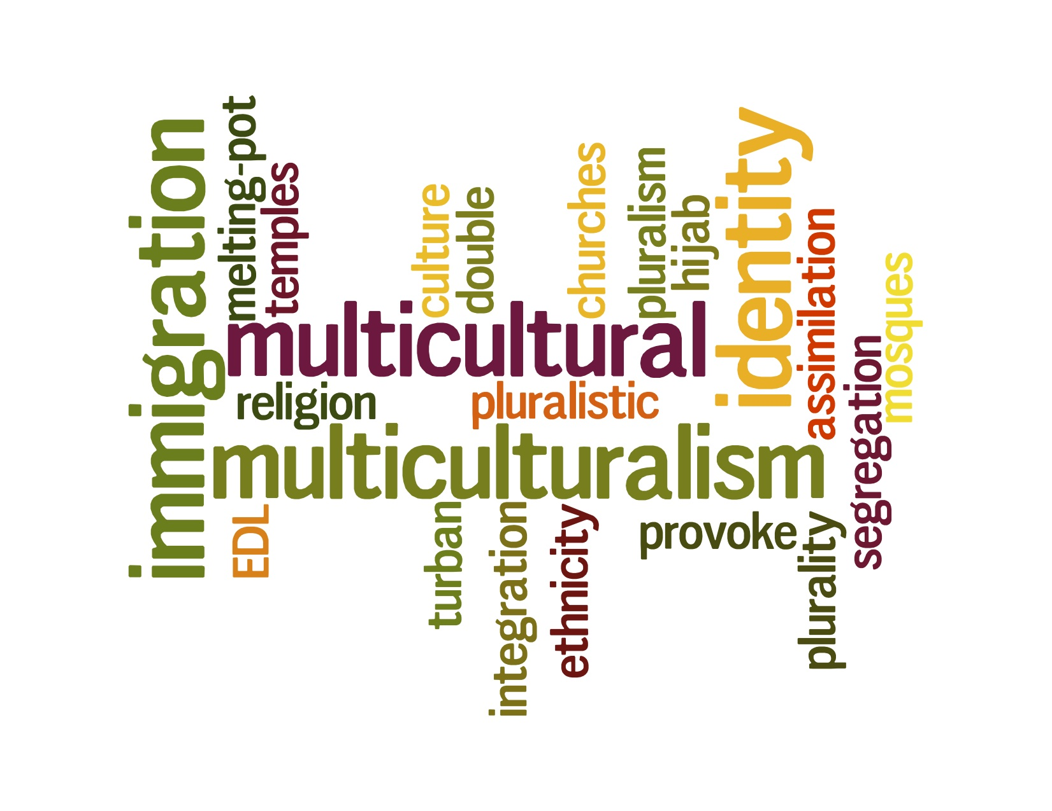

(Image by: ndla <https://ndla.no/subject:1:06270029-7aa7-4a7a-b383-128b275ff150/topic:2:184990/resource:1:91578>)

2.3) Pluralism

Pluralism as a political ideology says that we can and should "all just get along." Pluralism, which was first identified as an essential component of democracy by Ancient Greek thinkers, allows or even promotes a variety of political views and involvement.

Pluralism believes that its practice will encourage decision-makers to discuss solutions that benefit the "common good" of the entire community, and that in some situations, minority group acceptance and integration should be achieved and safeguarded through law, such as civil rights laws. Pluralism's theory and mechanics are also used in the fields of religion and culture.

People with various interests, opinions, and lives will peacefully coexist and be eligible to participate in the governance of the country, according to the political ideology of pluralism. Pluralists understand that power will be shared among a number of conflicting interest groups. Pluralism is regarded as a crucial component of democracy in this regard. A pure democracy, in which each citizen is given the right to vote on all laws and even court rulings, is the most illustrative case of plurality.

There are two types of this political philosophy that helps us understand how pluralism works:

2.3.1) Cultural Pluralism

Cultural pluralism refers to a situation in which minorities are completely integrated into all aspects of a dominant society while keeping their distinct cultural identities. Various groups are tolerant of one another and cohabit without considerable conflict in a historically pluralist society, while minority groups are allowed to maintain their historic ways. Cultural plurality can only succeed in the actual world if the majority community accepts the minority groups' customs and practices. In other circumstances, including such civil rights laws, this tolerance must be safeguarded by legislation. Furthermore, minority cultures could be forced to change or even abandon certain of its customs that are incompatible with the dominant culture's laws or ideals.

The United States is now regarded as a cultural "melting pot" wherein indigenous and immigrant civilizations coexist while maintaining their distinct customs. Little Italy in Chicago and Chinatown in San Francisco are examples of districts seen in many American cities. Furthermore, most Native American tribes have their own governments and societies in which they follow their customs, beliefs, and histories and pass them down to future generations.

2.3.2.) Religious Pluralism

Religious pluralism is defined as respect for the otherness of others and occurs when members of all religious belief systems or organizations coexist peacefully in the same community.

Religious pluralism is not to be confused with religious freedom, which refers to the acceptance of all religions underneath the shelter of civil laws or theology. Religious pluralism, on the other hand, presupposes that diverse religious groups would freely associate with one another for their mutual benefit.

Honoring the separateness of others might be defined as religious pluralism. All religions working inside the law in each region are considered to have freedom of religion.

Here are some examples of pluralism:

* Amish people coexist among non-Amish people, but they commute by horse and buggy, lack electricity, and have built stores, schools, and other groups that are used by Amish people.
* Tucson, despite not being in Mexico, exhibits many Mexican cultural influences due to its proximity to the border.
* If families of Christian, Muslim, and Jewish faiths want to live peacefully in the middle of the war surrounding them, the community of Bethlehem within Middle East exemplifies multiculturalism.
* People in ancient Rome worshiped a variety of gods and were allowed to follow their own religious traditions if they did not pose a threat to the Roman rulers.

1. **Sociology and International Relations**

The former's traditional concentration was on understanding the major processes of social development within national societies, whilst the latter was primarily concerned with explaining inter-state relations and analyzing other factors that have an impact on international political dynamics. In recent years, the two professions have become increasingly intertwined. The study of army competition between states resulted from sociological investigations of state formation, but not necessarily from a discussion and analysis with international affairs as an academic discipline. As John Hobson's contribution to this issue will demonstrate, scholars of international relations have reacted to such trends by incorporating components of historical sociology into their frameworks of study.

Martin Saw, an international relations and politics professor at the university of Sussex wrote a paper on sociological approaches to international relations. It begins by looking at the history of sociology and what historical sociology is. It argues that state theory is important to historic sociology, and then explains how this can be useful in international relations. It then goes on to look at the concepts of an interpretivist perspective, as well as the difficulties that may arise when applying it to international relations.

3.1) The relevance of sociology on international relations

The traditional concept of international relations as that of the study of international politics has come under fire. There has been a growing interest in creating a broad sociology approach to the issue, as well as the importance of classical and current sociologists' distinctive contributions to international relations. Because it originally emerged as a structured field in the early twentieth century, international relations might be regarded as a relatively "young" field of social science. As a result, it is considered a "secondary" field in comparison to the more "basic" humanities of sociology and economics, as well as politics.

The late-twentieth-century endeavors in international relations to overcome disciplinary boundaries between economics, politics, and sociology mark a watershed moment in the field. As a result, the notion that international relations should be regarded as an interdisciplinary field is still debatable. It is unlikely to be reversed, though, because it correlates to rough seas in the actual world of international relations.

Classical disputes, which are at the heart of contemporary social heritage, are vitally important in today's international relations. Sociology is a fundamental approach in the social sciences, even if it is a novel approach in international relations debates. Its relevance and links to both the classic "political" legacy of international relations as well as the emerging "political economic" tradition that has gained traction in recent years are explained by the setting in which it was created.

The following are two more considerations to consider at the outset:

* First, historical sociology is the most obvious way wherein sociology has been "introduced into" international relations.
* Second, sociological perspectives have been thought to be particularly beneficial in interpreting contemporary globalization methods.

As a result, international relations have leaned on two major streams of sociological theory and research, which are considerably different from one another and have opposing perspectives on the subject's history.

3.2) Sociology and International Relations similarities

When I look at international relations and sociology, I do catch similarities here and there:

* They both study interactions between bodies and they both emphasize how important studying the citizens of a country is to understand the needs and morality of society.
* It is thus also important to study political units and their political behavior to maintain good economical and societal balance. If your political unit’s behavior is negative, so will the economy and its society growing the economy be highly affected in immense negative ways. Society will lose hope in any future for growing a healthy and educated population. You may see some political uprising and rebelling taking place if the political behavior is negative and poorly impactful.
* When diplomacy comes into play, political bargaining always keeps in mind the health and safety of society and surroundings. As such, the intense study of sociology will give diplomacy the information it needs to make sure that the needs of its citizens are always taken care of. Knowing that society is the biggest contributor to the economy and peace.

1. **Conclusion**

In this assignment I have captures the essence of sociology and touched the meaning, ins, and outs of sociology.

Diversity came up as an important subject in sociology and I have realized what important subject it clearly is to the world as a fast-growing technological era. As the world is developing in paces so fast, we can only imagine the conflict people are going through to realize that not only is out technology changing but the people are too, a new generation is taking over, a generation that will most definitely throw out all old ideas and come up with new and innovative ones.

This can be hard for older generations to grasp, and that’s okay too. Not all people are susceptible to change. Thus, creating roadblocks for diversity, multiculturalism, and pluralism to grow.

But it is our responsibility to ensure that the older generation is well educated and informed about the changes happening in the world currently.

International Relations also peaked its head out in this assignment. Showing some similarities towards sociology and noticing how important sociology and the study of it is to understanding international relations.

In this assignment, I have learned valuable lessons. Lessons that will stay with me in the long run. Lessons I will carry forward to my family and encourage them to accept change and the people creating it, to accept anyone and everything but still contain a valuable moral standard.

# Bibliography

Chapel, J. N. (2021, September 20). *What is Sociology?* Retrieved from Study.com: https://study.com/learn/lesson/sociology-examples-study-themes.html#:~:text=Sociology%20is%20the%20study%20of%20the%20human%20behavior%20within%20society,development%20of%20different%20social%20movements

Çilkoparan, H. (2020, May 23 ). *International Political Sociology Contributions to International Relations*. Retrieved from E-International Relations : https://www.e-ir.info/2020/05/23/international-political-sociology-contributions-to-international-relations/

Gould, W. R. (2021, January 3). *What is prejudice?* . Retrieved from verywell mind : https://www.verywellmind.com/what-is-prejudice-5092657

Langley, R. (2019 , July 31 ). *What Is Pluralism? Definition and Examples*. Retrieved from ThoughtCo.: https://www.thoughtco.com/pluralism-definition-4692539

Longley, R. (2020, October 2020). *What Is Multiculturalism? Definition, Theories, and Examples*. Retrieved from ThoughCo. : https://www.thoughtco.com/what-is-multiculturalism-4689285

Nimesh. (2009, March 24 ). *Sociology* . Retrieved from Definition of Sociology : http://sociology-4-all.blogspot.com/2009/03/definition-of-sociology.html

Nittle, N. K. (2021, February 4). *What is a stereotype?* . Retrieved from ThoughtCo. : https://www.thoughtco.com/what-is-the-meaning-of-stereotype-2834956

Shaw, M. (n.d.). *Sociological Approaches to International Relations.* Retrieved from eolss.net: https://www.eolss.net/sample-chapters/C14/E1-35-01-07.pdf

Shilliam, G. L. (2010, February 10). *Sociology and international relations: legacies and prospects*. Retrieved from Taylor & Francis Online : https://www.tandfonline.com/doi/full/10.1080/09557570903433647

Twose, R. (2021, May 18 ). *The Importance of Cultural Diversity* . Retrieved from Langauge Insight : https://www.languageinsight.com/blog/2021/importance-cultural-diversity/

Ulster), A. L. (2021, July ). *Sociology and International Relations: The Future?* Retrieved from Human Figurations : https://quod.lib.umich.edu/h/humfig/11217607.0001.201/--editor-s-introduction-sociology-and-international-relations?rgn=main;view=fulltext

Vinney, C. (2019, July 21 ). *Understanding Social Identity Theory and Its Impact on Behavior*. Retrieved from ThoughtCo. : https://www.thoughtco.com/social-identity-theory-4174315