**Samantha C. Nortier**

**ID:UB77081HIN86284**

Politics in Developing Countries

Why are these countries still developing? And how can they change that?

ATLANTIC INTERNATIONAL UNIVERSITY

**June 2022**

**Table of Contents**

**Front Page 1**

**Table of Contents 2**

**Introduction 4**

1. **What is a developing country? 4**
2. **Africa and its political development. 6**
3. **Politics in India 7**

3.1) Why is India a developing country? 8

3.2) The negative impacts on India’s political system 8

3.3) What can India’s political system do to improve their developmental status? 9

1. **Politics in Egypt 9**

4.1) Concerns about Human Rights 10

4.2) Why is Egypt still a developing country? 10

1. **Politics in Mexico 11**

5.1) The war on drugs 11

5.2) Mexico’s economic front 12

5.3) What can Mexico do to improve their current developing status? 12

1. **My view on politics in South Africa 13**

6.1) The inequality in South Africa 13

6.2) Crime in South Africa 14

6.2.1) Violence against women and children 14

6.2.2) Corruption 15

6.3) How can South Africa improve? 15

1. **Politics in Thailand 15**

7.1) The political challenges in Thailand 15

7.2) Why is Thailand a developing country? 16

7.3) What can Thailand do to improve their developing status? 17

**Conclusion 17**

**Bibliography 18**

**Introduction**

In this assignment we will take a deeper look into the political systems and units of big developing countries. Dissecting the positive and negative effects it has on these countries.

We will be looking at how the political units affect the economy and the key role players of their economy. Are those effects good or bad and how can they improve the negative effects that they have on these areas?

We are going to dive into the links between these countries’ political units and what influence they might have on international relations, or what influence international relations might have on these countries.

Of course, the opinion about these countries’ citizens is always important, thus, the conversation about what affects the politics in these countries has on the thought and behavior of their societies.

1. **What is a developing country?**

The UN defines a developing country to consist of low-quality living, low developed industrial fade and a moderate Human Development Index. This index indicates a vast measure of poverty, literacy, education, life expectancy, and other factors for countries worldwide.

Between industrialized and developing countries, there are substantial social and economic contrasts. The lengthy tradition of development of these countries is at the base of several of the root factors of these variations, which also include international relations, geographical considerations, social, cultural, and economic aspects, as well as historical and political elements.

Which countries fall under the heading of developing countries is a subject of some debate. The term "developing nation" is used in a variety of analytical and comparative frameworks, each of which has its own set of standards. These frameworks range from theories of colonialism and political economics to modernization studies and Marxism.

Modern infrastructure is also necessary for development, as is a shift away from small value-added industries like agriculture and resource exploitation. Economic systems in developed nations are typically predicated on constant, self-sustaining economic development, and high levels of living.

A lot of emerging nations face difficulties such as income disparity and/or rampant poverty, low levels of education and literacy, poor infrastructure, and political corruption. They may produce insufficient amounts of energy and endure higher levels in violence against women. They might even suffer with health hazards such a lack of access to clean drinking water and sewage, high pollution levels, and a rise in the prevalence of infectious diseases. Programs have been formed by the United Nations plus numerous other aid agencies to assist developing nations in overcoming this and many other cultural, economic, financial, and environmental issues.

(Image by: World Population Review, <https://worldpopulationreview.com/country-rankings/developing-countries>) 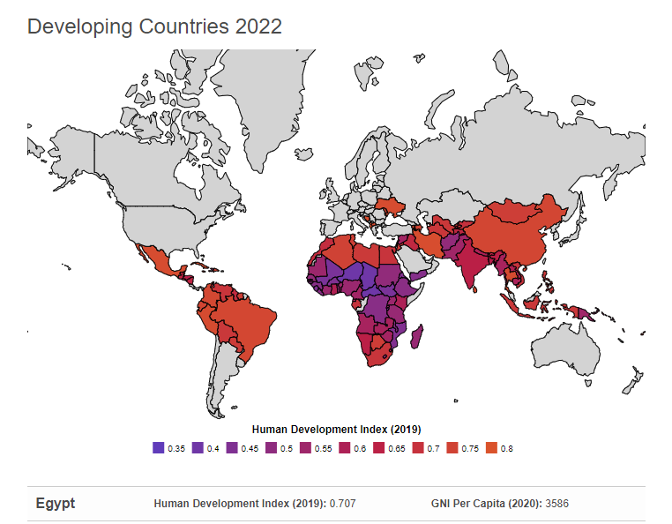

Above is a demonstration of the developing countries via the Human Development Index of 2019. The HDI takes a variety of elements into account, such as economic development, life expectancy, wellbeing, education, and standard of living. A 1.0 is the maximum available HDI score. A country is deemed developing if its score is below than 80.

Examining a nation's real GNI per capita, a valuable quick tool to gauge a nation's economic standard of life, is another often used approach of identifying whether a nation is developed or developing. Countries are categorized as developed when their nominal GNI exceeds a predetermined threshold, while those who’s nominal GNI is lower than that figure are regarded as still growing.

For instance, the World Bank categorizes 2022 high income economies as nations and territories with a GNI of $12,696 or more. Anything less would be categorized as a developing nation. 80 of such 217 countries and regions the World Bank was tracking in 2022 met the criteria for high income, while 137 met the criteria for developing economies/countries.

Here are the five developing countries we are going to look at in this assignment:

* India
* Egypt
* Mexico
* South Africa
* Thailand

1. **Africa and its political development**

Researching politics in developing countries was a struggle as most texts, articles and papers only seem to focus on the 1990's and down to the 80’s. This means that not a lot of focus has been put on how the developing countries are currently doing unless you look at the country, which I did at the end to make my conclusion for this assignment.

A big question arose for me when addressing this statement above. If there is not much recent research and published work about this subject, how will these countries ever make it out of the developing faze at all without information for problem solving people? Or is it the political units that decide to keep them developmental to gain or keep control over the country?

As seen above, most countries can be seen as developing. But what does that say about their politics and their political systems? Are they also “still developing” or are they doing more harm to the country than anything else? Seeing that these countries don’t pass the developmental phase, they either stay stagnant or decline economically and morally.

Africa is not improving their Human Development Index at all. Countries in Africa have declined their development or just stayed stagnant. And this is not at all a worry for richer first world countries.

The rest of the civilized world is depleting the Global South's resources at a much faster rate than it is gaining them. The entire world loses $192 billion annually to Africa alone. This is mostly in the hopes of earning money made by foreign corporations, tax evasion, and costs associated with climate change adaptation. Rich nations frequently mention the aid they provide to Africa, but in reality, this amount is little than $30 billion annually. The total annual loss for Africa is still $58 billion, even after accounting for remittances, foreign investment, as well as other resources that enter the region. It is incorrect to think that we are helping Africa; instead, Africa is helping the rest of the world.

This amount that Africa loses every year is more than 1.5 times what would be required to provide everybody in the world with access to affordable healthcare. Over the next ten years, the African people will lose $580 billion if the entire world continues to plunder it at the same rate.

Numerous African losses come directly to help wealthy nations. They are indeed a result of behaviors and policies that rob Africa of resources and maintain its citizens in dire poverty. Among them include tax evasion, unfair trade practices, the actions of transnational companies, and the exodus of highly qualified people.

Economic expansion is essential for progress. It's been the main force behind Sub-Saharan Africa and the world's reduction in poverty. Additionally, growth is a key justification for advancements in human evolution in African nations. In line with the body of general literature, it is necessary to emphasize economic progress inside the African region once again.

Following the poor performance of both the 1980s and the first half of the 1990s, there has been a recovery of economic growth in Sub-Saharan Africa from the middle to late 1990s. Additionally, over the past 15 years, Africa's GDP growth has outpaced those of the rest of the world, which is necessary for the continent to join the rest of the planet.

However, the recent economic rebound is less striking when measured per person, indicating the need to control reliance and demographic expansion. In theory, as incomes rise, Africa may rely on a "natural" demographic change, but that process might take too long. Additionally, unless output in the area increases stably, this transformation could take a long time to complete, delaying any economic grab significantly.

1. **Politics In India**

India is a Democratic, Secular, and Sovereign Republic. This means that no foreign authority has jurisdiction over it, but they are not permitted to meddle in its internal or external affairs. India is willing to make any domestic or foreign policy, and the people oversee politics. The president serves as the head of state, and the political party in charge ensures that steps are done to safeguard and protect the rights of the weaker and more disadvantaged segments of society.

Since July 25, 2017, Ram Nath Kovind, an Indian politician, has held the office of President of India. He is a Bharatiya Janata Party supporter. Additionally, he is the first citizen of Uttar Pradesh to hold the office of Indian President. A Hindu nationalist major group in India, the BJP, holds the idea that Hinduism and Indian cultural pride are essentially interchangeable.

Many members of the party simply associate Hindu culture with India. Considering that Hindus make up 80% of the population, BJP members consider India to be basically a Hindu country. And there is a wide range of viewpoints inside the party, its central tenet of "Hindu-ness" has frequently come under fire for having an anti-minority bent.

3.1) Why is India a developing country?

* In terms of demography, India has a high newborn mortality rate, a lower life expectancy than wealthy nations, and a high population density. Its economy is hence undeveloped.
* India's PCI was $ 1983 in 2017 and it was placed 140th out of 188 nations, as per the International Monetary Fund's report. Additionally, India's PCI in 2017 is $ 1940 and it was rated 138 from 184 nations, according to the World Bank's Report. As a result, we may say that an Indian citizen's per income per capita is less than those of most other nations.
* Being primarily a primary producer is one of India's core features as a developing economy. This indicates that agriculture is the main economic activity of the inhabitants.
* The high rates of births in India are a result of the high rates of illiteracy. The average lifespan of an Indian citizen has improved, while death rates have decreased because of improvements in medical facilities.
* It is challenging to put the whole population of India to work because of the country's capital shortage. Therefore, there is an abundance of inexpensive labor. As a result, the nation has long-term unemployment and underemployment.

3.2) The Negative Impacts of India’s political system

Is the political unit keeping India in a developmental phase, without any promise for growth and better living standards? Since the BJP has been in power, not much has been done to improve economical or sciatica breakages in their country.

The political party is constantly blaming the dense population for its social and economic challenges, but they take no responsibility to not providing sustainable and professional education for the poor, which leads to poor sexual education and decisions. India needs to significantly enhance the results of its elementary education, a task that can only be fully accomplished by a facility with state resources.

No improvements on the state of healthcare have been made either. India is ranked 66 out of 195 countries overall, with a GHS index score of 42.8, a drop of 0.8 marks since 2019. This emphasizes that while India's detection and reporting capabilities have increased, its strategies, healthcare system, or rapid response procedures have not. And yet again it is only the state that can allocate the funds towards their medical system to improve it.

3.3.) What can India’s political system do to improve their developmental status?

* They can start allocating funds towards the biggest problem areas in their country, namely, education and medical needs. Building the appropriate infrastructure like schools and clinics or hospitals and to appoint professional teachers and medical staff to man the operations set out to help the community.
* India has such a diverse and beautiful culture. I would say they need to focus on cleaning their environment, creating new jobs to enable a sustainable and living environment so that tourism can grow and be an extra supplement for their economy.
* The human and child trafficking in India is getting out of hand and yet, nothing is being done about it and yet again blamed on the dense population. Create task forces in areas where human and child trafficking are bad and start exposing big entities that feed the industry.
* “Control” your population amount by creating sexual awareness and education for young adolescents to inform them about the ins and the outs of sexual activity. Add sexual education into schools and help your youth understand sex and reproduction much better.
* Give access to planned parenthood and contraceptives for free to unmarried and married women above the age of 13, by providing them with the appropriate infrastructure and medical professionals to make them feel safe and heard.

1. **Politics in Egypt**

Egypt is a hive of economic growth: With a GDP of USD 394.28 bn, Egypt ranked third among the Arab world's largest economies on Forbes Middle East's list. Egypt became the continent of Africa's second-largest economy in 2016, surpassing South Africa. The country’s’ industry is among the most varied in the Arab world, and the country's information technology sector is growing quickly. Egypt scores high just on the United Nations Development Index, with a score of 0.707 that keeps rising year after year.

Egypt's President Abdel Fattah el-Sisi has held office since 2013. Abdel won a second term as president in the 2018 presidential election with 97 percent of the popular vote. Most of the pro-government Nation's Future group in the Egyptian legislative elections held in 2020 has further bolstered his position. Sisi was only permitted to serve as president for two terms underneath the 2014 constitution, but after a 2019 referendum, an amendment was passed that increased Sisi's tenure to six years and allowed him to run for reelection a third time in 2024.

4.1) Concerns about Human Rights in Egypt

* The way journalists, opposition organizations, and semi organizations are treated in Egypt raise concerns.
* For instance, those who criticized the Egyptian government's reaction towards the coronavirus pandemic have been harassed and detained. About 20,000 and 60,000 opposition leaders are thought to be held in Egypt, the facilities lack sufficient hygienic conditions and medical attention.
* Even though other countries have recognized some encouraging developments, Christians in Egypt still face threats to their safety, including attacks on newly built religious buildings and workplace discrimination.
* Organizations have also brought up the issue of LGBT people being arbitrarily detained and the long waits for autonomous unions to be recognized.

Despite the fact that the US's critique of abuses of human rights was comparatively restrained underneath the Trump Presidency, the US's support for a joint declaration by UN Human Rights Council members expressing concern over the nation of Egypt's human rights implies that the Biden Presidency may be more critical of Egypt. The purchase of Russian combat fighters by Egypt has drawn criticism from the Trump and Biden administrations, with the former threatening to apply penalties as a result.

4.2) Why is Egypt still a developing country?

* Egyptians' average lifespan has been increasing consistently for the past 50 years, although the country is still just 149th in the world overall.
* Egypt is a low- and middle-income country according to the World Bank's classifications even though its GDP is fairly high and its GDP growth is lower than the global average.
* When Egypt is contrasted with other countries, income, healthcare, schooling, and quality of life are not distributed equitably across the population in Egypt.
* High inequality is evident in the country given the wide disparity between this and Egypt's HDI, which is.700.

Although Egypt has a steady and fast-growing economy with loads of technological advances, the World Bank still sees them as a developing country. Is this because of their little to no contribution to the protection of human rights and diversity?

We must remember that inequality and poor education doesn’t disappear with a good and fast-growing economy. We can use the US as an example. Yes, the US is the world’s superpower and has been for a long time and this is because of their economic and technological advances but the US still has immense numbers of inequality. There is still no law in their constitution that protects women’s rights for equality like income at all, let alone the LGBTQ+ and people of color.

1. **Politics in Mexico**

Mexico is one of the world's 15 largest economies and the second largest in Latin America, with a population of close to 130 million people, a diverse and rich cultural heritage, and an abundance of natural resources. The nation is open to commerce and has robust macroeconomic institutions.

But why is Mexico still a developing country?

5.1) The War on Drugs

If we think about Mexico, I think that the first thing that comes up is the war on drugs. Mexico declared a war on drugs in December 2006. The cartels, the formidable gangs that have established themselves at the epicenter of the international drug business and polluted Mexican society for decades, are the target of the government's war against them. These many cartels are fighting each other for possession of such a multi-billion-pound illegal industry at the same time. Whilst this is happening, thousands if not millions of people are getting killed. During the first 4 weeks of 2022, 614 fatalities associated with the drug battles, as per global conflict monitor ACLED.

The cartels have quickly moved into other illicit sectors including human trafficking via crime and corruption. They have virtually supplanted security services in some areas of the nation, bought and bullied authorities and police officials into frightened total submission, and seized up profitable legal industries like avocado farming. A new Mexican president who proclaimed the end of the drug war was inaugurated in late 2018.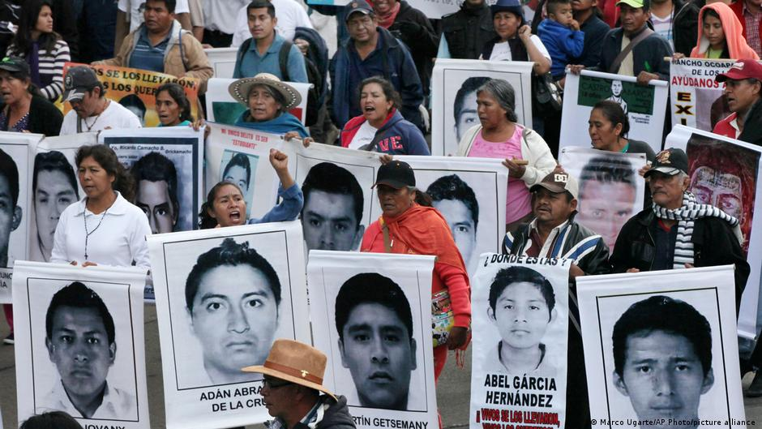

(Image by: DW.com <https://www.dw.com/en/90000-people-have-disappeared-amid-mexicos-drug-war/a-59033838>)

5.2) Mexico’s economic front

When compared to other nations over the past three decades, Mexico has failed in terms of economic growth, participation, and poverty reduction. Between 1980 and 2018, its economic growth was only slightly higher than 2 percent annually, which slowed convergence with high income economies.

After declining by 8.2 percent in 2020, the economy expanded by 4.8 percent in 2021. The manufacturing and service industries had strong first-half 2021 performances, helped by rising mobility and U.S. demand. However, due to supply chain constraints, an increase of COVID-19 instances, and weak investment, the recovery lost steam in the second quarter of 2021. The nation will moreover need to address some of the most urgent pre-crisis obstacles to development and inclusion to facilitate better and more rehabilitation goals over the medium term.

A big question does arise when drugs come into the conversations when talking about the economy. Does it contribute towards the economy and if so, how much? Or does it not contribute to the economy but only breaks it down and makes it somewhat unstable?

According to the Organized Crime and Corruption Reporting Project, Mexican drug traffickers earn roughly US$31 billion annually, yet the country's legal economy suffers because of being attacked by crime syndicates. A third of legitimate firms have acknowledged being the targets of theft, theft, and blackmail. Businesses are functioning less frequently and closing due to the criminal damage. Thus, affecting the economy at large.

5.3) What can the Mexican state do to improve their current developing status?

* Stop seeing the country as a lost cause.
* Provide protection to small and big businesses contributing towards your economy and motivate them to grow, giving them the resources to create more job opportunities which will lead to less crime and drug trafficking.
* The demand that drives drug trafficking activities, which frequently involve violence and crime, can be reduced with the support of cooperation between police departments, health, and social service organizations.
* Creating free resources and infrastructure for addicts, to motivate and promote good health and rehabilitation.
* Provide protection to those and their families who decided to speak out on the trafficking and drug cartels.
* Use the prison system as an access to rehabilitation rather than punishment and more management of drug trafficking.

1. **My view on politics in South Africa**

In this part of my assignment, I am not going to show facts or research like I did above. As I am a South African citizen, I am going to write about my own experience, knowledge, and my own opinions about the country.

South Africa is run by the African National Congress or ANC for short. They oversee the different municipalities across South Africa, which are run by other political parties like parts of the Western Cape run by the Democratic Alliance, or DA for short. The DA and other political parties in charge of the municipalities report financial, social and local economic resources and management to the ANC who oversees everything.

Currently South Africa has a president. Cyril Ramaphosa, and personally, probably the best president we have had since Nelson Mandela. Seeing that previous presidents weren't in their own country for more than a week at once or even using taxpayer money to build and improve their mansion somewhere on a hill. Cyril Ramaphonsa has been hands-on in every single disaster that seems to hit South Africa. His biggest test was the outbreak of Covid-19. There he acted fast and with political precision. Knowing that the economy will suffer dearly, the safety and health of his people were much more important. He put the whole country on lockdown. Which was a good decision at first, but unfortunately, the economy is still recovering from that decision.

6.1) The inequality in South Africa

As the whole world knows by now, South Africa is known for its bad part in history called apartheid, where people of color were separated from causation people and given less rights, movement, and harsh living environments to live in, bad education and were sometimes forcefully moved from their homes to relocate with nothing to their name.

The end of apartheid and the beginning of democracy in South Africa happened in 1994, when Mandela was released and people of color was able to vote and thus, the ANC was elected to power, apartheid was abolished, and Nelson Mandela became the first black president of South Africa.

And since then, South Africa has been seen as the Rainbow Nation, rising from the ashes and from all the despair that the previous government caused.

And it was going well, when Nelson Mandela was in power, everything was going well. He did try to make everything equal, and the ANC promised to keep the equality after his presidency. But they didn’t.

Today, South Africa is struggling with a huge wealth cap, and a big problem with Corruption. Majority of people of color are still in informal infrastructure and jobless. The ANC has not made any effort in closing the wealth gap or giving the people a better life at all.

South Africa is thus still divided.

6.2) Crime in South Africa

This can easily be in the top five reasons why RSA is still a developing country.

.6.2.1) Violence against women and children

Currently the extensive violence against women and children in the country have become a genocide. With a woman being sexually assaulted every five seconds. Babies as young as 6 months to about three years, being raped as men were told that it cures HIV and Aids. Killing the children. The abuse of women by their own husbands being blamed on their “culture” and not the fact that they are 80% of the time drunk or on the influence of drugs. Every day, women are being found murdered in their homes or in a field somewhere, probably raped and beaten. And yet, the ANC is doing nothing but giving speeches about it. 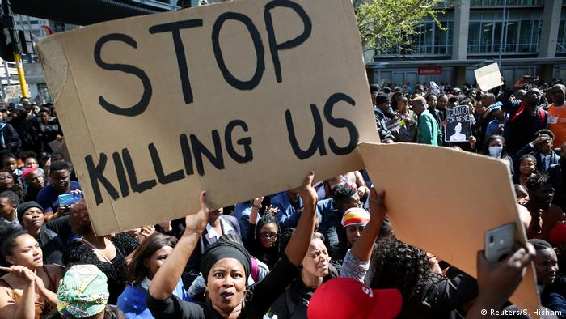

(image by: DW.com <https://www.dw.com/en/human-rights-watch-gender-based-violence-remains-rampant-in-south-africa/a-59923515>)

6.2.2) Corruption

Yes, there is a lot of money being pumped into SA. But the infrastructure and the people never see it. We have broken down hospitals, unsafe schools, unsafe roads filled with holes, causing motor vehicle accidents every day.

The education to the youth is failing, with bad infrastructure and barely qualified teachers teaching the youth. Children must travel on foot, sometimes alone between 5 to 20 kilometers to go to a broken-down school.

The constant stealing of the countries’ finances are really taking a toll on the country and its economy and most of all its people.

6.3) How can South Africa improve?

* Stop stealing the money our country desperately needs.
* Create task forces that stop crime against women and children.
* Protect the women and children in the country without restricting them.
* Prosecute the rapists, killers and the thieves causing harm to the country by creating and reinforcing a new criminal judgment system.

1. **Politics in Thailand**

Thailand has developed socially and economically in an impressive way over the past forty years, going from just a low-income to that of an upper middle-income nation in under a decade. As a result of its prolonged high growth and significant reduction in poverty, Thailand has received considerable attention as a developmental success story.

According to the World Bank, following the Asian Financial Crisis, Thailand's economy expanded at an average annual rate of 5% from 1999 to 2005 compared to 7.5 percent during the boom years of 1960 to 1996. Millions of jobs were produced by this growth, which enabled millions of citizens to escape poverty. Impressive improvements were made in a number of welfare-related areas, including the number of years that children spend in school, the prevalence of health insurance, and the growth of other social security programs.

7.1) The Political Challenges in Thailand

The monarch, led by Vajiralongkorn, is the head of state in Thailand, which is a constitutional monarchy. The nation's 17 constitution and bill of rights, the most recent of which was written in 2007, have been ratified by practically every government since 1932.

* Due to the Thai government's inadequate response to the COVID-19 pandemic, the sluggish vaccination rollout, and public dissatisfaction with economic disruptions and stagnant earnings brought on by widespread restrictive measures, protests and animosity at the government have grown more intense. But, with timely and generous infusions of fiscal stimulus packages, Thailand also avoided more severe virus outbreaks in 2020 and maintained the economy and companies busy.
* Thai protesters persisted in calling for the monarchy to be changed, a speedier schedule for fresh elections, and constitutional changes. A sizable demonstration against the Royal Defamation Law's reintroduction was planned for October 31, 2021, in the heart of Bangkok. A month later, a sizable crowd of demonstrators assembled in front of the German Embassy to deliver a letter denouncing absolute monarchy and requesting changes to the stringent lèse-majesté laws. The Constitutional Court's verdict, which stated that comments made by protest organizers earlier in the year amounted to overturning the Thai monarchy, was also rejected by demonstrators.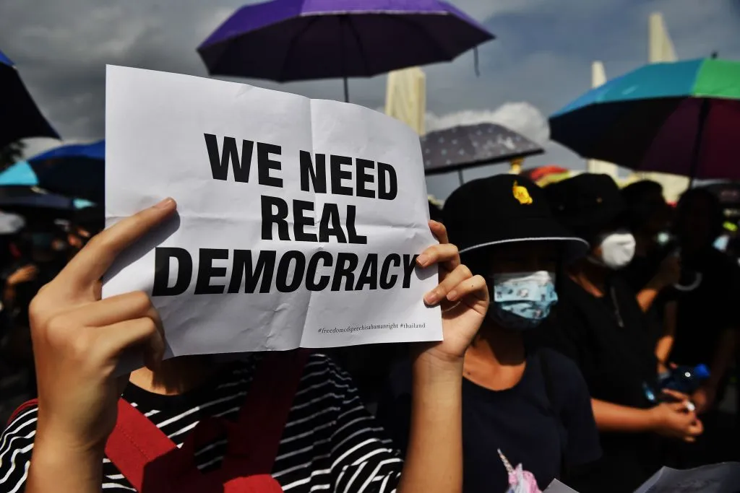

(Image by: Time.com <https://time.com/5880105/thailand-protests-monarchy/>)

7.2) Why is Thailand still a developing country?

* Private sector investment decreased from more than 40% of GDP in 1997 to 16.9% of GDP in 2019, and involvement in value chains and foreign investment flows has stagnated.
* It is improbable that structural transformation will continue to transfer assets from farming to industry the way it previously did.
* Although manufacturing has some forward linkages, it nevertheless relies on international inputs and is increasingly competitive with its neighbors in the region.
* According to the World Bank, since 2015, Thailand's progress in reducing poverty has stalled, reflecting a sluggish economy and stagnant agricultural, company, and wage incomes.

7.3) What can Thailand do to improve their developing status?

* Personally I think that Thailand should focus on what their people have to say. In other words, listen to your citizens that protest for a better country for their families and themselves.
* Get back to focusing on reducing poverty by injecting funds and supporting organizations that will benefit your poor.
* Motivate and provide resources to big produce companies to educate and boost the morale of their employees.
* Develop new and innovative business ideas to grasp international interests to invest in those businesses and boost your economy and workforce.

**Conclusion:**

In this assignment, I spent hours researching why a country is still a developing country. And there are multiple answers, but I think the one that answers the question of why a country is still stuck in that status is because political parties or units don’t listen to their country. They simply ignore what the people have to say and the conditions they have to go about with every day. Instead, the political systems of most developing countries decide to navigate their energies, resources, and finances towards other things more important to the politician system than the people.

I have learned, unfortunately, that in developing countries, people don’t have a voice. We are ignored, cast aside and in some countries not even thought of. Doesn’t matter what religion, culture, or skin color you possess, the chances that you can make a political difference is little to nun.

I will use this knowledge that I have gained doing this assignment to bring answers to those who have questions about where their tax money disappears to or why the political system doesn't listen to them, even though they have promised to when elected.

# Bibliography

Action, H. P. (2014, July 16). *Development aid to Africa negligible in comparison to illicit outflows*. Retrieved from GPF - Global Policy Forum: https://archive.globalpolicy.org/component/content/article/211-development/52662-development-aid-to-africa-negligible-in-comparison-to-illicit-outflows-.html

Bienen, H. (2011, July 18). *What Does Political Development Mean in Africa?* Retrieved from Cambridge University Press: https://www.cambridge.org/core/journals/world-politics/article/abs/what-does-political-development-mean-in-africa/2EB76346390394735F9E70AD872EB75C

Centre, P. R. (2021, June 29). *Nationalism and politics*. Retrieved from Pew Research Centre : https://www.pewresearch.org/religion/2021/06/29/nationalism-and-politics/

Fosu, A. K. (2018, June ). *Governance and Development.* Retrieved from The High 5: https://www.afdb.org/fileadmin/uploads/afdb/Documents/Publications/WPS_No_298_Governance_and_Development_in_Africa_A_Review_Essay_B.pdf

Manjal, D. (2022, June 26). *Explained | What are India’s laws on abortions?* Retrieved from The Hindu : https://www.thehindu.com/news/national/explained-what-are-indias-laws-abortions-amid-roe-v-wade/article65567494.ece

Otenyo, E. E. (2020, April 2). *Politics of African Development.* Retrieved from Oxford Bibliographies : https://www.oxfordbibliographies.com/view/document/obo-9780199756223/obo-9780199756223-0240.xml

Pillalamarri, A. (2018, December 14). *The Problem With India’s Major Political Parties*. Retrieved from The Diplomat : https://thediplomat.com/2018/12/the-problem-with-indias-major-political-parties/

Research, C. E. (2022, March 20). *Mexico Drug War Fast Facts*. Retrieved from CNN Travel: https://edition.cnn.com/2013/09/02/world/americas/mexico-drug-war-fast-facts/index.html

Seddon, S. (2022, February 9). *‘They kill like the Taliban’: Inside the horror of Mexico’s raging drug war*. Retrieved from Metro 50 : https://metro.co.uk/2022/02/06/mexico-why-2022-could-be-brutal-year-in-the-drug-war-16055265/

Tan, J. (2022, May 18). *Thailand’s Political Challenges in 2022 and Beyond*. Retrieved from Geopolitical monitor : https://www.geopoliticalmonitor.com/thailands-political-challenges-in-2022-and-beyond/

TREJO, G. (2021, February 17). *Mexico’s Illiberal Democratic Trap*. Retrieved from Carnegie Endowment for International Peace : https://carnegieendowment.org/2021/02/17/mexico-s-illiberal-democratic-trap-pub-83786

Unknown. (2021, October 14). *Why is Egypt a Developing Country?* Retrieved from CIB : https://www.cibeg.com/en/learning-center/economics-101/why-egypt-is-a-developing-country#:~:text=While%20life%20expectancy%20for%20Egyptians,income%E2%80%9D%20country%20%5B6%5D

Vaishnav, M. (2018, October 11). *What Is the Secret to the Success of India’s Bharatiya Janata Party (BJP)?* Retrieved from Carnegie Ednowment for International Peace : https://carnegieendowment.org/2018/10/11/what-is-secret-to-success-of-india-s-bharatiya-janata-party-bjp-pub-77477