**AJIBADE ALEX ADEWALE**

**UB74450SCO83615**

COURSE CODE:

**(CUS 218)**

COURSE NAME:

**(Creative Uses of Drones)**

Assignment Title:

**(Uses of Drones)**

**ATLANTIC INTERNATIONAL UNIVERSITY**

**April/2022**

**TABLE OF CONTENT**

**Frontpage i**

**Table of content ii**

**List of figures iii**

**1.0 Introduction 1**

**1.1 What is a drone 1**

**1.2 Common features and components of drones are 3**

**1.3 The features of a drone vary depending on how it is used 6**

**2.0 Types of drones 7**

**2.1 Single rotor drones 7**

**2.2 Multi-rotor drones 8**

**2.3 Fixed-wing drones 9**

**2.4 Fixed-wing hybrid VTOL 10**

**2.5 Advantages and disadvantages of single-rotor, multi-rotor, fixed-wing, and hybrid VTOL drones 12**

**3.0 Benefits and education use of a drone 14**

**3.1 Law Regulating Uses Of Drone 15**

**3.2 Most Rules In Place To Regulate Drone Use Differ From Legislative Requirements 15**

**4.0 Conclusion 18**

**References 19**

**LIST OF FIGURES**

**Fig. 1: The computing system of a UAV drone 1**

**Fig. 2: An Electronic speed controller 3**

**Fig. 3: A drone controller 3**

**Fig. 4: Drone GPS module 3**

**Fig. 5: 3.7v 400mAH Lipo Rechargeable Battery for RC Drone 4**

**Fig. 6: Various types of drone antenna 4**

**Fig. 7: Drone receiver 4**

**Fig. 8: High-resolution drone camera 5**

**Fig. 9: Drone sensors 5**

**Fig. 10: An accelerometer 6**

**Fig. 11: A single-rotor drone UAV 7**

**Fig. 12: Physical parts of single rotor UAV 7**

**Fig. 13: Different types of multi-rotor drones (RPAS Header) (remote piloted aircraft system) 8**

**Fig. 14: DJI Phantom3 quadcopter multi-rotor drone 9**

**Fig. 15: Fixed-wing drone basic labeling 10**

**Fig. 16: Fixed-wing UAV drone 10**

**Fig. 17: Hybrid VTOL UAV explanation 11**

**Fig. 18: Hybrid VTOL fixed-wing UAV 11**

**1.0 INTRODUCTION**

Long ago, achieving a technology to minimize humankind's effort and save lives was challenging. A significant shift in technology has resulted in significant changes in social structures and how people contribute to society and earn a living. humans have developed tools and technology to help us achieve our objectives.

Additionally, the desire for humankind’s survival has enabled many attempts to improve one’s ideas and objectives, which drives more technological transformations. Today technologies have rapidly advanced making it possible to automate much of the work currently carried out by humans, example is a drone an unmanned autonomous vehicle (UAV)

Technologies have added more merit to our community with the aid of introducing and inventing new ideas. The idea of inventing drones for search and rescue has saved many lives and time

**1.1 WHAT IS A DRONE?**

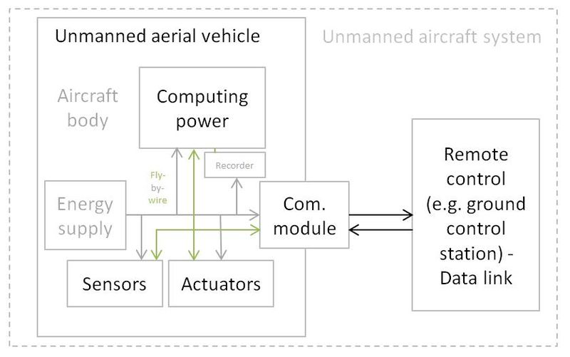A drone is an unmanned or uncrewed aerial vehicle, an aircraft without a crew, human pilot, or passenger on board. It only carried a system of panels on board, which the system program maneuvered. A drone can be operated remotely or fly autonomously through software-controlled flight plans in their embedded systems that function in tandem with onboard sensors and a global positioning system (GPS). Fig 1: **The computing system of a UAV drone**

Many drones are flown using a visual line of sight (VLOS), in which the pilot keeps the vehicle in view for the duration of the flight and controls it through observation. Other drones are operated through the first-person-view (FPV), in which the drone's cameras send footage to a pair of FPV goggles or a monitor, allowing the pilot to fly the drone remotely from an onboard perspective.

Drones were developed in the 1800s. Earlier drones were most commonly used by the military, where they were first utilized for intelligence gathering, anti-aircraft target practice, and, more controversially, as weapons platforms. Drones vary from regular aircraft in that they do not have a human pilot on board. They can either be controlled remotely by a software program or a human pilot on the ground, or they can fly independently with software-guided plans in their systems, such as a return home drone. It can also be stated that a drone is a flying robot.

Drones were now used for various types of things, especially civilian roles, drones were specially made for short-distance routines.

Because of the increased levels of safety and efficiency that drones provide, they have made their way into the mainstream. There are two basic functions knowns to drones, navigation and flight mode. These two functions are important to properly fly and navigate a drone for safety measures.

**1.2 COMMON FEATURES AND COMPONENTS OF DRONES ARE:**

* 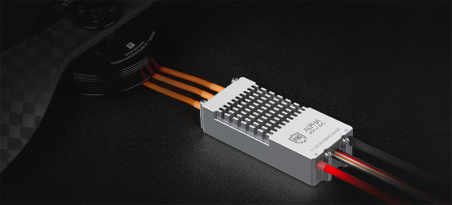Electronic speed controllers (ESCs) which control a motor's speed and direction. They also control and alter the speed of the aircraft's electric motors. The ESC responds to a signal from the flight controller by raising or lowering the voltage to the motor as needed, changing the propeller's speed.

**Fig. 2: An Electronic Speed Controller**

* 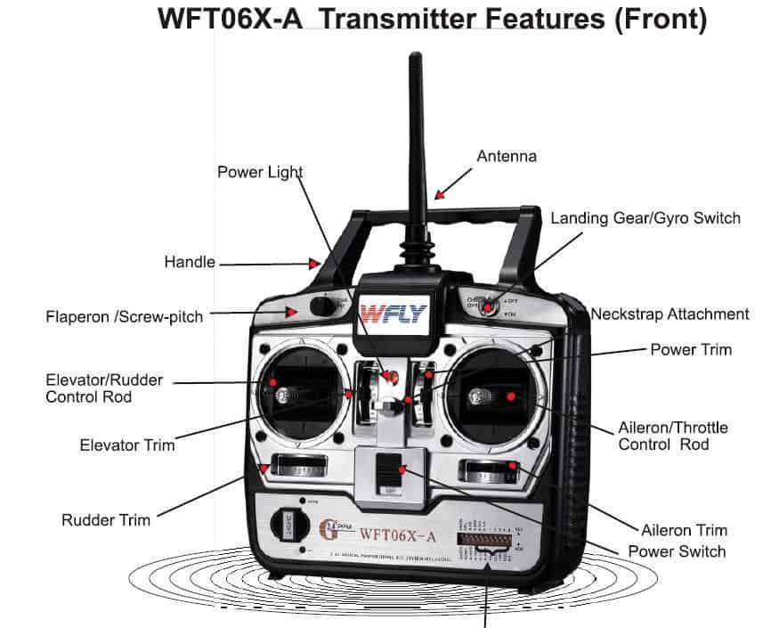Flight controller which transmits a radio signal to the drone from the remote control, instructing the drone on what to do. The drone controller's radio transmitter sends out radio signals received by the drone's receiver.

**Fig. 3: A drone controller**

* 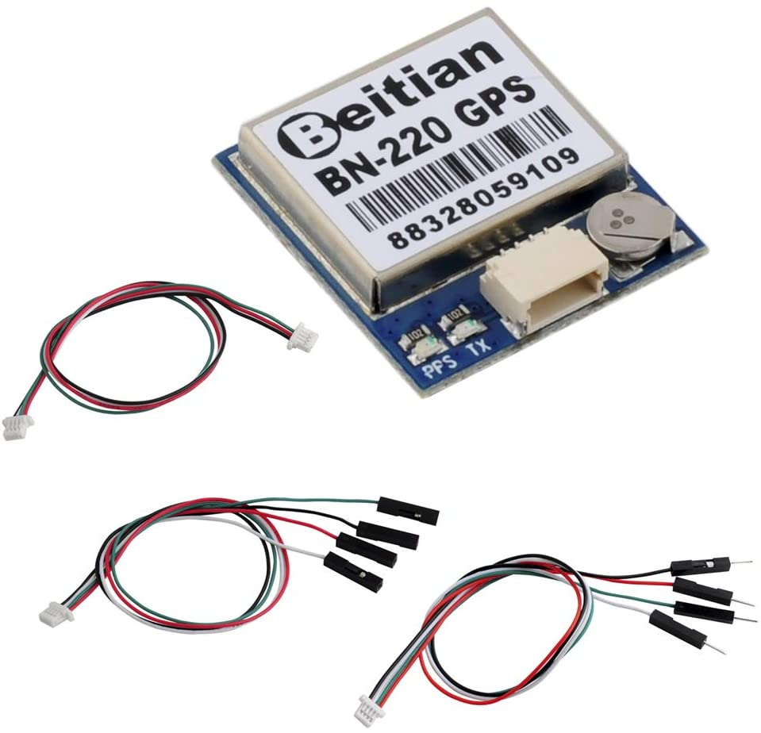GPS module which navigates the drone with the aid of generating a map of its surroundings while flying, as well as tracking its path within that area. An integrated lidar scanner detects physical surroundings and their distances by measuring how long laser pulses emitted in all directions take to bounce back to a sensor.

**Fig. 4: Drone GPS module**

* 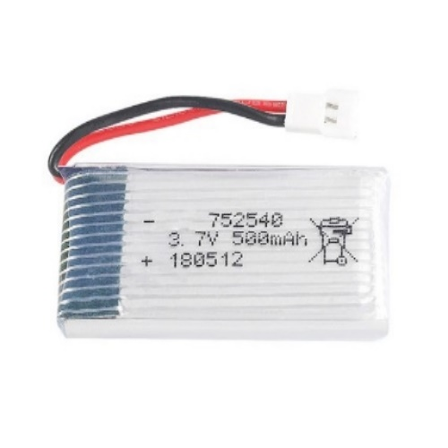Battery is the life force of a drone and it determines how long and far a drone can fly. Drone batteries came in a variety of shapes and sizes, although the majority of drones use Lithium polymer batteries (LiPo). The size of your drone determines the motors and propellers you use, and the battery you use is determined by the motors and propellers you use.

**Fig. 5: 3.7V 400mAH Lipo Rechargeable Battery for RC Drone**

* Antenna turns received electromagnetic waves into electrical signals. In two-way communication, the same antenna can be used for both transmission and receiving.

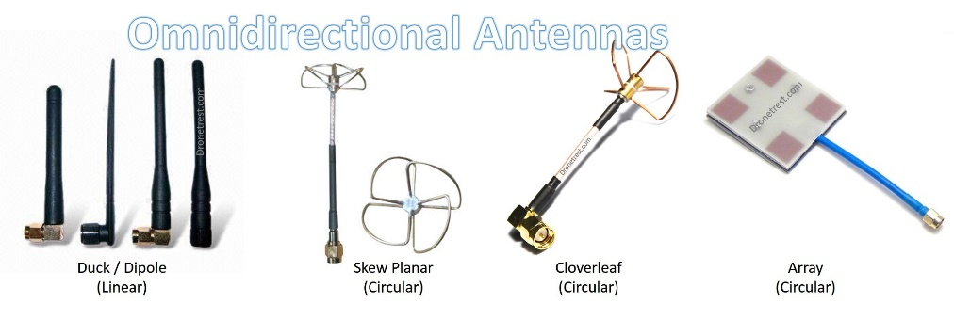

**Fig. 6: Various types of drone antenna**

* 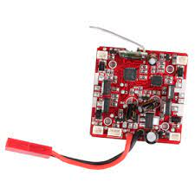Receiver is an electrical device that receives radio signals from the drone controller via built-in antennas. The drone controller's signals aren't the only ones it receives. It also decodes and turns signals into alternating current pulses.

**Fig. 7: Drone receiver**

* 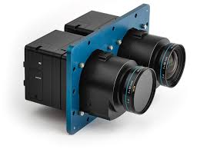Cameras are essential in a drone, it is mounted at the center of the drone to relay or broadcast a real-time video to the pilot and also maintain the stability, direction, and motion of the drone. A camera mounted on a drone can take a picture or video.

**Fig. 8: High-resolution drone camera**

* 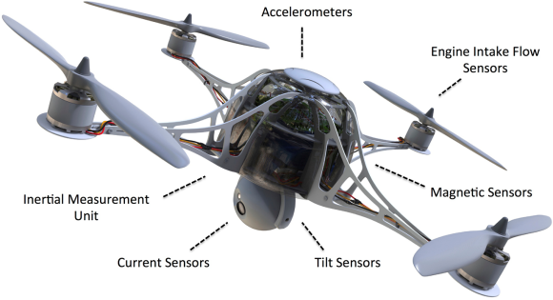Sensors, including ultrasonic sensors and collision avoidance sensors are the Inertial measurement sensors in a drone's multi-axis magnetometers that may detect any changes in the drone's direction and transmit this data into a central processor that displays the drone's direction, orientation, and speed to the operator. Although there are many sensors on board a UAV drone, such as engine intake flow sensor, inertial measurement unit, current sensors, tilt sensors, magnetic sensors, accelerometer, etc. **Fig. 9: Drone sensors**
* The drone's position and orientation in flight are determined using accelerometers. An accelerometer, which measures speed is subjected to all three axes X, Y, and Z is provided by an accelerometer. So as Altimeter, which measures altitude. It also determines the drone's tilt angle when it is stationary. If the drone is in a horizontal position and is motionless, the X and Y axes will output 0g, but the z-axis will output 1g. Everything on Earth experiences one gram of gravity. If the drone spins 90 degrees on the X-axis, the X and Z axes will give 0g, but the Y-axis will begin to give 1g. The output of X, Y, and Z during the tilt will be between 0 and 1g. These values may then be used to calculate the drone's tilt angle using trigonometric calculations.

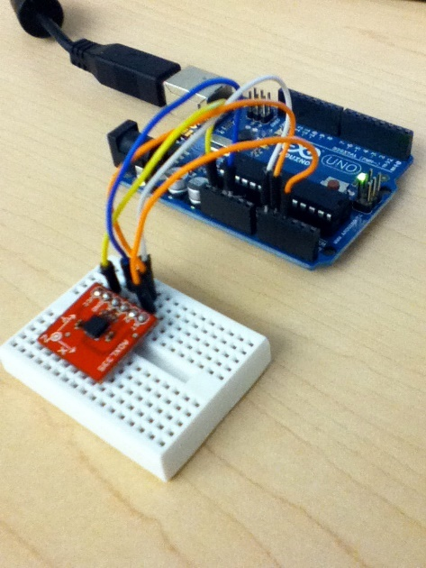Accelerometers are also used to calculate horizontal and vertical linear acceleration. Whit this information, calculating the drone's velocity, direction, and even rate of change in height is possible. The drone's vibration is also detected using an accelerometer.

The accelerometer is an essential sensor in any drone since it provides significant inputs even when the drone is motionless.

**Fig. 10: An accelerometer**

**1.3 THE FEATURES OF A DRONE VARY DEPENDING ON HOW IT IS USED. HERE ARE SOME EXAMPLES OF FEATURES:**

• Augmented reality features superimpose virtual elements on the drone's video feed; • The drone's artificial intelligence (AI) allows it to follow objects; • The real-time capture was saved and stored on a media storage device. • A drone's maximum flying time refers to how long it can stay in the air; • Maximum ascending and descending speeds; • Precision hovering; • Obstacle detection range; • Height hold (which keeps the drone at a steady altitude); • Live video feed; and • Flight logs

**2.0 TYPES OF DRONES**

The basic group is now categorized as a type of drone according to its strength, uses, and weaknesses. The categories are as follows:

* 1. **SINGLE-ROTOR DRONES:**

Single-rotor drones are sturdy and long-lasting. A single-rotor aircraft has only one rotor, which is similar to a large spinning wing and a tail rotor for direction and stability control. It often generates thrust more efficiently, which makes them more ideal for a longer flight time.

Because of the increased efficiency, single-rotor machines frequently use gas engines rather than batteries. Their range is significantly increased when running on gas options.

The single rotor is mostly used for drone surveying, carrying heavy payloads, aerial LIDAR laser scan, etc. it is mostly seen around courier service companies.

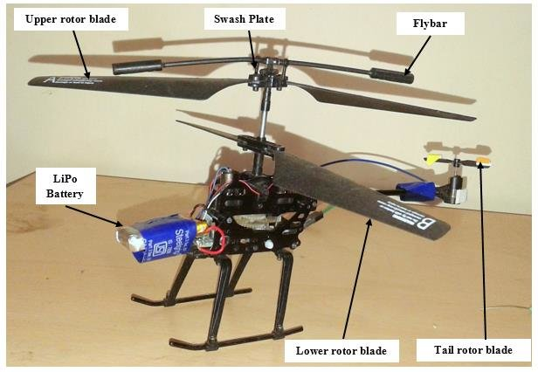

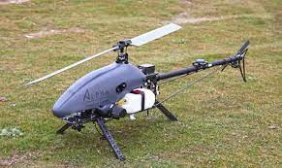

**Fig. 11:**  A single-rotor drone UAV **Fig. 12:** Physical parts of single rotor UAV

* 1. **MULTI-ROTOR DRONES**

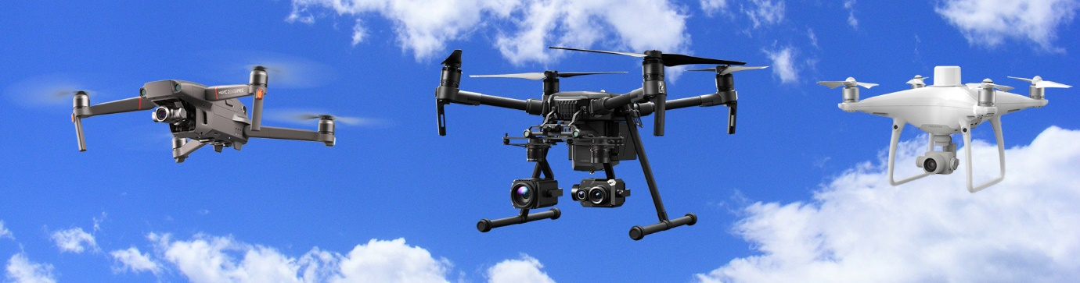

**Fig. 13:** Different types of multi-rotor drones (RPAS Header) (remote piloted aircraft system)

This is a type of commercial drone, is the cheapest and easiest type of drone. They also allow for more precise positioning and framing, making them ideal for aerial photography and surveillance. Due to the multiple rotors and propellers, they have low flight time.

By speeding up two motors on one side and slowing down the other two, a multi-rotor drone may control its roll and pitch rotation. For example, if the multi-rotor drone wished to roll left, the motors on the right side of the frame would speed up while the two on the left would slow down. Similarly, if it wants to spin forward, the back two motors accelerate up while the front two slow down.

Mostly this type of drone can be seen in the filmmaking industry, security companies, or fire fighters’ companies, it can also be owned by an individual, because of its usage. It is mostly used for photography and videography, 3D scans, visual inspections, and thermal reports.

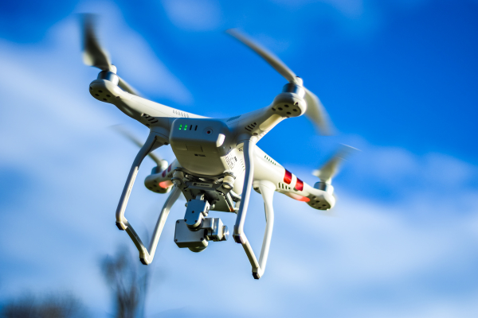

**Fig. 14:** DJI phantom3 *quadcopter* multi-rotor drone

* 1. **FIXED-WING DRONES**

Fixed-wing is unmanned aircraft drones that consist of one rigid wing that resembles conventional planes and must be launched from a runway or a catapult. They can’t take off vertically or a system to hover in the air but glide on a set path, and when it comes to flying and air control, they don't waste energy trying to stay balanced in the air against gravity. They are more efficient for a long-distance drones since they stay longer in the air and have better aerodynamics.

These attributes make them perfect for longer operation since they don’t use a rotor or need to hoover on the air, they only glide through a path and are mostly powered by gas engines or large batteries.

Large companies and big industries use this type of drone in surveying, mapping, etc. it is mostly used for agricultural aids, security, constructions companies, inspections, aerial mapping, drone surveying such as forestry or environmental drone surveys, and UAV coastal surveys, pipeline UAV surveys, etc.

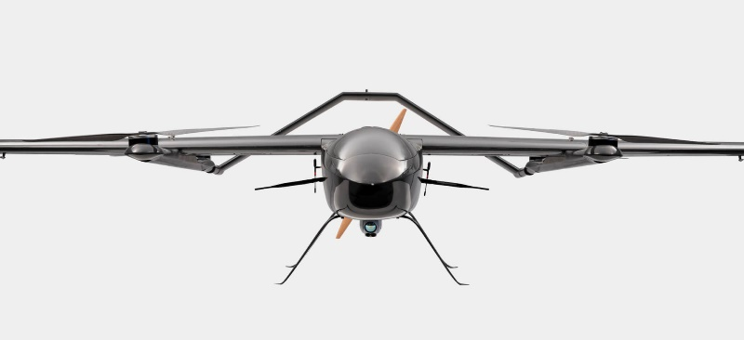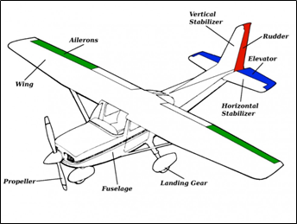

**Fig. 15:** Fixed-wing drone basic labeling **Fig. 16:** Fixed-wing UAV drone

* 1. **FIXED-WING HYBRID VTOL.**

I could say this type of drone is a combination of all the series of drones mentioned, fixed-wing hybrid VTOL vertical take-off and landing is a type that merges both the fixed-wing and multi-rotor drone but that has an infinite configuration. This makes it possible for autopilots to have high efficiency, adaptability, and durability to cover all possible configurations and designs in hybrid VTOL drones.

The purpose of hybrid VTOL is to combine the advantages of fixed-wing, multirotor, and single-rotor drones. Hybrid VTOL drones may have a single rotor or even up to 8 rotors generating thrust

Despite the high knowledge of designing both fixed-wing aircraft and rotorcraft, designing hybrid VTOL has been challenging and poorly understood. Currently, many companies are trying to meet the standard accepted generic methodology that can be used for designing this type of aircraft such as tiltrotor systems because there are numerous challenges regarding the selection of the proper hybrid VTOL configuration.

Hybrid-powered drones are changing the game and can be configured in a variety of ways, including gas/battery or battery/solar. These vehicles are unrivaled in terms of performance, and they have set numerous records with both rotary and fixed-wing aircraft.

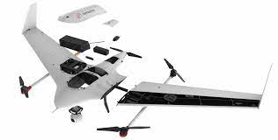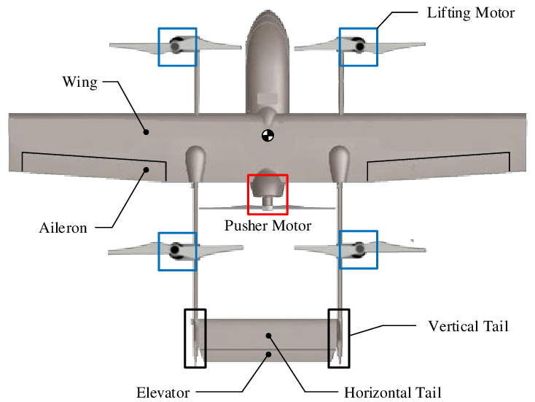

**Fig. 17:** Hybrid VTOL UAV explanation **Fig. 18:** Hybrid VTOL fixed-wing UAV

2.5 Advantages and disadvantages of single-rotor, multirotor, fixed-wing, and hybrid VTOL drones

|  |  |  |
| --- | --- | --- |
|  | **ADVANTAGES** | **DISADVANTAGES** |
| Single rotor | • They're made to be strong and durable  • A single-rotor helicopter can have extremely long blades that act more like a spinning wing than a propeller, resulting in high efficiency.  • Compared to a multi-rotor helicopter, a single-rotor helicopter has a significantly higher efficiency, which rises if the drone is gas-powered for even longer endurance.  • A single-rotor helicopter is your best bet if you need to hover with a high payload (e.g., an airborne LIDAR laser scanner) or if you need to combine hovering with extended endurance or quick forward flight. | • single-rotor drone types can be expensive and complex in operating.  • They vibrate, making them less sturdy and have a bad crash in the event of a dangerous landing.  • A single rotor's long, heavy spinning blades can be dangerous and difficult to maneuver in cities.  • Due to their mechanical intricacy, they also necessitate a lot of maintenance and care. |
| Multirotor | • It can fly significantly closer to structures and buildings than other drones.  • The capacity to carry many payloads on a single trip improves operating efficiency and minimizes inspection time.  • It allows for more precise control of the aircraft during flight.  • It can go up and down on the same vertical line, back and forth, side to side, and rotate in its axis due to its greater mobility. | • They are inherently inefficient, requiring a significant amount of energy just to defy gravity and stay in the air.  • Due to their limited endurance and speed, multi-rotor drones are unsuited for large-scale aerial mapping, long-endurance monitoring, and long-distance inspection of pipelines, highways, and power lines.  • Using a gas engine to power multi-rotors isn't viable because of the necessity for fast and precise throttle changes to keep them stabilized, therefore they're limited to electric motors. As a result, we can only expect minor improvements in flight time until a new power source is developed.  • They are limited to roughly 20-30 minutes when carrying a lightweight camera payload with current battery technology. Heavy-lift multi-rotors, on the other hand, may carry more weight in exchange for much shorter flying times. |
| Fixed-wing | • Fixed-wing drones traverse greater distances, explore far wider areas, and monitor their subject of interest for longer periods. A couple of hours is the average flight time. Many fixed-wing UAVs can stay aloft for 16 hours or more with a higher energy density of the fuel.  • Compared to other drone types, this one can fly at a higher altitude, carry more weight, and be more forgiving in the air.  • Fixed wings can fly at a high altitude and also have the ability to carry a heavyweight payload. | • With fixed-wing aircraft, taking off is only the beginning. Hundreds of thousands of photos must be analyzed and stitched together to form a single large tiled image. After that, there's a lot more to accomplish, including data analysis like stockpile volume estimations, tree counts, and overlaying additional data onto the maps, among other things.  • Flying fixed-wing drones usually necessitates training. When you launch a fixed-wing drone for the first time, you must be confident in your ability to maintain control during the flight and return to a comfortable landing. A fixed-wing drone is always moving forward, and they move faster than a multi-rotor, so you may not have the opportunity to hover it. A launcher is usually required to get a fixed-wing drone into the air.  • A launcher is mostly required to get a fixed-wing drone into the air and is most difficult to land than the other two types of drones. |
| Hybrid VTOL | • They are equally perfect at hovering and forward flight.  • The drone's autopilot can do all of the difficult work of keeping it stable, enabling the human pilot to focus on navigating it around the skies. | • The technology utilized in these types of drones is still in its infancy. |

**3.0 BENEFITS AND EDUCATION USE OF A DRONE**

Over the recent year, young children are more interested in digital roles, with drone technology being part of the most essential technology career the world has focused on and the demand for drone-related jobs is getting high and will continue growing. It is more appropriate for teachers to utilize physical drones as learning tools for the student classroom to improve their knowledge of drone technology in other to secure a successful future upon graduation.

By introducing drone technology into the classroom, teachers will make learning more entertaining, interactive, and imaginative for children instead of reprieve from the arduous task of intensely focusing on repetitive courses. The drone also provides students the chance to learn more about technologies, which they may choose to pursue as a future career.

Teaching drone technologies requires a variety of creative talents, such as drone motor development and hand-eye coordination, drone programming and coding, creative skills, and drone intellectual growth. All of these perceptive learning domains should lead the student to a precise future.

In addition to technical skills, the drone education program develops critical thinking and problem-solving skills, which will serve them in whichever job path they choose. Children may be digital natives in terms of using technology, but not in terms of producing or working with it. They don't come with an intrinsic understanding of coding, programming, or construction technology. Drones can help with this because these abilities must be taught.

Additionally, Drones are also perfect teaching tools for the fundamentals of design. A drone must work under specified parameters to dive, drive, or fly. The design of the unmanned aircraft must follow certain principles, such as lift and drag. A student must review the mathematics behind lift and drag so as the physics, coding software, and the professionally building technology of drones.

**3.1 LAW REGULATING USES OF DRONE**

Some years back when drones are seen as a pleasant and enthusiastic toy to play with until they were utilized as threats to people’s privacy and members of the public. This has sparked an opinion about the regulation of the use of drones by law enforcement officers. There are several rules for use of drones enforced by the Federal Aviation Administration (FAA). Each municipal government establishes a set of rules to govern the use of drones and updates them as new information becomes available.

The myriad rules that limit what drone owners and operators can do are the largest roadblocks to widespread drone use.

**3.2 MOST RULES IN PLACE TO REGULATE DRONE USE DIFFER FROM LEGISLATIVE REQUIREMENTS.**

* There are different sizes for drones weighed in different country legislatures, mostly drones must weigh less than 55 lbs or more in some legislatures.;
* This set of rules is probably the same for every drone pilot. It is most likely for all drones pilot can only be operated during daylight, which is defined as 30 minutes before official sunrise to 30 minutes after official sunset. Although there might be approval for night flights in most cases;
* There is a maximum speed for every UAV pilot in every legislature. Some countries set their maximum speed to 100 mph or higher;
* Maximum altitude is very compulsory for every drone. Mostly altitude above ground diver the type of drone been flown or type maximum altitude set by the country’s federal aviation administrations. In some cases, it is set to a maximum altitude of 400 feet above ground level;
* There is an age limit for drone pilots, it is not permissible for the person operating the drone to be at least 16 years old and hold a remote pilot airman certificate and it differs in some legislative;
* It is pulmonary that all drones must also be registered with the federal aviation administration (FAA) or its law enforcement and labeled with the registration number;
* It is not allowed to fly or use directly over people;
* Drones are not allowed to fly within five miles of any regulated airspace, including helipads or heliports (this can be a problem if there is a nearby hospital with a helipad).

Each state has set different types of drones that suit the issue that rises in their community. The table below states the prerequisite for operating a drone in Nigeria according to the Nigeria aviation authorities as at 2019

**Nigeria Civil Aviation Authority Prerequisites for operating an unmanned Aircraft**

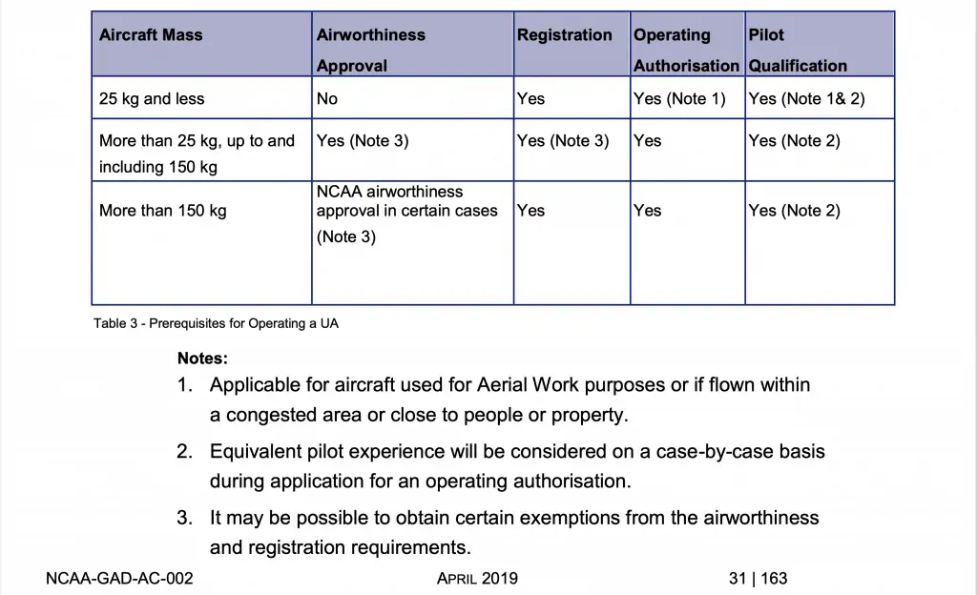

**4.0 CONCLUSION**

During my research, I learned that there are a variety of creative ways to make the drone more useful, as well as what the drone is built of, the technology behind it, and how the drone can be used both military and domestically.

Drones have a wide range of applications and are gaining popularity in the community. Drones have numerous applications in a variety of industries. These devices are no longer limited to military use, and they are also being used by a variety of enterprises for faster and more responsive customer support. Perhaps one day, commercial drones will deliver all of our packages.

The introduction of new ideas into enhancing and developing new features in drone technology has resulted in a high rate of market consumption. Many firms will begin to use drones in order to boost consumer satisfaction.

For example, a powerful tool that provides high-resolution, real-time imagery is critical for planning restoration through high-precision planting, accurate stratification of restoration efforts across complex landscapes, and accurate matching of species to substrates and growth conditions, as well as reducing labor costs through subsequent seedling performance monitoring. Every improvement in drone technology will benefit the agriculture and filmmaking industries, as well as the general drone consumer and military.

Only the manner in which a drone is used can be harmful and life-threatening to humans. It's feasible that as drone technology advances, we'll see more drone usage in our daily activities. The impact of regulations governing the usage of drones has limited the number of consumers who do not have a compelling reason to own one.

**REFERENCES**

Cusack, Dennis M.. Risk Management (00355593), Sep2016. The article discusses the regulations for drones that weigh 55 pounds or less released by the U.S. Federal Aviation Administration (FAA), which went into effect on August 29, 2016. Drone aircraft; Technological innovations; Remotely piloted vehicles; Commercial drones; United States. Federal Aviation Administration; Regulation and Administration of Transportation Programs

Wells, Jessica. Transmission & Distribution World, Mar2020, (H.W. Wilson) Commercial drones; Drone aircraft delivery; Four-wheel drive vehicles; Puerto Rico

Gerber, Gideon; Drones, Airborne. Pipeline & Gas Journal, Oct2020, Vol. 247 Issue 10, p48-50, 3p, Database: (H.W. Wilson) Pipelines; Artificial intelligence; Technology; Thermal imaging cameras; Petroleum pipelines; Oil and Gas Pipeline and Related Structures Construction; Pipeline Transportation of Refined Petroleum Products; Pipeline Transportation of Crude Oil; All Other Pipeline Transportation; Other Heavy and Civil Engineering Construction; Site Preparation Contractors