**Arlito P. Cuvin**

**ID No.: UB74040SAR83205**

COURSE NAME:

**Bachelor in Architecture**

Assignment Title:

**Building Management System (BMS)**

ATLANTIC INTERNATIONAL UNIVERSITY

**January/2022**

**Introduction**

In this assignment, we will learn about Building Management systems. We will begin this lesson with what BMS is so that we can understand this whole lesson. BMS is an intelligent microprocessor-based system that centers and simplifies the control, monitoring, operation, and management of heating, ventilation, air-conditioning (HVAC), and other building services to achieve. The temperature, humidity, circulation to be safe and in the comfortable working environment, and of course energy savings and efficient operation, in reduced time and cost. BMS provides a comfortable and safe environment for your building by controlling Air Handling Units, Fan Coil Units, Chillers, Pumps, Boilers, and VFD “Variable Frequency Drive”. BMS can be integrated with other building systems such as CCTV, Lighting, Security and Safety, Access Control System, Fire Alarm System, Energy Management System, Elevator, Energy Meter.

The BMS is categorized into three main components. First is the "Workstation Computer" level management with powerful user-friendly software. It is used for the day-to-day operation of the building. Second is the “DDC Controllers” direct digital control is the automation level that is microprocessor-based, fully programmable, and controls the building’s HVAC equipment. The third is “Field Devices” in which the field level monitors the temperature, humidity, pressure sensor, and can also monitor valves, actuator, damper, and VFD “Variable Frequency Drive”.

In this study, we can feature the BMS in the “MAN/Machines Interface” that interacts with the connected technical equipment in the building. It is easy to use for operators, engineers, and building managers. We can also feature “System Security” in BMS to prevent unauthorized use and password protection. The operator can grant specific access to system components and we can generate an operator login summary report. The most important feature is the "Alarm Management" it is the presentation in order of importance and time of potentially dangerous situations and deviation of the value of the process. It can guide the operator to take appropriate action through audible and, visible indications such as emails and SMS, it also generates a summary of alarm time, date priority, and descriptions. Another feature is “Data Logging/Trending” it is the automatic gathering and storage of data from field equipment for later analysis, it customizes charts, graphs, and generates tabular reports such as logging a return air temperature of an AHU for later evaluation. "Time Scheduling" is based on the start time 8 AM and stop the machine at 7 AM of the equipment and save energy cost and efficient operation, this feature is effective for lighting, occupancy control and can be daily, weekly for holidays and events. The last feature is “Remote Connectivity” which provides remote access to the system with full functionality via local area network and internet via a web browser.

The benefits of BMS are to improve the quality of the indoor environment to make a comfortable living and working environment for domestic and commercial to have better body temperature and humidity control and good air quality. Faster response to resident needs and end-user complaints, problem controls, can benefit the company for maintenance savings through efficient controls that provide less damage and fatigue of the mechanical equipment, provides longer operation life, generate runtime monitoring alerts that timely equipment maintenance, and avoids costly failures. Energy conservation eliminates unnecessary system operation, helping you take steps to reduce energy consumption such as optimal start, night cleaning, and schedule. Integrated control of the facility is the one-point centralized operation, to make the operation simpler, to reduce time and resources. It can reduce operator training due to its on-screen instructions, easy-to-use graphic displays, simpler operation programmed for regular and repetitive operation. This will enhance management reporting as it will be able to provide valuable real-time data, create reports, charts, critical information that are instantly sent to printers, emailed, and sent via SMS. Timely and effective control alerts you when your facility is not functioning properly, to reduce troubleshooting and downtime, remote connection access without visiting the site.

In the company I previously joined LM ISDN Inc. as AutoCAD Operator/QAQC Engineer, we had a project in Shangri-La-At-The-Fort Manila, Philippines where I was assigned to set up and install the Building Management System of (Fire Detection and Alarm System) FDAS Bosch Devices for the whole building and this is what we will study in this assignment. And you will know why you need an AutoCAD Operator or Draftsman to do this job.

Come on, let's start studying.

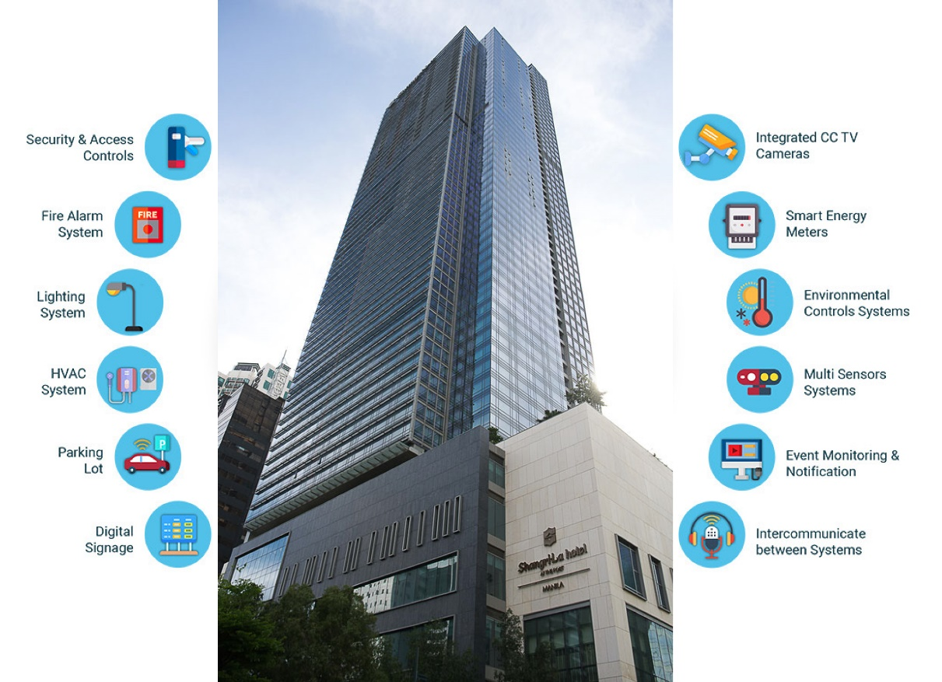

**Building Management System**

**SHANGRI-LA-AT-THE-FORT**



Building Management System Integrates the Security & Access Controls, Fire Alarm System, Lighting System, HVAC System, Parking Lot, Digital Signage, Integrated CCTV Cameras, Smart Energy Meters, Environmental Controls Systems, Multi Sensors Systems, Event Monitoring & Notification, and Intercommunicate between Systems. We will study the BMS of Fire Detection and Alarm System (FDAS).

**What is FDAS?**

FDAS stands for “Fire Detection and Alarm System” this means to detect – detective to find out something, to initiate. Alarm – give the signal to notify. FDAS – to find out if there is fire and to alert or give a signal to people or occupants to evacuate means vacate.

**What is Fire Alarm FDAS Devices or Components?**

Fire Detection and Alarm System devices to detect fire and to initiate the components use is the Smoke Detector, Heat Detector, Manual Pull Station, Flow Switch. Alarm to notify, Bell, Horn, Strobe.

**FACP – Fire Alarm Control Panel**

Intelligent Fire Alarm Panel that supports up to 508 points on two analog addressable loops. The standards control panel includes one SLC that supports 254 addressable points, 254 analog detectors or modules, or 127 analog sounder bases in combination with a suitable detector. Built-in Ethernet connector for web-browser-based programming and “Conettix” Alarm-over-IP communication. Two on-board NACs and Dual-line PSTN DACT. Peer-to-peer networking of up to eight panels in a single group. The built-in keypad can be used for total system control and programming even when wearing fireman gloves. In addition, a large 4-line by 20 characters alphanumeric LCD shows programmed device point information. With four keys enable drill, reset, silence, and acknowledge functions. The FPA-1000-UL enables various programming approaches, the front panel programming, the on-site programming, using a laptop with the possibility of pre-programming at the office, and off-site programming, with remote access via Ethernet browser-based.

**Fire Detection and Alarm System Initiating Devices**

**Addressable Smoke Detector (FAP-440 Analog Detectors)**

The smoke threshold is adjustable and automatically compensated, rotary switch addressing, flexible work modes determined by the control panel, the selectable base locking mechanism prevents malicious removal of the detector, and multi-criteria or multi-sensor technology reduces false alarms. The FAP-440 Analog Detectors are open-area smoke detectors of which some models are enhanced with heat or heat and CO sensors. These detectors work with the FPA1000 Analog Addressable Fire Panels. Use these detectors with the FAA-440 bases to provide general life safety and property protection.

**Addressable Heat Detector (FAH-440 Analog Heat Detectors)**

The selectable fixed temperature threshold, rate-of-rise feature can be switched on or off, the selectable base locking mechanism prevents malicious removal of the detector. The FAH-440 Analog Heat Detector is an open-area fire detector that works with the FPA-1000 Analog Addressable Fire Panels. Use it with the FAA-440 family of bases in indoor dry environments with high ambient temperatures where smoke detectors might not be suitable because of steam or fumes, such as kitchens, boiler rooms, or drying rooms.

The rate-of-rise heat detector, how does the ROR Heat Detector Work? The rapid rise in element temperature between 6 to 8 degrees per minute irrespective of starting temperature. Usually installed in EE Rooms, Attic, and Kitchen where fast flaming fires occur.

**Addressable Zone Module (FLM-325-CZM4 Conventional Zone Module)**

Provides a zone of up to 25 conventional smoke detectors (depending on detector type), supervises auxiliary power supply for conventional detectors, compatible with Class B (Style B) or Class A (Style D), module address programming with the D5070 Analog Device programmer between 1 and 127. Bi-colored LED provides module status, digital data communication, and power over a four-wire circuit compatible with advanced digital communications protocol (DCP).

**Manual Pull Station (FMM-325A Analog Manual Stations)**

This digital data communications and power are provided over the two-wire circuit. EEPROM addressing in module unit. Rugged die-cast housing and corrosion-resistant construction, single-gang mounting, latching alarm level.

**Flow/Supervisory Switch (FLM-325-2I4)**

The two independent contact monitoring circuits monitor Normally Open (NO) or Normally Closed (NC) contacts. Monitored Normally Open (NO) contacts can be configured with or without EOL resistor, module address programming with the D5070. Analog device programmer between 1-127, bi-colored LED provides module status. The FLM-325-2I4 Dual Input Monitor Module provides two independent contact monitoring circuits while only utilizing one address on the SLC loop. The module can be programmed to monitor Normally Open (NO) or Normally Closed (NC) dry contact types of fire alarm and supervisory devices such as pull stations or water flow devices. It fits into a standard 4-inch square or double‑gang electrical back box.

**Fire Detection and Alarm System Notification Devices**

**Horn Strobe (W-HS Series Wall-mount Multi-candela Horn Strobes)**

This device has sleek modern aesthetics, multiple voltages (12 VDC or 24 VDC), provides voltage test points, eight strobe candela options, and three horn volume options. Has universal mounting base and environmental-friendly low current draw.

**Addressable Interface Module (FLM-325-N4 Notification Appliance Circuit NAC)**

The programmable evacuation tones of 4 s with a granularity of 250 ms, contacts are rated 2 A at 30 VDC. Flexible application and quick response to emergency conditions can be alarmed or reset by zone or individual address. Module address programming with the D5070 Analog Device Programmer between 1-127 with digital data communications and power over a four-wire circuit. Compatible with advanced digital communications protocol (DCP).

**Addressable Interface Module (Relay Module FLM-325-2R-2A)**

The digital data communications and power provided over a two-wire circuit, provides one form C relay output, with two-color status LED. EEPROM addressing in module unit. The D328A is used to connect a fire alarm control panel (FACP) to other systems, controller inputs, door closures, fan controls, annunciators, indicators, or other dry contact input devices. Normally-Open (NO) or Normally-Closed (NC) contacts can indicate alarm, supervisory or trouble conditions.

**Indicator Light (FAA-420-RI Remote Indicator)**

The external detector alarm display should be mounted in corridors or access pathways of the corresponding building sections or rooms.

**Annunciator**

This annunciator is made of a stainless plate with the engraved SHANGRI-LA-AT-THE-FORT building image, on either side of which the number of the floor is visible and it has holes where the RED LED is placed. This annunciator is attached to the front side of the elevator door opening to see where the floor is on fire.

**FACP Image**

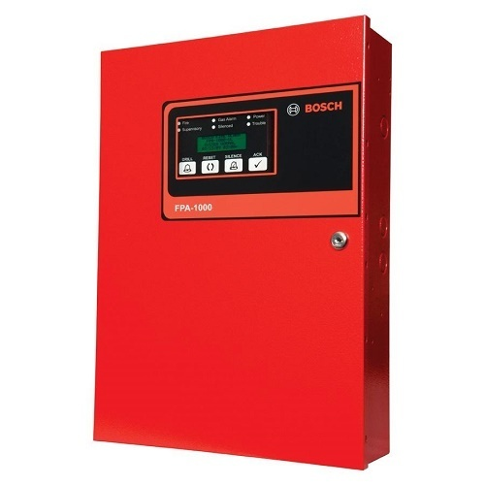

*FACP – Fire Alarm Control Panel*

**Images of FDAS Initiating Devices for Building Management System**

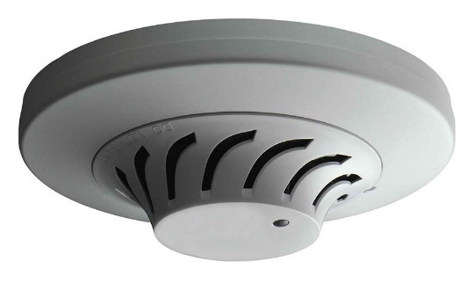 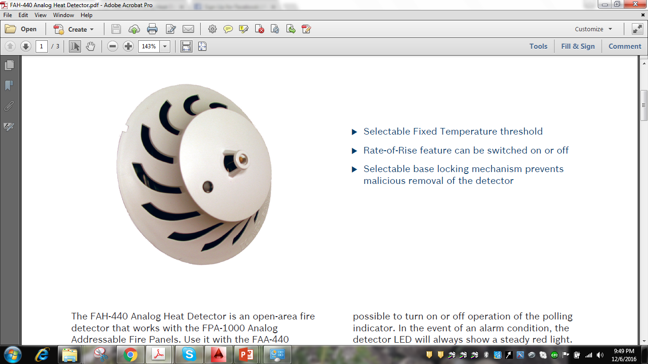

*Addressable Smoke Detector* *Addressable Heat Detector*

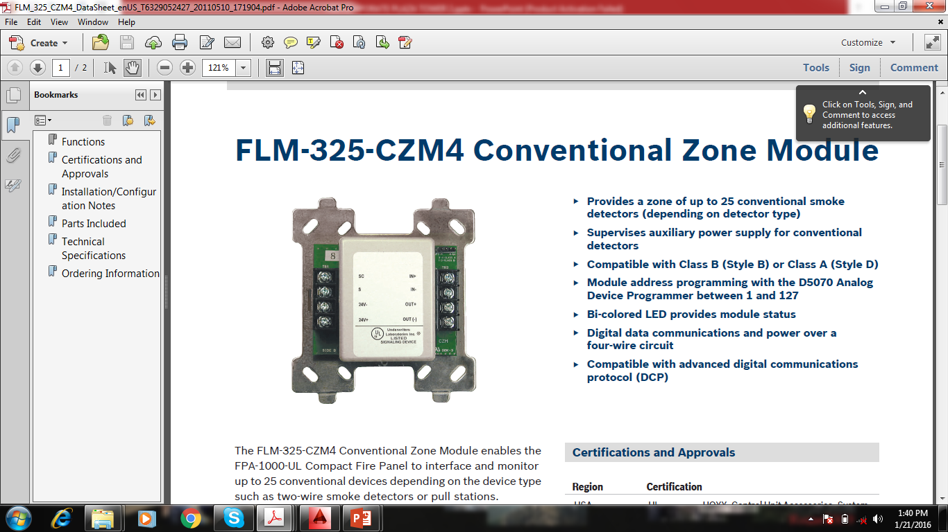 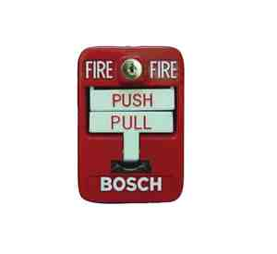 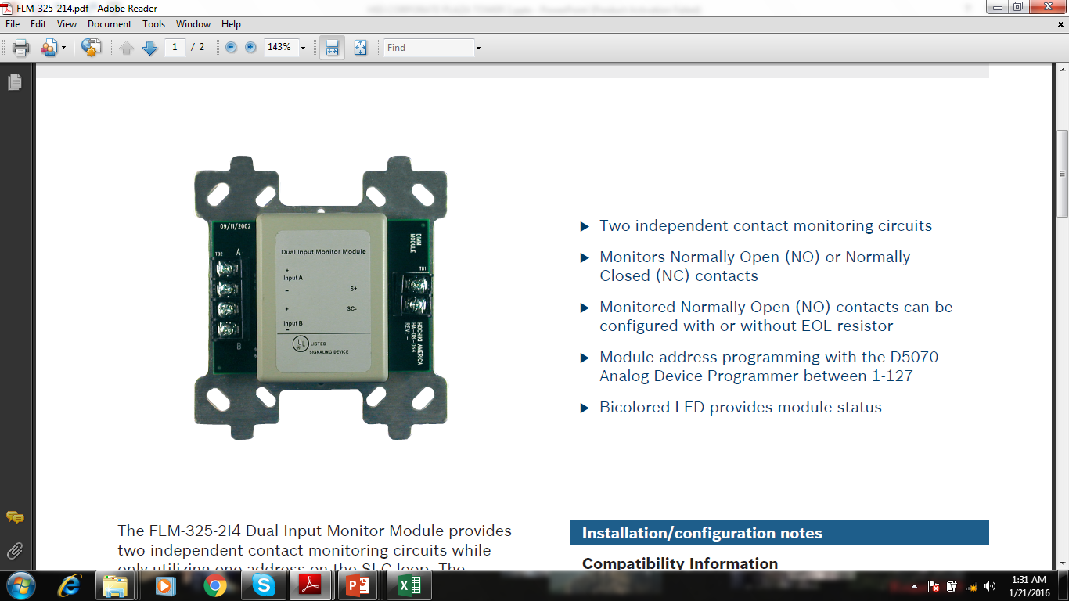

*Addressable Zone Module* *Manual Pull Station* *Flow/Supervisory Switch*

**Images of FDAS Notification Devices for Building Management System**

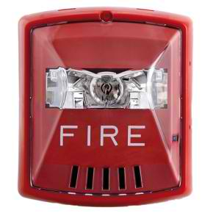 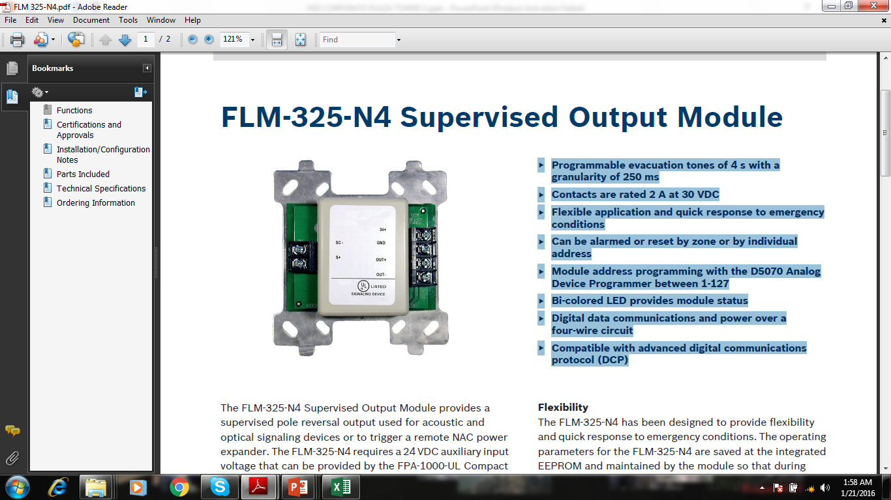

*Horn Strobe* *Addressable Interface Module (NAC)*

 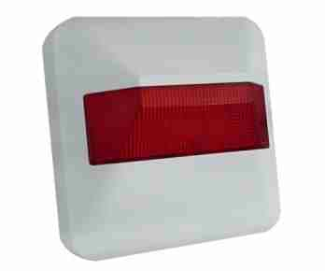

*Addressable Interface Module (Relay Module)* *Indicator Light*

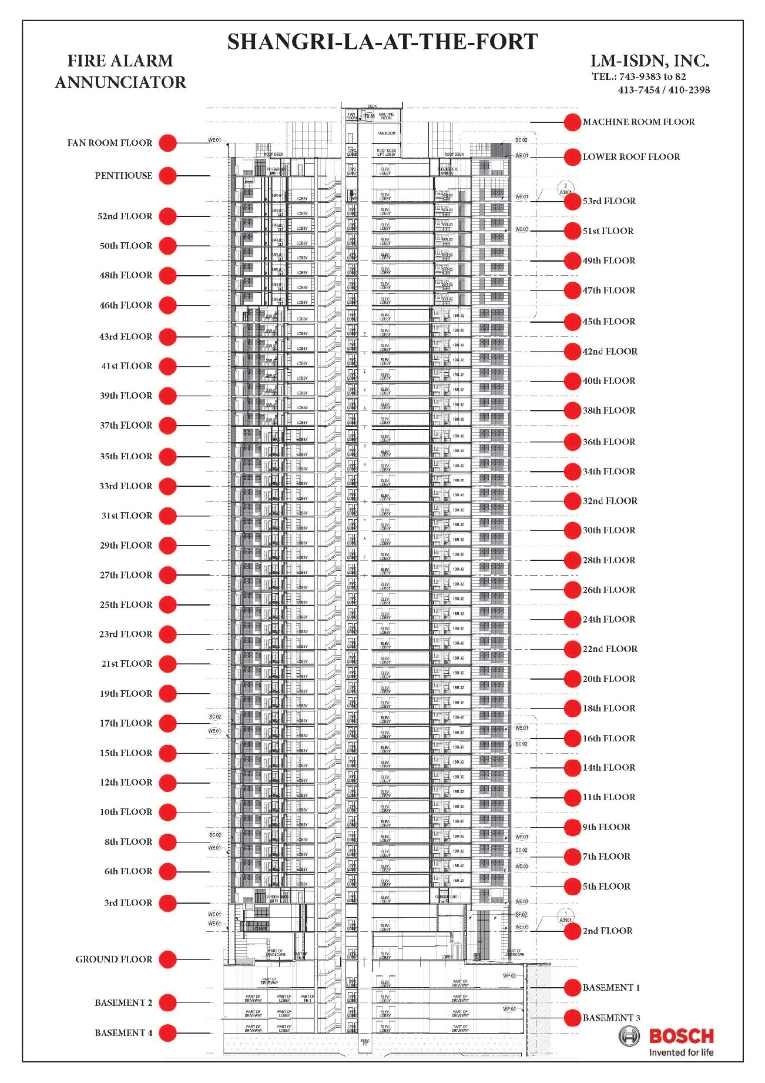

*Annunciator*

**The FDAS Process**

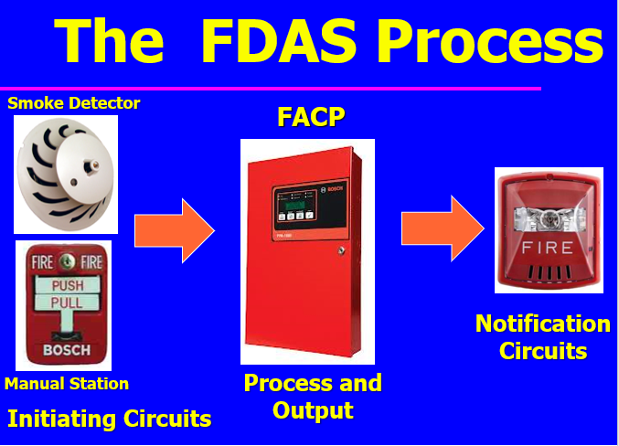

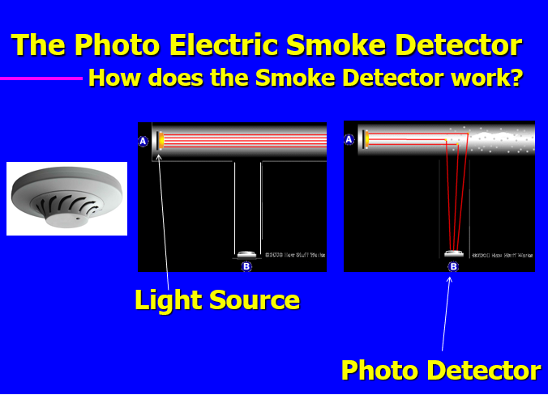

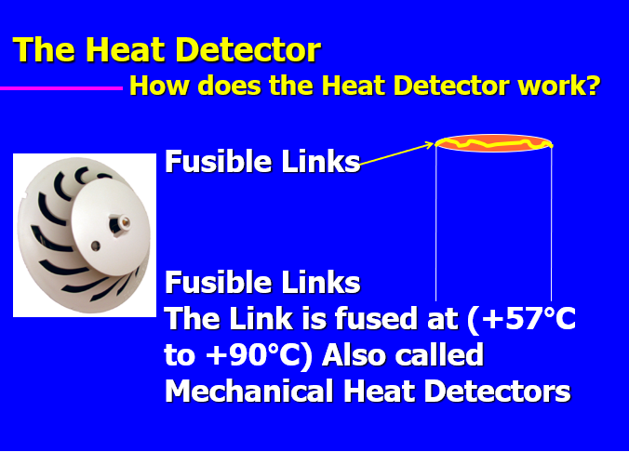

**Types of FDAS**

1. *Conventional System*

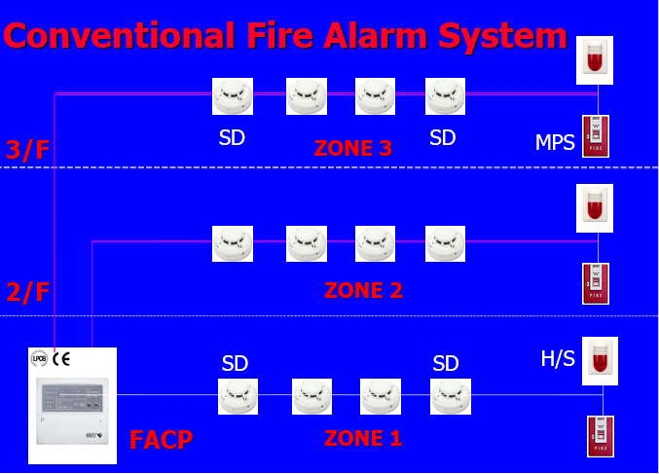

1. *Semi Addressable System*

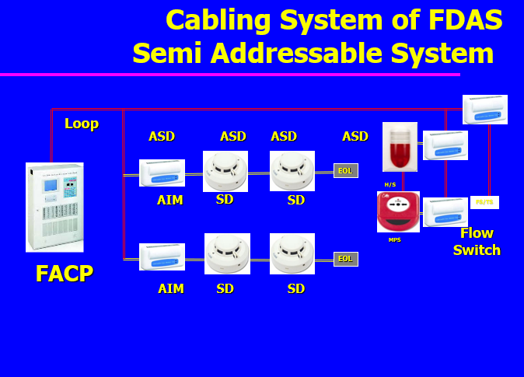

1. *Addressable System*

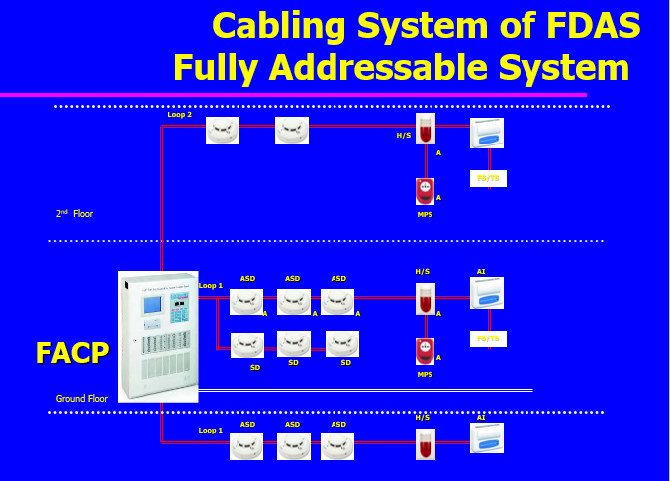

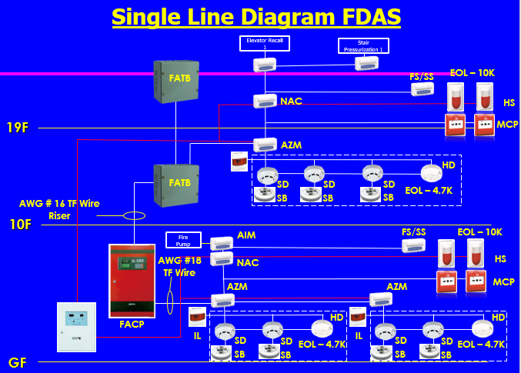

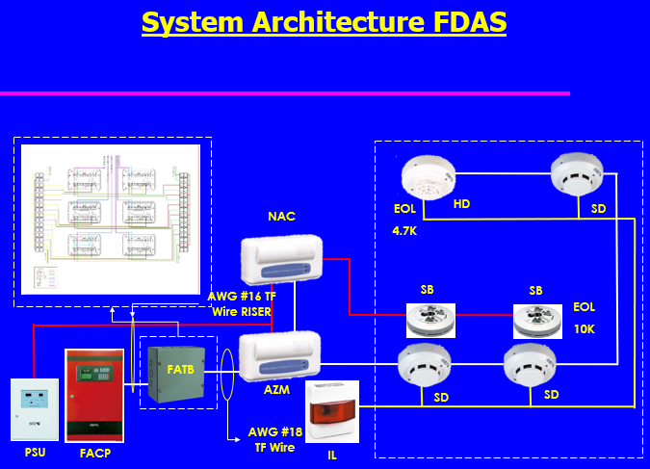

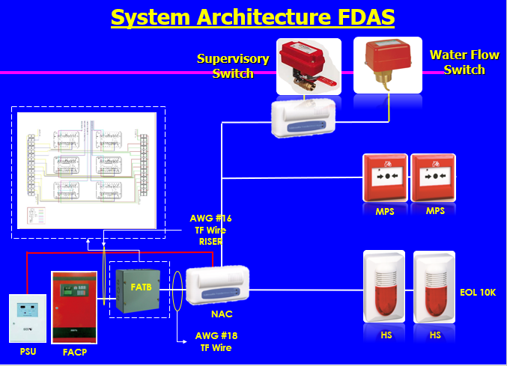

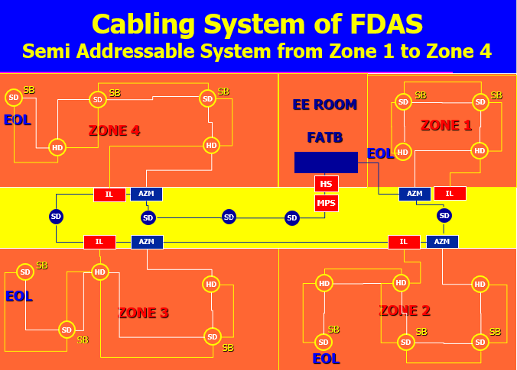

**Fire Alarm System – Supervision of Circuits.**

**Why do we need to supervise the Initiating and Notification Circuits?**

This is Life Safety and we need to make sure that the circuits are working properly when the need arises.

Supervisory Circuits are circuits that will tell the Fire Alarm Control Panel if the Initiating or Notification is shorted, open, or has a dirty detector.

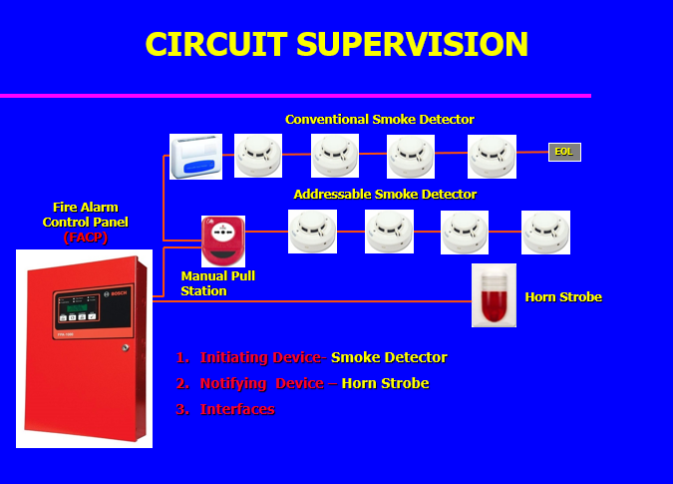

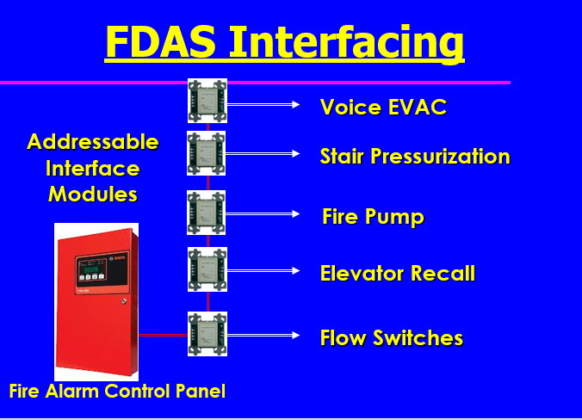

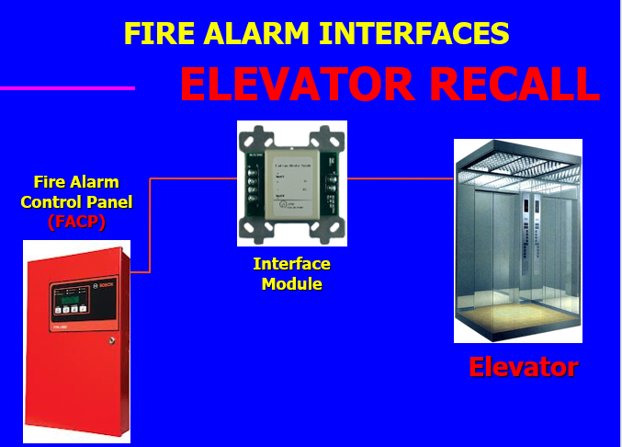

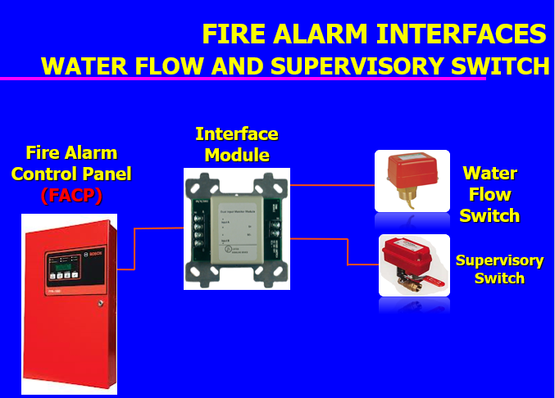

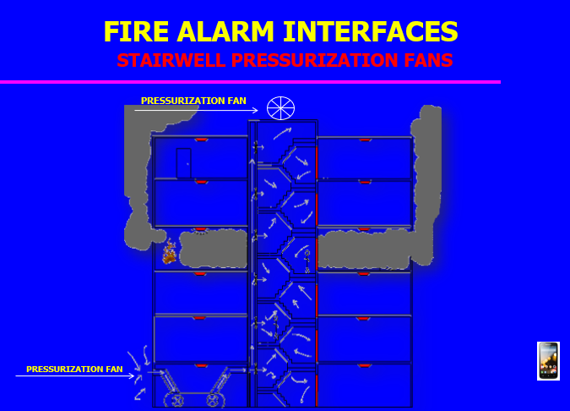

**Types of Notification**

1. General Alarm – the whole building is notified.
2. Programmed Alarm – selected areas only 2 floors up, the floor on fire and 1 floor below.

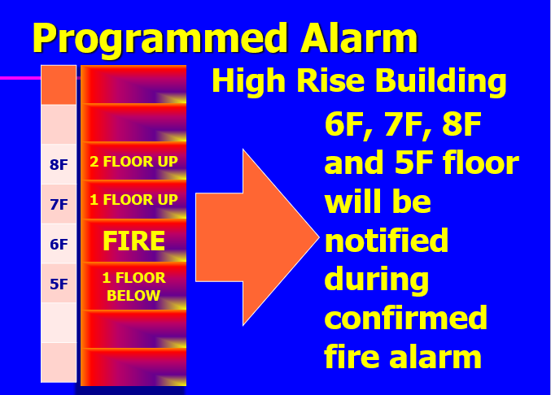

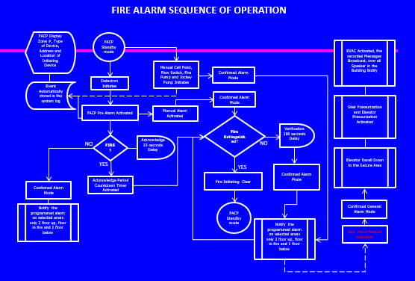 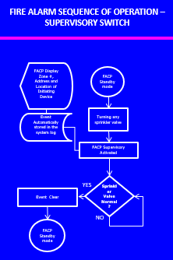

**FDAS Application Software for Building Management System**

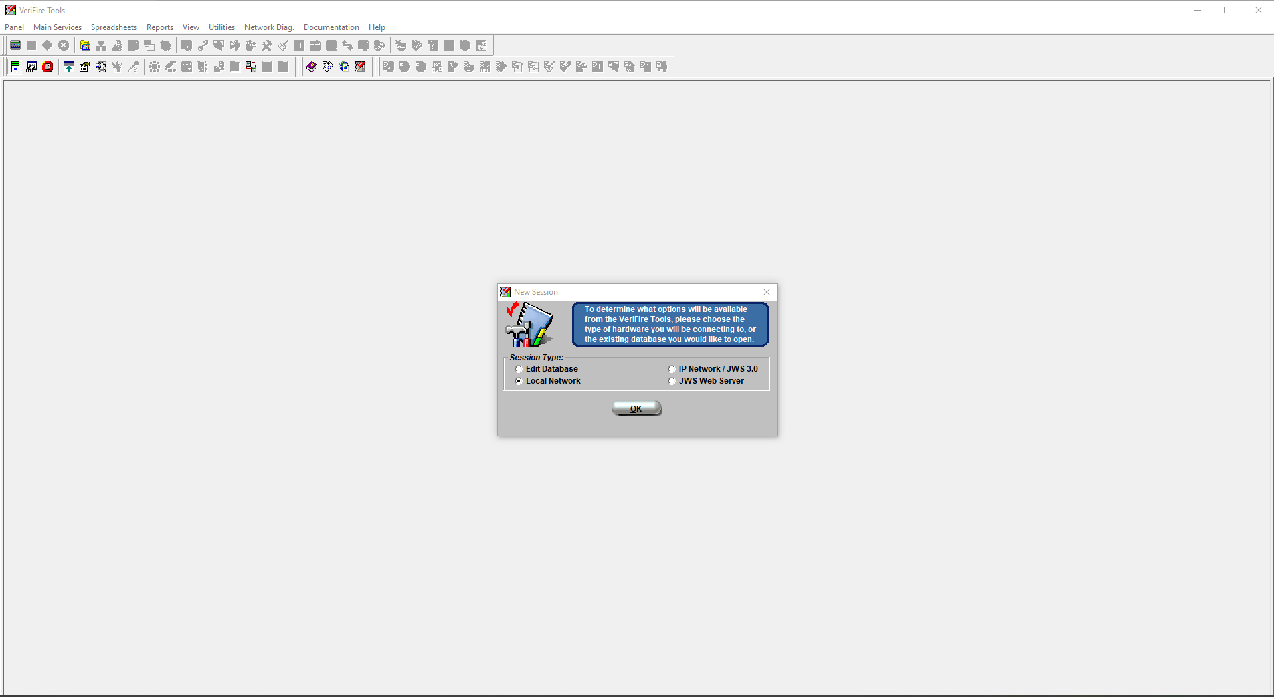

We will now move on to the Application Software used for the FDAS Building Management System. At SHANGRI-LA-AT-THE-FORT they use "VeriFire Tools" application software.

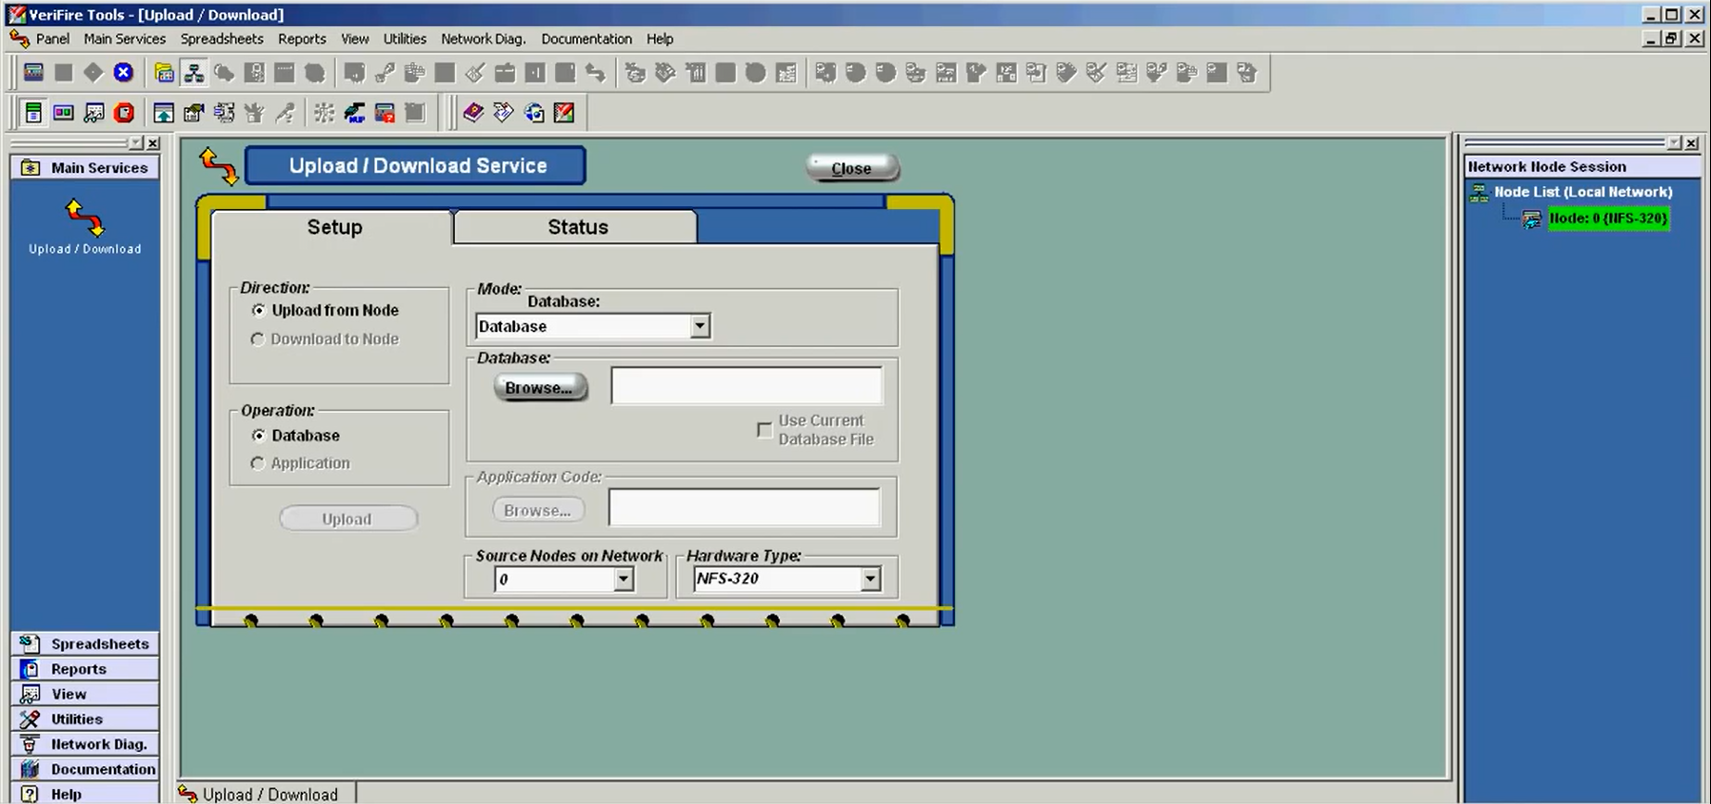

After uploading all the databases to the verifire tools software you need to upload the floor plans from the basement to the 42nd floor and this is how the floor plans will look.

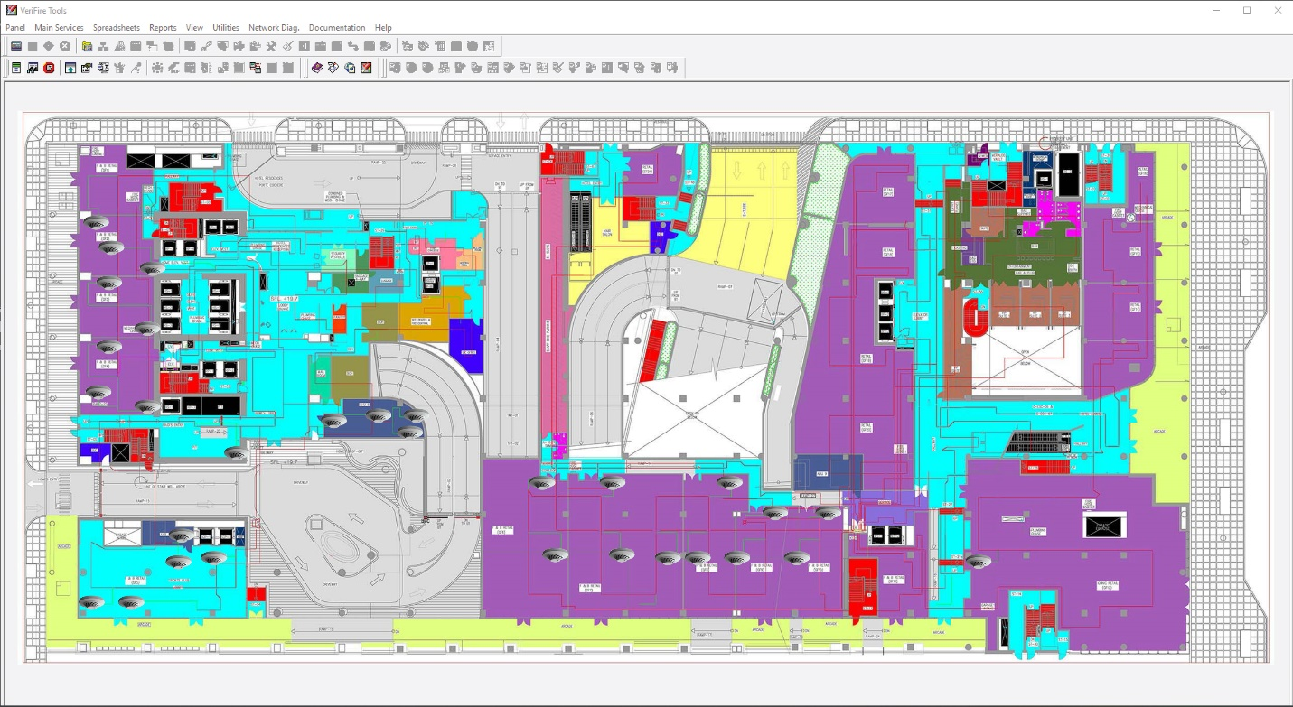

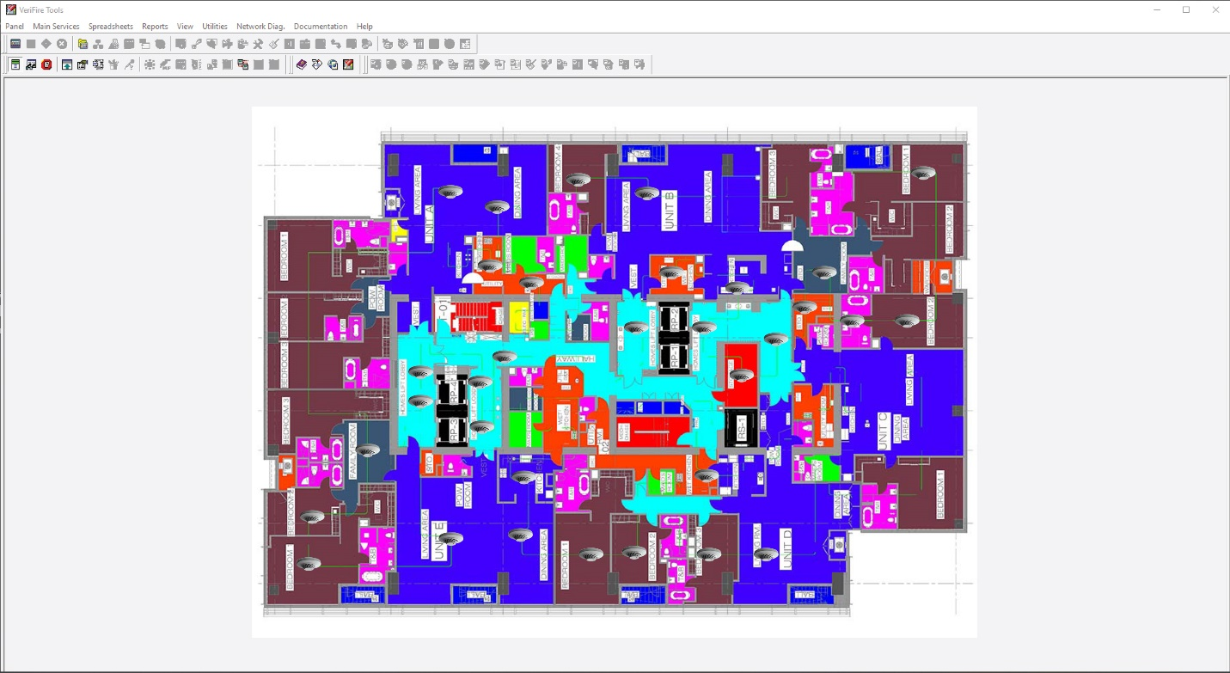

You can immediately see on the monitor screen of the "VeriFire Tools" application software if there is a fire, you will immediately know which floor there is a fire on and which place or room. And this is how important the FDAS Building Management System is.

**Conclusion**

To finish the assignment, the sequence operation to initiate the positive alarm system the signal from an automatic fire detection device selected for positive alarm sequence operation shall be acknowledged at the fire alarm control unit by trained personnel within 15 seconds of annunciation. If the signal is not acknowledged within 15 seconds upon activation of an automatic fire detection device, alarm devices, and remote signals shall be automatically and immediately activated. Fire floor, 2 floors above and a floor below. If the positive alarm sequence operation is initiated by NFPA 7220013 Section 23.8.1.3.1.1(1), trained personnel shall have an alarm investigation phase of up to 180 seconds to evaluate the fire condition and reset the system. If the system is not reset during the alarm investigation phase, notification signals by the building evacuation plan and remote signals shall be automatically and immediately activated. If the second automatic fire detector is selected for positive alarm sequence is actuated during the alarm investigation phase, notification signals by the building evacuation or relocation plan and remote signals shall be automatically and immediately activated, fire floor, 2 floors above, and a floor below. If any other fire alarm initiating device is actuated, notification signals by the building evacuation or relocation plan and remote signals shall be automatically and immediately activated.

Active Alarm Sequence automatic fire detector, manual pull station, or water flow switch selected for active alarm sequence, notification signals by the building evacuation or relocation plan and remote signals shall be automatically and immediately activated fire floor, 2 floors above, and a floor below. To proceed with the general alarm activation, Manual Pull Station shall be activated located at the right side of the FACP.

This should be interfaced with FDAS and automatically activated during a general alarm the voice evacuation messages, elevator horning on the ground floor, stair pressurization fan, elevator pressurization fan, and all alarm devices, and remote signals throughout the building.

Voice Evacuation Messages, emergency communications systems shall be capable of reproduction of pre-recorded, synthesized, or live messages with voice intelligibility by Section 18 of NFPA 2013. If the fire alarm system is in the alarm mode and a recorded voice message is playing or the audible signals are sounding, and then the mass notification system is actuated, it shall case deactivation of all fire alarm–initiated audible and visible notification. Fire alarm signal shall be distinctive, clearly recognize, and except mass notification inputs, take precedence over any other signal even when a non-fire alarm signal is initiated first.

Additional Note:

The supervisory switch shall be activated. Only FACP will notify if the supervisory switch is normally closed.

# **Bibliography**

*Building Management System - IJITEE.* (2019, September). Retrieved from IJITEE Website: https://www.ijitee.org/wp-content/uploads/papers/v8i11/K21610981119.pdf

*Building Management System*. (2018). Retrieved from Science Direct Website: https://www.sciencedirect.com/topics/engineering/building-management-system#:~:text=%20Building%20Management%20System%20%201%20Best%20Management,and%20reports%20on%20smart%20building%20technology...%20More%20

*Building Management Systems Design Standard.* (2018, January). Retrieved from Property MQ Website: http://property.mq.edu.au/__data/assets/pdf_file/0019/364114/MUP-BMS-Services-Design-Guidelines-V2.2-Jan-2018.pdf

*Chalmers - Building Automation Systems Design.* (2012). Retrieved from Publications Library Website: https://publications.lib.chalmers.se/records/fulltext/156136.pdf

*Integrated Data Center Management Architectural Guide.* (2022). Retrieved from Nyte Software Website: https://www.nlyte.com/resource/integrated-data-center-management-architectural-guide/