Arlito P. Cuvin
ID No.: UB74040SAR83205

COURSE NAME:
Bachelor in Architecture

Assignment Title:
Architectural Design and Structure

ATLANTIC INTERNATIONAL UNIVERSITY
March/2022

Introduction
In this assignment, Architectural Design and Structure we study the different kinds of loads. As student architects, we have to learn to bear the load of the major decision-making when it comes to designing. I’ll try to explain the key concepts that will help us do the heavy lifting by deciding which structural systems to go for while designing. Structure refers to a framework of elements that gives form and stability and resist stresses and strains. The easiest way to understand structure is that it’s the part of the building that resists the loads being imposed on it. The loads can be categorized in the following two ways. Number one is “Static Load”, the Static Load is assumed more or less constant. It includes “Dead Load”, or a load of fixed like the load of the structure itself or “Live Load”, load that may not be present all the time, like the weight of the occupants and furniture. Number two is “Dynamic Load”, this type of load can suddenly be asserted, greatly varying in magnitude and location like wind loads, earthquake loads. Let’s get back to the forces that we were talking about the force acting upon the structure. First is Compression or compressive forces that can cause members to get squashed. The second is Tension or tensile forces that can cause members to stretch. The third is Shear force that can make the structure tilt. Fourth is Torsion or torsional forces that can cause the structure to twist. Fifth is Bending forces that cause the bowing of members. In other words, the structure is a combination of interconnections of different elements that work together to resist stresses and strains of the structural system. That is why we use the term structural systems to understand how structural systems work, we need to understand what the elements of a structural system are. Some of them are walls, beams, columns, arches, trusses, cables, slabs, and shells. A combination of these elements and our requirements for the building type determines the type of structure that we generally use for a building. There are several types of structural systems we can choose from based on materials. Each system has its weaknesses and strengths. First is “Wood” joists, decking, trusses, and domes. The second is “Masonary” lintels, arches, posts, and beam. The third is “Steel” rigid frames, space frame, suspension, post and beam. Fourth is “Sitecast Concrete” one-way, two-way slabs, waffles, arches, and domes. Fifth is “Precast” slabs, beams, and single and double tee blocks. Six is “Pneumatic”. And the last is a “Composite” mixture of all materials. Let’s get started studying.

Architectural Design and Structure
Architecture in the Philippines is quite simply, the art of designing buildings since most people spend the majority of their days indoors. We are physically connected with the buildings around us in ways that we rarely are. For other forms of art when designing buildings. Architects need to take into consideration both the function of the building they're creating, as well as how it looks and feels to the people in it. Most buildings, after all, are far more than functional. They are created to be inviting and to give a sense of safety and security to the people who enter them.
One of the oldest building structures is the “Post-and -Lintel”. To our eyes, this looks like a giant doorway. But in older times, this was a simple way of keeping a roof over. People's heads are opposed and lintel is made of two types of pieces. The vertical posts are capped off on top by a horizontal lintel in order to hold up. Wait, the post and lintel depend on the weight of its raw materials. The stress of the weight pushes straight downward, keeping the posts under constant stress.
The “Arch” is often considered to be a superior form of construction to the post and rental, though it takes more planning and finesse to create the arch distributes the weight out and downward, putting less stress onto the material itself as a shape. The “arch” is often stronger than the post-and-lintel and is less dependent on the strength of the material. In a typical Roman rounded “arch” a keystone is placed in the upper center position. This is the most important part of the arch as it holds together the individual stones that fit together to create the arch shape. Though the Roman rounded arch is often the one we think of when we imagine an arch, there's another type of arch called the Corbelled Arch, rather than being completely rounded and using a keystone. The Corbelled Arch is graduated from the signpost to a central location. If an arch gets very big, it may require more support to help it stay strong and upright during the Middle Ages, arches that were many stories high were used to hold up cathedrals. The weight of such arches was so great that they needed buttressing a series of supports to keep them from bending outward. A regular buttress is a series of heavy reinforcements along with the posts of an arch. A flying buttress is a type that uses half arches to press back into the central arch. This form isn't quite as heavy as the regular buttress and lets in more light. When you put a series of arches together, you can make larger structures, many arches are placed back-to-back or create a long hallway-like structure called a tunnel vault or barrel vault, arches that are placed side to side to create something called an arcade. Both of these features can be used to support buildings and allow people to pass through different types of areas. Once you have tunnel walls, you can create a groin vault, a groin vault is an area where tunnel vaults intersect. When you look at the ceiling of a growing vault, you will see a large X on the ceiling with a formed of the two tunnel vaults meet. A ribbed vault is structurally the same as a growing vault, although it has more decoration. When decorative masonry is added to a groin vault, it becomes what we call a ribbed vault.
A “Cantilever” is one of the most exciting architectural structures. A cantilever is a structure that is supported only at one end, as though you had taken one leg away from the post and into a cantilever always seemed a little dangerous and dynamic to our eyes because we know it is fighting against gravity. To be safe and secure, a cantilever must be made so that the weight of the supporting leg is greater and stronger than the weight of what is holding it up. Taking into account the force of gravity that will be working against it.
Bearing Wall construction is a bit different than what is usually meant in the modern world, and someone mentions a bearing on the original use of the term bearing wall is meant to describe a house where the walls are holding up the weight of the roof by themselves. And bearing wall construction, the walls are solid and strong. They are holding up themselves and the rest of the house. This is in contrast to the type of construction we call a skeleton frame.
Skeleton frame construction is a type of building where the walls are supported by an inner structure. When you look at the walls of most homes, you know that they are hollow, filled with wires, pipes, and insulation. The joists and studs within the walls are what is holding up the house, not the surface that you touch when you touch your wall.
And we were talking about learning the Architectural Design and Structural Principles, and we're talking about a kind of basic understanding of how structures react to two loads and forces and how the individual components of those structures help the structure of the building deal with loads upon it. And then we will see how these architectural design and structural principles are incorporated into the structural design of a building. One note that some aspects of this have been simplified other aspects that an architect would consider have been omitted. This isn't the whole picture but it should give you hopefully enough to understand how structures are designed and the processes that need to be understood or the architectural design and structure principles that need to be understood. What do we need to understand in order to understand how buildings are designed as an architect? The first point is that buildings are subjected to two loads and these loads have to be considered when designing the structure not only the whole structure which works as a system but how individual components deal with the loads is important. To understand the role of structure, we need to understand the loads.
Action and reaction you’ve probably heard that every phrase action and reaction or every action has equal and opposite reactions, and this is also true for structures. And for a weight sitting on a bridge, we’ve got here, a load of those bricks will pass through the bridge structure, which will then pass through the ground on both sides. And that’s kind of the first action. The reaction is the support reaction at both ends where it touches the ground, where the ground effectively pushes back up into the building or bridge. And it’s important to think about it from the point of view of keeping a building in equilibrium. If the building is not in equilibrium and those two reactions are incompatible, then the building may sink to the ground or the ground will push up more largely and the building will rise. All reactions must be equal to keep the building stable and on the ground.
Dead Loads, when we talk about loads, we can categorize them in several ways. The first category that we can think of is dead loads. These are loads that are always present within the building. It could be the weight of the roof, the materials on the roof, Timbers to make it up, insulation, it could be floors, internal partitions walls, but it could also be any fixed furniture or things that are always going to be present within the building, but maybe don't form part of the construction.
Live Loads the flip side of these loads is that you can look at live loads and these are things that are not always present in the building and probably aren't fixed to the building. This might be furniture, beds, sofas, people moving around, cats, dogs, heavy dirt on the roof, anything that can reasonably be planned for but isn't always part of the building. An architect, if he was designing a floor, would probably consider the use of the room and would therefore be able to make some assumptions on the occupancy, which would then give him an idea about the live loads which are likely. And he would be designing a structure for the maximum live loads that would happen within the building.
Lateral Loads, the dead loads, and live loads tend to work vertically within the building, and they're passing all their loads down to the foundation. But we also have to contest with storm strong wind and strong wind tends to act in a sideways fashion on buildings. We would refer to this as "Lateral Loads". And we would have to deal or design with design windows, doors, walls, fences, all things which could be subjected to a lateral or sideways load would have to be designed to withstand that.
There are "Other Loads" that can happen to buildings. There are things that we can't possibly plan for, which are impact or explosions. And it is a very difficult thing to design for, but on larger buildings, it would probably consider the potential for impact on smaller domestic scale buildings. The architect has considered impact when dealing with the construction of garages. Many people have driven through the back of their garage at some point or hit the post that supports the door, and you wouldn't want the building to collapse through a small impact. The architect would consider that as part of the design.

Racking, when we have a load placed onto a building, we have to consider what the effect of that might be. And if we took a simple frame structure and we placed a load on top of it, or we replicate a dead load or a live load, or we pushed it from the side to replicate a lateral load, the likely way that this would deform would be to kind of shift sideways. We would refer to this as racking.
If we think about racking as the tendency for a frame structural to deform under those loads, the deformation would be to make something that is square or rectangular into a parallelogram so it's pushing it out of shape, it's deforming it. And what tends to happen if this is unbraced? The connections, the age of the corners, and the connection into the ground. The members would rotate relative to each other so they'd no longer be at 90 degrees. Some of this would form two angles, and some of this would form acute angles through a rotation of that joint. How do we stop that?
We need to find some way of stiffening the frame. One method which is often used is to infill a frame with a solid wall. The frame itself is the structural element, but the solid wall acts to resist the members moving, so it prevents racking.
We could also act in a much lighter way and use diagonal bracing, which would run from corner to corner. And that means that when you push the frame or tried to format the elements running from one corner to the other would act in tension where they were going to get longer and those diagonal lines would get longer. We'd be looking for something to resist that action of kind of pulling those corners apart.
And another common method is to try and resist the rotational aspects of those corners by providing a very rigid connection or a rigid joint. If in a steel frame, this might be a welded bracket, or it could be a heavily bolted makeup with a faceplate onto it. If this is a timber frame, it could be small corner brackets, slightly more difficult to make a rigid timber frame. But this would work, and that would give you a nice open space without the need for bracing. You might use a situation or you might use rigid joints in a situation where you need large windows or large openings.
Tension it's a force that acts to pull elements apart we're trying to kind of lengthen elements. Imagine that we've got a stationary hook and a cable which then connects down to a weight and the force acting on that cable is acting to try and make the cable longer. If the cable is strong enough then it will not deform, it will stay the same shape and it won't snap. However, if the cable or other structural element isn't a very strong intention and then it can fail either by stretching or by snapping. And as you go through, you'll discover that there are some materials which are very good intention and some materials which are not so good intention. And we tend to use steel cables for most aspects of buildings which need to work intention.
The opposite of tension is “Compression”. This is when a load placed on a particular element will act to shorten it, so the weight of the bricks sitting on the column here or the wall will push it down so the material becomes compressed. And likewise, if we don't design the column or the wall in the correct way, we can cause deformation. If the wall or column is too slender, it would probably deform under the weight or the load in such a way that would cause it to bend outwards and buckle and eventually snap and fail.
Bending, we can think about a simple beam when we try and kind of understand how things bend and the forces that are acting upon that. If we think about a simple beam and we drop a hold of bricks onto it the building that the beam is going to be under load, the two triangles at either end are just a representation of support. So, what happens to that beam when we put weight on it, as you can see it would bend so under load, the beam bends? The top part of the beam would effectively get shorter and the bottom part would get longer. If you think about the corner on a running track, the inside track, that bit nearest the inside of the field is a shorter distance than the outside off the track. And it's not just different from this what happens to a beam under load. The top of the beam is kind of getting squeezed in and it becomes slightly shorter the bottom of the beam because it's getting longer gets pulled apart. The bending of a beam like this is a combination of compression and tension and there is a point in the middle of the beam which doesn't change the length we would refer to that line as the neutral axis.
Types of Loads we also have to think about how the loads are distributed on a beam or within a structural system. If we have a primary beam resting between the two triangular things and we put other beams to sit on top of them. The loads carried by those other beams would hit that main beam at a point. So, we'd refer to those as point loads. If we were, however, to rest a concrete slab on the beam, the weight or a load of that concrete slab would be evenly distributed across the beams would refer to that as a uniformly distributed load or a U. D. L.
So we'll be looking at “Superstructure”, “Substructure” foundations. We'll be looking at how loads are transferred in a path down to the foundations, we will learn about walls and frames and study some of the problems associated with frame structures and some of the solutions to those problems.
When we're talking about buildings, it's sometimes convenient to describe them in terms of collections of components that become systems. So, one of the ways that we study and learn about buildings, especially domestic buildings is superstructure and substructure. The superstructure can be thought of in a very simplistic way, as the upper part of the building and substructure can be thought of as the lower part of the building.
So to give us a dividing line between the two, we usually consider substructures to be those components that are in contact with the ground or next to the ground. So these would be the foundations, strict foundations for a domestic building. The substructure walls sit directly onto the district foundations, any other basement walls or supporting walls, mid-span, and the ground floor or the basement floor. Any oversight concrete that's used in the construction. But our dividing line becomes a little bit arbitrary. We start to discuss it in terms of everything below the DPC. So the definition that I would use is substructure is everything below the lowest DPC that includes components that are in contact with the ground.
What is the DPC? DPC is a "Damp Proof Course", which is a plastic material, semi-rigid, which is rolled out on top of substructure walls. And it prevents any moisture from below from the saturated walls from rising up through capillary action. And reaching the timbers. Any timbers which are exposed to moisture have the potential to rot. So the DPC is a method of protecting the timber frame above.
So, if the “substructure” is everything below the DPC, it stands to reason that the superstructure is everything above the DPC. In “Superstructure” we can think of it as everything above the DPC which could include main house walls, the roof structure, intermediate floors, or indeed anything above that line.
The aspect is causing the load, that could be furniture or beams or other structure down to the ground and to then provide or then come up against the support reaction. And within a building, we have to think about this as a path. So, the load that's applied to the roof from its dead load, which is the rafters or any other construction that's built-in permanently into the building. And any live loads such as heavy dirt and wind have to find a continuous path down through the structure below, passing through structural elements down through the substructure to the foundations. And the foundations are the method by which the loads are transferred to the ground. And when those loads are transferred to the ground, the idea of every reaction has an equal and opposite reaction comes into play. If the loads from the building are transferred down to the foundation meet, the support reaction loads from the ground. So the grounds effectively pushing up and those two loads are equal to forces are equal, then the building stays where it is. So if you imagine two people of equal power with her hands touching each other, pressing against each other, pushing against each other. And if they're both pushing with the same force, then no one will win there. They will both be pushing and will remain static. And that equilibrium is the same principle. When the loads are transferred down to the foundations.
To give a wider surface area for those loads to be spread to the ground, we install a foundation so the purpose of our foundation is to transfer the load of the building to the ground evenly. And normally in domestic construction we would put or build a strip foundation which is a trench, a wide trench dug into the ground that would then be filled with concrete and the substructure wall would be built on top of that. The loads coming down through the substructure wall onto the foundation are then able to spread out diagonally and vertically over a larger surface area, which is then supported by the support reaction from the ground.

Problems and how to solve them in Architectural Design and Structure
So with this in mind, we need to understand, some problems and look at some of the solutions that are available for older buildings. It tends to be made of “solid walls”, it appears quite solid, that is in you know, and the walls are not large areas of glass. And traditionally buildings would have had a relatively small window, two large areas of wall and this is partly to do with the expense of creating windows, partly to do with the protection from the elements, but also to allow or to provide the advantage of being able to transfer loads down through the building and for those solid walls to act as sort of racking prevention.
Within a “frame structure” which could be a post and beam structure. It could be a small member platform frame structure or a balloon frame structure. It does not enjoy the same or it doesn't enjoy the same structural benefits as solid walls. Frames under a load, horizontal loader, and vertical load are susceptible to racking. So, to prevent that wrecking, we have to design other means of prevention.
“Racking” is the tendency for a frame to deform under a load. So if we don't provide a frame with adequate prevention or protection, the building will deform best case if the deformation is a very small amount, it will cause cracking. Worst case the building could collapse.
So how do we prevent racking within a frame structure? We could infill the gaps between the frame members with a solid wall, the timber frames where we had half-timbered houses with brick infill. This is effectively what we would do here and if we did put a solid wall within the frame, then that would effectively act as stiff in it would be very difficult to form a solid surface. This is partly how traditional walls gable walls work, they help to stiffen the building along its shortage to prevent racking now because we've got one solid wall on this diagram the image that I prepare for this assignment, in the short direction, the left to the right direction, that would protect it from loads coming horizontally from either the left or the right, but going front to back on this diagram, we would need another solid wall to prevent or to protect the building from wind from different directions or load from different directions.
For timber frames, platform frames, the normal method to prevent racking is to install a rigid timber board or plywood over the face of the timbers and they would be nailed to the structural members. The stunts would help prevent racking. So, we refer to this boarding as “Sheathing”.
A third alternative is to provide metal rods that connect from one corner to the next in a kind of diagonal pattern forming across within an open frame and this act is intended to prevent the corners from moving away from each other. You'll see that when racking occurs, the deformation of the frame from a square to a parallelogram, results in two of the corners moving further apart from each other and to the corners moving closer together. Now, if you have a frame, if you're bracing going across in each direction, then when the frame is deforming and causing two corners to move further apart, the tension in the wire or the ability of the rod to resist the tensile forces is enough to keep those two corners in place. And because we can expect storm strong wind coming from different directions, we would need crossing wires that would go in the other direction, just in case the storm strong wind came from that direction. We would need to provide protection from the left and right on this diagram and the front and back, and we would refer to any crossing wires like that as “bracing”.
On a kind of larger-scale building project, one of the problems that we might run into if a building isn't sufficiently anchored to substructure would be overturning. If there was a substantial sideways load, we could find that this superstructure can separate from the substructure, pivot around one of the corners, and overturn.
To prevent this, we have to anchor the superstructure to the substructure. And the normal method within a timber frame is to use stainless steel straps which are fixed to the timber frame and fixed to the substructure and act to hold down the superstructure and these are imaginatively called holding down straps so they do exactly, and then holding down straps, we can see there would be installed crossing the gap between the timber frame over the space where the DPC is and will be fixed down to the substructure.
Another problem that we might encounter with a significant horizontal load is where the building can actually slide off the top of its substructure. So the entire superstructure, the main house walls roof will move relative to its base. And this can happen if we don't anchor the building down to the substructure
And one of the normal ways to do this is to use frame anchors. So a frame anchor would go through the soleplate, which is the bottom part of the timber frame and it's an expanding role plug. So there's a plastic sleeve and these can be a hammer in fixings, you possibly might have seen these for fixing into masonry. So, the installers would drill down through the timber through the DPC into the top of the brick. Worker block work hammer in these fixings and then turn them to be able to tighten the sleeve and they work by friction within the brickwork. So, they act to hold those down and they would be installed at regular centers all the way around the perimeter of the building they help hold the building down and they work in tandem with the holding down straps to resist sliding and overturning.
There are two potential problems if the building is not in equilibrium. So if the loads in the building are greater than the support reaction at the foundations, this can result in the building sinking into the ground. So this could be if the bearing capacity of the ground is not substantial if the soil or ground itself was not capable of carrying a sufficient load, or the foundations weren't designed to spread the load sufficiently, the building sinks into the ground and this normally happens quite slowly over a period of time. And where it happens slowly and consistently over a period of time, we'd refer to that as “subsidence”. So you've possibly heard of building subsiding. It can happen even more often, not one side of the building will sink to a greater degree than another building and it will start to tilt and this can cause significant problems and it's actually quite difficult to fix.
The opposite of that is where the ground expands, pushes upwards, and lifts the building along with it and again, much like subsidence. This can cause significant problems with the building it can happen unevenly. So, you can get one side of the building heaving more than the other, and again it's a problem that could have been designed out by properly thinking about what's going to happen to the ground or removing the clay within the ground which is susceptible to expansion and contraction through moisture content.

Images of Architectural Design and Structure
Post-and-Lintel
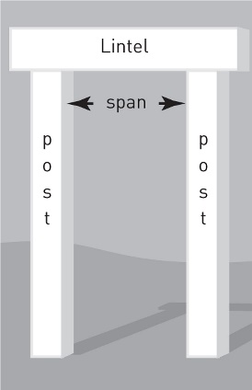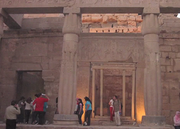
The columns supporting a horizontal beam

A horizontal “lintel” is supported by “posts”

Arch
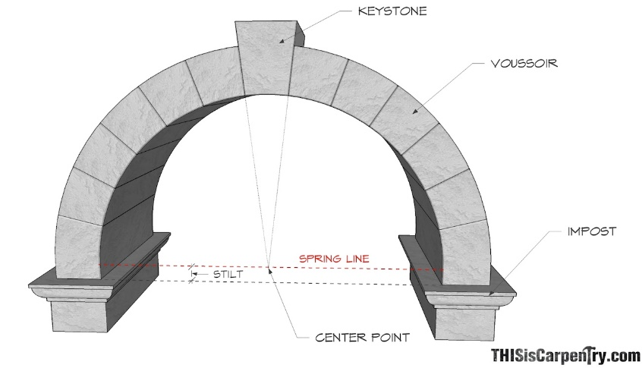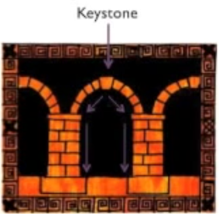
Stress transfer outward from the keystone to its legs
These arrows indicate how the weight is distributed in an arch

Types of Arches

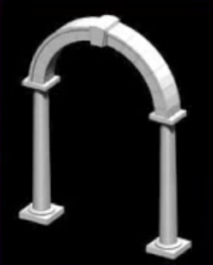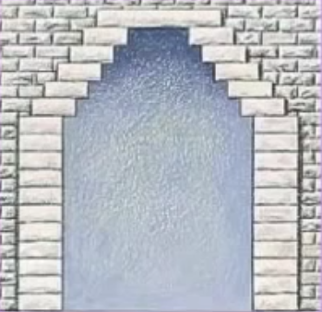
Roman Arch
Corbelled Arch

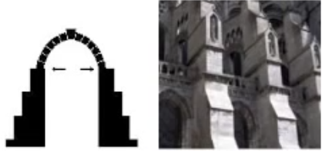
Buttress
Buttress keeps the legs of an arch from bowing outward

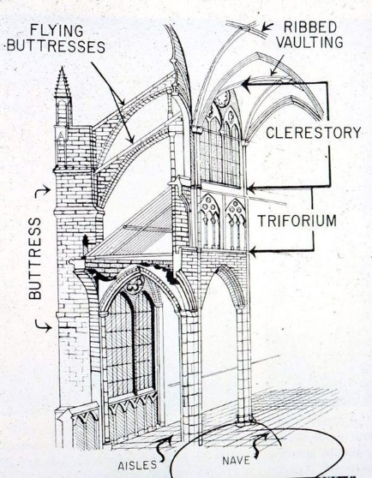
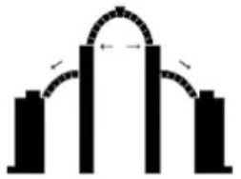
Flying Buttress keeps the legs of an arch from bowing and isn’t solid
Flying Buttress

What can you make with an arch?
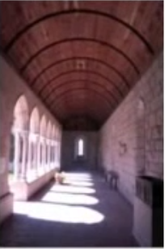
Several arches placed back-to-back
Tunnel Vault

Several arches placed side by side
Arcade

What else can you make with an arch?
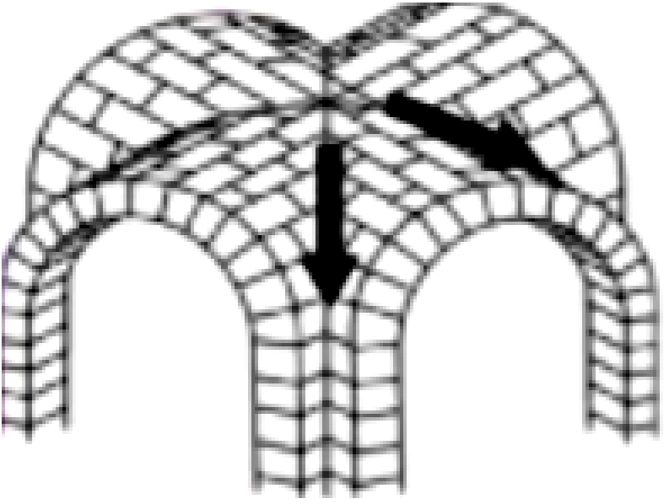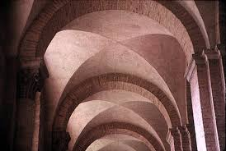
Groin Vault – when two tunnel vaults intersect at a ninety-degree angle.


Ribbed Vault – protruding masonry along the joining lines.

Cantilever
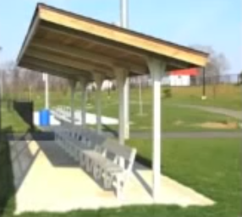
An overhanging beam or floor supported at only one end

Bearing Wall
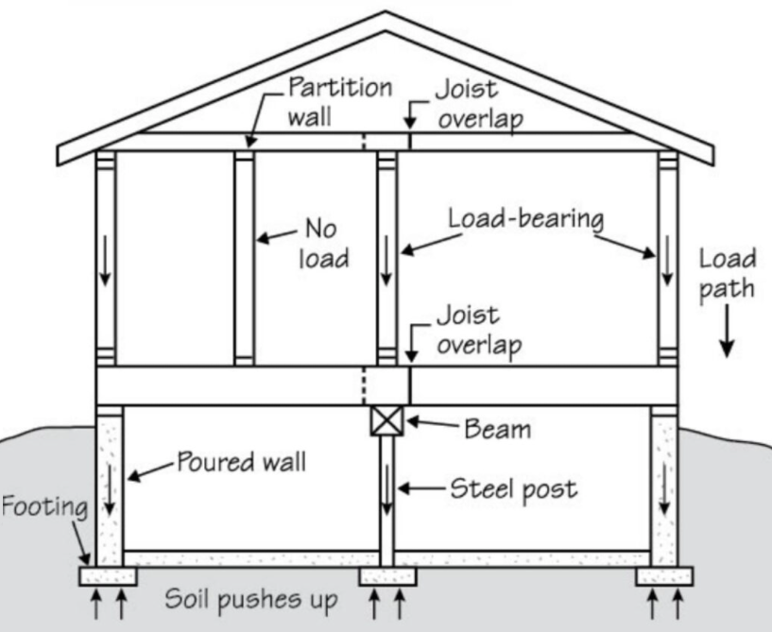
A system of construction in which the wall supports itself, along with the roof and floors.

Skeleton Frame
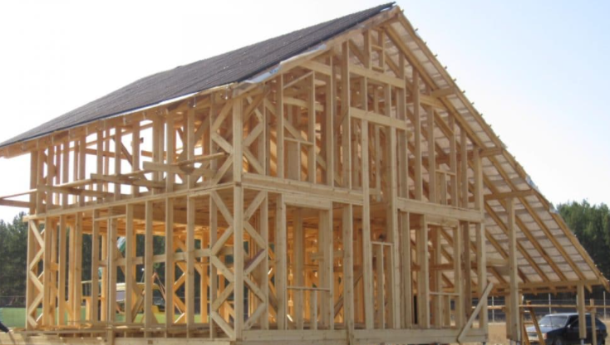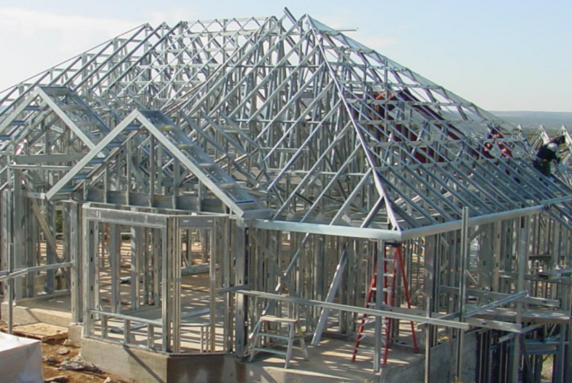
When a building is supported by a framework. Usually, the walls you see are the “skin” of the skeleton frame

Action and Reaction
The first thing we need to keep in mind is that for a structure to be stable, the forces acting upon it must be met with an equal force in the opposite direction, the support reaction.

Dead loads are loads that are always present in the building. This can include the loads from the building materials, fixed furniture, and anything else which is normally in place within the building.
Dead Loads

Live loads are loads that are not always present in the building and may increase or decrease. It might be people occupying space or heavy dirt on a roof.
Live Loads

Lateral loads are a type of live load that acts on the building sideways. The most common lateral load we have to deal with is storm strong wind. In other parts of the world, they may also have to deal with earthquakes.
Lateral Loads
Other Loads
There are other possible loads to which a building might be subjected, although these would be very difficult to predict. Earthquakes, fires, explosions, and impacts are difficult to plan for!

Racking
A solid infill wall can act to stiffen the frame and prevent racking.
To resist racking we can use a number of methods to ‘stiffen’ the frame.
Racking is the tendency for framed structures to deform under lateral and vertical loads. This deformation can be thought of as transforming a square into a parallelogram.
Under load from above or from the side, a frame that is unbraced will have a tendency to deform.

To resist racking we can use a number of methods to ‘stiffen’ the frame.
The joints of the frame can be made rigid to resist deforming under the load.
Diagonal bracing can be installed to act in tension to resist frame distortion.

Tension
If the cables or other structural elements under tension are not sufficiently strong, they can fail either by stretching or by snapping.
Tension is a force that acts to pull elements, pulling them tight or lengthening them. Cables suspending items from above or ropes supporting tents are examples of elements under tension.

Buckling
Compression

If the column or wall is too slender it can fail by deforming in a sideways direction. This is known as ‘Buckling’.
Loads that act to shorten an element are said to act in compression, the material is becoming compressed. Columns and walls which take a load from above a vertical load are usually subject to compression.

Bending
If we consider a simply supported beam with a load placed upon it.
The line in the center of the beam does not change in length and therefore is not subjected to tension or compression.
This line is called the neutral axis
Under load, the beam ‘bends’. The top part of the beam gets shorter while the bottom part gets longer.
Shorter = Compression
Longer = Tension

Types of loads

Superstructure & Substructure
When describing building we often separate the building into upper and lower parts.

Substructure
The substructure is the parts of the building which connect to the ground. This would include the foundations and any walls built up to just above floor level. We would normally use the DPC as the dividing line.
So, substructure can be thought of as everything below the lowest DPC.

DPC
A DPC is a “damp proof course” which is laid onto the substructure walls before the timber frame is built on top. It stops moisture from below rising into the frame

Superstructure
If the substructure is the parts of the structure below the lowest DPC then it stands to reason that the superstructure is those parts which are above the DPC!
So, superstructure can be thought of as everything above the substructure DPC

Load paths
It is important to consider how these loads are transferred through the structure and where they end up! Loads are carried down through the structure from one element to another until the foundations.

Foundations
The purpose of the foundation is to transfer the load of the building to the ground evenly. The foundations of domestic buildings are often wider than the wall above to provide a large surface area to spread the load

Solid Walls
Older domestic buildings have exterior walls which are for the most part solid, they aren’t made of glass. Traditionally, houses would have had relatively small window openings due to the elements. Solid walls had the advantage of helping deal with the loads that buildings are put under.
Frame Structures
Frame structures such as timber posts and beam or platform framing do not enjoy the structural benefits of solid walls. Frame structures are susceptible to racking. The functions that solid walls provide have to be designed in by other means.
Racking
Racking is the tendency for frames to deform under a horizontal or vertical load.
Racking Prevention
Racking can be dealt with by using solid walls. Usually, you would install solid walls in each direction to resist storm strong wind from different directions. In a traditional building, the gables serve to ‘stiffen’ the building, and these would work with the floors and internal walls to prevent racking.
For timber frames and platform frames the normal method to prevent racking is to install a timber board over the wall and nail it to each stud. This would be done for each wall to account for loads from different directions. This is referred to as ‘Sheathing’.
An Alternate to solid walls and sheathing is to install crossing metal rods that are attached to the corners of the frame. When the load is applied to the frame, the rods would act in tension to restrict the frame from deforming. This would need to be done in at least one location on each wall to account for loads from different directions. This is referred to as ‘Bracing’.
Overturning
If a building isn’t sufficiently anchored to its substructure, a sideways load the strong storm wind could also cause the superstructure to separate from the substructure and overturn.

Overturning Prevention
To anchor the superstructure to the substructure it is common for stainless steel straps to be installed between the two parts of the structure. These straps act to hold the superstructure to its base. These are imaginatively called ‘Holding down straps’.

Holding Down Straps
Holding down straps connect the timber frame superstructure to the foundation wall substructure.
Sliding
If there is complete delamination between the substructure and the superstructure, under a sideways load it is also possible that the entire superstructure can slide or shift out of position.
Frame Anchors
Frame anchors are usually bolts with an expanding sleeve which are drilled down through the timber frame into the substructure walls.
Subsidence
If loads of the building are greater than the support reaction at the foundations this can result in the building sinking into the ground. This is unlikely to be immediate but can cause long-term problems as the building slowly sinks. This is called ‘Subsidence’.

Heave
If loads of the building are less than the support reaction at the foundations this can result in the building being pushed upwards. This is usually related to an increase in moisture content of the soil causing it to expand. This is called ‘Heave’.

Conclusion
To conclude in this assignment, the architectural design and structural concept should remain very clear. The elements can be different, the materiality can be different depending upon the type of building that you are making. In simple terms, a structural system has to transfer the load of the building through its interconnected elements into the ground. The knowledge of the principles of architectural design and structure and even at a very basic level can help you understand the types of loads within a building, how those loads might affect beams and columns, and how you can design out the potential failure of those elements, how the structural frame or those elements might deform, and the reason why you might need to brace a structure or have rigid joints to stop frames deforming. We can do well architectural design and structured buildings, but to do so, we need to think about the aspects of how loads are transferred to the ground through the load path, making sure that the load path is continuous from each structural member to the next and that no structural members are left Unconnected to one below. We can understand the bearing capacity of the soil and the type of soil so that we can avoid subsidence and heave and in connection with that we can design the foundations appropriately to be able to spread loads of the building to the ground concerning the frame. We need to think about how we're going to prevent wrecking with a timber frame, platform frame. This is most likely to be done by installing sheathing, which is timber board or plywood. And we need to think about how the superstructure is anchored down to the substructure to prevent overturning or sliding. And that's using frame anchors or holding down straps. So that's the end of the assignment in Architectural Design and Structure.

Bibliography

Architectural Structures. (1990-2006). Retrieved from Archive Website: https://archive.org/details/Architectural_Structures
Architectural Structures by: Place, Wayne. (2007, March). Retrieved from Wiley Website: https://www.wiley.com/en-us/Architectural+Structures-p-9780471725510
Design of Wood Structures- ASD/LRFD, Eighth Edition by: Breyer, Donald; Cobeen, Kelly. (2019, September 30). Retrieved from Book Depository Website: https://www.bookdepository.com/Design-Wood-Structures-ASD-LRFD-Eighth-Edition-Donald-Breyer/9781260128673?ref=pd_detail_2_sims_cat_bs_1
Fundamental Structural Analysis by: Spencer, W J. (1988, November 24). Retrieved from Book Depository Website: https://www.bookdepository.com/Fundamental-Structural-Analysis-W-J-Spencer/9780333434680
Structural Design for Architecture. (1997, November 19). Retrieved from Semantic Scholar Website: https://www.semanticscholar.org/paper/Structural-Design-for-Architecture-Macdonald/7e555dbf2e8958d538d245fc7d423922b1acd24d
Structural Design for Architecture by MacDonald, Angus J. (1997, November 19). Retrieved from Goodreads Website: https://www.goodreads.com/book/show/4033340-structural-design-for-architecture
Structural Load Determination: 2018 and 2021 IBC and ASCE/SEI 7-16 by: Fanella, David. (2019, January 23). Retrieved from Book Depository Website: https://www.bookdepository.com/Structural-Load-Determination-2018-2021-IBC-ASCE-SEI-7-16-David-Fanella/9781260135626?ref=pd_detail_1_sims_b_p2p_1
Structures: Or Why Things Don't Fall Down by Gordon, J. (2003, July 10). Retrieved from Book Depository Website: https://www.bookdepository.com/Structures-J-Gordon/9780306812835?ref=pd_detail_2_sims_cat_bs_1
Wind and Earthquake Resistant Buildings by: Bungale S. Taranath Ph.D., S.E. (2019, October 18). Retrieved from Routledge Website: https://www.routledge.com/Wind-and-Earthquake-Resistant-Buildings-Structural-Analysis-and-Design/Taranath/p/book/9780367393496

