**Arlito P. Cuvin**

**ID No.: UB74040SAR83205**

COURSE NAME:

**Bachelor in Architecture**

Assignment Title:

**Engineering Economic Analysis**

ATLANTIC INTERNATIONAL UNIVERSITY

**April/2022**

**Introduction**

In this assignment, we will begin to study the “Engineering Economic Analysis” the content of this are really centers around a concept referred to as the time value of money and the time value of money really has to do with payments and interest rates and time periods, and how the value of money changes. As time passes. You really need to wrap your head around this concept of the time value of money. It's very common for architect students, in business, to learn the time value of money usually, in an introductory finance course. But for us as *architect students*, we're really learning the time value of money concepts for another reason. And we're learning that for decision-making and for decision-making, as it relates to something, we call engineering economics. How this assignment relates to the more technical part of architecture really occurs in two ways. The first way is the approach that we use to solve problems that are really of a financial nature. But we take a somewhat of an architectural engineering approach to these. And by that I mean, we look at the real world as heard of a complicated thing. We construct a simplified model of the world that is a model in engineering economics. Usually takes the form of something. We call a cash flow diagram, which we will learn today how to construct to study and learn in this assignment, but much like we do in architecture, we can have a very complicated situation with a complicated structure. We create a simplified model that we can then write equations. We can do some calculations and take the conclusions that we make as a result of those calculations back into the complicated real world. In engineering economics, the assumptions in the simplifications that we make are all generally financial. Some of them are business-related. Some of them are related to guessing and value for interest rates, things like that. And Architecture, the things that we might guess might be the material properties of a particular metal or if we don't have any actual test that gives us the exact number. So some of our assumptions in the use of a model to represent. The real world is very similar to the way we approach problems in the technical parts of architectural engineering. The other way that really engineering economics is connected to the technical part of architectural engineering, is in the application of the results. And the conclusions we draw from the calculations in the model. So a lot of what we can calculate in engineering economics, relates to should we invest in a particular construction project. Should we buy or lease a certain type of equipment for our architectural engineering purposes? Should a company replace a large piece of equipment with a new piece of equipment? These are all situations where the conclusions have a very strong effect on the practice of architecture in engineering. Also, when we do the calculations in engineering economics, using the skills that we learn related to the time value of money. We don't only use that information to make decisions. So not really relates to the management portion of architecture practice. So there may be other factors such as human factors. Environmental factors that play into the actual decision that we make and the ensuing economic analysis, really just become one piece of all of the piece of pieces of information that we use to make a final decision in architecture. The last point I'd like to make just as a, as a way of introduction is that many of the skills that will learn in this assignment. I find them are really more valuable to us as a student in our personal life than they will be in our architecture careers. So, it may be many years before you are doing financial analysis in the workplace, as a practicing architect, but everyone has loans and mortgages. Everyone tries to buy Investments and the tools that we learned in this assignment, really are quite valuable for that part of our life. So anyway, let’s get started studying.

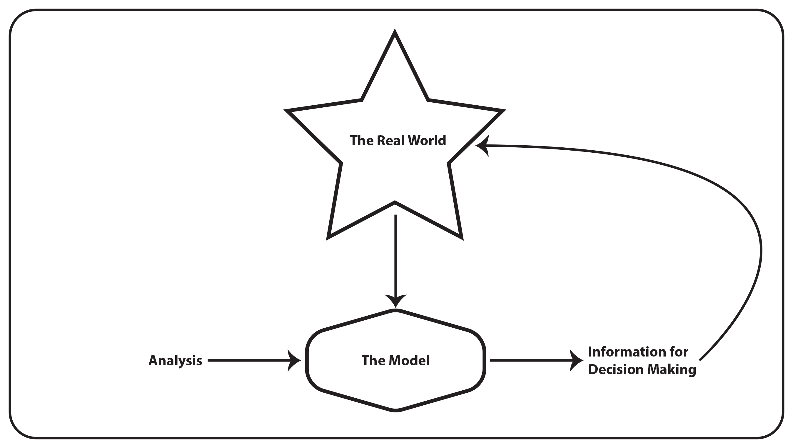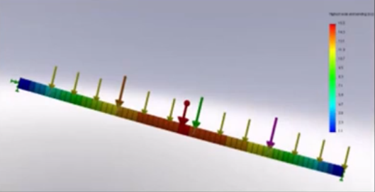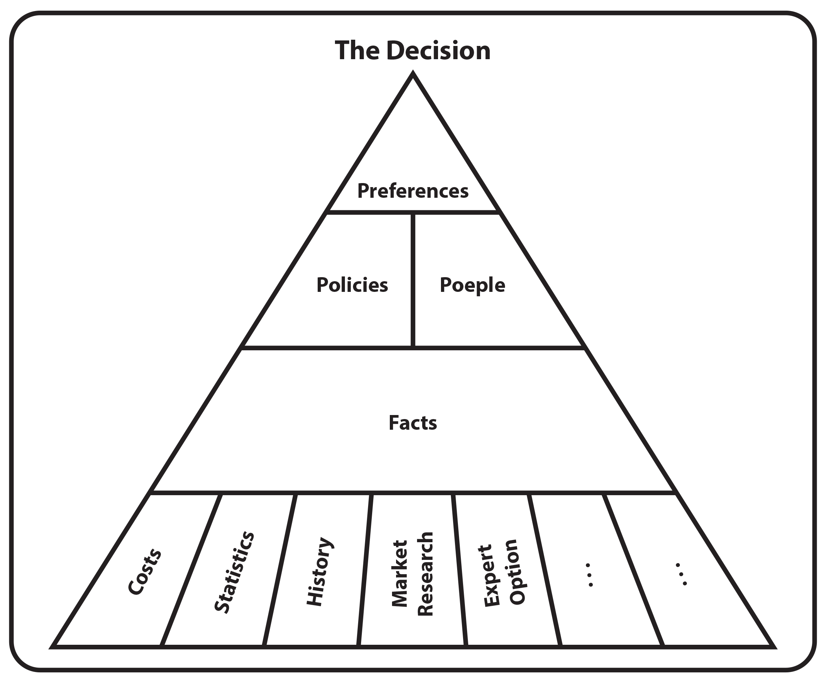

**Engineering Economic Analysis**

In the **Cash Flow Diagram**, in architecture, we use models quite frequently to represent more complicated aspects of real life. So, in engineering, we use a lot of computer models, sometimes small physical models, sometimes mathematical models, but in the world of finance, the model that we use is something we call a cash flow diagram and it allows us to visualize the size of payments and the timing of payments in particular engineering, economics problem. So keep that in mind. Read the problem carefully.

**“A company is considering buying a machine that will cost them Php1Million. After 7-years its salvage value will be Php100,000.00. An overhaul costing Php250,000.00 will be needed in Year 4. Costs will be Php125,000.00 per year. Draw the cash flow diagram associated with the purchase of this machine.”**

This problem contains a lot of information and we need to try to take that information and convert it into a cash flow diagram. So, the first thing I do I start by drawing. Align and the cash flow diagram is really nothing more complicated than a line. The most important point on the line is Time “T” equal 0 that's now and that is when our payments were usually referred to as a “P” or Present value of curve a timetable 0 on the cash flow in this problem. We can see that the total time that we need to model is 7 years. What I do is I draw a line that has 7 years on it and we just draw it like this put numbers One, two, three, four, five, six, and seven. And we see from the problem with this company would like to purchase a piece of equipment for Php1Million. If we purchase something for Php1Million that is a cost for that is money that comes out of our pocket and in the cash flow, diagram model money that we have to pay. We draw as down arrows. So, the purchase of equipment would occur at Time “T” equal to 0 that is now, the cost would be Php1Million. What do I do on the cash flow diagram? I draw a down arrow and I draw the Php1Million amount. The problem also tells something a bit strange. They say that this equipment that I buy for Php1Million, has a salvage value of Php100,000.00. What does that mean? Well, think of it, in terms of something like a car, you could buy a car for Php500,000.00 and use it for 10 years in the end. You resell it and the reselling of that used piece of equipment. We sometimes call the salvage value. So, in this particular problem, the salvage value occurs at the end of the useful life of the equipment. So that is, at the end of seven years with the salvage value, in itself is money that we receive rental when you sell your used car. It's money that you can put back in your pocket. So in this particular problem will draw and up Arrow. With a value of Php100,000.00. The next part becomes very important in terms of the future types of problems that you encounter in this assignment. So this is quite a long word problem. It seems to contain a lot of information and converting that information into the cash flow model is very important. The problem says something about a major rebuild a retrofit that has to occur on this piece of equipment in year four and that could be a bit complicated because I have these discrete points in time. It doesn't tell me exactly. When in the year for this extra cost is going to occur if that's what the refit is. A cost that has to be spent on this piece of equipment. Maybe just to keep it updated or keep it running properly. So we know it's going to be a down arrow. It occurs in your for well. Put that right at 4 or does it occur where it could occur anywhere in here? This is your one and so you can say this is Your 1-year or 2-year 3-year and year-4, that cost occurs sometime in here in the cash flow diagram modeling world. If a cash flow occurs in year-4, I place that at a time to equal 4. And we'll see you later on in the course about why that is. But if the time value of money calculations is done with years, as the discrete compounding intervals, it actually doesn't matter where in year-4 that cash flow occurs. I can just put it at the end of the time. And the time value of money, calculations end up being the same anyway, so I'll put that Php250,000.00 cost that I have to spend at year 4. The problem also talks about a yearly expense. That sounds like operating and maintenance costs of operating and maintenance costs occur every year. And again, because there are costs, they would be a down arrow on our cash flow diagram. So, if the cost occurs within each year, I place the cost at the end of that time. So, at the end of each of my time periods, including your 4, I have to sneak it down here. End of each of my time periods. Including the last time period. I have this Php125,000.00 cost just for completeness. I need some locations later on in the course will learn that these types of recurring costs. Are called an annuity? And will learn some shorthand shortcuts for how we should draw. Annuities. After you've drawn this cash flow diagram. We're now at the point where we can apply the time value of money calculation rules, but although this problem may seem very, very simple. It's important for you to 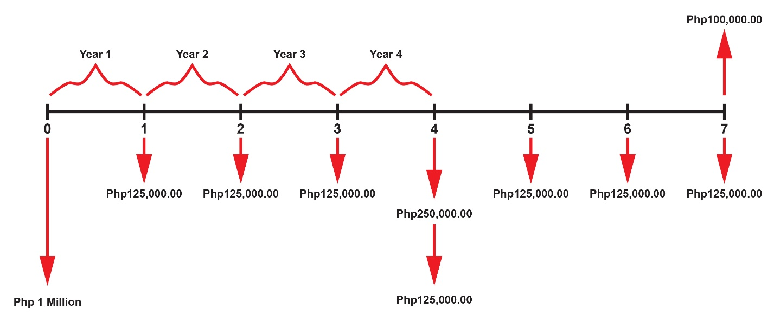practice reading the problem, and converting it to a proper cash flow diagram.

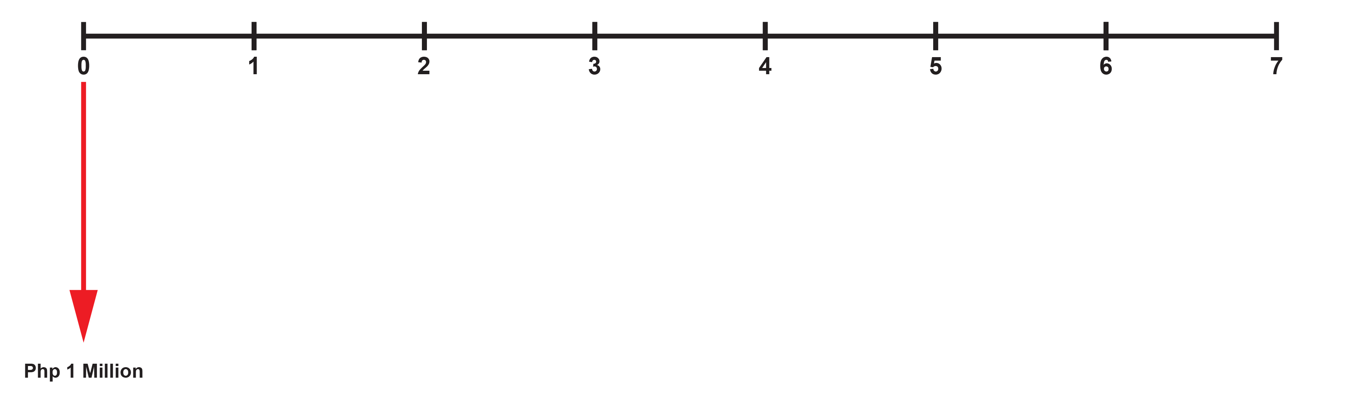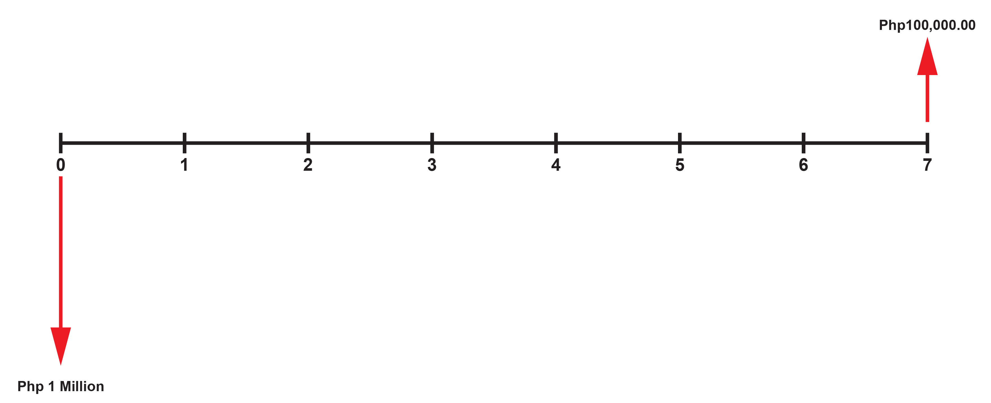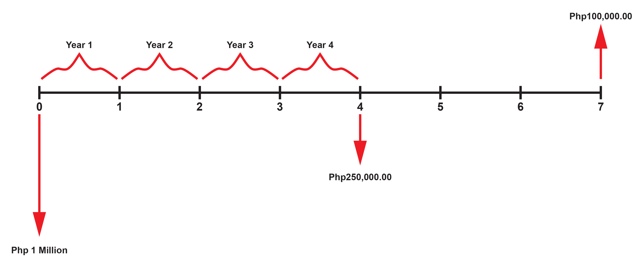

*Solution:*

The **Nominal and Effective Interest Rates**. This is one of the most important Concepts. You need to learn early on in engineering economics, or Finance. So, please take a moment to read the problem.

**“Suppose a savings account pays 6% interest compounded quarterly. In this case, how much money would be in the account at the end of 3-years, assuming that Php500 was deposited now?”**

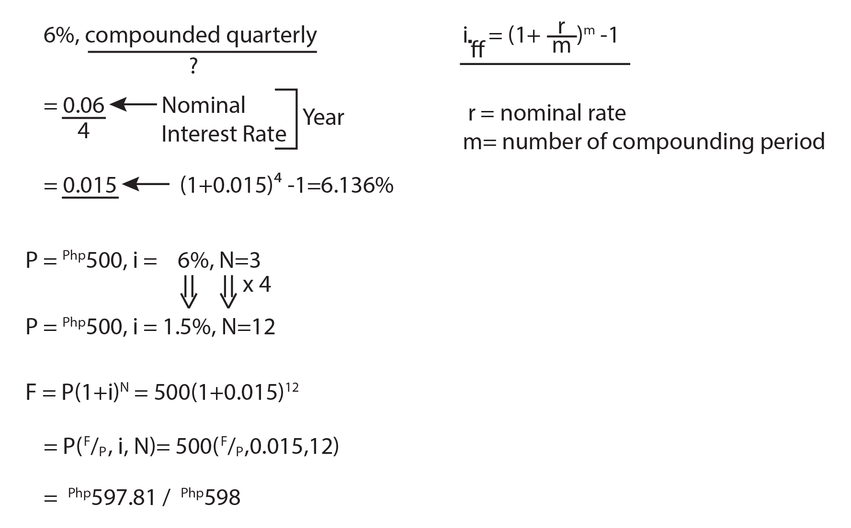As you can see this problem, it's more or less the same problem. We saw last time with an investment of Php500 and interest earned at 6%. However, if you read the problem carefully, you'll notice that it says something a little bit different after the 6%. It has the term 6% compounded quarterly. What does this mean? Does this mean that we calculate 6% every quarter? No, it doesn't. It's a very commonly made mistake. This is a terminology that's very specific to finance that you need to learn in this assignment. 6% compounded quarterly actually means we take 6% we divided by 4. Don't make it any more complicated than that. For the moment. Try not to worry too much about exactly why we do it this way. Just focus on this as a procedure. If we have different compounding. So compounded monthly. If it was compounded, monthly, we divided by 12. It was compounded daily. We divided it into 365. The important thing to realize is that the 6% is something very specific and referred to as the Nominal Interest Rate. And the nominal interest rate is really just the starting point for where we develop the numbers that we need to do the time value of money calculations. It's not the number that will use in the calculations themselves. The other important thing to realize about a nominal interest rate is that ninety-nine times out of a hundred when we talked about an interest rate, we're talking about a period of a year. So even when you listen, listen to the radio, you hear the announcer, talk about something like the inflation rate, you'll say something like the inflation rate last month was 1.5%. It actually doesn't mean it was 1.5% for that month. It's talking about a 1.5% equivalent yearly rate. And when we talk about interest rates in finance and engineering economics were almost always talk about a yearly rate. The nominal interest rate refers to the sort of interest rate were quoting for that year. And the number of compounding periods is how we'll actually do the calculations. So, if we look at this example, will say a 6% compounded yearly will take 6% divided by 4 actually will give us a value of 0.015, or 1.5%. You might say well now, what do we do with this 1.5%? If we'd like to go back to the problem and solve the value of the future value of this investment. So, recall previously, our “P” was Php500 or “i” was 6% therein was 3 in the regular 6% compounded annually version of this problem, but now because we know something about nominal interest rates. We know we have to convert the “i” to equal 1.5%. If the i was 1.5%. That means we also have to convert the “N”. We have to convert the “N” not to years but now to quarters because the interest rate we're going to use in the calculation is a quarterly interest rate. So, it's converted 3 years into quarters, will just multiply by 4 so now our “N” is equal to 12. The amount of the original investment doesn't change, it is still 500. But now if I write this problem, I'll write it like this. “F” Is equal to “P” * 1 + “I” to the N or in this case 500 * 1 + 0.015 power of 12. I could also write this in that special notation that we talked about, where I can refer to the P multiply some compound interest Factor will call this the F given P does F. What we're looking for P what we're given I, N and in this type of notation, I would write it like 500 times given P 0.015 or you can write 1.5% there and 12. And if you work out what this equals you can do it either by the formula or either you're using the compound interest table, and you should end up with a value of Php597.81. That's if I use the formula if I use the compound interest table because it doesn't have as many places after the decimal as I'll get from the formula itself. Actually, end up with Php598, but close enough for our purposes recall that when we did the problem with 6% compounded yearly that value was Php595.5. So, you can see the effect of compounding more frequently. We actually get a higher future value of the investment. If I go back for a second to this concept of a quarterly rate as calculated from my nominal yearly rate and I've noticed that my new value of Php595.81 is larger than the Php595.5 that I got when I did the problem, just with a 6% compounded yearly, then I should realize that there's a concept here. Related to something we call an effective interest rate. And if I want to calculate the effective yearly rate of a 6% nominal compounded quarterly. I can go back to my quarterly interest rate and I can say well 1 + i in this case. My quarterly rate raised to the power of 4 because there are four quarters minus 1 to get rid of the one that we added initially. So that we could do the compounding. This will actually give us the effective interest rate and if you do this math, you'll see that the effective interest rate for a 6% nominal rate compounded quarterly is actually more than 6% it’s 6.136%. Note that “6.136% is the effective interest rate” and “6% is the nominal interest rate”. Please make sure that you understand the difference between the two. If I move over here for a second, I'd like to introduce the formulas that we use when we do interest rate calculations, especially when we do. A lot of calculations relate to different compounding, interest rates, and different types of nominal rates. If I write the formula for the effective interest rate, I can write it like this and in general terms, I can say that the effective interest rate is equal to 1 + r/m divided by the number of compounding periods in the problem. So, this particular problem, compounded, quarterly, we divided by 4 for compounding periods in the yearly nominal interest rate. And then I raised it to the power of “m” when I did this calculation in order to calculate the effective interest rate and then I subtracted one to turn it into this number of actually working backward of using the example first to illustrate the idea. And then if we go back and construct, what the formula would look like, we end up with something like this. What is important in this formula is that you remember that the “r” in the formula is the nominal rate and the “m” in the formula is the number of compounding periods in the year. This becomes an important formula and we use this quite a lot.

*Solution:*

**Conclusion**

To complete this assignment, I'd like to go over a basic problem-solving strategy that will hopefully be useful to you throughout many of the problems that are presented within. This assignment. I find many times students will read engineering economics problems, and really struggle because they don't know where to start and many of the problems have a lot of information. And I just like to give you some tips and if you are stuck on a problem. It should help you in ultimately getting to a solution for the problem of this Problem-Solving strategy. The first step in solving engineering economics problems is really about reading, so **read** the problem and don't just read it once, ***read the problem many times*** because the problems in engineering economics are very densely packed with information. So it's rare to take out all of the information you need in the first read of a problem. *Step 1*, read the problem. Don't worry too much about what you're going to do. Just try to take in some of the information. The next thing that I like to do after I've read the problem a couple of times is to attempt a cash flow diagram. I'm talking about these types of diagrams. If you remember from the introduction of this assignment, the assignment really is about making a model, a simplified model of what's happening in the engineering economic problems. So, a cash flow diagram or trying to draw a cash flow diagram, and comes out of your interpretation of the question, so that's the second step. The third step, I'd recommend is to try to write it down. Write the variables that you can identify. For instance, a “P” value occurs in the present “F”, “A”, and “i”. What is the interest rate? “i” what is the number of compounding. How many periods are there in the problem? Is there a different compounding period two the number of periods that the payments occur will try to write down any of these types of variables as you understand them now in engineering economics so you can extract them from the castle diagram and from your tarot reading of the problem? The next thing I would suggest you do is to identify any formulas. Formulas or tables that you needed to solve. For whatever the variable is you're looking for. So it may be that in the problem. We're giving us an “A” and we'd like to find a “P”. So we need to identify the formulas for the tables where we can find the variable that we're looking for. The next thing I tell you in engineering economics is double check that the value of “n” or sometimes its capital “N”, that's the number or frequency of the periods. A number of months, number of years, and number of days are checked in lowercase or uppercase. And all quotes here “matches” the “I”. Whatever interest rate you're using, make sure that the interest rate is a monthly interest rate. If it is measured in months, make sure that I am at a yearly rate if “n” is measured in years. So at this point, it is really a really good idea to double-check that and if they don't match, then you have to use some of the skills that we learned. In this assignment, you convert the “i” that you're given in the problem into an “i” that matches the number of periods that you would like to analyze. The next thing is really doing the calculations. After you've identified, all of these do the “calc’s” or calculations. And at this point, you can say well if I've got an “i” that is a nice round number and up. Maybe I can use tables. If I don't, I may have to use formulas. But at this point in the process really, just try and do the calculations after you do the calculations. Ask yourself a question. Does the answer make sense? so, look at the question. Look at what they're asking. And then ask yourself, does the answer I've come up with? Does it actually make sense? And then the last thing, and this is something that's often forgotten is right down your conclusion. So, if the problem asks you should someone invest in option “A” or invest in option “B” the last step of solving a problem is actually right down. Actually, let's just say, answer the question and it comes up with an answer. I will generally write a statement like there for the company should buy a machine “B”. This is an important part of the problem. This is just a general outline to give you an approach to solving engineering economics problems. That’s it. So that's all I can share about what I learned in Engineering Economic Analysis.

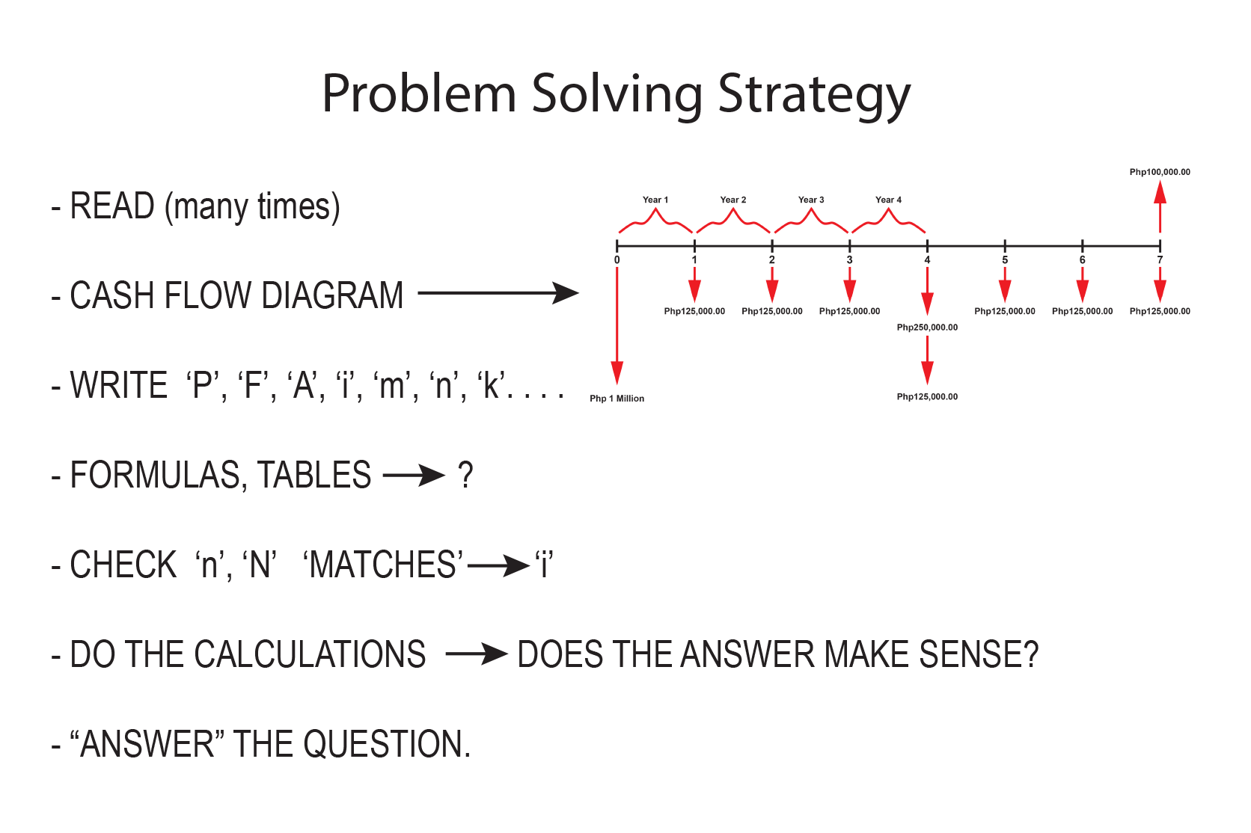

# **Bibliography**

*Engineering Economic Analysis - Eleven Edition.* (2012). Retrieved from PDF Drive Website: https://www.pdfdrive.com/engineering-economic-analysis-d191723603.html

*Engineering Economic Analysis - Ninth Edition.* (2014, January). Retrieved from Iugaza Website: https://www.google.com/url?sa=t&rct=j&q=&esrc=s&source=web&cd=&ved=2ahUKEwiZzY_quaz3AhVRQBoKHXuJA5kQFnoECAQQAQ&url=http%3A%2F%2Fsite.iugaza.edu.ps%2Fnsawalhi%2Ffiles%2F2014%2F01%2FEngineering-Economic-Analysis-9th.pdf&usg=AOvVaw007hUZNwg-oWUMowsMRU2K

*ENGINEERING ECONOMIC ANALYSIS.* (2012). Retrieved from Industry Website: https://www.google.com/url?sa=t&rct=j&q=&esrc=s&source=web&cd=&ved=2ahUKEwiZzY_quaz3AhVRQBoKHXuJA5kQFnoECAUQAQ&url=https%3A%2F%2Findustri.fatek.unpatti.ac.id%2Fwp-content%2Fuploads%2F2019%2F03%2F094-Engineering-Economic-Analysis-Donald-G.-Newnan-Ted-G.-Es

*Engineering Economic Analysis, Solutions.* (2012). Retrieved from PDF Drive Website: https://www.pdfdrive.com/engineering-economic-analysis-solutions-d189168043.html

*Engineering Economics and Economic Design for Process Engineers.* (2006). Retrieved from PDF Drive Website: https://www.pdfdrive.com/download.pdf?id=174439728&h=1c30f1f514fc16d5b9319c3a9f4a7153&u=cache&ext=pdf

*Engineering economics of life cycle cost analysis.* (2019). Retrieved from PDF Drive Website: https://www.pdfdrive.com/download.pdf?id=189907936&h=c91de1f91ef599892c5ea539d9ec7c30&u=cache&ext=pdf

*Engineering Economics: Financial Decision Making For Engineers.* (2012). Retrieved from PDF Drive Website: https://www.pdfdrive.com/engineering-economics-financial-decision-making-for-engineers-e186498607.html

*Fundamentals of Engineering Economics - International Edition.* (2013). Retrieved from PDF Drive Website: https://www.pdfdrive.com/download.pdf?id=184586319&h=868c66d82e5067ee931115d300cc5445&u=cache&ext=pdf