**GRACE ACHOKI**

**a9UB73512**

COURSE NAME:

**(PSYCHOLOGY)**

Assignment Title:

**(Human Communication Processes)**

ATLANTIC INTERNATIONAL UNIVERSITY

**October/2022**

Table of Contents

Introduction3

What is Communication?3

Intrapersonal Communication7

Interpersonal Communication 11

Group Dynamics13

Augmentative and Alternative Communication (AAC)16

**Family Communication17**

Ishin-denshin (以心伝心?) 20

Communication Difficulties in Couples21

Conclusion25

Bibliography28

**Introduction**

In this world we all need somebody. We cannot afford to stay alone in an island. We were made for relationships. The Bible says in Gen 2:25, “It is not good for man to be alone.” So a helpmate was created for Adam.

Therefore where there are people there must be communication whether verbal or non-verbal, conventional or unconventional. For example, in the olden days, people would send telegrams. This would be short and to the point because every character would count and was paid for. Examples of these messages would be, “Come home” or “Mother dead”. Personally, I found this to be very insensitive. There are also unconventional ways that were used in the African culture, for example, the beating of drums or the sign of smoke, or blowing of the horn or a war cry or ululations indicating that a child had been born. Some of these communication practices are still used to-date.

Communication is being able to express feelings, goals, needs, emotions to another human being or group of people as long as they understand each other. This can be either by language or action. The difference between us and animals is that we are able to communicate time and place.

There are two major categories that human communication can be broken into, that is, rhetorical (study of influence) and relational (transnational coexistence of two or more people’s perspectives agreed upon).

"The importance of communication in human society has been recognized for thousands of years, far longer than we can demonstrate through recorded history" As humans, we have the communication abilities that other animals do not, such as being able to communicate aspects like time and place as though they were solid objects *(Stacks and Salwen, 2009 ).*

The following are types of human communication

1. with themselves: Intrapersonal communication expression – with themselves: body language
2. another person: interpersonal communication
3. within groups: group dynamics
4. within organizations: organizational communication
5. across cultures: cross-cultural communication.

Communication requires a sender, a message and a receiver. As mentioned above this can be verbal or non-verbal but the message is complete when the receiver understands the message. So whose fault is it if a message is not understood? The sender or receiver. I would say both. The sender might have not been clear in sending the message but on the other hand the receiver might have misinterpreted what was being said thus not understanding the message. 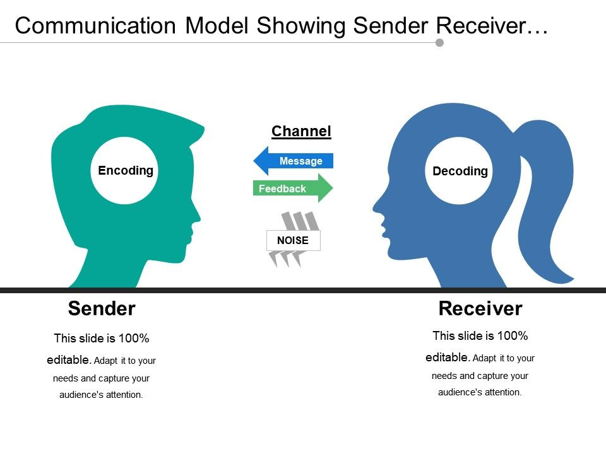

*(Communication Model showing sender receiver)*

Communication has three steps.

1. The thought of what one is going to communicate
2. Transmission of the thoughts to the receiver
3. Receiver translates and tries to understand the meaning of the message. Thus the thought, encoding and decoding.

There are also various ways of communicating, for example, sign-language, eye contact, body language, information and technology communication etc.

There is verbal and non-verbal communication. Verbal is the spoken word while non-verbal are mostly how one communicates the message but with non-word. These are gestures, facial expressions, eye contact or object communication which includes clothing, hairstyles etc. On the other hand is oral communication, which is communication through the mouth includes presentation, discussions and speeches. The difference between oral and verbal is that verbal refers to the words while oral refers to the mouth. Touching on business communication, communication needs to be clear in the organization for efficiency and reaching objectives.

Written communication has been in existence for a long time but has evolved. This emerged through pictographs but progressively evolved into moving information that we enjoy today. We go back to the days of the Ten Commandments written on stone in the Bible vis-à-vis the Ten Commandments on our phone bibles. We can see that written communication is getting more advanced. Written communication unlike verbal communication can easily be misunderstood. Sometimes people read too much between the lines thus clarification is needed.

Effective communication is just what it is. The message must achieve its objective, which is to clearly articulate the message and the receiver to understand what is being said. Some of the barriers to effective communication are ambiguity, being politically correct and language.

What we are learning is that communication is crucial but the barriers are also many, from physical, attitudinal, jargon, physiological (poor eyesight or hearing) just to mention a few.

Intrapersonal Communication

Intra is in, while inter is out, thus intrapersonal communication is self-talk where a person speaks to themselves, being the sender or receiver or repeating a phrase said by someone. As we introspect, do we communicate with others what we are thinking? This is normal. The problem is if one is talking to themselves as though they are having a conversation with other people or another person.

Introspection helps us to remember as we are studying. Eventually it might remain as an “inner speech”.

Joseph Jordania suggested that talking to oneself can be used to avoid silence. According to Jordania, talking to oneself is only one of the ways to fill in prolonged gaps of silence in humans. Other ways of filling in prolonged silence are humming, whistling, finger drumming, or having TV, radio or music on all the time.

In criticism of the concept of intrapersonal communication, Dr Thomas AIU, states that, the overall point is that this reconstruction of our inner mental processes in the language and idioms of everyday public conversation is highly questionable, tenuous at best. The question is, is it questionable because no one can know what one’s inner speech is all about if not communicated to another person.

Dr. Sian Beilock, cognitive psychology professor at the University of Chicago, presents several techniques in her book “Choke”, that could offer help to anyone facing a challenging situation and struggling with mental chatter. Since self-talk is a form of self-regulation, parents or instructors could use this technique to help focus a young student's inner dialog towards a process goal instead of an outcome based goal.

Body language varies from one culture to another. For example in India when one shakes their head from side to side it means “Yes” but in another culture it means “No”, thus, body language is not universal. Body language communicates a lot. It communicates attitude or state of mind of a person. It can be in a family or business or place of work. This is learned from an early age. For example when toddler frowns or shrugs the shoulders or when a teenager folds his arms up next to his chest and frowns communicating disagreement or defiance or one yawns when someone is presenting. One common one amongst African women is clicking followed by a defiant look or with contempt. This is similar to rolling of eyes to mean that one has had enough. Body language conscious or unconscious reveals the feelings.

Some emotions are universal e.g. smiling/laughing when happy, frowning/crying when sad, however in the 1990s Paul Ekman expanded his list of basic emotions, including a range of positive and negative emotions, not all of which are encoded in facial muscles. The newly included emotions are:

A study in body language.

1. Amusement

2. Contempt

3. Contentment

4. Embarrassment

5. Excitement

6. Guilt

7. Pride in achievement

8. Relief

9. Satisfaction

10. Sensory pleasure

11. Shame

Does verbal communication require body language? Yes. This shows the person that one is communicating with that they are listening. When clients come to the office, one can tell if they are listening or not. This is by them nodding or making a sound ”mmmm” (though this done excessively might be distractive) or looking directly into the eyes. But when they yawn or rub their eyes then that might indicate that they are tired or what is being said is boring.

I have observed that, when a child is tired they will rub their eyes or nose or cry as the mother talks to them. Adults on the other hand can show disinterest by yawning or using their phones, just to mention a few.

In physical expression, research has shown that human beings move their parts of the bodies e.g. shrugging of shoulders or pointing repeatedly, or shaking the head, to help ease mental effort when there is difficulty in communication, as research has shown.

Boredom, disbelief, lack of interest, consistent eye contact, excessive blinking are parts of physical expression. Amongst the things I have learned is, rubbing of the chin might mean disbelief. I had a client who mostly rubbed his chin when his wife would speak. Whether it was a habit or not I cannot tell, but could be he did not believe the change occurring in his wife’s life.

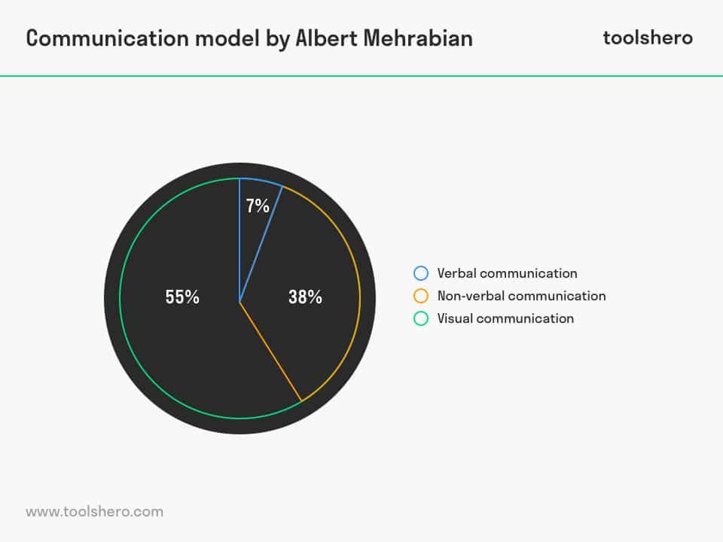 https://www.toolshero.com/wp-content/uploads/2013/10/communication-model-albert-mehrabian-toolshero.jpg.webp

*(Mehrabian, 2013)*

Interpersonal communication is the exchange between two or more people. The sender sends the message and it is understood by the receiver. Unattended proper communication causes conflict. Interpersonal communication is defined as what one uses with both spoken and written words as the basis to form and maintain personal relationships with others (Heil 2010)

There could a loss of proper communication when a text or social media is sent replacing face to face. One might not see facial expressions which is important.

Interpersonal Communication has certain theories. Uncertainty reduction theory e.g. when there are whispers and another person wonders what’s going on. Social exchange theory e.g., one shares information about themselves or others. Levinger (1965, 1976) discussed marital success as dependent on all the rewarding things within the relationship, such as emotional security and sexual fulfillment. He also argued that marriages either succeed or fail based on the barriers to leave the relationship, like financial hardships, and the presence of alternative attractions, like infidelity. Levinger stated that marriages will fail when the attractions of the partners lessen, the barriers to leave the spouse are weak, and the alternatives outside of the relationship are appealing. Symbolic Interactions theory. Relational Dialectic theory - there are three different types of relational dialectics. These consist of connectedness and separateness, certainty and uncertainty, and openness and being closed up. Coordinated management theory. Social penetration theory, Onion theory- relationships are like onions and get to know each other slowly. But once the layers are peeled you can take back. Online communication, people disclosing private information without meeting the person. Expectation theory – expectations from others.

Conflict resolution Sillars (1380) and Roloff (1876) expressed that conflict resolution strategies can be categorized as pro-social or anti-social in nature. When an individual is presented with an interpersonal conflict, they can decide how they want to deal with it. They can avoid (anti-social), compete (anti-social), or cooperate (pro-social). It has been learned that one who avoids conflict is less capable of solving problems because they are more constricted. Avoidance has negative effects on dyads.

What is the meaning of Social Penetration Theory? The theory was formulated by psychologists [Irwin Altman](https://en.wikipedia.org/wiki/Irwin_Altman) of the University of Utah and Dalmas Taylor of the University of Delaware in 1973 to understand relationship development between individuals *(Social penetration theory - Wikipedia).*

This theory involves two people intimately opening up in conversation. Moving from cliché to sharing the hearts, hurts, emotions, finances and whatever is dear to them. But this does not happen automatically. There must be some sort of trust developed before it gets to this level. This is what is called “Relational Capital” in coaching. Examples of such relationships would be family, business deals, couple intending to get married or in marriage. However, a loss of trust would cause a relationship to take a nose dive from very high to level zero. For social penetration theory to succeed, trust is paramount, coupled with integrity and confidentiality.

When two people start off in a relationship, there can be uncertainty. We all want to feel safe. What might help in the uncertainty is reciprocity. It is difficult if disclosure is one sided.

Group Dynamics. This is a system of behaviors and psychological processes happening in a group.

There were key theorists in this area: Gustave Le Bon, William McDougal, Sigmund Freud, Jacob L. Moreno, Kurt Lewin, William Schutz, Wilfred Bion, Bruce Tuckman, M. Scott Peck and Richard Hackman.

Hackman suggested that groups are successful when they satisfy internal and external clients, develop capabilities to perform in the future, and when members find meaning and satisfaction in the group.

In intragroup dynamics (In-group or within-group) it depends on how they define the boundaries. These are groups like churches, political parties, military, work groups, therapy groups etc. Here there is an interdependence on each other in the groups.

Intergroup dynamics (one group to the other) is behavior played out between two or more groups. This can include opinions, attitudes towards another group.

What is Interdependence? This is when members of a group rely on each other to reach a goal, for example planning for a retreat as a group. For a group to be successful in practicing interdependence, the task is not left to the leader alone. Everybody works to reach and accomplish their portion. This is really the way the human body works. One part depends on another. Clear instructions should be communicated if the group is required to be effective, so that every member knows what role they are playing.

### How does one resolve group conflict? (https://www.latrobe.edu.au/mylatrobe/common-types-of-group-conflicts-and-how-to-resolve-them/)

1. Acknowledge the conflict. In the group, respectfully bring up the conflict in the open. Allow the team member to work on it.
2. Communicate. Open and honest communication. Everyone deserves to be heard. Let the group members obtain objectivity? To be heard and resolve issue.
3. Attentively listen and aim to find a solution. Listen to each other without judging. Trying to understand and empathizing.
4. Take responsibility. As a leader, what part could they have played in this conflict. Allow others to take responsibility in their own way without forcing them.
5. Have a group leader. One cannot do it alone. Remember a leader is what you do and not who you are.
6. Work in unity. The relationship of the group is important, respect is paramount.
7. Consult with supervisor if things get out of hand
8. Take care each other and self.

Organization Communication. This is the communication in an organization. Its history can be traced back to 1093 and 1950 being involved in the mass communication or business communication and information according to Dr. Thomas, AIU.

Nobel Laureate Herbert A. Simon wrote in 1947 about "organization communications systems", saying communication is "absolutely essential to organizations" *(https://www.coursehero.com/file/154849451/...).*

People making serious decisions in organizations might not make a properly informed decision because of lack of information. They might go with the information they first received instead of waiting to have the full picture. Most of the time they might be under pressure especially if there another company is involved.

Communication networks might affect the completion of a task on time if clear instructions are not given or if the group feel threatened or fatigued.

Two years ago, I was privileged to team up with a group of people to write policies for a particular organization. As a leader we had a time line and the work was quite rigorous. At some point the people began to slow down and I quickly picked that they were fatigued after few months. We had to take a break then come back finish the task and execute. This was a success.

The more information the members of the organization have the better the morale of the member or workers. This discourages gossip and grouping to discuss issues but rather an open for communication. In this safe space the members will then be free to air their grievances and concerns without fear of losing their positions or jobs. Dialogue is encouraged in this space rather than a one man monologue execution.

A few years ago, I was involved in an organization where only one man made the decisions without consulting and the rest of the people were expected to jump and execute. Eventually this demoralized the employees and they began to leave one by one. People want to be involved and heard.

Augmentative and alternative communication (AAC) is an umbrella term that encompasses the communication methods used to supplement or replace speech or writing for those with impairments in the production or comprehension of spoken or written language.

AAC can be permanent or temporary aid to a person who has cerebral palsy, autism, speech impairments etc. Symbols used in AAC are eye tracking, pictures, signs, letters and words etc.

There are aided and unaided AAC. The unaided are gestures, sign language which have a linguistic base etc. Aided is using machines e.g. Speech Generating Device. The advantage of unaided is that one can always use it anywhere. Unfortunately the high-tech aids require maintenance and sometimes batteries and cannot be used all the time.

Aided AAC requires external support. Some examples are Printed words, objects, pictures, line drawings, visual-graphic symbols, handheld devices, etc. These generate speech through synthetically produced means *(asha.org)*.

The goal is effective communication bringing understanding, whether it is through symbols pictures or machines or sounds, Aided or unaided machines. In iconic encoding strategies, such as Semantic compaction, icons (picture symbols) are combined in a sequence to produce words or phrases.

A 2006 research review of 23 AAC intervention studies found gains in speech production in 89% of the cases studied, with the remainder showing no change. A descriptive review looking specifically at Picture Exchange Communication System (PECS) intervention studies found that several studies reported an increase in speech, often during later phases, while one noted little or no effect.

There those who are users of AAC who have disabilities and have been employed though on less stressful jobs.

Family Communication. When was the last time that a family sound around a fire to talk and encourage each other? Technology unfortunately has interrupted communication in the home. Research identifies communication as an essential building block of strong marital, parent-child, and sibling relationships.

There is a difference between hearing and listening. Listening requires processing the message. This call for attentiveness and response. Hearing does not require much effort. Openness and honesty should be found in a family. Poor communication is unclear. In a couple this causes lack of intimacy, less communication, less emotional connection and conflict.

Instrument and affective communication. Children might feel insecure, especially boys because he has been told that men don’t cry or show emotions. This is very common here in Africa. Starts off when one is young and sometimes crumbles when they get married because they have no one to show their toughness to and because the wife knows their weaknesses. It devastates the man.

There are four styles of communication, according to Dr. Thomas - AIU

1. Clear and Direct communication – This is when message to the point and directed to the receiver. It is clear that the message is to them and a face to face would be beneficial.
2. Clear and Indirect – The message is clear but not direct to the receiver. The receiver is not sure if this message is meant for them.
3. Masked and Direct – The message is direct but general. The receiver has no idea that the message is directed to them.
4. Masked and Indirect – The message is vague and general for example to the general public though the sender is hoping that the receiver will get it.

There are various ways to effectively communicate as a family

* Create time. We cannot look for time because it can not be found. Make use of the little pockets of time that we have. Switch off the T.V., put away phones at the dinner table, go for family lunches or picnics and have games together thus frequently communicating.
* Communication needs to be clear and direct and avoid vagueness especially when there is a problem. One of the reasons as parents we are vague is because when we require something from the children, for example, telling them not to do something that we find ourselves doing a lot – could be not watching too much T.V. but we spend endless moments on the screen. We fail to have the authority.
* Positivity. We waste a lot of time blaming each other in families, on things that have not been done and the way it was done instead of looking for the positive things to say. When people are unhappy in a family then the response is negativity (contempt, criticism etc.). Members of a family needs to have a positive attitude and complimentary tongue.
* Check out on non-verbal communication. A member of the family might be saying something but their facial expressions don’t match their words. For example, “I am fine”, but they are frowning. Follow up may be needed even if not immediately.
* Mind the level of understanding of the family member. Spouses cannot talk to each other or correct each other the way they do with their children. This is not to say that respect is not required at every stage. There are members of the family that are either fast or slow to grasp what one is saying. The slow might be processing it more before they respond. A parent should not talk to a child like talking to an adult and expect them to understand.
* Listen actively. Honest and open communication is required in a family unit. We can hear many sounds but it takes intentionality to listen to someone. We listen without judging or building answers in our minds and answering before the question or statement from the other person is complete. We should listen to first and foremost not to respond but to understand. Body language is required in active listening, for example, leaning over, eye contact, nodding or response sound (mmm) if it is a phone conversation etc.

Ishin-denshin (以心伝心?) originally comes from a Chinese proverb and is a Japanese idiom which denotes the traditional concept of interpersonal communication through unspoken mutual understanding *(https://en.wikipedia.org/wiki/Ishin-denshin)*.

This is a heart to heart talk. This can be non-verbal communication. E.g. table manners, child learning to speak – the nod their head or shake their head or waving “bye”. This makes them feel they belong.

Ishin-denshin is traditionally perceived by the Japanese as sincere, silent communication via the heart or belly (i.e. symbolically from the inside, uchi), as distinct from overt communication via the face and mouth (the outside, soto), which is seen as being more susceptible to insincerities. https://en.wikipedia.org/wiki/Ishin-denshin

Human spoken language is only one form of sign-system. Body language is another.

Small talk is intimate talk but informal and not with a particular topic in mind. The ability to conduct this is a social skill. The purpose of small talk is to bond but this bonding can go to the next level.

Small talk can be used as an ice breaker. As a conversation starter for either an existing or non-existing relationship. But it can also be used to break silence, for example in the corridors or the elevator. In a meeting a small talk would be used to make the participants comfortable. Some of the topics that can be discussed are weather, T.V. family, sports etc. Giving too much information if people are not familiar might make people uncomfortable.

Gender differences. Ladies small talks are different from men. Ladies tend to talk about their appearances then go into self-disclosure but men tease each other, matches or put downs.

In Africa, small talk topics are weather, children, school, spouses, economy and how things are deteriorating. Some of the small talk can be depressing so we have to end with giving hope.

Communication Difficulties. Couples can sometimes have difficulty in communication. A lack of proper communication can cause a couple to go separate ways and even end up in divorce. A lot of times there is misinterpretation of what is being said or acted out. Learning the skills of communication will enable the couple to develop a more understanding and intimate relationship.

Communication involves the collaboration of two people as they share and examine all of their perceptions, feelings, ideas and thoughts to come to an accurate understanding of what is happening. Dr. Thomas – AIU Lecturer

Most people don’t know how to talk with each other. People need to learn how to express their feeling with each other. Trust is a foundation of a relationship and this can only happen if the couple is vulnerable and open with each other.

The purpose of communication is to understand what the other is saying. That means, we disarm and drop our weapons, talk, listen and determine what the problem is. It is not about right or wrong or being in a battle field.

We often are quick as couples in blaming and accusing our partners instead of first talking about ourselves, that is how we feel hurt, disappointed or upset about a situation. Instead we want to force them to feel what we are feeling and if we are not careful revenge kicks in. We need to stick to our lanes instead of blaming our partners on how they made us feel. It is not how they made us feel but the emotions we are going through. When one partner feels that they are being blamed or judged, they quickly put up a wall emotionally and the conversation is lost. And yet if we use the right approach and share our wants, the more we share our personal wants with each other and become vulnerable the more we are in touch with our feelings and the more we become emotionally connected.

As for listening, one can be hearing many sounds but pay very little attention to what is being said by the partner. Listening is a skill. We might not agree with what is being said but have we understood the heart of the matter. We empathize and listen with the heart not head. Engage with your partner and indicate that you are listening by nodding and at the right time respond not interrupt. By not interrupting you show your partner that they are valued. The levels of understanding feelings and empathy seals the gap of confusion between the couple, thus giving the reality of a relationship. The couple then identifies a clear picture of what is ailing them and what they have learned.

Intimidation which means frighten to submission is one of the ways that a partner can manipulate. For the partner who has been intimidated, they end up having a broken spirit and sometimes demoralized. But in reality both parties have lost because the intimidated party is not happy and the relationship is not healthy.

Speaking. For one to learn a language properly, one must understand the context in which the words were used.

In sociolinguistics, SPEAKING or the SPEAKING model, is a model sociolinguistic study (represented as a mnemonic) developed by Dell Hymes. To facilitate the application of his representation, Hymes constructed the acronym, S-P-E-A-K-I-N-G (for setting and scene, participants, ends, acts sequence, key, instrumentalities, norms, & genre) under which he grouped the sixteen components within eight divisions *(Hymnes)*.

Telepathy. In 1979 the physicists John Taylor and Eduardo Balanovski wrote the only scientifically feasible explanation for telepathy could be electromagnetism (EM) involving EM fields. In a series of experiments the EM levels were many orders of magnitude lower than calculated and no paranormal effects were observed Both Taylor and Balanovski wrote their results were a strong argument against the validity of telepathy. A variety of tests have been performed to demonstrate telepathy, but there is no scientific evidence that the power exists.

**CONCLUSION**

Communication is part of our lives and a very important aspect. People communicate verbally or non-verbally. It is said that “Actions speak louder than words”. One might keep quiet but make certain gestures. This is still communication. The question I still ask myself is if intrapersonal communication is accepted in society or regarded as a mental illness. What about prayer? Talking to God that you do not see. As long as one is in church, there is no problem but outside the church, it might be considered as a mental problem. Why? So could it be that there are many people in mental hospitals who really don’t have a serious mental problem? Or could it be that, there are many people in church who pose as if they are praying but they are not and are ill?

In the recent years one of the most powerful ways of communication is through technology. Through movies and music. Music has captured the hearts of many and especially amongst the young people. There is negative messages that have been sent including the one that was disastrous about killing a mother. Not to mention the video games that our young children are involved in. Parents should refrain from giving toddlers phones to play games. The introduction of this has caused havoc in that the screen is introduced to the young toddlers too early in life and this becomes a problem in their later years, not to mention their being anti-social. On the other hand music and videos have also helped in positive communication, in that, healthy positive messages have been passed on leading people to be responsible. An example is inspirational talks, preaching and music that uplifts the spirit. Movies like, “Jesus movie” and “Passion of Christ” has brought change in our prisons and homes. All this is communicating a message about a fallen man receiving forgiveness from a merciful God.

So we clearly that whether communication is positive or negative it is still powerful. The sender plays his part but the outcome is determined by the receiver and how they interpret the message. When one makes wrong move, whose fault is it, the sender, receiver or both?

I have also successfully used acting through speech and mimes to communicate a message. This I have done mainly in church, social media and seminar platforms, especially during the Covid-19 season. Why I say successful, is because of the feedback I receive. I am intending to use this to pass more messages and especially a message of hope. The other means of communicating messages that I have used is, co-authoring two books on marriage and writing for a national daily newspaper every Monday (on relationships).

What I have also learned is that communication being a big aspect in life, we need at least one to communicate either with ourselves or with others. Our five senses being, touch, sight, hearing, tasting and smelling.

When we have had couples’ seminars we have used two games to pass messages that reinforce the experiential learning. The games are “Pictionary and Actionary”. In both games, Pictionary, one member of the team tries to communicate by drawing while in actionary one tries to communicate by acting out the words they have been given to draw and act out – that is communicating. When one member mentions the correct answer then the team has won.

There is so much I have learned about body language and this will help during the sessions with my clients, both on what I need to do and how the client behaves. I might have also sent a wrong message to the clients but will in future be on the lookout for both.

Having dealt with many couples in my coaching practice, the name de-penetration stage was an eye opener (even though I have encountered this but did not know its name), where a client begins with withdraw from the other partner maybe because they have been hurt or are facing unresolved conflict etc.

Self-disclosure has also helped the clients to relax and open up more

In an organization, it is important to give people an opportunity to be involved. Communication is passed on from one source but after discussions with various people in the organization. One man’s sole decisions rarely succeed. People don’t feel like a team and after a while would look for opportunities to exit. Communication needs to be clear, precise and to the point. This does not mean that communication runs through without policy. People need to understand why a system is in place so that one does not just walk into a CEO’s office and begin to shout at him letting him know how he feels about the organization. Whichever method is used, respect is paramount. Thus an organization will prosper when people can ask questions and receive answers.

In interpersonal communication, there is a sender, receiver and the goal is to be understood and to understand the other person.

We thank God for technology because people can have Augmentive Alternative Communication. In 1990 I worked in Kenya Institute of Special Education in Kenya and was privileged to see how some of the AAC aids e.g. hearing aid are made. Many children were brought to this institute for testing. This was also an institute training teachers on how to teach and take care of children with disabilities.

Effective family communication is vital in a family. Lack of this builds a big rift in the relationships and causes the members to drift away thus not solving problems when they arise. Most of the couples who come to the office have communication problems. Mostly lack of effective communication. We have been able to help them through.

In couple communicating especially serious heart to heart issues, it is important to create an appropriate time and place so that both parties are relaxed and running to the next assignment. The goal of a couple communicating is to be understood and to understand what the other is saying.

If couples can treat other people with decency and respect then the same should apply to each other as a couple.

In group dynamics, people cannot effectively deliver if they do not understand instructions or they are fatigued. They are human beings not robots. People need to digest the information before executing.

Basically I am finally putting names to every day coaching practice. With this course, I am hoping not only to be a good coach but a more knowledgeable and a good informed counselor.

# Bibliography

asha.org. (n.d.). Augmentative and Alternative Communication (AAC). *https://www.asha.org/NJC/AAC/*.

Communication Model showing sender receiver. (n.d.). *https://www.slideteam.net/media/catalog/product/cache/543x403/c/o/communication_model_showing_sender_receiver_channel_feedback_Slide01.jpg*.

https://en.wikipedia.org/wiki/Ishin-denshin. (n.d.). Ishin-denshin. *https://en.wikipedia.org/wiki/Ishin-denshin*.

https://www.coursehero.com/file/154849451/... (n.d.). https://www.coursehero.com/file/154849451/... *https://www.coursehero.com/file/154849451/...*

https://www.latrobe.edu.au/mylatrobe/common-types-of-group-conflicts-and-how-to-resolve-them/. (n.d.). Commom types of group conflicts. *https://www.latrobe.edu.au/mylatrobe/common-types-of-group-conflicts-and-how-to-resolve-them/*.

Hymnes, D. (n.d.). What is Speaking Model. *sage-answer.com/what-is-speaking-model-by-dell-hymes/*.

Mehrabian, A. (2013). Communication Model. *https://www.toolshero.com/wp-content/uploads/2013/10/communication-model-albert-mehrabian-toolshero.jpg.webp*, jpg.

Social penetration theory - Wikipedia. (n.d.). *Social penetration theory - Wikipedia*.

Stacks and Salwen. (2009 ). *Integrated Approach to Communication.* https://www.semanticscholar.org/paper/Book-Review...