**Tanya Hammond**

**Your student ID number**

**UB72389HED81548**

COURSE NAME:

**Critical Thinking**

Assignment Title:

**What is Critical Thinking?**

ATLANTIC INTERNATIONAL UNIVERSITY

**February 2022**

**Introduction**

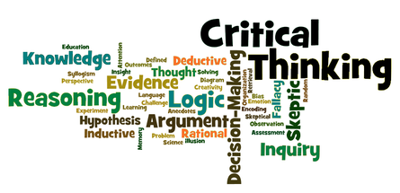

If I look at the above picture and read the words, this is what comes to mind - organized chaos. There is structure, with some things going from left to right, others going from bottom to top. Some small, some bold, some in different colors, some so tiny you need a magnifying glass to read them. Now personally to me this is how my critical thinking works – organized chaos. There is a reason for each and everything, placed in this picture, we have to learn to look at things from a different angle to see the other possibilities that may be lying in wait for us to discover.

In my secondary school I taught in I had a nickname given to me by the students – The Why Teacher. I was teaching ESL English to these students and trying to encourage them to practice speaking and trying to make the conversation flow instead of the usual sing song they had learnt. Hello Teacher, to which I would ask - How are you today? The universal sing song of “I’m fine thank you, and you?” The first week I let this go, as to build some confidence in the students – those who were brave enough to attempt to talk to me, the second and third week I explained that I want to know more, like are they happy, sad, hungry, good, bad, or wonderful. They liked this and often before classes or during breaks they would come to ask me and use new words to explain how they are. They enjoyed this very much as I would give a big wow expression when they came up with a new descriptive word.

We then moved on to the why question. With each answer they gave me I would ask them but why? What is the reason or the cause behind the happiness, tiredness or even the hungry? At first, they just shrugged their shoulders and would smile and move away. Then they started coming to me with reasons why. They were hungry because they woke up late. They were happy because they got a good score in Math’s or Science. At times I would even venture the second why – Why did they wake up late that morning? Then they told me because they went to be too late, but why? I prompted again and then a shy small laugh would come out and they would say – “oh we were playing computer games.” So, our conversations started very basically but they learnt that everything they had to say I could ask for a reason, thus starting to realize how a basic conversation works. That was my basic approach to teaching and helping them understand more about critical thinking.

They are not taught critical thinking in the schools; it is just rules and memorization. It is hard when teaching ESL English to get the students to understand the concept of critical thinking – thinking outside of the box, thinking about what ifs!

So, let us first have a look at - What it is? The definition and function of thinking. Why critical thinking is important? What are the 5 critical thinking skills? Lastly, I will look at the ultimate cheat sheet for Critical thinking.

**What is thinking and critical thinking?**

Let’s look at the definitions first –

Thinking is “*The process of considering or reasoning about something.”* Or *“using thought or rational judgement.”*

Critical Thinking is – “*the objective analysis and evaluation of an issue in order to from a judgement.” "Professors often find it difficult to encourage critical thinking among their students"*

To me thinking is what we do every day of our lives, it’s a natural thing and happens on its own when we want it to. We make plans and gather our thoughts to make things happen during the day.

Critical thinking is to me is thinking “out of the box” – looking at both the positives and the negatives, evaluating both sides and then coming to a conclusion for yourself. In many aspects I see there is no wrong or right answer because we each look at things in a different way and each of us have our own thoughts and ways of doing things. Being able to see someone else’s side to the subject, object or topic and being able to discuss your points is what I would say is critical thinking in a just.

**How to think critically?**

Here are steps you might take when using critical thinking for problem-solving:

1. Look for where there can be a problem or issue.
2. Why does this problem exist and how do we solve it?
3. Research the problem and look for more information about it.
4. Arrange the information accordingly.
5. Look for relevant answers and apply them.
6. Once applied see if it solves the problem or issue.
7. Furthermore, look for ways to make improvements.

**Why is critical thinking important?**

Critical thinking skills are important in any level of all careers, and good critical thinkers can work on their own or in a group to find the solutions for the problem or issue.

Employers do look for this skill when interviewing for a position as it shows that you can pack the puzzle or think outside of the box – as they say.

I will look at 5 critical thinking skills that you can focus on when writing your resume or for your next interview.

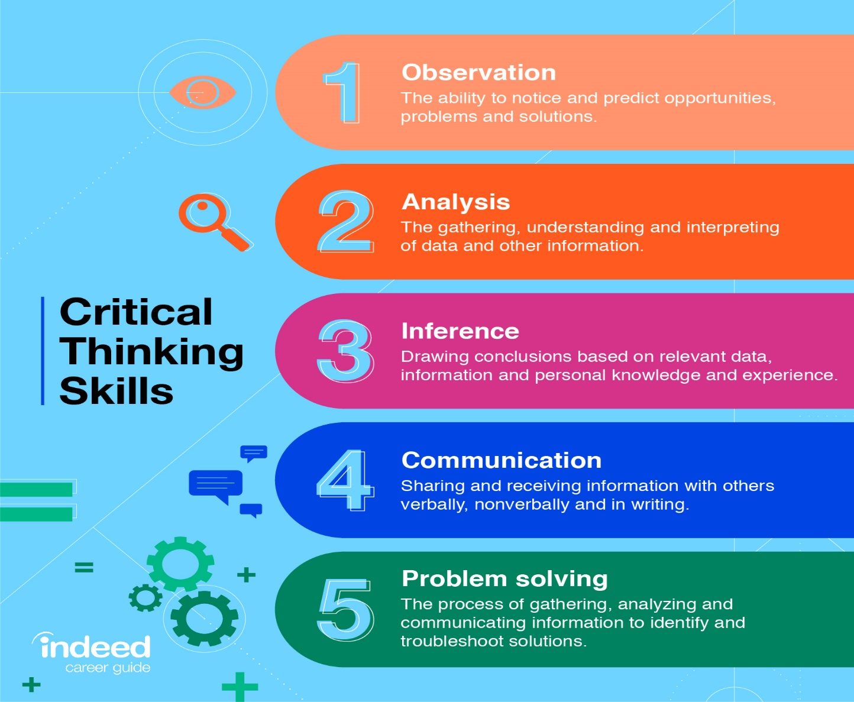

**1. Observation**

I find that being an observant person allows you to fall into the critical thinking skills very easily, as you will easily be able to see what the problem is just by observing. This makes us more open to understanding why something might be a problem. Sometimes purely by observing different situations you will be able to see others similar situations coming and prevent it before it becomes a problem.

How to improve observation skills? Pay closer attention to what is happening around you, slow down, listening carefully and watch what people do. I often find myself going to public places and sitting observing people and what they do. Sometimes I will draw pictures of what I am seeing or even make notes of how people react to different things. On rare occasions I will take pictures of different people and try figure out why they are doing what they are doing. Looking for patterns or behaviours that lead to certain results.

**2. Analysis**

So, the problem has been found and the next step is to pull it apart and look at it from all directions. Some knowledge is needed to be able to do this but can also be researched if you don’t know everything about it. This will then give you various options to look at and see what is relevant to the problem and thus make sure what we find is correct and objective.

How to improve your analytical skills? We gain knowledge by experiencing new things. Reading books on topics that are not known by us, even take a class or attend a seminar presented by those who are well known in the different fields. Push yourself to be open to others interpretations of situations and consider, that we can change our way of thinking.

**3. Inference**

Inference – the ability to make deductions about facts. This means taking the information you have collected and make logical deductions based on the facts

How to improve your inference skills? Place the focus on making an educated guess than jumping to a conclusion. For this you need to stop, take a step back and look at the information from others viewpoints too. Take into consideration of what they are saying and doing from there point of view – thus helping you to evaluate a situation.

**4. Communication**

This is one of the most important skills to have I think because if you can’t communicate properly then how are you going to carry across your message.

How to improve communication skills? Debating is a very good way of improving your communication skill. Having a topic and then having to debate the pros or cons about the topic will teach you too look at both sides of the problem. Always remember to respect and listen to what the other person is saying. You will get your turn, and then remain calm be rational in your answers. Do not personalize it.

**5. Problem-solving**

This is where you have now found the issue, have broken it down and found the optimum solution – now to implement the solution.

How to improve problem-solving skills? The more you know about the situation the better your ability will be to solve it. Watch how others solve a likely problem, learn from others experiences and knowledge.

**The ultimate cheat sheet for Critical thinking.**

To start use the 5 w- words. Who? What? Where? When? Why? That is the basics for me. With these 5 words many questions can be asked.

Who definition is – “*what or which person or people, used to introduce a clause giving information about a person or people”.* When I think of the word who – I relate it to people. Who was with you in the car this morning? Who was talking in the background? Who did you go with? It allows you to expand the conversation and find out more information. For example if I ask students who did they go away with for the holidays? They would answer – my family. This then leads to asking - oh so who is all in your family. This leads the students to expand there thinking for the future rather give the details in full than just saying my family.

What is the use of what? You use what when you are asking for information about something. You can use what as a pronoun or a determiner. When you use what as a pronoun, it can be the subject, object, or complement of a verb. It can also be the object of a preposition. What? I relate this to the action or thing that is being done. Be it the topic, the person or an object. An example is –Smoking. What does smoking do for a person? What benefits do people get from smoking? What alternatives can be offered? What are the pitfalls in smoking?

Where definition is – *“in or to what a place or position”, “at, in, or to which – used after reference to a place or situation.”* I relate where to the place for example the kitchen, office, bank, shopping mall. When using where it helps me find out about the area, and gives me an idea of size in relation to the place. For example asking students – Where do you play football with your friends? You expect the answer to be on the football field but many answer in the street outside our house, or there is a big field on the way to school, we play football there.

When definition is – “*“at what time” or “at or on which” - referring to a time or circumstance, “at or during the time that”.”* When is related to time – When will you be here? When will they have the books? When do you play football with your friends? When do we need to apply by? When do you find the time to practice?For example if students are writing a test you have to make sure they understand by when each section has to be completed as to ensure that they allow themselves enough time to complete the test.

Why definition is *– “for what reason or purpose”, “used to make or agree to a suggestion”, “with reference to a reason or the reason for which.”* Why is related to the reason things happen or the feelings attached to things. Why are you late this morning? Why did you not sleep last night? Why are they leaving early? Students often find this one of the most difficult questions to answer as they do not always realize that there is a reason behind what they are doing. Once they understand what they have to do and give a reason then they also realize they are thinking more about what is happening.

You can also add which and how to these words to take there thinking further.

Which definition is – “*asking for information specifying one or more people or things from a definite set, or used to referring to something previously mentioned when introducing a clause giving further information.”* Which for me relates to a choice between things or feelings. Which milk do you prefer the chocolate one or the strawberry one? Which car do you prefer? Which subject do you prefer at school? The students realize that this one they have a choice between two or more things, or that they can give you their different opinions and ask you to choose between them.

How definition is – *“in what way or manner, by what means” or “used when asking about the extent or degree of something.” “Can also be used to ask about the condition or quality of something.”* “*Used to express a strong feeling such as surprise about the extent of something.”*

How is related to in what way or manner is it done. How are they the same? How are they different? How does that action change the outcome? How long do we see this happening for? To use this in critical thinking it allows us to be curious – have the desire to learn new information and thus being open to new ideas or viewpoints. It also leans towards scepticism – forcing us to question new information rather than just accept it as is and humility – making us open to having the ability to change our minds and ideas when logically proven that yours was incorrect.

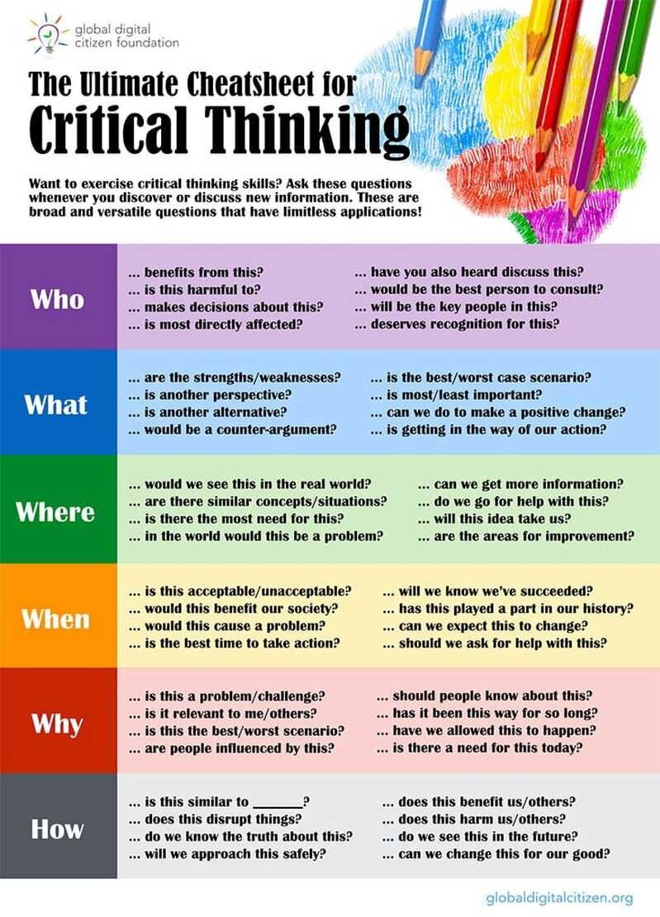

**Conclusion**

So I have looked at some to the skills needed to be able to develop yourself as a critical thinker. Just remember that becoming one is more about a consistent development and practice to reinforce the thinking habits of your ideas and opinions.

As teachers we need to help our students develop these habits, by encouraging them to be curious, sceptical and always remembering the human side to all things. Remind students to question their own thoughts, ideas and opinions and to evaluate these with opposing ideas from other students and evidence if available.

Try to at least once a week incorporate this into a lesson for the week and give students guidelines to follow and time to be able to do some research on the topic and discuss it within their teams. Remind them to keep open minds and not to try impart their own beliefs and skills onto the topic but make it a bias approach. Allow them to determine how credible the evidence is that they have found. And lastly allow them to make their own conclusions. Make sure they have the researched evidence and that they can present it is needed be.

The more we practice critical thinking in every day situations the more it will become and automatic part of our lives, allowing us to take this with us in the future to any career we would like to follow as it is a very important skill to have.

**Bibliography**

[**https://www.google.com/search?q=what+is+thinking&rlz=1C1CHBH_enZA939ZA940&oq=what+is+thinking+&aqs=chrome..69i57j0i512l9.3736j0j7&sourceid=chrome&ie=UTF-8**](https://www.google.com/search?q=what+is+thinking&rlz=1C1CHBH_enZA939ZA940&oq=what+is+thinking+&aqs=chrome..69i57j0i512l9.3736j0j7&sourceid=chrome&ie=UTF-8)

[**https://pz.harvard.edu/thinking-routines**](https://pz.harvard.edu/thinking-routines)

[**https://www.thoughtco.com/how-to-facilitate-learning-8390**](https://www.thoughtco.com/how-to-facilitate-learning-8390)

[**https://www.rasmussen.edu/student-experience/college-life/critical-thinking-skills-to-master-now/**](https://www.rasmussen.edu/student-experience/college-life/critical-thinking-skills-to-master-now/)

[**http://www.talenteducation.eu/toolkitforteachers/challengingyoungchildren/assets/Uploads/Document/4afa03a493/Thinkers_Keys-Tony-Ryan.pdf**](http://www.talenteducation.eu/toolkitforteachers/challengingyoungchildren/assets/Uploads/Document/4afa03a493/Thinkers_Keys-Tony-Ryan.pdf)