**Cover Page**

**MAY 24TH, 2022**

**TINA RASMUSSEN**

**STUDENT # A9UB71796**

**BASICS OF NUTRITION**

**ATLANTIC INTERNATIONAL UNIVERSITY**

**INTRODUCTION**

According to the World Health Organization, a very important aspect for health and development is nutrition.

**T**he stages of nutrition are ingestion, digestion, absorption, transport, assimilation, and excretion. Nutrition is the process of which food is chewed, swallowed, and digested. The absorbed nutrition from the consumed food is used by the body for growth, metabolism, and repair of the body. Nutrition can be described as the process by which substances in food are changed into body tissues and supply energy for the physical and mental activities that make up the human life. Nutrition is also the process in which one obtains food necessary for health and growth. Good nutrition alleviates the risk of a compromised immune system. It lowers the risk of non-communicable diseases, such as cardiovascular disease and diabetes.

Nutrition plays one of the most important roles in our daily lives. As we consume food or liquid, each contains a particular nutrient which is necessary for our mental health and physical growth. Any level of nutrition is essential for our body.

In addition, nutrition focuses on individuals use of dietary choices to minimize the risk of diseases. When individuals do not use the correct balance of nutrients, in their diet, there is a severe risk of the development of grave health conditions. There is the concept of macronutrients which refers to the nutrients that are needed in relatively large amounts.

**What is a balance diet?**

A balanced diet is one that consist of a wide variety of foods which provides enough nutrients that the body needs to be healthy.

The kind of diets that we consumed helps with our overall health. We should eat food in portions, hence the right amount that is digested will allow us to maintain a healthy weight.

Most of the daily diet should come from:

* Fruits
* Vegetables
* Legumes/ Beans
* Grains
* Nuts and seeds
* Lean meats
* Water

Guidelines are as follows for males and females:

|  |  |
| --- | --- |
| **Person** | **Calorie requirements** |
| Sedentary children: 2–8 years | 1,000–1,400 |
| Active children: 2–8 years | 1,000–2,000 |
| Females: 9–13 years | 1,400–2,200 |
| Males: 9–13 years | 1,600–2,600 |
| Active females: 14–30 years | 2,400 |
| Sedentary females: 14–30 years | 1,800–2,000 |
| Active males: 14–30 years | 2,800–3,200 |
| Sedentary males: 14–30 years | 2,000–2,600 |
| Active people: 30 years and over | 2,000–3,000 |
| Sedentary people: 30 years and over | 1,600–2,400 |

Daily calories are important, there are certain foods that provide very little nutrients and are often refer to as “empty calories”. In addition to the type of foods the ingredients make the food nutritious.

* cakes, cookies, and donuts
* processed meats
* energy drinks and sodas
* fruit drinks with added sugar
* ice cream
* chips and fries
* pizza
* sodas

Picture of a plate of how our foods should be portion for a healthy diet.

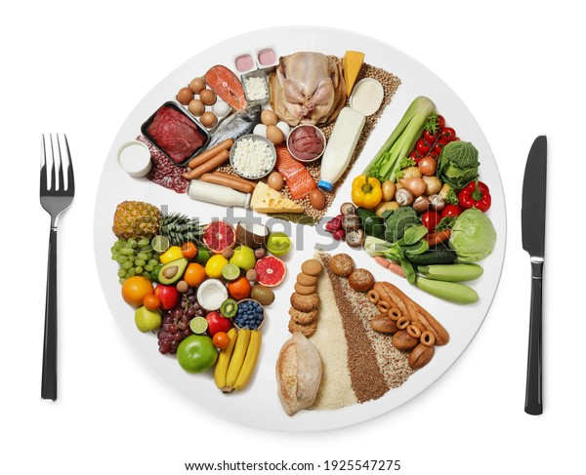

**Carbohydrates**

This is found in plant food. It can also occur in diary in the form of milk called lactose.

Bread, beans, potatoes, rice, pasta, and cereals are all foods high in carbohydrates. Carbohydrates are broken down by the body to produce energy which is their major role.

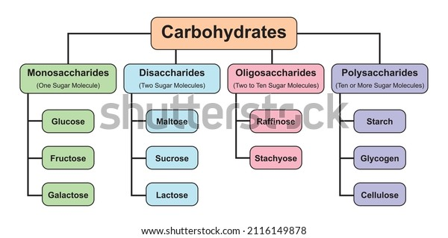

**diagraph of the breakdown of Carbohydrates**

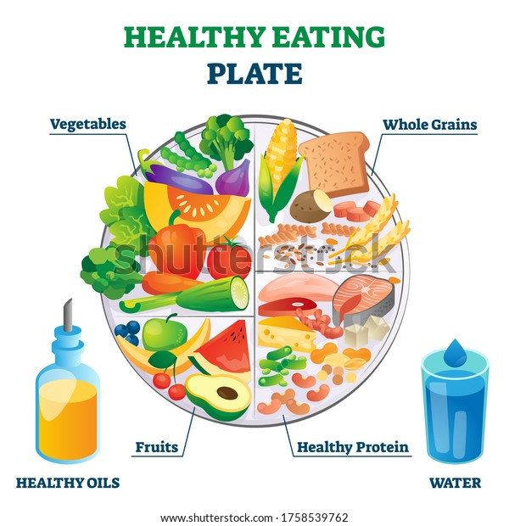

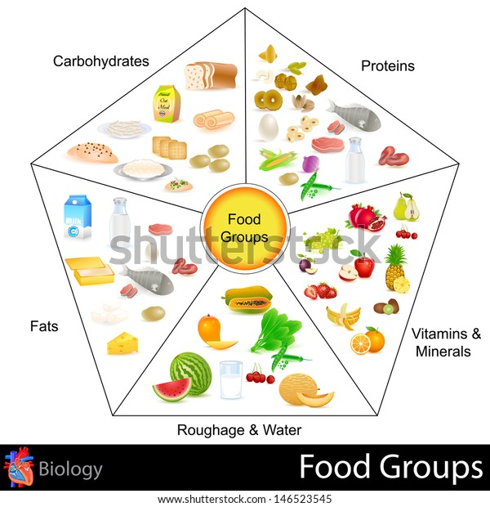

[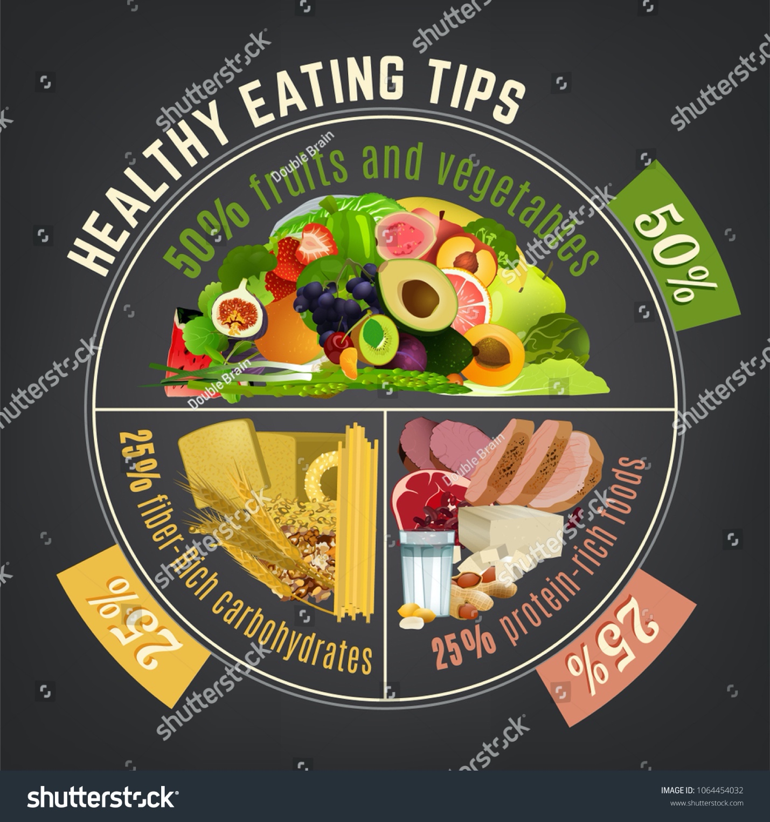](https://www.shutterstock.com/image-vector/healthy-eating-plate-infographic-chart-proper-1064454032)



**BASICS OF NUTRITION VIDEO**

**CONCLUSION**

Nutrition can be divided into two groups – macronutrients and micronutrients. Macronutrients refer to those nutrients that are needed by the body in large amounts. These provide the body with calories that help to prevent diseases and ensure the body remain healthy. Each of the identified categories vary in demands in terms of the individual’s weight, age, and any preexisting health conditions.

* Carbohydrates
* Proteins
* Fats

On the other hand, micronutrients are those nutrients that are needed by the body in smaller amounts.

* Water Soluble Vitamins
* Fat Soluble Vitamins
* Minerals
* Water

These two categories of Nutrients are required in varying amounts for the effective and efficient functioning of the whole body. Each has its own function to perform.

**BIBLIOGRAPHY**

<https://www.nhs.uk/live-well/eat-well/how-to-eat-a-balanced-diet/eating-a-balanced-diet/>

<https://www.shutterstock.com/image-vector/healthy-eating-plate-vector-illustration-labeled-1758539762>

<https://www.shutterstock.com/search/healthy+eating+plate?PPC_GOO_US_IG-555161141972&cr=c&kw=&c3apidt=71700000074097972&gclid=EAIaIQobChMIt8TOpofp9wIVCJyGCh2EHwhEEAAYBiAAEgKVgfD_BwE&gclsrc=aw.ds>

<https://www.youtube.com/watch?v=O-o3B9Q8S-4&t=13s>