Your name

**UB70199BBU79348**

COURSE NAME:

**Human Rights 3- AIU Course**

Assignment Title:

**Essay Answers on the Question to Human Right 3 Course: Right to Life**

ATLANTIC INTERNATIONAL UNIVERSITY

**April/2022**

**TABLE OF CONTENT**

* Introduction
* Body & Analysis
* Recommendation
* Conclusion
* Bibliography
* Appendices

**INTRODUCTION**

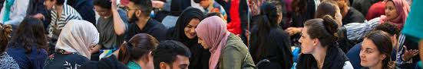 **Figure 1: Diagram showing some scene where women are denied their right to life.**

The Human Rights 3 is an introduction that simply is not being respected in a lot of countries as at today mostly in the aspect of the African Continent where the Government of some African Nations are using their decisions to be able to affect the lives of human beings especially through the example of the diagram of the information that is officially written above in the diagram indicated in Figure 1 where females and children are being denied rights to life which they are most victim in the regards of the rule that is going to talk about the ,meaning of Rights to Life.

**BODY & ANALYSIS**

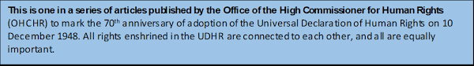**Figure 2: Explanation of the Human Rights Process talking about the Human Rights rule 3 in the society.**

The diagram on the Article 3 on Human Rights simply meajns that everyone regardless who you are have the full official rights to life, freedom of liberty and full protection rights provided that you are able to follow the rules of the constitution of your country with the guidance of the declaration of the human rights of United Nations which some context to it has been officially indicated in the Diagram that is officially written in Figure 2 that is shown above. The Human Rights 3 according to the law is not considered to be basic rights as it is recognized as Fundamental Rights regardless of your gender and your financial status because it makes us to realize that our parents gave birth to us free and equal. Right to life is a major issue that is causing a# lot of threats and issues that are affecting the growth and dignity of a# certain region at a certain time and some of the things that are affecting the growth of Human Rights 3 can be reduced when we are about to do the following that is listed above: Speak uo on the things that you officially care about. Volunteer or donate to an Organization. Choose free and fair ethically gifts from people in the society. Stand up against any form of discrimination. Stay connected with social movements. Listen to others stories and use it to be able to weigh your decisions as some might be right or wrong. Once you are able to do this you would be able to give people an opportunity to enjoy a free and healthy life in the society as they progress as an example of this format is the father and child diagram that is officially shown in Figure 3 below:-

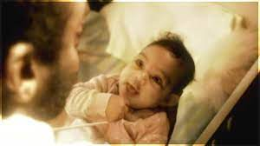 **Figure 3: Picture of a Father and its child enjoying the privilege of human rights in the society.**

There are challenges in the society that is affecting the rules of Human Rights for it to be able to grow in their career journey as this process can come in different forms but the first thing that you must understand that right to life has a limitation because it doesn’t ask us to become a criminal in our activities as the other aspect of the challenges that are affecting right to life are: Poverty and Global Inequalities, Discrimination, Impunity, Weak Institutions with Armed Conflicts and Violence in the society. During the declaration of the human rights by the United Nations which the diagram in figure 4 below of Roosevelt where he had already identified that the biggest challenge that countries and organizations would face in the future in terms of implementation is that there would be no mechanisms for them to be able to implement some of the policy in the Human Rights sector.

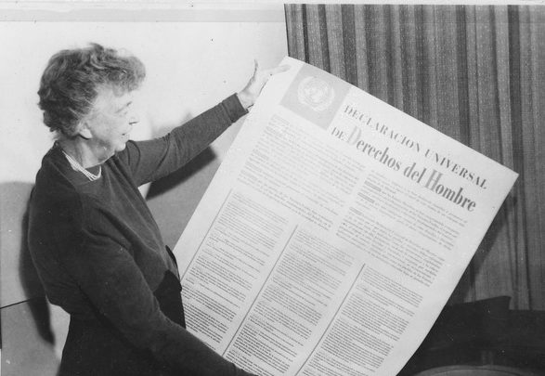 **Figure 4: Picture of Roosevelt holding the picture of the UDHR Rule 3 challenge in 1984 in Geneva Switzerland.**

The Future would have a greater challenge in terms of dealing with the situation of the issues that are around us today is the part of climate change which would most likely affect the security situations of things where things like torture, inhuman or degrading treatment or rape allegedly as an example is the picture that is officially indicated in the diagram that is officially shown in Figure 5 that is officially shown below of a woman being handcuffed and about to be raped.,

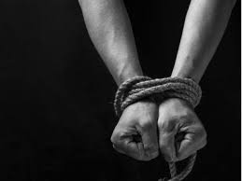 **Figure 5: Picture of a domestic violence of a woman being handcuffed and is about to be raped.**

The diagram below which is officially indicated in Figure 6 is an example that shows how Human Rights Violence is being recorded across the world in a study data analysis during the period of COVID-19 and things that are surrounded by this particular action that is been officially taken.

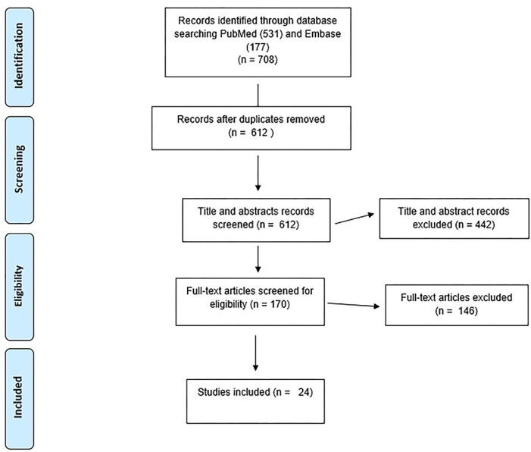

**Figure 6: A Study Data Analysis on Human Violence that is officially taken place across the world**

I would like to conclude my essay on giving a clearer context on the full difference between Justice and revenge as the two parts is common which is similar to the diagram that is officially indicated in Figure 7 having to do with the law. Justice is a fair hearing exercising his rights in a moralized form of equity, fairness and Law. Revenge in the other hand which sometimes comes in the form of taking back your own actions to things that comes in a form of wrongdoings especially sometimes when you don’t understand.

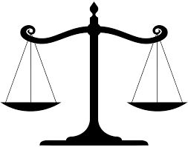 **Figure 7: Diagram showing the symbol that represents the law in form of actions of justice and doing illegal wrong doings.**

**RECOMMENDATION**

Let me start my recommendation by talking about my experience from this course on what I learnt and regardless of the things that I have seen in my life so far in my career. The first thing that I have said I would consider is the fact that I officially need to review and revisit the information that I have heard that has been able to control me on the full rights of tradition analysis that I have been listening to especially knowing the facts that my rights are not fully shown and I am unable to use them daily with the fact that I also need to be able to check the kind of books that I am going to read in terms of being able to build this human rights in the society especially looking towards being able to explore on more solutions on how I am able to use my knowledge to be able to connect the rules in the society through some of them that has been officially written in the diagram that has been officially written in the diagram shown in Figure 8 that is below:

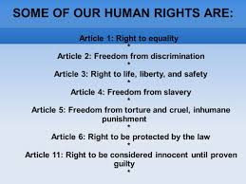 **Figure 8: Diagram showing some of the rules of human rights in the society connected together.**

I would always remember that in the future that there is a full structure of important that I need to be able to make sure that for my organization and my personal business that I am able to have a legal officer who would be able to have shown me some personal things that I need to be able to understand from my personal life to business life as I continue to heal towards things that are being important for the draft for the future that we intend to create that would make me to be able to stop performing any illegal act. .

**CONCLUSION**

Let me conclude that in the future that I would always remember that everybody including myself has a right to life regardless of the truth but I would go and sit down and think something’s out before I am able to make any strategic decision that would affect the growth of the future and in the light of this journey which is an important affair as aome of the things that I inend to go while going forward in life is by reading the particular book below that is officially shown in Figure 9.

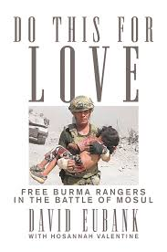 **Figure 9: Proposed book that I intend to read on love having to do with Human Rights in the society of Article 3.**

**BLIBLIOGRAPHY**

Equalityhumanrights.com. 2021. *Article 2: Right to life | Equality and Human Rights Commission*. [online] Available at: <https://www.equalityhumanrights.com/en/human-rights-act/article-2-right-life> [Accessed 2 April 2022].

Candle, P., n.d. *6 Ways to Protect & Support Human Rights for People Around the World*. [online] Prosperity Candle. Available at: <https://www.prosperitycandle.com/blogs/news/6-ways-to-protect-support-human-rights> [Accessed 2 April 2022].

Standup4humanrights.org. n.d. *Stand up for Human Rights*. [online] Available at: <https://www.standup4humanrights.org/en/article.html> [Accessed 2 April 2022].

**APPENDICES**

Figure 1: Diagram showing some scene where women are denied their right to life.

Figure 2: Explanation of the Human Rights Process talking about the Human Rights rule 3 sin the society.

Figure 3: Picture of a Father and its child enjoying the privilege of human rights in the society.

Figure 4: Picture of Roosevelt holding the picture of the UDHR Rule 3 challenge in 1984 in Geneva Switzerland.

Figure 5: Picture of a domestic violence of a woman being handcuffed and is about to be raped.

Figure 6: A Study Data Analysis on Human Violence that is officially taken place across the world

Figure 7: Diagram showing the symbol that represents the law in form of actions of justice and doing illegal wrong doings.

Figure 8: Diagram showing some of the rules of human rights in the society connected together.

Figure 9: Proposed book that I intend to read on love having to do with Human Rights in the society of Article 3.