Your name

**UB70199BBU79348**

COURSE NAME:

**Marketing Research-AIU Course Creation**

Assignment Title:

**Essay on Marketing Research in an Organization**

ATLANTIC INTERNATIONAL UNIVERSITY

**February/2022**

**TABLE OF CONTENT**

* Introduction
* Body
* Analysis
* Recommendation
* Conclusion
* Appendices

**INTRODUCTION**

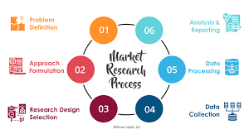 **Figure 1; Diagram showing the process of Marketing Research**

In an Organization, from the diagram 1 that has been indicated above this would help you towards being able to understand the viability of your products from a developed process through a conversation between members of the particular organization along with potential customers that would help in the process of being able to help with decision making. In Marketing Research most times the process always comes in the format of systematic, objective as well as analytical surrounding with the making of decision towards being able to create profitability and presence within a particular market sector in the community .

**BODY**

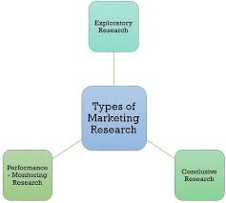 **Figure 2; Diagram showing the Types of Marketing Research**

Let me start the body of my essay by being able to describe some of the things that are involved in the areas that are involved in the process of Marketing Research. From the diagram written in Figure 2 that is indicated above it simply shows the 3 types of marketing research that are in an organization which this process raises what objectives are mostly behind every marketing research in the organization which is being shown in the diagram through Figure 3 that is been written below:-.

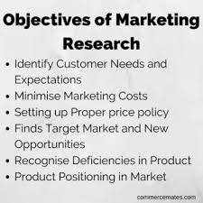 **Figure 3: Diagram showing the write-up of the Objectives of Marketing Research.**

Now in defining, Marketing Research in an Organization we can simply say that it is the process that is being used in the determination of the viability and decision making of a new service or products through research that has been conducted directly with potential customers. Research can be conducted most time in different formats which some of them are: In-house research, Companies outside that specializes in Market Research and Company personal research. There are seven types of marketing research and they are: Competitive Analysis, Customer Decision Journey, Pricing, Brand Awareness, Market Segmentation, Product Analysis and Marketing Message testing. Through the types of marketing research, the main 4 techniques that are involved in the area of marketing research are: Surveys, interviews, focus groups and Customer Observations. In the market study research there are things that defines what the process are it is helping in the analysis in a proactive market demands that shows the effect of products and services that influences the demand for the position as well as the demand that is being found in the market. The kind of marketing research that is mostly involved in an organization are being indicated in the diagram that is being shown in figure 4 below:-

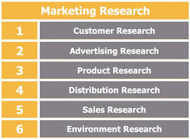 **Figure 4: Diagram showing the types of Marketing Research taking place.**

Sampling in Marketing Research is a very important criteria that can be used in the determination of trying to generate results to that particular research and they are of two types basically which are: Profitability and Non Profitability Sampling of Marketing. In Marketing Research, The goals that are driven towards the impact of the presence of why it is needed in an organization are: Making Important Business Decisions, Securing Investments and Funding, Determination of new business opportunities and Avoiding Business Failures. The diagram that is below shows the diagram of marketing research example result that is been generated in a particular organization after they have used the different method techniques to be able to generate the results that they want to have in their organization.

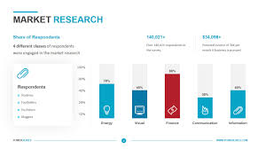 **Figure 5: Diagram showing an example of Marketing Research**

Through, the goal of marketing research which it is usually known to be written in the marketing research plan it can be determined that some of the importance that is officially involved in the process are: It helps you to be able to test your product before launch, you are able to understand your customers better through the process, competitors use different marketing techniques in their operations as different companies have separate goals for their brands. There are disadvantages of marketing research in an organization and some of these are indicated in the diagram that has been indicated below

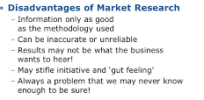 **Figure 6: Diagram showing the Disadvantages of Marketing Research**

The diagram that has been indicated in figure 5 that is going to be below is generally some of the context that is used to explain the purpose of doing a marketing research and how it works in an organization.

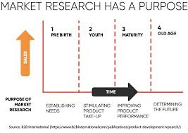 **Figure 7: Diagram showing the purpose of Marketing Research**

In Summary to my analysis of marketing research that when you are in the process of making a research for an organization there are needs you should investigate before you begin to proceed in doing the assignment for the company as this helps you to speak towards the records of the organization and these are officially written in the diagram of figure 8 that is below:

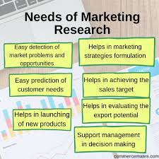 **Figure 8: Diagram showing the Needs that is required in Marketing Research**

**RECOMMENDATION**

I would start my recommendation by sharing some of my biggest takeaways from the marketing research course which is a very important context in every organization globally You need to be able to understand the purpose of why you want to do it by being able to most importantly check your source of the information that you put into the document and most importantly by being able to hire a marketing research analyst who would be able to review and analyze your source. I would understand that in the future the importance of being able to market research by being able to generate a research design analysis as well as being able to understand the types of them which some of them are officially being indicated in the diagram that is officially written in figure 9 below:

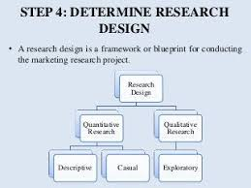 **Figure 9: Diagram showing the Research Design Determination for the Market**

**CONCLUSION**

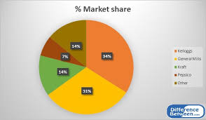 **Figure 10: Diagram showing an example of an Organization Market Share**

Let me start my conclusion of my essay by saying that Market Research may not be easy as we all look at it but once you are able to put yourself into this particular business you must be able to understand the percentage of how a market share basically works in an organization in which example has been basically illustrated in figure 10 that has been indicated above due to the fact as there are a lot of complexity but the process of research is always the same especially in the areas that is surrounding it depending on the type of business that is being involved which the future analysis can be made in the determination through forecasting of what is likely going to happen ahead in the business. When you are doing a marketing research there are main key areas that are being identified in the process and these can come in the form of Administration, Economical and Social Research serving different areas form of the organizational development.

**BIBLIOGRAPHY**

Twin, A. and Drury, A., 2021. *What Market Research Tells Companies About New Products and Services*. [online] Investopedia. Available at: <https://www.investopedia.com/terms/m/market-research.asp#toc-what-is-a-market-study> [Accessed 14 February 2022].

Grenier, L., 2021. *A Comprehensive Guide to Market Research: 4 Proven Methods | Hotjar Blog*. [online] Hotjar.com. Available at: <https://www.hotjar.com/blog/market-research/> [Accessed 14 February 2022].

Free Management Library. 2022. *How to Conduct Market Research - Free Management Library*. [online] Available at: <https://managementhelp.org/marketing/market-research.htm> [Accessed 14 February 2022].

**APPENDICES.**

Figure 1; Diagram showing the process of Marketing Research

Figure 2; Diagram showing the Types of Marketing Research

Figure 3: Diagram showing the write-up of the Objectives of Marketing Research.

Figure 4: Diagram showing the types of Marketing Research taking place

Figure 5: Diagram showing an example of Marketing Research

Figure 6: Diagram showing the Disadvantages of Marketing Research

Figure 7: Diagram showing the purpose of Marketing Research

Figure 8: Diagram showing the Needs that is required in Marketing Research

Figure 9: Diagram showing the Research Design Determination for the Market

Figure 10: Diagram showing an example of an Organization Market Share