Your name
UB70199BBU79348

COURSE NAME:
Credit Management- Course Creation

Assignment Title:
Essay on Credit Management for an Organization

ATLANTIC INTERNATIONAL UNIVERSITY
February/2022

TABLE OF CONTENT
- Introduction
- Body
- Analysis
- Recommendation
- Conclusion
- Appendices

INTRODUCTION
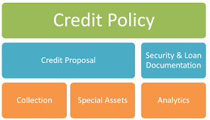 Figure 1: Diagram Showing Areas of Credit Policy in the Credit Management System
In credit management the diagram that has been shown above in Figure One speaks about some of the areas involved in the policy management which we need to understand the policy context in every single angle line development of how the risk is going to take place by knowing how to guard yourself through an action plan in the play of knowing the practice to use through the current situation that is currently taking place at hand towards avoiding defaults or late payments of business when you are able to understand the percentage interest and loss between the finance management and your company which works on a certain time frame. Many businesses have elapsed today based on the fact that they have been unable to solve the challenge by creating an action plan based on the realities in place as well as that they are having with customers in their business as this process has led to the fact that company has led to a lot of bankrupt with the loan company that has been able to do the credit for them which they have to go through the illegal process through a department known as the debt recovery which this process has destroyed things that is over the exceeded amount or interest that they have borrowed for their certain purpose towards the direction of their next level of business.
BODY & ANALYSIS
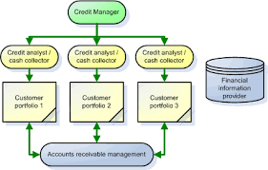 Figure 2: The Sector Wing Diagram of Credit Management of people in the Organization.
Let me start the body of my report that before I start to talk about the fact that in a company that the person that is involved in the operations of credit management is known as the Credit Manager as the diagram stated above in Figure 2 explains some of the roles and people that are involved in the process of lending credit to customers for the certain period. When the credit manager is performing his duties there are 5Cs that are being used to determine the credit process and these C are: Character, Capacity, Collateral, Conditions and Capital.
We can now explain and define credit management as a plan of action that is being established by owners of organization towards being able to guard against defaults or late payments by customers which is expected to be able to happen within a certain particular timeframe by being able to understand the process of protecting the cash flow of your business. There are so many reasons towards being able to identify the process objectives of credit management in an organization towards the business process and diagram 3 which has been indicated below talks about some of these objectives and how it is going to affect our future and all the philosophy ahead of the journey for the growth.
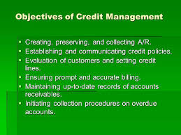 Figure 3: Diagram explaining the Objectives of Credit Management.
Credit Management has two process in monitoring the control movement and they are the qualitative (an example is the bank rate) which is generally also known as the General Methods and quantitative process also known as the Selective Methods (an example is the credit rationings). Through the diagram that has been indicated below other parts which makes up the Quantative and Qualitative analysis.
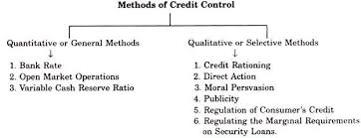 Figure 4: Diagram Explaining the Methods of Credit Control in a System Development.
In Credit Management, There are Seven types of the process which is used in saving you time in the journey and these are:- Dairies Courtesy Call, Use a debt collection agency, Perform Regular Credit Checks, Send Invoices electronically, Tighten the credit terms for some selective customers, Invest in Training, Prioritize Invoice. When you are working towards developing a credit management strategy the following guidelines should be used : Define your credit Management Process, Create and Establish the Client Credit Picture, Show documentation to support the credit and debit worthiness and monitor the progress of the payment that is being made. In Credit Management there are ways of improving the risk of dealing with Credit Finance and the debt process of a company and these have been listed in the diagram that has been indicated below;
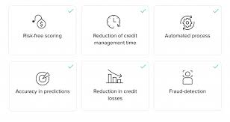 Figure 5: Diagram Explaining the Process on how to improve the Credit Management Structure
In Credit Management, It is very important to be able to understand the data rundown that you are going to collect from the customer involved, Some of the required information that is helpful when wanting to collect information are:- Talking about the Importance of Credit Management we can simply say that it helps to reinforce the liquidity of a company by presenting positive relations of the customer towards being unable to have a low debt financial portfolio with the credit management company. During the period of making credit transactions the following are the barriers that are being used in the process that is being used in granting the transaction to a customer in any company.
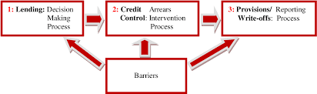 Figure 6: Diagram Showing the Criteria’s of Credit Transaction by any Credit Management in a company.
When dealing with Credit Management, Some of the process that is used in granting goods to a customer towards being able to maximize the returns of profit has been indicated in the seventh diagram trail that is being indicated below which the other diagram following it in Figure 8 would explain the performance towards being able to evaluate the credit management.
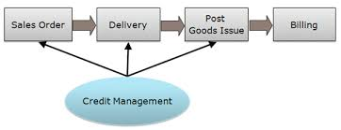 Figure 7. Diagram explaining the process of delivering Credit Management to a Company
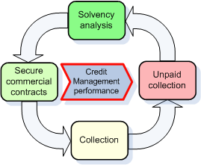 Figure 8: Diagram showing the Criteria towards being able to evaluate Performance of Credit Management
Let me now conclude my body analysis by saying that some of the ways that in credit management that is being used towards being able to determine the mat is used in the determination of quality control in a business is being displayed in diagram 9 below
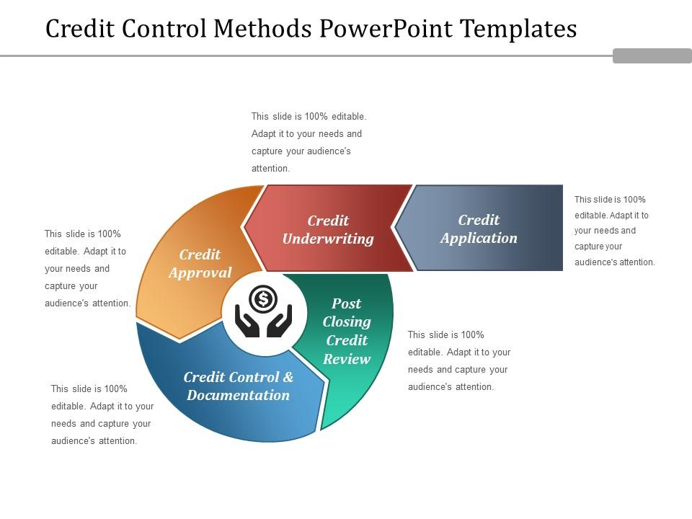 Figure 9: Diagram showing the credit control methods that is being used in an Organization

RECOMMENDATION.
Let me start my recommendation of my credit management process firstly by saying this course has been able to expose me to a lot of things when I am dealing with my financial management development by telling me on how I should deal with funds that comes into my hands by putting a balance check flow . Inculcating a data analyst is also an important factor that I intend to generate in my account system when dealing with clients in different respective of the organization by using the diagram in Figure 9 below towards being able to know and learn how to maintain the risk of credit management in an organization .
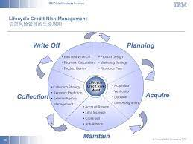 Figure 10. Diagram explaining the process of maintain credit risk management
Going forward I would be able to use the diagram below towards being able to analyze and use the formula that has been indicated through diagram 10 below to look through how Credit Management is going to run in my organization
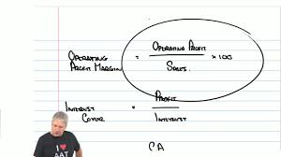 Figure 11: Some Mathematical Formula that is involved around the system of Credit Management

CONCLUSION
In Conclusion Let me say by ending my essay on Credit Management that you need to be able to understand the philosophy of credit control through the flowchart diagram that has been indicated in the diagram 11 on the essay across different levels of your business in order for you to be able to know how to control the management of your credit finance through this you are able to view the importance of credit control through the diagram that has been indicated below in Figure 12 on the effect of being able to determine in your business
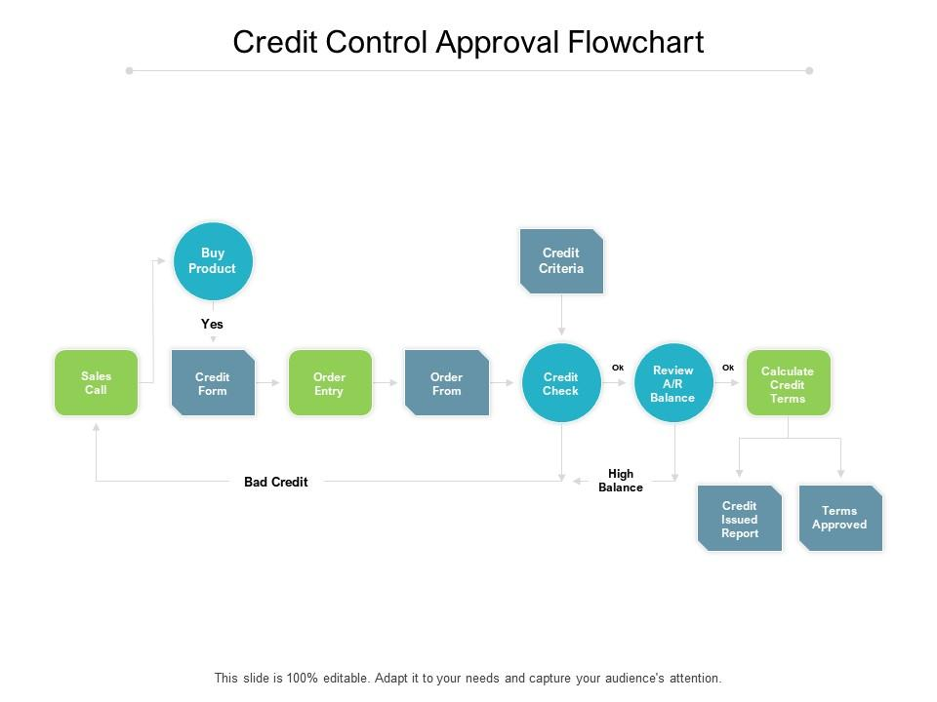 Figure 12: Diagram showing the Credit Control Approval Flowchart in a Company 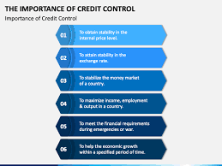 Figure 13: Diagram showing the Importance of Credit Control in an Organization
In addition that I would like to say that once you are able to understand the importance of credit control approval firstly in diagram 13 the credit control management place can be put in place through the diagram that has been indicated below after that you would now be able to find the main benefit through the diagram 13 indicated below on the importance of why there must be cash flow through credit control
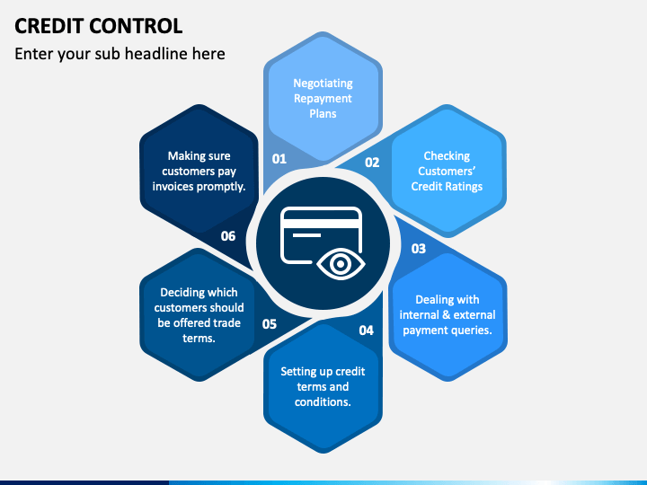 Figure 14: Diagram Showing the Criteria Used in Checking Credit Control
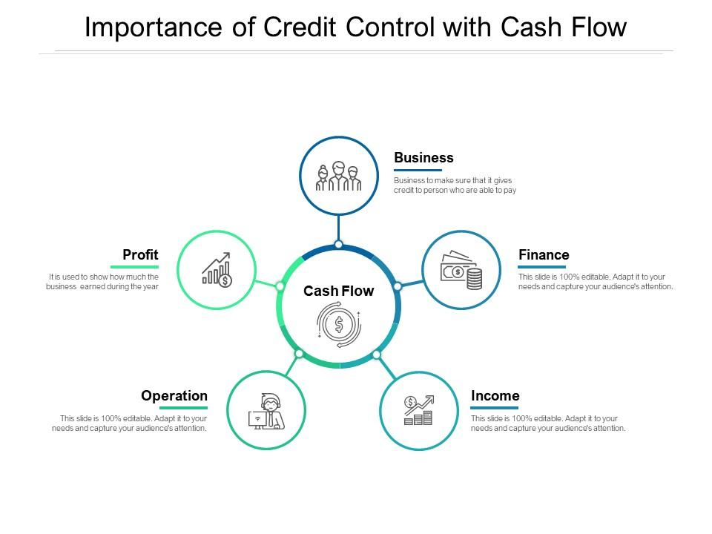 Figure 15: Diagram Showing the Importance of Credit Control with Cash Flow in an Organization

BIBLIOGRAPHY
Hermes, E. and Insights, N., 2021. What is credit management and what are its benefits | Euler Hermes. [online] Euler Hermes. Available at: <https://www.eulerhermes.com/en_global/news-insights/business-tips-and-trade-advice/what-is-credit-management-and-what-are-its-benefits.html#:~:text=Credit%20management%20refers%20to%20the,with%20your%20company's%20credit%20policy.> [Accessed 8 February 2022].
Hilton-Baird Collection Services. 2021. 7 Credit Management Techniques That Will Save You Time | Blog. [online] Available at: <https://www.hiltonbairdcollections.co.uk/7-credit-management-techniques-that-will-save-you-time/> [Accessed 8 February 2022].
KENTON, W. and BROCK, T., 2021. Credit Control. [online] Investopedia. Available at: <https://www.investopedia.com/terms/c/credit-control.asp> [Accessed 8 February 2022].
APPENDICES.
Figure 1: Diagram Showing Areas of Credit Policy in the Credit Management System
Figure 2: The Sector Wing Diagram of Credit Management of people in the Organization.
Figure 3: Diagram explaining the Objectives of Credit Management.
Figure 4: Diagram Explaining the Methods of Credit Control in a System Development.
Figure 5: Diagram Explaining the Process on how to improve the Credit Management Structure
Figure 6: Diagram Showing the Criteria’s of Credit Transaction by any Credit Management in a company.
Figure 7. Diagram explaining the process of delivering Credit Management to a Company
Figure 8: Diagram showing the Criteria towards being able to evaluate Performance of Credit Management
Figure 9: Diagram showing the credit control methods that is being used in an Organization
Figure 10. Diagram explaining the process of maintain credit risk management
Figure 11: Some Mathematical Formula that is involved around the system of Credit Management
Figure 12: Diagram showing the Credit Control Approval Flowchart in a Company
Figure 13: Diagram showing the Importance of Credit Control in an Organization
Figure 14: Diagram Showing the Criteria Used in Checking Credit Control
Figure 15: Diagram Showing the Importance of Credit Control with Cash Flow in an Organization

