Your name

**UB70199BBU79348**

COURSE NAME:

**Mid Academic Summary Report-AIU Leadership**

Assignment Title:

**Essay on Mid Academic Summary Report-AIU Leadership**

ATLANTIC INTERNATIONAL UNIVERSITY

**May/2022**

**TABLE OF CONTENT**

* Introduction
* Body & Analysis
* Conclusion
* Appendices

**INTRODUCTION**

I have been having a wonderful experience studying at the Atlantic International University over the last years as there are so many stories to tell and things to write about as we prepare for the journey that is ahead of us in the Future beyond the institution as I got the opportunity to see real life views of the world comparing to all the lies and fake information that I have spent all my years listening to growing up. Dr Edward Lambert has been able to give me full example of the full definition of hope that things can be fixed regardless of whatever the world has to officially say about you on that particular issue. Miss Maricela and Mr Tobi has also joined by supporting me to be able to push more towards being able to understand the importance of how you must be able to push yourself to be able to achieve the required goals that would help your career to be able to push forward.

This institution has helped me in bridging the gap between what is at stake and being able to help me towards drive the kind of future I need to recreate by helping me to take a step back towards the difference of helping me in define the difference between tradition and professionalism for the future growth especially when you are dealing with people who are your seniors or are within the old age category. Atlantic International University has been able to make me to realize the effectiveness of making me to be able to direct my journey from being Non Profit personnel which I was officially to the point of why I need to focus and build more on my entrepreneurship journey as a person who desires growth on a legacy level and make sure that I am able to focus on a scale towards building a maximum profit level when It is officially being required especially with the fact that I was able to rebrand and get a proper family of leadership to be able to drive the new growth of this particular business forward in our respective career that is needed.

**BODY & ANALYSIS**

There are too many stories too write about my story at the Atlantic International University (AIU) today to where exactly I am headed towards my future knowing the path keeps getting clearer daily for me. One thing that I would never forget in the future is the fact that you can please everyone in life especially when it comes to running a business which I have being doing without putting any law or principle as well as putting a legal adviser into this task journey. Which Dr Edward has been able to share some insights with me on how matters can be done when especially when you are trying to run a journey? I am someone who has been protecting people in order to get myself into trouble many times in my life especially with the mentality of tradition when you have to deal with your seniors who carry recorder to a meeting as a means of generating harassment around people in your journey. as a means of slavery sometimes but I have been able to come to the fact through my learnings with the Atlantic International University that I must take a step back especially by making people know what the rules of my principles and how I intend to work with organization before I proceed to do any assignment with them. I have also made it clear through my learnings at the Atlantic International University that I do not have to be front all the times sometimes I need to be either at the back or in the middle especially when these things are not my line of field assignment when I am proceeding on my journey towards being able to build the African Village Organization and in any other place that I might to choose to work in going forward in my life as I have come to realize one learning that in life sometimes the answer to everything is not always about age but it is about some of the personal decision or the kind of tradition that you have officially choose to come from generally as a person especially to be able to learn to how to position myself especially when I am writing about things or activities that has happened to me from the past till the current century.. .

AIU curriculum has also exposed me through data analysis on the part of the Quantative methods with the support of Qualitative methods that I must learn to be able to use influence to be able to check my performance with some of the decisions that I am officially making around the things that I do and to be able to know how to prepare for the future that is officially ahead of us in our respective career that we want to have especially in the fact of knowing how to deal with people management with the analysis that is not everything that has to do with leadership in your career that you have respond to as sometimes you must officially learn how to walk away with joy towards building a successful career that you desire to have. While some people are trying to tell me to focus on going to learn and grow more better knowing the fact that there are so many insecurities that I see around me especially when they see young people that are doing something’s well by trying to destroy their reputations without generating any proof of evidence lor creating false evidence that has no back up sometimes to some of their actions to what they are saying specifically. Atlantic International University is continuous reminder that as I intend to start running this new brand that I am officially working on as the logo that is indicated in Figure 1 as shown in the diagram below I must always remember the fact that security management is always important and must not hire people who do not understand the ethics of how to respond to security issues in order not to be able to put other people into trouble where it is not meant to be so officially. AIU is a continuous reminder why you are trying to work hard to address the sustainable goals of the United Nations and how your presence would be off effect from your family, society and your entire generation at large on earth and beyond eternity. Through the Atlantic International University curriculum design I have been exposed to the fact of learning that whenever you are presenting a report to someone you must learn to understand that you do not write a report without ensuring that there are full pictures towards that particular report that you have been presenting on for example on the project PPR for IITA on some errors mistakes that I have been able to identify that where I wrote some information’s which I didn’t put any picture of me doing that information of the exact thing of what I am claiming to be doing at that particular thing. The diagram that is officially indicated in Figure Two (2) was an opportunity to be able to bring out the first product of App that would be launched by my organization which the Atlantic International University gave me the privileged to learn how to rebrand and restrategize my organization towards becoming a better person ahead of me.

 **Figure 1: Diagram showing the official logo of my new rebranded organization from my journey with the Atlantic International University.**

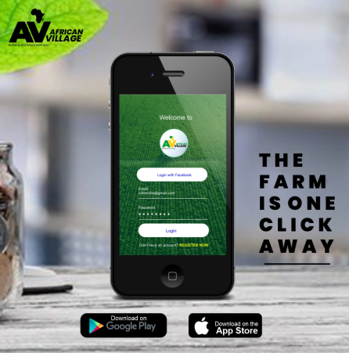 **Figure 2: Diagram showing the report of the first product that is to be launched in my organization.**

Through my knowledge with the Atlantic International University I have been able to understand the fact there is need to be able to determine and understand your issues of being able to determine the kind of Human Rescources that you need to be able to make your organization to be able to move forward in a way that you desire it to be in order to be able to know how to get the best tools to be able to drive your business forward to avoid the business from collapsing. Atlantic International University is changing my narrative as a person for the future that is ahead of me by opening the space by making people to be able to see the reality of things that builds the path that I am exactly headed at for the future. My experience with the Atlantic International University would be forever rembered as I am grateful to the Academic Committee and Administration as It is a way to honor my legacy with the institution beyond as well as having the opportunity to be able to use my skills to be able to add value to the society. In the diagram that is having figure 3 that is shown below is the cover of the book that was approved by the academic committee.

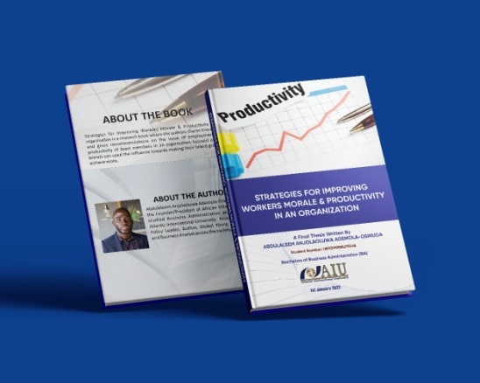 **Figure 3: Diagram showing the picture of my thesis E Book Cover as approved by the Atlantic International University.**

Atlantic International University is a continuous reminder that age should not be used an excuse for me not to be able to achieve my goal but rather see how my presence would be off added value to those that even older than me but be reminded that I must know when to be able to use the law and principle of professionalism to the effect of tradition that is being used in the society in order to be able to cause complication issues in the future for the company as well as all the activities that are meant to help you grow your business. Through my last period I have had the privileged to be able to continue to practice something that I had started before which I went back to the farm though I habe agreed to have a confrontation with my ex academic tutor until the academic dean had to tell me something’s during the academic thesis on some realities that had to do with life by going to the farm to finish my learnings with the International Institute for Tropical Agriculture in Ibadan Nigeria. The diagram that is in figure 4 below shows pictures of me in the farm with a work colleague and the supervisor on the site in the building.

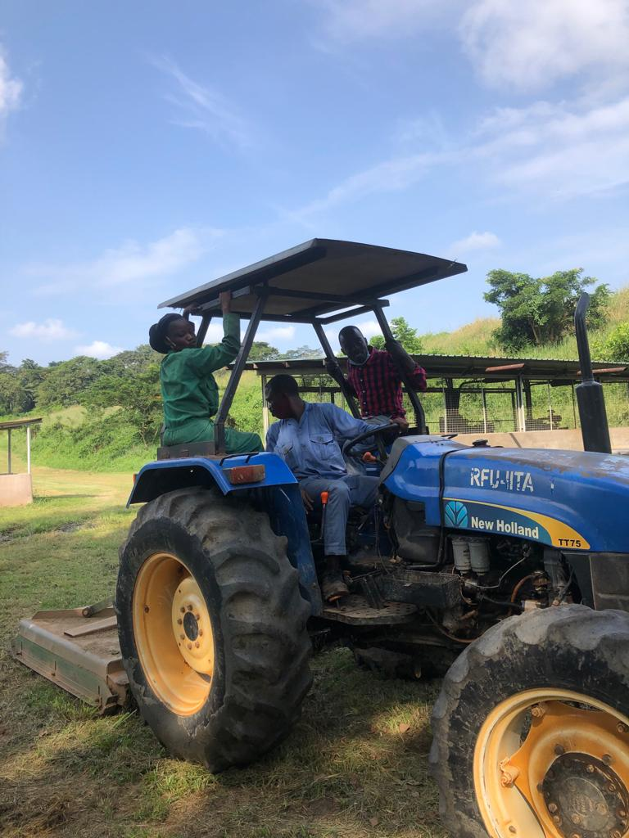 **Figure 4: Diagram of myself colleague and supervisor at the IITA Work Site when we were doing fabrication on the land.**

**CONCLUSION**

Let me start my conclusion on my journey so far with the Atlantic International University as a journey that is worthwhile and experience fully achieved. I have had the experience to be able to gain more tools that would be able to drive me as well as the fact that some of the conversations and learning experience feedback would help me towards being able to carry on my goal forward in life. Through the institution I have had more opportunities to be able to work towards being able to learn some more photography skills especially through the diagram that is indicated in Figure 4 below where I had the chance to be able to get selected to support a big sister outreach programme through the media learning as well as even the fact that some of the lessons Dr Edward has also helped me to be able to earn the opportunity of being selected as one of the top people to get selected at the 100 talks on business entrepreneurship in Nigeria which has enabled me towards being able to fix my mess as diagrams of conversation with people and pictures from the volunteer conference is shown in the diagram that is officially indicated in Figure 4 and 5 that is attached below:-

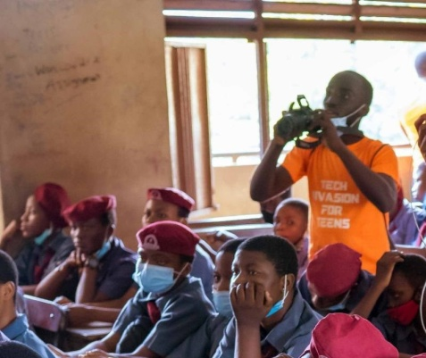 **Figure 5: Diagram showing the volunteer picture where I had the chance to be able to use my photography skill**

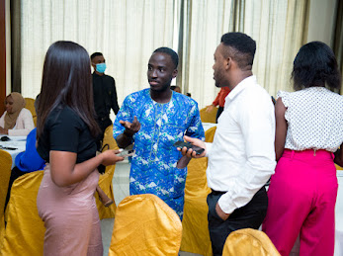 **Figure 6: Diagram showing myself having a chat with people at the 100 talk’s business summit on entrepreneurship.**

In addition let me add to my education that through this blessings of education I have been able to connect and have two great leaders and aunties whose pictures are attached below and were happy to join me to build African Village and we all move into the future together which I know and believe that together we can achieve our dreams for the future we ahead. I feel hope and I see a resounding joy ahead for me as a person. As a picture of me and one who serves in the administration is attached below in Figure 7 and the other personally is serving as the Vice President is attached in Figure 8 below:

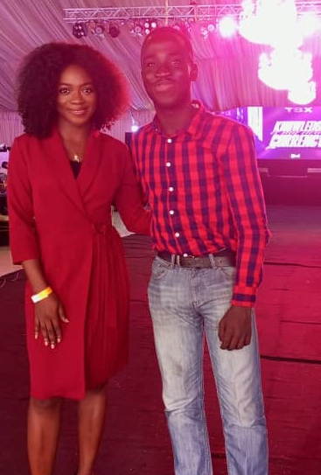 **Figure 7: Diagram of myself and the HOA of African Village at a Conference in Lagos Nigeria.**

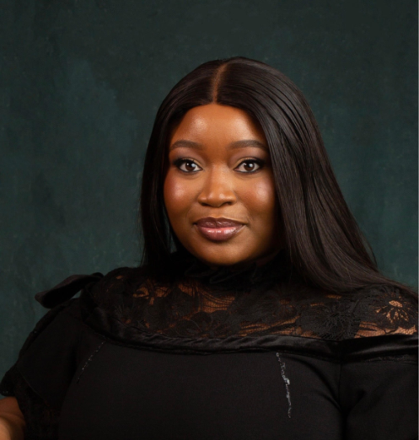 **Figure 8: Diagram of a Full Portrait showing the Vice President of African Village.**

Let me end my conclusion on the Mid lesson on my academic summary on Academic Summary saying every time spent with AIU especially the fact that the school had given me the opportunity to be able to express myself in every area of my life was a blessing especially with Dr Edward and Mr Tobi as I look forward to completing my academic journey where I am able to do some blogs online and share my story on how my last years with the institution has been officially especially looking forward to connecting with other people who are in the institution as well as those who have passed out from the institution.

AIU is home for learning and the Future is bright. I look forward to presenting my full academic summary soon where I have been able to share online tools on different blogs about the institution.

**APPENDICES**

Figure 1: Diagram showing the official logo of my new rebranded organization from my journey with the Atlantic International University.

Figure 2: Diagram showing the report of the first product that is to be launched in my organization.

Figure 3: Diagram showing the picture of my thesis E Book Cover as approved by the Atlantic International University.

Figure 4: Diagram of myself colleague and supervisor at the IITA Work Site when we were doing fabrication on the land.

Figure 5: Diagram showing the volunteer picture where I had the chance to be able to use my photography skill

Figure 6: Diagram showing myself having a chat with people at the 100 talk’s business summit on entrepreneurship.

Figure 7: Diagram of myself and the HOA of African Village at a Conference in Lagos Nigeria.

Figure 8: Diagram of a# Full Portrait showing the Vice President of African Village.