Your name

**UB70199BBU79348**

COURSE NAME:

**Business Statistics- Course Creation**

Assignment Title:

**Essay on Business Statistics**

ATLANTIC INTERNATIONAL UNIVERSITY

**February/2022**

**TABLE OF CONTENT**

* Introduction
* Body
* Analysis
* Recommendation
* Conclusion
* Appendices

**INTRODUCTION**

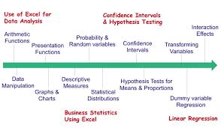

**Figure 1: Some Mathematical topics used in generating Data in an Organization.**

When we are talking about Business Statistics generally, Business Statistics is something that is most times that are usually being written in Greek Letters which is the science of being able to generate data and information into the business as this is a major criteria that is being used in the determination of the performance of the management as well as in the beginning when you are starting a business in the light of being able to conduct research and giving analysis to issues in the company. I am simply going to start my introduction by using it to refer the term on being able to know how to predict the future practices that would be needed to be able to run your organization through the current data and figures from the mathematical formula diagrams that are indicated above in Figure 1 through issues that are currently taken place as well as the ones that have been taken from the current happens in the organization which can be generated through a running statistics of all the services and profit margins that is being generated into the organization to be able to serve in a real world experience which many are missing today due to the quality of information that is being presented to them.

**BODY & ANALYSIS**

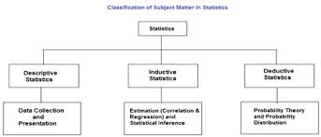 **Figure 2: Classification of Subject Matter that are involved in Statistics Diagram.**

Let me start my body of my essay by showing the diagram on classifications that has been indicated above which basically going to show more realities generally into the part of statistics generally a major part of business which has several scopes in handling them which some of them are basically: Presentation, Collection of Data, Classification, Analysis, Applied Area, Tabulations, Interpretations, and being able to forecast into the realities of the future that is ahead of us. Statistics generally shows us how to be able to collection, interpretation, analysis and the presentation of numerical masses data into be able to generate a profitable results that is required to be able to generate the future that is required.

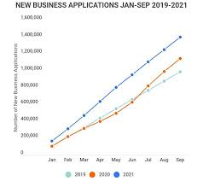 **Figure 3: Example Diagram of Business Application Data Analysis for 2 years.**

In the analysis we would dive deeper into the meaning and context of Business Statistics all round as well as the effect of organization development. From the example of data that has been indicated in the information above we can simply business statistics to be the science scope and requirements of an intelligent decision making using the face of principles of disciplines that most times comes in the face of many uncertainties. In Business Statistics as a major some of the things that you are able to generate in this form are: Probability and Random Variable, Describing Population and Samples, Probability Distributions, Simple Linear Regression and Sampling of Business Data. Through Business Statistics there are majorly 2 types of them in the business and mathematical world and these are: Descriptive and inferential which these have been able to be divided into majorly four different elements which they are: Variable, Sample, Parameter and Statistics which is also known to be called the singular form.

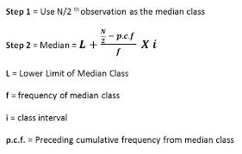 **Figure 4: Diagram Showing the Types of Mathematical Expression in Business Statistics.**

In Business Statistics from the diagram above which basically shows some mathematical formula on some things that are essential Business Statistics helps towards being able to give a greater population towards something that is currently happening towards helping in generating an accurate conclusion. The diagram below that has been indicated in figure 3 is able to show some of the examples of data that can be Business statistics from any company in the world.

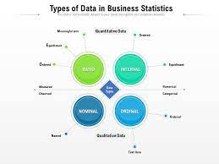 **Figure 5: Diagram Showing the Types of Data in Business Statistics.**

In Business Statistics there are 5 methods or process that needs to be followed when we are dealing with creating solutions that are around Business Statistics and some of them are: Standard deviation, hypothesis testing, mean, Sample Size Determination, and regression which leads towards being able to generate two types of data which usually would come in the form of qualitative and quantitative analysis. This would also lead us to part which we are going to talk about a major benefit of being able to build on Business Statistics we can simply say that it is informing the manager on how to be able to work on the employee’s performance management until the employee is able to meet the minimum level that is required by the management of the company as well as evaluating other scenarios through conducive mathematical research and solution development that may be facing the growth of the company towards being able to move forward in life as well as other importance and benefits of dealing with business statistics have been indicated in the diagram that has been written below:-

.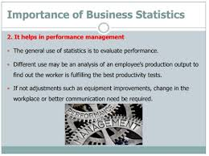 **Figure 6: Diagram Showing Importance of Business Statistics in an Organization.**

In Business Statistics some of the characteristics that make up the provided answers are: All the Information must be basically collected in systematic order, It should be comparable to each other on a specific planning purpose and It has an aggregate of facts. In Business Statistics, Your data which would be targeted towards the next 5 years of the company should be able to show the certain information that has been indicated in the diagram as indicated below:-

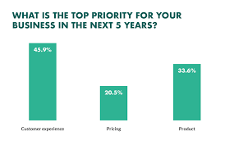 **Figure 7: Diagram showing the prediction sample of a business future in the next 5 years through business statistics**

**RECOMMENDATION.** Let me start my recommendation by saying that some of my major take away that I intend to apply towards being able to learn on how I am going to implement this is by being able to understand the fact that as I start towards the final launch and rebranding the mission of my business I am going to make sure that I am able to work in hand with a data analyst and use in my knowledge towards being able to create data and fact into information on being able to build a full fundamental structure of not just being able to build a business alone but by being able to generate data to back up information that is needed for the growth and advancement of the business. Another thing that I want to look into is the issue of ownership of my organization as the data below has been able to explain by giving me current source information of how business ownership has been happening around the world by me being able more clearer and deeper context towards being able to predict

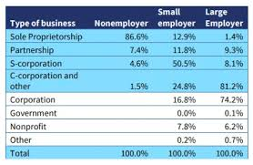 **Figure 8: Diagram showing the statistics of the current types of ownership of business globally**

**CONCLUSION**

Let me start to conclude my essay on Business Statistics by saying that Variable which some of the types of variables indicated below is something that we need to look into as we are building our curriculum this is a vital need that every business owner must be able to have in mind as you dream to be able to have your own business you must be able to understand the question statistics of the current status of people that are doing business around your sector by being able to answer relevant questions through several marketing channels such as being able to follow the diagram below towards being able to make your business to be able to make continuous improvement every single day:-

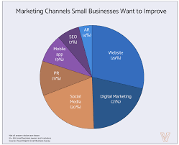 **Figure 9: Diagram showing statistics of Marketing Channels of how small Business would want to Improve**

I would also want to add to my conclusion by saying once you are able to understand the characteristics of business statistics then you are able to see the realities through the diagram below towards being able to know how to run a successful business in the determination of telling where your business would be able to stand in the future that you want to create.

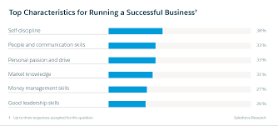 **Figure 10: Diagram showing the top characteristics of being able to run a successful business.**

**BIBLIOGRAPHY**

Schmid, G., 2021. *Small Business Statistics: 19 Essential Numbers to Know (2022)*. [online] Fundera.com. Available at: <https://www.fundera.com/blog/small-business-statistics> [Accessed 7 February 2022].

Anderson, A., 2021. *Business Statistics For Dummies Cheat Sheet*. [online] Dummies.com. Available at: <https://www.dummies.com/article/business-careers-money/business/accounting/calculation-analysis/business-statistics-for-dummies-cheat-sheet-207822> [Accessed 7 February 2022].

Mohsin, M., 2022. *10 Small Business Statistics You Need to Know in 2022 [Updated]*. [online] Ng.oberlo.com. Available at: <https://ng.oberlo.com/blog/small-business-statistics> [Accessed 7 February 2022].

**APPENDICES.**

Figure 1: Some Mathematical topics used in generating Data in an Organization.

Figure 2: Classification of Subject Matter that are involved in Statistics Diagram.

Figure 3: Example Diagram of Business Application Data Analysis for 2 years.

Figure 4: Diagram Showing the Types of Mathematical Expression in Business Statistics.

Figure 5: Diagram Showing the Types of Data in Business Statistics.

Figure 6: Diagram Showing Importance of Business Statistics in an Organization.

Figure 7: Diagram Showing the prediction sample of a business future in the next 5 years through business statistics

Figure 8: Diagram showing the statistics of the current types of ownership of business globally

Figure 9: Diagram showing statistics of Marketing Channels of how Small Business would want to improve

Figure 10: Diagram showing the top characteristics of being able to run a successful business.