Your name

**UB70199BBU79348**

COURSE NAME:

**Financial Management- AIU Course**

Assignment Title:

**Essay on Financial Management**

ATLANTIC INTERNATIONAL UNIVERSITY

**April/2022**

**TABLE OF CONTENT**

* Introduction
* Body & Analysis
* Recommendation
* Conclusion
* Bibliography
* Appendices

**INTRODUCTION**

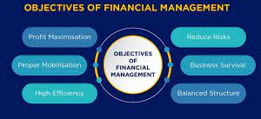 **Figure 1: Diagram showing the main objectives of financial management taken place in most organizations.**

In every business organization, one thing that controls the rules of how finance is being handled in a firm depends on the system of management for the future as most times this comes with a lot of high underground planning and upgraded execution in order to make sure that the goals of the organization are being met. You can understand the strategies that are involved in this finance management when planning and executing if only you are able to understand what exactly the main objectives of the finance management in most organization firstly through the diagram that is officially indicated in the diagram that is being indicated in figure 1 above along with knowing where your business sector lies using this main objectives. .

**BODY & ANALYSIS**

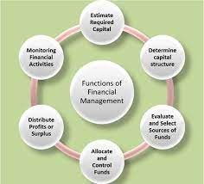

**Figure 2: Diagram showing some of the functions that are involved in Financial Management in an Organization**

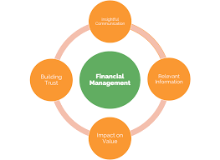 **Figure 3: Diagram showing some of the programmes that are officially involved in the system of Financial Management in an Organization.**

Let me start the body of my essay by showing some two diagrams that are involved in Financial Management which are the major things that are essential before I head to define what Financial Management is generally all about in the society. I would start by saying that Figure 2 is known as some of the functions that are officially involved in the financial management system and Figure 3 has to do with the Programmes that are officially involved in the Financial Management System within any Organizational types.

Financial Management therefore in any sense can officially be defined as the business functions which has to do with the concern of profitability, expenses, cash and credit which would guide the organization in order to be able to carry out it means officially as satisfactorily as possible. Financial Management in an Organization is officially divided into two types and these are: Investment Decisions, Dividend Decisions, , Financial Decisions and Working Capital Decisions. Financial Management in any Organization generally comes to us with seven (7) different principles in a company and these are officially indicated as follows in the diagram that is officially indicated in Figure 4 which these principles are used to help the guiding practices of financial management that is officially indicated in the diagram that is officially indicated in Figure 5 as shown below:

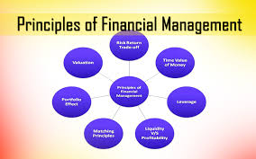 **Figure 4: Diagram showing some of the principles that are officially involved in Financial Management in an Organization.**

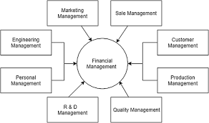 **Figure 5: Diagram showing some of the practices that is used to guide the principles that are officially involved in Financial Management**

In an Organization that is most times guided by the rules of constitution, The Financial Manager is officially known to be in charge of the financial health system of the Organization and helps to make sure that it works with the Board of Management to be able to continue the necessary liquidity that is required for the organization to be able to grow and develop as the diagram that is officially shown in Figure 6 which does explains the cycle of financial management in an Organization is something that they take in very keenly to be the growth of every company. Another thing they have taken to growth as financial managers in a company which is officially shown in the diagram that is officially shown in the 7th Figure explains some of the strategic cycle that is officially involved in the Financial Management system in an Organization.

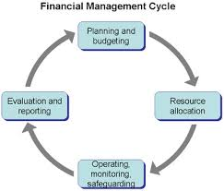 **Figure 6: Diagram showing some of the principles that are officially involved in Financial Management Cycle in an Organization**

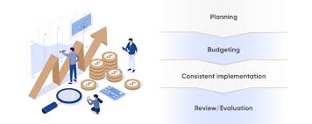

**Figure 7: Diagram showing some of the types of strategic formulas that are involved in Financial Management in an Organization.**

In the diagram that is officially indicated in Figure 8 and Figure 9, some of the examples of the advantages and disadvantages that are officially involved in Financial Management are being shown below and can be used in the process of developing the aspects that are involved in financial management which is officially shown in the diagram that is hereby written in Figure 9 that is officially written below

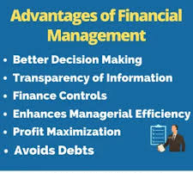 **Figure 8: Diagram showing some of the advantages of Financial Management that is being designed into the Organizational System.**

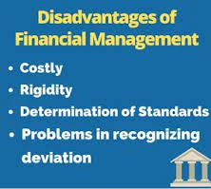 **Figure 9: Diagram showing some of the disadvantages of Financial Management that is being designed into the Organizational System.**

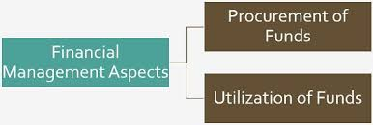 **Figure 10: Diagram showing some of the aspects of financial management that is notable in an Organization.**

**RECOMMENDATION**

.Let me start my recommendation by being able to share some of my biggest take away from doing the Financial Management course and some mistakes that I intend to correct which might have to do with legal complications. Firstly, The biggest thing that I have done which was wrong is that there was no financial plan both in legal and financial aspect when I started running my first organization which this course has been able to show that it is something that I must look into as I begin the process of being able to run my second organization which I have officially signed into legal trademark I want to be able to make sure that even if I need to make my personal finances to run some aspect of my organization I won’t be able in any way use this process to be able to affect the money that comes to the Organization Account in doing certain investment in the name of the Organization. I would always remember in the future that in Financial Management using the diagram of light that is officially indicated in Figure 11 I would always remember that there is a difference between my personal finances and business finances in order not to be able to enter any investment or insecurity trouble with any national security agency in the Future.

 **Figure 11: Diagram showing some lights that are used in representing the effects of financial management in an Organization.**

**CONCLUSION**

Let me conclude my essay on Financial Management by saying that in the future of dealing with Financial Management that determines the approach that you want to use in your running your organization business before making decision you need to understand the approach of dealing with Financial Management and some of these are officially indicated in the diagram that is officially written below in Figure 12.

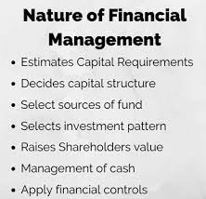 **Figure 12: Diagram showing some of the nature of Financial Management in an Organization setting.**

In addition, I would also add to my conclusion by saying that some of the sources that are officially involved in Financial Management are: Long term sources, Medium term sources, Owners Fund, Borrowers Fund, Internal Sources, External Sources and Short term Successes.

**BLIBLIOGRAPHY**

Management, F., 2022. *Which of the following is not a source of long-term finance*. [online] Examveda.com. Available at: <https://www.examveda.com/which-of-the-following-is-not-a-source-of-long-term-finance-30188/> [Accessed 12 April 2022].

Juneja, P., 2022. *Financial Management - Meaning, Objectives and Functions*. [online] Managementstudyguide.com. Available at: <https://www.managementstudyguide.com/financial-management.htm> [Accessed 12 April 2022].

Worldscientific.com. 2022. *Journal of Financial Management, Markets and Institutions*. [online] Available at: <https://www.worldscientific.com/worldscinet/jfmmi> [Accessed 12 April 2022].

**APPENDICES**

Figure 1: Diagram showing the main objectives of financial management taken place in most organizations.

Figure 2: Diagram showing some of the functions that are involved in Financial Management in an Organization

Figure 3: Diagram showing some of the programmes that are officially involved in the system of Financial Management in an Organization.

Figure 4: Diagram showing some of the principles that are officially involved in Financial Management in an Organization.

Figure 5: Diagram showing some of the practices that is used to guide the principles that are officially involved in Financial Management

Figure 6: Diagram showing some of the principles that are officially involved in Financial Management Cycle in an Organization

Figure 7: Diagram showing some of the types of strategic formulas that are involved in Financial Management in an Organization.

Figure 8: Diagram showing some of the advantages of Financial Management that is being designed into the Organizational System.

Figure 9: Diagram showing some of the disadvantages of Financial Management that is being designed into the Organizational System.

Figure 10: Diagram showing some of the aspects of financial management that is notable in an Organization.

Figure 11: Diagram showing some lights that are used in representing the effects of Financial management in an Organization.

Figure 12: Diagram showing some of the nature of Financial Management in an Organization setting