Your name
UB70199BBU79348

COURSE NAME:
Marketing Plan- Course Creation

Assignment Title:
Essay on Marketing Plan for an Organization

ATLANTIC INTERNATIONAL UNIVERSITY
February/2022

TABLE OF CONTENT
- Introduction
- Body & Analysis
- Recommendation
- Conclusion
- Appendices

INTRODUCTION
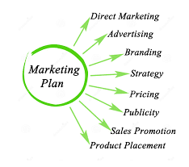 Figure 1: Component of a Business Plan in Marketing of an Organization
Marketing Plan of a business is very important because these are the steps that would help in increasing your presence towards being able to determine where your target market is located in the world as a company which basically comes through in the format of the development of a business plan from the concept that you would like to develop from the advice of a marketing consultant through the different components showing an action plan that comes in towards being able to convince them towards being able to buy your goods and services from your competitor.

BODY & ANALYSIS
There are so many reason why businesses fail in marketing plan especially when it comes to targeting a prospect in business market some of the ways we can avoid them towards being able to target a prospect are: Identify your best customers to find your prospects, Calculate the Customer Value with your Organization, Increase spend on Campaign Core Target Prospects of the Brand and Run More Campaign Core Target Prospects.
A Marketing Plan has been made up of an element which is basically going to be involved towards being able to achieve the 7p in the development and these are; Product, Price, Promotion, Place, People, Process and Physical evidence. A Marketing Plan is achieved most times using the different marketing strategies and the major 4 types of business marketing strategy are: Product Development Strategy, Market Development Strategy, Diversification Strategy and Market Penetration Strategy. In a marketing plan, the first thing that comes to your mind though as a definition is your understanding towards being able to develop your business concept towards generating for a week, month and a year in a form of marketing strategy report on how you intend to put your business into action. There are different formats that you must understand when you are building your marketing plan development for your organization some of these component format are being indicated in the diagram that is being indicated in figure two below:-
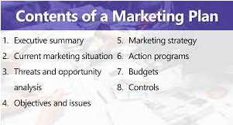 Figure 2: Component Diagram of a Marketing Plan in an Organization
When you are talking about marketing in a# company there are clear parts that helps to show what roles and information’s are needed in the process of trying to get profit and customers to be able to know you and buy into your business strategy, Figure 3 diagram explains some of the roles and case studies that are basically going to be involved around marketing Development.
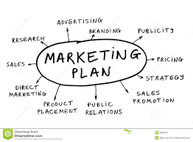 Figure 3: What are the criteria’s that are basically going to be involved in a Marketing Plan
There are different types of Marketing Plan that is being developed generally as some of these are: Paid Marketing Plan, Social Media Marketing Plan, Content Marketing Plan, New Product Marketing Plan and Quarterly or Annually Marketing Plan. Some of the examples of being able to know some of the example of marketing are: Branding, Advertising, Direct Marketing, In Store Marketing, Customary Pricing, Flat Pricing and Showrooms. For you to be able to know how to write a Successful Marketing Plan, Some of the things that must be present in the journey are: Stating the mission of your business, Determine the KPIs for this mission, What are the personas of people who would be buying your products, What are your company content initiatives and strategies, Clearly define your plan omissions, Identify your competitors, show your contributors role and responsibility when they are going to be working with you and show the marketing budget that intends to be generated. In a Marketing plan there are different processes that needs to be understand and revealed when you are trying to build the process some of these things have been indicated through diagram in Figure 4 that has been indicated in the mail trail below:-
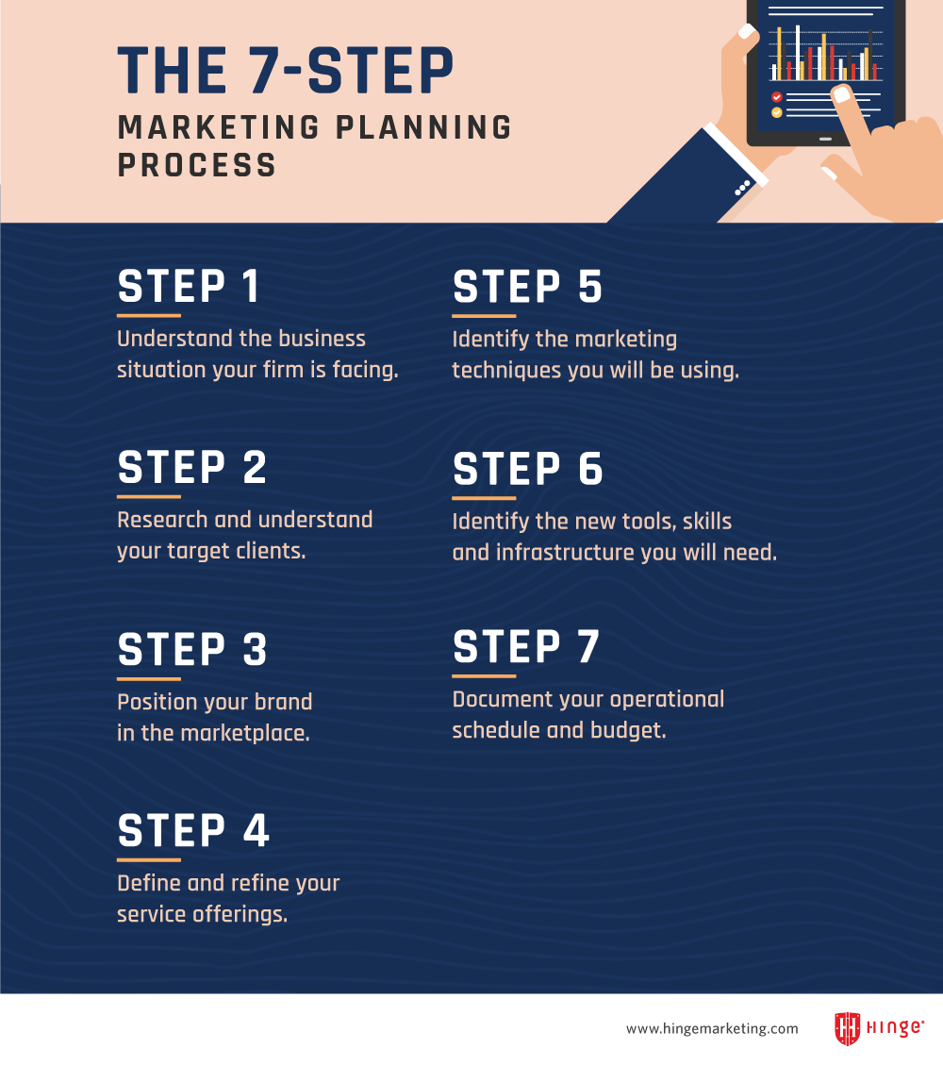 Figure 4: Diagram explaining the 7 steps of Marketing Plan Process in an Organization.
Before you are able to determine the marketing plan result through the write-ups that has been designed there is one common thing that must be present when you are able to determine your facts when they are known through your business which is the diagram in Figure 5 that has been indicated below through the support of the diagram that is being indicated in the figure 6 also below explaining the process that is being involved in knowing how to design an effective marketing strategy which basically talks about the SWOT Analysis of what people should know about your business
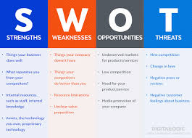 Figure 5: Diagram Showing Examples of SWOT Analysis that explains all about an Organization.
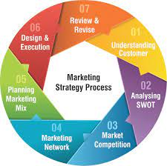 Figure 6: Diagram Showing the Process of Marketing Strategy that is being implemented in an Organization
When you are working towards building your marketing plan the following results that has been attached in the document has been able to explain the result application that helps you towards gaining the customer attraction into the market. The diagram that has been indicated in Figure 6 are some of the tools that helps you towards getting the desired result on being able to know how to market your business into the world as at today.
 Figure 7: Tools that helps in generating the results of the marketing plan in an organization.
In the Social Marketing world some of the greatest challenge that they face which in some ways also affects other parts of the other marketers are indicated in the mail trail that has been indicated below:-
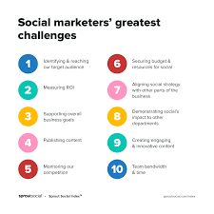 Figure 8: Diagram Showing the Greatest Challenges that is being faced in the Social Marketers in the Marketing Plan.
In Addition, When you are developing your marketing plan as a business some of the checking’s that helps in the growth process of determine if your business is progressing according to the indicated strategies of operations towards the future are being shown in Figure 8 that has been indicated below:-
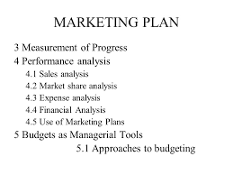 Figure 9: Checking Document Information of the Success of the Marketing Plan of the Organization.
RECOMMENDATION.
My recommendation for the marketing plan course is basically to show by sharing my experience from what I have been able to learn to take away from this particular course which is basically are never build a marketing plan on the pricing part on sentiments to feel that trusting people sometimes help to increase your view on business as well as being able to get payment towards being able to continue to operate on the focus point of my business. This course has also helped me towards being able to sharpen more realities that with the fact through the fact that in order to be able to make my marketing plan to be more effective and relevant in the society some of the actions that I need to take or get involved in are being indicated as follows below in the diagram 8 showing a result plan.
 Figure 10: Diagram of Some things that is being used in the determination to show whether a marketing plan is going to be successful.
I would make sure that I would have in a marketing officer and a checking analyst who would put in a check to every single marketing plan write-up that I continue to design for my organization for the future that I intend to create as many times I would be needing more guidance towards being able not to get distracted along the way by the world of adult education sometimes which does not favorable work in place for me in some parts of me growing up as a person generally which has also guided me towards being able to show me the difference between marketing plan and marketing strategy through the diagram below:
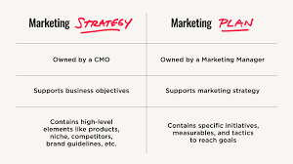. Figure 11: Diagram Showing the difference between the Marketing Strategy and Marketing Plan in an Organization.

CONCLUSION
.Let me now conclude my analysis of this particular report by saying that when you are asked or in the process of writing a marketing plan for an organization is very important as you proceed into the future as it takes you to more realities that you didn’t know and shows you a step towards being able to know how to lead an effective marketing strategy for your business by being able to know how to make your own decisions as well towards where you want your business to be in the coming years. Through the diagram below you need to also understand your social media strategy by being able to know the kind of post and information that you need to include as some of the strategies of how you can connect social media into your marketing plan are being indicated in the Figure 10 as indicated below:-
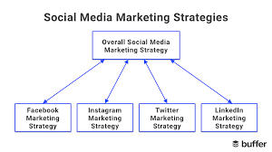 Figure 12: Diagram Showing the Forms of Social Media Marketing Strategies that has been indicated in an Organization.

BIBLIOGRAPHY
MCGUIRE, S., 2021. What is a Marketing Plan and How to Make One? - Venngage. [online] Venngage. Available at: <https://venngage.com/blog/marketing-plan/> [Accessed 8 February 2022].
Chi, C., 2021. What is a Marketing Plan & How to Write One [+Examples]. [online] Blog.hubspot.com. Available at: <https://blog.hubspot.com/marketing/marketing-plan-examples> [Accessed 8 February 2022].
Editorial Team, I., 2021. 7 Marketing Functions: What They Are and Why They're Important. [online] Indeed Career Guide. Available at: <https://www.indeed.com/career-advice/career-development/marketing-functions> [Accessed 8 February 2022].
APPENDICES.
Figure 1: Component of a Business Plan in Marketing of an Organization
Figure 2: Component Diagram of a Marketing Plan in an Organization
Figure 3: What are the criteria’s that are basically going to be involved in a Marketing Plan
Figure 4: Diagram explaining the Seven 7 steps of Marketing Plan Process in an Organization.
Figure 5: Diagram Showing Examples of SWOT Analysis that explains all about an Organization.
Figure 6: Diagram Showing the Process of Marketing Strategy that is being implemented in an Organization
Figure 7: Tools that helps in generating the results of the marketing plan in an organization.
Figure 8: Diagram Showing the Greatest Challenges that is being faced in the Social Marketers in the Marketing Plan.
Figure 9: Checking Document Information of the Success of the Marketing Plan of the Organization.
Figure 10: Diagram of Some things that is being used in the determination to show whether a marketing plan is going to be successful.
Figure 11: Diagram showing the difference between the Marketing Strategy and Marketing Plan in an Organization.
Figure 12: Diagram Showing the Forms of Social Media Marketing Strategies that has been indicated in an Organization.

