Your name

**UB70199BBU79348**

COURSE NAME:

**Human Rights- AIU Course Creation**

Assignment Title:

**Essay on Human Rights-Academic Summary-AIU Course Creation**

ATLANTIC INTERNATIONAL UNIVERSITY

**March/2022**

**TABLE OF CONTENT**

* Introduction
* Body & Analysis
* Recommendation
* Conclusion
* Bibliography
* Appendices

**INTRODUCTION**

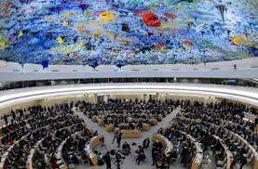 **Figure 1: Diagram showing the Human Rights Council Room at the United Nations Complex.**

Let me start my introduction by talking about the Human Right law of Number 28 that was officially declared at the United Nations Human Rights Council Room shown in the diagram that is officially indicated in Figure 1 that is shown above. This is focused on creating a free and fair world across the globe which has been sadly denied to a lot of people in the society within some certain parts of the region today which is still has speed denial increase aspect for female gender especially in my country where things are most times being controlled by the rules of tradition. This particular one most times doesn’t give youths the much space towards being able to express ourselves to some of the challenges that they are generally have been facing in their lives in other for them to be able to move forward as human as this is why the picture that is officially indicated in the diagram that is officially written in figure 2 explains the day that has been set aside to mark the celebration as a general reminder to both gender parties to be able to know what roles that needs to be played in the society for us to be able to grow as a community.

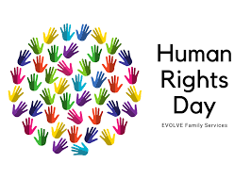. **Figure 2: Diagram Information showing the celebration set aside by the United Nations to address challenges faced by people.**

**BODY & ANALYSIS**

Let me use the introduction that I have officially written above by beginning to define Human Rights which was officially founded by Babylon Cyprus the great as the principal norms that are officially set in a constitution towards the moral of human behavior that are regularly set to be protected by the International and Municipal Law.

Now moving to the analysis of defining the context of human right in particular of No 28 rule popularly known to be the Freedom of Attendance Development that has been officially set aside of how this is going to affect as a principle of development of my region called Nigeria which sadly has a lot of high rate of killings and wickedness in the world today in some parts of the region that is affecting the people to have high tension due to bad Governance and increase in the lack of insecurity in this particular regions. Today the highest terrorist which is controlling my country Nigeria affecting Human Rights 28 from not being achievable in Nigeria as the female gender are mostly affected by this action is popularly known as Boko haram as I have attached a picture of them as well as their logo symbol performing their action officially as indicated in the diagram that is officially indicated in Figure 2 and Figure 3 that is officially shown below:

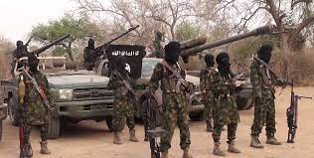

**Figure 3: Diagram showing some of the operational members that are involved in Boko Haram across Nigeria.**

 **Figure 4: Diagram showing the official logo that is used in the represenation of boko haram in Nigeria.**

This action has shown the world by the citizens of Nigeria coming together by making people to understand that the Human Rights process in Nigeria is not free and fair especially for those that are leaving in the Northern part of the country. Bad Governance in Leadership, Poor Educational System leading to a lot of misinformation for young ones to grow and Corruption Embezzlement has been one of the greatest challenges that has been lacking in Nigeria as both the Governmant and the people many of us do not understand what the word respect and dignity does in order to be able to ensure that is country is able to work free and fair as it is expected for it to become after a certain agenda timeframe projections that has been made by International bodies such as UNESCO and its allie. Some of the pictures from fig 5 and 6 shows examples why Nigeria is not living in a# fully free and fair world which we ought to have learnt from America

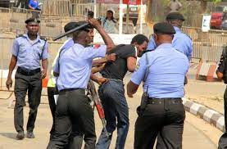 **Figure 5: Diagram of the Nigerian Police Force Illegally beating up a Citizen walking on the road on his own.**

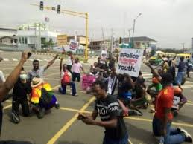 **Figure 6: Diagram of Nigerian Youths going to the street to protest to the Governor after the guy in diagram 5 was killed.**

In Human Rights agenda of the section number 2, the diagrams that are officially indicated between the numbers 7 and below are some of the things that happens which are considered to be some of the threats that has happened in Human Rights which usually affects it from working in the certain region across the world today especially from the diagram of the ones of the Uniited States of America which is a major one that Nigerians as a commuity need to learn from generally especially through the way we make the kind of conversations that we intend to create with both the internal and external community around the world.

 **Figure 5: Diagram of an example of Hate speech Violence war that happened in the United States of America.**

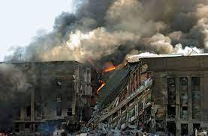 **Figure 6: Diagram of the 9/11 attacks that took place in the United States of America**

Human Right 28 can only be achievable once we are able to understand the roles that we need to play in the society by first knowing that everyone has a different journey of where they are headed to in their life generaally. The role that we need to play in order to ensure that we are able to work towards being able to address the issue of Human Rights generally are: Speak up for what you care or you are not comfortable about. Listen to others story and weigh the information that you are receiving generally as a human. Stay connected with social movements in your community and country that has to do with your passion then voluntary or monetary get involved in them. Choose free trade and ethically made gifts. Stand up against any form of discrimination that officially takes place in your society.

**RECOMMENDATION**

When I would speak about the recommendations that are officially involved in human right my answer would come in three ways: What have I learnt in this regards. Have I made any mistake in this particular journey of this course and how would I ensure that the section of human rights number 28 is duely free and constituted in the society as a person.

As a person I would be able to learn how to weigh information and make sure that I am able to make my own decision by speaking out regardless of whatever I feel that is wrong about a particular person or action in the society regardless of the tribe and culture that you basically come especially learning how to make sure that the influence of tradition and listening to some certain wrong information in my career does not lead me to doing the wrong things are not really not going to help me towards being able to grow in my certain daily life. I would also remember that as I begin the process of starting my project startup as a founder back, I would always remember that in the constitution that I would be developing going forward that it is very necessary to include barriers towards making sure that there would be full flexible structure that would aid the growth of my organization.

**CONCLUSION**

I would like to finally conclude my essay by saying that regardless of the most brilliant person in the world that you are trying to show the world that you are basically there is a need to understand the fact that at one point of the other people need help towards being able to achieve how human rights can work basically for them in the society as there are a lot of misinformation that is affecting the growth of making people live in a greater society that they deserve. This is why we must be part of the people who are basically part of the solutions by inculcating the law where it is necessary for me to live freely in a society that we are living today. .

**BLIBLIOGRAPHY**

News18. 2021. *Human Rights Day 2021: What Are The 10 Basic Human Rights One Must Know?*. [online] Available at: <https://www.news18.com/news/lifestyle/human-rights-day-2021-what-are-the-10-basic-human-rights-one-must-know-4537706.html> [Accessed 15 March 2022].

Candle, P., 2022. *6 Ways to Protect & Support Human Rights for People Around the World*. [online] Prosperity Candle. Available at: <https://www.prosperitycandle.com/blogs/news/6-ways-to-protect-support-human-rights> [Accessed 15 March 2022].

Ohchr.org. 2021. *OHCHR | Universal Declaration of Human Rights at 70: 30 Articles on 30 Articles - Article 28*. [online] Available at: <https://www.ohchr.org/en/NewsEvents/Pages/DisplayNews.aspx?NewsID=23997&LangID=E#:~:text=Article%2028%3A%20Right%20to%20a%20Free%20and%20Fair%20World&text=Article%2028%20says%2C%20in%20its,to%20challenge%20their%20very%20humanity.%22> [Accessed 15 March 2022].

**APPENDICES**

Figure 1: Diagram showing the Human Rights Council Room at the United Nations Complex.

Figure 2: Diagram Information showing the celebration set aside by the United Nations to address challenges faced by people.

Figure 3: Diagram showing some of the operational members that are involved in Boko Haram across Nigeria.

Figure 4: Diagram showing the official logo that is used in the represenation of boko haram in Nigeria.

Figure 5: Diagram of the Nigerian Police Force Illegally beating up a Citizen walking on the road on his own.

Figure 6: Diagram of Nigerian Youths going to the street to protest to the Governor after the guy in diagram 5 was killed.

Figure 7: Diagram of an example of Hate speech Violence war that happened in the United States of America.

Figure 8: Diagram of the 9/11 attacks that took place in the United States of America