Your name

**UB70199BBU79348**

COURSE NAME:

**Project Management-AIU Course Creation**

Assignment Title:

**Essay on Project Management in an Organization**

ATLANTIC INTERNATIONAL UNIVERSITY

**January/2022**

**TABLE OF CONTENT**

* Introduction
* Body
* Analysis
* Recommendation
* Conclusion
* Appendices

**INTRODUCTION**

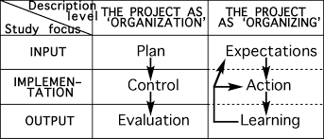 **Figure1: Diagram Showing the Study Focus of Project Management**

When we talk about Project Management in an organization we need to understand that the landscape is changing rapidly before any decisions is being made it is very crucial to understand the study focus through the diagram indicated in figure one that shows some of the areas affected as well as the difference between the modern and traditional system of management especially with the span scale of the increase in technology that is happening around the world which has a scale of 80% tentatively to come from Data Analytics on the Future as this would be a major factor to help determine if you yourself as the business owner and members of team to be able to understand the kind of method to adopt using the components and required principles that is being required in the system of Project Management in a business when during operations as there is no easy feat towards being able to achieve success within a particular timeframe and budget that has been designed towards achieving the goal of the work in order to meet up with the goals that the client’s needs which you have to understand by getting to know the life cycle of things that are around the assignment that is being delivered to the officer. People have failed in the areas of project management because during the terms of delivering an assignment or in the beginning many fail in the aspect of being able to deliver their personal brand or statement that would help their clients towards being able to understand their kind of person as well as the assignment that needs to be delivered through being able to understand their purpose as well as that of the organization which the diagram below has been able to understand the life cycle of how project management in an organization.

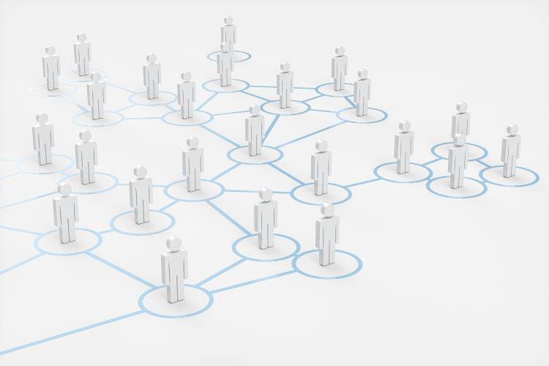 **Figure 1a: Drawing diagram on the Project Management System in an Office using art**

**BODY**

To start talking about project management we must be able to talk about what the components which is not dynamic or fixed but rather it is adaptive or static depending on the situation that is required in order to be able to achieve the assignment of project management and some of these things are: defining why the project is necessary, monitoring progress against plan, leading and giving proper information to the project management team, maintaining the budget that is allocated for the project, preparing a# business case to be able to justify the investment of the project and maintaining the conversations and sometimes having the right attitudes with the stakeholders of the project.

In the terms of defining what the terms of project management means we can easily say that it is the process, of using skills, experience, and knowledge to be able to achieve a specific objectives to the minimum accept project development criteria along with the final deliverables that has been agreed within a particular partners for a specific purpose in order to be able to produce a particular product or project as the end goal. Project Management can be structured in an organization in the following areas: Number Organizational Structure, There are two types of project management and these are the Traditional and Modern types of Project Management. When dealing with Project Management we need to know that in a system the first person that influences the decisions is the project managers of the firm and some of the important key factors that is used in influencing the decisions and process that is being used in the project management that is required in the systems either being made by a particular client or organization management are being indicated in the diagram in figure two:-

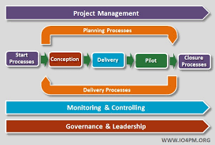 **Figure 2: Diagram on the Process and Requirement that is needed in Project Management**

When we talk about the process and requirement that is needed in project management we need to as well as speak on the importance of why cause is very important in an organization in order for the organization to be able to maintain a system disciplinary process. Some of the importances of why project management is needed in an organization are: It helps in creating strategic alignment for every officer in the company; it helps the organization to be able to give a clear focus and objectives of what the company is all about. It helps in making people to understand what kind clear leadership behavior they need to exhibit when working with the organization by knowing when they need to do a quality control check. The diagram below also explain the lifecycle of project management structure as well as the Change Management Structure in an organization which is a major thing that is very important for us to be able to understand

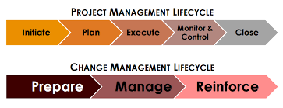 **Figure 3: Diagram on the Project and Change management lifecycle plan**

Let me now conclude my body analysis by speaking some of the value of effective management in an organization as some of the reasons why it happens in an organization are: - It helps to change the landscape of project by everyone being able to stop using their feelings towards the development of only their personal understanding alone towards being able to meet up with the requirement in an organization by being able to help project managers towards trying to bring value by making sure that everyone is able to understand their purpose as well as being able to control their emotional intelligence in some parts till the close of every single project operations that is being carried out which some of the role that is involved in the process is being able to understand the stakeholder and their relationship with the organization as the diagram below has been able to explain how the process and role usually work in a matrix organization .

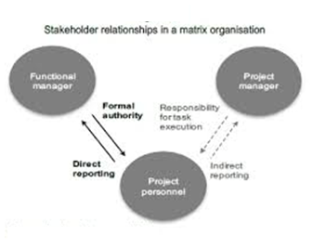 **Figure 4: Figure 2 Diagram of Stakeholders Relationship in a Matrix Organization**

In addition I would like to note that there are reasons why project management fails in an organization drastically and the effect of these failure most times comes in from the two parties which are the management and the staff officials side and some of these reasons are: Inadequate Project Planning, Scope Creep, Used of unpracticed tools and techniques, Shortage of Rescources and Requirements, No or poor Risk Management, Lack of user engagement, Poor Controlling and Monitoring and Inexperienced Project Managers.

**RECOMMENDATION**

Let me start to make my recommendations from saying how this course has been useful and what is the biggest take away that I have learnt in project management that I intend to apply going forward in life is that the main thing I need to understand in this course is the value that I am going to bring into the organization by not allowing anyone to intimidate me but being able to connect the process that my team members are facing in the company through being able to go back to the underlying structure for evaluation by checking the grasp that has currently taken place. Another thing that I would recommend going forward Is looking at the economy situation of the project not working or being able to make sure myself and team member do not work with the aim of sentiments when we are dealing with clients in our respective business sectors by looking at both the good and bad sides would also be one of the best ways that I am able to deliver on the work.

**CONCLUSION**

In conclusion, Let me finalize my project management write up by saying that if you are part of the private sector before you start any project in order to avoid failure or lateness in the deliverables of the project to the client you need to make sure that you are able to understand the project before you are able to determine the style and sometimes both concluding with your team members towards being able to understand the principles of project management that would be used in delivering the assignment towards the particular client which some of the effects of why we use the word called Project management when dealing in the aspect of our business going forward in our different lives. When we are talking about project management this is something that we must make sure that we do not use the aspect of finance and growth development on sentiments when we dealing with clients to avoid do being involved in fraud or duped by people own the business.

**BIBLIOGRAPHY**

Corporation, A., Corporation, A., Software, C. and tesfahunegn, M., 2021. *Why Is Project Management So Important To An Organization?*. [online] The Digital Project Manager. Available at: <https://thedigitalprojectmanager.com/why-is-project-management-important/> [Accessed 30 January 2022].

Harris, K., 2021. *The Value of Effective Project Management*. [online] Georgia Tech Professional Education. Available at: <https://pe.gatech.edu/blog/industry-trends/project-management-value> [Accessed 30 January 2022].

Clarizen, T., 2021. *Project Management Organization: The Basics*. [online] Planview Blog. Available at: <https://blog.planview.com/project-management-organization-the-basics/> [Accessed 30 January 2022].

**APPENDICES.**

Figure1: Diagram Showing the Study Focus of Project Management

Figure 1a: Drawing diagram on the Project Management System in an Office using art

Figure 2: Diagram on the Process and Requirement that is needed in Project Management

Figure 3: Diagram on the Project and Change management lifecycle plan

Figure 4: Diagram of Stakeholders Relationship in a Matrix Organization