Your name

**UB70199BBU79348**

COURSE NAME:

**Strategiv Management-AIU Course Creation**

Assignment Title:

**Essay on Operations Management in an Organization**

ATLANTIC INTERNATIONAL UNIVERSITY

**February/2022**

**TABLE OF CONTENT**

* Introduction
* Body
* Analysis
* Recommendation
* Conclusion
* Appendices

**INTRODUCTION**

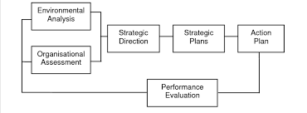 **Figure 1: Diagram Showing the Model that is being used in Strategic Management in an Organization.**

When you are dealing with strategic management in an organization you need to know first that this has to do with the process of knowing how business management works by being able to understand the model as indicated in the diagram that is indicated in Figure 1 above is very important and in the light of this the main thing that answers this question is for someone to be able to understand the personal mission statement of the organization which is the Mission and Vision of the Organization in order to be able to help guide the actions as well as knowing how to allocate and efficiently use all the available rescources that is required for the growth and presence of the brand through its values and aim towards its achievement in the society towards where it wants to become in the future ahead of us.

**BODY**

Before I define Strategic Management, Let me begin to share some important information that surrounds how this type of management works in a business development. Strategic Process are being divided into several process when you are working in a company and these process are: being able to look at the current moves of the strategy that is in place in the organization, knowing and telling the strength as well as the weakness of the organization, Create and execute action plans that are required for the organization growth, evaluate by checking if the organization is coming out successful and make execution plans that are necessary for the movement plan of the organization. In Strategic Management being able to understand the types which are being classified into 5Ps which are Plan, Ploy, Pattern, Position and Perspective are some of the things that helps in growing an organization. In Strategy Management there are different implementation approaches to be able to make sure that this is a success in companies as some of this are being indicated in diagram 2 that is indicated below for action:-

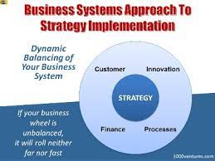 **Figure 2: Diagram of Successful Business Strategy Implementation that is being used in an Organization**.

Let me now go into the deeper analysis of talking about Strategic Management by saying that we can define it as the process which is used in creating goals, procedures and objectives in order to be able to make the company or organization to be able to be competitive in the society through being able to deploy the respective staffs that is needed for the execution to take place. In a Company Setting. In Strategic Management some of the process coming in the phase format that is being used in the determination of being able to execute the process of development are hereby indicated in the email trail as written below:-

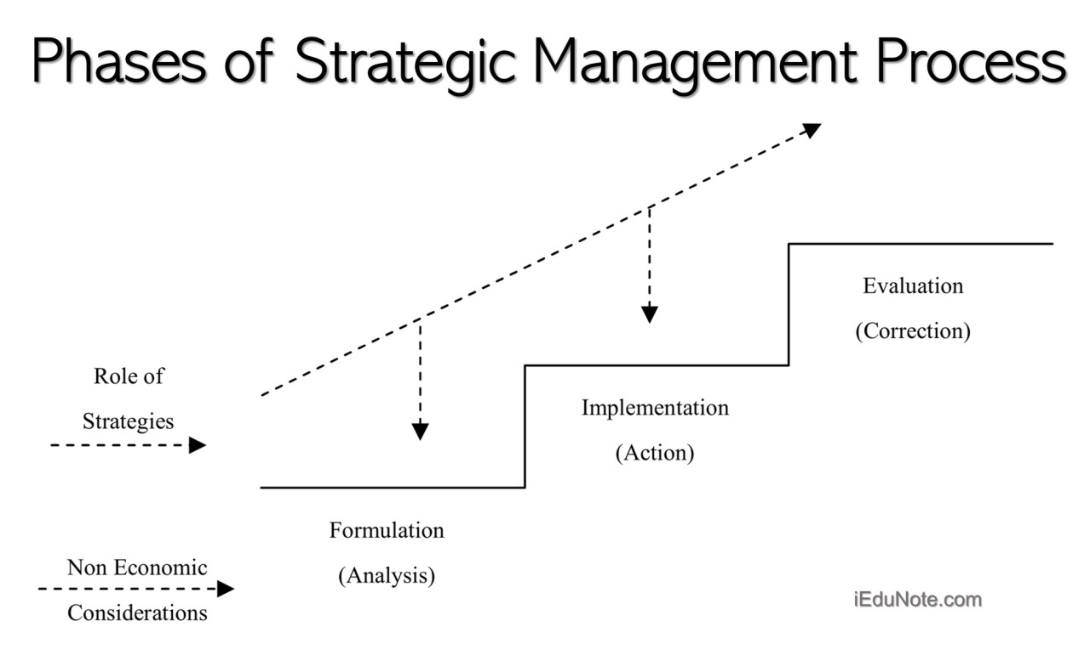 **Figure 3: Diagram Showing the Phase of the Strategic Management Process that is basically being used in an Organization**

Strategic Management is considered to be very important in the building because it helps the company to be able to analyze all the areas of operational movement in the process of being able to follow the guideline they desire to follow which might be sometimes analytical by being able to identify some of the threats and opportunities that surrounds this development which a descriptive approach sometimes is being used to consider some of these specifically approaches.

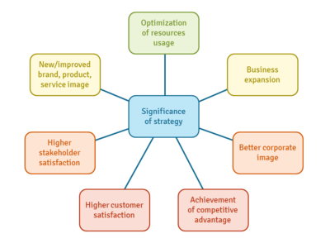 **Figure 4: Diagram showing the Main Significance of Strategy Management in an Organization**

Strategic Management has a lot of signifance in the growth development of the society in an organization when it is being developed in the world as some of the effects are being shown in the diagram that is written above in Figure 3. Through the diagram that is being found in figure 4, it is easy to say that some of the systems that is being involved in the process of strategic Management are found below

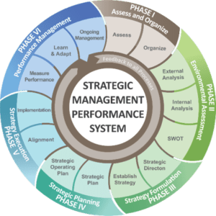 **Figure 5: Diagram Showing the Performance Management System of Strategic Management in an Organization**

In Companies, there are ways that Strategy Management can be developed in the society through different respective organizations and the diagram shows the process of how it can be used for the purpose of being able to generate profit maximization in the society,

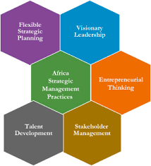 **Figure 6: Diagram showing how Strategy Management can be used in the development of an Organization.**

Let me begin to round up my body by being able to say that there are so many ways that you can use in the determination of someone who has a strategic mindset in an organization and some of these are hereby officially indicated in the diagram that is being shown in figure 7 that is written below:

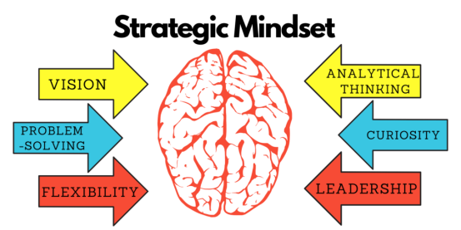 **Figure 7: Diagram of Signs of Someone who has Strategic Mindset in an Organization**

I would also like to share on some of the benefits of having Strategic Management in the business policy development of the organization as these factors are: It is able to give you an advantage to be able to compete in the society. It helps in creating sustainable growth towards being able to achieve the desired goal that is generally required in your Organization and It helps in the creation of managerial awareness in a cohesive organization setting depending on the sector where your organization would belong.

**RECOMMENDATION**

In my recommendation for Strategic Management, I would like to say that this topic has been able to expose me to some factors that I need to use when I am in the process of executing decisions for my organization that would be in the process of being able to carry my organization forward by also being careful of the kind of information and decisions that I am going to make. I would also advice all my team members who also own their respective organizations across the world about the process of ensuring that they are able to watch the decision approach to issues that they would also face which I would be involved too in their brand by sharing with them solutions and implementation strategies on how they are able to build their strategy implementation plan towards being able to meet the goals that they have set for themselves to become in the career of the world that they desire for daily.

**CONCLUSION**

Let me officially conclude my research paper by saying that there are different parts that divide the thoughts of how people think about strategic management in the society and how they want to develop it personally for their organization but one thing we must never forget as we embark on the process in the future is how we want to our business culture should look like which would also affect the ones of our employees that we have with us.

We should also remember that in strategic management while we are going to do our best to make sure that we are able to communicate effectively to the best of knowledge that we can communicate on this should also serve as a reminder that not everyone opinion should be accepted in some parts of the decisions making especially in some parts that has to do with personal matters of the growth of the organization going forward to be able to know the real members and officials that we are dealing with in our company.

**BIBLIOGRAPHY**

Tucci, L. and Roy, M., 2022. *What is Strategic Management, and Why is it Important?*. [online] SearchCIO. Available at: <https://www.techtarget.com/searchcio/definition/strategic-management> [Accessed 10 February 2022].

Kenton, W., Mansa, J. and Williams, P., 2021. *How Strategic Management Works*. [online] Investopedia. Available at: <https://www.investopedia.com/terms/s/strategic-management.asp#:~:text=Strategic%20management%20is%20the%20process,resources%20to%20achieve%20these%20goals.> [Accessed 11 February 2022].

Editorial Team, I., 2021. *Strategic Management: Definition, Purpose and Example | Indeed.com*. [online] Indeed Career Guide. Available at: <https://www.indeed.com/career-advice/career-development/what-is-strategic-management> [Accessed 11 February 2022].

**APPENDICES.**

Figure 1: Diagram Showing the Model that is being used in Strategic Management in an Organization.

Figure 2: Diagram Showing the Phase of the Strategic Management Process that is basically being used in an Organization

Figure 3: Diagram of Successful Business Strategy Implementation that is being used in an Organization.

Figure 4: Diagram showing the Main Significance of Strategy Management in an Organization

Figure 5: Diagram Showing the Performance Management System of Strategic Management in an Organization

Figure 6: Diagram showing how Strategy Management can be used in the development of an Organization.

Figure 7: Diagram of Signs of Someone who has Strategic Mindset in an Organization