Your name

**UB70199BBU79348**

COURSE NAME:

**Introduction to Global Marketing-AIU Course**

Assignment Title:

**Essay on Introduction to Global Marketing**

ATLANTIC INTERNATIONAL UNIVERSITY

**May/2022**

**TABLE OF CONTENT**

* Introduction
* Body & Analysis
* Recommendation
* Conclusion
* Bibliography
* Appendices

**INTRODUCTION**

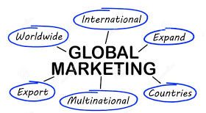 **Figure 1: Diagram showing some of the keywords that are surrounded by Global Marketing.**

In the world today there are different concepts people are trying to use market their business within the global society which the process of action is officially done step by step according to the sector knowing the fact that there has been a prediction of high increase of unemployment to take place within the beginning of next year 2023. The diagram that has been officially been listed above in Figure 1 are some of the things that is being considered before people start to venture into global marketing in the society and in the process of figure 2 below helps to be able to understand some of the rescources that can be used in reaching the customers through the strategies that has been explained in the body of the research paper.

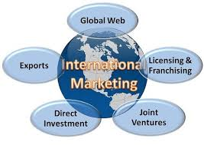 **Figure 2: Diagram showing some of the process that can be used in Global Marketing.**

**BODY & ANALYSIS**

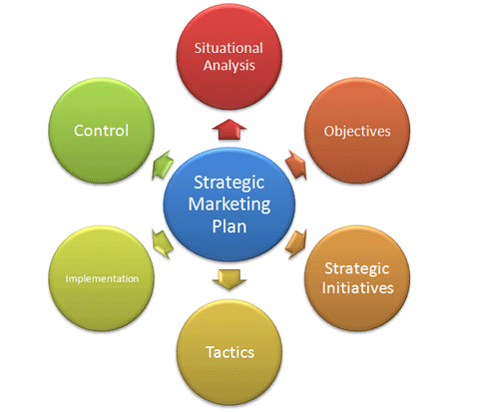 **Figure 3: Diagram showing the strategies that are involved in global marketing.**

To explain something’s about global marketing before going to the definition and full context. The strategies that are being used in the development of global marketing strategies by most companies is officially indicated in the diagram above having figure 3. These strategies can happen when we are able to officially explain the different types of global marketing that is officially used in the society and these are: Localization, Multinational, Global Standardization, and International. Global market is involved with three different categories and they are the Individual consumers, government and business.

I would like to start by defining the meaning of global marketing by saying that this is an aspect of the field of business management study that is used in the process to be able to market products and services to customers locally, nationally and internationally to achieve a common goal. The process of global marketing has a concept and this can be defined as the systematic frame design which an enterprise or a company adopts to be able to design, introduce distribute, and it is able to maintain its product in an official arena.

Criteria is a very important sector in the global marketing system for you to be able to grow to the next stage and doing this there are different process that are involved in the selection process and these is officially indicated in the diagram that is shown in Figure 4 below which is according to their order of process

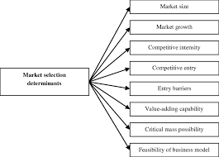 **Figure 4: Diagram showing the global market selection criteria process by customers in the market**

In the global marketing system features some of the most common things that are involved in the process are: Product, Price (The diagram below that has been pasted in Figure 5 officially shows global pricing matrix that is involved in global marketing), Placement and Promotions. It is also important to consider that while the features are very important in this century some particular things that helps to show that customers can get it are: Product Development, Promotional Tactics and Pricing Mechnicisms.

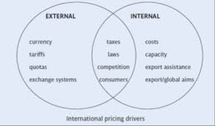

**Figure 5: Internal and External Pricing Decisions to consider in the global marketing system index.**

In global marketing there is a major thing that is being used in developing the answers and results that are being produced in people’s business to show they are either progressing or digressing and that thing is called an analysis of the drive and an example is officially displayed in the diagram that is officially indicated in Figure 6 as shown below:

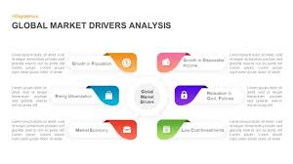 **Figure 6: Diagram showing an example of an analysis drive in the global market in business.**

There are different advantages that help in the journey of developing the global market in the international society and some of these are: Expansion of Business, Customer Engagement, Sales Promotions, Increase in the awareness of the brand in the society, Customer Orientation, Better/Market Understanding and Diversification. Through this we are able to understand some of the major decisions that influences the effect of global marketing that takes place in business expansion as the diagram indicated in Figure 7 indicates some of the process. While there are advantages of Global Marketing, It is clear that the disadvantages of the global marketing are officially shown in the diagram that is officially shown in Figure 7 that is officially below:

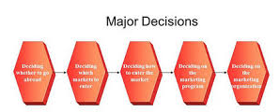 **Figure 7: Diagram showing some of the major decisions that takes place in the global marketing system.**

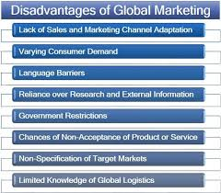 **Figure 8: Diagram showing some of the disadvantages of global marketing in the society.**

Let me conclude my body analysis by sharing some of the most important market parts of marketing and these are: Global marketing for both small and big businesses can sell and ship their products knowing the fact that there are different factors that are important towards being able to achieve the success of being able to succeed in an International level and these things must be considered for you to be able to scale on an International level. The diagram that is officially indicated in Figure 9 shows some of the examples of these factors that we need to put in place when addressing our products to the International Community.

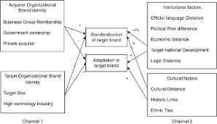 **Figure 9: Diagram showing some of the influence factors that helps businesses to be able to scale in an International market.**

**RECOMMENDATION**

In the global marketing course, some of my biggest takeaways which I intend to improve on going forward as I begin my journey towards developing my project on African Village though I have been able to get global attraction with the International Market already but I would necessary need to retrace some of my mistakes that I have implemented in advertising some of the things that I claim to be doing in the society especially knowing the fact that as I start my African Village Project knowing the fact that I need to be able to understand my kind of market as well as the approach that I would use knowing the fact that this is a new century as some of the modern ways of marketing their business through carriers and tradition method won’t really help you to be able to push forward in the 21st century especially when you think of being a successful person in your career. Another thing that I would do is to be able to learn how to be able to build my network to make sure that business is fully maximized fully

**CONCLUSION.**

In conclusion, I would like to summarize and include my recommendation in the global marketing course by sharing some of the greatest challenges that are officially involved in the area of global marketing and these are: Increased digitalization, Changes in the consumer behaviors, Economic Uncertainty, Working Remotely, Delivering a better customer experience, Managing Data and Analytics, Prove Marketing Values and Pressure to be able to deliver the monthly Return on Investment to any product that has been delivered by customers. Global Marketing is basically done through research and sales to institutional clients across fixed income, credit and currency to deliver equity in businesses sometimes which most times the people that are known in an organization to be responsible for a task like this are known to be the Global Division Market especially they are involved in managing risk and funding as well as the advertisement process that is involved in the growth of the business. .

In my own view it is very important that you are able to understand the process of how you are able to know how to be able to access the global market and this is necessary for entrepreneurs who intend to grow their business and the process that has been indicated in the diagram that has been officially indicated Figure 10 that can be officially be used for 6 weeks once you are able to understand the particular law that is for the region.

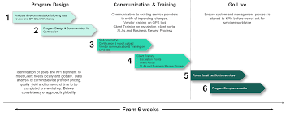.

**Figure 10: Diagram showing the steps towards how you are able to access the global market.**

BLIBLIOGRAPHY

Fleishman, H., 2021. *13 Businesses With Brilliant Global Marketing Strategies*. [online] Blog.hubspot.com. Available at: <https://blog.hubspot.com/marketing/global-marketing-and-international-business> [Accessed 18 May 2022].

Woschnick, V., 2021. *Top 10 Most Effective Marketing Strategies for B2B and B2C*. [online] Weidert.com. Available at: <https://www.weidert.com/blog/top-10-most-effective-marketing-strategies> [Accessed 18 May 2022].

Stoppel, M., 2022. *What is the future for privacy legislation and how should business leaders prepare?*. [online] reuters.com. Available at: <https://www.reuters.com/legal/legalindustry/what-is-future-privacy-legislation-how-should-business-leaders-prepare-2022-04-01/> [Accessed 11 May 2022].

APPENDICES

Figure 1: Diagram showing some of the keywords that are surrounded by Global Marketing.

Figure 2: Diagram showing some of the process that can be used in Global Marketing.

Figure 3: Diagram showing the strategies that are involved in global marketing.

Figure 4: Diagram showing the global market selection criteria process by customers in the market

Figure 5: Internal and External Pricing Decisions to consider in the global marketing system index.

Figure 6: Diagram showing an example of an analysis drive in the global market in business.

Figure 7: Diagram showing some of the major decisions that takes place in the global marketing system.

Figure 8: Diagram showing some of the disadvantages of global marketing in the society.

Figure 9: Diagram showing some of the influence factors that helps businesses to be able to scale in an International market.

Figure 10: Diagram showing the steps towards how you are able to access the global market.