Your name

**UB70199BBU79348**

COURSE NAME:

**Operations Management-AIU Course Creation**

Assignment Title:

**Essay on Operations Management in an Organization**

ATLANTIC INTERNATIONAL UNIVERSITY

**February/2022**

**TABLE OF CONTENT**

* Introduction
* Body
* Analysis
* Recommendation
* Conclusion
* Appendices

**INTRODUCTION**

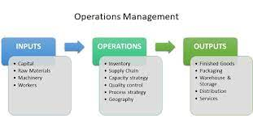 **Figure 1: Diagram Showing the Criteria’s of Operations Management in an Organization**

Let me start my introduction by saying that when you are in an organization dealing with Operations Management, The requirements must be met to be made sure that there is a principle towards making a sustainable running affairs of the organization which the criteria for doing so has been indicated in the diagram in Figure 1 above by releasing the value of being able to balance all the cost that is required in business and also being able to show the 4Vs of Operation Management which are Volume, Variety, Variation and Visibility towards being able to ensure that impact and profitability has been able to gain achievement and weight in the company. Operation Management is a strategy that would also help you to understand the process of Project Management that is being required by every member of the team as well as yourself as the owner of the business to be able to know the steps to take and not running a business organization towards being able to drive on a impact sentiments team in order for the business not to collapse.

**BODY**

I will start my body and analysis by diving deeper to provide some little information and context about Operation Management before going back to the definition. By this let me talk about the scope that is being involved in the area of Operations Management in a company across every level. Some of these areas are: Increases Productivity, Generates Revenue, Enhances Goodwill, Improves Innovation, Reduces Investment needs, Improves Customers Satisfaction and Achievement of Organization Goals. In Operation management one major purpose that defers us from it is by being able to understand the production process and business operations in an effective manner across every efficient ways possible.

I would now define Operations Management to be defined as the business practices administration to be able to create the frequency of the highest level by converting the labor into goods and services in the efficiency of generating profits and bringing impact into the office in the Organization. In Operation Management there are two categories that helps to determine the kind of operations that would basically take place in an Organization and they are Efficiency and Effective Metrics. Operation Management has different things that are required in the execution process for an organization and these are being shown in the diagram in the figure 2 that is being shown above Figure 3 below the text. In Operation Management there are very important value and benefits towards the running of Operations Management and some of these process are hereby indicated as below:-

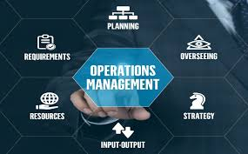 **Figure 2: Diagram Showing the Steps of Operations Management in an Organization**

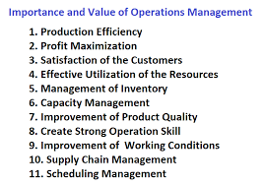 **Figure 3: Diagram Showing the Importance and Value of Operations Management in an Organization**

The main goal of Operations Management in an Organization is for us to be able to understand how we can maximize tools and efficiency of rescources through Increasing Profits with the area of being able to reduce too much cost in an organization. For an Operations Manager there are 15 principles you must be able to understand and these are: Continued Rapid Improvement, Team Up with Customers, Know the Competition, Focus, Organize Rescources, Undefined Competitors, Maintain Equipment, Invest in Human Rescources, Cut times, Minimize Human Errors, Visibility Management, Total Quality Control. Pull Systems, Cut Setup, Fix Causes and Simply Best Equipments. An Operating Management in examples can include: Purchasing Woods and Fabrics, Hiring and Training Workers finally purchasing Cutting Tools and Other Fabricating Equipments. In Operating Management there are 4 modern theories that you must understand to analyze the workflow of the company and these are Business Process Redesign (BPR), Six Stigma, Lean Manufacturing and Reconfigurable Manufacturing Systems (RMF). Operation Management through the diagram that has been indicated in Figure 4 below is being used in an organization to perform the following options in the growth of a Company.

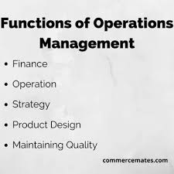 **Figure 4: Diagram Highlights showing the Functions involved in Operation Management**

In an Organization most times the Operations of the firm are usually determined between the Chief Executive Officer, Chief Operations Officer, Operations Manager and Members of the Organization Operations Team with people who must be ready to be able to take feedback but a constructive one. Operation Management has twelve components that makes it up when you are dealing with the process in an organizational system as some of the process are included in this email that are written below in Figure 5

**: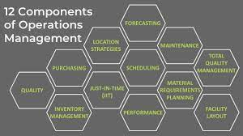 Figure 5: Diagram showing the 12 Components of Operations Management that is present in an Organization.**

There are so many external factors that happens within in an organization that makes Operations Management not to perform their duties especially when multiple services are being offered sometimes as a brand in a company and some of these things are indicated in the email trail written below:-

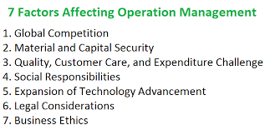 **Figure 6: Diagram Showing the Factors that are affecting Operation Management from Working in an Organization.**

The Diagram that has been indicated in figure 6 below explains some analysis showing all the areas that are involved when you are working on Operations Management especially when you are in the areas of making the decisions that affects the growth and progress of the company from working due to certain influential factors that happens within different places across the world :-

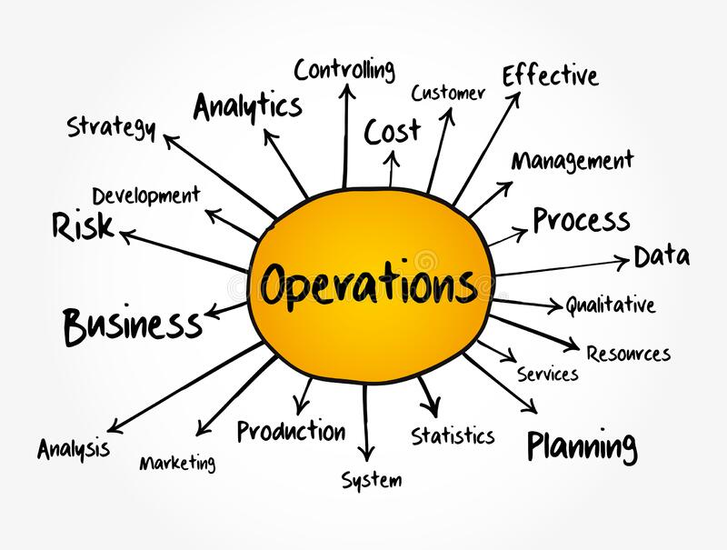 **Figure 7: Diagram Showing the Areas that are involved in Operations Management in an Organization.**

**RECOMMENDATION**

Let me start my recommendation by sharing some of my feedbacks and experience on dealing with operation management with some organizations the first reality I have come to understand is that different companies have their own constitution that they want to achieve for their brand and this is the first thing I would check through with the owners of the firm if I may choose to take up any operation role in the Future through the kind of workflow of the organization Another thing I have been able to take away through so many much lies that I have listened to concerning Operations Management I have come to realize that it is very important that information is always checked before making decision which many comes most times from people that you call your team members who sometimes they are either my seniors or mates as it is not every answers that is correct as this I should be able to understand and make my principles as an entrepreneur to be able to understand what context of Project Management is being required to be able to grow as an entrepreneur and succeed in my career. I would always remember in the Future that the diagram that has been indicated in Figure 7 below are the main criteria’s that I must use in the determination of making the success of my organization or any organization that I am going to find myself involved in the Future.

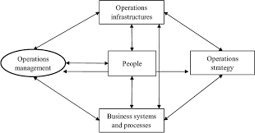 **Figure 8: Diagram Showing the Criteria that makes up the Operations Management Success in an Organization.**

**CONCLUSION**

 **Figure 9: Pictorial Information explaining the role of an Operations Manager in an Organization**

In Conclusion to my essay, Let me start by including the diagram above that would be tagged as Figure 9 by saying that an Operations Manager in an organization is mainly designed to perform that particular task in a company with the person being able to understand that some of the qualities that determines if he is fit for the job is officially determined through the mail that has been indicated below in diagram 10:-.

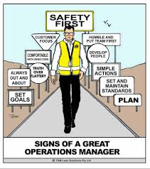 **Figure 10: Pictorial Information showing the signs that make up a great Operations Manager in a Company.**

I would like to officially say also that Operation Management is a lot of demanding challenge which mostly involves the area of mathematics especially understanding the analysis of being able to multitask in delivery of day to day demand which is very important in your career In the line of being able to manage productivity and the principle of adaption in Operation Management that needs to be adopted towards being able to understand the strategies that is required at the particular time towards being able to execute a particular operation towards being able to maintain the delivery to the client. You must be able to make decisions for yourself as an operations member in order for you to be able to not get deceived by external factors to take steps that is not required for the growth of the organization.

**BIBLIOGRAPHY**

Hayes, A., Drury, A. and Jackson, A., 2021. *How Operations Management (OM) Works*. [online] Investopedia. Available at: <https://www.investopedia.com/terms/o/operations-management.asp#:~:text=Operations%20management%20(OM)%20is%20the,the%20profit%20of%20an%20organization> [Accessed 10 February 2022].

Free Management Library. 2022. *Introduction to Operations Management of Products and Services: Overview and Resources - Free Management Library*. [Online] Available at: <https://managementhelp.org/operationsmanagement/index.htm> [Accessed 10 February 2022].

Varon, L., 2021. *Operations Management: Maximizing Efficiency in Any Business | Full 2022 Implementation Guide*. [Online] Sweet Process. Available at: <https://www.sweetprocess.com/operations-management/#ch3> [Accessed 10 February 2022].

**APPENDICES.**

Figure 1: Diagram Showing the Criteria’s of Operations Management in an Organization

Figure 2: Diagram Showing the Steps of Operations Management in an Organization

Figure 3: Diagram Showing the Importance and Value of Operations Management in an Organization.

Figure 4: Diagram Highlights showing the Functions involved in Operation Management

Figure 5: Diagram showing the 12 Components of Operations Management that is present in an Organization.

Figure 6: Diagram Showing the Factors that are affecting Operation Management from Working in an Organization.

Figure 7: Diagram Showing the Areas that are involved in Operations Management in an Organization.

Figure 8: Diagram Showing the Criteria that makes up the Operations Management Success in an Organization.

Figure 9: Pictorial Information explaining the role of an Operations Manager in an Organization

Figure 10: Pictorial Information showing the signs that make up a great Operations Manager in a Company.