Your name

**UB70199BBU79348**

COURSE NAME:

**Modern CapialismAIU Course Creation**

Assignment Title:

**Essay on Modern Capitalismin an Organization-AIU Course Creation**

ATLANTIC INTERNATIONAL UNIVERSITY

**March/2022**

**TABLE OF CONTENT**

* Introduction
* Body & Analysis
* Recommendation
* Conclusion
* Bibliography
* Appendices

**INTRODUCTION**

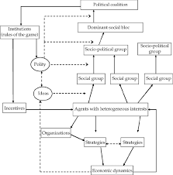 **Figure 1: Diversity Diagram to understand some of the factors of Modern Capitalism.**

From the designed chart Diagram that is officially indicated Figure 1 which is above, The Popular Modern Capitalism was a philosophy that was developed in 1700 centuries and was officially emerged into the international community in 1848 in the Western Europe and Oceania by Professor Adam Smith who was on the earth surface between the year 1732-1790. The capitalism is established in order to show how diversity is discovered towards how we are able to untap into the modern rescources and human materials through the production of goods and services in our country with other foreign partners that is different from the ones that has been currently existing in their different phase of the economy especially the part that is always officially known to be a market-oriented economy.

**BODY & ANALYSIS.**

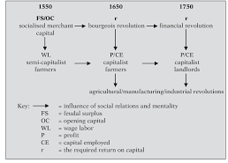 **Figure 2: Diagram to understand the common capitalism revolutionary.**

The body of my essay would show the diagram that is officially indicated above in the label Figure 2 which is speaks about the max accounting history of revolution of capitalism as this process would lead us to define capitalism as an economic system in which both private and individual business own the goods and create their own services to become in capital. The characteristics that generally makes a development of a pure capitalism in an Organization is officially indicated as follows below: Lack of Government Intervention, Means of Owned and Services Production developed by private firms and Goods along with services that are officially distributed according to private mechanisms which is officially most times opposed to the method price from the Government of a particular country.

The main pure principles that are involved in capitalism are as follows: a higher purpose, stakeholder’s orientation, conscious leadership and conscious culture programme. Pure Capitalism is officially made up to be known to be having five characteristics in building the company brand and they are: Private Ownership, Free Enterprise, Freedom of Choices, Competition and The Possibilities of generating Profits. In Capitalism using the principles of business, some of the people that are officially going to be involved in the development of construction programme officially are indicated in the diagram that is officially indicated in Figure 3 that is officially indicated below:

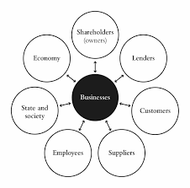 **Figure 3: Diagram showing the series of parties of business that are involved in the growth of capitalism in the Society.**

Modern capitalism was officially introduced based on the elements of Feudal Society, Breakdown of Prosteant Information and Industrial Information. I would now proceed to define the term which is officially known to be as the Modern Capitalism itself as a term that is officially known to be used in representing a capitalist society in which comes in the category of two capitalism clites classes which are the old and new elites concerned with maximizing their wealth secures a political system that serves and protects their official interests which is officially used to be able to lead to a wage-earning class. In Modern Capitalism development it is very important that before we choose to know how we are going to head for Operations, The characteristics that are involved in capitaiism is sometimes very differ and that is why you need to understand the importance of the purpose of the capitalism business that you want to achieve in the official business criteria as you head towards your sector for the journey that you want to create for your future as diagram that is officially written in figure 4 lists the basic characteristics that are involved in modern capitalism that are involved below:

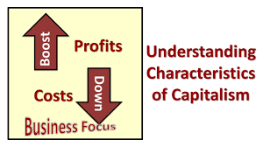 **Figure 4: Diagram showing the Characteristics that an Organization needs to know when it comes to Modern Capitalism**

It is very important that we are able to understand the pros and cons of how it works as the diagram that is officially indicated in Figure 4 would guide us towards being able to understand the two sided effects of how it basically works.

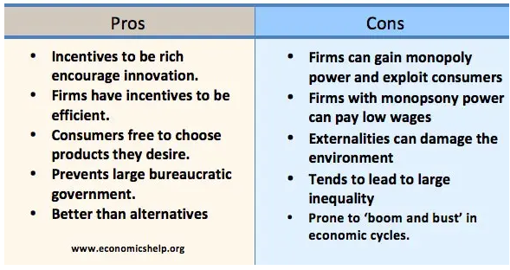 **Figure 5: Diagram showing the pros and cons that an Organization needs to know when it comes to Modern Capitalism**

The advantages of capitalism towards developing a global economy in the society are

Officially indicated as follows: Dynamic Efficiency, Creative Destruction, Economic

Freedom helps political freedom, Efficient allocation of Rescources, Mechanism for

Overcoming discrimination and bringing people together regardless of the religion.

In career development, someone who is officially involved in Modern Capitalism is

Officially known to be called a Capitalist and the following are the steps that are taken

towards becoming a successful capitalist in the industry: Get some Capital. Clues in the

Name, Own the official means of production too, Own other assets in your category too,

Treat and Turn yourself to a Company, Diversify and create a multiple streams of

Income and Become an Expert Affiliate Allocator. In Capitalism there is a major chart

that is officially used towards being able to explain what are the major stakeholders that

are involved in the developing and growing of capitalism in the society through diagram

6 that is officially indicated below you would able to see the ranking as officially develop

as well as an example of the capitalism in the effect of a Modern Capitalism effect in an

Agro business system. That is officially indicated through the official diagram that is in figure 7 officially written below:

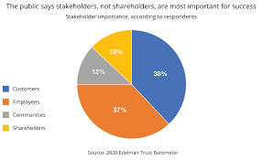

**Figure 6: Diagram showing the Stakeholders that are involved in Modern Capitalism in an Organization.**

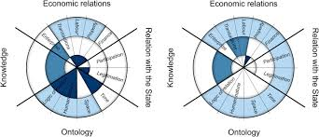 **Figure 7: Diagram showing some capitalism effect in an agro business system of an Agricultural Developmen.**

**RECOMMENDATION**

In the development of Modern Capitalism from the Course of Atlantic International University some of my biggest takeaway and mistakes that I have been able to view from my mis information on this development especially in the fact that many people feel that it has end goal which is something that is always dominating our planet towards helping us to be able to increase our public norms. I have also been able to learn through this particular course that before you get yourself involved in capitalism you need to understand the purpose of what you are doing it for, what are the legal laws behind this particular action and finally through the diagram that is officially indicated below you would be able to understand the sustainability that is behind the capitalism development,

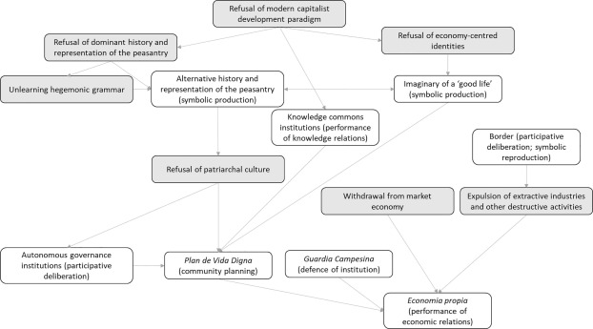 **Figure 8: Diagram showing the Sustainability Development that is involved in Modern Capitalism in an Organization.**

**CONCLUSION**

Let me conclude my essay on modern capitalism in an Organization by officially saying that in this aspect it is very important that we always remember the words and associations that are involved in this development when we officially here in the society are officially written in the diagram that officially indicated figure 8 below and officially being able to understand how you can perform your duties officially to the world through the diagram that is officially indicated in Figure 9:

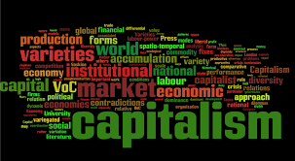 **Figure 0: Diagram showing some of the factor words that we must always remember when it comes to Modern Capitalism in the Society.**

 **Figure 10: Diagram showing how you can build capitalism across the world.**

**BIBLIOGRAPHY**

Cohen, R., 2021. *Modern Capitalism Needs a Revolution to Undo the Damage It Has Caused*. [online] Time. Available at: <https://time.com/6111683/capitalism-impact-investment-ronald-cohen/> [Accessed 5 March 2022].

Schwab, K. and Vanham, P., 2021. *What is stakeholder capitalism? It's History and Relevance*. [online] World Economic Forum. Available at: <https://www.weforum.org/agenda/2021/01/klaus-schwab-on-what-is-stakeholder-capitalism-history-relevance/> [Accessed 5 March 2022].

Lisbdnet.com. 2021. *what are the 5 main characteristics of capitalism - Lisbdnet.com*. [online] Available at: <https://lisbdnet.com/what-are-the-5-main-characteristics-of-capitalism/> [Accessed 5 March 2022].

**APPENDICES**

Figure 1: Diversity Diagram to understand some of the factors of Modern Capitalism.

Figure 2: Diagram to understand the common capitalism revolutionary.

Figure 3: Diagram showing the series of parties of business that are involved in the growth of capitalism in the Society.

Figure 4: Diagram showing the Characteristics that an Organization needs to know when it comes to Modern Capitalism

Figure 5: Diagram showing the pros and cons that an Organization needs to know when it comes to Modern Capitalism

Figure 6: Diagram showing the Stakeholders that are involved in Modern Capitalism in an Organization.

Figure 7: Diagram showing some capitalism effect in an agro business system of an Agricultural Developmen.

Figure 8: Diagram showing the Sustainability Development that is involved in Modern Capitalism in an Organization.

Figure 9: Diagram showing some of the factor words that we must always remember when it comes to Modern Capitalism in the Society.

Figure 10: Diagram showing how you can build capitalism across the world.