**Name:**

**UB70199BBU79348**

**Course Name:**

**MANAGEMENT THEORY AND PRACTICE**

**Assignment Name:**

**ESSAY ON MANAGEMENT THEORY AND PRACTICE**

**ATLANTIC INTERNATIONAL UNIVERSITY,AIU**

**January, 2022.**

**TABLE OF CONTENT**

* Introduction
* Body
* Analysis
* Recommendation
* Conclusion
* Blibliography
* Appendices

**INTRODUCTION**

Firstly, The production of management theory has two First, theory professionalizes researchers through creating a shared embrace of the scientific framework and commitment to disseminating findings using a common language. Second, theoretical knowledge acquired within the academy offsets the inexperience of novice managers and improves the practice of more seasoned ones. Scientific theory thus legitimizes both management research and practice as professional vocations.

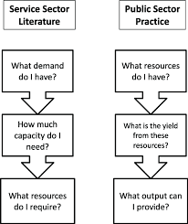 **Figure 1: Management Capacity System Format Diagram**

The process of which an organization develops and grow is determined by the management of the company. When we begin to start talking about Management theory and practice generally this is something that many organization has failed to produce today simply because there has been no plan towards being how they intend to run the firm through a business principles. Through the diagram above we need to be able to determine what exactly do we want to do whether it is pure business or rendering a service to someone on a particular purpose. Management theory and practices is simply best explained through introduction as the cultural framework designed for the teeam towards being able to manage and perform their highest various task for them in order to perform to their best of ability and achieve their highest framework goal by comparing them towards being able to use knowledge towards being able to emulate on the best practices that its needed in running the firm as an entity in their different sectors which this document would be able to go into full details of what the designed management thory and practices takes to be achieved in any organization and the disadvantages

**BODY**

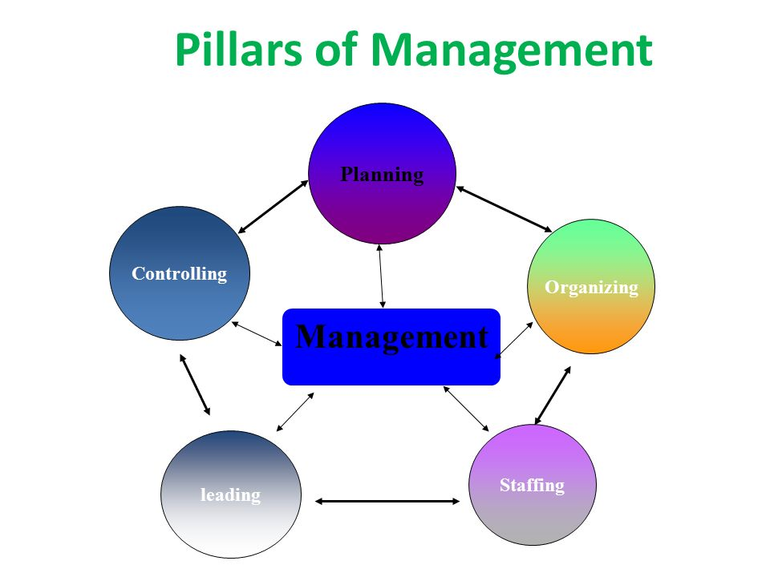 **Figure 2: Pillars of Management Diagram.**

Now lets start by defining that Management theory and practices is known to be the collection of ideas that comes from a particular problem that needs a defined solution and business principles that would explain bestly on how to run and manage the organization for it to be able to attain its desired goal through the understanding knowledge of best understanding the pillars of what management are through the diagram that is being designed above in figure 2. The relationship between the management theory and practices is that the knowledge of theory that you get on the business it is the process that you would use in order to put the skills and practice in place in order to be able to make the right descisions in order for the business to grow.The main benefit of why there needs to be manajgement theory and practices in an organization is that: It helps to inncrese productivity, Simplifies the descision making and encourages staff participation with collaboration in the organization. Some of the things that are included when it comes to having the management theory and practices in an organization are: Introducing new schemes for new quality, empowering and training both old and new staff then introducing various technology devices and machines to the organization. Through the chart diagram below in Figure 3 you are able to understand the systematic approach towards how the system of Management theory and practices is being developed in companies by them looking ahead to the Future.

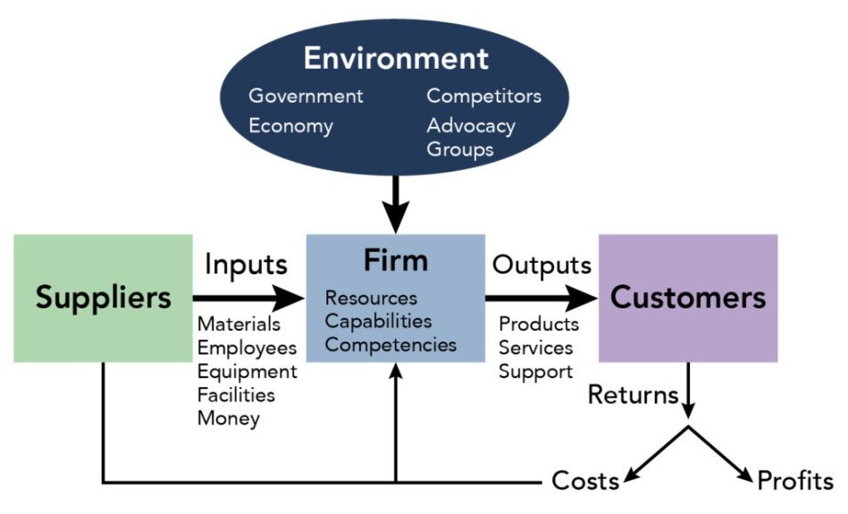 **Figure 3: Systems used towards building Management Practices and Theory**

**ANALYSIS**

Let me start my analysis by saying that the effect of having management theory and practices in the organization are as follows: Reduces cost, Establishes Sound Equilibrum and organization development, Essentials for the prosperity of the society, Optimum Utilization of Rescources and then Helps in Achieving the group goals through which this are being created through a force which are Place of Change, Globalization, Technology, Socialization, Operations Management and Diversity that helps to determine the organization goals.With the knowledge of Management theory designed in an organization, The places where we need to put the practice into place can be majorly distinct into 5 categorized areas and these are: Communication through all the formal means available within the organization, Leading by example, Setting and Demanding realistic goals that can be achievable within a particular timeframe, Open Management Style, Being able to create a strategic plan.

Management Theory and practces using the diagram that is indicated in figure 4 which are the factorss to consider when dealing wiith management practices and theory is very essential and important to business because it helps the organization board and members of staff to be able to communicate among themselves, evolve and achieve their goals in the different sectors of the company by being able to set their piorities right through exhibiting the different kind of leadership style that is essential for the growth of the brand. A major factor that is very important when it comes to dealing with Management Practices and Theory has to do with the Organizational Behaviour which has to do with the modes of trying to develop their communication strategy in the different format of trying to achieve the aim target that is required for their different department in order to help increase the productivity of all employees of the company. We must always remember that one Management and theory practices that works for one Organization might be definetly not relevant for the other company.

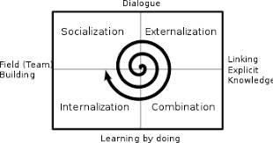 **Figure 4: Factors to consider during Management Theory and Practices**

**RECOMMENDATION**

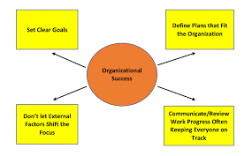 **Figure 5: Factors that organizations used in the determination of their success growth**

From the diagram 5 above that is being designed it simply explains what are the factors that leads to the success of an organization in their different sector through this that is being design above allow me to start saying inrecommendation to the system that when it comes to dealing with the Management Theory and practices in an organization you need to be able to understand what the theories are and how does your ability want to influence the motivation and the descision of your staffs towards developing the spirit of entrepreneurship theory when it comes to be able to develop management structures in an organization especially in the modern century where the common ones that are used generally are: Quantitative Management theory, Contigency Management theory, Systematic Management theory, Human relations Management Theory, Theory X and Y and Principles of Administrative Management theory. When you are dealing with the Management Theory and practices in a company the diagram below which has to do with the organization strength, weakness, opportunities and threats explains one of the most important criteria that needs to be looked into when going forward through a check after a year growth:

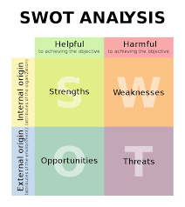 Figure 6: Diagram Explaining Swot Analysis in a Management Theory and Practices

**CONCLUSION**

Let me begin the conclusion to my write up that change of system developoment is the most difficult thing that can be implimented in any organization especially in a form of theory and practices which there are many times always having a gap between this two particular areas which researchers always use their skills in order to be able to provide answers to the problems that the company is generally facing in the growing the brand. When the system of negative assumption is change here is what you avoid from happening below from the diagram that is being indicated below:-

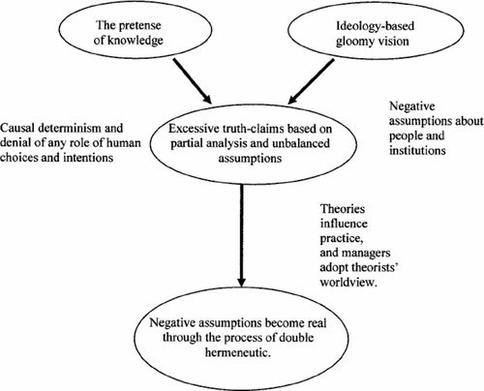 **Figure 7: Diagram explaining some Bad Management Theory and Practices that happens in a company.**

Going forward in life, Some of the ways I feel that I would be able to apply this knowledge from the Atlantic International University Course Creation towards being in the process re structiuring and rebranding of my business on a better direction in life is that: I would make sure that when I am running the African Village and other going forward that I am able to make sure that policies that would be used in building on Management theory and practices are hereby implimented by my members of team in our daily act through being able to identify if there are any missing gap daily through our pending deliverables as a company by being able to ensure that the culture and business principles that I have set for the organization would be used fully with or without my presence in the office.

**REFERENCE**

Editorial Team, I., 2021. *7 Types of Workplace Management Theories | Indeed.com*. [online] Indeed Career Guide. Available at: <https://www.indeed.com/career-advice/career-development/types-of-management-theories> [Accessed 23 January 2022].

Corporate Finance Institute. n.d. *Management Theories*. [online] Available at: <https://corporatefinanceinstitute.com/resources/careers/soft-skills/management-theories/> [Accessed 23 January 2022].

Courses.lumenlearning.com. n.d. Management Theory and Organizational Behavior | Organizational Behavior / Human Relations. [online] Available at: <https://courses.lumenlearning.com/wmopen-organizationalbehavior/chapter/management-theory-and-organizational-behavior/> [Accessed 23 January 2022].

**APPENDICES.**

Figure 1: Management Capacity System Format Diagram Figure 2: Pillars of Management Diagram

Figure 3: Systems used towards building Management Practices and Theory

Figure 4: Factors to consider during Management Theory and Practices

Figure 5: Factors that organizations used in the determination of their success growth

Figure 6: Diagram Explaining Swot Analysis in a Management Theory and Practices