Your name

**UB70199BBU79348**

COURSE NAME:

**Introduction to Risk Analysis-AIU Course**

Assignment Title:

**Essay on Introduction to Risk Analysis**

ATLANTIC INTERNATIONAL UNIVERSITY

**May/2022**

**TABLE OF CONTENT**

* Abstract
* Introduction
* Body & Analysis
* Recommendation
* Conclusion
* Bibliography
* Appendices

**ABSTRACT**

The main purpose of this research work assignment is to be able to share some information that is related to the analysis of risk in my organization as well as other organization that usually happens across different level of business strategy and decisions making. In this research, I would be able to share some of my experience in the aspect of taking business from my different startup that I have created till the point that I got to in order to be able to build the African Village Organization as well as looking at the risk that is ahead of us.

**INTRODUCTION**

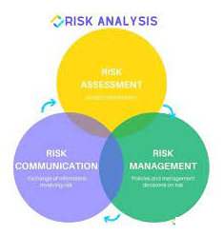 **Figure 1: Diagram showing the types of risk analysis that most times happens in a business.**

When you are starting off a business in an Organization the major influence that put a check on whether you would either gain or lose profit very fast is the risk analysis that comes from the business and most times from the diagram that is indicated in Figure 1 there are three lines that thing usually happen or fall place into depending on the sector of the business that it happens to which most times there are usually a risk process that is indicated in the diagram that is indicated in Figure 2 that is being displayed below for most of this action.

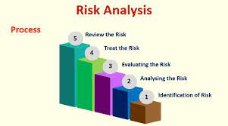 **Figure 2: Diagram showing the process of risk analysis that takes place in an Organization**

**BODY & ANALYSIS**

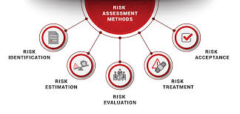 **Figure 3 Diagram showing the management methods that is involved in a risk analysis.**

Let me start the body of my research work by giving my views on what the meaning of risk analysis is all about: Risk Analysis is the negative identification issue that happens to a project during the process of trying to build the right system for the future and it is done in other to help the company plan towards mitigating or avoiding them from happening. There are different management methods that are being used in the process of checking how risk happens in an Organization and these methods are written in the diagram that is indicated in Figure 3 above. Through this methods you are able to know the formula to understand how and when to know the process to be able to follow to be able to mitigate this risk which is very important as the diagram that is indicated in Figure 4 are some of the process that is used in assessing the method risk that takes place in an Organization

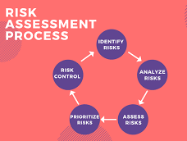 **Figure 4: Diagram showing the process chart of assessing a risk in an Organization.**

There are three types of risk that most times people intend to perform in their lives and career and these risks are: Business Risk, Non-Business Risk and Financial Risk. In dealing with risk it is important that you are a decisions maker especially when you are doing it for a particular purpose that would be of benefit to the future and the Ts that you need to understand in this particular aspect are: Tolerance, Treat, Terminate and Transfer. When you are taking risk or trying to understand the issues that are surrounded the analysis of taking risk there are different factors to be able to consider when you are trying to assess an issue or a presentation probably for an investment. The diagram that has been indicated in Figure 5 that has been indicated below shows the strategy assessment checklist that must be considered before taking that particular risk for a purpose:

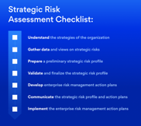 **Figure 5: Diagram showing the checklist risk assessment review designed for Organizations.**

Every time you try to understand the situation of what is happening around you it iis very important that you are able to know how to control and mitigate the risk as this process would help you towards knowing how to become a better person. Some of the ways in which you can help towards being able to control risk are: Trying a less risky option, preventing access to the hazards, organizing your work to be able to reduce the exposure to the hazard. There are different things that you need to know about when you see the characteristics of some of the risk that are happening in an Organization. These characteristics of risk are included in the diagram that is indicated in Figure 6 that is officially written below:

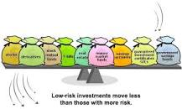 **Figure 6: Diagram showing some of the characteristics of risk that takes place in an Organization**

Through the diagram that is above in Figure 6. We are able to come with the reality that this two risk are majorly divided into the two form which are Systematic and Unsystematic Risk. There are basic methods for risk management and these are: Avoidance, Loss Prevention, Retention, Transferring and Reduction.

The Factors of Managing risk is very important and some of the process that is being used to manage risk are: Deciding on what matters to you most, Consult with Stakeholders, Identify the risk, Analyze the risk, Evaluate the risk, Treat risk to the business and Commit to reducing the risk. There are different factors that you need to take before you are going to a risk from the environment that the event is happening and these factors are indicated in the diagram that is currently shown in Figure 7 below as this process would help you to be able to identify the problems and consequences that is being tabled in the diagram that is officially written in Figure 8 that is written below

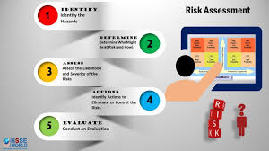 **Figure 7: Diagram showing how to conduct a risk assessment from a particular environment.**

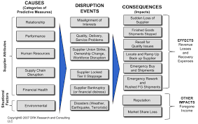 **Figure 8: Diagram showing the major tabular form having to do with the problem and consequences involved in Risk Analysis.**

Let me finally conclude that it is very important to be able to understand that some of the words and information that has to do with the process of developing a risk analysis flowchart in your business as I have been able to indicate from the diagram that is indicated in Figure 9 that is below showing some of the risk analysis process flowchart as through this we are able to remember some of the words that we need to remember in Risk Analysis that is being shown in the diagram that is indicated in Figure 10 that is being written below:

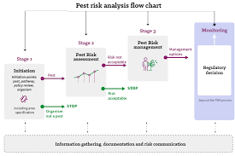 **Figure 8: Diagram showing an example of the analysis of the flowchart that is being structured in the Organization Process.**

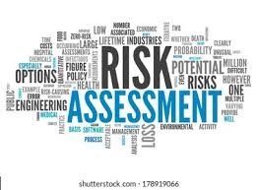 **Figure 9: Diagram showing some of the information that you need to remember when you hear the word Risk.**

**RECOMMENDATION**

I would like to start my recommendation by sharing some of my experience since I have been taking risk for different things as well as how this course has been able to sharpen my mind towards the future hoping that the rules of tradition from Nigeria won’t allow the demons me to the second time to be able to not meet my desired point of career goal is required for me to be able to meet up with. I have accepted that a lot of times that I have taken risk that most times it should have not been my business or something that I should have been involved in especially with the fact when my dad uses the opportunity to make leadership a means of correction You need to be able to understand the importance of knowing the system of the particular workplace before you decide to take that particular risk that you desire to make for the Organization. This course has been able to show me some of the explanation point of how you need to know how to use the Ts to be able to handle your position to deal with mitigating the risk by making it turn to a positive result and sometimes knowing in life that it is not all risk you are still able to handle but you just need to know when and how you would control the risk from happening by the time it comes to you.

**CONCLUSION.**

I would like to conclude my essay by saying that from my perspective I would like to share and inform that in Risk Analysis which is used by different business industry owners and leaders in different sectors most times usually the solutions turns out to be positive but this can only happen if we are able to understand the process of how we are able to control and understand the situation of the environment that is happening to us at that particular time. It is important that you also acknowledge that risk sometimes cannot be cured especially when the remedy might have been scattered to different point of hole. It is every important that if we want to reduce the rate of risk that takes place in an Organization we need to be able to practice team work and understand the kind of personnel that we are hiring into the project for us to be able to progress in our journey. One thing that I want to share from the diagram that is officially indicated in the diagram that we must be able to identify for anyone that wants to put in their investment money into any particular business must be able to understand the diagram that is officially indicated in the diagram that is currently indicated in the diagram that is indicated in Figure 11 to know the business position before you are able to put in your money.

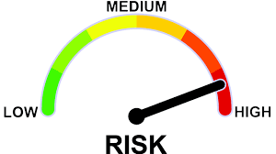 **Figure 11: Diagram showing how the level of risk is being designed in a business by investors.**

**BLIBLIOGRAPHY**

Glossop, A., 2021. *What Is A Risk Matrix? | Ideagen*. [Online] Ideagen.com. Available at: <https://www.ideagen.com/thought-leadership/blog/risk-matrix-what-is-it-and-should-you-use-one> [Accessed 22 May 2022].

Yu, J., Potter, C. and Costagiola, D., 2021. *5 Basic Methods for Risk Management*. [online] Investopedia. Available at: <https://www.investopedia.com/articles/investing-strategy/082816/methods-handling-risk-quick-guide.asp> [Accessed 22 May 2022].

Bridges, J., 2022. *Risk Analysis: Definition, Examples and Methods*. [online] projectmanager.com. Available at: <https://www.projectmanager.com/training/how-to-analyze-risks-project> [Accessed 22 May 2022].

**APPENDICES**

Figure 1: Diagram showing the types of risk analysis that most times happens in a business.

Figure 2: Diagram showing the process of risk analysis that takes place in an Organization

Figure 3 Diagram showing the management methods that is involved in a risk analysis.

Figure 4: Diagram showing the process chart of assessing a risk in an Organization.

Figure 5: Diagram showing the checklist risk assessment review designed for Organizations.

Figure 6: Diagram showing some of the characteristics of risk that takes place in an Organization

Figure 7: Diagram showing how to conduct a risk assessment from a particular environment.

Figure 8: Diagram showing the major tabular form having to do with the problem and consequences involved in Risk Analysis.

Figure 9: Diagram showing an example of the analysis of the flowchart that is being structured in the Organization Process.

Figure 10: Diagram showing some of the information that you need to remember when you hear the word Risk.

Figure 11: Diagram showing how the level of risk is being designed in a business by investors.