Your name

**UB70199BBU79348**

COURSE NAME:

**Obstacles to Human Development-AIU Course Creation**

Assignment Title:

**Essay on Obstacles to Human Development in an Organization**

ATLANTIC INTERNATIONAL UNIVERSITY

**February/2022**

**TABLE OF CONTENT**

* Introduction
* Body & Analysis
* Recommendation
* Conclusion
* Appendices

**INTRODUCTION**

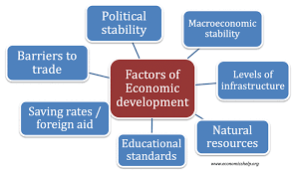 **Figure 1: Diagram showing the factors in the obstacle of economic development.**

In the world that we are facing today especially those who come in from a third world war countries such as Nigeria and Ethiopia in this affect knowing that are so many external and internal factors that affects the growth of human development which might come in different types that may affect a person in one from to another process of life journey through the form of it being happening according to the factors of economic development according to the diagram that is indicated above in figure 1 that is limiting them to enjoy the different kinds of freedom that they deserve to get in their career which can be overcome through different principles through the indication of this that would be able to explain in the analysis that is indicated in the body analysis of the essay. .

**BODY & ANALYSIS**

Let me start the body analysis of my essay by diving deep into the introduction of the meaning of obstacles of human development by saying that this is the hindrance action that is being done that is used in the process of being able to affect the growth of things from expanding. Obstacles are usually taken place in different formats and these are: Political, Cultural, Technological, Military, Physical and Economical. There are three Ps which is the main challenges that is being able to show the effect of human development and these are: Production, Poverty and Potential as the effect of this has led the United Nations to be able to develop a plan towards being able to meet up with the required goals of the community by developing the Sustainable Development Goal that is being showed in the diagram that is indicated in Figure 2 below to answer all our challenges facing the world.

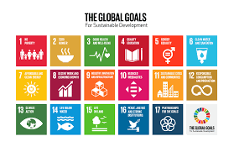 **Figure 2: Diagram showing the sustainable development goals of the United Nations as Criteria to solve the Obstacle.**

There are main issues that happen in human development when it comes to the area of most youths today when it comes to development and these are: Physical, Cognitive and Socio Economical Development. Majorly the obstacles that we are facing in our development is basically to tied to three things which is not helping us to achieve the required growth that we need to have in our life and the three things are officially shown in the diagram that is indicated in Figure 3 that is officially written in the mail message below:-

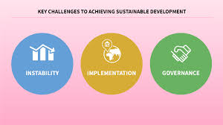 **Figure 3: Diagram showing the Key Challenges of Sustainable Development in Human Development Obstacles**

When you are at work or somewhere, there is no need towards being dominant as being strong or a man process in this criteria as sometimes you need to admit that through diagram in figure 3 below showing teamwork in an organization as some of these can help the other criteria’s towards helping you how to overcome all the other obstacles that is stopping you in growing in the organization as some of these are : Remain Positive at Work, Know when to delegate a particular assignment, New Challenges Hire, Challenges once a promotion has been made in an Organization, Don’t be an arrogant person when you are delegating an assignment in an organization especially in the area where you want people to help you with and Set Small Goals

 **Figure 4: Diagram showing the formalities of teamwork of avoiding obstacles in an Organization**

In the Future, It is very essential to understand that if you want to solve the obstacles that is officially involved in Human Development in the society it is very important to be able to put in the criterias that are officially involved in the planning of the Dynamic External Management of Human Rescources as this would help everyone in their party to understand

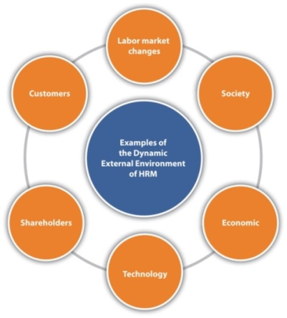 **Figure 5: Diagram of the HRM Format of Solving Obstacles of Human Rescources Management.**

Obstacles in Human Development is very important that it is something we must be able to overcome in any way that we can as Hard times stimulates growth in any way that we can comparing to the times that good times does not especially in the area of when we are trying to make sure we are able to build resilience capacity towards making sure that we are able to lay a solid foundation for a later life for the future that we want to create. When we are talking about Obstacles to Human Development, There is one thing that we must not always forget as this is a persistent thing that happens as a barrier to human development and it is officially indicated in the diagram in Figure 6 below:

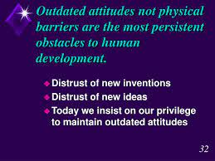 **Figure 6: Visual Information Diagram of the Most Persistent Issue of Human Development**

Let me finally conclude my essay analysis by saying that in human development in trying to resolve the issues and obstacles that are around this process some of the things that you need to remember in this process of the journey are indicated in the diagram that is being showed in figure 7 that is officially written in the below diagram which would also serve as a core function of the Human Rescources Management in an Organization

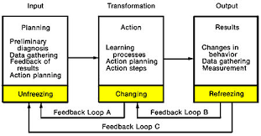 **Figure 7: Diagram that shows the factor core function that is being affected in the change of Human Development.**

**RECOMMENDATION**

My Recommendation from this course which basically talks about how I can avoid myself and help other from being an obstacle to human development in their respective areas is by Firstly I intend to have an interview with them where I am able to understand their perspectives towards their meaning of what life is to them and how they have been able to explore themselves with the way they are especially the challenges that they are having in their environment, understand by seeing also what their ability to learn is all about and how much they are able to show the commitment towards wanting to learn is being achieved in their daily lives as they are able to progress. One thing I have come to observe about Obstacles of Human Development as far a lot of people are asking me to forgive some certain people, I won’t use the opportunity to be able to tolerate stupidity that would take place any further as I progress in my daily life. I would always remember to apply to see some of the barriers physiological that may affect the human development as well as some of the major problems that is likely basically to take place generally through the diagram that is officially indicated in the diagram that is written in Figure 8 that is officially showing below:

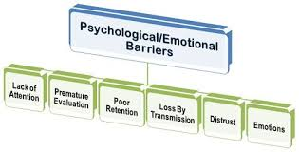 **Figure 8: Diagram showing some the physiological barriers on Human Development**

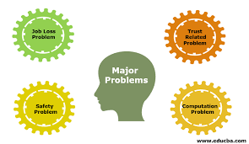 **Figure 9: Diagram showing Major Problems of Human Development**

**CONCLUSION**

Officially, I would conclude my essay on the Obstacles to Human Development by saying that it is very important that we are involved towards helping people to grow in their lives at the same time we must also be careful of the people we are adding to the topic especially we are able to understand the diagram in Figure 10 which understand the scope of human beings that we are dealing with in the society as well as Figure 11 showing some of the fact of achieving them in order areas of the world towards creating Organizational Development which the diagram in officially indicated in Figure 12 beneath.

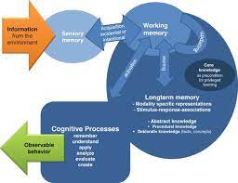 **Figure 10: Diagram showing some the processes that can be used towards being able to identify the potentials of humans**

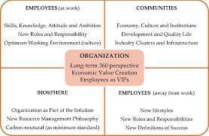 **Figure 11: Diagram showing some of the criteria’s of Human Development.**

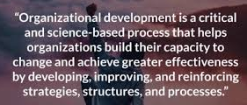 **Figure 12: Graphical Information on the meaning of Organizational Development**

**BIBLIOGRAPHY**

Cherry, K., 2021. *Developmental Psychology Overview*. [online] Verywell Mind. Available at: <https://www.verywellmind.com/developmental-psychology-4157180> [Accessed 19 February 2022].

Thill, R. and Rice, A., 2021. *4 Major Domains of Child Development*. [online] Verywell Family. Available at: <https://www.verywellfamily.com/definition-of-domain-3288323> [Accessed 19 February 2022].

World, T., 2021. *What are the Barriers to Economic Growth and Development?*. [online] The Scientific World - Let's have a moment of science. Available at: <https://www.scientificworldinfo.com/2021/01/barriers-to-economic-growth-and-development.html> [Accessed 19 February 2022].

**APPENDICES.**

Figure 1: Diagram showing the factors in the obstacle of economic development**.**

Figure 2: Diagram showing the sustainable development goals of the United Nations as Criteria to solve the Obstacle.

Figure 3: Diagram showing the Key Challenges of Sustainable Development in Human Development Obstacles

Figure 4: Diagram showing the formalities of teamwork of avoiding obstacles in an Organization

Figure 5: Diagram of the HRM Format of Solving Obstacles of Human Rescources Management.

Figure 6: Visual Information Diagram of the Most Persistent Issue of Human Development

Figure 7: Diagram that shows the factor core function that is being affected in the change of Human Development.

Figure 8: Diagram showing some the physiological barriers on Human Development

Figure 9: Diagram showing Major Problems of Human Development

Figure 10: Diagram showing some the processes that can be used towards being able to identify the potentials of humans

Figure 11: Diagram showing some of the criteria’s of Human Development

Figure 12: Graphical Information on the meaning of Organizational Development