Your name

**UB70199BBU79348**

COURSE NAME:

**Introduction to Law-AIU Course**

Assignment Title:

**Essay on Introduction to Law**

ATLANTIC INTERNATIONAL UNIVERSITY

**May/2022**

**TABLE OF CONTENT**

* Introduction
* Body & Analysis
* Recommendation
* Conclusion
* Bibliography
* Appendices

**INTRODUCTION**

 **Figure 1: Diagram representing the logo symbol of lawyers in the court of law.**

In a society today at every arm, company and work place in the society has a principle guiding the structure of the organization to make sure that everyone is able to perform their duties rightly as well as for retain information purposes and that development is officially set to be called a Law which also are in different types for example we have the criminal and business law. Different countries have their principles that they use in responding to the legal issues that are affecting them officially in the society. The system has a sign that is most times used in representing the people who are lawyers that are in the bar as an example is officially attached in the diagram that is officially written in Figure 1 above.

**BODY & ANALYSIS**

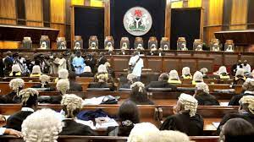 **Figure 2:Diagram officially showing an example of a court room in the Federal Republic of Nigeria.**

Let me start my introduction on law by sharing some of the principles that affects the decisions that officially helps in the structure of rule of law. The diagram that is officially indicated in the figure that is indicated 2 is an example of a court room which is an example of Rule of Law basically has four universal principles from the World Justice Project and they are: Accountability (Government and Private Institutions responsibility), Just Law (Contract and Intellectual Rights), Open Government (Efficiency in delivering Justice) and Accessible Impartial Justice (Independent Representatives of communities). In the rule of law in an organized system of policy there are factors that affects the decisions that is being made at the different courts of arm and some of these factors are: Absence of Corruption, Fundamental Rights, Civil Justice, Criminal Justice, Open Government, Order and Security. There are pros and cons of being the law department especially when you are being gifted academically and these are being listed in figure 3 diagram as it is being shown below:-

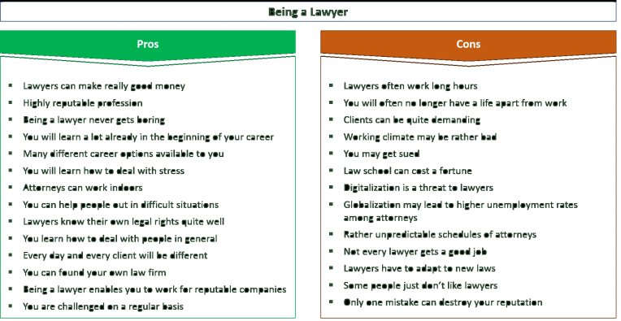 **Figure 3: Diagram showing some of the advantage and disadvantages of being a lawyer.**

I can now define the word LAW as a set of rules that is being enforceable in the court of law, regulating the organs of body and the Government of a state which is being made by the legislature or conducts that is being made or taken place towards each other. A law is usually written in a book which is most times being regarded as a constitution which an example is officially that is indicated in the diagram that is written in Figure 4 below. Law is basically divided into 4 main types and they are: Eternal Law, Divine Law, Natural Law and Human or Positive Law. The types of law are divided into 7 different classification and they are: Public and Private Law, Common Equity Law, Written and Unwritten Law, Municipal and International Law, Substantive and Procedural Law. There are different skills that you need to have become you can become a lawyer some of these skills are: Analytical Skills, Attention to Details, Organizational Skills, Time Management, Interpersonal Skills, Technical Skills and Persuasive Communication.

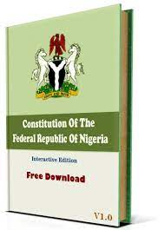 **Figure 4: Diagram showing the constitution of the Federal Republic of Nigeria as an example.**

In the rule of Law, there are some major cases that are being considered when dealing with cases depending on the client (these are people who stand officially stand in a dock for what they are accused for an example has been included in the diagram in Figure 5 below) scientifically they are divided into two types and they are attached below in diagram 6 which from this effect that they have been able to make some examples of the different types of research which examples are shown in Figure 7 as below

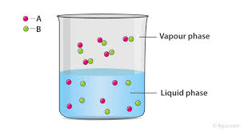

**Figure 5: Diagram explaining some of the two major phases that they use before dealing with a case**.

 **Figure 6: An example of an accused girl in a dock room in the court of law on a case.**

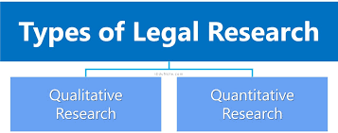 **Figure 7: Diagram showing the types of legal research that is commonly done by a lawyer.**

Most times in the court of law when calling the attention of the people in order there is always an hammer known as a gavel to the judge in charge of the particular case which was brought to them that they hit as this would be able to send a message to everyone in the court on the issue that is happening as an example of the gavel has been listed in the diagram that shown in Figure 7 below. In the society the law has been an opportunity to be able to serve as a continuous reminder in the society that we need to be very careful of the behaviors that we agree to accept in the society especially it would help us to be able to provide any public dispute to provide certainty and stability to matters that are related to the public in order to make sure that there is peace and stability in the society.

 **Figure 7: Diagram showing an example of a gavel used in the court of law by Judges.**

To end my analysis, I would like to say that Law is a very good career that people study in school for at least within the period of 4-5 years depending on the institution that you are studying in school and some of the main sources that helps you to be able to understand the legal process easily are: Judicial Decisions, Treaties, Constitution Code Legislative Enactment-Statue and other sources.

**RECOMMENDATION**

Some of my biggest take away from this particular course especially during the different types of course that are related to this particular activity in different areas that is an opportunity to serve as a reminder that one must be careful before making certain decision at every level especially when it comes to business and sharing some of my personal life with some other people. Barr Jite Abere is a reminder of the future of African Village where working with him especially during our first conversation that we have been able to take some resolutions of how some of the issues that are facing the future that is ahead of us basically towards creating a peaceful process for the future that is in the desire need to achieve. African Village when I am working on it in the future , I would always remember to ensure that before we get involved in any project across every level of business in the society to make sure we are able to create a sustainable relationship without affecting any third party life in my journey In this recommendation, I would like to add that some of my biggest take away from this particular course is to remind me of the fact that in the future through this particular research work that I must always be able to remember the fact between relationship and business principle in Law so I would be able to know how to categorize people according to their own lane and in the diagram that is officially indicated in Figure 8 are some of the best books that I officially intend to read about law to help me to be able to build my path and see through some of the line that has to do with the development of growing in life.

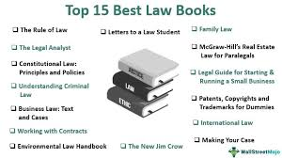 **Figure 8: Diagram listing some of the best law books to read to build your career in.**

In addition to some of my biggest takeaways as a conclusion from the law course, this course would come in as a continuous reminder to everyone and myself that is going to be in the African Village Organization that the mistake that was made with Inspired Leadership Group would not be made in this aspect as I would make sure that I am able to do my full best to make the best that the law and principles together are being followed towards making sure that both parties are able to enjoy the opportunities and privileges that they have from being able to work with the African Village this time by making sure that I am able to do my best towards making sure that I am making the world a better place for all as well as knowing how to be careful of the kind of information that I am learning to approve especially as I proceed towards being able to move forward with my career. In the Future, legal affairs is one of the things that I would love to make sure that I take very seriously as in the process I would continue to do my very best to make sure that people are aware of any information or action that I make before I go ahead in doing them as well as making sure that I am able to do my best to promote equity in the society before I am officially being able to take things forward.

**CONCLUSION.**

Let me start my conclusion by ending my essay on some of the things that has to do with lawyers and judges on the issue of court. In a court setting there are different things that I would like to add that a successful lawyer understands the fact that there are needs to be able to adapt technology to the principle sometimes in a court especially when you are country that has to do with technology you need to be able to understand the policy of where you are as a lawyer before you are able to attend to their court and address the issue that is currently ahead of us by making sure that they are able to know the rule to be able to produce Artificial Intelligence and automation when they are in proceedings. Another thing that I would like to post is that the wig called peruke is to bring a sense of formality to help in the proceeding of the sense of power to help in the respect principle of the court. The diagram that is indicated in Figure 10 is an example of a peruke that is being worn in a court knowing that the judge own is longer than the lawyers on the bench.

 **Figure 10: Diagram of a Judge and a Lawyer Peruke that is officially worn in a Court.**

In summary to add to my conclusion, I would like to add that the society banks on the principle of law in different categories especially on our housing, nutrition, consumer rights, and environment. This thing have effects to how it benefits some of our daily lives and they are: Law helps us towards building financial stability, Helps us in taking multiple path in our career, Builds a strong foundation towards our lucrative career purpose and helps towards to be able to build mutual respect understanding between people regardless your age.

**BLIBLIOGRAPHY**

Americanbar.org. 2022. *Law Day 2022*. [Online] Available at: <https://www.americanbar.org/groups/public_education/law-day/> [Accessed 11 May 2022].

CGC. 2022. *8 Benefits of Doing LLB*. [online] Available at: <https://www.cgc.ac.in/blog/8-benefits-of-doing-llb> [Accessed 12 May 2022].

Crimsoneducation.org. 2021. *How to Become a Lawyer: The Complete Guide for Law Students - Crimson Education ZA*. [online] Available at: <https://www.crimsoneducation.org/za/blog/campus-life-more/becoming-a-lawyer/> [Accessed 14 May 2022].

Stoppel, M., 2022. *What is the future for privacy legislation and how should business leaders prepare?*. [online] reuters.com. Available at: <https://www.reuters.com/legal/legalindustry/what-is-future-privacy-legislation-how-should-business-leaders-prepare-2022-04-01/> [Accessed 11 May 2022].

Warren, Z., 2022. *Legal Tech's Predictions for E-Discovery in 2022 | Legaltech News*. [online] Legaltech News. Available at: <https://www.law.com/legaltechnews/2022/01/05/legal-techs-predictions-for-e-discovery-in-2022/?slreturn=20220411124057> [Accessed 11 May 2022].

**APPENDICES**

Figure 1: Diagram representing the logo symbol of lawyers in the court of law.

Figure 2: Diagram officially showing an example of a court room in the Federal Republic of Nigeria.

Figure 3: Diagram showing some of the advantage and disadvantages of being a lawyer.

Figure 4: Diagram showing the constitution of the Federal Republic of Nigeria as an example.

Figure 5: Diagram explaining some of the two major phases that they use before dealing with a case

Figure 6: An example of an accused girl in a dock room in the court of law on a case.

Figure 7: Diagram showing the types of legal research that is commonly done by a lawyer.

Figure 8: Diagram showing an example of a gavel used in the court of law by Judges.

Figure 9: Diagram listing some of the best law books to read to build your career in.

Figure 10: Diagram of a Judge and a Lawyer Peruke that is officially worn in a Court.