HERMON YEMANE ANDEMARIAM
BBM4105879606

BUSINESS MANAGEMENT

Leadership and Directing

ATLANTIC INTERNATIONAL UNIVERSITY
HONOLULU, HAWAII

DATE 14th /JANUARY /2022

TABLE OF CONTENTS
Introduction--------------------------------------------------------------3
What is the motto of being a leader and how should a leader behave? ---------------------------------------------------------------------4
The 'real' world is the only one that counts------------------------7
The psychological contract of a director---------------------------9
Reward and job satisfaction -----------------------------------------10
How a leader should use the Expectancy Theory on ground --------------10
Contingency theories of leadership--------------------------------11
How leader functions and directs well on field----------------13
Developing and managing the relationship with employees-------17
How are meeting conducted with employees and not cause friction! ---------17

Conclusion----------------------------------------------------------------17
Bibliography --------------------------------------------------------------19

Introduction
Most of research on leadership has tended to concentrate on one or other of these factors and so one definition of leadership has not emerged. It is important to understand that the theories were discussed in the lecture contributing to my overall understanding of what is a very complex activity; inevitably there will be.
Effective leaders are not always glamorous or charismatic. The great names behind the successful corporations are seldom the people who dominate in a crowd. They work behind the scenes. The people at the top are not larger-than-life figures: their charisma comes from their achievements, not from their extrovert personalities. In their book In search of Excellence, Tom Peters and Robert Waterman define leadership as:
"...meticulously shifting the attention of the institution through the mundanel language of management systems. It is altering agendas so that the new agendas get attention. It is being visible when things go away and invisible when they are working well. It is building a loyal team that speaks more or less with one voice. It's listening carefully most of the time ....it's being tough when necessary, and it's the occasional naked use of power- or the "subtle accumulation of nuances, a hundred things done a little better" as Henry Kissinger once put it."
{Peters and Waterman, 1982}

Leadership is not always quite what you expect it to be!
Most successful leaders have a good health {perhaps they have to}; other studies mention enthusiasm, sociability, integrity, outrage, imagination, decisiveness, determination, energy and faith. In other words, almost anything helps, but it seems to matter how these traits combine to produce effective leadership!
Having given up the search for core traits common to all leaders, later researchers considered other factors which might contribute towards successful leadership. John Hunt, of the London Business School, came to the following conclusions about the common characteristics of senior manager.
Leadership is concerned with influencing other people in ways that are both important and more or less acceptable to them on core issues that face the group or organization. Leaders are those people whose previous acts of leadership mean that they are now expected and perceived to provide leadership .In short, leadership means being influential on things that matter. Leaders are those who are expected and seen to be influential on important matters.
What is the motto of being a leader and how should a leader behave?
Behavior is driven by needs; ‘Maslow and Alderfer’
An alternative way of explaining human behavior might be look for the needs which an individual seeks to satisfy. One such approach was developed by Maslow, who suggests that there are really five levels of need that influence an individual's behavior:
- Psychological needs- the need for food, drink and shelter
- safety needs- protection against danger, threat, deprivation
- social needs- the need for belonging, acceptance, friendship
- 'ego' needs - self esteem, reputation, status
- 'Self actualization' - the need for realizing one's own potential for continual self development.
These were defined by Maslow as a hierarchy of needs, as shown in Figure 1.1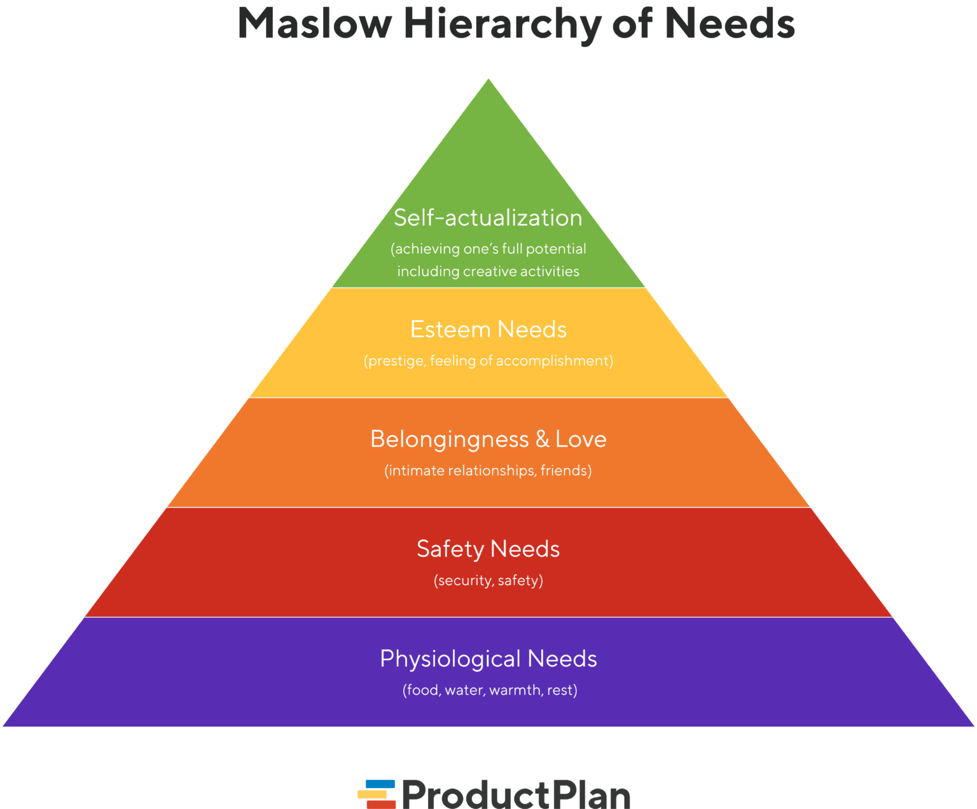

The needs form a hierarchy, according to Maslow, because the lower-level needs have to be satisfied to be satisfied first. Only when these needs have been satisfied will the individual seek to satisfy the higher needs. Thus, hungry cold individuals will focus on getting food and warmth with no concern for their higher-order needs; but when well fed and warm, they will seek safety and then the comfort of being with others.

Maslow, however, made an important contribution to our understanding of the behavior of individuals by drawing attention to the importance of multiple motives. A development of the needs-driven approach has been proposed by Alerfer {1972}, who sees just three levels of needs:
- Existence needs- these are related to survival and reproduction, for example the need for food, clothing and shelter
- Relatedness {or belongingness} needs- these are the social needs, which can be satisfied through contact with others, for examples the need to be respected
- Growth need- these are needs not for physical growth, but for personal development, for example the need to learn new skills and the need for self respect.

The approach is referred to as the 'ERG theory', from the initials of the three levels of need. It gives less emphasis to a strict hierarchical ordering of need-satisfying behavior because needs at different levels may operate at the same time and there is no automatic progression from one level to the next. There may also be a compensating substitution of lower -level needs where higher-level needs cannot be satisfied. These are potentially useful refinements of Maslow's approach, although there are clear similarities in the level of needs identified. (Simon, 2009)
We also have to be aware of what can happen when needs are not satisfied, or when the source of satisfaction is removed or threatened. Try removing a bone from a hungry dog - you will get a violent reaction. By analogy, if people perceive that some element which satisfies their current needs is likely to be removed, they too are likely to react adversely. An overtime ban, the threat of redundancy, a drop in standards of working conditions, arbitrary instructions that challenge self esteem can all produce reactions such as a drop in productivity, stress-related illness or industrial action. As a manager, you have out understand the needs of the people who work for you and relate any changes you may want to make to the level of satisfaction they require.
The 'real' world is the only one that counts

Human relations problems often arise because we do not all acknowledge the same reality. Even when we are looking at precisely the same thing, we usually see it differently. One person's efficiency drive might be another's cut in services or job loss.

So what is 'reality'? What is 'real world'? The answer is that, for each of us, the real world is what we believe it to be. We each have our own view of the world. We each believe that our own view represents 'reality' it is, and we act accordingly. We frequently regard people who hold a different view of reality as being wrong. (R.Stephen, 2004)
The fact that people hold different views, and that they act according to what they believe to be 'reality', might make them, from your point of view, wrong but it does not necessarily mean that they are being awkward, difficult or foolish. For you to regard other people as perverse fools, or treat them as such , however irrational their actions might appear from your point of view is to fall into the trap of assuming that only one 'reality' {your own} counts . The first step in avoiding human relations problems is to recognize that other realities exist and must be taken into account. You should be prepared to respect and listen to other views, even if you disagree with them. (Mack,Ria)


The psychological contract of a director
Motivation is an outcome of the relationship between an individual and the employing organization. This relationship can be thought of in terms of a psychological contract between parties. The psychological contract is essentially a set of expectations. The individual expects a set of outcomes or reward from work in return for expending certain energies and talents in doing the work of the organization. Similarly, the organization has certain expectations of what it wants the individual to contribute to the work of the organization, and certain rewards and outcomes that it will give the individual in return. The terms of the psychological contract are not usually explicitly stated, unlike employment contracts and other formal agreements, and participants may remain unconscious of some of the expectations.
The management implications of this approach to motivation is that it stresses the importance of people with management responsibilities reaching an agreement on the appropriate psychological contract with those who work for them , otherwise problems are likely to arise. This suggests a process of enquiry and negotiation, where each side spells out its expectations of the other, and comes to some form of workable agreement. In reality, this is often easier said than done. People are often not fully aware of their expectations or they may find it difficult to express them. They may lack confidence or feel it is somehow not legitimate to talk about their expectations.

Reward and job satisfaction
So far all the theories of motivation discussed in the lecture assume that people are motivated by various needs and that they will be motivated if the organization provides rewards or incentives that enable them to meet these needs. However, there is no guarantee that giving someone a reward will lead to increased effort or that increased effort means better performance, one approach that focuses on the links between efforts, performance and reward is known as expectancy theory.

How a leader should use the Expectancy Theory on ground
This theory emphasizes the importance of the relationships between effort and reward" to exert extra effort, a person must believe that their effort will increase the probability of obtaining the reward. Some rewards come anyway, regardless of the effort put in, and these are not likely to be effective as motivators. Some are linked directly to effort, and they can motivate people's efforts. Other rewards are not guaranteed but they can act as motivators as long as the individual believes that by exerting effort they can increase the like hood of obtaining the reward, for example the sales bonus on reaching the sales target.
In practice, one rarely rewards efforts unless the effort has resulted in a good performance, for example increased output or better quality. So, clearly, it is the performance that is being rewarded rather than the effort itself.
The result of poor performance could be punishment rather than reward; this negative sense of punishments or sanctions is not adequately conveyed by the word "reward", so we substitute the word "outcomes" as a neutral word that can convey either the positive or negative sense. The negative sense also includes outcomes such as fatigue or reduced leisure time which may result from increased effort. Expectancy theory concentrates on the importance of these links as a way of explaining motivation. If the links are clear and strong, the outcome, whether it be a reward or a punishment, will have a powerful motivating effect; if the links are weak or absent, the outcome will have no power to motivate. Note, also, that if an outcome is to have any effect on person's behavior, the person must either want that outcome {reward} or want to avoid it {punishment}.
To summarize: if we want to improve motivation at work, we need to consider three distinct factors:
- the link between effort and performance
- the link between performance and outcomes { reward/punishment }
- the types of outcome available
Contingency theories of leadership
Contingency theories of leadership are really a development of style theories. The difference is that they do not assume that there is one universal best style of management; but that an appropriate style will depend or be contingent on the context.
Early and influential advocates of a contingency approach were Tannenbaum and Schmidt {1958}. They suggested a continuum of leadership styles based on how leaders used their authority and the corresponding amount of discretion that this allowed their subordinates.
Tannenbaum and Schmidt suggest that an appropriate style will be contingent on four variables:
- The leader- his or her personality and preferred style
- The led - the needs, attitudes and skills of the subordinates or colleagues
- The task- the requirements and goals of the job to be done
- The context- the organization and its values and prejudices.
Even among contingency theories, there has been much debate about whether or not it is good idea for managers to try to change their style of leadership. Some writers suggest that a person's style is too deeply ingrained and stable to attempt to change it, and so it is better to try to change the context; other writers argue that people are flexible and can adapt their style to suit the situation. The truth probably is somewhere between these two extremes. Most people are capable of some flexibility but would probably find it difficult to move confidently over the whole range of styles. The range of styles that we adopt is influenced by several factors, including the following:
- Our values and benefits- we all have our own sense of what is proper way to treat the people with whom we work. Some people believe that, as managers, it is their responsibility to direct the work of others; other people believe that a more democratic approach is appropriate.
- Our confidence in colleagues and subordinates- it would be unwise to hand over responsibility for a task if people do not possess the confidence or skills to do it effectively. A democratic approach requires that you have confidence that people can meet their responsibilities
- Our tolerance of uncertainty- a more democratic management style involves handing over some control to other people and thereby increasing your own uncertainty. If you dislike taking risks, or have a low tolerance of uncertainty, you are more likely to prefer a more autocratic style of leadership.
- Our personal contribution- if we believe that we know what is the right than encourage participation. Of course, we may be mistaken. Equally, other people may not see it this way
- Stress- too much stress may push people to extreme forms of behavior. They either become very autocratic in order to try to regain control over the situation or they may abandon control altogether and become apathetic.
How leader functions and directs well on field
Leadership has three main functions within a group or organization, corresponding to the core issues described above:
- The strategic function- developing a sense of direction in the group of organization.
- The tactical function- identifying and choosing the most appropriate means to pursue the groups or the organization’s chosen path.
- The interpersonal function -maintaining the morale, cohesion and commitment of the group or organization.

This section focuses on some of the key activities that contribute to these functions of leadership and how you can improve your ability to carry these out effectively.
As I stressed above, leadership is about acceptable influence. In most circumstances, persuasion is the most acceptable form of influence. Effective persuasion depends on knowledge and expertise. What sort of knowledge do you need to be able to contribute to leadership?
Regarding the strategic function of leadership, you need knowledge of the organization’s or the group's environment, in particular the opportunities and threats that the group or organization is likely to face. Regarding the tactical function of leadership, you will need an understanding of the group's or the organization’s strengths and weakness, knowledge of those "means" of working that have proved successful in the past and under what circumstance.
Much relevant knowledge will be acquired through experience, through moving around within an organization and its environment. Many management development programmers recognize this and deliberately move managers systematically around the organization. It hardly needs saying that communication is an important leadership skill which will enable you to exchange information more effectively with your colleagues and team members.


A person may also exert influence through providing an example or being a role model. This is particularly important for establishing shared values and norms of individual performance and behavior and for dealing with interpersonal relations. Being a role model is an important part of carrying out the tactical and interpersonal functions of leadership.
Any group will face anxieties, conflict and tensions. Another important leadership activity is to help the group deal with theses anxieties and tensions and so maintain the morale and commitment of the group.

If you are seen as a leader, or if you occupy a position of authority, then you will almost certainly be a role model for other people. As a result, you need to take account of the effects of your behavior on others. Whether you are aware of it or not, you will lead by example.
As discussed in the lecture, a part of leadership is focusing people's attention on the issues that the leader insiders are important. You are more likely to do this effectively if your own deeds match your words- that is, you do as you say. If you are trying to emphasis the importance of product design to the success of your organization members of staff are more likely to be influenced by this if they see you treating designers with respect and involving them more in the process of design management. If you are inconsistent, do not be surprised if others follow your deeds rather than your words.

You may need to make a special effort to establish the standards that you want. In particular, if you are seen as a leader your behavior wild is an important factor in whether or not a climate of trust develops within the group or organization. If you are willing to communicate openly and honestly and to accept responsibility for your own mistakes rather than blame others, the group members will probably follow your lead.

Developing and managing the relationship with employees
Everyone has their own idiosyncrasies and their own way of doing thing and you and your boss are no different. The Purpose is the obvious section was to make you aware of how much you know and do not know about your boss so that you can appreciate these differences. Having done this you are now in a position to establish a method of working that allows both work styles to dovetail, facilitating an effective relationship.
How are meeting conducted with employees and not cause friction!
It is likely that a boss will dictate the pattern of meetings with you, decide whether papers should be circulated before the meeting sticks to it, whether papers should be circulated before the meeting and so on. It can be a source of considerable frustration if this does not match your preferred way of doing things. However, an effort to fall into line will be well received and if there are any insurmountable problems you should try to mention these to your boss. It is to your mutual advantage that your meetings run smoothly. Greater problems are often caused by an incompatibility of management styles.

Conclusion
We have already seen that the relationship between boss and subordinates one of mutual dependence. Your boss needs you to be working towards the organization’s goal because your boss's responsibilities include the success of you and your team. Your fulfillment of your own responsibilities will frequently depend on direction and priority setting from your boss. This dependence will only work if there is clear communication between the pair of you.

This is easier said than done. How often do you assume that your subordinates know what they should be doing? How often have you left a meeting with your boss thinking? "I'm not quite sure what they mean; why do they want me to do that?" Sometimes managers act as if they believe that their subordinates can "mind read". For most people, communication is not easy; it is a skill, like many others, that managers have to work at - your boss is probably as bad as everyone else.

Bibliography
Mack, R. &. (n.d.). https://www.td.org/insights/the-5-types-of-leaders.
R.Stephen, C. (2004). Seven habits of effective people.
Robert, P. T. (2004). In search of excellence.
Simon, S. (2009). Start with Why.

