STRUCTURAL MATERIALS

**Table of contents**

1.0 Introduction 4

2.0 Concrete 5

2.1 Concrete mix design 5

2.2 Properties of fresh concrete 6

2.3 Properties of Concrete 7

2.4 Advantages of concrete as a structural material 7

2.5 Disadvantages of concrete as a structural material 8

3.0 Steel 8

3.1 Types of structural steel: 8

3.2 Structural steel 8

3.3 Properties of structural steel 9

3.3.1 Ductility: 9

3.3.2 Hardness: 9

3.3.3 Toughness: 10

3.3.4 Fatigue: 10

3.3.5 Resistance against corrosion: 10

3.4 Advantages of steel as a structural material 10

3.5 Disadvantages of steel as a structural material 10

4.0 Timber 11

4.1 The structure of timber 12

4.2 TYPES OF TIMBER 12

4.2.1 Softwoods 12

4.2.2 Hardwoods 13

4.3 NATURAL CHARACTERISTICS OF TIMBER 13

4.3.1 Knots 13

4.3.2 Slope of grain 14

4.3.3 Reaction wood 14

4.3.4 Conversion of timber 15

4.3.5 Seasoning 17

4.3.6 Seasoning defects 17

4.3.7 Cracks and fissures 18

4.3.8 Fungal decay 18

4.4 STRENGTH GRADING OF TIMBER 18

4.4.1 Visual grading 18

4.4.2 Machine grading 18

4.5 Advantages of timber as a structural material 19

4.6 Disadvantages of timber as a structural material 20

5.0 Conclusion 20

6.0 References 21

**List of figures**

Figure 1: Reinforced concrete (RC) 6

Figure 2: example of stress-strain curve 8

Figure 3: Cross section through timber 10

Figure 4:Examples of log breakdown and cutting pattern. 14

Figure 5: Defects in timber 15

**List of tables**

Table 1: Effect of grain deviation on strength properties of timber 13

Table 2: Softwood combinations of species and visual grades that satisfy the requirements for various strength classes 18

# Introduction

As the oldest branch of engineering, civil engineering has been the foundation of all civilizations throughout history, providing higher standards of life. The Pyramids, the Coliseum, the Great wall of China are some of the structures where civil engineering principles where mainly used.

The primary aim of all structural design is to ensure that the structure will perform satisfactorily during its design life. Specifically, the designer must check that the structure is capable of carrying the loads safely and that it will not deform excessively due to the applied loads. This requires the designer to make realistic estimates of the types of the material comprised in the appropriate to meet the design requirements (Chanakya , 2009). Structural materials look at the materials used in construction.

Decisions taken both in the design process of buildings and their modernization should comply with basic requirements, such as: strength and stability, resistance to dampness and water, resistance to fire, heat insulation, sound insulation, durability, comforts and conveniences. However, the deciding factor is usually the economic aspect which includes the costs of materials, construction and assembly (DOI, 2020).

The most commonly used structural materials are;

* Concrete
* Steel
* Timber

# Concrete

Concrete is one of the most versatile construction materials, offering potentially unlimited opportunities for developing diverse forms of construction. Concrete is what is known as a universal material, as its ingredients, namely cement, sand, aggregates, and water, are available all over the world. There are different types of admixtures used to modify certain properties of the concrete and can be categorized according to their function as follows:

* Air-entraining admixtures.
* Water-reducing admixtures.
* Retarding admixtures.
* Accelerating admixtures.
* Cementing agents.
* Workability agents.
* Miscellaneous agents such as bonding, damp-proofing, permeability-reducing, grouting, and gas-forming agents.

The strength of concrete is dependent on the mix ratios of the ingredients. Therefore, it is the role of the engineer to ensure that correct mix ratios are used for a concrete of a particular purpose and indeed that the maximum strength required is attained. This in turn, guarantees the safety of the structure against different kinds of failure.

## Concrete mix design

One of the ultimate aims of studying the various properties of the materials of concrete, plastic concrete and hardened concrete, is to enable an engineer to design a concrete mix for a particular strength and durability. Mix design is the process of selecting suitable ingredients of concrete and determining their relative quantities with the objective of producing as economically as possible concrete of certain minimum properties such as workability, strength and durability. With the given materials, the four variable factors to be considered in connection with specifying a concrete mix are;

* Water-Cement ratio
* Cement content or cement-aggregate ratio
* Gradation of the aggregates
* Consistency.

There are different procedures used in determining the concrete constituent ratios, some are listed below;

* Arbitrary proportion
* Indian Road Congress, IRC 44 method
* High strength concrete mix design
* Mix design based on flexural strength
* Road note No. 4 (Grading Curve method)
* ACI Committee 211 method
* DOE method
* Mix design for pumpable concrete
* Indian standard Recommended method IS 10262-82

## Properties of fresh concrete

* Workability
* Consistency
* Segregation
* Bleeding
* Setting Time
* Unit Weight
* Uniformity

## Properties of Concrete

**Concrete strength**

Concrete has high compressive strength, hence when subjected to compressive stresses, it tends to withstand the stresses. However, when subjected to tensile stresses, concrete tends to fail. This is because concrete is weak in tension. For this reason, for the purpose of construction or concrete as a construction structural material is reinforced with steel, which is a material with high tensile strength. Therefore, it is normally referred to as Reinforced concrete (RC).

Reinforced concrete structures utilize the best qualities of concrete and steel i.e., concrete’s high compressive strength and steel’s high tensile strength. The main idea behind reinforced concrete is to provide steel reinforcement at locations where tensile stresses exist that the concrete cannot resist. Due to its strength, only a relatively small amount of steel is needed to reinforce concrete. Steel’s ability to resist tension is around 10 times greater than concrete’s ability to resist compression. It is very important to note that reinforcement in concrete structures is effective only if it is appropriately used, strategically placed, and in correct quantity.

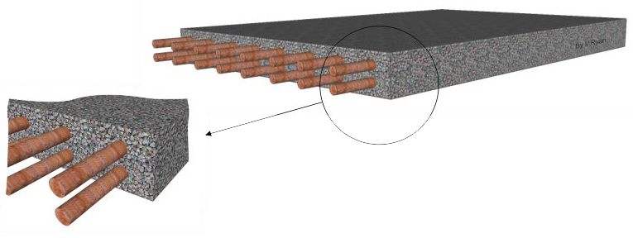

Figure 1: Reinforced concrete (RC)

## Advantages of concrete as a structural material

* Ability to be cast
* Economical
* Durable
* Fire resistant
* Energy efficient
* On-site fabrication

## Disadvantages of concrete as a structural material

* Low tensile strength
* Low ductility
* Volume instability
* Low strength to weight ratio

# Steel

### Types of structural steel:

Different structural steel can be produced based on the necessity by changing slightly the chemical composition and manufacturing process.

*Carbon steel:*

In this type of structural steel carbon and manganese are used as extra elements.

*High Strength Carbon Steel:*

By increasing the carbon content this type of steel can be manufactured which basically produces steel with comparatively higher strength but less ductility.

*Stainless Steel:*

In this type of steel mainly foreign material like nickel and chromium are used along with small percentage of carbon.

### Structural steel

The physical properties of structural steel that are worth noting are;

$$Unit mass of steel, ρ = 7850 kg/m^{3}$$

$$Modulus of elasticity,E = 2.0×{10}^{5}N/{mm}^{2}$$

$$Poisson^{'}s ratio,μ = 0.3$$

$$Modulus of Rigidity,G = 0.769×{10}^{5}N/{mm}^{2}$$

$$Co-efficient of thermal expansion,α = 12×{10}^{-6}/℃$$

The most important mechanical properties that are used in the design of steel structures include;

* Yield stress, fy
* Ultimate stress, fu
* Minimum percentage elongation

These properties can be obtained by performing tensile tests of the steel sample. From which a stress-strain curve is produced.

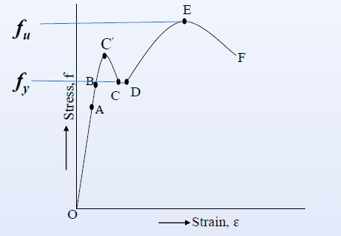

Figure : example of stress-strain curve

### Properties of structural steel

The mechanical properties of steel largely depend on its;

* ultimate strength,
* yield stress,
* weldability,
* machinability.

Some other important mechanical properties of steel are;

#### Ductility:

It is defined as the property of a material by virtue of which it undergoes large inelastic i.e. permanent deformation without loss of strength under the application of tensile load.

#### Hardness:

It is one of the mechanical properties of steel by virtue of which it offers resistance to the indentation and scratching. The hardness of steel is measured by;

* Brinell hardness test,
* Vickers hardness test,
* Rockwell hardness test

#### Toughness:

It is one of the mechanical properties of steel by virtue of which it offers resistance to fracture under the action of impact loading.

$$Toughness = The ability to absorb energy up to fracture$$

Toughness is generally measured by the area under the stress-strain curve.

#### Fatigue:

It is defined as the damage caused by the repeated fluctuation of stresses which leads to the progressive cracking of the structural element.

* Damage and failure of the material under the action of cyclic loading.

#### Resistance against corrosion:

In the presence of moist air corrosion of steel is an extremely important aspect. To avoid corrosion paint or metallic coating may be used.

### Advantages of steel as a structural material

* Better quality control
* Lighter
* Faster to erect
* Reduced site time - Fast track Construction
* Large column free space and amenable for alteration
* Less material handling at site
* Less percentage of floor area occupied by structural elements
* Has better ductility and hence superior lateral load behavior; better earthquake resistance

### Disadvantages of steel as a structural material

* Skilled labor is required.
* Higher cost of construction
* Maintenance cost is high.
* Poor fireproofing, as at 538oC, (1000oF) only 65% of its strength remains and at 871oC, (1600oF) only 15% of its strength remains.
* Electricity may be required during fabrication.

# Timber

Timber from well-managed forests is one of the most sustainable resources available and it is one of the oldest known materials used in construction. It has a very high strength to weight ratio, is capable of transferring both tension and compression forces, and is naturally suitable as a flexural member. Timber is a material that is used for a variety of structural forms such as beams, columns, trusses, girders, and is also used in building systems such as piles, deck members, railway sleepers and in formwork for concrete.

Timber is a good construction material due to a number of intrinsic qualities. These include a high strength-to-weight ratio, a long track record of durability and performance, and superb heat and sound insulation. Timber's natural growth qualities, like as grain patterns and hues, as well as its availability in a wide range of species, sizes, and shapes, make it a very adaptable and visually beautiful material. Timber can be easily bent and joined together with nails, screws, bolts, and dowels, or by utilizing adhesive.

Recent innovations in composite and engineered wood products have overcome the constraints in maximum cross-sectional dimensions and lengths of solid sawn timbers imposed by available log sizes and natural flaws. Finger jointing and different lamination processes have permitted the construction of consistent and high-quality timbers (elements and systems) in any shape, form, and size, restricted only by production and/or shipping constraints.

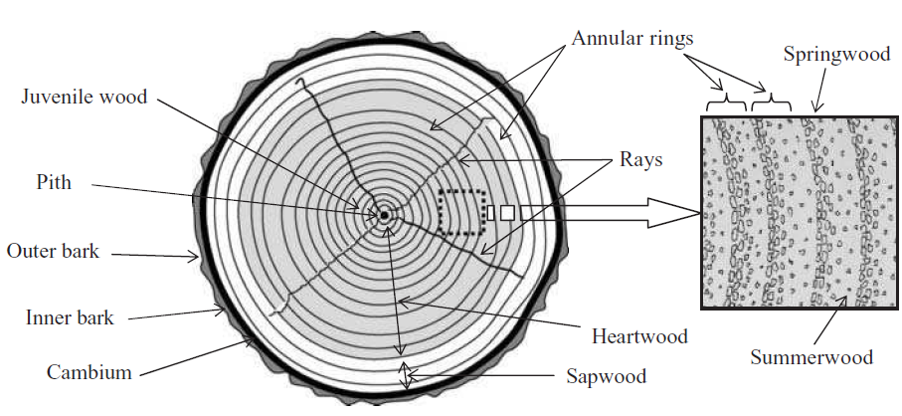

Figure : Cross section through timber

##### The structure of timber

The trunk of the tree is sawn (milled) for structural timber, which provides stiffness, mechanical strength, and height to keep the crown in place. The trunk resists load imposed by gravity and wind on the tree, as well as transporting water and minerals from the roots to the crown. Roots collect moisture-containing minerals from the soil and transport them via the trunk to the crown by spreading through the soil and acting as a foundation. The crown, which is made up of branches and twigs that support the leaves, serves as a catchment region for chemical processes that produce sugar and cellulose, which fuel the tree's growth.

##### TYPES OF TIMBER

Softwoods and hardwoods are the two categories of trees and commercial timbers. This nomenclature relates to the wood's botanical origin and has no influence on its physical softness or hardness, as certain physically softer hardwoods, such as balsa from South America and wawa from Africa, and some physically hard softwoods, such as pitch pines, exist.

###### Softwoods

Softwoods, which are distinguished by their bare seeds or as cone-bearing trees, are evergreen with needle-like leaves (such as conifers) that contain single cells called tracheid, which are arranged in a straw-like pattern and perform conduction and support functions. Softwoods have rays that run perpendicular to the growth rings in a radial orientation. Their purpose is to store food and allow liquids to convect to where they are needed.

***Softwood characteristics***

* Quick growth rate (trees can be felled after 30 years) resulting in low-density timber with relatively low strength.
* Generally poor durability qualities, unless treated with preservatives.
* Due to the speed of felling they are readily available and comparatively cheaper.

###### Hardwoods

Hardwoods are typically deciduous (broad-leaved) trees that lose their leaves at the end of each growing season. Hardwoods have a more complicated cell structure than softwoods, with thick-walled cells called fibers providing structural support and thin-walled cells called vessels supplying the food conduction medium. The demand for sap is great due to the need to grow new leaves every year, and in rare cases, bigger vessels may form in the springwood, resulting in 'ring-porous' woods such as oak and ash. When there is no definite growing period, the pores spread out more evenly, resulting in 'diffuse-porous' woods like poplar and beech.

***Hardwood characteristics***

* Hardwoods grow at a slower rate than softwoods, which generally results in a timber of high density and strength, which takes time to mature, over 100 years in some instances.
* There is less dependence on preservatives for durability qualities.
* Due to the time taken to mature and the transportation costs of hardwoods, as most are tropical, they tend to be expensive in comparison with softwoods.

##### NATURAL CHARACTERISTICS OF TIMBER

Wood is a natural material with a wide range of structural features and faults that are introduced during the growing process, as well as during the conversion and seasoning processes. Such traits or faults can often cause problems with wood in usage, lowering its strength or degrading its attractiveness.

1. Knots

These are common characteristics of wood's structure. A knot is a section of a branch that is surrounded by the tree's natural growth and originates in the core of the trunk or a branch. Knots' impact is determined by their size, form, frequency, and position inside the structural member. Because knots twist the fibers around them, generating fiber discontinuity and stress concentrations or non-uniform stress distributions, knots have a negative impact on most mechanical properties of timber. Their effects are amplified in members that are subjected to tensile stress, either directly or through bending.

1. Slope of grain

The general direction of the arrangement of fibers in wood is represented in terms of the longitudinal axis of sawn or round timber (log or pole). The direction of the fibers in sawn or round timbers does not always run parallel to the longitudinal axis. In softwoods, the deviation from the log (longitudinal) axis is frequently consistent, resulting in spiral grain formation. Interlocked grains are seen in tropical hardwoods where the grain orientation varies frequently.

When the grain direction is at an angle to the sawn section's longitudinal axis, it is called a cross grain. A cross grain appears during the conversion (sawing process) of a bent or strongly tapered wood, or a log with spiral or interlocking grain. Table 1 shows the impact of grain variation on several timber characteristics.

Table : Effect of grain deviation on strength properties of timber

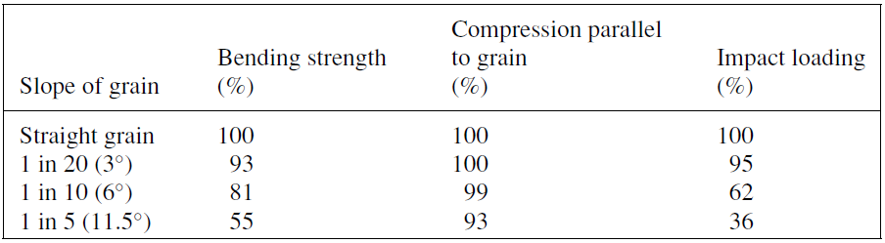

1. Reaction wood

Reaction wood refers to aberrant wood tissues that develop in tree trunks exposed to high winds. Horizontal and leaning branches are thought to generate reaction wood to prevent them from bending and splitting excessively under their own weight. There are two forms of reaction wood: compression wood and tension wood in softwoods and hardwoods, respectively.

The specific gravity of reaction wood is approximately 35 percent higher in compression wood and 7% higher in tension wood than regular wood. Longitudinal shrinkage is also higher, with compression wood shrinking 10 times faster than tension wood.

1. Conversion of timber

When a tree is fallen in the forest, the crown is removed, and it is frequently debarked. To keep logs from trying out, they are classified and stored underwater sprays. Some of the higher-quality ones are delivered to veneer-making companies, while the bulk (depending on quality) are sent to saw millers who convert round logs to sawn timber. Most sawmill operations begin by scanning the log for the optimal alignment and cutting pattern for optimum return; then removing one or two wings (slabs) from the logs to provide some flat surfaces to operate from. The log, known as a cant, is flattened flat on one side and sawn through and through to produce boards (sections) of the desired thickness. Reaction wood is substantially denser than regular wood, with a specific gravity of roughly 35 percent higher in compression and 7% higher in tension. Longitudinal shrinkage is also higher, with compression wood shrinking 10 times faster than tension wood.

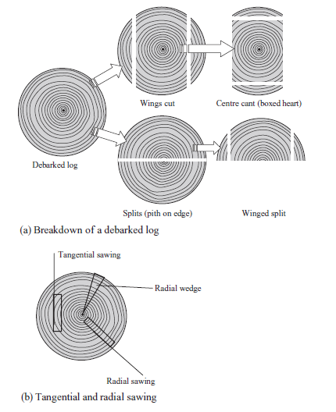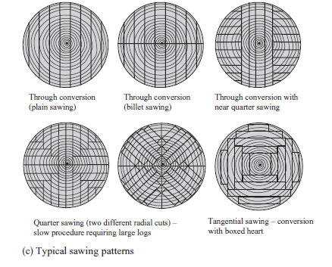

Figure :Examples of log breakdown and cutting pattern.

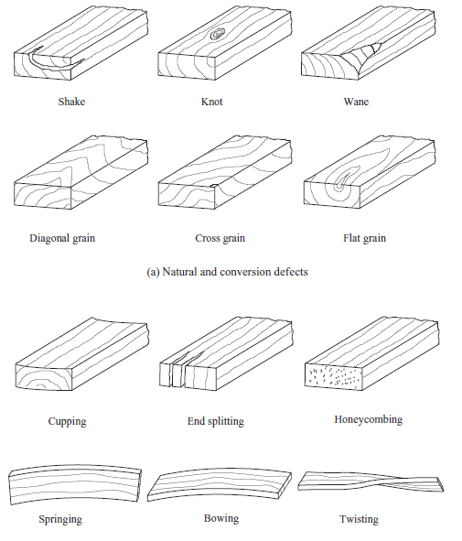

Figure : Defects in timber

1. Seasoning

Seasoning is the process of lowering the moisture content of wood to make it acceptable for the environment and intended purpose.

1. Seasoning defects

Seasoning flaws are caused by variations in moisture content in the wood, which cause the wood to shift. Excessive or uneven drying, the presence of compression wood, juvenile wood, or even knots, wind and rain exposure, and inadequate stacking and spacing during seasoning can all cause faults or distortions in wood.

1. Cracks and fissures

Fissures and cracks are formed when fibers separate along the grain, generating fissures and cracks that emerge on one face or at the end grain but do not always continue through to the opposite side. Their presence could signal decline or the start of decay.

1. Fungal decay

This can happen in both growing mature wood and recently converted wood, and it's generally a good idea to reject such wood.

##### STRENGTH GRADING OF TIMBER

Timber's strength is difficult to gauge because its quality and growth are frequently uncontrollable. The species type, density, size and form of members, moisture content, duration of the applied load, and presence of numerous strengths decreasing qualities such as grain slope, knots, cracks, and wane all affect the strength of timber.

The requirements for strength grading of timber are detailed in the following standards:

* BS EN 14081-1:2005
* BS EN 14081-2:2005
* BS 4978:1996
* BS 5756:1997

1. Visual grading

An approved grader does visual grading, which is a manual process. The grader inspects each piece of wood for knots, grain slope, rate of development, wane, resin pockets, and distortion, as well as the size and frequency of certain physical features or flaws.

1. Machine grading

The link between the modulus of elasticity, E, and the modulus of rupture of a species of wood from a specific geographical region is calculated from a statistical population, based on a large number of laboratory-controlled tests. The modulus of elasticity can be determined in a variety of ways, including by resonant vibration (dynamic response), but the most frequent procedures are load- or deflection-controlled bending tests.

Table : Softwood combinations of species and visual grades that satisfy the requirements for various strength classes

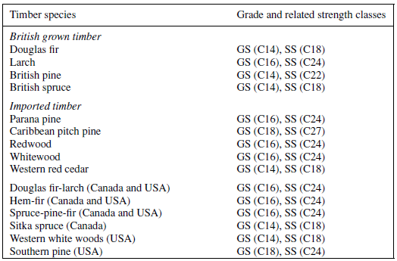

##### Advantages of timber as a structural material

***Durability and versatility***

As previously said, lumber is one of the most adaptable building materials available. This material may be bent into any shape, joined to other materials, and much more. Many different types of wood can tolerate and resist extreme weather conditions.

***Cost***

Of course, the cost will vary depending on the scope of the project, but timber can be less expensive than steel-framed or masonry structures, partly due to its speed of construction. Steel framing will almost certainly be necessary if big open plan spaces are required for structural stability.

***Insulation***

Timber can provide excellent sound and heat insulation in structures. When used as external cladding to help keep the heat in, timber performs far better than steel or brick, which may be incredibly advantageous for anyone trying to build a construction that is both efficient and environmentally friendly.

It's also worth noting that timber is a renewable resource, making it extremely environmentally friendly.

##### Disadvantages of timber as a structural material

***Swelling and Shrinkage***

Timber is a natural substance with the potential to absorb water, therefore it may shrink or swell. Timber should always be treated appropriately for its intended use and exposure, as water rot can result in quality loss if left untreated.

***Condensation***

Condensation is an issue that can occur in any construction, but dealing with it can be extremely challenging. When warm air from the inside comes into contact with a chilly wall that hasn't been properly insulated, condensation forms. If this occurs in a construction with a timber frame, the skeleton of the building may decay.

***Fire***

A timber-framed house will not be able to survive the heat and flames as well as a brick or steel construction would in the event of a fire. Although a timber-framed house can be sprayed with fire retardants, this only slows the spread of flames on the surface and reduces smoke production.

# Conclusion

Of the three structural materials, reinforced concrete is the mostly used type. However, in recent years, the use steel high increase tremendously due to the ease of analysis, design and fabrication using the modern design techniques.

# References

Chanakya , A., 2009. *DESIGN OF STRUCTURAL ELEMENTS.* 3rd ed. Oxon: Spon press.

DOI, 2020. *Construction, materials and installation.* s.l.:s.n.