Daniel Mani
ID: UB69199SAR78333

COURSE NAME:
Residential Architecture and Detailing

Assignment Title:
Systems and Functionality

ATLANTIC INTERNATIONAL UNIVERSITY
February/2022

Table of Contents
Introduction 3
Decision Making 4
Structural Materials 5
Mechanical Systems 8
Control Layers 11
Conclusion 13
Bibliography 14

Introduction
Residential architecture refers to the designing and building of a structure used specifically as a private dwelling. This dwelling or private domicile are non-commercial living spaces that include single-family homes such as bungalows, mansions, villas, and multi-family units like apartment buildings, duplexes, condominiums, and townhouses. When it comes to home building, bad decisions in the design and building process can be extremely costly, resulting in serious implications in the future, both economically and socially.
As globalization continues to inflate the cost of materials and labor skywards, it is a constant challenge when constructing homes to meet a reasonable budget target, finish the build on time, and provide the homeowner a comfortable and sustainable space to live in. The era we are in today is an important period of disruption to the building industry, due to the impact of environmental concerns, forcing design practices and construction methods to align themselves with energy efficiency, reduced carbon emissions, health in the workplace, and material conservation.
The objective of the essay is to discuss and examine how to incorporate appropriate design principles and construction methods that is functional, aesthetically pleasing, and sustainable to residential architecture. The insight into this realm of design is to target decision makers and stakeholders, and share knowledge of the design process. The mantra here is sustainability, to meet the needs of the present without compromising the ability of future generations.

Decision Making
An essential part of the design process are initial considerations of style, material selection, and construction methods. The mechanics of decision making are usually straight forward, weighing all the pros and cons, then choosing the option best suited to the project. To make informed choices, it is important to note that ingrained biases should go unchecked as it could impact the design and building process, even risking the quality and outcome of the home in its entirety.
In the approach to design or construction, there tends to be one of two assumptions. Those who are inclined to accept the success of a new solution without giving much thought to the latent risks, and those who dismiss the promise of a new solution without applying analysis. Ideas, materials, and systems have somehow proven to work and found to be the best means to achieve the required standard, based on the rational that society expects new technologies to perform to a high standard, while normal ideas are inherently flawed. To minimize this disparity, it is pivotal that designers and builders utilize both accepted solutions as well as alternative methods to an equal standard prior to committing to conclusions.
Translating the design ideas into a render is a very instructive process in understanding as details become more precise and fully scaled. Although there is a temptation to go straight into creating drawing plans, a sufficient amount of time should be concentrated on visualizing the design in three-dimensional spaces to allow imagination to build a stronger sense of what living in that space would entail. Technology, a great catalyst for the design industry, has allowed for drafting software programs to produce professional looking renderings of simple to complex designs, adding a vivid vision and value to the decision-making process (Magwood, 2017).

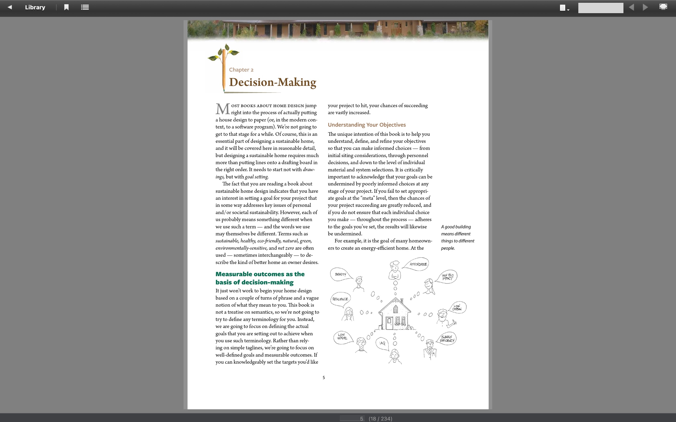
Figure 1: Considerations at the planning stage of the design process. Source: Chris Magwood.

Structural Materials
After the architect has converted the design into a plan of drawing conventions, the builder, engineer, plumber, electrician, interior designer, and quantity surveyor, will use elements of the drawings to plan their construction, and installation methods. These drawings include a site plan, floor plan, elevations, sections, details, and mechanical drawings. A background knowledge of the local building code outlines parameters required for room sizes, window sizes, ceiling heights, door widths, hallway, and stair widths, and more.
A scope of work can therefore be determined from these detailed plans, as well as a budget for cost of materials, labor, and contingencies. Structural components of walls, columns, beams, floors, and ceiling slabs are elements under constant compression, tension, or both, depending on their location or role. Knowledge and limitations of these loadbearing elements are monitored by the engineer, in order to determine the structural feasibility of the project.
Wood is comparatively light and can be cut and fixed easily, making it the first choice for most structural materials. Wood functions very efficiently in both tension and compression due to the fibers that form a structural continuity. Wood is also adequate for ceiling and floor joists, and for framing walls when constructed in its simplest form. Wood can be used as a composite material for wood-based sheet materials, and rival steel and concrete for strength when used as laminated beams.
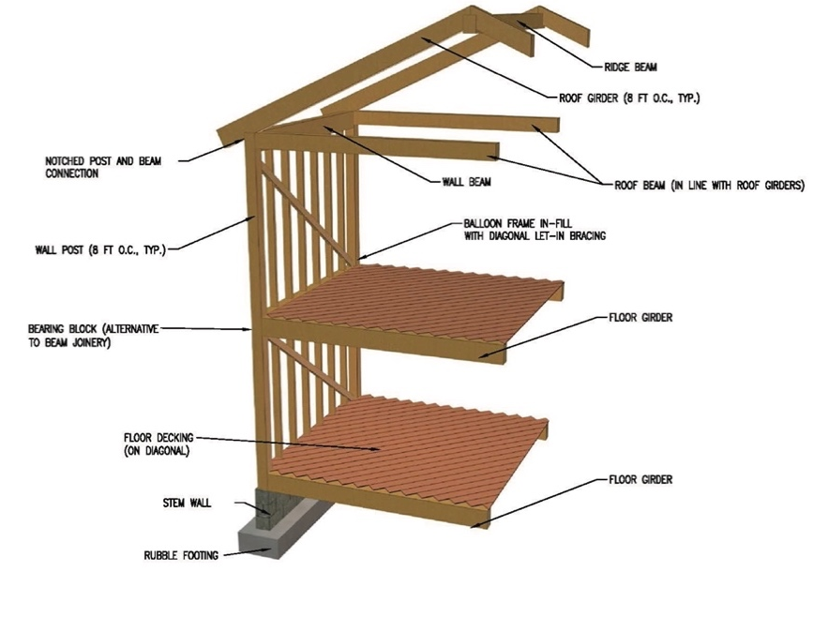
Figure 2: Wood as a structural material. Source: huduser.gov.
Steel, although perfect in tension, it is combatively poor in compression. However, its malleability during production allows it to withstand bending under compression. The production in steel is manufactured in I, L, and C sections to reduce the volume required, decrease the width-to-depth ratio, and increase it lateral rigidity. Varying dimensions of the steel sections allow for loadbearing capabilities responsible for approved structural work.
INCLUDEPICTURE "https://www.steelconstruction.info/images/thumb/0/07/Portal-1.jpg/400px-Portal-1.jpg" \* MERGEFORMATINET 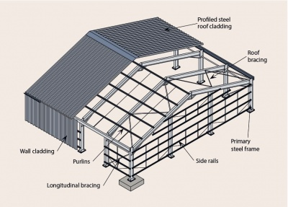
Figure 3: Steel used in a structural frame building. Source: structuralconstruction.info.
Concrete is significantly strong in compression but very weak in tension. Usually used in foundations, columns, and walls, it is positioned inside the wet mold in which the concrete is to be poured and reinforced with mesh or steel rods. The pour covers a depth of approximately 50mm to protect the steel against being rusting and swelling that may fracture the concrete. The thermal expansion rate of steel and concrete are the same, making it compatible for constructing structural components. However, should their expansion and contraction rates vary then there is a risk of fracturing the concrete.
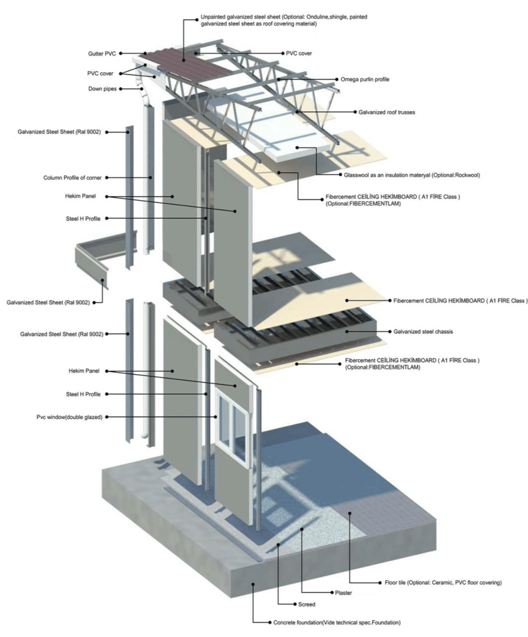
Figure 4: Concrete used as structural material for foundation and flooring. Source: researchgate.net.
Masonry or brickwork, function as primary supporting elements and a great alternative to steel or concrete. Curved profiles like shallow arches supported on metal or wooden framework that is complicated to construct, allow brickwork to be used to support the structure and provide a decorative element (Plunkett, 2010).
INCLUDEPICTURE "/var/folders/mc/4y46c2jx1kj5268fkn5dtp240000gn/T/com.microsoft.Word/WebArchiveCopyPasteTempFiles/FBR-block-house.png" \* MERGEFORMATINET 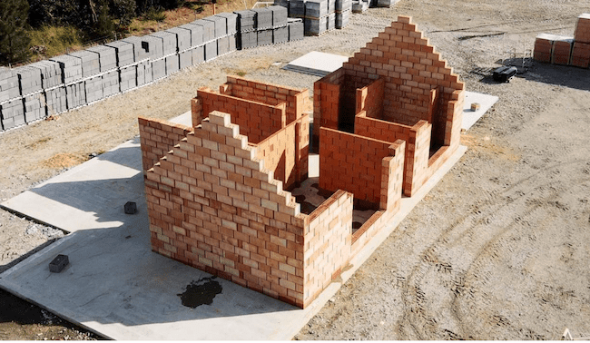
Figure 5: Masonry or bricks used as a structural material to build a house. Source: constructionequipment.com.

Mechanical Systems
The modern home is much about mechanical systems as its structure. These mechanical systems of water collection, electrical generation and distribution, waste removal, heating, ventilation, and cooling are all key components of a residential project. These systems are the costliest elements of everyday living, therefore the systems selected for the building at the start of the design process will have a significant impact on the sustainability and carbon footprint of the future (Budds, 2019).
Water systems are highly regulated and subject to many levels of restriction on how, when, and where it is extracted and treated. There are feasible options to sourcing, storing, and using water conservatively. Should the home be located in an area served by the municipal, then the homeowner will be obliged to connect to this water supply. The roof area of a building used to capture rainwater mostly flushes down the water via a downspout into the street drainage. Rainwater is typically very clean and can be re-mineralized by directing it into a storage tank where it is held until required for use. Desalination uses distillation methods of separating salt content from the water or membrane processes of capturing salt while allowing water to pass through. These processes are supported by low-tech companies and basically installation can be undertaken at residential level to provide high quality treated water.
INCLUDEPICTURE "/var/folders/mc/4y46c2jx1kj5268fkn5dtp240000gn/T/com.microsoft.Word/WebArchiveCopyPasteTempFiles/Cooling-flow-cycle-of-rainwater-harvesting-system.png" \* MERGEFORMATINET 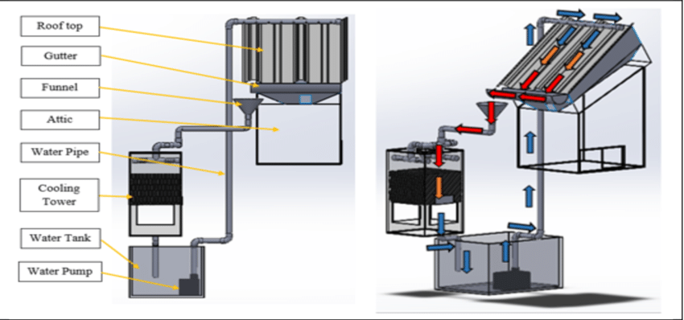
Figure 6: A rainwater collection mechanical system. Source: researchgate.net.
Waste removal by composting of toilets is disposing human waste on site until it is transformed into useful compost. One method is using a self-contained unit that provides a seat over an integral composting tray in a self-contained structure and the deposits are received in a tray. Due to limited storage capacity, these toilets use a system to reduce odor and a mechanical action to accelerate the compost process prior to removing the tray unit. The composting results in the separation of water containing human waste, known as grey water. Using a weeping field system, the grey water is disposed directly in the ground using a process similar to septic systems, in which a holding tank is used for the settling of solids and rising of scum, and perforated drainage releases the water into the ground where microorganisms deal with any harmful bacteria. Some systems include a biological filter in place of a septic tank to reduce costs.
INCLUDEPICTURE "/var/folders/mc/4y46c2jx1kj5268fkn5dtp240000gn/T/com.microsoft.Word/WebArchiveCopyPasteTempFiles/Constructed-wetland-septic-system-EPA.jpg" \* MERGEFORMATINET 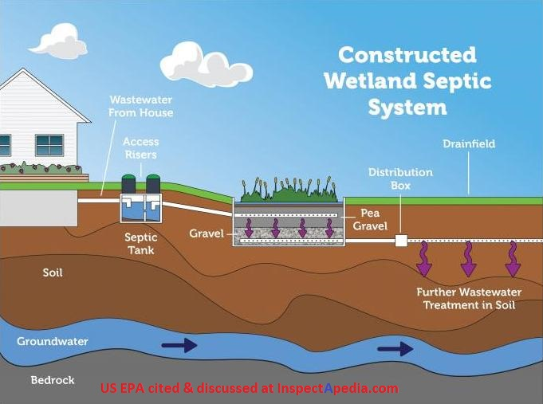
Figure 7: A natural septic system used onsite as a wastewater treatment. Source: inspectapedia.com.
Electrical generation using a grid-tied method in which electricity is moved from a point of generation directly to a point of consumption, bypassing distribution systems and reducing production and transmission losses. Homeowners and small businesses can produce power using renewable resources such as a wind-turbine or small-scale hydro that generate their own power and contribute it to the grid system. This net zero method benefits both the homeowner and the utility company receiving a portion of the power. The wind turbine uses the force of moving air to spin an airfoil blade and generate electricity. Power generated is produced in either AC or DC current.
INCLUDEPICTURE "/var/folders/mc/4y46c2jx1kj5268fkn5dtp240000gn/T/com.microsoft.Word/WebArchiveCopyPasteTempFiles/6.jpg" \* MERGEFORMATINET 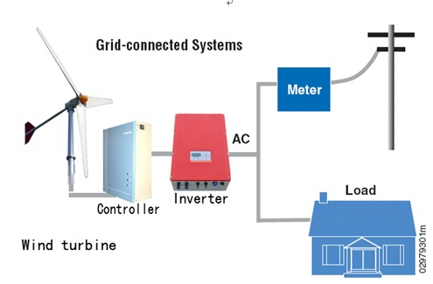
Figure 8: A grid-tied electrical generation system. Source: yueniao.com.
Heating and cooling are often complex, and often the choice of system will determine how much energy will be consumed. Energy-modeling is an effective way to select a system that provides overall efficiency and minimal impact to the environment. Solar hydronic heating and solar air heating are two similar systems that collect the suns heat and stored for use when required. These systems differ from the conventional ones as it has a design process to determine an adequate storage-to-go production ratio so that heat is used economically (Tobias, 2021).
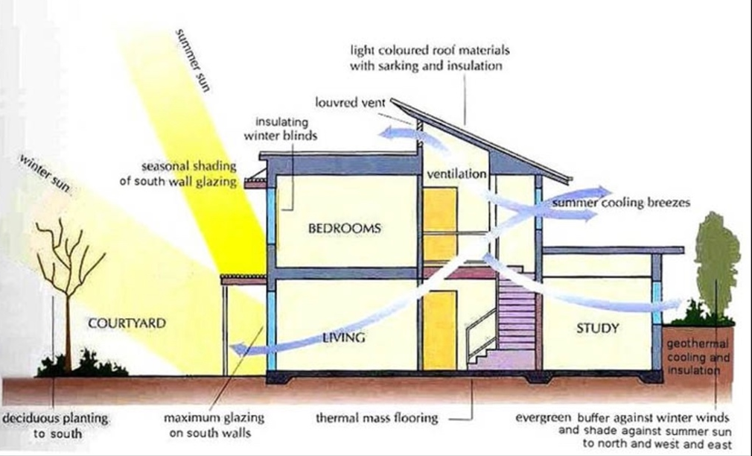
Figure 9: A design approach that applies passive solar heating for residential architecture. Source: inhabitat.com.

Control Layers
A well-designed building keeps water out, keeps heat energy in or out as desired, manages vapor migration, and controls air flow into and out of the building.
The water control layer is the most critical layer of the building that is vulnerable to damage if exposed repeatedly to water. Mold, mildew, rot, thaw damage, are a few issues that can arise when building assemblies are exposed to excessive amounts of water. To eliminate or mitigate these risks, considerations at the design phase should include, the use of simple roof lines, generous roof overhangs, rainscreen cladding, window placement at the edge of a wall that includes a drip sill and protecting wall-to-foundation transitions with proper grading, drainage, and durable materials.
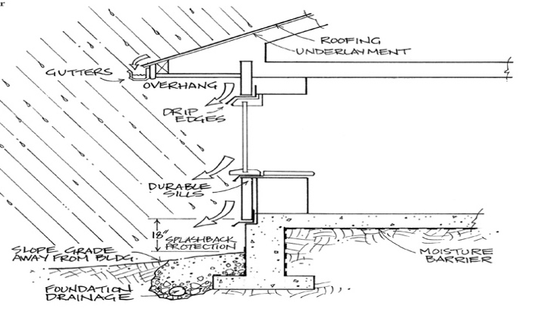
Figure 10: Different parts of a building enclosure that requires a water control layer. Source: Chris Madwood.
The thermal control layer, also known as the insulation layer, minimizes heat losses and gains to maintain a consistent desired temperature through the building enclosure, with minimal input from fuel sources. To ensure the heat continuity between different building components, the design phase must be cognizant of, structural components passing from inside through to outside, floor framing systems touching the enclosure, and bridging at wall-to-roof transitions. At the construction phase, builders must ensure that all insulations fills have no voids or gaps, and the resistance value of insulation materials are rated at a density that maintains efficient thermal performance.
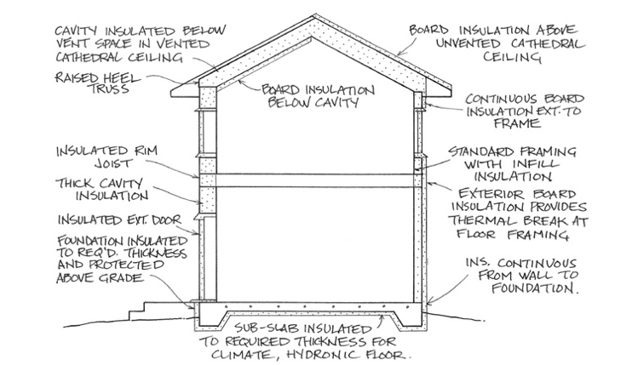
Figure 11:A building enclosure using a thermal control layer to maintain a desired temperature. Source: Chris Magwood.
The air control layer is to prevent the uncontrolled transfer of air indoor and outdoor in the building enclosure. Uncontrolled air exchange through the building enclosure is likely to cause contamination and infiltration of dust, pollen, bacteria, viruses, that will impact the air quality and cause mild to severe health problems. At the design phase, a strategy must be developed for service cavities such as electrical boxes and wiring, HVAC and plumbing, window and door openings, that minimize the penetration of air. For an air-tight building, ventilation and pressure must be balanced when installing combustion appliances or gases may be drawn into or leak into the building.
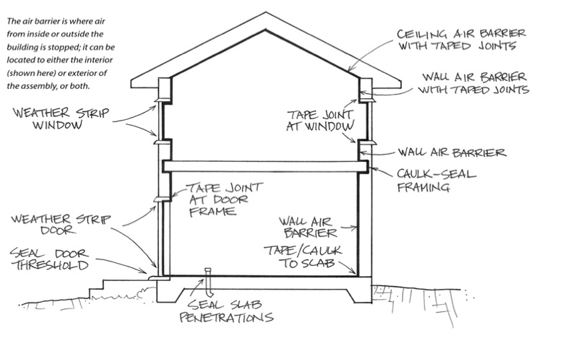
Figure 12: Maintaining an airtight structure to prevent air leaks and contamination. Source: Chris Magwood.
The vapor control layer is to manage the diffusion of moisture into the building enclosure. This control system differs from the water control layer as the water control is to shed and repel all water from the outside. Simply put, the vapor control layer is to manage moisture. Excessive vapor diffusion causes degradation in thermal performance and accumulation of mold and mildew. Vapor permeability, measured in perms, is where different materials allow diffusion due to vapor drive at different rates. At the design stage, an awareness of climatic conditions and material choices can help develop a strategy for vapor control. Proper installation techniques and materials specified for construction are adhered with in order to maintain permeability requirements and keep the vapor under control (Quinn, 2018).
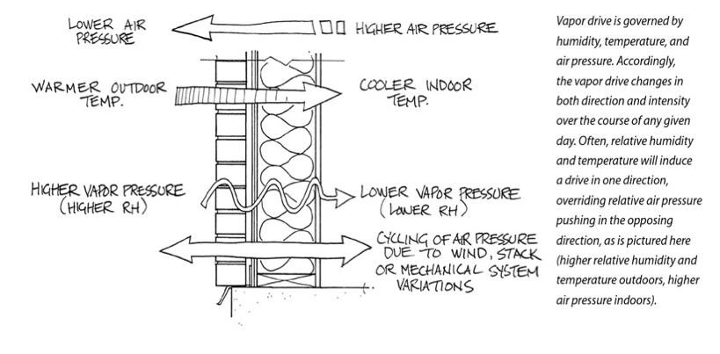
Figure 13: A depiction of water molecules moving through a solid material. Source: Chris Magwood.

Conclusion
To inform a good design, the initial stages must start with as many relevant considerations as possible. More importantly, the homeowner must ask themselves what they need and what they want from the design. Compile a list by taking note of the built environment around and elements of the public and private workspaces, as well as homes of friends, traffic circulation from room to room, family input, collecting images, shapes and volumes of little details like handles and knobs, as these all play a role in the decision-making process. Gradually, other details such as heating devices and mechanical systems, can be added before committing the design to plan from computer to paper.
It is clear that a combination of structural materials utilized for different aspects of construction each bring qualities that makes it suitable for structural integrity. Exterior and interior architects choose materials based on aesthetics and cost. The examination of wood, steel, concrete, and masonry are evidently the most common materials that exhibit tension, compression, and strength when acting on a structure. The recommendation of wood, steel, concrete, and masonry, over other materials such as textiles, glass, and stone are due to these materials being easily sourced, readily available and require less scientific testing, and mainly due to its utilization for many centuries.
There is always a broad range of systems that distribute and heat water, dispose waste, generate electricity, and provide cooling to the entire home. Technology is usually at the forefront of these systems with a touch of a button, manufactured for commercial and residential use. With the environment being impacted by climate change, sustainable mechanical systems that have been discussed offer a cost efficient and reduced carbon footprint that is competitive, unique, and favorable over advanced automated systems.
The discussion of understanding the distinct control layers is pivotal in being kept continuous, airtight, and wrapped completely around the building enclosure that separates the inside environment from the outside. Water control, thermal control, air control, and vapor control have common mitigation strategies of design, deflection, drainage, deposit, and drying. A simple concept using these five Ds are effective in creating a comfortable and efficient indoor space without compromising human health and future building hazards.
As mankind continues to surge ahead with innovative design ideas, stakeholders in the design and building industry must incorporate sustainable methods to help reduce the embodied energy that accounts for 28 percent of emissions globally. The intensity of the design and building sector will have to decarbonize by addressing building systems and design processes to achieve net zero emissions. Collaboration and consultation with governments, financial institutions, policy makers, and architects, are our last defense to build a future for the next generation.

Bibliography

Budds, D. (2019, September 2019). How Do Buildings Contribute To Climate Change? Retrieved from archive.curbed.com: https://archive.curbed.com/2019/9/19/20874234/buildings-carbon-emissions-climate-change
Magwood, C. (2017). Essential Sustainable Home Design: A Complete Guide to Goals, Options, and the Design Process. Gabrola Island, BC: New Society Publishers.
Plunkett, D. (2010). Construction and Detailing for Interior Design. London: Laurence King Publishing.
Quinn, J. (2018, October 9). The Four Control Layers- Fundamentals of Building Science. Retrieved from sustainable engineering.co.nz: https://sustainableengineering.co.nz/controllayers_fundamentals-of-building-science/
Tobias, M. (2021, June 21). Mechanical Design Options to Heat and Cool Residential Buildings. Retrieved from ny-engineers.com: https://www.ny-engineers.com/blog/mechanical-design-options-to-heat-and-cool-residential-buildings

