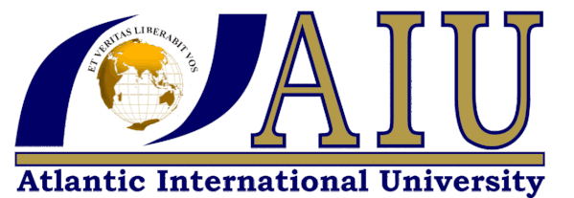

GIFT SITUMBEKO
ID UB68508SEL776

BACHELOR IN ELECTROMACHENICAL
ENGINEERING

ASSIGNMENT: UNITED NATIONS ARTICLE 6
CLEAN WATER AND SANITATION

ATLANTIC INTERNATIONAL UNIVERSITY
21/03/2022.

Water is very essential for our lives, our climate and environment. we need water for drinking, sanitation for growing our foods, for power generation and for bathing.
According to unicef and un report, unsafe water, poor sanitation and hygiene kills 3.5 million people every year, the shortage of water affects 40% of the world population, poor sanitation claims 775,000 lives every.
Every human being has the right to good health, clean water and sanitation. Enesco’s article 6 emphases on the protecting our natural resources and away from polluting our water bodies, our ecosystems need to be restored to improve and generate safe water for all.
Article 6 of the united nation is concerned with the warfare of people around the globe, and through the Enesco’s SDG 6, certain measures has been outlined to protect our communities from the disease that are transmitted through the use of unsafe water and sanitation system that is poor.
Water is not just water if it is not safe for drink, water should be clean from harmful wastes and chemicals that are harmful to our bodies, fish in the rivers lakes and the sea. Enesco’s aim is to ensure the availability and sustainability of water and sanitation for all SDG 6.
It is the responsibility of every human being to act and work towards proving clean safe water and good sanitation for all.it is the human right to have clean water and good sanitation for a health nation and world at large.
Without clean water we have our beloved sister and brothers suffering from diseases that are caused by unsafe, untreated water and poor sanitation, our communities suffer from diseases like typhoid and dysentery, all these are water borne diseases related with unsafe water and poor sanitation. 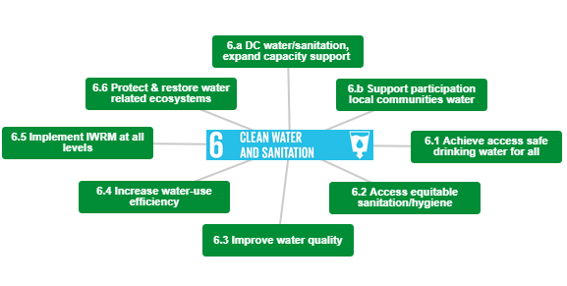
Q1.why is un`s goal of clean water and sanitation important in your opinion
Water is life and every person has the right to a good health life, every human being is entitled to the right of having safe clean filtered water and a good sanitation and we need water that is easily accessible for all.
Sanitation is also one of the most important part of our lives, we need clean toilets to practice good personal hygiene free from diseases lie cholera, typhoid and other water born and hygiene related diseases.
We need our sanitation facilities to be always clean so as to wash our hands every time we are from using the toilets and every time we are from public places.
Access to clean water is very important and every human has the right to clean water for a health living. All the people who use unsafe water and poor sanitation are deprived from their human rights of having the rights to safe and treated water.it is every one’s responsibility to work towards the provision of safe water and good sanitation, personal hygiene is very important to safe guard our lives from the outbreak of diseases and transmitting these diseases to other people who do not follow the guide lines of WASH.
Because of so any lives that are being lost globally, it is the aim of the united nations to strategies to save lives and Enesco’s article 6 gives the guide lines of protecting our ecosystem and all the sources of water and the nature at large from pollutants that can destroy our environments so as to save lives.
Q2. How is the clean water and sanitation in the world?
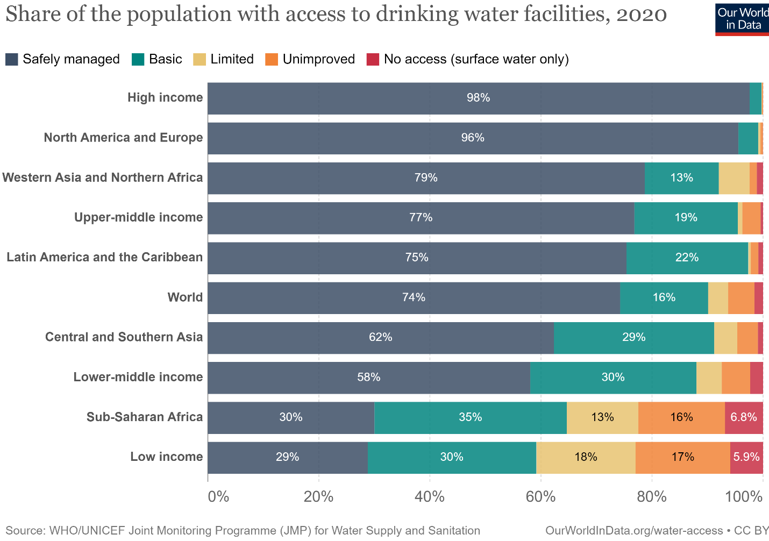
According to the chart above by WHO/UNICEF through our world in data ,74% of the world has access to safely managed water while 16% has the basics of safely managed water facilities. Countries in the low income nations only has a 29% of safely managed facilities of safe water and 5.9 % has no access to safely managed water but only has surface water and 17% of unimproved water facilities while sub-Sahara has 6.8% of people with no access to safely managed water source but only use rivers and streams us their surface water sources for drinking and bathing meaning the sanitation infrastructure is not in place making their lives very difficult as it’s difficult to fight diseases that comes as the result of using unsafe water and with poor sanitation or nor sanitation facilities at all.
The Enesco has set 2030 as the target of reaching their goal where they should be zero tolerance to unsafe water and poor sanitation but the rate at which the implementation process is moving its very slow and if the rate at which we are moving with the improvement at this rate we will only reach slightly above 82% by the year 2030 unless more focus is put in more that more sensitization is done to make more people aware of the benefits and the aim of Enesco’s article 6 and the need for every human being exercising their rights to safe water and good sanitation.
The death rate is still high as a result of using unsafe water and poor sanitation and cases like cholera and typhoid is still high in low income countries and sub-Sahara countries, leaders and the non-governmental organization should keep on working extra hard to the world to record above the 82% projection for safe water and sanitation and clear the transmission rate of the disease by the year 2030.
A girl child is still being deprived of their human right to safe water and sanitation, the right to education and good health as they spend most of their time searching for water in most low in come nations and in most sub-Sahara countries.
The rate of transmission of the water born diseases are still way high as most people are still lacking safe, treated and filtered tape water and in most home and places they don’t have sanitation facilities and they don’t use latrines but open space due to non-availability of toilet facilities and other customs beliefs.

Q3. what changes that needs to happen to achieve clean water and sanitation?
The importance of safe water and easy accessibility of clean water at a walkable distance for all should be the way to go, so that everyone has access to safe tape treated water and good sanitation so as to have a disease free world which results from using unsafe water and poor sanitation facilities.
By education the communities on the importance of safe water and the dangers of using the surface water through the communities that has challenges with sanitation facilities and no tape water will continue adding more value for people to fully understand the aim of the united nations on the provision of clean safe treaded water that perfect us health free from water borne diseases.
With the outbreak of covid 19, it has open up many people’s eyes on the need of good sanitation with tape water that will make every one`s life much safe as everyone know and understand the need for WASH and having the sanitation and tape within the proximity of people’s houses and work stations, public places should also have tape running water and proper sanitation facilities so as to have a better health environment and health nations away from diseases that are caused by the use of unsafe water and poor sanitation facilities.
The right to education is also one way of improving our communities ,people in our communities should be well sensitized about the importance of education ,if young people ,every girl child are subjected to attend schools so that our young generation knows how to handle the implementation of WASH and the dangers of using unsafe water and sanitation facilities ,personal hygiene will also play a vital role, the community should also come to gather in educating the elder and mothers so that the all communities will be able to fully understand the need of safe water and the need and importance of good sanitation facilities
Toilets and tape water should be made available by sinking of boreholes with using solar to generator power that will be able to supply water for people who are off the grid mostly in rural areas. Sanitation facilities should be provided in public places mostly in rural areas, community schools, markets and personal hygiene should be practiced at all times.
Q4. Do you think it is possible to archive clean water and sanitation around the world? Why or why not?
The Enesco’s SDG 6 has been implemented and governments and organizations are working hand in hand with every community to make sure that the implementation of WASH and personal hygiene is adhered to, and hoping that by the year 2030 the number of mortality as a result of drinking unsafe water and access to poor sanitation is reduced and the number of people with access to safe water and improved sanitation facilities is increased.
The rate at which we are moving with the implementation of article 6 is still slow and this may have been attributed with the pandemic of covid 19 that has ripped off the great minds of this world, the progress is still slow but we are heading in the right direction and yes it is possible to archive safe water and sanitation so long we work together in building a strong foundation free from diseases that are caused by drinking of unsafe water and improve our sanitation facilities by improving our person hygiene and sensitizing our communities on the WASH system and its importance to safe guard the lives of people.
The introduction or the provision of building new latrines in public places and eating places, markets communities’ school’s churches and all places that have large gatherings will advantage the move of achieving the SDG`s go for 2030.
The involvement of churches, community school, advertising in all public places buses and transport stations about this fight against the use of unclean water and improving the sanitation, improving personal hygiene will safe guard millions of lives against the diseases that is as the result of using unsafe water and using poor sanitation facilities.
More resources are needed to fight the problem of unsafe water and poor sanitation in our communities, more money is needed to build sanitation facilities and promote hygiene standards. Most of the people in the communities don’t have money to buy cleaning utensils to use for cleaning the facilities that they are being given to uplift the living standard of people to fully exercise the right to safe water and sanitation and a good person hygiene with a health life.
Q5. How can education lead a world to a clean water and sanitation?
Every human being has the right to education and no one should be deprived of their right to education. If we can educate our children and the community to be aware of the benefits of understating the importance of using safe water and sanitation, to protect our environment and all the nature inhabitants to safe guard our ecosystem so that the rivers, the streams and all water bodies and water sources are kept clean and safe from contaminants, our future will be brighter with more tools to use to fight poverty and to improve our resources.
Education should start from early childhood gain the knowledge and the importance of one’s life and to understand the needs and wants to a health and better lives, children in communities should be made away of the rights and its importance so that they can know when they are being deprived of their rights and freedom. Free education should be exercised by every child so that their future is preserved and protected for the children of today to have a better generation and more advanced environment.
Education will give the learners better ideas to develop and manage our resources in filtration and water treatment processing that will be able to produce clean safe, filtered water for all.
Education will give birth to great brain thinkers, doctors and engineers who will work on our current strategies and engineering system on how to protect our environment better than it is from the contamination of fossil fuels that has brought climate change globally.
educations will give students and all learners ideas to foster development projects on our ecosystem, improve our water treatment plants and bring about better ways of providing safe water and sanitation closer to the homes of people in a cheaper way.
It is through education that we can transform our world, make it better free from disease that are as the result of water borne diseases and reduce the mortality rate across the world. The right to a better health, right to clean water and sanitation and the right to education are interlinked and we should strive to give our children the right them deserve and educate them to be better technocrats for a better generation.no life is worthy dying because of poor sanitation and use of un clean water.
Q6. How can education improve in your community so that the next generation has the tools and mind set to clean water and sanitation?
Enesco’s SDG`s articles are all inter linked and works side by side. For us to combats the diseases that results from drinking unsafe water and use of poor sanitation, firstly we must be in good health to learn and adapt to the education system where we can learn and understand the concept and the challenges of things that we are dealing with e.g. covid 19.
Educating our community and every child in our communities will have great impact on the improvements in terms of adherence to the problems that the community is facing or fighting against.
Our communities should understand that every child has the right to education as much as they have rights to good health, parents and guardians mostly in rural areas and low income regions should be made aware of the importance of educating every child and the benefits it upholds on every child who has been given the op
The right to education and equal right to education plays a transformative effect on the right to good health and right to clean water and sanitation, children who gets education are given he development tools and knowledge Tobe developed in to responsible adults.
Education should be free for all and every child in our community, from the poorest community and from low-income and children with disabilities have the right to education and should be given the knowledge and empower them with knowledge and understanding the careers that they want to acquire for them to be equipped with the tools that will build our communities and become civilized and responsible adults
Through education children will be able to influence their families, parents and their siblings and neighbors and change their behavior in a lifelong with positive habits.
We need to improve our sanitation facilities by providing our communities with safe tap water, latrines, toilets and enclosures toilets we need to promote and practice the importance of WASH facilities and to improve water quality at low cost to be provided in communities and provide water treatment equipment even in our homes apart from the use of chlorine, use of filters and other cheaper way of providing safe water and good sanitation facilities to our community.

BIBLIOGRAPHY
farrukh, H. (n.d.). solving the global water criss. TEDx north adams. Retrieved 03 21, 2022, from https;//www.yutube.com/watch?v=mnTg11eQ74
Hannah ritchie, M. r. (2021). clean water and sanitation. our world in data. Retrieved from htpps;//ourworldindata.org/clean-water-sanitation
nijmeyer, K. (n.d.). how to provide cean water for everyone. TEDxTwenteu-youtube. Retrieved 03 02, 2022, from https;www.youtube,com/watch?v=Arek-J5t5E
Rotary service engagement. (2018, 03 02). 5 ways to improve water qualityand access to water. Retrieved 03 21, 2022, from https;//rotaryserviceblog.org|2018|03|02|5-ways to-improve-watter-quality-and-access-to-water
unesco. (n.d.). the global goals. goal 6;clean water and sanitation. Retrieved 03 21, 2022, from https;//www.globalgoals.org>goals
world economical forum. (n.d.). universal access to clean watter and sanitationwith reach|world economical forum. Retrieved from https;www.weforum.org|agenda|2021|06|archieve-universal-access-clean-water-sanitation

