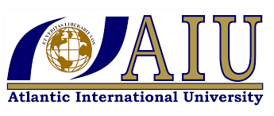

Human Rights and social justice in Global perspective

*Book Revision*

Name: Sanaa Matragi

Student Number: UB67027HIN76099

School of social and human studies

Major: International relation

Semester, Winter 2021

Submitted as partial fulfillment of academic requirement  
 to Atlantic International University

www.aiu.edu.com

Social work is a practice-based and an academic discipline that promotes social change and development, social cohesion, and the empowerment and liberation of people. Social workers mostly work on local issues. Issues that are confronted on a local level in countries in the global North are the same issues faced by people struggling across the world. Although they take a different form depending on the cultural context . The purpose of the social work profession is to promote human and community well being guided by a person in environment from work at global perspective, respect for human diversity and knowledge bases on scientific inquiry. The purpose of social work is actualized through its quest for social and economic justice, the prevention of conditions that limit human rights, the elimination of poverty and enhancement of the quality of life for all persons, locally and globally. Throughout the book more information on the United States and its impact on the issues discussed had been added, as well as some information on how these issues are also seen within its borders.

Chapter1- International Social Development

The effect of maps on our world view . Even for those who are geographically knowledgeable, how people learn about geography can influence their perception of the world, even though something as simple as the map used to learn about other countries. For each map focuses on a particular feature or features that are considered important, the social development approach. Economic and social development . However, to achieve the greatest success, these two must occur together, social development and economic development are inextricably linked. Social development opportunities, such as education and health care must work together with economic and political opportunities, when one occurs without the other distorted development will occur. If social development occurs without economic development, there will be a lack of financial resources to pay for the programs. So both must occur together for human potential to be reached .Two examples of these , modernization theory and dependency theory. Modernization theory is known as the neoclassical approach, this theory states that the reason for the origins of underdevelopment and poverty in a country are internal, they are located within that country itself and many include the lack of democratic institutions, capital technology or initiatives on the part of its citizen. The mentioned theory modernization believes that global inequality exists due to technological and cultural differences between nations and that every country can achieve the level of development seen today in the global North through a free market economy tailored to the culture of that country. Rich countries can help poorer countries by serving as role models and by providing assistance. Dependency theory does not focus on the conditions within individual nation states, but rather on global interaction between the nation states by focusing attention on the conditions within individual nation states, but rather on global interactions between the nation states by focusing attention on the international context of the global South. Dependency theory asserts that as a result of economic growth in advanced capitalist countries, poverty increased in developing nations, dependency was first created through the colonization of countries, with the prime agriculture land resources being allotted to a concentrated few. The colonists, these colonists used the natural resources of the land for their own benefits, such as the diamonds and gold of South Africa. Goods were produced for export to foreign markets as opposed to use by the country itself , for example cotton was grown in Sudan and Uganda, but these countries imported cotton goods. Modernization theory states that more industrialized nations can give aid to other countries to help them develop. Although the nations of the organization for economic co-operation and development have pledged to donate 0.7% of their gross national income to the countries in the Global South to help them develop, the worst majority do not.

Chapter 2, Human Rights

In the aftermath of World War II and its atrocities, the United Nation (UN) decided to create a Universal declaration of Human rights (UDHR). The document would elucidate the rights to which system, religion or any other grouping, simply by the fact of their humanity, the full text of (UDHR) in box (2.1) the rights it defines were intended to be universal and indivisible. That is all humans have the right to them regardless of culture, political system, ethnicity or any other characteristics. All human should have all rights. The (UDHR) contain three grouping of rights are sometimes referred to as first (political and civil) second (social, economic and cultural) and third (collective) generations of rights. However, these grouping tend to be artificial. Universal and indivisible . Some Asian countries argue that the (UDHR) reflects a western approach to rights, with a greater emphasis on the individual than on society, they state that the community should be more important than the individual and prefer a strong government and deference to the authority (Muntarbhorn,2005).The human rights declared in its conventions, covenant and declarations are a minimum standard, and each culture can choose the most appropriate manner by which to realize those rights noted in the code of ethics of international federation of social workers (2012). “Social workers should respect and promote people’s right to make their own choices and decision, irrespective of their values and life choices provided this does not threaten the rights and legitimate interest of others”.

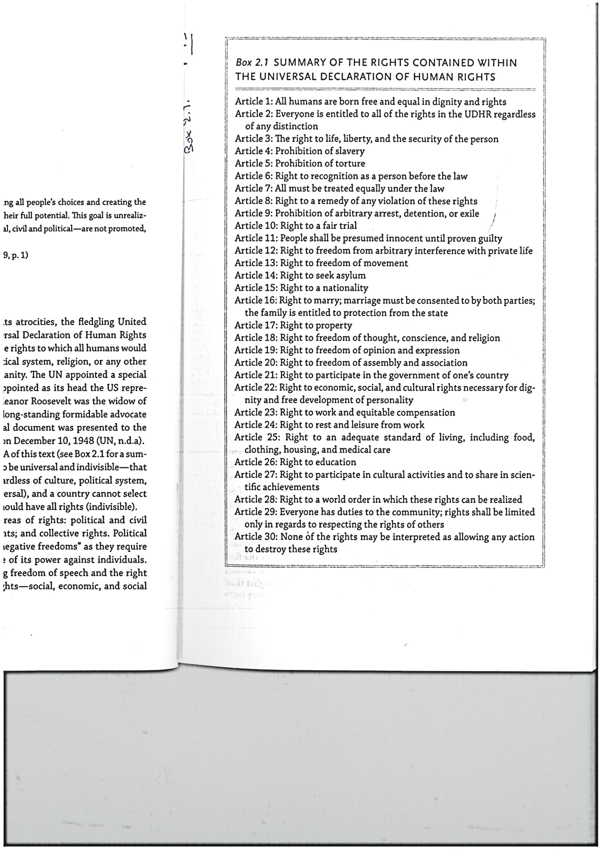

Other human rights documents and the role of United Nations, the Geneva convention. State that people who cannot or do not take part in the conflict must be protected, this includes civilians as well as military personal which have been wondered or surrendered. Medical personnel are considered neutral and must not be attacked. They are marked by a standard emblem of a red symbol on a while back round. In addition, prisoners of war are entitled to be treated with respect and must be allowed to exchange news with their families. Although these conventions and convents have been ratified by a vast majority of countries, it is clear that not all countries abide by their provisions. Countries that had certified these conventions, are responsible for submitting a report to the relevant committee every five years that evaluates their progress in achieving the goal established by the outsides of that convention in achieving the goal established by the articles of that convention (NGOs) are also able to submit a “shadow report” which offers their interpretations of the nation’s achievement, or lack thereof. These shadow reports help the UN make sure that nations do not paint an overly positive picture of the state of human rights within their borders.

UN human rights council, while each convention has its own monitoring body, the official body responsible for monitoring body, the official body responsible for monitoring violations of (UDHR) is the UN human rights council. The new council consists of representatives from 47 countries who are elected by the general assembly and it meets almost twice as often as the commission did. Membership is based on population distribution. The reorganized human rights council established the process known as the universal Periodic Review in which the human rights recode of all UN member nations is received on a rotating basis. The purpose of these assessment is to improve the state of human rights in all nations (UN) human rights council, 2018). Individual countries also monitor human rights. The US state department produces a report each year assessing the level of human and worker rights as recognized in the (UDHR) in 196 countries. The states purpose of this assessment is to promote the rule of law and respect for human rights. China, Russia and North Korea have been called out as a particular violates (US department of state 2018). U.S exceptionalism to human rights . Despite the role in helping to develop the UDHR, the United States has long held itself back in joining the international community in its work for human rights. Respect for human rights and a commitment to promote social justice are at the core of social work practice throughout the world. Principles of social justice, human rights, collective responsibility and respect for diversities are central to social work. Social work program in the United States are more likely to teach about social justice than human rights are more likely to teach about a rights based approach than the documents on which those rights are based (Gatino Gabel and Mapp, 2019).

The rights bases approach in Social work and in Social development.

The right based approach is based in the rights guaranteed by the international covenants and conventions, especially the right for people to participate in decisions that affect them. The rights based approach requires consideration of the universally recognized principles of human rights, the equality of each individual as a human being, the inherent dignity of each person and the rights to self-determination, peace and security (Gatenio Gabel 2016). Whereas Androff (2016) bases his right based approach to social work on the following human rights principles, human dignity, nondiscrimination, transparency and accountability. A right- based approach to development promotes justice, equality and freedom and tackles the power issues that lie at the root of poverty and exploitation to achieve this. A right-based approach makes use of the standards, principles and methods of human rights, social activism and of development. A rights-based approach should not only asses the achievement of rights. Including that of participation, but should also ensure the following, 3 strategies are empowering 8- programmers aims to reduce disparity, 13 programmers support accountability to all stake holders. Examining the issue in the text, three main barriers exists that prevent full access to human rights and the fruits of social development, poverty, discrimination, and lack of education. Poverty inherently prohibits access to the realization of social human rights . The lack of adequate income typically prohibits other necessities. Discrimination involves grouping people into a category and denying them full access to human rights based on that category. This category may be sex, gender ethnicity, race, ability, age, social class or any other categorization. Without education, the individual is not only locked into poverty but also placed at higher risk for the issues discussed in this text . These three barriers are often intertwined and difficult to separate. People are locked into poverty due to their lack of education and they do not have access to education due to discrimination. Social workers, can do nothing less than work for a society in which everyone has all their rights realized, truly universal and indivisible. The book includes World Wide Web resources on human right and what they do on page 32 and 33. Among them, Amnesty International, human rights first, human right watch, pew research center, social watch, United Nations human rights treaty information portal.

Chapter 3- Human trafficking

Article 4 of the Universal declaration of Human rights states, no one shall be held in slavery or servitude, slavery and the slave trade shall be prohibited in all their forms there has been a growing realization in the united states that slavery did not end after the US civil war, but continues around the world and is now commonly called human trafficking. The most recent estimate by the international labor organization (ILO 2017) is that 40 million people around the world are currently in modern slavery. Modern slavery is much more cost effective than historic slavery in that people are enslaved for only as long as they are productive and able to earn money for their traffickers. Trafficking is prohibited in a wide variety of other human rights documents, in addition to the UDHR. Article 6 of the convention on the elimination of all form of discrimination against women prohibits trafficking and the exploitation, and article 35 specifically references the right to be free from child trafficking. The ILO (2009) notes a set of indicators that a situation may be considered as trafficking. These indicators fall into six categories, depictive recruitment, coercive recruitment, by abuse or vulnerability, exploitative condition of work, coercion at destination and abuse of vulnerability at destination. Natural disasters can also create vulnerability to trafficking. In 2015 Nepal was struck by two severe earthquakes, destroying almost a million homes, this caused many people to seek jobs outside the country to earn enough money to rebuild. Types of human trafficking, exploitation by the state approximately 17% of those who are trafficked are exploited by the state or assumed forces, approximately 4 million people, this can be economic purposes including public works to be the most common, forced prison labor, and forced military service. Myanmar is noted for its governmental use of child soldiers and for forcing its citizens to provide free labor for the government. Villages had been required to travel form their homes to build roads, dams and temples as well as act as porters for the military. Uzbekistan had been condemned for its use of state sponsored forced labor. During the cotton harvest each year, people were forced to work in the field to bring in the crops . The government sets such a low price for cotton. North Korea has also been found to force children to perform labor as part of their schooling . However this has been deemed to go far beyond vocational education and is at times physically harmful.

In the past, South Asia had high numbers of people living in bonded labor for agriculture, they had borrowed money from the landowner for things such as food, dowries or funerals and worked to pay it off through their labor, which could become a generational obligation. In India, the Indian government has set up programs to assist workers who are freed from bonded labor. When the laborer is identified and registered, they are eligible for a grant. A non-governmental organization (NGO) volunteers for justice has been working in India to arrange the release of people kept in Debt bondage and to punish those who commit crimes against people of the Dalite case. Founded in 1985, they have helped to identify and free over 30,000 bonded laborers since their inception, they have helped workers to from unions, to understand and protect their rights. Domestic workers due to the isolated nature of the work, those employed as domestic workers are vulnerable to exploitation of the types of employment where labor trafficking by private citizens occurs. Domestic work is the most common and estimated 24% followed by construction and manufacturing. In some cases, bans can sometimes be counterproductive. Myanmar banned its citizens from travelling abroad to work as domestic servants due to the high number of abusive cases. However, due to a lack of other economic opportunities, women would evade the ban and travel illegally to take the jobs. A large number of children also work as domestic servants, the vast majority of whom are girls. They are regarded as cheaper , more compliant than adults. In India, those who pick tea leaves are paid so poorly that traffickers target their daughters. In Paraguay, families living in poverty might have a child informally adopted by a wealthier family for such an exchange, but in many cases they are not allowed to attend school (Issa 2017).

Other industries child institutionalization, such as placement in orphanages, has been found to both increase the risk of being trafficked, as well as being in places where trafficking occurs (US department of state 2018). Countries in the global North have moved away from institutional model due to the long-term physical emotional, psychological and social detrimental impact, including decreasing child’s ability to attach due to the lack of a consistent caregiver and recognizing that children do best in a family environment. Sexual exploitation by private citizen . Sex trafficking is often an outcome of interacting oppressions, poverty and sex discrimination. Poor girls often have no other means of economic survival of perceived skills other than the sexual use of their bodies. Sex discrimination and poverty have often barred them an education or developing other skills, while cultural expectations in some parts of the world require females to support their families, sexual exploitation provides clear example of how voluntary immigration may become trafficking. Many are tricked with false job offers or offers of marriage while some of the women realize that they will be working as prostitutes, many do not know until it is too late. Even those who do not know the conditions under which they will be working, they are often forced to service 10 men a day without protection while suffering additional physical sexual violence (Tuerdoua, 2011). Forced Marriage . North Korea is among the poorest countries in the world, and the situation for its citizens is even direr due to the repressive nature of its government. Citizens from North Korea will flee to china with the hope of finding jobs that will pay enough to allow them to send money back to their families in North Korea. One study conducted in just two provinces in Northern Myanmar and one province in China estimated that as many as 16,000 women and girls were trafficked to China from 2013 to 2017 for forced marriage. Each chapter of the book includes a story of a victim of oppression, whether it is females, males or children that took place in poor countries of the world.

What can be done, as it is noted in the U.S trafficking victim’s protection act. Fighting human trafficking is often conceptualized as three PSs, prosecution, protection, and prevention. The following section will discuss work that is being done to address each of based approach. Pearson (2001) states when working against trafficking, it is more effective to work on strengthening the rights of those oppressed than to work on oppressive responses, such as more restrictive imagination polices or more severe penalties. The first will help eliminate the conditions that drive trafficking, while the second may also work against those who are trafficked by restricting their freedom of movement and perpetuating the violation of their human rights. Prosecution opinions have been divided on the best legal approach to reduce trafficking in terms of sex trafficking. Some countries believe it is best to legitimatize the buying and selling of sex to eliminate the criminal element, while others have criminalized only the buying of sex to focus on reducing demand. Research has found that legalizing prostitution tends to increase sex trafficking. In Spain after the selling of sex was decriminalized in 2005, prostitution boomed and criminal gangs controlling it have taken hold (Kelly and de Pablo, 2019) .Protection. To achieve the rights based principle of nondiscrimination, it is essential that services be tailored to the needs of survivor in that particular culture and community. Due to the focus on trafficking for the purpose of sexual exploitation almost all service is designed to serve this population. Major Donors such as international agency . Typically give to international NGOs in part due to the complexity of applying for grands as the matching funds that are often required, these agencies will win the guard and the majority of the funding goes to them for coordination and management. When survivors of trafficking were asked about their needs, emotional support was identified a key (GAATW 2015b). This support can be informal but it must be ongoing, trauma does not resolve itself quickly. Additionally, psychological service is needed, but they must be open and accessible to all. Accountability needs to be achieved not only by determining if the project met the goals determined by the donors, but also it met the needs of the community (Nwogu 2014). Prevention in terms of prevention. A primary approach that countries have taken is education of those who are risk of being trafficked. In India they have distributed comic books to school children explain how children can be lured into trafficking and what can occur. To prevent trafficking more needs to be done on the demand side of this issue. Much attention has been paid to warning those deemed at risk for trafficking but when people are in economic desperation they will act to meet that need. Governments can also take action to require businesses to address trafficking. The walk free foundation (2018) estimated that the United States has by far the highest rate of consumption of good produced by those who are trafficked. Electronic made with conflict mineral, example computers, smart phones, tablets as well as clothing, fish and Cocoa.

The professional role of social workers.

Social workers can wear many of their hats in responding to condition of human trafficking in the world. They are able to work nationally on the micro and on the macro level. Efforts such as counselling , legal assistance, financial assistance and help in food and housing. Social workers can conduct research to evaluate the effectiveness of these services and policies, increasing transparency and accountability. Chapter 3 has illustrated how the three vulnerabilities, poverty, discrimination and lack of access to education can lead to human slavery , Social workers can play a unique role in stopping this violation of human rights. As they are equipped to work on the micro level with the victim and also on the macro level to stop the conditions that create the atmospheres when this can occur . At the end of the chapter the writer mentions, “what one can do and how”. As individual, ex support groups that are working to solve the problem, see the section on websites to learn more about these organizations. In the end of each chapter also the writer states, what can social workers do in their career. As work for an international humanitarian organization ,such as Save the children. Another is to work with community development organization such as Oxfam to help prevent the conditions that make people vulnerable to trafficking. The chapter ends with a number of world wide web resources, to know more about them and what do each of them do, so it will be easy for a social worker or other to find them. Just to mention two of them. Anti-slavery international ([www.anti](http://www.anti) slavery,org). This organization has been working since 1839 to end slavery around the world. Another is global alliance against trafficking in women ([www.goatw.org](http://www.goatw.org)). An international coalition working to end trafficking in women, their website offers a variety of high quality resources.

Chapter 4. Child welfare and wellbeing.

Child labor. According to article 32 of CRC children have the right to be protected from economic exploitation. It states that children should not perform “any work that is likely to be hazardous or that interfere with the child’s education or be harmful to the child’s health or physical, mental spiritual moral or social development”. Child labor in agriculture does not only occur in the global South. In the United States, it is legal for children of any age to work on a farm owned by their parents and children as young as 12 are legally permitted to work on farms owned by others with no limit on the number of hours they work. (U.S department of labor 2016). Children also work as factory workers, making such items as bricks, fireworks, clothing and rugs. In Bangladesh many poor children work full time to earn money for their family survival. Children are also engaged in mining, such things as gold, salt or cobalt. Gold mining requires the use of mercury which can lead to injury (Human rights watch 2015). They do not have protective equipment while using these toxic and use tools designed for adults ,which leads to hazards facing children in agriculture labor. There is a circular relationship between poverty and child labor, while poverty leads to an increase in child labor. Child labor leads to increase in poverty. Children who during their childhood are not able to receive a solid education, which inhibits their ability to obtain well-paying jobs as adults. International pressure can help reduce child labor as well. A number of manufactures have created codes conduct that outline the expectations for the precaution of goods of their company and refuse to purchase products that do not meet those standards including using child labor. Some countries have passed laws to try to reduce the number of child laborers. India ,a major country where child labor occurs .The country reformed its laws to ban child labor. Adding to existing ban on hiring children in occupation considered hazardous. India passed a new child labor law in 2006 that forbade the hiring of children less than 14 years of age to perform domestic labor or work in hotels and restaurants (gentleman 2007). However, it was decided that permitting employment of children under 14 clashed with governments guarantee of education to all under 14 and in 2012. A complete ban for those under 14 was approved, together with a strengthening of protection for those aged 14 to 18 years (Kazmin, 2012).

Street children . The estimated number of street children varies widely from 10 million to 50 million, illustrating that it cannot be accurately stated. Street children typically receive attention for being perpetrators of crime such as theft, assault and drug use. However, children of the streets are typically very vulnerable to being crime victims (Bashir and Dasti 2015). For example, in Haiti children described experiencing physical and sexual abuse, both from the other street children, as well as those they described as while foreigners (Cerat et al, 2018) harmful habits are common among street children, including use of drugs and alcohol as well as risky sexual practices. Child maltreatment, globally sexual abuse is the type of abuse most commonly considered to be maltreatment followed by abandonment and physical abuse by a parent. The world health organization (WHO) together with nine other agencies including Unicef and USAID have proposed a new campaign to end violence against children called (Inspire).There are forms of violence not only child maltreatment, but also bullying intimate partner violence and others. Increasing education, both enrollment in formal education as well as violence prevention programs (WHO 2016 P5), by working to operate from the community cultural norms about the role of the child, it fosters nondiscrimination and participation. It works to foster a positive relationship between the parent and the child to support secure attachment through its core principles and guidelines and can be used at different system levels (Armstrong 2011).

Orphans and orphanage Tourism . In many cases children available in sending nations live in orphanages prior to adoption as this is the most cost- effective means caring for them, however the use of orphanages has been a controversial topic. In Romania, at the end of the cold war, it was found that hundreds of children had been abandoned due to their parent’s inability to care for them. Donations typically go in the pocket of the orphanage director, as it is to their advantage to keep their children looking desperate, as that will bring in more money (Butter foundation 2016). Approximately 70 million a year is donated to just one third of Haittis orphanage (most of which are not registered) and that the majority of this funding comes from North American Christian donors (Lumos foundation 2017). Institutional care is markedly more expensive than supporting a child to live with their family about 10 times more and produces worse outcomes for that child. Ethics in international adoption . In Guatemala an estimated 1000 to 1500 infants were being trafficked to the United states and Europe each year (Unicef 2009). Guatemala have been sending such huge numbers of children to the United states that 1 of every 100 Guatemalan children born every year was growing up in the United States (adoptions 2008). Commercial global surrogacy. A growing ethical issue tied to the decline in inter-country adoption is the use of inter-country surrogacy. In this Scenario, people from the Global North who wish to be parents contract with a person in the Global South to bear a child from them using in Vitro fertilization Stateless children. One of the primary causes of being stateless is that the child does not have their birth officially registered. Another reason is that some countries pass on citizenship only to those who are already established citizen rather than to all who are born in the country. Birth registration is important because it provides access to the other rights that can come with citizenship, such as access to education, health care, employment and the right to vote.

Without citizenship, children are unable to attend public school and their parents cannot afford to send them to private school, therefore, these children tend to start working at an early age (Taib 2013). In some cases, the problem has gone so long that some children now grown to adults that are now having children, who will also be stateless (Lumayag 2016). Government may refuse to register children whose names do not conform to expectations. In some cases, lack of birth registration can be political .Certain ethics groups who do not have equal standing in societies may be derived the right to register their child’s birth, such as no Muslims in Kuwait, (Refugees international and open society Justice Initiative 2011). Although much work needs to be done to reduce statelessness, a concentrated effort can be very effective. Countries have been developing different campaigns to increase registration. UNICEF has teamed up with the UNHCR to conduct a campaign to end statelessness. In goals of campaign are states in 5 points, two of them 1- Ensure that no child is born stateless 2- Encourage states to acede to the UN statelessness conventions (UNHCR 2018 a para 2). Research has found that education of girls has an impact far beyond the immediate learning. Children of mothers who have been educated have lower child mortality rates due to improved nutrition and immunization rates and are more likely themselves to be educated (UNICEF 2012). Educated girls also grow up to have a much higher income than uneducated girls, thus their lack of education costs countries trillions of dollars in lost productivity an income (Wodon, Montenegro, Nguyen.H and Ornaguruwa, 2018). Social workers can work in reducing these threats to child wellbeing by working on the Micro level to help individual clients or their families to attain child wellbeing. Social workers can also work on the macro level to improve systems to improve access to child rights, such as education and birth registration. They can work to help families be able to provide for their children so that the children do not need to be placed in an orphanage or be sent to work at an early age. What can be done now, volunteer to tutor children in someone own area to help their education, this is just one of the points among five other. What could a social worker do in his or her own work. Work promote ethical international adoption, as well eliminating the need for it through support of families and in country adoption, this is one among five other missions. In the last part of each chapter, mentioned world wide web resources on international child welfare to refer to when needed. Just to mention two of them, human rights watch (hrw.org/children) human rights watch section, provides reports on a number of different issues, plan international ([www.plan-international.org](http://www.plan-international.org)). An international NGO that works from a development approach to improve the lives in children in poor nations.

Chapter 5. War and conflict

In war the taking of hostages and the torture of prisoners of war are expressly forbidden, the universal declaration of human rights supports these principles of the Geneva conventions. Article 5 states, “No one shall be subjected to torture or to cruel in human on degrading treatment or punishment”. Physical and mental health impact, doctors without borders is better known for its physical health interventions, they also offer psychological services. As one staff member stated “what do you do if there is enough food but no one wants to eat?” social workers are among the mental health professional who volunteer to work with doctors without borders, these volunteer are experiencing in working with trauma issue, sexual violence during conflict. The united nation top relief official stated that “organized premeditated sexual attack had become a performed weapon of war, with rapists going unpunished and victims of rape stunned by their communities. (Hoge 2005 para1). Even in camps for those who have fled the violence, the risk of sexual assault remains high, this is due in part to the not even by a front door. The perpetrators may also be government troops assigned to protect the camp or nongovernmental organization (NGO) workers who are supposed to aid them. Sexual violence has been recognized as a war crime for its tactical use to inspire fear and humiliation in a population. It can be used as a psychological tactic to terrify or intimate the population or as a reward mechanism for soldiers. Sexual assault of men also been found to be a common in many conflicts in the democratic republic of Congo, Sudan, Libya, and Liberia and among those displaced to Lebanon and Morocco (Allegra 2017).

Prosecution of sexual Assault perpetrators.

In some cases, national law may be insufficient for prosecution, for example the rape of a man may not even be recognized as a crime under the laws of that nation (medicines Sans Frontiers 2009). Due to Stigma, the fear of Stigma and rejection also prevented them from telling friends and family about the assault, these fears were legitimized by those who reported that after the assault, their husbands left them, their family blamed them, and they were taunted by community member. Particular impact on men, women, and children. The impact of violence and conflict can differ by population, men, women and children, due to their societal roles and how they might be targeted. Men republic of Congo, found that 71% of those who died as a result of violence were men. A man may be forced to witness the rape of his wife or daughter or be forced to commit the act himself to degrade and humiliate him, violating his role as a protector (Zhindula and Maheraj, 2015). Women.Women may also experience restrictions on their movement for a variety of reasons, they may fear attack they may not be able to go out without a male escort or they might not have the proper documents for free movement. Governance and social development resource center 2009. Women difficulties do not end with the end of conflict. Women may face additional burdens due to the death of their husbands, in countries where women do not have equivalent legal standing, they may be prohibited from inheriting their husband’s possessions, increasing poverty. Children approximately a quarter of the world’s children live in a country affected by conflict or other disaster and many of their human rights are placed at risk as a result. Social impact . Such as child marriage also increase as parents seek to find ways to provide for their children and lower house hold expenses. For example, among these displaced from Syria the average age of marriage has lowered, while the engagement period has shortened (Mourtada, Schlecht and De Jong, 2017).

Child soldiers . Article 38 of the convention on the rights of the child (CRC) requires that those taking a direct part in combat must be at least 15 years old, and children less than 15 years old may not be recruited into the armed forces. In 2002 the optional protocol to the CRC on the involvement of children in Armed Conflict raised age to 18 and only with the consent of parents or guardian. As of this writing, 168 countries have notified this protocol, including the United States. Child soldiers not only take part in combat but may also serve as spies, messengers, porters and forced sexual partners. In some cases, children voluntarily join the force while, in others they are for-ably recruited. Psychologically, there are a number of mental health impacts from having been a child soldier , They may have been forced to kill a family, a community member by the group that captured them. This as well as the other deaths they caused or witnesses, can create psychological difficulties. Landmines, cluster munitions and unexploded ordnance landmines and cluster munitions have been identified as a special risk to the killing and marinating of children. Cluster munitions are weapons that release small sub munitions , however they do not always explode on contact and thus remain a threat. In Syria, houses and household items, such as pillows and toys are rigged with explosive devices to target displaced persons as they attempt to return home (Doctors without borders 2018). Children in poor families are at particular risk because these children are more likely to be in minded areas when scavering for fire wood, fetching water, cultivating their crops or herding animals (Machel, 2001). An international treaty to ban cluster munitions entered into force in 2010 and currently has 120 state parties 104 of whom have ratified it. Unfortunately, a number of the largest producers, including the United States and Russia have not joined. Education. War and armed conflict disrupt children’s education, a third world of children living countries affected by 20% of them have never attend school at all (Unicef, 2018a). During times of violence, parents are more opt to keep children home to protect them. Children can be at risk at becoming targets of violence during their journey to school including being sexually assaulted or recruited for use as child soldier’s schools are often attacked both by rebel groups. As well as by official state forces in countries such as Afghanistan, Colombia, Iraq and Somalia. Schools and teachers have been a repeated target of rebel groups. Schools have been looted, bombed, burned and forced to be closed, while teachers were intimidated, kidnapped or killed (global coalition to protect education from attack 2018). Additionally, both rebel groups and militias have carried out mass atrocities against civilian for control of areas with minerals (Zongwe 2012). To attempt address this, laws were passed by the European Union parliament, Australia and the United States requiring discloser of the supply chain of these minerals (KPMG, 2012). So armed groups turned to other sources of profit, including gold mines and robbing civilians, (parker and Vadhein, 2017).

The rights based approach to providing services, and the professional role of social workers. Social worker can work with many different types of organizations in the field, the United nations, international NGO such as Medicine Sans Frontiers/doctors without borders and local service provides are all potential employers. Social workers can work in countries in which conflict is occurring and to help communities heal afterwards. As explained by Androff (2010, 2019). Social workers have the skills to contribute to truths and reconciliation commission (TRC). The most well-known TRC took place in South Africa at the end of the apartheid era but have been utilized in countries around the world including Sierra Leone, Peru and the United States. Social workers work with many who have experienced violence and must be knowledgeable about the impact that conflict has had on their lives and the trauma they may have suffered, the impact will vary by where they are from and their individual characteristics. What could be done look at the company form where you buy your electronics. Do they certify they are not using conflict minerals? In the social work career what could be done! Work with youth affected violence in Urban communities in a home country where the violence and its impact can be as severe as those in countries experiencing declared conflicts. To mention two of worldwide web resources. International rescue committee (rescue.org) this organization works around the world to help those affected by war and conflict. Another web resources war child ([www.warchild.org](http://www.warchild.org)) with affiliates in six nations. This organization world jointly with local communities to help children recover from war and conflict.

Chapter 6-displaced by war and conflict.

The UNHCR monitors the condition of people it identifies as members of populations of concern. In addition to refugees, this includes asylum seekers, stateless persons, and returned refugees as well internally displaced persons and people fleeing aboard threat such as war or natural disaster. During the war in Syria which began in 2011. Approximately half a million people are believed to have died ,many of them civilians, around 13 million people had been displaced. More than half of the Syrian population both internally (6.2 million) and externally (6.7 million) many of them to Turkey 3.6 million (UNHCR 2019). There have been numerous violations of international humanitarian law, including attack on civilians of international humanitarian law, including attacks on civilian, attacks on medical personal and use of chemical weapons (why is there war 2018). Refugees and asylum seekers have been facing growing barriers to being able to access the rights to which they are entitled, to help explain these issues, will mention condition in Pakistan, Australia, Israel and the United States Pakistan is a host to 1-4 million or 50 refugees from Afghanistan hosting the higher number of refuges offer Turkey (UNHCR, 2019). Pakistan has consistently tried to pressure Afghans to return to their country and in 2016 there was a campaign by the Pakistan government to force Afghani refugees to return to Afghanistan even those who were formally registered with UNHCR. Israel has been facing an asylum seeker crisis in recently years as people from African nations, primarily Eritrea and Sudan come there to seek asylum. Israel is a signatory to the 1951 refugee convention, but it has granted refugee status to very few people ever (Greenberg, 2012). Two hundred people from Sudan were granted humanitarian status, while this allows them to legally remain. They are not allowed to work or receive assistance from the state and therefore struggle to survive. United States historically the U.S paced the rest of the world in the number of refugees resettled, this changed under the trump administration. Under president Obama, the United States resettled an average of 67,000 refugees each year until 2016 when the cap was raised in response to the Syrian crises and approximately 97,000 refugees were admitted (levy 2018). For years the low admission rate of refugee status for Iraqi and Afghani nationals who assisted U.S troops in their country has been of concern. There is a special program to be considered for refugee status for these individuals because their work in supporting U.S troops .Typically makes them and their families a target of those who oppose them causing many to have been killed.

Detention of Asylum seekers. As noted, when individuals request asylum at the border, they are often placed in detention ,while their case is head even though this is against international standards and tends to ritualize these individuals .Those held in immigration detention have been found to suffer further mental health impacts as a result compared to asylum seekers living in the community those who are detained have higher rates of depression, anxiety and post-traumatic stress disorder .Media awareness of this issue exploded in 2018 with the larger numbers of families from the Northern triangle seeking Asylum. There had been previously a wave of unaccompanied children from these countries seeking asylum, but this evolves to entire family fleeing. Australia, the treatment of Asylum in Australia has been Controversial for decades since 1992, the government has automatically detained all person attempting to enter the country without proper documents despite the fact that the 1951 refugee convention specifically states that people feeling persecution often cannot follow regular procedures for entering a country and should not receive adverse treatment for arriving in a country without proper paper work or approval. Un-accompanied child Asylum seekers, the issue of unimpaired children seeking refuge in new countries has concerned human rights activities for some time. Articles 22 of the convention on the rights of the child requires nations to provide protection and assistance to child refugees. Children may have been sent without their parents or other care gives for a number of reasons, in a bid to keep them safe because they were separated from their family during the conflict or because their care givers had died during the conflict (Michell 2003). In the United States, policies were changed after studies in the early part of this detention facilities with juvenile offenders or adults. As part of the 2008 trafficking victim’s protection act reauthorization, new standards were developed and children were supposed to be placed in appropriate residential facilities with access to education and recreation unless they have been documented with criminal or dangerous behavior (Levinson 2011). Resettlement service anxiety depression and PTSO have been found to be common on refugees and asylum seekers, affecting approximately 40% perception of safety and stability have been found to be important factors affecting the development of these issues. Women can experience unique impact if resettled in a Western nation. They are often expected to become economically independent including being able to get around by themselves, due to their experience in their home country, they may not have had the opportunity to get an education, learn to drive or develop employment skills, which can inhibit their ability to become self-sufficient in their new country. Due to the situation from where they’re fleeing. Children often have gaps in their education. In the United States, have the right to public education, however school officials have been known to turn children away. Children may also lack access to medical care, depending on where they reside. Social workers can work with refugees and asylum seekers in countries in the global north as well as another places to which they have been displaced either within their home nation or elsewhere.

What can be done now! Volunteer to teach English is one. Another, ensure that those we know have accurate information on the process to receive asylum or refugee status and what survivors have experienced. Where as in social work career, one may work for an international organization such as UNHCR or the International committee of the Red Cross and Red Crescent. As each chapter ends with some of Worldwide web resources. Just to mention two out of seven 1- Bridging refugee Youth and children’s services ([www.brycs.org](http://www.brycs.org)) provides information for social service practitioners working with refugees, especially children. Another organization is the United Nations high commissioner for refugees ([www.unchr.org](http://www.unchr.org)). the United Nation agency in charge of refugee issues, its main purpose is to lead a coordinate international action to aid refugees to help ensure their rights.

Chapter 7. AIDS

Article 25 of the Universal declaration of Human rights (UDHR) states that all people have the right to medical care, adequate for their health and wellbeing. In many nations, including the United Sates, people access to medical care is based on their personal financial resources. Examining AIDS in global content highlights this social injustice. While new infections are decreasing in most regions of the world, they are rising in North Africa, as well as Eastern Europe and central Asia. However, in terms of number Eastern and Southern Africa still been the heaviest burden (UNAIDS, 2018). In Sub-Saharan Africa, 75% of new infections among those aged 15 to 19 are in girls and young women aged 15-24 are more than twice as likely to have been infected then young men (UNAIDS, 2018). Health is determined by social causes, as poverty, discrimination, education, and social norms (US office of disease prevention and health promotion, 2019) (UNAIDS 2005) stated that if Aids is viewed in isolation as only a medical illness, the epidemic is to reduce poverty, increase development and address gender roles in addition to other macro-level interventions. These issues seemingly unrelated to medical diseases, are vital to stopping the epidemic. The inter-winning of AIDS and poverty. One of the major social determinants of health is poverty and in many parts of the world high infections rates are caused by factors related to living in poverty. AIDS can also cause a various cycle in which it creates further poverty , leading to increased vulnerability. Women may become in the sex trade to earn money for survival, ethic after migration or at home. Food insecurity has found to have a particular serve impact on women as they may then engage in transactional sex to earn money for food (UNAIDS 2018) this greatly increases their risk. Females sex workers are 13 times more likely to be infected with HIV than other women, on the Mezzo level increased familial poverty is due not only to the money that must be spent on health care and medicine but to lost income as well, the death of Middle aged parents causes a rise in the number of orphans staining the traditional kinship care system. Children ate doubly affected by AIDS, they are at risk of contracting if from their mothers and when one or both of their parents die from the diseases, they are left even close to poverty. In South Africa, para professionals have been trained to conduct home visits to households to help connect them to governmental child support grants. Thus supporting care givers is an essential step, not only important in itself, but also to help protect children against further risk, keeping away from high risk activities, in addition to educating them about the risk of sexual activities. Continuing the cycle of AIDS spread poverty, which further increases vulnerability on all system levels. On a macro level, a high HIV infection rate can threaten the development of a nation. The impact of the disease can result in loss of economic productivity due to illness and death. There are also fewer consumers to participate in the economy, children or planned by aids are forced to leave School, reducing the number of potential educated workers and thus the country’s economic output.

Girls and young women. Unlike in the early days of the disease, women and young adults, especially girls are now the fastest growing population of those infected, young people are seen to be at high risk due to ignorance about how HIV is transmitted as well as always to reduce risk. Globally only 33% of young people have accurate knowledge about HIV prevention and transmission. Females all ages are of greater biological and social risk for contracting HIV than men. Biologically, females are two to four times more likely than men to become infected during heterosexual intercourse due to the larger surface area exposed to contract (National aids commission 2003). Those children who are not in school typically have to find a way to meet their basic needs in some manner. This may include a girl marrying on older man whole will pay a good bride price for a young wife, or it may include entering a relationship to help acquire goods they need or desire, typically with a person elder than themselves. The girl may also be married at a young age for men who are knowledgeable about methods of transmission of AIDS, young girls and virgins are seen as a safe resource. Men will marry as young a girl as possible to have a wife with the highest likelihood of being diseases free. The DREAM intervention is sub-determinants of health for young women. These interventions are designed not only to reach young women, but also their families their next partners, and their communities to create broader system change. Adult women and men. Socially women all too often lack the ability to control what happen to their bodies due to cultural traditions and financial difficulties, Women are also in a position of cultural social inferiority which limits their ability to protect themselves against infection, including following HIV prevention strategies, such as the ABS model, a study in Ghana found an association between women’s sexual empowerment and use of contraceptives. Women with higher level of education, with greater wealth and who were unmarried were all more likely to report to use contraceptives (Crissman, Adanu, and Harlow 2012). Social entrepreneurship has also been utilized to provide jobs for those affected by the disease, employment is one of the social determinants of health. One major social organization Ashoka has helped to fund projects around the world that focus on activities as educating the community and or medical personal about the disease to reduce myths and Stigma, meeting the basis needs of those with HIV including food and shelter and working on the macro level to improve access to medications and improve policy (Chandra& Shang 2019).

The impact of societal stigma

While the level of stigma has decreased over the years, it is still strong in many regions (UNAIDS, 2017). This includes stigma from health care professional who not might deny treatment, but also might give misinformation, violate confidentiality, or mandate services that are not needed for example. They might seek to sterilize women who are HIV testing without consent (UNAIDS, 2017d). Across to medical services. South Africa is now aggressively promoting ARV treatment, initially these medications did not find favor with top South African officials, instead their minister of health promoted good nutrition as equivalent to ARV medication in fighting HIV, (Nullis, 2005) but south Africa has now reversed course and had seen substantial progress. ARV medications are not promoted and new HIV infection rates have been drastically reduced 50% since 2010 (UNAIDS 2018c). While they have the world’s largest AIDS epidemic, they have also the largest number of people on treatment. ARV medication were traditionally very expensive but much cheaper generic alternatives have been developed the vast majority (95%) of medications used by low and middle-income countries are generic, which has brought down the average annual cost of ARV medication to approximately 100$ (World health organization, 2015). The use of resident health workers can be especially helpful in Africa as the medical infrastructure is lacking, another major barrier to treatment not only is there a lack of physical buildings and roads to transport medications, but there is a shortage of trained medical personal. Thailand, Thailand had been recognized worldwide for its battle against HIV/AIDS. Initially AIDS was seen in foreigners and then some injecting drug users, therefore it was not seen as a “Thai problem” Thailand initially did not want to mount a large anti AIDS campaigns because a large portion of its revenue is derived from Tourism, Thailand achieved remarkable success in the battle against AIDS and saw its rate of new infections fall from 140,000 in 1991 to 6400 in 2016. It is the first country to have effectively eliminated mother to child transmission which it did through training of medical personnel, counseling and testing of pregnant women and their partners and provision of medication as needed.

Human rights approach and professional role of social workers. While many challenges remain in the global battle against HIV/AIDS, there are also signs of hope. As noted a rights- based approach is essential to stopping diseases, social worker can fight this battle- helping to end stigma and discrimination, address the social determinants of health, as well as connecting people to needed medical and psychological services. Addressing AIDS not merely as a biological illness, but also as “social disease” is seen as critical to effectively addressing it (Belton and Skousal, 2014, P160). As social worker or other, what could be done now! Donate money to an organization that is working to reduce the impact of HIV and AIDS. Another is to become knowledgeable about how the disease spreads and then spread the word. Ignorance is the enemy, what could be done in the social work career. Work for an International organization in the countries that are directly affected. Doctors without borders, seeks mental health workers including social workers, to assist in the work. Save the children operates a number of projects in affected countries. Partners in health is another option, two of six organizations form the world wide-web resources on AID, UNAIDS ([www.unaids.org](http://www.unaids.org)). the United Nation agency that is responsible for coordinating the United Nations response to the AIDs epidemic, they have an abundance of information on their website. Another is the Unicef ([www.unicef.org/hiv](http://www.unicef.org/hiv)) the unicef website that has information on their campaign for children affected by AIDS.

Chapter 8, Issues Particular Affecting Women.

While the issues discussed in this text are experienced by members of all societal groups, certain forces can act to place some people at high risks , these forces include discrimination, poverty and lack of access to education. Because of wide spread discrimination, women are more likely to live in poverty and more likely to pack a formal education than them. In addition, there are issues that are unique to women due to their lower societal position. Discrimination includes both international discrimination as well as acts that have a discriminatory effect countries are required to work to eradicate harmful practices based on discriminatory attitudes towards women. Such as female genital cutting (IGC) and lack of access to education. An organization (CEDAW) is not the only international document for the equality of women from which United States has withheld support. In 1994 an international meeting in Cairo developed a plan of action to address reproductive health concerns to increase sustainable a plan of action to address reproductive health concern to increase sustainable development and decrease poverty. The lack of US support for the human rights of women goes beyond funding. In 2018, The United States opposed a UN measure to support breast feeding that would have called for government to “protect promote and support breast feeding” (Iacobs 2018, Para.4). Research has found that universal breast feeding would save almost one million lives a year as well as saving approximately 300$ billion in medical costs to fewer infections, increased intelligence, probable protection against overweight and diabetes and cancer prevention for mothers (Breast feeding 2016 P404). Sex selective abortion, this violence begins even before birth as female fetuses are more likely to be absorbed than male ones in some regions of the world, Such as South and East Asia, as well as South East Europe and the South Caucasus. The Indian government stated that due to the factors of missing girls, it was missing 63 million females and that an additional 21 million girls were “unwanted” (Gowen 2018).

Early marriage, like FGC, child marriage is considered a harmful cultural practice by UNICEF due its detrimental impact of those affected (UNICEF.n.d.b) and is considered a violation of human rights under both CEDAW and the one on rights of the child. Although many countries have laws against child marriage, they are often weak or ineffectively enforced. If the girls can be married at an early age, her parents no more have to bear the expense of raising her, and if a bride price is offered she can be a source of income for the family, lack of education is also a factor. Girls who are educated are less likely to marry young, there is also a lack of education on several and reproductive health, which can negatively impact girls. The international center for research on women (2007) suggests several strategies to end child marriage within each country there is “a tipping point” in age, after which a girl’s risk decrease typically 13 to 14 years old. Therefore, intervention must be focused on children younger than this age to reach them and their women, 2007. Education increases a girl’s self-esteem, which reduces her risk (UNFPA, 2015). There should also be education campaign about national laws, as well as the harmful impact of child marriage (Pandey, 2017). Unequal under the law, in the vast majority of countries, women have fewer rights under the law than men. The World Bank conducted a study on laws that affect women’s ability to work including laws on their ability to work, including laws on their ability to freely travel, have parental leave, and manage their money. Only six countries Belgium, Denmark, France, Latvia, Luxemburg and Sweden were found to have equal rights under the law for men and women. A number of nations have limitations on property ownership. Inheritance rights and credit access for women, therefore restricting their ability to earn income (UNFA, 2005). In the Middle East many countries have been improving equality in their laws, including gender quotes for elections, the ability for women to pass on citizenship to their children, and out lawing intimate partner violence (Bichin and Cheirf, 2018). Saudi Arabia made a number of recent changes, allowing women the right to travel without a male guardian’s permission, vote increased access to employment and child custody, the right to drive and seats in parliament. Whereas in Afghanistan women have been fighting for equal treatment for decades and still have not achieved it, even after the fall of the Taliban. The Taliban continue to try to reassert their radical form of Islam and have attacked a number of women working to oppose it including female ministers in the government. In 2019, global political violence against women began to be tracked by the armed conflict location and event data project as such violence has been markedly increasing (Rat Cliff, 2019).

Access to education, although gender parity is improving. It is still more common for girls to be denied access to an education than boys, thus the majority of children out of school are girls. The result that almost two thirds of illiterate adults in the world are female (UNESCO, 2017,2018). There are a number of barriers to girl’s education including structural barriers cultural beliefs and safety concerns. So structural barriers to education can include a lack of female teachers or schools for girls in cultures that do not believe it is appropriate for male teachers to be teaching female students or for female students to be educated with male student (human Rights watch, 2017a). Cultural beliefs can also limit girl’s education. Some cultures believe it is not useful to educate girls because they will “only” grow up to marry and have children. Safety concerns can also be a barrier to girl’s education. Continuing attacks by the Taliban in Afghanistan have made going to school dangerous and many families are keeping their children especially girls, home to ensure their safety, reversing gains that had been made (Human Rights Watch, 2017s). Girls may not be safe once they reach school, research has found that girls may be targets of sexual exploitation, harassment and abuse by teachers and others school officials. Gender and development. When attention is given to helping women and girls achieve their human rights the impacts are not only them as an individual, but are systematic, improved health, education and economic opportunities. Improves conditions not only for them but also their children and their community through improved health, increased economic activity and better governance (UN women, 2014). Even when aid is given to support gender equality, it rarely goes to local women’s rights organization. In 2010 these groups received only 1.3% of such funding from countries in the organization for economic cooperation and development. The money typically goes to international non-governmental organizations (NGOs). Who then subcontract to local groups, thus violating a right based approach. The self-employed women SEWA in India, it is a labor union, it goals are full employment and self-reliance for its members. It is an unusual labor union that its members consist of poor, self-employed female workers , SEWA developed a bank, so these women who previously could not access traditional financial institutions can save money as well as borrow it. At the (SEWA) bank they can borrow money at reasonable rates once they have established themselves, helping them on the path out of party, this system is similar that of micro credit.

For the rate of professional social workers, due to varied means by which women experience discrimination there are a variety means by which women experience discrimination there are a variety of methods that social workers can use to help alleviate the situation. Social workers can work on the macro level to help charge laws to allow women equal rights under the law. Just as each chapter ends with a part on, what a social worker or other can do soon! Raise funds to help a local organization, continue its work ,what a small money to those in the United States can make a major difference in other countries. Other, what can be done in a social work for a domestic agency that focuses on issues faced by women and girls, change created in one country can spread to others and no country is immune to those issues. Two among the worldwide web resources to refer to as needed. Association for women in development ([www.awid.org](http://www.awid.org)). An international organization committed to achieving gender equality, sustainable development and human rights for women. The goal is to create policy, institutional and individual change to improve the lives of women and girls. Another organization is Dawn (development alternative with women for a new Era) ([www.dawnet.org](http://www.dawnet.org)).A network of women scholars and activities from the global south who engage in feminist research and analysis and are committed to working for economic justice, gender justice and democracy, UN Women ([www.unwomen.org](http://www.unwomen.org)). This UN site also provides information and resources on gender equality and empowerment of women.

Chapter 9. Social work and the physical environment.

The 2012 global Agenda for social work, the international council on social welfare and international federation of social worker’s places working toward environmental sustainability as one of its four priority areas. However, these issues are still not included in the codes of ethics of many nations, including the United States and social work has tended to respond to the crises that have emerged rather than being a part of the policy conversation that relate to planning a head for the impacts of climate change that are already occurring and only worsening (Alston, 2015). The impact of the physical environment on human rights is extremely evident when assessing the impact of climate change. In 2019 the United (UN) special Rapporteur on Extreme poverty delivered a blistering repost regarding the link between change and human rights. Impacts of the physical environment. Air quality and overuse of natural resources. Air pollution kills millions of people every year and worsens the health issues of millions more, worldwide it is the fourth leading risk factor death (World Bank, 2016). It is estimated that air pollution kills 8 to 9 million people each year from both outdoor air pollution and poor indoor air quality caused by dirty work stove and other. As a result, improving air quality, improving air quality is included in the targets for the sustainable goals under goal 11 make cities and human settlements inclusive, safe, resilient and sustainable. In the United States air quality has improved in the last 40 years due to federal regulations and a move toward clean energy.

A growing threat to the sustainability of life on this planet is the overuse of its resources, including its forests, animals and energy sources. This threat is reflected in sustainable development goal 12 ensure sustainable consumption and production patterns. Despite the fact that it is the global north who uses a disproportionate amount of resources and is therefore disproportionately responsible for the decline in sustainable ecosystems, it is those in the global south who been the heaviest burden as a result of them. For example, although the continent of Africa contributes little to the emission of greenhouse gases, it is experiencing, increasing desertification and drought. One of the worse in causing climate change is Deforestation as it does not results in the loss of associated plant and animal life, but impact those who live there, especially indigenous people, but is also expected to contribute the climate change because forests absorbs the greenhouse gases that contribute to the warming of the planet (Nunez, 2019). Deforestation can create natural disasters such as mudslides and floods due to a reduced ability to retain water in the land, as well as reducing the availability of potable water (Nunez, 2019). Climate crisis. Climate change has been called the defining challenges of our time and due to the ever worsening impacts many are new referring to the “climate crisis” rather than simply just “climate change”. Climate change is defined as “a change of climate which is attributed directly or indirectly to human activity that alters the composition of the global atmosphere and which is in addition to natural climate variability observed over comparable time periods (UN,1992 P7). These physical environment changes then have impacts on peoples physical, emotional and social wellbeing, unless environmental issues are tended to the gains made in eradicating poverty and improving health could be erased (watts et.al. 2017). Climate change is expected to have a major impact on population served by social workers due to increase in the temperature extremes, natural disasters, hunger, poverty armed conflict and migration, these impact are interlinking and do not stand apart from one another.

Impact of climate change on the physical environment. The number of natural disasters, including heat waves, hurricanes, cyclones, floods, droughts, and wild fires has increased 46% between 2000 and 2018, with climate worsening many of them and in the same cases, wholly responsible for them occurring at all (Fritz, 2017 watts et.al. 2018). With wildfires alone, people living in 77% of countries experienced and increase in wild fires between people have died and trillions of dollars in economic damaged have resulted direct economic damages have increased more than 150% over the past 20 years (UN economic and social council, 2019). The use of coal needs to be eliminated ,the use of renewable energy such as solar wind for agriculture would need to be converted to grow threes (IPCC, 2018). For example, one study estimated that catastrophe could be converted with the planting of a trillion trees that could capture two thirds of emission (Carrington, 2019) to help with this goal, Ethiopia planted 350 million trees in a single day (Polajaski, 2019). Impact of climate change on human physical wellbeing. Climate change is expected to negatively affect physical health in a variety of ways, starvation and malnutrition will increase due to decreasing food sources combined with an increasing population. The global number of hungry people is already increasing, due in part to climate change and this is expected to only worse, causing an estimated half a million additional deaths by 2050 (Springman, etal 2016 Winkler 2017 world food program 2018). Climate change is expected to play havoc with water, creating increased flooding, rising sea levels and evaporation of fresh water and increased drought water security will decrease as a result of glacier melt, decreased rain fall, rising sea level, and natural disasters such as hurricanes and typhoons (Rossing, 2010). Impact of climate change on emotional wellbeing. Physical health is not the only type of health that will be affected. Psychologist are examining the mental health impact of the effects of climate change and have noted the development of “psychoterratic” syndromes (Albrecht, 2017). Humans relate innately to the “rythms and patters” of their home environment and one effected when these are disrupted (Albrecht, 2011). Impacts on women. Women tend to be excluded from decision making as they are often seen as unqualified or ill-suited for this public role, most countries do not have gender-sensitive disaster polices (Dematriades and Esphen, 2010 “putting Women” 2013) and few countries disaggregate data by sex when considering disaster response Lovell and Gerson 2014. When gender is considered, it tends to focus on women as vulnerable population (Victim role) as opposed to including their voice in determining solutions (Bee, Bierman, and Tashakert, 2013 Committee on the elimination of discrimination against women, 2018, Okali and Naess, 2013).

Impacts on children. The committee of the rights of the child has noted that climate change poses on the biggest threats to children health and exacerbates health disparities (2013, Article 24 paragraph, 2(c)(d)). Children are expected to experience 88% of the increased disease burden caused by climate change and are at higher physiological risk of dying as a result of extreme heat, with those living in poverty at highest risk (Philips born and Chan, 2018, Watts et al, 2019). Greta Thunberg in 2019 and 15 other children from around the world sailed Argentina, Brazil, France, Germany and Turkey for violating their rights to life and health delineated in the convention on the rights of the child. These countries are five of the world’s biggest carbon pollutes and are part of the group of 51 nations that have signed the third optional protocol to the convention on the rights of the child that allows children to submit compliant about violations to the committee on the rights of the child (Kahn, 2019). Indigenous persons, the world bank (2008) states that although indigenous people account for only 5% of the Words population, they care for 22% of the earth surface, including 80% of its biodiversity. Indigenous peoples are likely to live and sensitively (eg, artic region, tropical forests and their lives and cultures are closely tied to their ecosystems impacting their physical as their spiritual wellbeing (Levy and Patz 2015). Indigenous communities in Alaska and Canada have already had to relocate due to these changes or are seeking to do (Alaska climate change 2019 UN high commissioner for Human rights 2009).

Migration as a result of climate change.

Climate change can lead to an increase in forced migration due to increased conflict or lack of ability to survive as a result of changes in the climate. The president of the international committee of the Red Cross has stated that an increase in armed conflict was likely due to a decrease in access to resources including food and water (Davidson, 2018). The global compact on refugees notes, “while not in themselves causes of refuges movements, climate environmental degradation and natural disasters increasing interact with the drivers of refugee’s movement (UNHCR, 2018, P2). Between 2008 and 2018 approximately 265 million people were displaced as a result of natural disasters more than three times as many as armed conflict with an increasing number being related to weather and climate change (International displacement die to disaster, the countries with the highest number of people displaced by disasters were Cuba (1.7 million) and the United States (1.7 million, Internal Displacement monitoring center, 2018). United Nation Treaties to address climate change. As a result of inadequate national action a growing number of states and cities have declared climate change to be a crises and are creating change on the local level to attempt to mitigate it (Bernard 2019). As one example, Boston is working to transform its waterfront to a set of flooding resistant parks with designed features to handle influxes of water, stating that the cost of doing so is much cheaper than the cost of the increased flooding that will occur with rising sea levels (Rois 2019). United States have formed the US climate Alliance action on climate change, it currently has 25 members, half of U.S states (US climate alliance, 2019). Globally, governments and corporations in over 25 countries are being sued over their actions, or inactions, regarding climate change (Laville, 2019). The World Bank is making increasing funds available ($200 billion for the period of 2021-2025) to try to reduce emissions as well as cope with the impacts sustainable development aligns well with the human rights approach due to its central tenets of participation nondiscrimination, and accountability (arts, 2017) as noted by arts development can be inclusive and reduce poverty, only of all groups of people contribute to creating opportunities share the benefits of development and participate in decision making (P58). As discovered earlier including the voices of traditional oppressed group is essential, including women’s voices. Women tend to be excluded from these policy discussions as it is seen outside their role or that they do not have knowledge to contribute. However, women make up half of the world’s agriculture labors and are the main producer of state crops (Dankelman and Hansen, 2010) women are also the vast majority of those responsible for supplying house hold water, knowledge passed from mother to daughter and therefore have specific knowledge in local water management (Dankelman and Jansen 2010). To conclude, the UN development programmer call climate change “one of the defining changes of our time” (2013, Para, 1). As voted ,it undergirds access to other until rights necessary for survival. We must act, both on the individual and collective level to make changes to avert outcomes even more distrous than those currently occurring.

At the end of the chapter. The part what can be done now! Just to mention two points. Refuse single use of plastic including bottles water bags, straws and serving utensils. Beside, educate those around us about climate charge and its impacts. In social work career can help the development community assess, how climate change will impact their projects and determine any needed adjustment. In the world wide web resources section, a number of websites and what they do. Would mention two of them here. Intergovernmental panel on climate change by the United Nations with assessing the impact of climate change. Another is -World Bank, climate change ([www.worldbank.org](http://www.worldbank.org)). It contain a number of reports examining and mechanism to alleviate it.

Chapter 10. Sustainable Development Goals

The MDG (See box 10.1) were develop in 2000 by the United Nations (UN) in an attempt to address primary social development issues and provide a roadmap to solutions, sharing knowledge and technology such as water purification and advanced medicines. The wealthier nations were to examine the structures that made it difficult for other nations to develop, such as trade policies and debt.

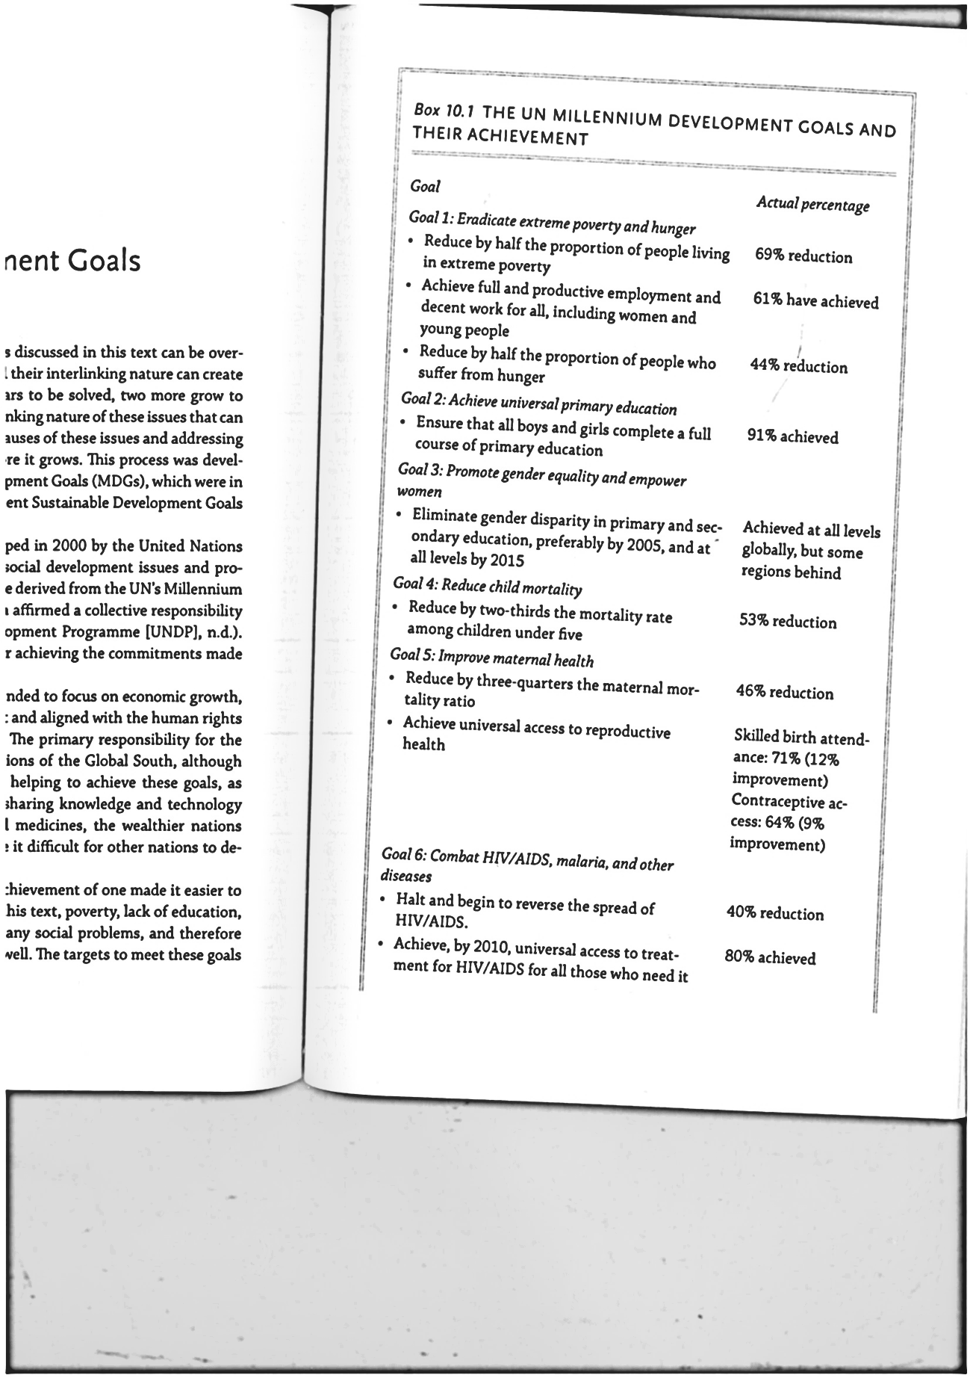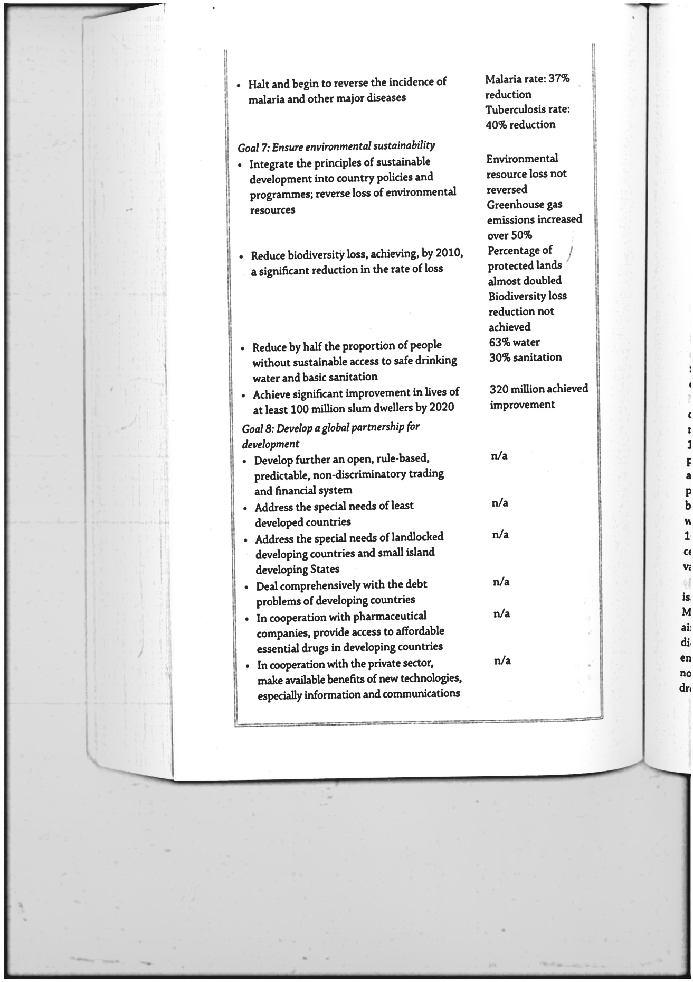

*Sustainable development goals*

These goals were based on what they termed “five big transfer national shifts” that they deemed necessary to remove the barriers to full social inclusion and achievement for (UN, 2013).

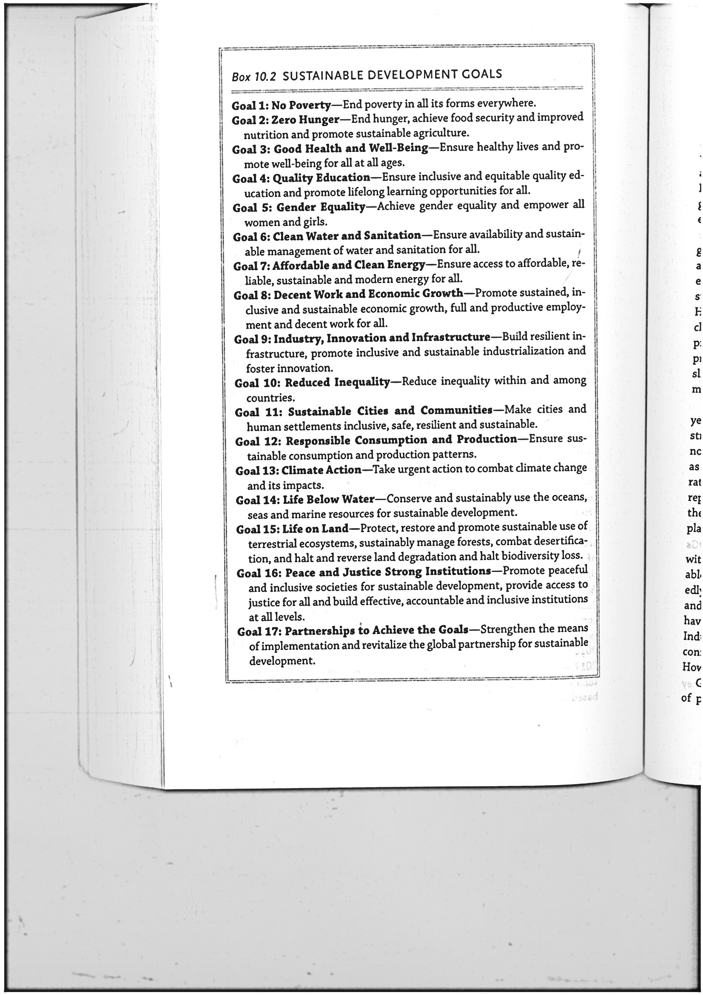

Role of social workers. Research has found that in countries where social workers were not involved with MDGs, they were further marginalized (Healey, 2017) when that occurs in the populations. The social workers serves are further marginalized as well the systems thinking inherent to social work is a key tool for working to achieve the SDGs, this social work must be at the table for these conversations. Because social workers’ involvement on multiple system levels. Social workers have the ability to bring the stories and experiences of those they serve to eras of policy makers to improve polices to help each the SDGs (healthy, 2017). A shared alone goal on human rights was not achieved, the integration of human rights in the goals is clear, The world is at a tipping point where growing inequality threatens all that we have achieved. As social workers, it is the calling of social workers to step forward and work for a more just world. What could be done now is to reduce our own levels of consumption, including both goods and services as well as intangibles such as electricity, in the world wide web resources section at the end of the chapter. Two websites among other five. 1- The United Nations Educational , Scientific and cultural organization (UNESCO) 2-Education for sustainable development goals ([www.unesdoc.unesco.org](http://www.unesdoc.unesco.org)). learning materials for education about the SDGS, another is the United Nations sustainable development goals ([www.sustainble](http://www.sustainble) development.un.org). The UN side that list all the goals and their targets as well as other information to achieving them.

Chapter 11. A Call to Action.

This text has focused on issues as they occur in the global south to help those living in the global North to understand how these issues can be, both similar to and different from what occurs in their own nations. At the end of each chapter is a list of actions that people can take right now to help create change as well as what they can do in their social work career. While it is true that a single person cannot solve all the problems of the world, people gathered together to create change can be extra- ordinary effective social workers can also be extra ordinary effective. Social workers can also be involved, through the international organizations of the international federation of social workers and the international federation of social workers. The international association of the school of social work, as well as advocating to their own governments for improved polices (healthy, 2017). The international issues affect not only social workers practicing outside of the global north but also those within the global north countries.

Due to their involvement at multiple system levels, such workers can bring stories and experience of affected persons to the ears of policy makers . They are also able to work with others disciplines to achieve change (Healy, 2017). Beside social workers, there are task- oriented and know how to develop and implement solutions in full partnership with the client. More over social workers can analyze a situation and use all variable to effect change (problem-solving skills). Social work clearly has much to offer as social issues around the globe grow in importance, they also understand what should not be done, as discussed in the section on volunteerism in chapter 4 Operating from a human rights stand point and advancing social justice, they can promote “social change and development, social cohesion and the empowerment and liberation of people. The profession of social workers has much to offer the world and their values compel us to act. Their skills and knowledge can help to create a world in which everyone has access to their human rights and they can all take action to achieve this. Finally, I would like to end this article with a powerful quote for Margaret Mead, when she states “never doubt that a small group of thoughtful, committed people can change the world. Indeed, it is the only thing that ever has”.

**Readings and references**

Human rights and social Justice in a global perspective.

Third edition- Susan C. Mapp. 465 pages.

Oxford University press- 2021. New York 10016.