Introduction

Cognition refers to a child's or young person's developed cognitive skills and thought processes as a result of their earlier experiences. Learning requirements vary from subject to subject and situation to scenario. Despite adequate differentiation, children with learning disabilities may develop at a slower rate than their classmates. Learning challenges can be general or specialised, and they might be related to one or more curriculum areas. Difficulties can be temporary in one or several areas, or they can be severe and last for a long time. One or more specific areas of learning are affected by specific learning disorders (SpLD). This includes a variety of issues like dyslexia, dyscalculia, and dyspraxia. Wigan's graded approach to supporting children and young people with special needs accommodates all learners' diverse requirements.

Description of requirements

The children and young people to whom this guidance applies will have a variety of differences that will make learning and maybe social inclusion difficult for them. Individual children and teenagers exhibit a variety of variations that vary in severity and intensity and may change over time. It is unlikely that any kid or adolescent will meet all the criteria listed below. Children and young people with additional learning needs may have challenges in one or more of the following areas of cognitive functioning (for a list of skills within these areas, see Appendix I 'What is cognitive functioning?'):

• Perception and processing

• Attention, organisation, initiative, and motivation

• Logic and reasoning

• Working memory, fluency, maintenance, and recall

• Self-regulation and evaluation

They may also have difficulty learning basic literacy and numeracy skills.

For this group of children and young people, the suggested provision in this advice document, as well as adequate resources, will promote effective teaching and learning. The ideas and strategies used in the curriculum are not prescriptive or exhaustive. They are designed to instruct schools on the type and level of intervention that should be provided as part of the graduated approach to identifying and meeting special educational needs, and they should be delivered in accordance with a child's or young person's assessed needs and agreed-upon outcomes.

1. Learning and cognition

Descriptions of the several levels at which children and young people's needs are met

Teaching of the highest calibre comes first.

A happy and exciting learning environment that supports all children and young people's learning and cognitive development, with special attention to those with special learning and developmental needs.

The description of needs on pages 1 - 3 will identify learning needs in children and young people, which may limit their access to various areas of the National Curriculum, such as the social/emotional curriculum and school life.

Priority is given to quality. Differentiated instruction (including 'catch-up' and 'booster')

A happy and exciting learning environment that supports all children and young people's learning and development, with special attention to those who have additional learning and cognitive developmental needs.

The description of needs on pages 1 - 3 will identify learning needs in children and young people that will affect their access to several areas of the National Curriculum, including the social/emotional curriculum and school life. Support for Special Education Needs (Provision Map/IEP) A progressive strategy to ensure a growing awareness of the child's or young person's learning needs and positive outcomes (Assess, Plan, Do, Review). Schools utilise their own method of planning and recording SEN Support services, such as Provision Maps/IEPs. Learning needs recognised by the description of needs on pages 1 - 3 will moderately or severely limit children and young people's access to the National Curriculum, including the social/emotional curriculum and wider school life, especially in new and unfamiliar circumstances.

Support for Special Education Needs (IEP/My Support Plan) A progressive strategy to ensure a growing understanding of the child's or young person's major learning needs and positive outcomes (Assess, Plan, Do, Review). To guarantee a customised and coordinated planning approach, schools employ their own individualised strategy to planning and tracking SEN Support services, such as IEPs/ANPs or the My Support Plan. Children and young people will have learning needs identified by the description of needs on pages 1 - 3 that will have a significant/severe impact on their access to the National Curriculum, including the social/emotional curriculum and all aspects of school life, especially in new and unfamiliar contexts, but also at times of high stress within familiar contexts.

EHC Strategy

An EHC needs assessment evaluated the child's or young person's complex learning needs, as well as the outcomes and support needed to help them progress. There is an EHC Plan in place. Learning needs identified by the description of needs on pages 1 - 3 will severely/profoundly/exceptionally affect children and young people's access to the National Curriculum, including the social/emotional curriculum and all aspects of school life, even in known and familiar contexts and with familiar support available. Planning and evaluation. To inform pupil progress, use high-quality ongoing assessment (using effective techniques and early assessment materials), as well as other information acquired from within the school and national data and expectations of progress. This evaluation should be revisited on a frequent basis.

•Assessment is usually included in school and class instruction and assessments. SENCos may be asked to participate in more detailed assessments and observations.

• Individual/group targets should be included in curriculum plans.

•The child/young person should be involved in setting goals, and their family should be active in supporting those goals at home, if suitable.

Environment

Quality takes precedence. Instruction that is differentiated (including 'catch-up' and 'booster')

A joyful and stimulating learning environment that promotes all children's and young people's learning and development, with special attention paid to those with unique learning and cognitive developmental needs.

The learning needs described on pages 1–3 will be identified in children and young people, affecting their access to numerous areas of the National Curriculum, including the social/emotional curriculum and school life. Support for Students with Disabilities (Provision Map/IEP) A gradual technique for raising understanding of a child's or young person's learning needs and ensuring favourable outcomes (Assess, Plan, Do, Review). Schools use Provision Maps/IEPs or other methods of planning and recording SEN Support services.

Learning needs identified on pages 1–3 will moderately or severely impede children and young people's access to the National Curriculum, including the social/emotional curriculum and other aspects of school life, especially in new and unfamiliar situations.

Support for Special Education Needs (IEP/My Support Plan) A progressive strategy aimed at ensuring a growing understanding of a child's or young person's major learning needs and positive outcomes (Assess, Plan, Do, Review). Schools use their own personalised strategy for planning and tracking SEN Support services, such as IEPs/ANPs or the My Support Plan, to ensure a customised and coordinated planning approach. Children and young people will have learning needs identified by the need’s description on pages 1 - 3 that will have a significant/severe impact on their access to the National Curriculum, including the social/emotional curriculum and all aspects of school life, particularly in new and unfamiliar contexts, but also at times of high stress within familiar contexts.

EHC Action Plan

An EHC needs assessment looked at the child's or young person's complex learning needs, as well as the outcomes and support they'd need to go forward. There is a plan in place for

EHC.

Learning needs described by the description of needs on pages 1–3 will severely/profoundly/exceptionally influence children and young people's access to the National Curriculum, including the social/emotional curriculum and all elements of school life, even in well-known and well-understood situations. In familiar situations, with familiar backing.

Curriculum strategies and approaches

Perception and analysis

Pupils are provided verbal explanations of the task and its goals.

Along with spoken directions, visual reinforcement and gestures are used.

Teaching professionals link new vocabulary to past concepts and knowledge and explain word origins to assist students understand the structure and meaning of words.

For educational research, we are living in fascinating times. Learning and cognition research is rapidly evolving. The outcomes of this study are increasingly being implemented in the classroom. Several educational organisations and individuals (including the Chartered College of Teaching) are testing how we may employ findings from what is becoming known as the "science of learning" in classrooms and schools. Several organisations and individuals are also attempting to spread these discoveries throughout the profession (of which this journal is an excellent example). Cognitive load theory is being used by schools and instructors all around the country.

The concept of limited working memory, abbreviated as CLT... More to shape their instruction, as stated in the opening portion of this topic. This is a fantastic idea, although it does have some clear drawbacks. Scientific concepts can be transformed and repackaged as new fads. And the new 'learning styles' are the last thing we need in school.

Metacognition and self-regulation, for example, are excellent examples of both concepts.

An increasing body of evidence suggests that the ability to self-regulate and use metacognitive methods can aid students in learning more successfully and efficiently. Improved self-control has a minor positive impact on student achievement. However, the concepts can and have been used to support unhelpfully generic approaches, such as separate courses on 'learning to learn,' or to imply that the teacher's responsibility is solely to assist students in developing their own self-regulation.

It's important to define self-regulation and metacognition. There are a variety of definitions, so it's not as simple as it appears. Self-regulation, as defined by James Mannion in this issue, is concerned with learners' awareness of their strengths and weaknesses, the strategies they employ to learn, whether and how they can motivate themselves to engage in learning, and whether and how they can develop strategies and tactics to improve learning.

Metacognition is a subset of self-regulation. Self-regulation is frequently viewed as a three-part psychological process: cognition, metacognition, and motivation (see Figure 1). Cognition refers to the skills that students employ to process information when doing a task, such as paying attention or practising.

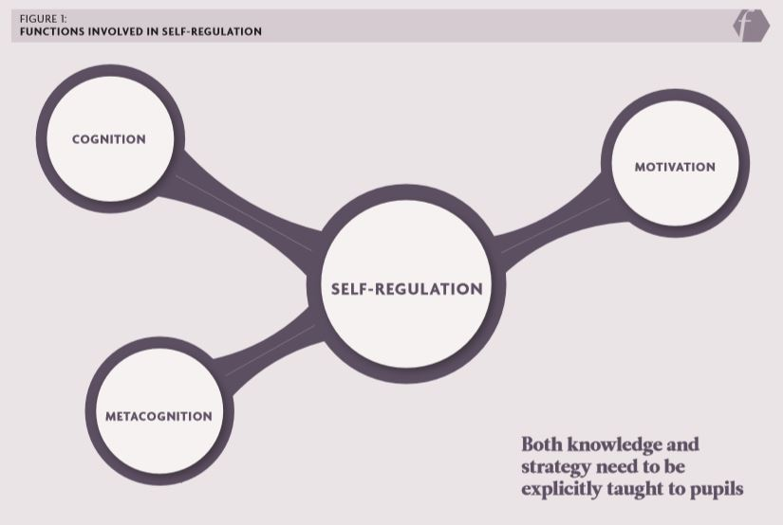

All these factors are significant, but I'm going to concentrate on metacognition in this article. Improving students' metacognition is a worthwhile endeavour, but we must be clear about what it entails. Metacognition refers to the ways in which students can keep track of and direct their own learning. They can, for example, determine whether a particular memorisation technique is likely to be effective, track whether it has been successful, and then change (or not change) their memorisation strategy depending on the evidence. Planning, monitoring, and assessment are the three primary components of metacognition:

• Monitoring includes the self-testing activities that are necessary to control learning, such as retrieval practise during a learning task. • Evaluation refers to appraising the outcomes of one's learning and deciding whether to use a different strategy next time.

These are skills that educators and teachers can assist students develop. However, there are a few things to keep in mind in order to do so efficiently. To begin with, while self-regulation does develop naturally in children to some amount, it does not do so to the same extent or in all children. As a result, education and teaching have a distinct role to play in its ongoing development. Second, the seeds of self-control appear early in life and can be nurtured even in pre-schoolers. Tania Choudhury writes in this issue about attempting to accomplish just that, replicating a previous work published in Impact (Lewis, 2018) in a nursery setting. Third, while metacognition increases with age, maturation alone does not guarantee effective study abilities, for example. Even university students have difficulty employing effective and efficient tactics, and they frequently neglect to reflect on their actions. This is demonstrated in Elizabeth Mountstevens' article, which describes how metacognitive approaches were utilised to increase study abilities among sixth-form students. Because metacognition does not always develop naturally, we must intentionally teach metacognitive knowledge and practises to students.

The most prevalent metacognitive methods are: • planning strategies, such as formulating a plan or deciding how much time to spend on an activity; and • monitoring strategies, such as self-testing and questioning, which are used to assess understanding and learning during a task. Performance analysis strategies (assessment strategies) (Shraw and Dennison, 1994).

Making generalisations and drawing rules about a thinking strategy • naming the thinking strategy • explaining when, why, and how such a thinking strategy should be used and when it should not be used • considering the disadvantages of not using appropriate strategies • considering what task characteristics call for the use of the strategy (Ben-David and Zohar, 2009).

Metacognitive knowledge is crucial, and it should not be overlooked. As Jonathan Firth notes in his piece on reflective practise, this also applies to instructors. Pupils must be explicitly taught both knowledge and strategies. In meta-analytic investigations, strategy instruction has demonstrated considerable effect sizes, with de Boer et al. (2014) indicating moderate to large effects. The essay by Matt Corry and Claire Badger in this issue provides a useful account of explicit metacognitive strategy education at the Godolphin and Latymer School. Of course, explicit instruction isn't simply about employing metacognitive tactics; students must understand cognitive strategies like retrieval practise before they can utilise them (and in their articles in this issue, Victoria Waller and James Kilsby and Dannielle Dennis illustrate why this strategy is so helpful).

**Reference:**

Ben-David A and Zohar A (2009) Contribution of meta-strategic knowledge to scientific inquiry learning. International Journal of Science Education 31 (12); 1657-1682.

Boekaerts M (1999) Self-regulated learning: Where we are today, International Journal of Educational Research 31(4): 445-457.

De Boer H, Donker A and van der Werf MPC (2014) Effects of the attributes of educational interventions on students’ academic performance: A meta-analysis A quantitative study design used to systematically assess the research.

Kim RY, Park MS, Moore Tj et al. (2013) Multiple levels of metacognition and their elicitation through complex problem-solving tasks. The Joiurnal of Mathematical Behaviour 32(3): 377-396.

Lewis H (2018) Developing metacognition in young children: The impact of talking about thinking using video reflection as a stimulus. Impact 3: 33-36.

Shraw G and Dennison R (1994) Assessing metacognitive awareness. Contemporary Educational Psychology 19(4): 460-475.