Introduction

Pillay (2003) claims that psychologists in South Africa need to be trained and supervised to operate in communities as a result of recent advances in higher education institutions. Pretorius-Heuchert and Ahmed (2001) cite an abundance of people with psychological problems and too few people to help, a lack of financial and physical resources, and the fact that mental health services have historically provided inefficient, ineffective, and inappropriate services as reasons for this need. Furthermore, systemic concerns such as apartheid, poverty, and oppression have led to psychological issues and pressures, necessitating intervention within the wider system (Pillay, 2003; Pillay, 2006).

As a result, educational psychologists' training must educate them to work within an ecosystemic paradigm that emphasises prevention and mass intervention while also advancing theory and research, particularly in oppressed and disadvantaged groups. In addition, training should address the need for educational psychologists to take on new roles and get more involved with communities and community organisations in order to focus on prevention and broaden interventions (Pillay, 2003). Furthermore, students are exposed to the necessity to be critical of existing psychological approaches and are urged to make improvements to their skills or discover more relevant intervention methods through working with communities and non-urban locations (Pillay & Kometsi, 2007).

What are students' impressions of an Educational Psychology practicum related to community participation in an MEd Educational Psychology module? The investigation's goal is to improve educational psychology training knowledge and methods.

According to Pillay (2003), for educational psychologists' training to be relevant in the South African context, training should be integrated into all courses in a coherent and comprehensive manner, and it should be more realistically oriented. In the context of South Africa, it has become increasingly clear that the traditional role of the educational psychologist in providing an individually based service, whether in private practise consulting with schools or based at a school or similar agency, is ineffective and does not have a long-term impact on children (Pillay, 2007; Lubbe & Eloff, 2004). According to Lubbe and Eloff (2004), educational psychologists must focus more on communities, establish networks and partnerships, and collaborate with relevant stakeholders in order to address vast socio-economic and socio-psychological disparities and inequalities in terms of the needs of the people of South Africa. As a result, educational psychologists should not only be exposed to theories, but also get hands-on experience working with communities through practicums, fieldwork, and case studies (Pillay, 2003).

Pillay (2003) identifies several reasons why psychologists' training and supervision should be more community focused. The following are some of the reasons: educational psychologists should put theory to the test in real-life circumstances and get cross-cultural training in the context of South Africa; a paradigm change from individual to collective practise is required, and students should participate in action research. Furthermore, action research should be focused on acting and intervening to satisfy the needs of communities. Educational psychologists should use an ecosystemic approach in their training, and trainees should learn how to empower and mobilise community members to address social challenges in the setting of South Africa. Educational psychologists should cooperate with stakeholders and develop a repertoire of general abilities for working with communities, as they must be able to deal with a wide range of problems and implement a wide range of solutions if they are to be of benefit to their clients and communities. Psychologists should also focus on interventions that are preventative rather than curative (Pillay, 2006; Pillay, 2003).

Several universities in South Africa, including the University of Pretoria, the University of Johannesburg, and Stellenbosch University, are implementing these tactics in their educational psychology courses, which reflect the changing scope of the educational psychologist (Pillay, 2003). Community participation is one type of training that is useful to educational psychology students. Universities around the world, including those in South Africa, have been under increasing pressure in recent years to bridge the gap between higher education and society and to become active partners with communities. The White Paper 3 (Department of Education (DoE), 1997) provided the groundwork for making community service, or more accurately, community involvement, a fundamental aspect of South African higher education. According to the White Paper (DoE, 1997), one of the purposes of higher education should be to encourage and build a social responsibility consciousness among students, both socially and economically, by incorporating community engagement into academic programmes' curricula (Bender, 2007; Bender, Daniels, Lazarus, Naude & Sattar, 2006). The University of Pretoria, like the rest of South Africa's universities, has come to appreciate the potential of community engagement to transform higher education in relation to societal needs and, as a result, to produce graduates with a sense of civic responsibility and the ability to apply their disciplines' theory to local developmental issues (Bender, 2007).

Conceptualisation

Community engagement and curricular community engagement are two different things.

The following definition of community engagement (CE) is provided by the Quality Committee of the Council on Higher Education (Higher Education Quality Committee, 2004:24), as quoted in Bender (2008a): Community involvement is described as the efforts and processes through which a higher education institution's expertise in the fields of teaching and research is used to address issues that are important to the community. Community participation can take many forms, from informal and generally unstructured activities to formal and structured academic programmes that meet specific community needs.

The concept of curricular community participation is employed as a framework for academic programmes at the University of Pretoria. Curricular community involvement is a credit-bearing educational experience that involves academic staff, students, community service agencies/organizations, and community people in mutually productive and respectful collaboration. Their interactions address community-identified needs and assets, boost students' civic and academic learning, and add to the University's scholarship. Community-based learning, academic service-learning (an example of best practise), community service, internships, clinical practicals, practicums, work-based learning, experiential education, community-based education, cooperative education, community-based projects, and community outreach are all examples of curricular community engagement at the University of Pretoria (Bender, 2007; Bender, 2008a; Bender, 2008b).

Several modules in the MEd (Educational Psychology) programme at the University of Pretoria's Department of Educational Psychology incorporate community interaction to train future educational psychologists. One example of how educational psychologists' training at the University of Pretoria has been adjusted to accommodate changes in their scope of practise is seen in the changes made to the practicum in one of the MEd Educational Psychology Program's modules, namely Career assessment and counselling, since 2006 (Ebersöhn, 2007). This collaboration grew out of an existing relationship between a lecturer and educators at a rural secondary school in Mpumalanga. The ongoing collaboration's training goal is to provide Educational Psychology students with the opportunity to gain practical experience with the I asset-based approach and (ii) positive psychology principles (Ebersöhn, 2007) and to provide Educational Psychology students with the opportunity to work in a community located in a secondary school in a rural area. The goal of the Educational Psychology students' involvement with the school and the students was to build partnerships and generate learning and research possibilities. This cooperation was developed in order to get educational psychology practise experience with Grade 9 students and instructors. Furthermore, the partnership entails working closely with the school and educators to address any career and learning challenges that the learners may face, as well as assisting those learners in gaining skills in their schoolwork so that they can better support themselves during their further education and after leaving school (Ebersöhn, 2009).

The practicum takes place twice a year. In terms of assessment, the first visit comprised implementing planned group-based activities with Grade 9 students. The objective of the assessment is to I develop rapport, (ii) get to know the group's learners, and (iii) decide the group's intervention emphasis. The assessment's goal is to gather information on each learner's strengths and challenges so that an educational psychology intervention can be planned for that group. The second visit was devoted to putting the planned group-based intervention activities into action. The intervention was focused on areas highlighted during the post-first-visit assessment (Ebersöhn, 2009). Individually, students devised an assessment and intervention method. Following that, during the two-day visits, the students travelled to the school and worked with groups of Grade 9 students for one-and-a-half to two hours each day.

The students were evaluated on their competence to behave as educational psychologists-in-training in a new and diverse context with diversity and linguistic disparities in the appropriate module. The competence of each student to develop and facilitate the activities, as well as her subsequent reflection, was assessed (Ebersöhn, 2007). The practicum at the secondary school was supervised by lecturers from the University of Pretoria's Department of Educational Psychology. Each student met with her supervisor prior to the two implementation stages to discuss her plans for both the evaluation and intervention phases of the project. During their contacts with Grade 9 students and other important people at the school, the lecturers watched the students. They also assisted the students with the assessment and intervention processes, as well as the reflective discussion that took place after each session away from the school (Ebersöhn, 2009).

Theoretical foundation for experiential learning

Learning is described as "the process by which knowledge is formed through the transformation of experience" from an experiential learning perspective. "Knowledge is the result of a process of grasping and transforming experience" (Kolb, 1984, 38). As a result, the success of such learning is determined by the ability of the student to learn from the experience (Le Roux, 2007). Individuals can learn, grow, and develop through experiential learning, which gives a complete understanding of the learning process (Kolb, Baker & Jensen, 2002). Kolb's experiential learning model (1984) depicts two dialectically related modes of grasping experience: apprehension (concrete experience) and comprehension (abstract conceptualisation), as well as two dialectically related modes of transforming experience: intension (reflective observation) and extension (extension) (active experimentation). Experiential learning is a type of knowledge construction that involves a creative tension between the four learning modes and is responsive to context. This process of knowledge construction is depicted as an idealised learning cycle in which the learner interacts with all the bases, namely experiencing, reflecting, thinking, and acting, in a cyclical process (see Figure 1) that is sensitive to the learning setting and what is being learned (Kolb & Kolb, 2005; Kolb et al., 2002). Concrete experiences entail hands-on experience, so the learner is actively participating in an activity. The focus of reflective observation is on the learner intentionally reflecting on the event, which necessitates the individual to notice, study, analyse, and interpret the influence of a specific concrete experience. The abstract conceptualisation of discoveries provides them meaning by linking them to other discoveries and kinds of knowledge. This frequently leads to the student having to come up with a hypothesis or model to explain what they're seeing. Finally, active experimentation occurs when a learner plans how to put a theory or model to the test in preparation for a future encounter. Learning in this cycle (see figure 1) is flexible since it can start at any point along the way (Healey & Jenkins, 2000; Bender et al., 2006). Kolb's experiential learning cycle was employed in this study as a framework for curricular community engagement in academic programmes and learning technique with community service.

To summarise, experiential learning entails the learners' active participation in their surroundings. It is emphasised the necessity of reflecting on actions both during and after an experiential learning activity or event. Furthermore, the learner's experience is influenced by the context and environment in which the experiential learning activity takes place (Benecke, 2004). Kolb's theory is credited with laying the foundation for the concept of community engagement, as it recognises the importance of experience in increasing learning. Experiential learning emphasises the value of activities and practises such as practicums, internships, service learning, on-the-job training, and work-based learning, among others. Experiential activities are diverse and creative, and their use will be influenced by several factors, including the support systems available in higher education (Benecke, 2004).

Research Methodology

The researchers purposely chose a group of eight female Educational Psychology students from the University of Pretoria's Department of Educational Psychology (McMillan & Schumacher, 2001). (Constituting all students enrolled in the module for a specific year). The participants were chosen based on the following criteria (McMillan & Schumacher, 2001): (a) they had all completed the master’s in educational psychology course and (b) they had all completed the Educational Psychology practicum. All the participants were female, and all of the pupils were white save one (African).

To add depth and richness to our study, we used a variety of qualitative data production methodologies, including I focus group interviews, (ii) reflective journals, and (iii) visual data (photographs).

We performed a focus group interview with the eight participants about their experiences with the Educational Psychology practicum (Morgan, 1997; Greeff, 2005, Nieuwenhuis 2007a; Cohen, Manion, & Morrison, 2003). To boost the richness of the data, we picked focus groups as a strategy to establish a social setting in which participants were stimulated by one another's thoughts, opinions, and ideas. Furthermore, focus groups allow members to have a better knowledge of their own opinions and experiences (McMillan & Schumacher, 2001). The focus group interview took place in a secure, silent room, with the participants' seats placed in a circle in the centre and the audiotape recorder in the centre. The data from the focus groups was then transcribed and analysed. After each session at the secondary school in Mpumalanga, the students kept reflective notebooks of their everyday experiences to chronicle their personal expressions and perspectives on the practicum (Babbie & Mouton, 2001). These reflective diaries were then sent into the lecturer as part of their evidence portfolio. We accessed the reflective journals for data collection and analysis after receiving verbal and written consent. We also used images taken by students and lecturers during their practicum as a source of information. The examination of the images provided a new perspective from which to examine the Educational Psychology students' community participation practicum experiences.

We employed thematic analysis to analyse data from all sources, which allowed us to examine key words, meanings, themes, messages, and meanings derived from the data (Cohen et al., 2003) with the goal of determining what students experienced throughout the practicum. In order to become familiar with the content of the data sources, we also looked at transcripts, participant reflective journals, and images. We next used a coding technique to limit the data to themes, condensed those codes, and lastly showed the data in tables and conversations (Creswell, 2007). The goal of the photo analysis was to find meaningful and symbolic content in the visual data (Nieuwenhuis, 2007b). According to Viljoen (2004), as described by Ebersöhn and Eloff (2007), the images allowed the researchers to work with a visible, concrete medium rather than just field notes, which could be subjective. We forwarded themes that emerged following data analysis of all data sources to each participant for member checking (Babbie & Mouton, 2001).

Ethical and rigour considerations

The reliability of this study was assessed by comparing different data collection methods to see whether there were any differences in our findings (Maree, 2007; Babbie & Mouton, 2001; Schwandt, 2007). Various sources and approaches were used to see if the same patterns recurred in the data in order to uncover regularities. Different techniques of data generation were used to improve credibility (Maree, 2007; McMillan & Schumacher, 2001), as well as member checking to analyse the participants' purpose, fix evident errors, and have them contribute more volunteer information (Babbie & Mouton, 2001).

As researchers, we got written informed consent from the Dean of the University of Pretoria's Faculty of Education to conduct this study with master’s students in the Educational Psychology Department, as well as written informed consent from the students themselves. The students were made fully aware in the consent forms that all the activities in which they would participate would be kept confidential, and that the study's findings would be published. Furthermore, all participants in the study were told, both verbally and in writing, that their participation in the interviews and the examination of their reflective journals and images was completely voluntary, and that they might leave at any time. This means that after being told of the information that might impact their decisions, the research participants realised they had the right to choose whether to engage in the study (Cohen et al., 2003).

Findings from the research

Because of thematic analysis and interpretation, three key themes pertinent to the topic of our paper emerged. The following section uses samples from the raw data to illustrate each of the selected themes. Direct statements from focus group interviews and members' reflective journals, as well as visual data from images, make up the raw data. The raw data is numbered according to the name of the person who made the comment (each participant was assigned a number, e.g., P2 or P8). The students first discussed how they got insight into themselves as educational psychologists in South Africa during the focus group interview. The educational psychologists-in-training felt that the practicum had provided them with the opportunity to work with people of many cultures, races, and ethnicities, and that the experience had helped them acquire respect for diversity.

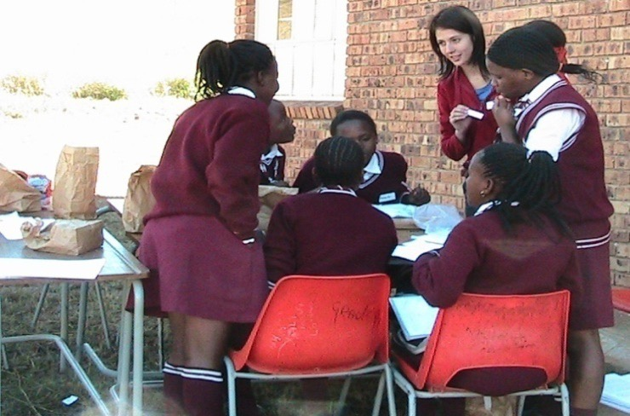

Plate 1: Students learning to work with groups during the practicum

Theme 2: Professional Development Experiences

Second, as a result of their experiences in the Educational Psychology community engagement practicum, the students gained professional growth. This included feeling more confident, being able to adjust to different situations, and having a better understanding of their duty as a professional. "When I got there, I actually realised, I got more self-confidence" (P6); "Today was a positive experience, and I feel that I have more confidence in myself" (P7); "It challenged me because I am a very structured person, so the personal growth is to go into a situation and see what you get, be flexible with what you get, and just to calm down and be flexible" (P2); "I was able to think on my feet, how I was adaptable" (P5).

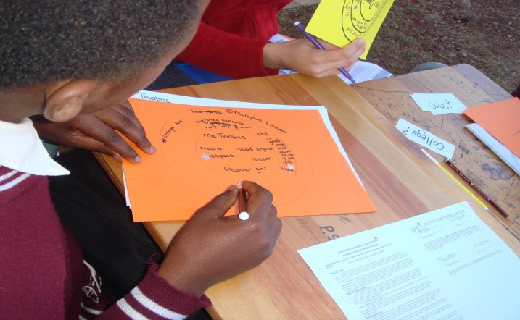

Plate 2: Students and learners implementing the asset-based approach

Learners in the photo above are creating asset maps of themselves as individuals, which will help them apply the theory of the asset-based approach in real-life situations.

Pillay and Kometsi (2007) explain how critical existing psychological methodologies and many traditional approaches to psychological care are for students working in communities. Students should alter their techniques or learn more appropriate intervention strategies if this is the case. These authors emphasise the importance of students understanding the necessity to adjust methods to their consumers' demands. The students realised that the standardised assessments and theories currently used by the University are not indigenous to the South African setting while implementing their assessments and intervention strategies in the practicum. They realised how critical it is to adapt theories and assessments to the South African context: "But we actually need to go in there and actually make our psychology South African as well, because what good is learning about all these western instruments and everything else if you can't apply it to your own context?" (P1) and "The evaluation tools that I utilised to obtain information were not the same as the traditional psychometric instruments that I used in Pretoria." I had to think outside the box, be more creative, and make sure that the activities I prepared were culturally appropriate, so that the students felt at comfortable with themselves and their talents throughout the visit" (P1).

Conclusion

It was shown that students appeared to benefit from increased intercultural ability. Some pupils are said to have gained the ability to speak in a different cultural setting as a result of their experience. A student needs develop a mindset (analytical framework for understanding culture), a skillset (interpersonal and group competence for bridging gaps), and a heartset (motivation and desire to study cultural variables) to be culturally competent (Reitenauer, Cress & Bennett, 2005). The pupils indicated a wish to collaborate with people from all over the country in the framework of South Africa. This subject prepared student to work with people of many cultures, races, and ethnicities. Students gained group work skills such as facilitating group development (which includes forming the group, storming, norming, and performing), group cohesion (factors that encourage members to stay united and committed to a group), and group communication (ensuring contributions from all members of the group) in terms of community engagement (Collier & Voegele, 2005). Furthermore, pupils were exposed to a wider range of diversity than they would have been at the university's training centre. In this regard, students collaborated with children of all ages, races, and genders. The students said they loved the practicum because it allowed them to reach out to more people. According to reports, pupils who learned how to operate in groups can reach out to people in rural communities.

Finally, a community engagement practicum in Educational Psychology provides an opportunity for hands-on learning. Educational psychology training gives students a place to work on their personal and professional growth while also assisting them in combining theory and practise.

References

Babbie E & Mouton J 2001. The practice of social research, 7th edn. Oxford: Oxford University Press. Bender CJG 2007. Pathways to change for integrating Community Services Learning into core curriculum.

Special Issues of Education as Change – Community Service Learning, 11(3):127-142. Bender CJG 2008a. Curriculum enquiry about community engagement at a research university. South African

Journal of Higher Education, 22(6):1154-1171. Bender CJG, Daniels P, Lazarus J, Naude L & Sattar K 2006. Service learning in the curriculum: A resource for higher education institutions. Pretoria: Council on Higher Education/Higher Education Quality Committee

JET Education services. Benecke DR 2004. Experiential learning as implemented by higher education institutions in the education and training of public relations practitioners in South Africa. MA dissertation. Johannesburg; University of Johannesburg.

Brockbank A & McGill I 2006. Facilitating reflective learning through mentoring and coaching. United Kingdom:

Kogan Page. Cohen L, Manion L & Morrison K 2003. Research methods in education. New York: Routledge Falmer. Collier PJ & Voegele JD 2005. Groups are fun, groups are not fun. Teamwork for the common good.

Sage Publications. Department of Education South Africa (DoE)1997. Education White Paper 3. A programme for higher education transformation. Government Gazatte No. 18207, 15 August 1997. Pretoria: