Name:

Tamalee Dwyer

ID Number:
UB65545BBU74602

COURSE NAME:
(Research Methodology)
Assignment Title:
Qualitative vs Quantitative Research Methodology
ATLANTIC INTERNATIONAL UNIVERSITY
May 2022
Introduction
Scientific Research according to AIU’s course material acknowledged research as, “ a systematic process that focuses on being objective and gathering a multitude of information for analysis so that the researcher can come to a conclusion”. When conducting research and following the research process, the first step that a researcher should take is to identify the problem. Certain things are predetermined such as whether descriptive or experimental method will be used. This is because it is due to which of these are selected that will guide the research and determine how the researcher would gather, analyse and interpret the results. When we speak of descriptive research, it is one that hundreds or thousands of subjects are normally measured once. It is done with the intention of making a general and valid estimate of the relationship between the variables. In opposition, the experimental design uses a smaller sample purposely chosen, which are measured before and after a particular treatment. This was done with the intention of establishing casualties between variables.
The second steps would be reviewing the literature by locating the resources. These would range from journals, books or electronic resources. When selecting these resources, you need to ensure that they are relevant to the topic. You will also have to create a literature map to organize the resources. The next thing to do would be to summarize the resources in a literature review. After reviewing the literature, you would then specify the research purpose. In doing this, one must identify the intent of the study, the participants and the site that the study will be conducted. You would then want to narrow down the purpose statement and use either quantitative research that writes a research question and or hypothesis or the qualitative research that identifies a central phenomenon and write a sub question.
The third step in the process would be collecting the data, so the researcher would start to think about the selection of the samples and getting the necessary permissions. They would also have to design or select the data collection instrument and outline the procedures. The analysis of data depends on whether quantitative or qualitative methodology was used for the research. When using qualitative research, there are normally five steps. These steps include preparing and organizing the data, then reviewing it to identify any patterns. The final of these steps would be to categorize your data for those patterns to be easily identified. When using quantitative research, you must ensure that a method was chosen, sampling is done and there is a solution preparation. There also needs to be means to collect the data, calculate the results, which will then be evaluated statistically.
After the collection of data, the researcher will then have to focus on their data analysis method to know how to present the findings. The analysis of data in qualitative research normally shares five steps; preparing and organizing data, review the data and identify patterns. You would then categorize your data by using codes that will make the patterns easily identifiable. Quantitative research analysis data for this type are in the form of and numbers and other non-textual representation. It aims to classify and count features that you would try to explain in the observation by using statistical representation.

Body
Studies have shown that research method is different from research methodology because according to Dawson (2019), “a research methodology is the primary principle that will guide your research”. On the other hand, he also stated that, “research methods are the tools used to gather your data”. There are several steps that must be taken when conducting research. The first step among these, is to develop a research question or identify a problem. It is normally recommended that one chooses an area that they are interested in personally and professionally, because it will make the process a lot easier for them and they will dedicate the needed attention conducting and executing research.
The research question is considered as a statement normally asked in the form of a question. It can be a condition that needs improving or area of concern. A research question can also be a difficulty to be eliminated or about a topic that there is need to get more meaningful understanding about, among other things. An example of a research question could be, “What is the mental state of women like during pregnancy and after childbirth?”. It is important to then do some research on the topic. This might help in better understanding it and might aid in either broadening the scope of the investigation or narrowing it down.
After identifying the topic, one must make the problem more precise/focused and determine how it would be approached. This is formulating the hypothesis. According to research, an hypothesis is a tested research that is done in such a way that the factual data collected would give evidence that would either support or disprove them. In formulating the hypothesis, it is important to take the approach of seeking input or information with experts on the issue. It is also vital to understand its origin as well as objectives in seeking a solution. The researcher also must examine the available data, records, possible trends and other clues. In addition, the researcher should look at similar study or studies on a relatable issue. Personal investigation can also be done such as in the form of interviews on a population that might be affected or persons interesting in getting insight on the problem. An example of an hypothesis statement would be, “It is hypothesized that many mothers experiences pre and or postpartum depression”. This hypothesis as a research question would ask, “Does mothers experience pre and or postpartum depression?”. At the end of it all, the hypothesis turns into practical theory that would make the research more of an expert on the issue.
After the hypothesis has been formulated, the researcher must decide how the information will be collected and this is considered as the research design. The researcher can use one or more research methods to conduct their research based on the objective. The researcher can choose from conducting interviews, survey or issuing questionnaires. It can also be done by doing experiments. Research methods can be categorized as experimental, descriptive, exploratory or diagnosis. Research methodology, however according to abdul awal is, “a highly intellectual human activity used in the investigation of social phenomena, nature, and matter that deals especially with the manner in which data is collected, analysed, and interpreted for a scientific research project”.
According to research, it can also be classified as “a systematic and theoretical analysis of the research methods applied to a field of study that combine the techniques and approaches of the used tools for conducting a scientific research study". Qualitative and quantitative are opposing research

methodology techniques. The difference between them is that qualitative research is conducted by the examination of information such as experiences, opinions and behaviours that are based on evidence. Quantitative research on the other hand deals with numerical statistics by using research methods such as survey, to gather data. Examples of qualitative research methodology include action research, ethnography, feminist research and grounded research.
There are some instances in which research integrate themselves in groups or organization to understand how it operates, this is referred to ethnology. It was also published by Jack Caufield as a flexible research method in the form of written research reports that gives one more insight in understanding a group’s culture and social dynamics, that ethnographers then produce. Ethnographic is often used to conduct common research about groups such as gangs, sports fans, call centre workers and school or university students. Using ethnographic as a research method provides a lot of benefits such as having direct access to the cultures and practices of the group. It gives a first-hand experience that would help you to better understand the behaviour aspect of the group and the dynamics. It also gives you the opportunity to get information, authenticity and clarity on very specific questions or concern that you might not be able to get from general research. It allows flexibility and aims to offer an opportunity to get different perspectives of the group. It provides a substantial narrative about the culture rather than just confirming a general theory.
While there are so many advantages, there are also challenges faced while using this research method. This process is very time consuming because it will take you no less than a few weeks, even months are longer to truly immerse oneself in the culture to gather enough information to provide a true reflection of the observation. Using this method may involve subjective interpretation that poses the risk of observer bias, as one may find it challenging to maintain a healthy distance and balance being a part of the group. The members of the group might also get concerned about your involvement in the group and the part you play in observing and reporting sensitive information about the group but as a reporter. As such, one must have ethical consideration of making the group aware of your position. If a researcher chose to use ethnology, it is recommended to use a small accessible group that will make the research more feasible and reduce the timeframe for collecting the research data. There are also several approaches that can be taken when using this research such as the open vs close, overt vs convert and active vs passive.
Another example of qualitative research is action research. This method is a common approach that is often taken in organizational management, education, and communication among other areas. It is aimed a working with a group of people with the intention of improving something within a specific environment. This method not only includes observation of groups but also using recording devices such as audio and video taping. In addition, it entails interviews, taking photography, field notes or even conducting interviews or distributing surveys. It can be any combination of the mentioned research methods, since all the observation, interpretation and analysis is done first hand by the researcher.
After choosing the research method, the next step that a researcher would want to take is to collect and then analyse the data. The analysis of data in qualitative research normally shares five steps, the first of which is to prepare and organize your data. This might be typing field notes or transcribing data. The next thing that you would want to do is to review the data and explore it to see if you can identify any patterns or repeated idea. You would then categorize your data by establishing a set of codes. These codes will be determined based on original ideas. They will then be assigned to the data and linked together into cohesive overarching themes that will make it easier to identify the patterns with similar data.
The analysis of data also includes several approaches that emphasizes different concepts. There is concept analysis that is used to categorize and describe ideas, words and phrases that are common. There is also thematic analysis that focuses on identifying and interpreting patterns and themes, while textural analysis would examine content and the design of text, as well as structures. Lastly, there is disclosure analysis. This is used to study communication and the use of language to accomplish effects in specific context such as how political scientist can study how politician generates trust based on their campaigns.
With all the approaches and methods used in qualitative research, it surely managed to yield many great benefits. Qualitative research aims to preserve the perspective of participants. It offers flexibility, as data analysis and the collection process can adapt as new ideas and pattern arises. This is due to them not being decided beforehand. It also gives one the opportunity to collect data in a real-world context or in naturalistic ways with its natural settings. This also contributes to a meaningful insight because it is detailed based on persons feelings and the experiences. It is also based on the perceptions that can be used in the designing, testing or improving of systems or products. It also provides the advantage of being able to generate new ideas based on open-ended responses that researcher can use to unveil problems and opportunities that might have not been thought of otherwise.
Whilst there are many advantages, there are also some areas of disadvantages. This includes the fact that it can be unreliable because of its uncontrollable factors affecting the data due to the real-world settings. There is also subjectivity because it is hard to replicate. This is because of how the research was done and the primary role that the researcher played in the collecting of the data, the analysis and the interpretation. It is subjective because it is the researcher who determines what is important or irrelevant in the analysis, therefore there can be great variation based on the perspective of the researcher. Due to qualitative research being more personalized with mostly small samples being used to gather data, it makes it hard to draw a general conclusion because it might be biased and not a representation of the wider population. It is also labour intensive because the researcher has to collect most of the data first hand and be engaged in the process. This results in a large amount of data to be compiled and based on the nature in which the research was conducted, data analysis often has to be done manually.
After covering the important factors and approaches of qualitative research, you would also want to consider the opposing research methodology, quantitative research, which was previously mentioned. The research guide from LeTourneau University coiled from principles, including Research Design, Creswell, J.W.(2013) states that, “Quantitative research methods emphasize objective measurements and the statistical, mathematical, or numerical analysis of data collected through polls, questionnaires, and surveys, or by manipulating pre-existing statistical data using computational techniques”. It focuses on collecting numerical data to come to a general conclusion or explain a particular phenomenon. It is normally used to determine the relationship between an independent variable and a dependable variable.
Quantitative data can be used for descriptive research that is aimed at finding an overall summary of the study variables. It may also be used as correlational research that investigate relationships of variables as well as the systematic relationship of cause and effect between them when using experimental research. A descriptive research objective is to describe a population or situation accurately and systematically. It can explain what, when and how of the research but doesn’t address why. It can use a wide variety of research methods to investigate one or more variables but doesn’t manipulate or controls the variable. It rather observes and measures them.
Descriptive research is also a good choice to consider when aiming towards identifying characteristics, trends, categories, and frequencies. This research design must be carefully done to guarantee valid and reliable results. It uses surveys that allows for large volumes of data to be analysed for patterns and averages. These surveys are used to evaluate the satisfaction of an organization’s products or services, describe a regions demographics or asses public opinion, in relation to political and social topics. Descriptive research also utilizes observations. This allows a researcher to collect data on phenomena and behaviours without relying on the accuracy and honesty of the subjects. It is very vital to ensure that a researcher observes and systematically describe the subject under investigation before developing a testable hypotheses or theories.
Descriptive research also uses a case study that describes the characteristics of a specific subject such as an organization. Case study gathers detailed data of a defined subject to identify the characteristics rather than to collect large volume of data. Case studies also focus on unusual cases that challenge assumptions or reveal a new factor about research problem. For businesses, using quantitative research will help to learn more about customers buying patterns and their opinions. It also helps to analyse the behaviour of competitors and make business decisions such as about product packaging and branding.
With the many uses of quantitative research come many benefits in. These includes the fact that it can be tested and checked as it requires careful experimental design and requires the ability to be replicated and tested, which means that if a researcher was to follow the same method, she should get the same results. This makes the date more reliable and less opportunity to be argued. The analysis is also very direct and precise because when collecting quantitative data, the type of results will instruct on the type of statistical test is appropriate. Due tom this, there is less room for errors or subjectivity, which also makes interpreting and presenting the findings straightforward. Another advantage is that it considered as prestige due to its complex statistics and data analysis that makes it valuable and impressive, which can reflect well on small businesses and is associated with technical advancement.
Where there are advantages, there will be challenges, as such there are also a few disadvantages when using quantitative research. Since it is focuses solely on numbers which causes it to be limited in finding concrete statistical relationship and may overlooking important information that would have been beneficial to your business. Quantitative research is also difficult in setting up because there must be a hypothesis and a model has be set up for the collection and analysis of the data. Any errors in the set-up process success such as researcher bias or mistakes in the execution can result in the results being invalid.
Quantitative research has several main characteristics. This includes the fact that it this type of study normally has a clearly defined research question that is objected to answer. It is used to collect data using structured research instruments and uses tools such as questionnaires or computer software to collect numerical data from large sample sizes. This allows the information to be replicated or repeated, which is what gives research credibility. The data for this type of research are in the form of statistics and numbers that are normally presented in the form of tables, charts, figures, and other forms of and other non-textual representation. The aim of quantitative research is to classify and count features that you would try to explain the observation by using statistical representation. Some of the analytical software used to do these types of presentation includes Excel Spreadsheet, SPSS and Microsoft Publisher.
When using quantitative research to report information, there are several factors that should be considered. This includes the fact that interpretation of results isn’t appropriate or this section because you will have to be able to explain the data collected and the statistical treatment along with the relevant results in comparison to the investigated issue. There might also be differences in the actual analysis from what was anticipated, and one would have to be able to report those unexpected events. One would also need to explain why missing data does not exist so that is doesn’t undermine the validity of the research. You would also have to consider the usage of tables to present precise values that can use figure that may convey global effects and usage of graphical representation.

Conclusion
It can be concluded that Scientific Research according to AIU’s course material acknowledged research as, “a systematic process that focuses on being objective and gathering a multitude of information for analysis so that the researcher can come to a conclusion”. It went further to explain that this process is used for every type of research, as well as evaluation process regardless of the research methods. It includes a series of steps or processes that are interlinked. These steps are normally documented along the way such that someone else can conduct the same research again. This process is referred to as the replicating of study. Methodology, according to Oxford dictionary is,” a system of methods used in a particular area of study or activity”. Hence, research methodology involves the actions that take place during research, how to go about the process as well as measure the process. It also entails what is considered as success for the research.
When conducting research, there must be a scope of investigation as there must be a reason why the research is being done. All the variables that a study is intended to consider should be in the research question, while the hypothesis deals directly with the expected resulted. After developing the research question and the hypothesis, the next would be to decide what method will be used to collect the data. This is just a part of the research design because the method chosen will also be used to analyse the data and determine how it all will answer the research question. It will also validate the test and its reliability.
Studying research methodology has also helped me to specifically understand the concepts of conducting research. It also helped me to understand the different approaches that can be taken in research which are qualitative and quantitative research. It also explained the approaches taken for each of them, what makes them different and when they should be utilized.

Chart
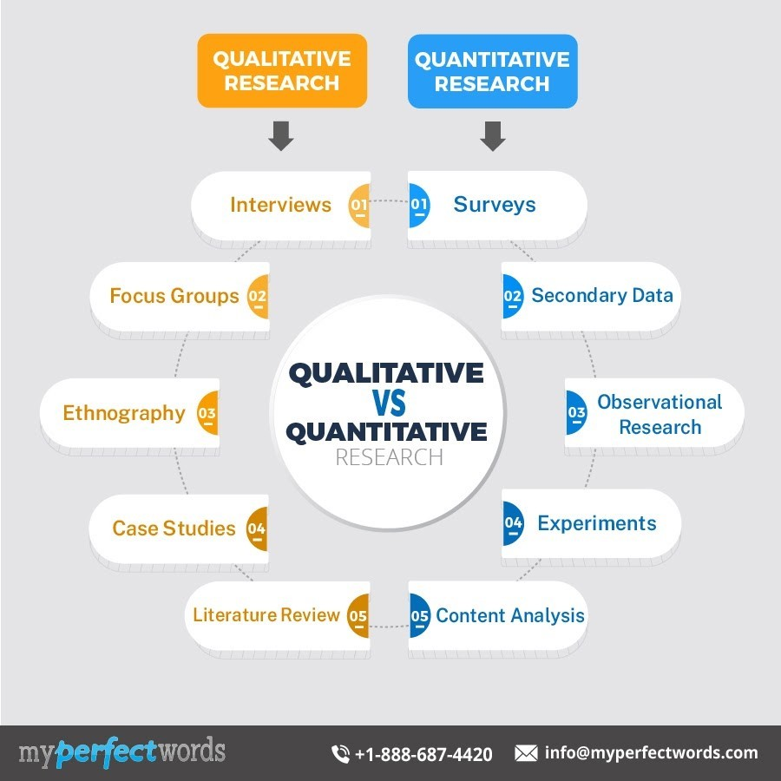
Bibliography
- Article:
- Author: Jack Caulfield
Article: An Introduction to Ethnography | What Is It and How Is It Used?
Date: March 13, 2021
Company: Scribbr

- Author: Abdul Awal
Article: Basic Concept of Research Methodology and Method
Date: February 12,2019
Company: Campus Career Club

- Author: Jessica McCallister
Article: Action Research in Education: Methods & Examples
Date (Updated): 8/30/21
Company: Study.com

- Author: Printha Bhandari
Article: Data Collection | A Step-by-Step Guide with Methods and Examples
Date: June 5,2020
Company: Scribbr

- Books:
- Babbie, Earl R. The Practice of Social Research. 12th ed. Belmont, CA: Wadsworth Cengage, 2010; Muijs, Daniel. Doing Quantitative Research in Education with SPSS. 2nd edition. London: SAGE Publications, 2010. Creswell, J. W. (2013). Research design: Qualitative, quantitative, and mixed methods approaches. Sage publications.

- Edmonds, W. A., & Kennedy, T. D. (2010). A reference guide to basic research design for education and the social and behavioral sciences. New York, NY: Pearson.
- Websites:
- URL: https://library.tiffin.edu/researchmethodologies
- URL: https://research-methodology.net/research-methodology/research-process/
- URL: https://courses.aiu.edu/RESEARCH%20%20METHODOLOGY

