Your name
Bakary K. Manneh

Your student ID number
UB64243SCI73300

COURSE NAME:

(Road Safety Engineering)

Assignment Title:

Introduction to Traffic Engineering

ATLANTIC INTERNATIONAL UNIVERSITY
FEBRUARY/2022

Table of Contents:

- Summary
- Introduction
- Description
  - Speed and Speed Sign
  - Design Speed
  - Operating Speed
  - 85th Percentile Speed
  - Targeted Speed
  - Mean Speed
  - Speed Distribution
  - Posted Speed
  - Speed Limit
  - Dense built-up area
  - Statutory S
  - Speed Zone
  - Advisory Speed
  - Flow of Traffic
  - Traffic studies and characteristics
  - Performance evaluation
  - Facility design
  - Traffic Control
  - Traffic operations
  - Intelligent transportation systems

- General Analysis

Appropriate Speed Limits
  - Engineering Approach
  - Expert System Approach
  - Safe System Approach
  - Transportation Demand
- Recommendations
- References

1. Summary

Traffic engineering is the aspect of transportation engineering that deals with the efficient and functional planning, geometric design and traffic functions of roads, streets, and highways, their core networks, terminals, adjacent lands, and relationships with other forms of transportation.

This paper gives detailed explanations of common concepts in traffic engineering and some of their piratical applications and also provide visual representation of the different traffic or road signs.

2. Introduction

Transportation engineering is the application of technology and scientific principles to the effective planning, functional design, traffic functions, and management of facilities for any form of transportation in order to provide the necessary safe, convenient, comfortable, economical and environmentally compatible movement of goods and services.

Transportation is defined as the process of using technology and useful scientific principles to the designing, functional planning, management and operation of facilities that are embodied in a particular mode of transportation, to ensure efficient and convenient movement of goods and services (people).

And traffic engineering is the aspect of transportation engineering that concerns with the planning, geometric design and traffic operations of roads, streets and highways, their networks, terminals and relationships with other modes of transportation. Safety can be provided for the public through positive programs, good practice, knowledge,
and proper procedure.

Safety can only be maximized for the transportation users through good practice and proper procedures to plan and implement traffic related projects.

Traffic related deaths are astronomically high year in and year out. The primary objective of using engineering principles in traffic planning and designing is to ensure safety, convenience and efficiency (delivery of goods and service).

3.Description

3.1 Speed and Speed Sign
Oftentimes, how fast one thinks can drive safely differs from what the recommended speed limit on the speed sign.
In addition, individual drivers sometimes disagree about how their current state, that is how fast is "too fast."

Divers often question themselves the need to slow down, say, slow down to a certain speed, 40mph. And when the road is free, such as driving on a four-lane flat roadway drivers tend not to consider speed recommendation.
Traffic engineers work greatly to recommend through a careful design processes speed recommendation that are suitable for every section of the roadway.

A periodic research is needed on traffic recommendation and their effectiveness along roadways, to maintain their usefulness. Hence, it is important for policy makers and engineers to have access to the most technically accurate and up-to-date information, so they can form accurate explanation on how roadways are designed and operated, as well as ensure that the evolution and improvement of official documents continue.

Below is a speed-related concept that are defined and/ or discussed to highlight the relation with fundamental speed measures.

While speed of travel is much to be desired, it is limited by transportation
technology, human characteristics, and the need to provide safety. (Higher speed means
shorter travel time. Interstate highways encourage long distance trips.)

Speed is limited by a lot of factors from the designing of the road (transportation technology to safety needs). Drivers tend to go higher speed to shorten travel time, this is often true when they embark on a long journey and when the road is perceived to be straight and flat.
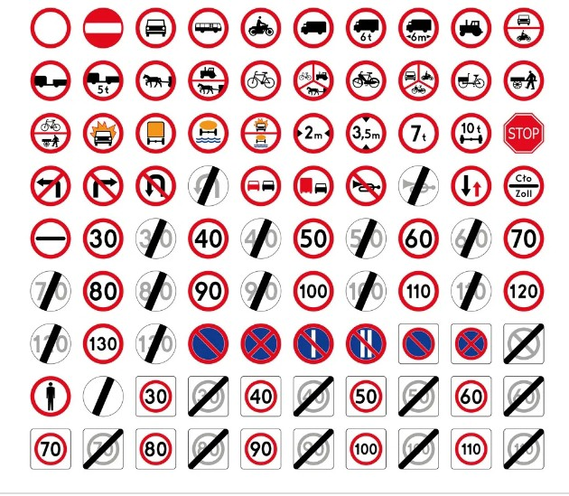Figure 1: road signs examples

3.2 Design Speed – Design speed is considered to be the selected speed that is used to evaluate the various geometric design characteristics of a roadway. This concept is essential so that appropriate and recommended speed, that is based on reasonable desires of the majority of drivers is selected, and it influence all highway geometry characteristic designed to include that speed.
3.3 Operating Speed - Operating speed is considered as the highest overall speed on a given highway under normal weather conditions and under prevailing traffic conditions at which drivers may travel on without at any point in time exceeding speed limit observed (stipulated) by the design speed on various sections of the highway at which vehicles are allowed operating during free flow conditions. Free flow conditions are phenomena where vehicles or drivers are unimpeded or obstructed by some what other vehicles or by traffic police or other traffic control devices such as traffic signals.
3.4 85th Percentile Speed – This is the speed at which 85% of drivers travel or below which 85% of driver’s travel. Or the 85th percentile speed is the speed at or below which 85% of drivers operate their vehicles. This is calculated through a spot speed studies to obtain dependable approximate of 85th percentile speeds. Where a speed measurement spot is identified on a road way, and speeds are calculated for sufficient sample of free-flowing vehicles.

It is also known as “operating speed”, this is considered to be the maximum safe speed for motorists traveling at a certain position. However, it is not the same as the speed limits on traffic signs.
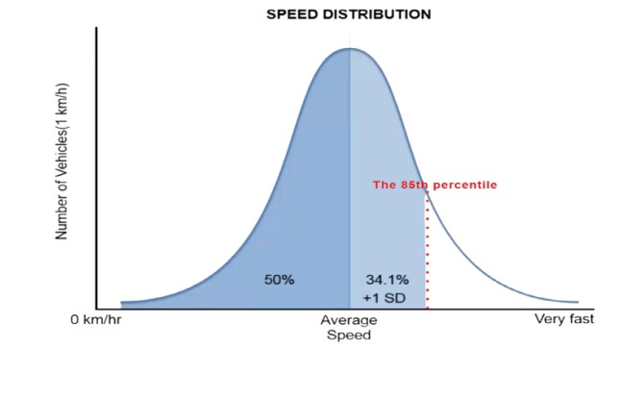Figure 2: Speed Distribution showing 85th percentile
3.5 Target Speed -target speed is the maximum operating speed at which vehicles are expected to operate on a roadway in a specific condition or context.
3.6 Mean Speed - the sum of all the measured speeds of passing vehicles at a specific location over by the number of passing vehicles of a place in a specific time .
3.7 Speed Distribution - the grouping of speed values or numbers that shows their observed frequency distribution of a place in a specific time.
3.8 Posted Speed - the maximal lawful or recommended speed for a specific location as observed on a traffic regulatory sign. Posted speed limits, often called regulatory speed limits, are speeds that are systematically sign-posted along roadway and are enforced by traffic regulatory laws. Posted speed limit is sometimes the same as the statutory speed set by the legislative body of the state, or established and regulated by a particular city or a recognized transportation agency as an improvement to the statutory speed limit.

Some town and cities establish an all-inclusive speed limit for roads within their jurisdictions. Those speed limits are broadly at entry points. The recommended posted speed limit sometimes differ from the recommended statutory speed limit; in these scenarios , the posted speed limit is evaluated using an engineering speed survey or study and takes precedence over the regulated statutory speed limit.
3.9 Speed Limit – The speed of a vehicle must, at all times, be attuned to the state of the roadway with particular consideration of the safety of others. The conditions of the vehicle, road visibility condition and weather condition need to be taken into consideration as well as the overall state of the traffic by the driver at all times. The speed and control of the vehicle must be in full control of the diver and at no point should the vehicle goes faster than the controlling capacity of the driver.


It must be possible to stop on the stretch of the roadway in front of the vehicle which the driver has a view of and in front of any obstacle that can be expected. When switching from full-beam headlights to low-beam headlights, the speed before switching must be adjusted to the new visibility condition.

The driver at all times must be able to stop the the vehicle on the stretch of the highway in front of the vehicle which the has to make sure has a view of and any obstacle that is in front of driver’s vehicle.

3.7.1 Dense built-up area A dense built-up area need a sign to show the driver the location the vehicle is entering is a densely built-up area.
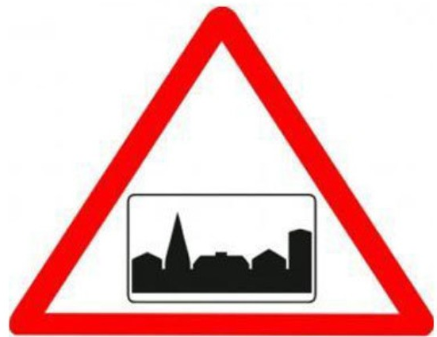

3.10 Statutory Speed - the numerical speed limits established by state law that apply to various classes or categories of roads in the absence of posted speed limits.
3.11 Speed Zone - the speed limit established on the basis of an engineering study for particular section of road, for which a statutory speed limit is not appropriate.

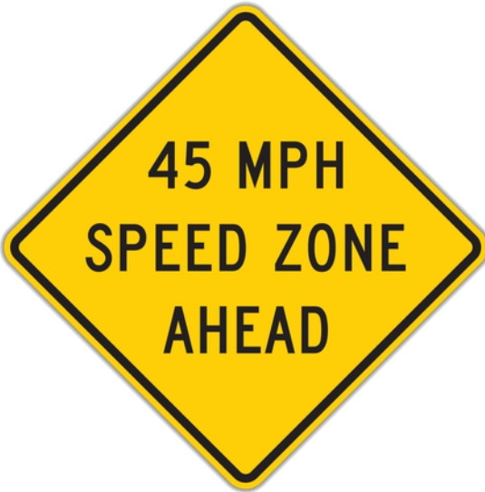

3.12 Advisory Speed - a recommended speed where the need to reduce speed below the speed limit is recommended due to a specific road condition.

3.13 Flow of Traffic- It is the term that refer to speed that is prevalent in the 85th percentile of passing vehicles in a location. The flow of traffic is sometimes below the speed limit. But often, the flow of traffic is above the posted limit.

Generally, the frequent speed is what traffic experts or engineers use to evaluate and determine what the official(recommended) speed limit should be on any given roadway. Speed limits are essentially set using the speed of passing vehicles which 85% of traffic flows.

Studies and surveys show that this 85th percentile is considered the safest speed level. Drivers consider different factors, such as weather, visibility within a particular environment more than the recommended speed or posted speed limit.

3.14 Traffic studies and characteristics
This include evaluating and numerating various aspect of highway traffic flow. Studies are based on data collection from locations on roads and analysis that is used to qualify traffic, including traffic travel time and volume, demands, delay, accidents (data on injury and fatality), initial destinations and final destinations and other variables that influence traffic on road.

3.15 Performance evaluation
This a process by which traffic experts and engineers rate the operating functionalities of particular locations of facilities and facilities as a whole in relative terms. This is evaluation is depended on measuring performance quality and sometimes referred to as ‘levels of service.’

3.16 Facility design
This is the process where experts or engineers in the operational and geometric design of roads and other functional traffic facilities. This help in determining the structural design of the traffic to give it the convenience and safety protocols it required for its absolute efficiency.

3.17 Traffic control
This is a central operation of traffic experts or engineers and include the formation of traffic recommended rules and all the work that goes in to display or communicate the information to the driver, using traffic control devices, such as marks (paintings) and traffic signals.

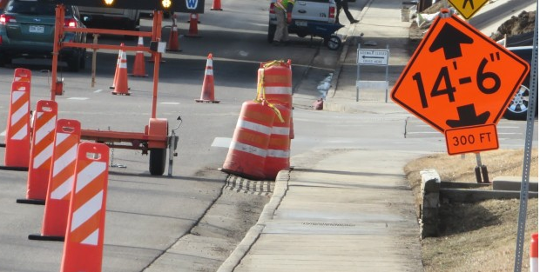

3.18 Traffic operations
This include factors or variables that influence overall functional or operational traffic facilities, such as transit operations, two-way highways, curb management of the roadway, and network control systems that encompasses all facilities of the traffic.

3.19 Intelligent transportation systems
This refers to the scientific use of technology to the functional and control of core transportation systems. These systems involve automation of highway facilities, vehicle-tracking systems, GPS and city or town mapping systems, automated toll-collection systems and automated enforcement of traffic lights.

4. General Analysis

4.1 Appropriate Speed Limits
The choice of the speed limit for any particular location of a roadway type is simply an exercise in considering the goals of safety and serviceable efficiency.
The functional efficiency is measured by travel time and the safety level, evaluated by the frequency of crashes and resulting fatalities and injuries with consideration of the function of the road.
High-level roads and freeways can sustain higher speeds as a result of their design characteristics that have very little or no event interacting with non-motorized user or adjacent improvement. Roadway types with lower operational classes, such as collector, local roads and minor arterial give for different road users, ensuring and requiring that safety becomes the top priority.
4.2 Engineering Approach - A two-way activity where a basic speed limit is set accordant to the 85th percentile speed, the designing level speed for the roadway, or other typical conditions. This speed limit is improved according to traffic and infrastructural conditions such as pedestrian use, median presence.
In the engineering method or approach there are two well defined approaches: The Operating Speed approach is set to within the range of 5 mph of the 85th percentile speed measured from the speed studies and the necessary changes are added or removed depending on the due consideration made.
Under the Road Risk Method, the level of development and the function adjacent of a roadway of a road are the most basic determinants of the necessary speed limit.
4.3 Expert System Approach - Speed limits are derived and suggested by computer stimulation that uses knowledge and deductive procedures that simulate behavior and judgment of speed limit experts (data driven).
Generally, the system include a knowledge base already accumulated knowledge and continue to do so and a set of well-defined rules for applying the knowledge and make prediction to each particular situation.
There is different expert system developed to carry this work. USLIMITS2 is a perfect example that is designed to evaluate speed limits in speed zones on all kinds of roads, from rural two-lane roadways to urban freeway roadways.
Through the use of access points, number of lanes, environmental factors, crash history the device stimulate to its maximum accuracy and make recommendation for speed limits.
4.5 Safe System Approach - The safe systems method put emphasis on making sure a high degree of safety protocol for all roadway users is ushered in the design, and to minimize errors such that they do not result in serious injury or a fatality.

With this method, speed limits are set in accordant to the crash types that are more likely to happen, the effect of all forces that result, and the tolerant threshold of the human body in such situations.
In the safe system method, the primary consideration is the safety of all road users, that include cyclists and pedestrians that are sometimes more vulnerable to injury and even death sometimes when they are hit by a passing vehicle.
Therefore, this method usually yields in lower speed limits than the speed limits that would be determined by the engineering and expert system methods.
A safe systems method demands a holistic planning and designing of the roads and take into account the interrelated factors for optimal safety of all road users. The safe systems method is an ideal method for many urban roads and to broaden safety and protection for all vulnerable users (persons with disability and school children).

4.6 Transportation Demand
It is observed that transportation demand is directly related to land-use patterns (In Gambia the markets along major highways cause a lot of delay to the flow of traffic. Vehicle hardly experience any free flow in those areas. The land use pattern along the highways in the Gambia is the biggest contributor to traffic congestion) and to available transportation systems and traffic facilities. Transportation designers or planners and traffic designers or engineers endeavor to provide capacity for expected or predicted or observed travel (traffic) demand by constructing transportation systems.
However, proximity of land to highways and transportation facilities increase its value. The issue of mobility is not a concern when the land is close to major highways, because mobility is simply the ability to move to different destinations and accessibility to other parts of the land or town become fully attainable. This factors determine the value of the land.

Conclusion and Recommendations
Traffic engineering make it possible to plan and design roadways that have the capacity to handle certain degrees of low speed and high speed vehicles, enhances the comfort of traveling and increase the overall traveling convenience. It also reduces travel time; this contribute to the economic significant part of traveling. And contribute immensely to the development of roadways that that promote environmental compatibility.

Bibliography
Put the bibliography of the
books and other sources used to write the assignment.

Title Authors Publishers Year

Engineer and Traffic Survey C. Thnay Stanec 2017
Temporary Traffic Control Manual City of Mesa City of Mesa 2017
Traffic Count NRA(Gambia) NRA(Gambia) 2016
Traffic Engineering and Transport Planning S. Morgan The English Press 2018
Distribution of Vehicle Speed and Travel Time S. B. Donald & D. M. Belmont University of California 2019

